**Class Test 07**

1. Create the tables given below with all given specifications and insert the given data in the created tables. Use sequences to create primary key values. Create one index for each table manually. Both tables must have a synonymous name.

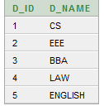 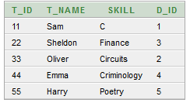

Table: Department Table: Teacher

1. There are 3 roles in this database i.e.
2. Director,
3. Head and
4. Teacher.

The role Director has access to all tables and has the credentials to all system and object privileges. Sam (Password: dean) is the Director.

The role Head can only update and see all data. Sheldon(Password: amy) is the Head.

The role Teacher can only see all data.

Oliver(Password: twist),

Emma (Password: henry) and

Harry (Password: ginny) are all teachers.

1. Create a complex view that displays the employee name and the name of the department they work in.

***Hints:***

1. *From System’s user account create all the users and roles*
2. *From Director’s user account perform all DDL and DML operations for the tables Department and Teacher*