Supplementary Material
This document contains the supplementary appendices of the article. Appendices A to H are numbered independently of the article: equations, tables and figures carry the letter of the appendix in which they appear, for example Eq. (A.12), Table C.1 and Figure H.4, and the article refers to them by those labels. Equation numbers without a letter, such as Eq. (12), refer to the numbered equations of the article. The nomenclature applying to both documents is printed in the article, following the keywords, and the works cited in these appendices are listed at the end of this document.

Appendix A. Model formulation
This appendix gives the model formulation in full; Section 3 of the article summarizes it. Equations are numbered A.1 onward, independently of the article, and the equations reproduced in Section 3 of the article appear here in their derived context.
The zero-liquid-discharge desalination (ZLDD) cascade is represented by a multi-physics, distributed-parameter model coupling energy, mass, and momentum conservation across six coupled domains: the glass cover, the vapor gaps, the falling liquid films, the absorber plates and floor slab, the enclosure side wall, and the recirculating air stream.

A.1 Physical model description
The configuration of the cascade still is shown in Fig. 1(a). A solar-transparent glass cover, inclined at β to the horizontal, spans an insulated enclosure containing a stack of absorber plates, each inclined at θ and arranged serpentine so that successive plates discharge at opposite ends. The enclosure floor forms the terminal stage and bears a film in the same way as the plates above it. Saline feed is introduced at the head of the uppermost plate and descends under gravity as a thin film, transferring at the end of each plate to the head of the one below, so that a single continuous stream traverses the cascade and leaves as concentrated brine at the floor outlet. Dried air is admitted to the bottom gap and drawn upward through the stack counter-currently to the film, taking up vapor at each stage before leaving beneath the cover. The side walls are insulated on their outward face, and the gap formed between each plate and the surface above it tapers along the flow direction with the plate inclination.
Radiation transmitted by the cover is partitioned at each stage between the liquid film and the plate beneath it, in proportion to their absorptivities and the optical transparency of the plate, with the unabsorbed remainder passed to the stage below. The absorbed radiation raises the film temperature and drives evaporation into the adjoining gap, so that the brine is concentrated progressively along the cascade.
The transport processes resolved within a gap are presented in detail in Fig. 1(b). The panel is drawn for a single gap and applies without modification to every gap in the stack.

A.2 Domain, indexing and state variables

A.2.1 Cascade topology
The enclosure contains $N_{p}$ tilted absorber plates stacked vertically beneath a tilted glass cover, plus the enclosure floor, which is treated as a fully active film-bearing terminal stage. The total number of film-bearing stages is
$$N_{s}=N_{p}+1,$$
with stage $N_{s}$ denoting the floor. Each stage $k$ carries a falling film discretized into $N_{x}$ streamwise nodes. Gap $k$ is the vapor compartment lying above stage $k$; there are therefore $N_{s}$ gaps, gap 1 lying beneath the glass cover and gap $N_{s}$ above the floor.
Consecutive plates are inclined in opposite senses, giving a serpentine or accordion stack, so the local streamwise coordinate of plate $k$ runs counter to that of plate $k+1$. Nodal vectors crossing a gap are index-reversed accordingly. Feed enters at the head of stage 1; the outlet of stage $k$ is the inlet of stage $k+1$; concentrated brine leaves the cascade at the floor outlet and passes to the crystallizer, described in Section 3.5 of the article.
The air stream is counter-current to the liquid: the fan draws air in at gap $N_{s}$ (bottom) and it travels upward, $N_{s}→1$, leaving beneath the glass cover.

A.2.2 State variables
Symbol | Meaning | Units | Dimension
$$T_{g}$$ | glass cover temperature | K | scalar
$$T_{v,k}$$ | vapor-gap air temperature | K | $$1×N_{s}$$
$$ω_{k}$$ | vapor-gap humidity ratio | kg kg$​^{-1}$ | $$1×N_{s}$$
$$T_{\text{wall},k}$$ | side-wall node temperature | K | $$1×N_{s}$$
$$M_{k,i}$$ | film areal solution holdup, $M=ρδ$ | kg m$​^{-2}$ | $$N_{s}×N_{x}$$
$$M_{s,k,i}$$ | film areal salt holdup, $M_{s}=Cδ$ | kg m$​^{-2}$ | $$N_{s}×N_{x}$$
$$T_{w,k,i}$$ | film temperature | K | $$N_{s}×N_{x}$$
$$T_{p,k,i}$$ | plate and floor-slab temperature | K | $$N_{s}×N_{x}$$
$$u_{k,i}$$ | depth-averaged film velocity | m s$​^{-1}$ | $$N_{s}×N_{x}$$

Film thickness $δ$ and salt concentration $C$ are not states; they are recovered algebraically from the conserved holdups, as δ = M/ρ(T_w, S_m) and C = M_s/δ. M is therefore the mass of saline solution per unit area, not of water alone, and Eq. (8) is a total-mass balance whose sink removes water from the solution. Conserving $M$ and $M_{s}$ rather than $δ$ and $C$ is what makes the mass and salt balances exactly conservative under evaporation and density variation.

A.2.3 Sign conventions
All interfacial powers $Q$ are defined positive in the direction stated by their subscript. Radiative quantities returned by the enclosure solver, $Q_{f}$, $Q_{\text{top}}$, $Q_{w}$, are net radiative losses from that surface (positive = net emitter).

A.3 Glass cover energy balance
The glass cover is a single lumped node with areal heat capacity ${\left(mc_{p}\right)}_{g}$ [J m$​^{-2}$ K$​^{-1}$], so every term below is areal [W m$​^{-2}$]:
The four loss and gain paths are:
Solar absorption: $α_{g}I_{g}$, with $I_{g}\left(t\right)$ obtained by interpolation of a prescribed diurnal irradiance record, identically
$$I_{g}\left(t\right)=G\left(t\right)$$
an identity rather than a constitutive relation, and therefore not assigned an equation number. The irradiance forcing is a plane-of-array series for the design site and month, taken at the glass cover slope β; site, glass cover tilt and irradiance record form a single consistent set and are reported together with the design case in the results.
Enclosure radiation: $Q_{\text{top},1}$ is the net radiative loss from the glass cover in its role as the top surface of gap 1, obtained from the three-surface radiosity network of Appendix A.8. Its negative is a gain to the glass cover.
Convection from gap 1:
Qgap1→g=hc,1 Tv,1-Tg Ag, hc,1=1Nxi​hc,1,i (A.1)
This single value is computed once and passed to both the glass cover and the gap-1 balances, so the two control volumes agree exactly on the heat crossing between them.
External convection and sky radiation:
$$h_{\text{wind}}=5.7+3.8 V_{\text{wind}} {\text{[W m}}^{-2}{\text{K}}^{-1}\text{]} (A.2)$$
$$T_{\text{sky}}=0.0552 T_{a}^{1.5} h_{r,g\text{-sky}}=ε_{g}σ \left(T_{g}^{2}+T_{\text{sky}}^{2}\right)\left(T_{g}+T_{\text{sky}}\right) (A.3)$$
The Swinbank sky-temperature relation and the McAdams wind correlation are both empirical; the latter is valid for $V_{\text{wind}}≲5$ m s$​^{-1}$.

A.4 Vapor gap $j$ energy and moisture balances
Each gap is a single well-mixed control volume of geometric volume $V_{\text{gap},j}$.

A.4.1 Air-stream mass flow
The fan delivers a fixed moist-air mass flow
$${\dot{m}}_{a}=ρ_{a}\left(T_{\text{fan,in}}\right) {\dot{V}}_{\text{fan}}, {\dot{m}}_{da}=\frac{{\dot{m}}_{a}}{1+ω_{\text{fan,in}}}, {\dot{m}}_{v,\text{in}}={\dot{m}}_{a}-{\dot{m}}_{da} (A.4)$$
Because the air loop is closed through the dehumidification/condensation unit, the inlet humidity ratio is fixed by its coil, not by ambient air:
$$ω_{\text{fan,in}}=ω_{\text{sat}}\left(T_{\text{coil}}\right)=\frac{0.622 p_{\text{sat}}\left(T_{\text{coil}}\right)}{p_{\text{atm}}-p_{\text{sat}}\left(T_{\text{coil}}\right)} (A.5)$$
The relative humidity at the still inlet, $ϕ_{\text{fan,in}}=ω_{\text{fan,in}}/ω_{\text{sat}}\left(T_{\text{fan,in}}\right)$, is therefore a derived quantity, not an input.
Since the air travels $N_{s}→1$ and picks up vapor at every stage, the flow through gap $j$ is
$${\dot{M}}_{\text{out},j}={\dot{m}}_{a}+\sum_{i=j}^{N_{s}}{E_{i}}, {\dot{M}}_{\text{in},j}=\left\{\begin{matrix}{\dot{m}}_{a}+\sum_{i=j+1}^{N_{s}}{E_{i}}, & j<N_{s} \\ {\dot{m}}_{a}, & j=N_{s}\end{matrix}\right. (A.6)$$
where $E_{j}$ is the total evaporation rate from stage $j$
$$E_{j}=W Δx_{j}\sum_{i=1}^{N_{x}}{\dot{m}}″_{\text{evap},j,i} \left[{\text{kg s}}^{-1}\right] (A.7)$$

A.4.2 Sensible energy balance
with $M_{v,j}=ρ_{m}\left(T_{v,j},ω_{j}\right) V_{\text{gap},j}$ and inlet state
$$\left(T_{\text{in},j}, ω_{\text{in},j}\right)=\left\{\begin{matrix}\left(T_{v,j+1}, ω_{j+1}\right), & j<N_{s} \\ \left(T_{\text{fan,in}}, ω_{\text{fan,in}}\right), & j=N_{s}\end{matrix}\right. (A.8)$$
Enthalpy datum: All streams are referenced to liquid water at 273.15 K. On this datum the latent heat does not appear explicitly in the three vapor streams of Eq. (4). Each of those streams carries the same constant latent contribution per unit mass of vapor, and because the outlet vapor flow equals the inlet flow plus the stage evaporation rate, as the mass balance above requires, those contributions sum to zero and cancel identically. The film correspondingly loses only its own latent term.
Consistency of the film-side and gap-side latent terms: The quantity that multiplies all three streams and cancels is the latent heat evaluated at the datum temperature, a constant, rather than one evaluated at the local film temperature. Its temperature dependence is not discarded with it: that dependence is carried separately by the explicit vapor specific-heat term of Eq. (4), which is not cancelled. On the film side, Eq. (11) removes the latent heat evaluated at the local film temperature together with the sensible enthalpy of the liquid that leaves the film on evaporating. Because the latent heat at any temperature differs from its datum value only by the difference between the vapor and liquid specific heats acting over the interval between the two temperatures, these two descriptions are algebraically identical: what the film loses is exactly what the gap receives. The local and datum evaluations are therefore consistent rather than competing. The correction implied by that specific-heat difference amounts to 3.2–4.2 % of the datum latent heat across the cascade, and 3.3 % at the interior-stage mean film temperature; it is carried by the model, not neglected.
The interfacial terms are taken as nodal integrals, not lumped products:
Qf→v,j=W Δxji​hc,j,i Tw,j,i-Tv,j (A.9)
Qv→top,j=W Δxj-1i​hc,j,irev Tv,j-Tp,j-1,i, j≥2 (A.10)
$$Q_{v→\text{wall},j}={\overset{‾}{h}}_{c,j} \left(T_{v,j}-T_{\text{wall},j}\right) A_{\text{wall},j} (A.11)$$
The distinction matters because the lumped and nodal forms differ by the covariance of the convective coefficient with the film temperature, and both vary monotonically along the tapering gap, so that covariance is systematic rather than random. Sharing a single nodal flux between each conjugate pair makes the interfaces conservative by construction.
Where the lumped form is used instead: The nodal treatment is applied at the film–gap and gap–plate interfaces, Eqs. (A.9) and (A.10), which carry the dominant transfer. Three interfaces retain the lumped mean-coefficient form: the glass-cover and wall convection of Eqs. (A.1) and (A.11), which are small in absolute terms and whose receiving nodes are themselves lumped, and the radiative exchange of Appendix A.8.1, whose sensitivity to the axial gradient enters only at second order in $\left(T-\overset{‾}{T}\right)/\overset{‾}{T}$, giving a neglected covariance below 1 % of the radiative term. That accepted at the convective interfaces is larger, $h_{c}$ varying by roughly a factor of two along the tapering gap, which is why the nodal form is retained there and not elsewhere.
The specific heat of freshly evaporated vapor, $c_{p,\text{vap}}$, is evaluated at its source temperature ${\overset{‾}{T}}_{w,j}$ using the linear fit tabulated in Table C.3; it is not restated as a separate numbered relation here.

A.4.3 Moisture (water-vapor mass) balance
The gap is treated as a well-mixed control volume of dry-air mass $m_{da,j}$:
whose relaxation time is $τ_{j}=m_{da,j}/{\dot{m}}_{da}$.
Omitted storage-mass derivative: The storage term of Eq. (4) treats the gap moist-air mass as constant, whereas the complete form of the vapor enthalpy derivative adds a further term in the rate of change of that mass, driven by the humidity ratio evolving through Eq. (5). The gap air mass changes only through the humidity ratio, so its fractional rate of change is of the order of the fractional rate of change of the humidity ratio itself. At the humidity ratios of the present case this makes the omitted term a few per cent of the temperature-storage term during the transient, and it vanishes altogether at the quasi-steady operating point. It is therefore neglected.

A.5 Liquid film mass, salt, momentum, and energy
All film equations are written per stage $k$ over $x∈\left[0,L_{k}\right]$, where $L_{k}=L$ for $k≤N_{p}$ and $L_{N_{s}}=L_{\text{floor}}$.

A.5.1 Solution mass

A.5.2 Salt mass
The conservative balance on the areal solution holdup is stated as Eq. (8) of Section 3.2. Its sink removes water from the solution, so the holdup is the mass of saline solution per unit area rather than of water alone.
There is no sink term: salt does not evaporate. The absence of a salt sink is what permits the model to represent progressive concentration of the brine along the cascade ($M_{s}$ is transported and concentrated but never destroyed) without itself constituting a claim that saturation is reached at stage $N_{s}$; the terminal brine concentration is a solved output that depends on the operating point, and zero-liquid-discharge closure is completed downstream in the crystallizer, described in Section 3.5 of the article.
Both are integrated in conservative flux-divergence form, with the true inflow flux supplying the node-1 boundary rather than an extrapolated stencil:
$${\left. \frac{∂\left(Mu\right)}{∂x}\right|}_{i=1}=\frac{{\left(Mu\right)}_{1}-M_{\text{in}}u_{\text{in}}}{Δx}, {\left. \frac{∂\left(Mu\right)}{∂x}\right|}_{i>1}=\frac{{\left(Mu\right)}_{i}-{\left(Mu\right)}_{i-1}}{Δx} (A.12)$$

A.5.3 Streamwise momentum
The film momentum is a genuine PDE state rather than an algebraic Nusselt closure:
with wall shear closure and Boussinesq momentum correction factor
$$τ_{w}=\frac{3μu}{δ}, β_{m}=\frac{\overline{u^{2}}}{{\overset{‾}{u}}^{2}}=\frac{6}{5} (A.13)$$
The momentum correction factor in Eq. (A.13) is the value for the parabolic velocity profile consistent with the wall-shear closure stated alongside it; the two must be changed together. The terms of Eq. (10) are, in order: advection, gravitational body force, hydrostatic (thickness-gradient) pressure, wall drag, and streamwise diffusion.
Why a momentum PDE rather than an algebraic closure: At the film Reynolds numbers of this cascade inertia is negligible and a Nusselt closure reproduces the steady thickness profile well, which is why the boundary conditions, Eqs. (A.16) and (A.17), are themselves algebraic Nusselt values. The PDE is retained for what the algebraic closure cannot represent: thickness transients during startup, drainage, and stage-to-stage handoff, where the hydrostatic term $gcosθ ∂δ/∂x$ redistributes liquid over a finite time rather than instantaneously. The cost is additional stiffness, which the implicit integrator absorbs.
Two stated limitations: (i) The wall-shear closure presumes a stress-free interface: the counter-current air stream exerts no drag on the film surface, so the film velocity field is decoupled from the air-side momentum. This should be stated explicitly, because the air stream is found to govern stage evaporation: the coupling between air and film in this model is thermal and diffusive, not mechanical. (ii) The streamwise viscous term $νu_{xx}$ is retained for numerical regularization; its magnitude relative to the other terms is $O\left(δ^{2}/L^{2}\right)$ and it does not represent a physically significant transport mechanism at these aspect ratios.

A.5.4 Film energy
This is the non-conservative form. It follows from the conservative balance on the holdup by substituting the solution-mass equation (8) for the rate of change of holdup, whereupon the advective and mass-loss terms cancel identically. The sensible enthalpy carried away by the evaporating mass is therefore accounted for automatically: no separate vapor-enthalpy sink belongs in the film balance, and adding one would double-count it.
The individual fluxes are
Flux | Expression | Units
Plate → film conduction | $$q″_{p→w}=\frac{k_{\text{water}}}{δ} \left(T_{p}-T_{w}\right)$$ | W m$​^{-2}$
Film → gap convection | $$q″_{\text{conv}}=h_{c} \left(T_{w}-T_{v}\right)$$ | W m$​^{-2}$
Evaporative latent loss | $$q_{\text{evap}}^{″}=\dot{m_{\text{evap}}^{″}} h_{\text{fg}}(T_{w},C)$$ | W m$​^{-2}$
Enclosure radiation | $$q″_{\text{rad},f}=Q_{f,k}/A_{p,k}$$ | W m$​^{-2}$

The plate–film conduction coefficient treats the film as a pure conduction layer across its thickness, the coefficient being the water conductivity divided by the local film thickness. This is appropriate at the film Reynolds numbers of this cascade, which lie between about 4 and 15, but it neglects any convective enhancement within the film.
Advection uses first-order upwinding with the true inflow temperature at node 1:
$${\left. \frac{∂T_{w}}{∂x}\right|}_{i=1}=\frac{T_{w,1}-T_{w,\text{in}}}{Δx}, {\left. \frac{∂T_{w}}{∂x}\right|}_{i>1}=\frac{T_{w,i}-T_{w,i-1}}{Δx} (A.14)$$
Axial diffusion uses a centered three-point stencil in the interior and a zero-gradient-consistent one-sided stencil at both ends.

A.5.5 Inlet conditions
$${\left(M_{\text{in}},M_{s,\text{in}},T_{w,\text{in}}\right)}_{k}=\left\{\begin{matrix}\left(ρ_{f}δ_{0}, {\text{TDS}}_{f} δ_{0}, T_{f}\right), & k=1 \\ \left(M_{k-1,N_{x}}, M_{s,k-1,N_{x}}, T_{w,k-1,N_{x}}\right), & k≥2\end{matrix}\right. (A.15)$$
Stage-to-stage continuity is therefore exact by construction. The inflow velocity is the Nusselt value evaluated at the true inflow state,
$$u_{\text{in},k}=\frac{ρ_{\text{in}} gsinθ δ_{\text{in}}^{2}}{3 μ_{\text{in}}} (A.16)$$
and the feed film thickness follows from the Nusselt falling-film closure at the areal feed rate $Γ_{f}$:
$$δ_{0}={\left(\frac{3μ_{0}Γ_{f}}{ρ_{0}^{2}gsinθ}\right)}^{1/3}, Γ_{f}=\frac{V_{f}ρ_{f}/1000}{W t_{\text{op}}⋅3600} (A.17)$$
Eq. (A.17) is also the point at which the daily operating basis of this work is defined: $t_{\text{op}}$ is the operating window in hours, and every per-window quantity reported anywhere in this paper (feed volume, distillate production and salt recovery) is referred to this window rather than to a 24-hour day and is written kg (10 h)⁻¹ or L (10 h)⁻¹. This definition should be cited wherever such quantities are quoted, since the two bases differ by a factor of $24/t_{\text{op}}$.
No penalty or relaxation boundary condition is used anywhere in the model; every inlet condition enters through the flux divergence or the upwind derivative.

A.6 Absorber plate and floor slab energy balance
Each solid stage is a thin slab of areal capacity $ρ_{s}c_{p,s}t_{s}$:
The back-side terms differ between the interior plates and the terminal floor.

A.6.1 Interior plates, $k<N_{s}$
Plate $k$ forms the upper surface of gap $k+1$:
$$q″_{\text{conv},vp}=h_{c,k+1}^{\text{rev}} \left(T_{v,k+1}-T_{p,k}\right), q″_{\text{back}}=-\frac{Q_{\text{top},k+1}}{A_{p,k}} (A.18)$$
$h_{c,k+1}^{\text{rev}}$ denotes the gap-$\left(k+1\right)$ coefficient vector index-reversed because the transfer coefficients for that gap are indexed in plate $\left(k+1\right)$’s frame where its taper is defined and must be reversed before being applied against plate $k$’s temperature field under the serpentine arrangement. Since the inter-plate gap height varies along the stage under the taper defined by Eq. (A.42), the convective coefficient varies by a comparable factor along the stage, and the pairing therefore affects the nodal distribution materially.

A.6.2 Terminal floor stage, $k=N_{s}$
The floor has no gap beneath it. Its back side conducts to the wrapping wall strip and to ground, both evaluated from the floor’s spatial-mean temperature ${\overset{‾}{T}}_{p}$ and applied as a uniform areal loss:
$$Q_{\text{floor}→\text{gnd}}=\frac{\left({\overset{‾}{T}}_{p}-T_{\text{gnd}}\right)}{R_{\text{floor,gnd}}} A_{p,\text{floor}}, R_{\text{floor,gnd}}=\frac{t_{\text{base}}}{k_{\text{base}}}+\frac{t_{\text{ins}}}{k_{\text{ins}}} (A.19)$$
$$Q_{\text{floor}→\text{wall}}=\left({\overset{‾}{T}}_{p}-T_{\text{wall},N_{s}}\right) {\text{UA}}_{\text{floor,wall}}, {\text{UA}}_{\text{floor,wall}}={\left(\frac{R_{\text{floor,wall}}}{A_{\text{contact}}}+R_{\text{spread}}\right)}^{-1}, R_{\text{floor,wall}}=\frac{t_{\text{wall}}}{k_{\text{wall}}} (A.20)$$
$$A_{\text{contact}}=2 \left(L_{\text{floor}}+W\right) t_{\text{base}} (A.21)$$
$$q″_{\text{conv},vp}=0, q″_{\text{back}}=-\frac{Q_{\text{floor}→\text{gnd}}+Q_{\text{floor}→\text{wall}}}{A_{p,\text{floor}}} (A.22)$$
The floor temperature field is resolved in the streamwise direction only, so transverse conduction from the wrapped perimeter towards the slab interior is absent from the discretization and is supplied as a lumped spreading resistance in series with the contact path. It is obtained by treating the slab as a two-dimensional conductor held at the wall-strip temperature around its entire perimeter and exchanging heat with the film over its whole area and taking the area-averaged temperature rise. The classical odd-mode series solution for that boundary condition is exact and carries no aspect-ratio restriction; for the square footprint of the present geometry, it converges to a resistance of 0.0351 divided by the product of the slab conductivity and its thickness, independent of size.
Spreading dominates the series path. The contact term alone is proportional to $t_{\text{wall}}$, so a thinner wall skin would strengthen rather than weaken the bridge, and taken by itself it exceeds the floor-to-ground conductance by three to four orders of magnitude; with the spreading resistance included the two paths are of comparable weight and the floor energy balance remains well posed. $R_{\text{floor,wall}}$ carries no insulation in series whereas $R_{\text{floor,gnd}}$ does, which is a consequence of the assumed wall construction and is listed among the assumptions of Appendix A.13.

A.7 Solar cascade

A.7.1 Per-stage radiative partition
The beam admitted through the glass cover sets the flux incident on the first stage,
$$I_{T,1}=τ_{g} I_{g} (A.23)$$
Within each stage the film attenuates the beam by Beer–Lambert absorption, and the surviving beam is partitioned at the solid surface into absorption, reflection, and transmission:
$$a_{w}=1-exp\left(-κ_{w}δ\right) (A.24)$$
$$q″_{\text{sol},w}=a_{w}I_{T}, I_{T}^{\text{solid}}=\left(1-a_{w}\right)I_{T} (A.25)$$
$$q″_{\text{sol},p}=α_{s,k} I_{T}^{\text{solid}}, q″_{\text{refl}}=R_{F,k} I_{T}^{\text{solid}}, I_{T,\text{next}}=\left(1-α_{s,k}-R_{F,k}\right) I_{T}^{\text{solid}} (A.26)$$
The partition closes exactly by construction:
$$q″_{\text{sol},w}+q″_{\text{sol},p}+q″_{\text{refl}}+I_{T,\text{next}}=I_{T} (A.27)$$
All reported results use the Beer–Lambert form of Eqs. (A.24)–(A.27). An alternative in which the film absorptivity multiplies the same exponential, so that the film absorbs a fixed fraction of the beam regardless of its thickness, is used only for sensitivity assessment (Appendix A.13).

A.7.2 Stage-to-stage hand-off
Because consecutive stages do not share a footprint ($A_{p}=LW$ for plates, $A_{p,\text{floor}}=L_{\text{floor}}W$), the conserved quantity across the hand-off is power, so the areal flux is rescaled:
$$I_{T}^{\left(k+1\right)}=I_{T,\text{next}}^{\left(k\right)} \frac{A_{p,k}}{A_{p,k+1}} (A.28)$$
Under the serpentine arrangement the beam arrives at stage $k+1$ at the same physical location at which it left stage $k$, which corresponds to the reversed node index; the flux vector is therefore index-reversed at each hand-off.

A.7.3 Aperture spill
The glass cover aperture $A_{g}=L_{\text{ch}}W/cosβ$ exceeds the plate footprint $A_{p}$, so a fraction of the admitted beam falls beyond the plate edge:
$$A_{\text{spill}}=A_{g}-A_{p}, f_{\text{spill}}=A_{\text{spill}}/A_{g} (A.29)$$
The spill fraction is a fixed geometric ratio, reported with the design case. The spill power is carried as an exit term in the optical accounting of Appendix A.12 and is deposited on no node. This is a modeling simplification rather than a physical statement: the spilled beam strikes the enclosure shell, which is itself a modeled node, so discarding it biases the wall temperature low and under-predicts the wall loss. The error does not act in the conservative direction and is bounded by the spill power itself. Depositing the spilled beam on the gap-1 wall instead, at the wall absorptivity, is available as a sensitivity-study option only (Appendix A.13).

A.7.4 Untracked streams
Two streams leave the radiative model rather than being propagated: the reflected component $q″_{\text{refl}}$ at every stage, and the residual $I_{T,\text{next}}$ at the terminal stage. Both are booked as losses in the solar accounting. Physically the reflected stream re-enters the gap above and strikes the underside of the plate overhead; discarding it removes energy from the device rather than returning it to a neighboring stage, so it under-predicts absorbed solar and makes the optical closure a bookkeeping identity rather than a complete inter-reflection treatment (Appendix A.13). Both streams appear explicitly as exit terms in the optical accounting of Appendix A.12.

A.8 Enclosure radiation

A.8.1 Three-surface radiosity network
Each gap $k$ is a closed grey-diffuse enclosure of three surfaces: the film $f$ below, the top surface $p$ (the glass cover for $k=1$, plate $k-1$ otherwise), and the lumped side wall $w$. The vapor phase is treated as non-participating in radiation; it exchanges heat with all three surfaces convectively only.
The radiosity of each surface satisfies
Ji=εiEb,i+1-εij​FijJj, Eb,i=σTi4 (A.30)
which is assembled as the linear system
$$\left[\begin{matrix}1 & -\left(1-ε_{f}\right)F_{fp} & -\left(1-ε_{f}\right)F_{fw} \\ -\left(1-ε_{p}\right)F_{pf} & 1 & -\left(1-ε_{p}\right)F_{pw} \\ -\left(1-ε_{w}\right)F_{wf} & -\left(1-ε_{w}\right)F_{wp} & 1-\left(1-ε_{w}\right)F_{ww}\end{matrix}\right]\left[\begin{matrix}J_{f} \\ J_{p} \\ J_{w}\end{matrix}\right]=\left[\begin{matrix}ε_{f}E_{b,f} \\ ε_{p}E_{b,p} \\ ε_{w}E_{b,w}\end{matrix}\right] (A.31)$$
The self-view terms $F_{ff}$ and $F_{pp}$ vanish because both surfaces are flat; $F_{ww}$ is retained on the diagonal because the wall ring is concave and sees itself. Omitting $F_{ww}$ (a common error when a general $N$-surface formulation is specialized to three surfaces) breaks the energy balance of Eq. (A.35) below.
Net radiative losses follow as
$$Q_{f}=A_{f}\left[F_{fp}\left(J_{f}-J_{p}\right)+F_{fw}\left(J_{f}-J_{w}\right)\right] (A.32)$$
$$Q_{\text{top}}=A_{\text{top}}\left[F_{pf}\left(J_{p}-J_{f}\right)+F_{pw}\left(J_{p}-J_{w}\right)\right] (A.33)$$
$$Q_{w}=A_{w}\left[F_{wf}\left(J_{w}-J_{f}\right)+F_{wp}\left(J_{w}-J_{p}\right)\right] (A.34)$$
Because each pairwise term $\left(A_{i}F_{ij}-A_{j}F_{ji}\right)$ vanishes exactly under reciprocity,
$$Q_{f}+Q_{\text{top}}+Q_{w}=0 \text{to machine precision} (A.35)$$
which serves as a hard conservation assertion rather than an approximate check.
The film and top-surface temperatures entering the radiosity solution are each a single spatial mean over the $N_{x}$ nodes, and the resulting single $Q$ per gap is applied uniformly across all nodes, so that axial gradients within a gap are not visible to the radiative exchange; the justification for accepting this is given in Appendix A.4.2 and the assumption is listed in Appendix A.13.

A.8.2 View factors for the tapered gap
The gap separation varies linearly along the flow direction, from $h_{n}$ at $x=0$ to $h_{w}$ at $x=L_{\text{gap}}$. The film-to-top view factor is obtained by scaling Hottel’s closed-form flat parallel-rectangle result (Hottel & Sarofim, 1967), evaluated at the mean height $\overset{‾}{h}=\left(h_{n}+h_{w}\right)/2$, by the ratio of the per-unit-width crossed-strings view factors for the tapered and flat geometries. The remaining six view factors follow from summation and reciprocity without further approximation, retaining the wall self-view term $F_{ww}$ because the wall ring is concave; the full algebra is given in Appendix B.
This construction is exact only in the limit $W/L→∞$, where the three- and two-dimensional problems coincide, and it collapses exactly to the flat parallel-plate result when $h_{n}=h_{w}$. For finite $W$ it is an engineering interpolation rather than a derived identity, and it has not been validated against a higher-order quadrature or Monte-Carlo reference; accuracy should be treated with caution where $W$ approaches $L$ or $\overset{‾}{h}$.

A.9 Side wall energy balance
The wall is discretized into one node per gap, each an areal composite of structural material plus insulation:
$${\left(mc_{p}\right)}_{\text{wall}}=ρ_{\text{wall}}c_{p,\text{wall}}t_{\text{wall}}+ρ_{\text{ins}}c_{p,\text{ins}}t_{\text{ins}} \left[{\text{J m}}^{-2}{\text{K}}^{-1}\right] (A.36)$$
with the outward resistance a series stack of wall material, insulation, and external film:
$$R_{\text{wall,out}}=\frac{t_{\text{wall}}}{k_{\text{wall}}}+\frac{t_{\text{ins}}}{k_{\text{ins}}}+\frac{1}{h_{\text{wind}}} (A.37)$$

A.9.1 Axial conduction along the wall sheet
Conduction is a property of the link between adjacent nodes, not of either node individually. The link resistance is the series combination of the half-spans on either side:
$$R_{\text{link},j}=\frac{L_{c,j}/2+L_{c,j+1}/2}{k_{\text{wall}}A_{\text{cond}}}, A_{\text{cond}}=2 \left(L_{\text{ch}}+W\right) t_{\text{wall}}, L_{c,j}=\frac{h_{n,j}+h_{w,j}}{2} (A.38)$$
$$q_{\text{link},j}=\frac{T_{\text{wall},j}-T_{\text{wall},j+1}}{R_{\text{link},j}}, j=1,…,N_{s}-1 (A.39)$$
is the single flux carried by the link connecting nodes $j$ and $j+1$, defined once per link rather than once per node. The net conduction source entering node $j$ is the difference of the two adjoining link fluxes, with the two terminal links (below node 1 and above node $N_{s}$) set identically to zero since the wall sheet does not continue past the end nodes:
$$q_{\text{cond},j}=q_{\text{link},j-1}-q_{\text{link},j}, q_{\text{link},0}≡0, q_{\text{link},N_{s}}≡0 (A.40)$$
so that $q_{\text{link},j}$ leaving node $j$ appears with the opposite sign as heat entering node $j+1$: the two control volumes agree on the flux crossing between them by construction, and assigning each node its own resistance instead of a single shared link value would break this property whenever adjacent spans differ, which is the case here (the top compartment is several times taller than an inter-plate gap, and the floor gap differs again).

A.9.2 Terminal-node source terms
Two additional, non-conductive sources are added to the node balance of Eq. (15) at the two terminal nodes only:
$$q_{\text{cond},N_{s}}^{\text{total}}=q_{\text{cond},N_{s}}+Q_{\text{floor}→\text{wall}}, q_{\text{cond},1}^{\text{total}}=q_{\text{cond},1}+Q_{\text{spill}} (A.41)$$
The first is the floor’s own wall-strip conduction, transferred as an exact single value from the floor energy balance of Appendix A.6.2 so that the two control volumes agree. The second is identically zero for all reported results, since aperture-spill deposition is not the setting used to produce them (Appendix A.7.3); it is retained so that the node balance is complete under that option (Appendix A.13) in which spill routing is enabled.

A.10 Interfacial transport closures

A.10.1 Evaporative mass flux
The interfacial driving force is the difference between the saturation pressure at the film surface and the vapor partial pressure in the adjacent gap:
Condensation onto the film is neglected: the driving potential is restricted to its positive part by the composite of Eq. (A.48), so the moisture balance of Eq. (5) carries evaporation alone. The restriction is what makes the driving potential non-negative, and hence what the exact latent-heat cancellation of Appendix A.4.2 depends on. The fraction of nodes at which the unclamped potential is negative, and the suppressed flux as a percentage of total evaporation, are reported with the verification results; the smooth regularization used to apply the positive part is given in Appendix A.11.1.
The mass flux follows from the mass-transfer coefficient and the ideal-gas relation:

A.10.2 Convective and mass transfer coefficients
The compartment cross-section tapers along x, so velocity, Reynolds number, hydraulic diameter, Nusselt number and hence hᴄ and hₘ are evaluated locally at each of the Nₓ nodes:
$$h\left(x\right)=h_{n}+\left(h_{w}-h_{n}\right)\frac{x}{L_{\text{gap}}}, A\left(x\right)=h\left(x\right) W, D_{h}\left(x\right)=\frac{2Wh\left(x\right)}{W+h\left(x\right)} (A.42)$$
$$u_{\text{gap}}\left(x\right)=\frac{{\dot{m}}_{\text{loc},k}}{ρ_{a}A\left(x\right)}, Re\left(x\right)=\frac{ρ_{a}u_{\text{gap}}\left(x\right)D_{h}\left(x\right)}{μ_{a}}, Pr=\frac{μ_{a}c_{p,a}}{k_{a}} (A.43)$$
Property basis: Transport properties are taken on a dry-air basis at the gap temperature, whereas the fan specification of Eq. (A.4) and the gap balance of Eq. (4) use moist-air mass and specific heat; the mass flow entering Eq. (A.43) is the true local moist-air flow. At the humidity ratios reached in this work the resulting error in hᴄ is below 1 %. Mass flow is conserved along x; the cross-section, and therefore the velocity, varies.
Nusselt correlation: A smooth step blend between the fully-developed laminar value and Dittus–Boelter is used over the transition band 2300 ≤ Re ≤ 4000, the blend avoiding a discontinuity in the numerically-evaluated Jacobian at the branch change, where the two values differ by approximately a factor of two:
$${\text{Nu}}_{\text{lam},k}=\frac{5.385}{\left(1-0.3461r_{k}\right)}, {\text{Nu}}_{\text{turb}}=0.023 {\text{Re}}^{0.8}{Pr}^{0.4} (A.44)$$
$$ξ=\left\{\begin{matrix}0, & Re≤2300 \\ \frac{Re-2300}{4000-2300}, & 2300<Re<4000 \\ 1, & Re≥4000\end{matrix}\right. , s=ξ^{2}\left(3-2ξ\right) (A.45)$$
$$Nu=\left(1-s\right) {Nu}_{\text{lam}}+s {Nu}_{\text{turb}} (A.46)$$
The laminar value is evaluated per gap rather than taken as a single constant, because every vapor gap is bounded by two thermally active surfaces: Eq. (A.44) makes it a function of the wall flux ratio rₖ, and interior gaps, which are near-symmetric, therefore differ from the two uppermost, which are bounded above by the glass cover and by the coolest plate in the stack. The per-gap values used are reported with the design case. Because hₘ scales one-for-one with Nu through the Chilton–Colburn analogy, this value is a first-order parameter for the evaporative flux.
Two validity limitations: Dittus–Boelter is established for Re > 10⁴ and L/D > 10, so its use from Re = 2300 upward is an extrapolation. The flux ratios are diagnosed from a single converged operating point and held fixed, so the laminar branch does not follow the flux asymmetry as it evolves over the diurnal cycle and should be re-evaluated if the stack geometry, plate count or air path is altered. A further limitation is that the correlation takes no account of entrance and turn effects, although each gap is only about ten hydraulic diameters long and every gap except the floor gap is entered through a sharp 180° turn; the expected under-prediction of the gap coefficients is discussed in the article. For the comparison with CFD in the article, the gap coefficients were multiplied by entrance and turn factors; all other results use the correlation as stated here.
The mass-transfer coefficient follows from the Chilton–Colburn analogy:
$$h_{c}=\frac{Nu k_{a}}{D_{h}}, h_{m}=\frac{h_{c}}{ρ_{a}c_{p,a}} {Le}^{-2/3} Le=0.845 (A.47)$$

A.10.3 Local duct mass flow
The air stream accumulates vapor as it travels from stage Nₛ to stage 1, so the duct flow in gap k is the quantity Ṁ_out,k already defined by Eq. (A.6). Because the evaporation rate depends on hₘ, which depends in turn on that flow, the relation is implicit and is resolved by the iterative scheme of Appendix D. The resolved flow is shared by every downstream consumer, so conjugate surfaces use identical coefficients.

A.11 Thermophysical property correlations
Saline-water, water-vapor and moist-air properties are evaluated as functions of local temperature and, for the liquid phase, of local salinity, rather than held constant. The correlations are those of Sharqawy et al. (2010) and Nayar et al. (2016) except where noted, and standard psychrometric relations are used for the moist air. Full functional forms, coefficient sets, salinity bases and fitted validity ranges are collected in Appendix C, Tables C.1–C.4; only the points that bear on how the correlations are used are given here. All temperatures are in K unless noted, with t = T − 273.15 in °C.
Salinity basis: Two salinity scales appear in the source correlations, and they are not interchangeable. The density correlation takes salinity as a mass fraction of solution, whereas the remaining saline-water correlations take grams of salt per kilogram of solution. Substituting one for the other passes an argument wrong by a factor of one thousand, which the correlations accept without complaint, and which corrupts the density silently. The two are therefore written throughout as Sᵍ in g kg⁻¹ and Sₘ in kg kg⁻¹, with Sₘ = Sᵍ/1000, each formed from the salt concentration per unit volume as C/ρ.
Here C is the salt concentration per cubic meter of solution, the quantity carried by the state variable Mₛ = Cδ, and ρ is the solution density. Because ρ is itself a function of salinity, the relation is implicit and is resolved by an inner fixed-point sweep on ρ within the holdup inversion of Appendix D. Every correlation argument in Appendix C is tagged with the scale it requires, and the unsubscripted symbol S is not used anywhere in this work.
Range of validity: The limit on extending the model to higher concentration factor is set by the fitted range of these correlations, not by the conservation formulation. The most restrictive member of the set is the viscosity correlation, fitted to 150 g kg⁻¹. The terminal brine of the design case reported below lies near 106 g kg⁻¹, equivalently 114 kg m⁻³ on the volumetric basis used in the results and is therefore within the fitted range of every correlation used. Operation approaching sodium chloride saturation, near 270 g kg⁻¹, lies outside the fitted range of every correlation in Tables C.1 and C.2; reaching that regime would require the property set to be replaced with one valid to saturation, such as a Pitzer or extended-UNIQUAC treatment, before any result could be quoted. The consequence for the present flowsheet is taken up in Appendix A.13.

A.11.1 Numerical solution method
The system is reduced to ordinary differential equations in time by the method of lines and integrated with a variable-order implicit backward-differentiation solver(Shampine & Reichelt, 1997). Discretization, upwinding, initial conditions, tolerances, and integrator settings are given in Appendix D. One element of the scheme is physically consequential rather than cosmetic and is therefore stated here.
Regularization of the phase-change switch: Restricting the model to evaporation requires the positive part of the driving potential, which is not differentiable at equilibrium and would render the numerically differenced Jacobian discontinuous wherever film and gap approach it. The positive part is therefore replaced by
$$Δp_{\text{reg}}=1/2\left(Δp+\sqrt{Δp^{2}+ϵ^{2}}\right)-1/2ϵ, ϵ=1 \text{Pa} (A.48)$$
evaluated as the composite max(Δpᵣₑᵧ, 0). The shift by ½ε places the smoothed function exactly at zero when the driving potential vanishes, at the cost of taking small negative values, bounded below by −ε/2, once the potential is negative; the outer maximum removes those and is what makes the flux non-negative. The composite is therefore smooth and monotonic on the evaporating branch and agrees with the positive part to first order in the smoothing width, but it retains a slope discontinuity at equilibrium, where the one-sided derivative falls from ½ to zero. The unshifted form ½(Δp + √(Δp² + ε²)) would be smooth and non-negative everywhere but would impose a spurious flux at ε/2 = 0.5 Pa at equilibrium; the form above was preferred so that equilibrium is exact. Since the smallest stage driving potential at the design point is 861 Pa, three orders of magnitude above ε, neither the offset nor the kink is active in the results reported here. Its properties and the consequences for the latent-heat cancellation of Appendix A.4.2 are set out in Appendix D.
The complete geometric and material parameter set required to reproduce the model glass cover, plate, floor, wall and insulation properties, compartment dimensions, and the fixed closure constants is given in Appendix E. Case-specific ambient, feed and air-loop boundary conditions are reported with the design case in the results.

A.12 Global balances and conservation invariants
The following identities are enforced or checked and provide the verification basis for the model. Three hold exactly by construction, in the sense that the discretization admits no residual: the per-stage optical partition of Eq. (A.27); stage continuity, under which the inlet value of M, Mₛ and T_w at each plate is the outlet value of the plate above; and salt conservation, which carries no sink term. Three more hold to machine precision, because each is assembled from a single shared quantity rather than evaluated twice: the enclosure radiation identity of Eq. (A.35), the conjugate film–gap and gap–plate interfaces, which see one nodal flux from both sides, and the wall axial link flux, which is shared by both neighboring nodes.
Two are genuine numerical residuals and are reported with the verification results in Section 4.1. The first is the still-only energy balance of Eq. (A.50). The second is the optical exit closure,
$$Q_{spill}+\sum_{k=1}^{N_{s}}{Q_{refl,k}}+Q_{resid,N_{s}}+\sum_{k=1}^{N_{s}}{\left(Q_{sol,w,k}+Q_{sol,p,k}\right)}=τ_{g}I_{g}A_{g}$$
which states that every watt admitted through the glass cover is either absorbed on a stage, reflected out of the model, spilled past the aperture, or transmitted beyond the terminal stage. Two further quantities are monitored rather than conserved and are reported alongside these residuals: the fraction of nodes at which the unclamped evaporative driving potential is negative, together with the flux thereby suppressed (Appendix A.10.1); and the assertion that the stage absorptance and front-surface reflectance sum to no more than unity, which is checked at initialization rather than during the solve.
Global solution-mass balance:
ddtA​M dA=mf,in-mb,out-k​Ek (A.49)
Control volume definition: Two boundaries are used throughout this work and are defined here once; the results sections refer to these definitions rather than restating them.
(i) The still-only boundary encloses the glass cover, the vapor gaps, the films, the plates and floor slab, and the side wall; that is, exactly the domain modeled from first principles in Appendix A.3–A.11. Its inputs are the absorbed solar radiation and the enthalpy of the entering feed and air streams; its outputs are the exhaust air, the brine leaving the floor outlet, and the losses to ambient, sky and ground. The blower lies outside this boundary, so Q_air,in in Eq. (A.50) is the enthalpy flux of the entering air stream evaluated at (T_fan,in, ω_fan,in) on the T_ref datum, and not blower shaft work; the blower work appears only as an external input to boundary (ii).
(ii) The modeled process-train boundary additionally encloses the crystallizer, the feed preheat exchanger, the air-to-air recuperator, the vapor-fired air preheater, the electric air heater, and the dehumidification/condensation unit. It does not enclose the plasma treatment chamber, for the reason given in Section 4.3 of the article, where the order of magnitude of its load is also estimated. It is not a complete plant boundary: the photovoltaic array, battery storage and inverter losses, the condenser fan of the refrigeration unit, and the condensate pumping and filtration loads also lie outside it, so the specific energy reported on it is a lower bound on the demand of the complete plant. Its external energy inputs are the absorbed solar radiation, the blower work, the crystallizer electrical duty, the electric air heater duty, and the compressor work of the condensation unit. Units internal to this boundary, notably the recuperator and the feed preheat exchanger, transfer energy between streams already inside it and therefore contribute no external input term, though they change how much external input is required.
Specific energy consumption is reported on boundary (ii); still-only figures on boundary (i) are reported alongside so that the performance of the modeled component is distinguishable from that of the specified balance of plant.
Global energy balance on the still-only boundary (i):
αgIgAg+k​Qsol,w,k+Qsol,p,k+Qair,in+Qfeed=k​Ekhfg+Qglass→amb+Qwall→amb+Qfloor→gnd+Qvapor,out+Qbrine,out+dEstoreddt (A.50)

A.13 Summary of principal modeling assumptions
The assumptions on which the formulation rests are collected here; those bearing on the reported figures are revisited with the results. The vapor phase is non-participating in radiative exchange, and the radiative network within each gap is evaluated on spatially lumped film and top-surface temperatures, so axial gradients are invisible to the radiative and moisture balances; the gap is treated as well mixed. The liquid film is a pure conduction layer across its thickness ($h_{p\text{-}w}=k_{w}/δ$) with a stress-free interface, so the air exerts no drag, and the film velocity field is decoupled from the air-side momentum. The tapered-gap view factor of Appendix A.8.2 is an interpolation not validated against a quadrature or Monte-Carlo reference, and is evaluated over the chamber length L_ch whereas the convective coefficients of Appendix A.10.2 use the plate length L. With L_ch/L = 1.10 for the design case, the two closures are assigned streamwise extents differing by 10 %; the excess is the aperture spill region of Appendix A.7.3, over which no plate surface exists, so the plate length is the physically correct extent, and the view factors carry a bias of this order. Condensation is not admitted at any surface: neither onto the film (Appendix A.10.1) nor onto the glass cover, so Eq. (1) carries no latent term. The glass cover exclusion is verified a posteriori by the cover dew-point margin reported in Section 4.5.5. The Chilton–Colburn analogy is evaluated at constant Lewis number, and the laminar Nusselt value is diagnosed per gap at a single converged operating point and held fixed. The salt solubility limit is held constant at $C_{\text{sat}}=317$ kg m$​^{-3}$ on a saturated-solution basis consistent with the state variable $M_{s}=Cδ$, neglecting its temperature dependence. The property correlations of Tables C.1 and C.2 are binding at 150 g kg$​^{-1}$ and are the binding limitation on extension to higher concentration factor. Floor-to-side-wall conduction carries no insulation in series, and the lateral spreading resistance within the floor slab is lumped rather than resolved, transverse conduction being absent from the streamwise discretization. The optical partition is a bookkeeping closure rather than an inter-reflection treatment; the consequences of that, and of aperture spill being deposited on no node, are quantified in Table H.4. Atmospheric pressure is fixed at 101 325 Pa.

Appendix B. Tapered-gap view factor construction
The gap separation varies linearly along the flow direction, from $h_{n}$ at $x=0$ to $h_{w}$ at $x=L_{\text{gap}}$. The film-to-top view factor is obtained by scaling Hottel’s closed-form flat parallel-rectangle result (Hottel & Sarofim, 1967), evaluated at the mean height $\overset{‾}{h}=\left(h_{n}+h_{w}\right)/2$, by the ratio of two per-unit-width crossed-strings view factors:
$$F_{2D}^{\text{taper}}=\frac{\sqrt{L^{2}+h_{w}^{2}}+\sqrt{L^{2}+h_{n}^{2}}-h_{n}-h_{w}}{2L}, F_{2D}^{\text{flat}}=\frac{\sqrt{L^{2}+{\overset{‾}{h}}^{2}}-\overset{‾}{h}}{L} \left(\text{B}.1\right)$$
$$F_{3D}^{\text{flat}}=\frac{2}{πXY}\left[ln\sqrt{\frac{\left(1+X^{2}\right)\left(1+Y^{2}\right)}{1+X^{2}+Y^{2}}}+X\sqrt{1+Y^{2}} arctan\frac{X}{\sqrt{1+Y^{2}}}+Y\sqrt{1+X^{2}} arctan\frac{Y}{\sqrt{1+X^{2}}}-XarctanX-YarctanY\right] \left(\text{B}.2\right)$$
with $X=L/\overset{‾}{h}$ and $Y=W/\overset{‾}{h}$, and
$$F_{fp}=F_{3D}^{\text{flat}} \frac{F_{2D}^{\text{taper}}}{F_{2D}^{\text{flat}}} \left(\text{B}.3\right)$$
The remaining six view factors follow from summation and reciprocity without further approximation:
$$F_{fw}=1-F_{fp}, F_{pf}=\frac{A_{f}F_{fp}}{A_{\text{top}}}, F_{pw}=1-F_{pf} \left(\text{B}.4\right)$$
$$F_{wf}=\frac{A_{f}F_{fw}}{A_{w}}, F_{wp}=\frac{A_{\text{top}}F_{pw}}{A_{w}}, F_{ww}=1-F_{wf}-F_{wp} \left(\text{B}.5\right)$$
Approximation status: The multiplicative combination of a three-dimensional flat baseline with a two-dimensional taper correction is exact only in the limit $W/L→∞$, where the three- and two-dimensional problems coincide. For finite $W$ it is an engineering interpolation, not a derived identity. It collapses exactly to the flat parallel-plate result when $h_{n}=h_{w}$, which is a necessary but not sufficient check on its validity. The construction has not been validated against a higher-order quadrature, such as Gauss–Legendre evaluation of the double-area integral, or against a Monte-Carlo ray-tracing reference. Such a comparison is recommended before the radiative results are reported as high accuracy, particularly for geometries in which $W$ approaches $L$ or $\overset{‾}{h}$, for which the $W/L→∞$ approximation is least justified. This is an open item rather than a resolved one.

B.1 Linearized two-surface radiative coefficient
Where the model treats a pair of surfaces as simple two-body exchange rather than the full three-surface enclosure of Appendix A.8.1, the linearized grey-diffuse coefficient is
$$h_{r}=\frac{σ\left(T_{1}^{2}+T_{2}^{2}\right)\left(T_{1}+T_{2}\right)}{\frac{1}{ε_{1}}+\frac{1}{ε_{2}}-1} \left(\text{B}.6\right)$$
valid for surfaces with view factor unity, that is, infinite parallel plates.

Appendix C. Thermophysical property correlations
The correlations below are those used throughout the model. Each row is tagged with the salinity scale its argument requires, $S_{m}$ in kg kg$​^{-1}$ or $S_{g}$ in g kg$​^{-1}$, defined in Appendix A.11. All are taken from Sharqawy et al. (2010) and Nayar et al. (2016) except where stated; the specific-heat correlation originates with Jamieson et al. (1969), as compiled by Sharqawy et al. (2010).
Note on the density coefficients: The leading salinity coefficient 802 requires $S_{m}$ in kg kg$​^{-1}$: at seawater salinity $S_{m}=0.035$ it contributes $802×0.035≈28$ kg m$​^{-3}$, which is the correct order. Substituting $S_{g}=35$ g kg$​^{-1}$ into the same expression would give $≈2.8×{10}^{4}$ kg m$​^{-3}$, a factor-of-1000 error. Therefore, the basis is tagged per row rather than declared once.
Table C.1. Saline-water property correlations. Temperature $t$ in °C, $T$ in K.
Property | Correlation | Validity range
Density, $ρ_{sw}$ [kg m$​^{-3}$] | $ρ_{sw}=ρ_{0}\left(t\right)+802S_{m}-2.001S_{m}t+1.677×{10}^{-2}S_{m}t^{2}-3.060×{10}^{-5}S_{m}t^{3}-1.613×{10}^{-5}S_{m}^{2}t^{2}$; $ρ_{0}\left(t\right)=999.9+2.034×{10}^{-2}t-6.162×{10}^{-3}t^{2}+2.261×{10}^{-5}t^{3}-4.657×{10}^{-8}t^{4}$ | $0≤t≤180$ °C; $0≤S_{g}≤160$ g kg$​^{-1}$
Dynamic viscosity, $μ_{sw}$ [Pa s] | $μ_{sw}=μ_{w}\left(1+AS_{m}+BS_{m}^{2}\right)$; $μ_{w}=4.2844×{10}^{-5}+{\left[0.157{\left(t+64.993\right)}^{2}-91.296\right]}^{-1}$; $A=1.541+1.998×{10}^{-2}t-9.52×{10}^{-5}t^{2}$; $B=7.974-7.561×{10}^{-2}t+4.724×{10}^{-4}t^{2}$ | $10≤t≤180$ °C; $0≤S_{g}≤150$ g kg$​^{-1}$ (binding limit of the set)
Specific heat, $c_{p,sw}$ [J kg$​^{-1}$ K$​^{-1}$] | $c_{p,sw}=1000\left(A+BT+CT^{2}+DT^{3}\right)T$ in K; $A=5.328-9.76×{10}^{-2}S_{g}+4.04×{10}^{-4}S_{g}^{2}$; $B=-6.913×{10}^{-3}+7.351×{10}^{-4}S_{g}-3.15×{10}^{-6}S_{g}^{2}$; $C=9.6×{10}^{-6}-1.927×{10}^{-6}S_{g}+8.23×{10}^{-9}S_{g}^{2}$; $D=-2.5×{10}^{-9}+1.666×{10}^{-9}S_{g}-7.125×{10}^{-12}S_{g}^{2}$ | $0≤t≤180$ °C; $0≤S_{g}≤180$ g kg$​^{-1}$
Latent heat, $h_{fg}$ [J kg$​^{-1}$] | $h_{fg}=h_{fg,w}\left(1-S_{g}/1000\right)$; $h_{fg,w}=2.501×{10}^{6}-2361 t$ (linear fit) | Fit: $0≤t≤100$ °C ($≤0.4$ % at 100 °C); correction: $0≤S_{g}≤240$ g kg$​^{-1}$
Thermal conductivity, $k_{w}$ [W m$​^{-1}$ K$​^{-1}$] | $k_{w}=0.61$, constant; temperature and salinity dependence neglected | Assumed over the cascade operating range, 30–45 °C

Table C.2. Vapor–liquid equilibrium and psychrometric relations. $T$ in K, $p_{\text{atm}}=101 325$ Pa.
Property | Correlation | Salinity basis | Notes
Pure-water saturation pressure, $p_{\text{sat}}$ [Pa] | $$p_{\text{sat}}\left(T\right)=exp\left(23.1964-\frac{3816.44}{T-46.13}\right)$$ | – | Antoine-type
Saline saturation pressure, $p_{\text{sat},sw}$ [Pa] | $$p_{\text{sat},sw}=p_{\text{sat}}\left(T\right)\left(1-5.37×{10}^{-4}S_{g}-1.0278×{10}^{-6}S_{g}^{2}\right)$$ | $$S_{g}$$ | Raoult-type reduction; fitted to $≈160$ g kg$​^{-1}$
Humidity ratio, $ω$ [kg kg$​^{-1}$] | $$ω=0.622 p_{v}/\left(p_{\text{atm}}-p_{v}\right)$$ | – | –
Vapor partial pressure, $p_{v}$ [Pa] | $$p_{v}=ω p_{\text{atm}}/\left(0.622+ω\right)$$ | – | Inverse of the above; exact

Table C.3. Dry-air and moist-air properties. $T$ in K, $t=T-273.15T_{0}=273.15$ K.
sProperty | Correlation | Basis | Notes
Dry-air density, $ρ_{a}$ [kg m$​^{-3}$] | $$ρ_{a}=101 325/\left(287.05 T\right)$$ | ideal gas | –
Dry-air viscosity, $μ_{a}$ [Pa s] | $$μ_{a}=1.716×{10}^{-5}{\left(T/T_{0}\right)}^{1.5}\frac{T_{0}+110.4}{T+110.4}$$ | Sutherland (1893) | –
Dry-air conductivity, $k_{a}$ [W m$​^{-1}$ K$​^{-1}$] | $$k_{a}=0.0241{\left(T/T_{0}\right)}^{1.5}\frac{T_{0}+194}{T+194}$$ | Sutherland (1893) form | –
Dry-air specific heat, $c_{p,a}$ [J kg$​^{-1}$ K$​^{-1}$] | $$c_{p,a}=1005+0.05 t$$ | linear fit | –
Water-vapor specific heat, $c_{p,\text{vap}}$ [J kg$​^{-1}$ K$​^{-1}$] | $$c_{p,\text{vap}}=1860+0.12 t$$ | linear fit | Evaluated at the source film temperature, Appendix A.4.2
Moist-air density, $ρ_{m}$ [kg m$​^{-3}$] | $$ρ_{m}=\frac{101 325}{287.05 T}⋅\frac{1+ω}{1+1.608ω}$$ | mixture rule | –
Moist-air specific heat, $c_{p,m}$ [J kg$​^{-1}$ K$​^{-1}$] | $$c_{p,m}=\left(c_{p,a}+ω c_{p,\text{vap}}\right)/\left(1+ω\right)$$ | mixture rule | Per unit moist mass; must be paired with the moist-air mass flow, not the dry-air flow

Table C.4. Optical and radiative surface properties.
Surface | $α$ (solar) | $R_{F}$ (solar) | $τ$ (solar) | $ε$ (LWIR)
Glass cover | 0.05 | 0.05 | 0.90 | 0.94
Cascade plate (PMMA) | 0.01 | 0.08 | 0.91 | 0.90
Water film | in-depth, $κ_{w}$ | – | – | 0.95
Floor (absorber) | 0.95 | 0.05 | 0 | 0.90
Side wall | 0.30 (spill routing only) | – | – | 0.90

The cascade plates are treated as semi-transparent ($τ_{p}=1-α_{p}-R_{F}=0.91$), giving a per-stage beam survival of $\left(1-α_{w}\right)τ_{p}≈0.851$, combined with the polymer-range density, specific heat, and conductivity appropriate to acrylic. If the plates are instead coated metal, the full optical and thermal property set must be changed together.

Appendix D. Numerical solution, verification and the downstream chain
Spatial discretization: Each stage is discretized into $N_{x}$ uniformly spaced streamwise nodes, $Δx=L_{k}/N_{x}$. The advective terms use first-order upwinding in the direction of film flow, with the true inflow flux supplied at the node-1 boundary from the upstream stage outlet rather than an extrapolated stencil; the mass and salt equations are integrated in conservative flux-divergence form so that stage-to-stage continuity holds exactly. Axial diffusion in the film and solid energy equations uses a centered three-point stencil in the interior and a zero-gradient one-sided stencil at both ends. Upwinding is first-order and therefore introduces numerical diffusion of order $u Δx/2$; mesh convergence of the reported quantities is established separately by grid refinement.
Regularization of the phase-change switch: The smoothing of the positive part is given as Eq. (A.48) of Appendix A.11.1 and is not repeated here. The smoothing width $ϵ=1$ Pa is small compared with the driving potentials of order ${10}^{2}$–${10}^{3}$ Pa that prevail over the active cascade, so the curvature the regularization introduces is confined to a narrow band about equilibrium. The shift term is not so confined: expanding for a driving potential large compared with $ϵ$ gives $Δp_{\text{reg}}→Δp-ϵ/2$, a uniform offset across the whole active cascade and hence a systematic under-prediction of the driving potential of order 0.05–0.5 % at the design point. The offset is retained deliberately, because without it the smoothed function would return a positive evaporative flux at equilibrium and the property $Δp_{\text{reg}}≥0$, on which the exact latent-heat cancellation of Appendix A.4.2 depends, would be lost. Because the construction is bounded below by half the smoothing width, a small spurious condensation flux is admitted at nodes where the unclamped potential is negative; those nodes lie in the immediate neighborhood of equilibrium, where the flux itself is negligible, and the cancellation is therefore exact to first order in the smoothing width on them rather than identically.
Fixed-point iteration for the local duct flow: The implicit relation of Appendix A.10.3 (evaporation depends on $h_{m}$, which depends on the local duct flow, which depends on the accumulated evaporation) is resolved by Picard iteration within each right-hand-side evaluation. Starting from the flow with no accumulated vapor, the sweep evaluates the transfer coefficients, the resulting per-stage evaporation, and the updated accumulated flow, in that order, and repeats. Three sweeps are used. This is a fixed sweep count rather than a convergence test: the map is a mild contraction here because the accumulated vapor is a small fraction of the dry-air flow, so successive corrections fall by roughly an order of magnitude per sweep and three sweeps leave a residual well below the discretization error. A fixed count keeps the right-hand side a smooth, deterministic function of the state, which a variable iteration count would not be, an important property given that the Jacobian is formed by differencing that same function.
Iterative inversion of the density–salinity coupling: Recovering $\left(δ,C,ρ\right)$ from the conserved holdups $\left(M,M_{s}\right)$ requires solving the coupled set $C=M_{s}/δ$, $ρ=ρ\left(T,C\right)$, $δ=M/ρ$, which is implicit because the density correlation of Table C.1 takes salinity per unit mass of solution while the transported state is salt mass per unit volume. It is resolved by an outer Picard iteration on $δ$ with a relative tolerance of ${10}^{-10}$ and a cap of 40 iterations, wrapped around the inner iteration by which the density correlation resolves its own salinity–density coupling (tolerance ${10}^{-3}$ kg m$​^{-3}$, cap 50 iterations). On exit, $C$ and $ρ$ are recomputed from the final $δ$ so that the returned triple satisfies $C=M_{s}/δ$ and $ρ=ρ\left(T,C\right)$ exactly even if the outer loop terminates on its iteration cap. Two distinct floors are applied to $δ$ and their purposes differ: the value used to form $C$ is floored at a physically meaningful minimum wet-film thickness, preventing an unbounded concentration as the film approaches dry-out, while the returned $δ$ is floored only at ${10}^{-12}$ m as a guard against division by zero. The concentration is additionally capped at $C_{\text{sat}}$.
Initial condition and startup transient: The system is initialized from a cold start. All solid thermal masses (glass cover, plates, floor and wall nodes) begin at ambient temperature; the vapor gaps begin at the fan inlet temperature; the films begin at the feed temperature with a uniform areal holdup built from the Nusselt-closure feed thickness at the feed state, $M_{0}=ρ_{0}δ_{0}$ and $M_{s,0}=C_{0}δ_{0}$, and a film velocity seeded from the same Nusselt closure used for the inflow boundary condition, Eq. (A.16). Using one closure for both the seed and the boundary condition avoids forcing the momentum equation to relax away a spurious cold-start velocity transient. The gap humidity is seeded at 70 % of the feed film’s own saturation pressure rather than from dry ambient air, so that the initial evaporative driving force starts near its true early-transient value rather than at an artificially large one. None of these values is enforced during integration; all are initial conditions only, and the reported operating point is reached asymptotically. Because the reported quantities are taken from the stationary window at the end of the run, the startup transient does not enter them; the stationarity of that window is verified by requiring the least-squares relative drift of the freshwater production rate over the trailing quarter of the run to fall below ${10}^{-3}$.
Integrator and tolerances: Time integration uses a variable-order (orders 1–5) implicit numerical differentiation formula solver of the backward-differentiation family(Shampine & Reichelt, 1997), appropriate to the stiffness introduced by the disparate time constants of the system: the film momentum and gap humidity relax in seconds, while the glass and floor thermal masses relax over hours. A relative tolerance of ${10}^{-6}$ is used throughout, with absolute tolerances set per state group to reflect their differing magnitudes: ${10}^{-4}$ K on all temperature states (glass, gap, wall, film, plate), ${10}^{-8}$ on the humidity ratios and on the areal water and salt holdups, and ${10}^{-6}$ m s$​^{-1}$ on the film velocities. The non-negative states (holdups and humidity ratios) are constrained as such by the solver. A sparsity pattern for the Jacobian is supplied so that the solver evaluates and factorizes only the non-zero entries, which is what makes the fully coupled system tractable at the mesh densities used; the pattern includes the feed-preheat recycle coupling, which would otherwise be missed. Terminal events are registered on the dry-out and saturation criteria.

D.1 Integration of the cascade
The streamwise coordinate is discretized by the method of lines on forty uniform finite-volume cells per stage, with upwind advective fluxes consistent with the strictly one-directional film flow. Stages are coupled at the true boundary flux (the inlet state of stage k is the outlet state of stage k−1), which preserves the conservation property of the holdup formulation across the whole cascade. The resulting system of ordinary differential equations is stiff, since the film thermal response is of order seconds while the terminal-stage salt field settles over hundreds of seconds; it is integrated over the ten-hour operating window with a variable-order backward-differentiation method.
The cascade is initialized with a uniform film at the Nusselt thickness and all solid nodes at ambient temperature. This state does not lie on the solution manifold, so the opening seconds contain a drainage transient as the initial inventory redistributes. All reported integrals are therefore taken over the window beyond that transient. Since the solution spans the full ten-hour period, the window distillate is a true time integral and requires no extrapolation. This distinction matters because a rate still contaminated by initial drainage would over-estimate production.

D.2 The downstream chain and its moisture closure
The still is one component of a closed-loop train, whose units are described individually in Section 3.5. Only those aspects that are solved rather than specified, and the baseline values they take, are given here. The feed preheat exchanger is solved at every step of the integration: the instantaneous cascade brine fixes the vapor raised in the crystallizer, the vapor fixes the condensing duty, and the duty fixes the feed temperature, so both the outlet temperature and the condensed fraction are outputs rather than inputs. At the baseline the feed rises from 300 to 320 K, the condensed fraction is approximately 0.12 as a vapor-weighted mean over the operating window (0.11 at the final instant, which is the value that sizes the exchanger), and the split is limited by the design target rather than by the pinch, leaving 48.2 K of slack below the 368.15 K ceiling. The vapor the feed cannot absorb is not lost: 0.73 g s⁻¹ is rerouted to the vapor-fired air preheater, where it condenses and is collected; on the window-mean basis of Table 2 this stream is 0.65 g s⁻¹. Air leaves the top gap at 309.9 K carrying only the moisture it picked up across the cascade, crosses its dew point inside the recuperator, and is dried on the coil, whose surface is held at a fixed 295 K. Four condensate streams, from the feed exchanger, the air preheater, the recuperator drain and the coil, are collected as product; the vapor-side condensate of the coil, which the formulation also carries, is zero in the closed loop. The coil duty is sensible plus latent,
${Q̇}_{coil} = {ṁ}_{da} \left[ c_{p} \left(T_{ret} - T_{coil}\right)+ Δω · h_{fg} \right] (D.1)$
and the refrigeration work follows from a second-law efficiency referred to the Carnot cooling coefficient evaluated at the TERMINAL temperatures (the coil surface and the reject air), with the condenser rejecting to ambient rather than to the return air,
$COP = η_{II} · \frac{T_{coil}}{\left(T_{cond} - T_{coil}\right)}, T_{cond} = T_{a} + {ΔT}_{app} (D.2)$
A constant coefficient of performance is not adequate here, because the thermal lift moves with air flow, plate count and ambient state. In this configuration the coil temperature is a fixed design input rather than a derived quantity: it sets the still inlet humidity ratio, which is the saturation value at the coil temperature, so deriving it from the solved exhaust dew point would be circular and would require an outer fixed-point iteration; the formulation excludes that mode rather than reinterpreting it. The coil temperature is therefore a first-order design variable: lowering it dries the loop air and raises the vapor-pressure difference between the film surface and the gap throughout the cascade, at the cost of coil duty and a larger heat-pump lift. At the baseline the reject temperature is 5 K above ambient, or 313.0 K and the terminal lift is 18.0 K, so with $η_{II} = 0.45$ the coefficient is 7.38. A fixed value in the range usually assumed for stock atmospheric water generators would understate it by roughly a factor of two.
The basis on which that efficiency is defined is not neutral, and its consequences for the reported energy figures are set out in Section 4.6. In brief, referring the coefficient to the terminal temperatures absorbs the compressor irreversibility and both heat-exchanger approaches into a single figure, so the terminal-basis value should be read as an optimistic bound. Applying the same second-law efficiency of 0.45 to the 28.0 K refrigerant lift instead gives a coefficient of 4.66 and a compressor draw of approximately 1 270 W against the 802 W reported. Both bases are carried through Section 4.5.4 rather than one being quoted alone, and the condenser fan implied by the 5 K reject approach is not included in either.
The loop must also close on moisture, and in a closed loop the closure is exact rather than a balance between an intake and a discharge: what the cascade evaporates is what the loop condenses. At the baseline 1.991 g s⁻¹ evaporated in the cascade is split between 0.206 g s⁻¹ drained in the recuperator and 1.785 g s⁻¹ condensed on the coil, closing to a residual of 3.6 × 10⁻⁷ kg s⁻¹ with nothing rejected to atmosphere; the residual is the rate at which the loop moisture inventory is still changing, not a closure error. The 4.368 g s⁻¹ of moisture carried by the loop air is circulating inventory, not an input, and cancels from the balance. This is the primary consistency check on the assumed coil temperature and is reported with the results. Closing the loop also eliminates the principal moisture loss of an open arrangement, in which a substantial fraction of the moisture presented to the coil would leave the plant uncondensed.

D.3 Closure parameters and the solar forcing of the design case
The laminar Nusselt number of Appendix A.10.2 depends on the wall flux ratio and is therefore diagnosed per gap from a converged solution of this case and held fixed thereafter. The values used are 5.214 for gap 1 and 4.489 for gap 2, both bounded above by a surface colder than the film, and the both-surfaces-isothermal value 7.541 for the remaining gaps. Being case diagnosed, they are a quasi-steady approximation to the thermal boundary condition and should be re-evaluated if the stack geometry, plate count or air path is altered. They are not perturbed in the sensitivity study of Section 5, which screens design and scenario factors rather than closure parameters; the uncertainty they carry is therefore not bounded by that study and is discussed with the limitations in Section 4.6.
The solar forcing is not idealized. Plane-of-array irradiance was taken from the PVGIS–SARAH3 database for a site in central Saudi Arabia (25.624° N, 42.353° E) and for the month of March, with the horizon computed for that location and the array plane taken as that of the glass cover defined in Table 1, and the tabulated series was interpolated onto the solver time base by monotone piecewise cubic interpolation so that the forcing remains smooth and free of overshoot between tabulated points. The ten-hour operating window is centered on the productive part of that day; the resulting irradiance history, and the cascade evaporation rate it drives, are shown in Figure 2 of the article. A representative rather than an extreme month was chosen deliberately, since the purpose of the design case is to establish a defensible operating point rather than a best case, and the sensitivity of the reported figures to the irradiance level is left to future work.

D.4 Verification
The solution is verified before any performance estimate is quoted. Four quantities close to machine precision by construction of the discretization: interface reciprocity across all film–gap and gap–plate pairs, internal conduction within the wall network, the solar cascade, and the air-stream enthalpy convention. Four further quantities are genuine numerical residuals: the cascade water balance (of order 10⁻⁶ relative, with the film-holdup storage term included), the salt balance (of the same order on the same basis), the global energy closure (0.11 % of the total input), and the air-side moisture balance. Grid convergence was assessed by systematic refinement of the number of streamwise nodes (Nₓ = 20, 40, 80) at a constant refinement ratio of two, using the Grid Convergence Index with a factor of safety of 1.25. The observed order of accuracy is approximately 1.1 for both cascade evaporation and terminal brine concentration, consistent with the first-order upwind treatment of axial film transport, and the asymptotic-range indicator evaluates to unity, confirming that the solutions lie within the asymptotic regime. On the Nₓ = 40 mesh adopted here the grid convergence index is 0.12 % on cascade evaporation and 0.36 % on terminal brine concentration, and the predicted specific energy consumption changes by less than 0.1 % on further refinement. Discretization error is therefore small compared with the uncertainty carried by the closure relations, which is the binding limitation on accuracy rather than mesh resolution. Every stage is predicted to operate in the laminar falling-film regime, with film Reynolds numbers between about 4 and 15, so the Nusselt closure is applied within its range of validity; the gap flow is turbulent throughout (Re ≈ 2–3 × 10⁴), consistent with the correlation used there.
Two features of the verification warrant comment. The balances close only when the film-holdup storage term is carried. Evaluated without it, the per-plate water residual is of order 10⁻⁴ g s⁻¹ and the cascade salt residual of similar magnitude; with it, both fall by two orders of magnitude. The residual represents the physical rate at which inventory is still accumulating in the films at the end of the window, approximately 3.8 × 10⁻³ g s⁻¹ of water across the cascade, rather than an error in closure.
The final-time state is quasi-steady, which is the condition under which the per-stage results below may be interpreted as an operating point. The test window is taken as the last 2 845 s of the solution, exceeding the predicted cascade residence time of about 1 420 s so that the slowest mode, the salt field, is resolved by the test. Over that window the relative drift in film temperature, thickness, concentration, and evaporation rate is compared with the relative drift in the solar forcing. At both the first plate and the terminal floor stage the ratio of state drift to forcing drift does not exceed 0.08, indicating that the state tracks the forcing without appreciable lag. No experimental validation is available for this configuration, and the quantities reported below should therefore be read as design-feasibility estimates rather than as measured performance. Mesh convergence establishes that the discretization is resolved; it does not bound the error in the closure relations, which remains the dominant source of uncertainty.
Two limiting-case tests were run in addition to the residual and mesh checks above, because neither of those interrogates the transport closures: a balance can close exactly while the coefficients that populate it are wrong. Both tests were run under constant zero irradiance with the wall and floor conduction paths suppressed, a zero-salinity feed, twenty-five plates and the lowest admissible fan flow, so that the cascade is driven purely by the enthalpy of the entering air and the solution is free to relax to a thermodynamic endpoint.
The first test asks whether the model reaches a stationary state and conserves energy in the absence of forcing. Over a trailing window of 5 353 s, itself exceeding the 2 677 s cascade residence time so that the slowest mode is resolved, the relative drift is 9.2 × 10⁻⁹ in film temperature, 2.0 × 10⁻⁸ in film thickness and 6.9 × 10⁻⁷ in evaporation rate. The global energy balance closes to −1.48 W against an evaporative load of 1 036 W, or −0.14 %. Interface reciprocity is exact to machine precision across all fifty-one film–gap and gap–plate pairs, and the two independent evaluations of the inlet air enthalpy, by component and as a moist mixture, agree to 2.3 × 10⁻¹³ W. The terminal stage reproduces the behavior identified in Section 4.5.3 for the design case: the film cools by 4.2 K along the floor while carrying the largest stage evaporation in the cascade, because the evaporative load of 182 W exceeds the sum of the 104 W convective and 28 W conductive gains. That this appears in a second, independent configuration establishes it as a property of the counter-current arrangement rather than an artifact of the design point.
The second test checks the film hydrodynamics against the closure they are meant to reproduce. At steady state the momentum equation of Appendix A.5.3 should collapse onto the Nusselt relation of Appendix A.5.5, and the two are evaluated by independent paths in the solution. Taking the mid-cascade and terminal stages, the solved film velocities of 9.9069- and 8.9971-mms⁻¹ agree with the Nusselt values of 9.908 and 8.998 mm s⁻¹ to about one part in 10⁴. The agreement is a statement about discretization and internal consistency rather than an independent confirmation of the physics, since at steady state with a small thickness gradient the momentum equation reduces analytically to a balance of gravity against wall drag, which is the Nusselt relation itself; what it establishes is that the discretization has converged and that the wall shear and the film mobility are mutually consistent as implemented.
These are verification exercises in the sense of ASME V&V 20 (ASME, 2009): they establish that the equations are solved correctly, and that the solution possesses the conservation, stationarity and limiting-case properties the formulation requires. They are not validation. No experimental data exist for this configuration, and the published cascade-still literature cannot substitute for it, because those devices transport vapor across the gap by buoyancy whereas the present model resolves a forced counter-current duct flow and contains no natural-convection closure. Running the present model in a nominally passive mode would replace one closure with another and compare the result, which would not be informative. Validation against a purpose-built experiment therefore remains outstanding and is identified in Section 4.6 as the principal limitation on the results reported here. The gap heat- and mass-transfer closure has, however, been compared with an independent two-dimensional CFD model of the cascade in the article; that comparison checks the closure against a second model and is not a validation.

D.5 Mesh and time-step check of the CFD model
The CFD model was solved on three meshes built with the same procedure. Between meshes, the cell size along the walls, in the gaps and under the glass, and the number of cells across the films, solids and near-wall layers were scaled by a linear factor of about 1.4, so that each mesh has about twice the cells of the previous one. The first near-wall layer height of 0.1 mm and the total thickness of the near-wall layers were kept the same on all meshes, which keeps the wall y+ close to 1 on every mesh. All inputs, boundary conditions and solution settings were unchanged. The medium mesh is the one used for the results in the main text. A fourth run repeated the medium mesh with a time step of 30 s instead of 60 s, with the film coupling and the results written at the same clock times. The results are listed in Table D.1.
Table D.1. Results of the CFD model on three meshes and with two time steps; temperatures are means over the operating window.
Mesh | Cells | Time step (s) | Largest wall y+ | Cascade evaporation (kg) | Air leaving the cascade (K) | Air leaving the floor gap (K)
Coarse | 90 585 | 60 | 3.4 | 91.82 | 306.22 | 321.44
Medium | 177 049 | 60 | 3.7 | 92.54 | 306.01 | 321.50
Fine | 349 650 | 60 | 3.9 | 93.22 | 305.88 | 320.91
Medium | 177 049 | 30 | 3.7 | 92.52 | 306.01 | 321.50
Halving the time step changed the cascade evaporation by 0.03 % and the air temperatures by less than 0.01 K. From the coarse to the medium mesh and from the medium to the fine mesh, the cascade evaporation changed by 0.8 % and 0.7 % and the air leaving the cascade by 0.2 K and 0.1 K. These changes are small compared with the 5.1 % difference in cascade evaporation between the CFD and the numerical model discussed in the main text. The largest local change is in the air leaving the floor gap, which is 0.6 K cooler on the fine mesh; this is where the supply air enters the cascade through the sharpest turn of the air path. On the fine mesh this temperature, 320.9 K, is closer to the value of the numerical model.

Appendix E. Geometric and material parameters
Table E.1. Geometric and material parameters required to reproduce the model. Values marked “design variable” are set per case and are reported with the design case in the results; all others are fixed properties of the assumed construction.
Group | Parameter | Symbol | Value
Geometry | plate length, width | $$LW$$ | design variable
 | plate tilt angle | $$θ$$ | design variable
 | glass cover tilt angle | $$β$$ | design variable
 | number of plates; stages; nodes per stage | $N_{p}$; $N_{s}=N_{p}+1$; $N_{x}$ | design variable
 | compartment (plate-to-plate) height | $$h_{\text{comp}}$$ | design variable
 | top compartment height | $$h_{\text{top}}$$ | 0.10 m
 | plate-edge to side-wall clearance | $$c$$ | 0.10 m
 | chamber length; floor footprint length | $L_{\text{ch}}$; $L_{\text{floor}}$ | $$L+c$$
Glass cover | transmissivity (solar) | $$τ_{g}$$ | 0.90
 | absorptivity (solar) | $$α_{g}$$ | 0.05
 | reflectivity (solar) | $$R_{F,g}$$ | 0.05
 | long-wave emissivity | $$ε_{g}$$ | 0.94
 | areal thermal capacity | $${\left(mc_{p}\right)}_{g}$$ | 6300 J m$​^{-2}$ K$​^{-1}$
Absorber plate (cascade) | material | – | PMMA (acrylic)
 | long-wave emissivity | $$ε_{p}$$ | 0.90
 | thickness | $$t_{p}$$ | 2.0 mm
 | density; specific heat | $ρ_{p}$; $c_{p,p}$ | 1190 kg m$​^{-3}$; 1470 J kg$​^{-1}$ K$​^{-1}$
 | thermal conductivity | $$k_{p}$$ | 0.19 W m$​^{-1}$ K$​^{-1}$
Floor slab | absorptivity, reflectivity (solar) | $$αR_{F}$$ | 0.95, 0.05
 | long-wave emissivity | $$ε$$ | 0.90
 | thickness | $$t_{\text{base}}$$ | 2.0 mm
 | density; specific heat | $ρ_{\text{base}}$; $c_{p,\text{base}}$ | 2700 kg m$​^{-3}$; 900 J kg$​^{-1}$ K$​^{-1}$
Side wall | thickness | $$t_{\text{wall}}$$ | 2.0 mm
 | thermal conductivity (aluminium) | $$k_{\text{wall}}$$ | 205 W m$​^{-1}$ K$​^{-1}$
 | density; specific heat | $ρ_{\text{wall}}$; $c_{p,\text{wall}}$ | 2700 kg m$​^{-3}$; 900 J kg$​^{-1}$ K$​^{-1}$
 | external long-wave emissivity | $$ε_{\text{wall}}$$ | 0.90
 | solar absorptivity (spill routing only) | $$α_{\text{wall}}$$ | 0.30
Insulation | thickness | $$t_{\text{ins}}$$ | 50 mm
 | thermal conductivity | $$k_{\text{ins}}$$ | 0.03 W m$​^{-1}$ K$​^{-1}$
 | density; specific heat | $ρ_{\text{ins}}$; $c_{p,\text{ins}}$ | 40 kg m$​^{-3}$; 1200 J kg$​^{-1}$ K$​^{-1}$
Water film | thermal conductivity | $$k_{w}$$ | 0.61 W m$​^{-1}$ K$​^{-1}$
 | solar absorptivity; long-wave emissivity | $α_{w}$; $ε_{w}$ | 0.05; 0.95
 | solar absorption coefficient | $$κ_{w}$$ | design variable
Closures and constants | Boussinesq momentum correction factor | $$β_{m}$$ | 6/5
 | laminar gap Nusselt number | $$Nu_{\text{lam}}$$ | 7.541 interior; 5.214 gap 1; 4.489 gap 2
 | salt saturation concentration (solution basis) | $$C_{\text{sat}}$$ | 317 kg m$​^{-3}$
 | atmospheric pressure | $$p_{\text{atm}}$$ | 101 325 Pa
 | enthalpy datum temperature | $$T_{\text{ref}}$$ | 273.15 K
 | recuperator cold-side effectiveness | $$ε_{\text{recup}}$$ | 0.75
Ambient and feed boundary conditions $T_{a}$, $V_{\text{wind}}$, $T_{\text{gnd}}$, $T_{f}$, feed volume and salinity, fan volumetric flow, coil and still-inlet air temperatures, and the operating window $t_{\text{op}}$ are case-specific and are reported with the design case in the results.

Appendix F. Air-to-air recuperator formulation
A passive exchanger transfers heat from the humid cascade exhaust (hot side) into the cold, dried air returning from the condensation unit (cold side). The two streams do not mix. Because this unit supplies a substantial fraction of the total air-side thermal lift, its formulation is given in full rather than by description.
Which stream carries $C_{min}$ and why the effectiveness is defined on the cold side. The hot stream condenses within the unit, so it sheds enthalpy at nearly constant temperature and its effective capacity rate is very large. The cold stream is single-phase and sensible-only and is therefore $C_{min}$. The effectiveness must therefore be defined on that stream. This is the point at which the standard effectiveness–NTU framework, which presumes single-phase streams and a well-defined $C_{min}$, would otherwise fail. Defining the effectiveness on the hot side and then crediting the cold side with the full sensible-plus-latent release is not equivalent: it assigns the cold stream more duty than the exchanger area can transfer and can return a cold outlet exceeding the hot inlet, which no counterflow unit can produce. Clamping such a result would conceal the inconsistency rather than remove it. With that definition, the cold outlet and the duty follow directly:
$$T_{c,\text{out}}=T_{c,\text{in}}+ε_{\text{recup}}max\left(T_{h,\text{in}}-T_{c,\text{in}}, 0\right), {\dot{Q}}_{\text{recup}}={\dot{m}}_{da}c_{p,m}\left(T_{c,\text{out}}-T_{c,\text{in}}\right) \left(\text{F}.1\right)$$
The recoverable ceiling is $T_{h,\text{in}}-T_{c,\text{in}}$: the exchanger cannot drive the hot stream below the cold-stream inlet whatever its area, so a narrow temperature spread caps recovery regardless of $ε_{\text{recup}}$.
Dew-point crossing and the hot-outlet state: The unit is adiabatic, so the hot stream must shed exactly ${\dot{Q}}_{\text{recup}}$. It does so as sensible cooling plus whatever it condenses on the way, and whether it condenses at all depends on the outlet temperature being sought. The closure is therefore implicit in $T_{h,\text{out}}$:
$${\dot{Q}}_{\text{recup}}={\dot{m}}_{da}c_{p,m}\left(T_{h,\text{in}}-T_{h,\text{out}}\right)+{\dot{m}}_{da}max\left[ω_{h,\text{in}}-ω_{\text{sat}}\left(T_{h,\text{out}}\right), 0\right]h_{fg}\left(T_{h,\text{out}}\right) \left(\text{F}.2\right)$$
The right-hand side is monotonically decreasing in $T_{h,\text{out}}$, so Eq. (F.2) is solved by bisection, bracketed below by the cold-stream inlet, which the hot stream cannot be driven past, and above by its own inlet. Bisection is used in preference to a Newton method because the $max$ operator makes the residual only piecewise differentiable at the dew point, while monotonicity guarantees that bisection converges unconditionally. The dew-point test is thus not a separate branch: the $max$ in Eq. (F.2) returns zero condensate whenever $T_{h,\text{out}}$ lies above the hot-stream dew point, and the solution reduces to pure sensible cooling automatically.
Condensate and closure: With $T_{h,\text{out}}$ resolved, the condensate drained from the unit and collected as product is
$${\dot{m}}_{\text{cond}}={\dot{m}}_{da}max\left[ω_{h,\text{in}}-ω_{\text{sat}}\left(T_{h,\text{out}}\right), 0\right] \left(\text{F}.3\right)$$
and the adiabatic closure ${\dot{Q}}_{\text{sens}}+{\dot{Q}}_{\text{lat}}={\dot{Q}}_{\text{recup}}$ is asserted numerically to a relative residual of ${10}^{-6}$ rather than assumed. The humidity entering the coil of the condensation unit is whatever survives the recuperator: $ω_{\text{sat}}\left(T_{h,\text{out}}\right)$ where condensation occurred and $ω_{h,\text{in}}$ otherwise.
What the unit cannot do: The latent duty is not transferred to the cold stream. It is released on the hot side and credited to the hot-side balance so that the cold-side rise is not understated, but only the coil of the condensation unit can take the loop air below its dew point. The recuperator moves sensible heat into the returning stream and reduces both the coil and the electric-heater duties simultaneously; it does not substitute for the coil.

Appendix G. Solution algorithms
This appendix states the solution procedure as executed, in the order in which the operations are performed. It is intended as a companion to Appendix D, which gives the discretization, the regularizations, the iteration tolerances, and the integrator settings; those are not repeated here. Algorithm G.1 gives the top-level workflow and Algorithm G.2 gives a single evaluation of the coupled right-hand side, which contains the physical model of Appendix A. Symbols follow the nomenclature of Appendix A.

G.1 Top-level solution procedure
Algorithm G.1 Solution procedure for the transient cascade still
Input: Geometry (number of plates Nₚ, nodes per stage Nₓ, stage lengths, width, tilt angle, gap height profile); feed specification (areal feed flow, supply temperature, salt mass fraction); air-loop setpoints (fan volumetric flow, coil temperature, still-inlet air temperature, recuperator effectiveness); ambient and irradiance time series for the site; operating window.
Output: Freshwater production rate, overall water recovery, gained output ratio, specific energy consumption, and the stream table.
1. Assemble the parameter set: stage-wise geometry, node spacing for each stage, material, optical and thermophysical property data, and the tapered-gap view factors of Appendix B.
2. Construct the initial state vector from the cold-start condition of Appendix D, comprising the glass cover temperature; the gap air temperature, humidity ratio and side-wall temperature for each of the Nₛ gaps; and the nodal fields of areal water holdup, film temperature, areal salt holdup, solid-stage temperature and film velocity over the Nₛ × Nₓ grid, where Nₛ = Nₚ + 1 and stage Nₛ is the floor.
3. Determine the Jacobian sparsity pattern by probing the right-hand side, including the feed-preheat recycle coupling, so that only the non-zero entries are evaluated and factorized.
4. Integrate the coupled system forward over the operating window with the implicit backward-differentiation solver and tolerances of Appendix D, subject to the non-negativity constraints on the holdups and humidity ratios and to the terminal dry-out and saturation events. Each right-hand-side evaluation proceeds as in Algorithm G.2.
5. Screen for premature termination. If an event is triggered, record the stage index, node index and local concentration at the crossing, and report the run as terminated rather than as having reached a stationary operating point.
6. Post-process the trajectory: recover the film thickness and concentration at every node and output time by the inversion of Appendix D, and integrate the evaporation rate, the stage outlet fluxes and the stored energy over the stationary window.
7. Verify stationarity of the reporting window by the drift criterion of Appendix D before any reported quantity is taken from it.
8. Evaluate the downstream chain once per run, in flowsheet order: recuperator, coil of the condensation unit, vapor-fired feed preheater, electric trim heater, blower, and brine evaporator and crystallizer. The solved cascade exhaust state supplies the entry condition to this sequence.
9. Form the global mass and energy closures of Appendix A.12, assemble the stream table and the performance metrics, and screen the result against the validity criteria: concentration below saturation at every node, the required temperature ordering across the recuperator, and closure residuals within tolerance.

G.2 Evaluation of the coupled right-hand side
The following sequence is executed at every accepted and rejected step of the integrator, and again during the formation of the Jacobian. Its ordering is not arbitrary: the enclosure radiation and the local duct flow are resolved once, before the stage sweep, so that the two sides of every conjugate interface are evaluated from a single shared flux rather than independently.
Algorithm G.2 Right-hand-side evaluation at time t
Input: Time, state vector, parameter set.
Output: Time derivative of the state vector.
1. Unpack the state vector into the scalar, gap-wise and nodal fields.
2. Evaluate the global and tilted incident irradiance at the current time from the site data.
3. Solve the three-surface enclosure radiation network of Appendix A.8 (film, upper surface, side wall) for every gap, giving the net radiative flux at each surface.
4. Resolve the local duct mass flow in every gap by the fixed-point sweep of Appendix D, accumulating the evaporated vapor along the counter-current air path.
5. Execute steps 6 to 15 for each stage in turn, from the uppermost plate to the floor.
6. Recover the film thickness, concentration and density from the conserved areal holdups by the inversion of Appendix D.
7. Evaluate the temperature- and salinity-dependent film properties of Appendix C: viscosity, specific heat capacity, latent heat and saturation vapor pressure.
8. Evaluate the local convective heat and mass transfer coefficients of Appendix A.10 from the gap flow, using the local duct height of the tapered gap at each node.
9. Compute the evaporative mass flux from the regularized vapor-pressure difference between the saline film surface and the bulk gap air.
10. Partition the incident radiation through the stage by the Beer–Lambert cascade of Appendix A.7 into the fraction absorbed within the film, the fraction absorbed by the solid beneath, the reflected fraction, and the fraction transmitted to the stage below.
11. Impose the inlet condition of the stage. For the first stage, evaluate the feed temperature from the feed-preheat exchanger, whose duty is set by the vapor raised from the current cascade brine, and take the inlet velocity from the Nusselt closure at that condition. For every subsequent stage, take the inlet state as the solved outlet state of the preceding stage at its final node, including the solved film velocity.
12. Form the conservative water and salt balances of Appendix A.5 in flux-divergence form, with the inlet condition imposed through the upstream flux and the evaporative sink entering the water balance only.
13. Form the film energy balance from solar absorption, conduction from the solid stage, convective and radiative exchange with the gap, the latent loss associated with evaporation, upwind streamwise advection and axial conduction.
14. Form the film momentum balance from the gravitational component along the slope and the wall shear, with the inlet condition imposed by the same upwind treatment.
15. Form the solid-stage energy balance of Appendix A.6, including axial conduction. For the interior stages the back face exchanges with the gap above; for the floor stage it conducts to the wall strip and to ground.
16. Form the gap energy and moisture balances of Appendix A.4 for all gaps, using the shared conjugate fluxes and the counter-current air flow.
17. Form the side-wall energy balance of Appendix A.9 for each gap from gap convection, enclosure radiation and loss to ambient.
18. Form the glass cover energy balance of Appendix A.3 from absorbed solar radiation, exchange with the uppermost gap, and convective and radiative loss to the sky and to ambient.
19. Pack all derivatives into the returned derivative vector.

The feed-preheat evaluation at step 11 is the only recycle closed inside the integration. It is negative feedback, and therefore stable: a warmer feed raises cascade evaporation, which reduces the brine available to the evaporator, which reduces the vapor raised and hence the exchanger duty. It is nonetheless a genuine algebraic loop coupling every stage to the inlet of the first, and the sparsity pattern of Algorithm G.1 must carry that coupling. The air-side units carry no such recycle, the coil and still-inlet air temperatures being setpoints, and are therefore evaluated once after the integration rather than within it.

Appendix H. Supplementary results, tables and figures
This appendix collects the tables and figures supporting Sections 4 and 5 that are not required to follow the argument of the main text, together with the defining relations of the Morris screening method.

Morris elementary-effects relations
Both studies quantify the response of a scalar model output to a perturbation of an input factor, but they differ in how the input space is sampled. The sweep reported in Sections 5.2–5.6 varies one factor at a time about a single nominal point and therefore measures local sensitivity at that point. The screening reported in Sections 5.7–5.8 uses the elementary-effects design of Morris (1991), in which one-at-a-time perturbations are repeated from a set of randomly located starting points so that the derivative information is sampled across the admissible region rather than at one location. For a factor $i$ perturbed by a step $Δ$ from the $j$th starting point, the elementary effect is
$${EE}_{i}^{\left(j\right)}=\frac{Y\left(x^{\left(j\right)}+Δe_{i}\right)-Y\left(x^{\left(j\right)}\right)}{Δ} (H.1)$$
where $Y$ is the response, $x^{\left(j\right)}$ the starting point of trajectory $j$, and $e_{i}$ the unit vector in the direction of factor $i$. All factors are mapped onto the unit hypercube before sampling, so effects computed on different factors share a common scale and the ranking does not depend on the physical units or on the width of the declared range. Over $r$ trajectories the effects are summarized by their mean, their mean absolute value and their standard deviation:
$$μ_{i}=\frac{1}{r}\sum_{j=1}^{r}{{EE}_{i}^{\left(j\right)}} , {μ_{i}}^{*}=\frac{1}{r}\sum_{j=1}^{r}{\left|{EE}_{i}^{\left(j\right)}\right|} (H.2)$$
$$σ_{i}=\sqrt{\frac{1}{r-1}\sum_{j=1}^{r}{{\left({EE}_{i}^{\left(j\right)}-μ_{i}\right)}^{2}}} (H.3)$$
The mean absolute effect ${μ_{i}}^{*}$ is used in preference to $μ_{i}$ throughout, following Campolongo et al. (2007), because several factors here change the sign of their effect across the admissible region and would otherwise cancel to a small mean while remaining influential. The standard deviation is formed on the signed effects and measures the extent to which a factor’s influence depends on where the other factors sit, so a large $σ_{i}$ relative to ${μ_{i}}^{*}$ indicates interaction or nonlinearity rather than a large main effect. Factor levels are drawn from a $p$-level grid on the unit hypercube with the step chosen as
$$Δ=\frac{p}{2\left(p-1\right)} (H.4)$$
which for the $p=4$ grid used here gives $Δ=\frac{2}{3}$ and makes the design equiprobable in the sense of Morris. The screening is a factor-ranking exercise and is not intended to apportion output variance; a variance-based decomposition in the sense of Sobol’ (2001) would require a sample several orders of magnitude larger than the solve cost admits, and the screening is used here to identify which factors would merit that treatment in a subsequent optimization study. The limitations of relying on a purely local one-at-a-time design, and the value of comparing it against a global screening, are discussed by Saltelli and Annoni (2010); Section 5.8 makes that comparison for this model.

Supplementary tables
Table H.1. Separation performance at the baseline design case. Basis: window integral over the clean window, except for the terminal brine salinity, the cascade concentration factor, and the terminal brine density, which are FINAL-STATE values. The concentration factor quoted here is the final-state ratio of terminal to feed salinity; the value implied by the window-integrated cascade recovery is larger, and the two are not interchangeable. With the air loop closed, every gram of product originates in the seawater feed and the overall water recovery therefore characterizes the separation completely.
Quantity | Value | Unit
Total product collected | 98.2 | kg (10 h)⁻¹
Cascade evaporation | 71.7 | kg (10 h)⁻¹
Seawater feed (water) | 98.7 | kg (10 h)⁻¹
Overall water recovery | 99.4 | %
Cascade recovery | 72.6 | %
Terminal brine salinity | 114 | kg m⁻³
Concentration factor, cascade | 3.25 | –
Terminal brine density | 1075 | kg m⁻³
Salt recovered, dry basis (overall salt balance) | 3.45 | kg (10 h)⁻¹
Cascade residence time | 23.7 | min
Wetted plate area | 11.1 | m²

Table H.2. Per-stage solution at the final time. Air enters the bottom gap at 325.0 K and leaves the top gap at 309.9 K, cooling as it humidifies. Basis: final instant. The evaporation column therefore sums to 1.92 g s⁻¹, the final-instant rate, and not to the 1.99 g s⁻¹ window mean reported in Table 2.
Stage | T_{w,out} (K) | C_{out} (kg m⁻³) | δ_{out} (mm) | u_{out} (mm s⁻¹) | I_{k} (W m⁻²) | ṁ_{ev} (g s⁻¹)
1 | 306.55 | 35.64 | 0.266 | 10.26 | 135.1 | 0.056
2 | 306.10 | 37.23 | 0.263 | 9.93 | 113.7 | 0.115
3 | 306.06 | 38.98 | 0.259 | 9.62 | 95.5 | 0.116
4 | 306.40 | 41.09 | 0.255 | 9.30 | 80.3 | 0.128
5 | 306.80 | 43.74 | 0.249 | 8.93 | 67.6 | 0.142
6 | 307.28 | 47.15 | 0.243 | 8.51 | 57.0 | 0.159
7 | 307.84 | 51.65 | 0.235 | 8.02 | 48.1 | 0.179
8 | 308.50 | 57.87 | 0.226 | 7.44 | 40.7 | 0.201
9 | 309.32 | 66.98 | 0.215 | 6.75 | 34.6 | 0.227
10 | 310.54 | 83.04 | 0.201 | 5.85 | 29.4 | 0.279
11 | 304.51 | 113.8 | 0.191 | 4.49 | 22.8 | 0.312

Table H.3. Cascade performance summary. Basis: window integral over the clean window, except the gained output ratio, which is a final-instant value on the total boundary-supply denominator. The specific energy shown is the still-only figure; the process-train figure quoted in the article encloses the crystallizer, preheaters and condensation unit and is not comparable with it.
Quantity | Value | Unit
Cascade evaporation | 71.7 | kg (10 h)⁻¹
Cascade recovery | 72.6 | %
Thermal efficiency (window-integrated, ambient datum) | 48.5 | %
Gained output ratio (final instant; evaporative power over boundary supply, 4 937 W) | 0.89 | –
Specific energy consumption, still only | ~1170 | kWh m⁻³

Table H.4. Solar closure at the final time. The cascade closes to −3.55 × 10⁻¹⁴ W by construction; the losses below are physical routes out of the model, not residuals.
Term | Value | Share of incident
Incident on aperture (1.18 m²) | 176.8 W | 100 %
Reflected at the glass cover | 8.8 W | 5.0 %
Absorbed in the glass cover | 8.8 W | 5.0 %
Aperture spill, no target stage | 24.1 W | 13.6 % (15.1 % of admitted)
Reflected off solid surfaces, lost | 53.2 W | 30.1 %
Absorbed in the films | 52.9 W | 29.9 %
Absorbed in the plates and floor | 29.0 W | 16.4 %

Table H.5. Factors, blocks and swept ranges. Levels are the extremes of the swept set and n is the number of perturbed levels, which excludes the shared baseline run; intermediate levels are given in the supplementary material.
Factor | Unit | Block | Baseline | Levels | n
Fan flow | m³/s | design | 0.25 | 0.03 , 0.30 | 21
Coil temperature | K | design | 295 | 282 , 291 | 4
Feed flow | L (10 h)⁻¹ | design | 100 | 90 , 150 | 6
Still inlet air temperature | K | design | 325 | 315 , 324 | 10
Number of plates | – | design | 10 | 5 , 15 | 4
Gap height offset | m | design | 0.02 | 0.005 , 0.05 | 6
Film tilt | deg | design | 2 | 1 , 5 | 4
Recuperator effectiveness | – | design | 0.75 | 0.70 , 0.85 | 2
Feed salinity | kg/m³ | scenario | 35 | 5 , 75 | 4
Feed preheat target | K | design | 320 | 305 , 350 | 5
Plate area | m² | design | 1.00 | 0.16 , 1.96 | 20
Crystallizer vessel loss | – | uncertainty | 0.15 | 0.05 , 0.25 | 2
Ambient temperature | K | uncertainty | 308 | 309 , 313 | 4
Feed supply temperature | K | design | 300 | 305 , 310 | 2
Film absorption coefficient | 1/m | uncertainty | 300 | 150 , 600 | 4
Boiling-point elevation | K | uncertainty | 8.5 | 7 , 10 | 4
Table H.6. Uncertainty and scenario parameters. Ranges reflect the defensible band for each parameter rather than a common fractional perturbation.
Parameter | Range swept | ΔSEC range | % of baseline
Feed salinity (scenario) | 5 , 75 kg/m³ | 55.6 | 8.48
Crystallizer vessel loss | 0.05 , 0.25 | 35.0 | 5.34
Ambient temperature | 309 , 313 K | 20.8 | 3.17
Film absorption coefficient | 150 , 600 1/m | 3.7 | 0.57
Boiling-point elevation | 7 , 10 K | 1.1 | 0.16
Table H.7. Validity screens across the sweep.
Screen | Runs failing | Factors affected (failing/levels) | Interpretation
Salinity correlation limit | 20 | coil temperature (4/4), plate area (6/20), fan flow (2/21), feed salinity (2/4), N plates (2/4), gap offset (2/6), film tilt (1/4), feed flow (1/6) | Brine exceeds the fitted range of the property correlations (162 kg m⁻³); retained in the curves and flagged in the text
Overall water recovery ceiling | 0 |  | Satisfied at every swept level
Glass cover dew-point margin | 0 |  | Satisfied at every swept level
Preheat capacity, gap Reynolds number, stack height | 0 |  | Satisfied at every swept level
Solver convergence, mass balance, conservation residual, SEC band | 0 |  | Satisfied at every swept level

Table H.8. Morris screening of the design block, r = 20 trajectories. μ* is the mean absolute elementary effect per unit normalized factor range and carries the units of the response, kWh m⁻³ for SEC and percentage points for the cascade recovery, R_{still}; s.e. is the standard error of μ* over the retained trajectories; σ/μ* is the ratio of the standard deviation of the elementary effects to their mean, so that σ follows as the product of the two adjacent columns; n is the number of elementary effects retained after discards. Factors are ordered by μ* for SEC.
Factor | SEC |  |  |  | R_{still}
Factor | μ* | s.e. | σ/μ* | n | μ* | s.e. | n
Fan flow | 230.9 | 41.6 | 0.74 | 17 | 36.5 | 4.65 | 17
Plate area | 156.6 | 30.2 | 0.80 | 17 | 17.7 | 2.57 | 17
Gap height offset | 138.1 | 81.9 | 2.44 | 17 | 10.7 | 2.33 | 17
Feed flow | 130.3 | 43.5 | 1.46 | 19 | 14.3 | 2.75 | 19
Number of plates | 104.0 | 38.1 | 1.56 | 18 | 12.3 | 2.30 | 18
Film tilt | 68.1 | 27.6 | 1.67 | 17 | 6.96 | 1.20 | 17
Still inlet air temperature | 52.1 | 14.4 | 1.23 | 20 | 7.93 | 1.33 | 20
Coil temperature | 51.4 | 12.6 | 1.01 | 17 | 5.54 | 0.88 | 17
Feed preheat target | 47.2 | 8.97 | 0.71 | 14 | 4.71 | 0.11 | 14
Recuperator effectiveness | 17.9 | 8.11 | 1.98 | 19 | 0.00 | 0.00 | 19
Feed supply temperature | 4.74 | 1.75 | 1.33 | 13 | 0.06 | 0.02 | 13

Table H.9. Sweep and screening compared over the eleven design factors. The sweep column is the SEC range from Table 4; the screening column is μ* from Table H.8. Both are in kWh m⁻³ and both refer to the full range of the factor. Ranks are taken within these eleven factors only.
Factor | Sweep range | Rank | Screening μ* | Rank | Rank shift | Ratio
Fan flow | 321.3 | 1 | 230.9 | 1 | 0 | 0.72
Plate area | 38.1 | 10 | 156.6 | 2 | +8 | 4.11
Gap height offset | 135.6 | 6 | 138.1 | 3 | +3 | 1.02
Feed flow | 238.5 | 3 | 130.3 | 4 | −1 | 0.55
Number of plates | 154.7 | 5 | 104.0 | 5 | 0 | 0.67
Film tilt | 121.8 | 7 | 68.1 | 6 | +1 | 0.56
Still inlet air temperature | 180.1 | 4 | 52.1 | 7 | −3 | 0.29
Coil temperature | 251.9 | 2 | 51.4 | 8 | −6 | 0.20
Feed preheat target | 40.9 | 9 | 47.2 | 9 | 0 | 1.15
Recuperator effectiveness | 73.5 | 8 | 17.9 | 10 | −2 | 0.24
Feed supply temperature | 10.3 | 11 | 4.74 | 11 | 0 | 0.46

Supplementary figures
The figures collected here support Sections 5.4, 5.7 and 5.8 but are not needed to follow the argument. Figure H.9 is the tornado construction applied to cascade recovery, whose content is given numerically in Section 5.4. Figures H.10 to H.12 are the remaining panels of the Morris screening: the importance ranking for energy demand, and the (μ*, σ) plane and ranking for cascade recovery. All quantities plotted in Figures H.10 to H.12 are tabulated in Table H.8; the figures are provided so that the screening can be inspected in the same form for both responses.
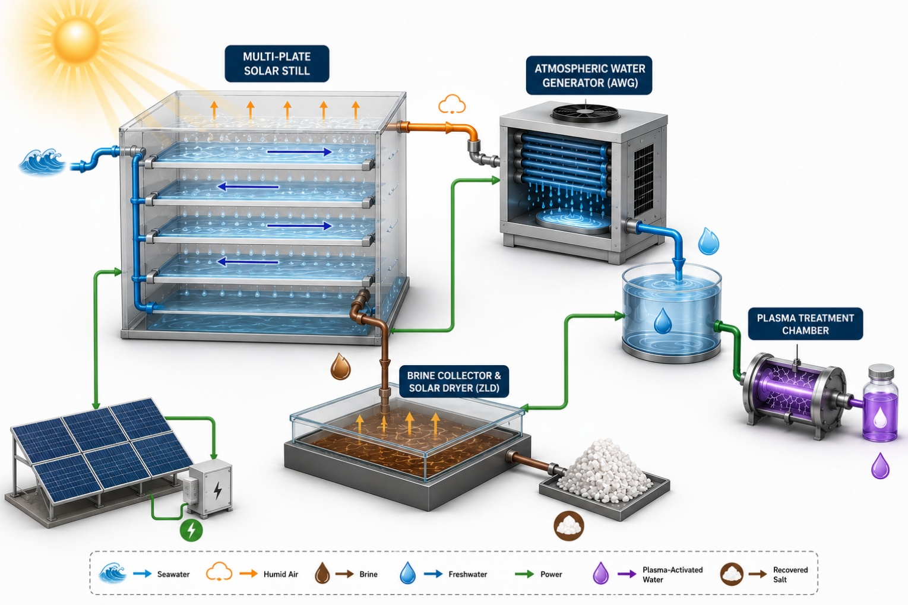
Figure H.1. Schematic illustration of the patented integrated solar desalination system (US Patent 12,115,465 B1) comprising a multi-layer inclined PMMA solar still, a zero-liquid-discharge (ZLD) brine collector, an atmospheric water generation (AWG) subsystem, and a dielectric barrier discharge (DBD) plasma treatment chamber. [AI-generated figure (OpenAI ChatGPT) based on original concepts and detailed iterative instructions provided, reviewed, and approved by the authors.]
Figure H.2. Evaporative driving force ΔP per stage, decomposed into the thermal contribution and the activity (salinity) depression, with the net ΔP and its interior maximum, at stage 10, marked.
Figure H.3. Streamwise brine salinity profiles for representative stages (a), and the ratio of outlet to inlet salinity within each stage (b), showing how much concentrating duty each stage performs.
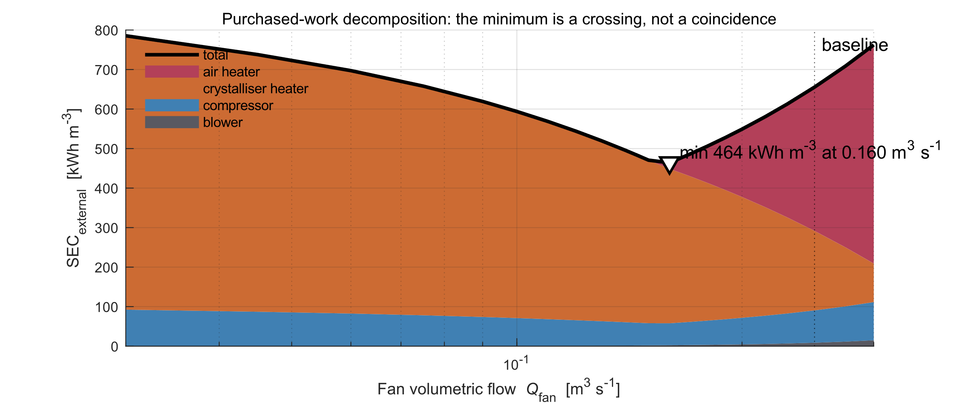
Figure H.4. Decomposition of purchased specific work against fan volumetric flow.
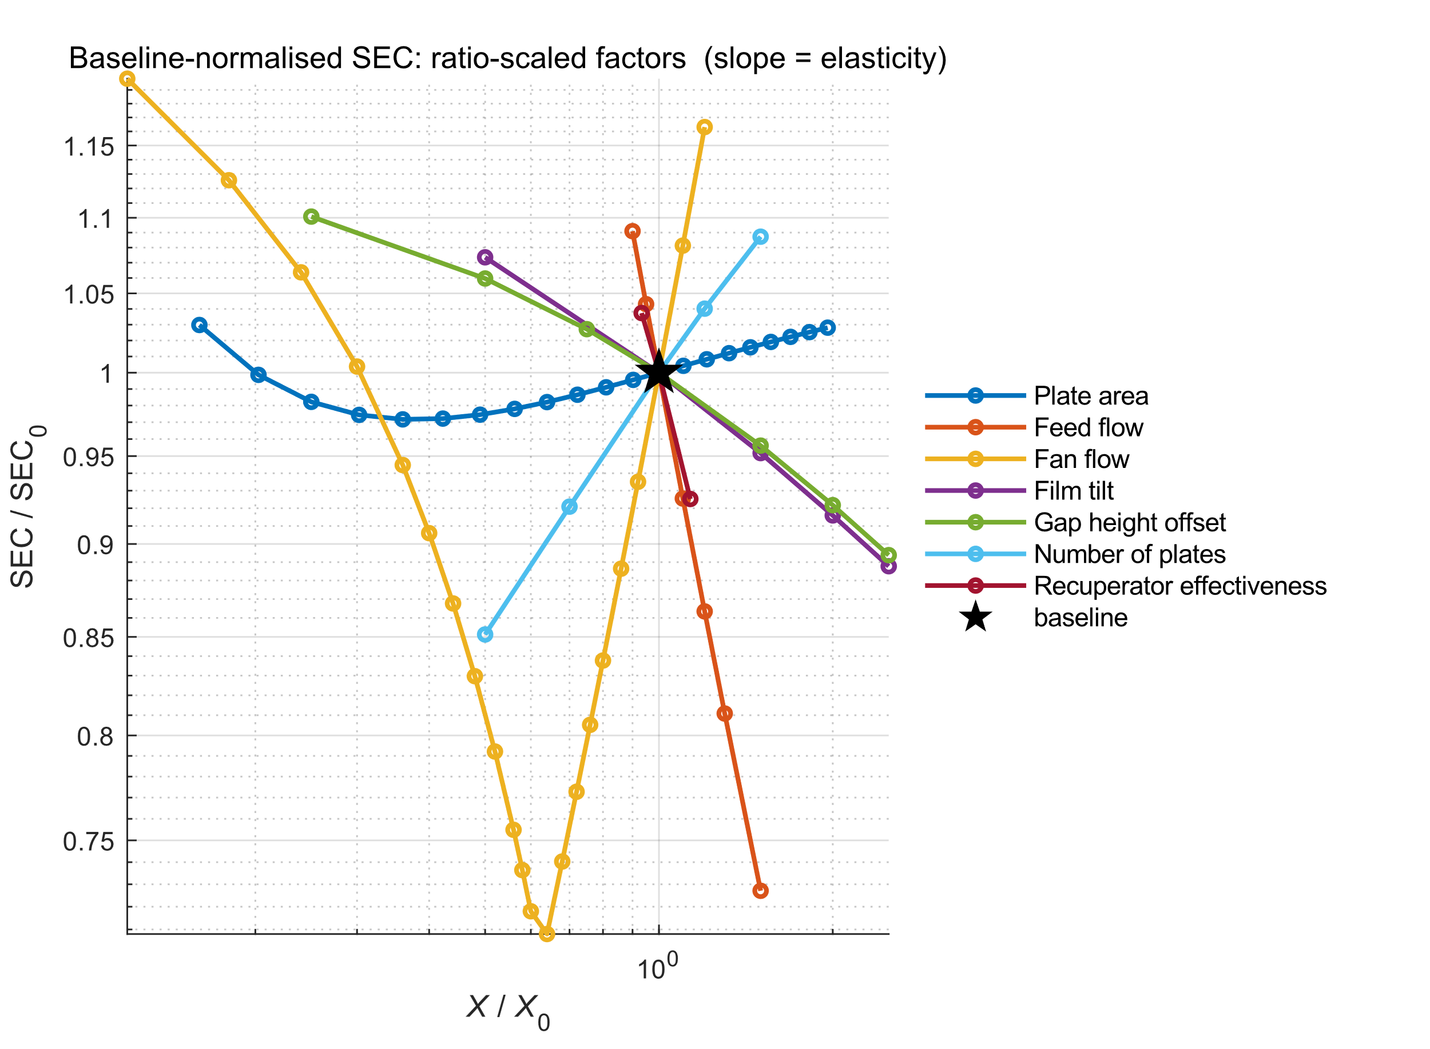
Figure H.5. Baseline-normalized SEC response for the ratio-scaled design factors.
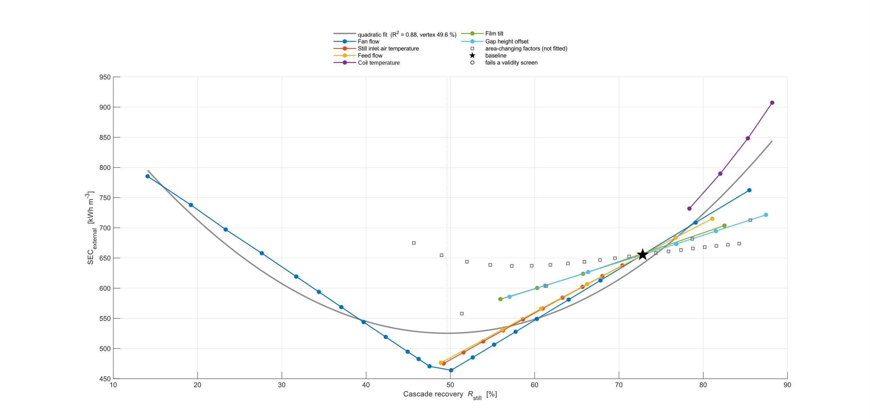
Figure H.6. Specific energy consumption against cascade recovery.
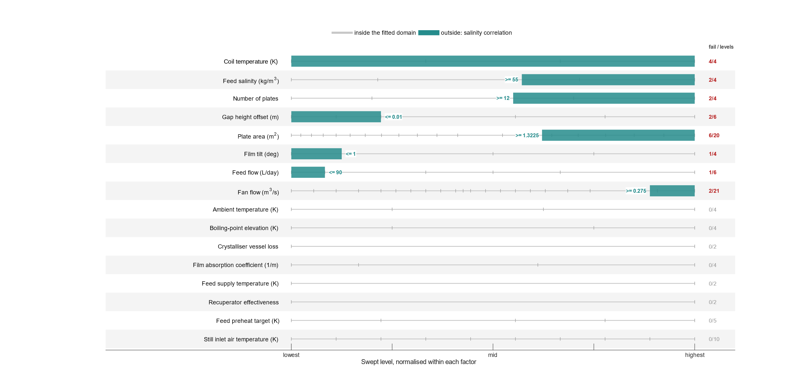
Figure H.7. Levels lying outside the fitted domain of the brine property correlations.
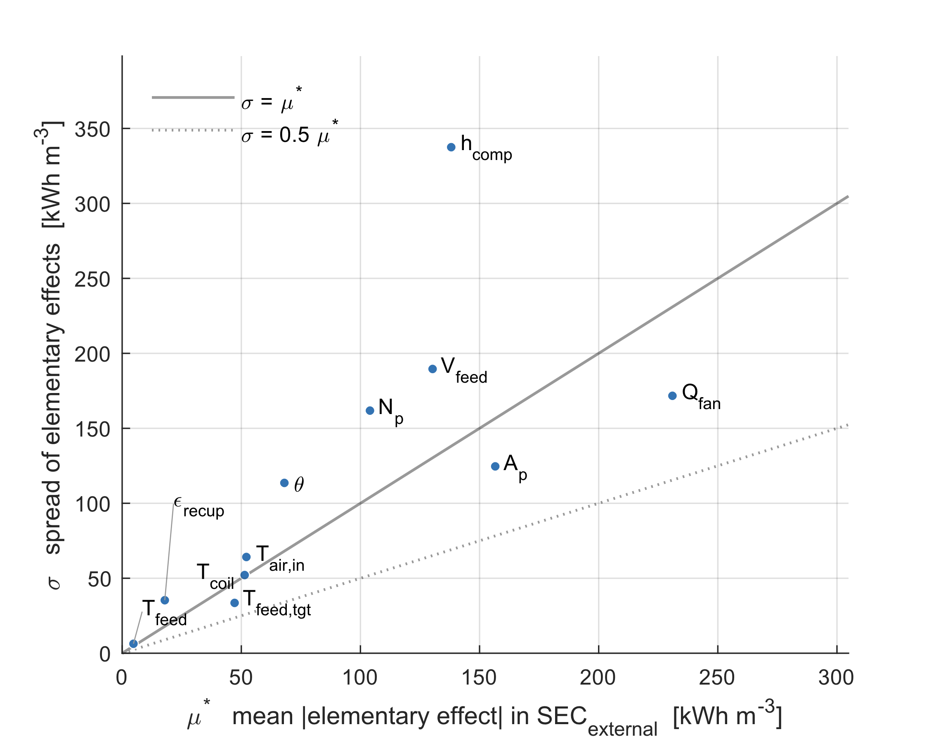
Figure H.8. Morris screening of specific energy consumption in the (μ*, σ) plane.
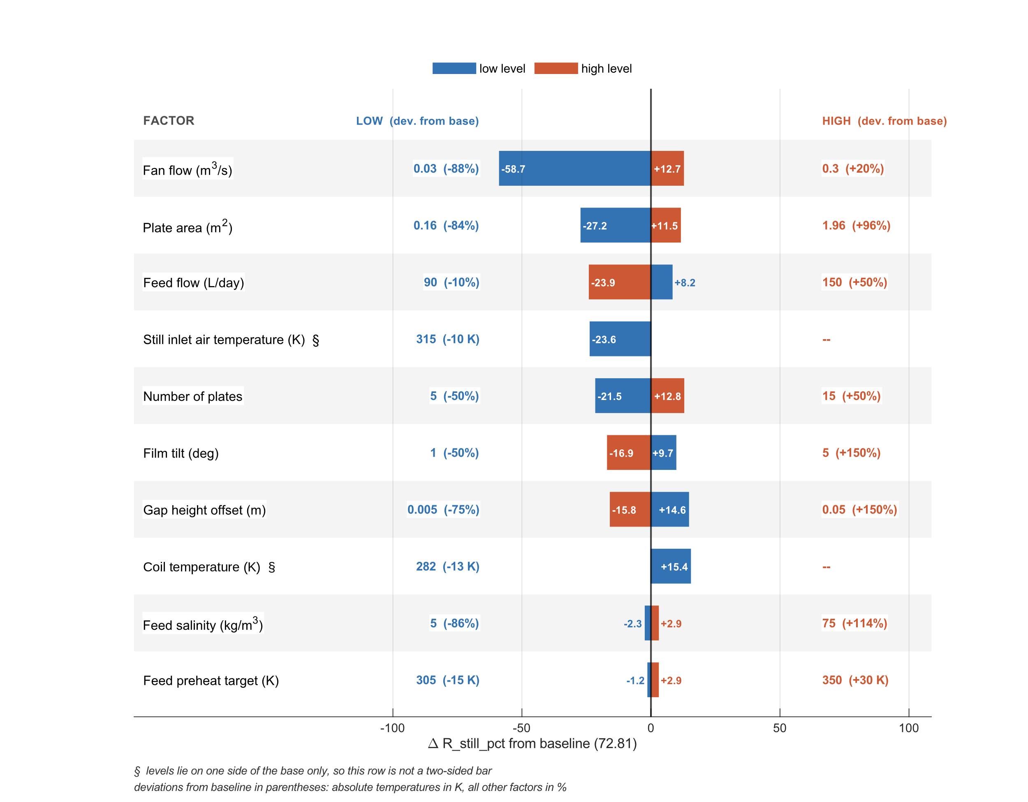
Figure H.9. Tornado diagram for cascade recovery. Each row is one factor, the two bars give the deviation from the baseline at the lowest and highest swept level, and factors returning identical cascade recovery at every level are omitted.
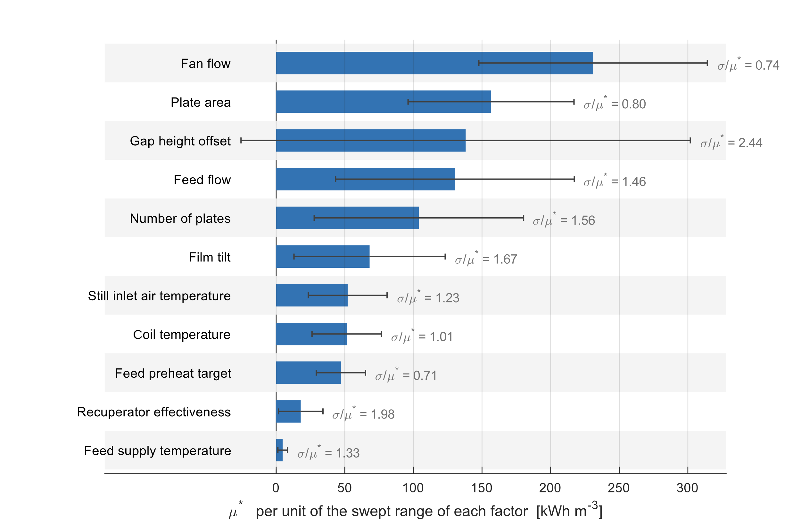
Figure H.10. Importance ranking for specific energy consumption, error bars at 2× the standard error of μ*. The ratio σ/μ* is printed beside each bar. The overlap of the leading five intervals is the basis for treating them as one group in Section 5.7.
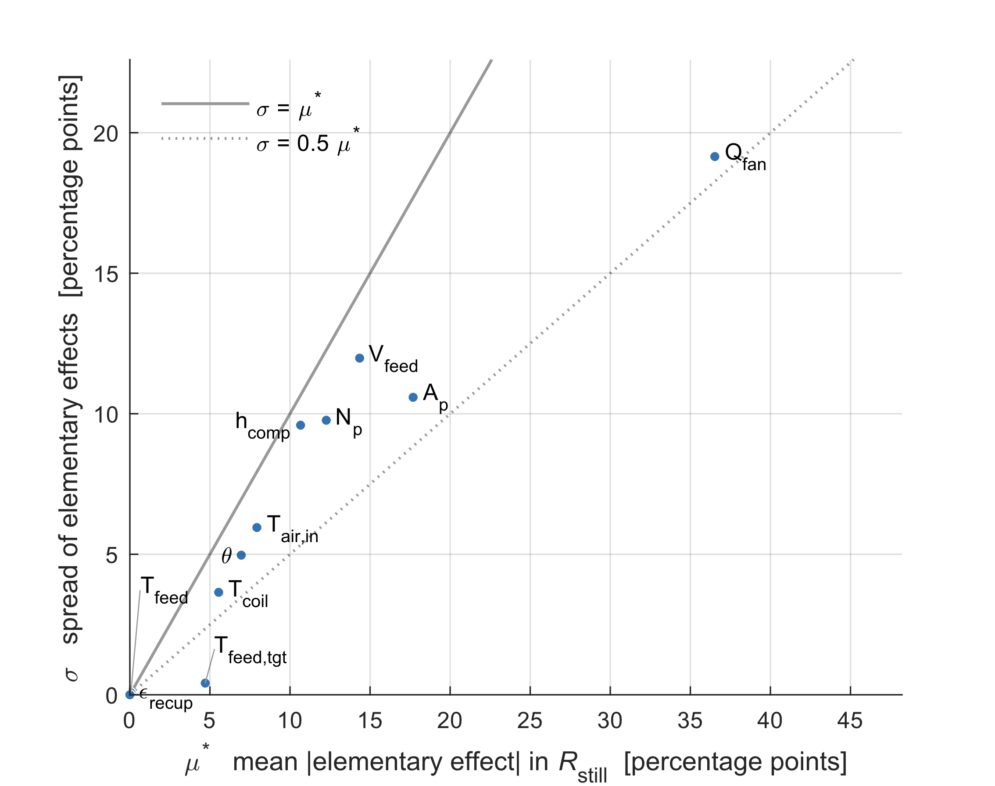
Figure H.11. Morris screening of cascade recovery in the (μ*, σ) plane. Every factor lies at or below the σ = μ* diagonal, so cascade recovery responds to the design more additively than energy demand does.
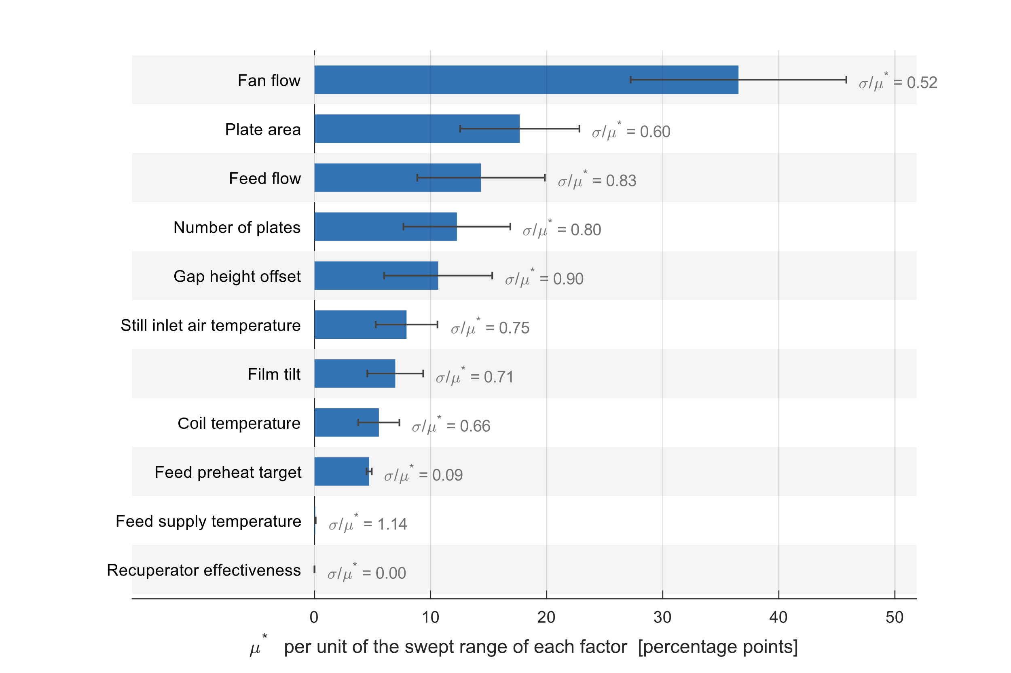
Figure H.12. Importance ranking for cascade recovery, error bars at 2× the standard error of μ*.
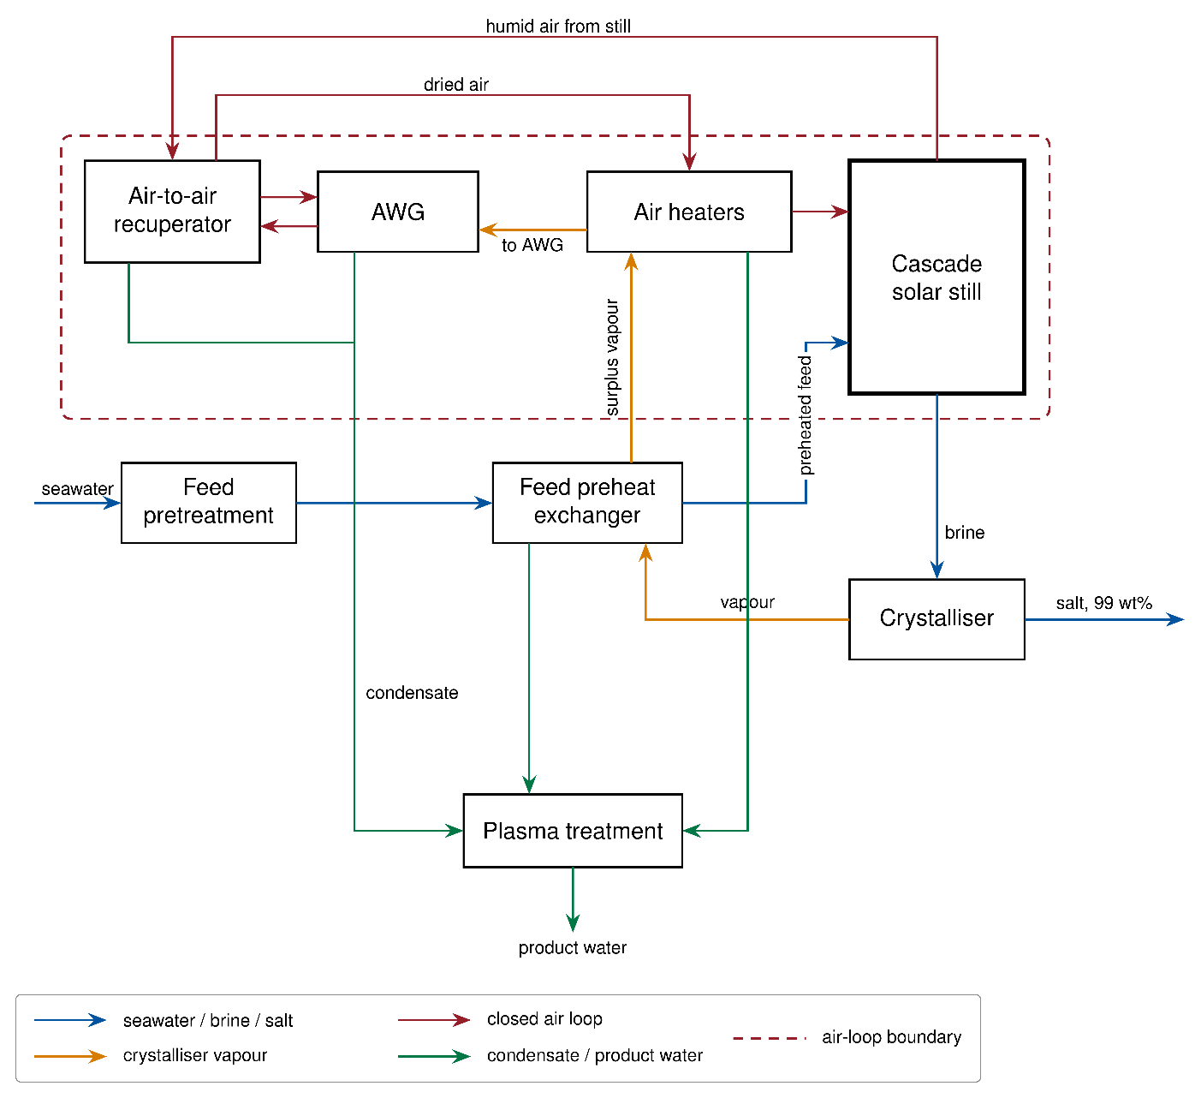
Figure H.13. Block diagram of the ZLDD train: feed pump and filter, cascade solar still, electrically heated crystallizer, feed preheat exchanger, air preheater exchanger, electric air heater, air cooler, dehumidification/condensation unit (labeled AWG, after the patented component) and plasma treatment chamber. Process streams are color-coded by type; electrical work is shown in black. The dashed boundary encloses the closed air-recirculation loop only. The air-to-air recuperator and the vapor-fired air preheater are shown on the air loop, since between them they supply more than half of the air-side thermal lift. Neither unit appears in the patented configuration; both are additions of the present model, as explained in Section 3.5 of the article. The full unit list is given in Section 3.5, and the two control volumes on which results are reported are defined in Appendix A.12.

References
ASME. (2009). Standard for verification and validation in computational fluid dynamics and heat transfer (ASME V&V 20-2009, reaffirmed 2021). American Society of Mechanical Engineers.
Campolongo, F., Cariboni, J., & Saltelli, A. (2007). An effective screening design for sensitivity analysis of large models. Environmental Modelling & Software, 22(10), 1509–1518. https://doi.org/10.1016/j.envsoft.2006.10.004
Hottel, H. C., & Sarofim, A. F. (1967). Radiative transfer. McGraw-Hill.
Jamieson, D. T., Tudhope, J. S., Morris, R., & Cartwright, G. (1969). Physical properties of sea water solutions: Heat capacity. Desalination, 7(1), 23–30. https://doi.org/10.1016/S0011-9164(00)80271-4
Morris, M. D. (1991). Factorial sampling plans for preliminary computational experiments. Technometrics, 33(2), 161–174. https://doi.org/10.1080/00401706.1991.10484804
Nayar, K. G., Sharqawy, M. H., Banchik, L. D., & Lienhard V, J. H. (2016). Thermophysical properties of seawater: A review and new correlations that include pressure dependence. Desalination, 390, 1–24. https://doi.org/10.1016/j.desal.2016.02.024
Saltelli, A., & Annoni, P. (2010). How to avoid a perfunctory sensitivity analysis. Environmental Modelling & Software, 25(12), 1508–1517. https://doi.org/10.1016/j.envsoft.2010.04.012
Shampine, L. F., & Reichelt, M. W. (1997). The MATLAB ODE suite. SIAM Journal on Scientific Computing, 18(1), 1–22. https://doi.org/10.1137/S1064827594276424
Sharqawy, M. H., Lienhard V, J. H., & Zubair, S. M. (2010). Thermophysical properties of seawater: A review of existing correlations and data. Desalination and Water Treatment, 16(1–3), 354–380. https://doi.org/10.5004/dwt.2010.1079
Sobol', I. M. (2001). Global sensitivity indices for nonlinear mathematical models and their Monte Carlo estimates. Mathematics and Computers in Simulation, 55(1–3), 271–280. https://doi.org/10.1016/S0378-4754(00)00270-6
Sutherland, W. (1893). The viscosity of gases and molecular force. Philosophical Magazine, Series 5, 36(223), 507–531. https://doi.org/10.1080/14786449308620508

