CENTRE OF CORPORATE EXCELLENCE FOR STRATEGIC MANAGEMENT
United Airlines: COVID Crisis to Recovery
Aviation & Global Logistics Operations Study — Strategic Management Case
Crisis: 2020 | Recovery: 2022–2023 United Airlines Holdings, Inc. · Chicago, IL · Mainline Fleet: 800+
$43.26B  ANNUAL REVENUE (FY19) | +6.9%  NET INCOME MARGIN | 84.6%  PASSENGER LOAD FACTOR | -$33M  CRISIS CASH BURN / DAY

Crisis Timeline
From demand collapse to a full-year profitability turnaround
MAR 2020 Demand Collapse Post-Lockdown
Passenger volumes drop 95% overnight; payroll pressure mounts to protect crews and staff.
MAY–JUN 2020 Cash Flow Crunch
Daily cash burn peaks near $33M as rivals begin retiring fleets to stop losses.
JUL 2020 Operational Intervention Begins
Emergency multi-system data diagnostic across booking, cargo, loyalty, and maintenance data.
AUG–OCT 2020 Strategy Rollout (Phase 1)
Asset-hoarding, network re-segmentation, and the 7-Day Mid-Air Cargo Pivot deployed.
NOV 2020–MAR 2021 Vaccine & Freight Turnaround
13,400+ cargo-only flights; cargo revenue tops $2B, cushioning passenger losses.
FY 2022–2023 Full-Year Profitability Achieved
Revenue rebounds to $57.43B as the intact widebody fleet captures global market share.
Cargo Pivot in Charts
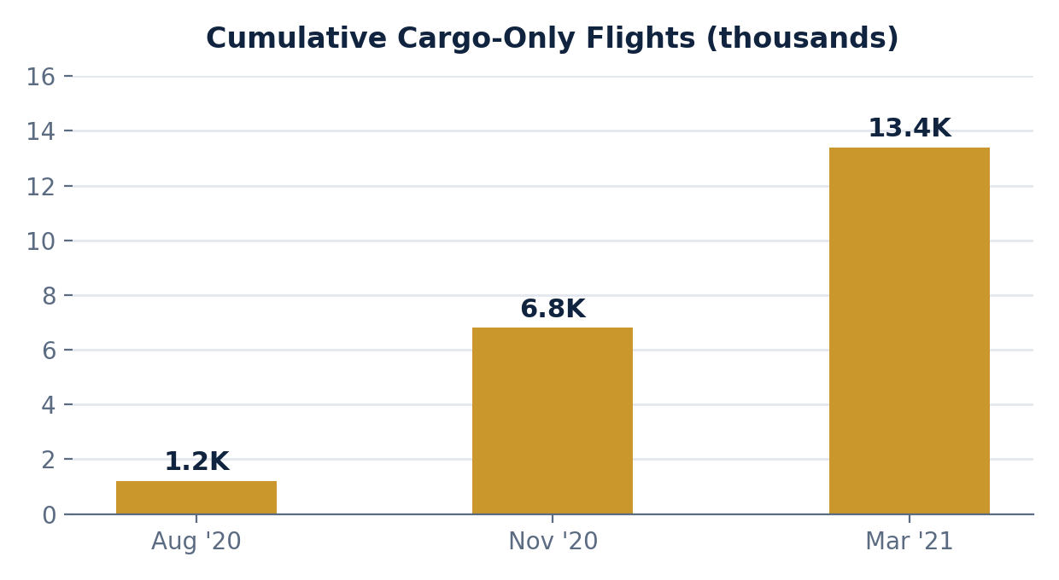
Cargo revenue generated: $2B+ | Widebody dry-ice workflow expansion: +400%

Strategic Interventions Deployed
Four moves that protected operating capacity through the downturn
Loyalty Asset Segregation
Isolated MileagePlus into a standalone subsidiary used as debt collateral.
RESULT: Secured $6.8B in private capital

Underbelly Capacity & Cold-Chain
Reconfigured idle widebody holds for premium freight within 7 days.
RESULT: 13,400+ vaccine-logistics flights

Counter-Cyclical Asset "Hoarding"
Kept widebodies in high-readiness storage while rivals downsized.
RESULT: 36 active transatlantic destinations

Fleet "Up-Gauging" Optimization
Predictive models shifted capacity from regional jets to mainline aircraft. As part of this, United ordered 274 new narrowbody aircraft (Boeing 737 MAX and Airbus A321neo) to systematically phase out low-yield 50-seat regional jets.
RESULT: Seats/departure up 40%, CASM down

Before vs. After: Performance Dashboard
FY2020 crisis low vs. FY2023 recovery snapshot
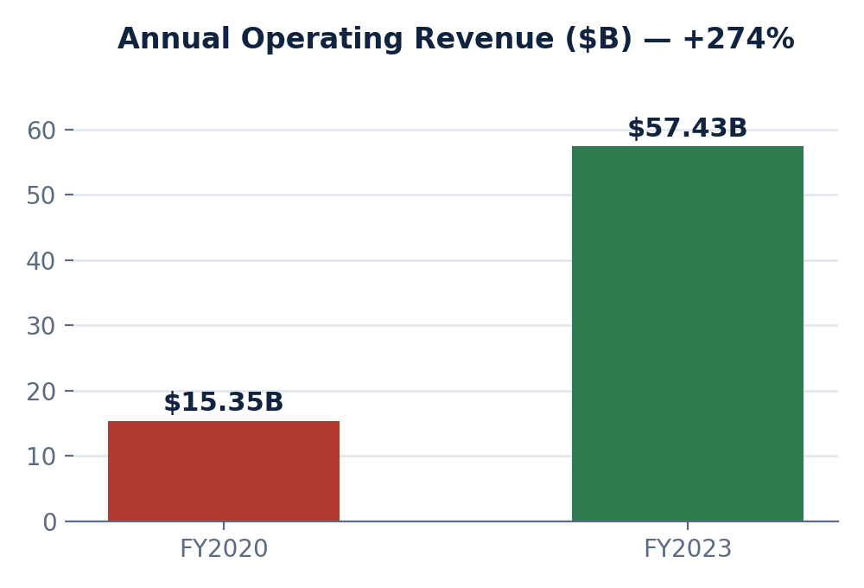 | 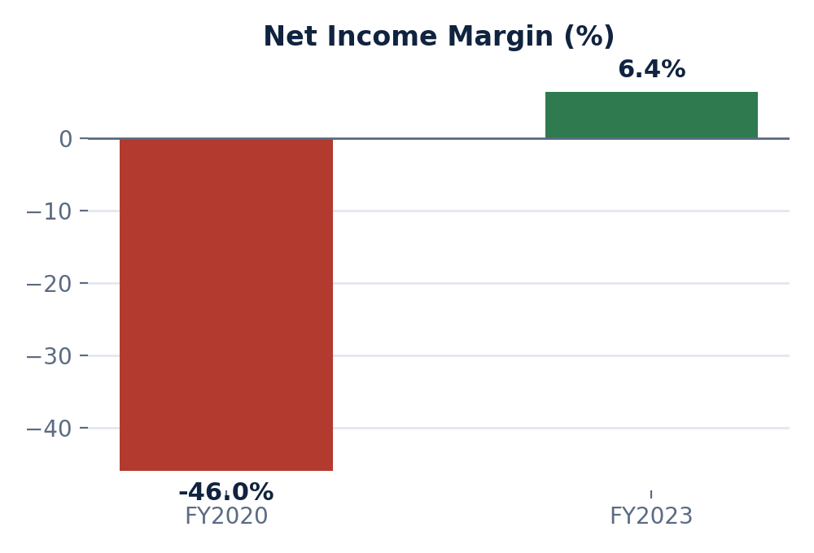

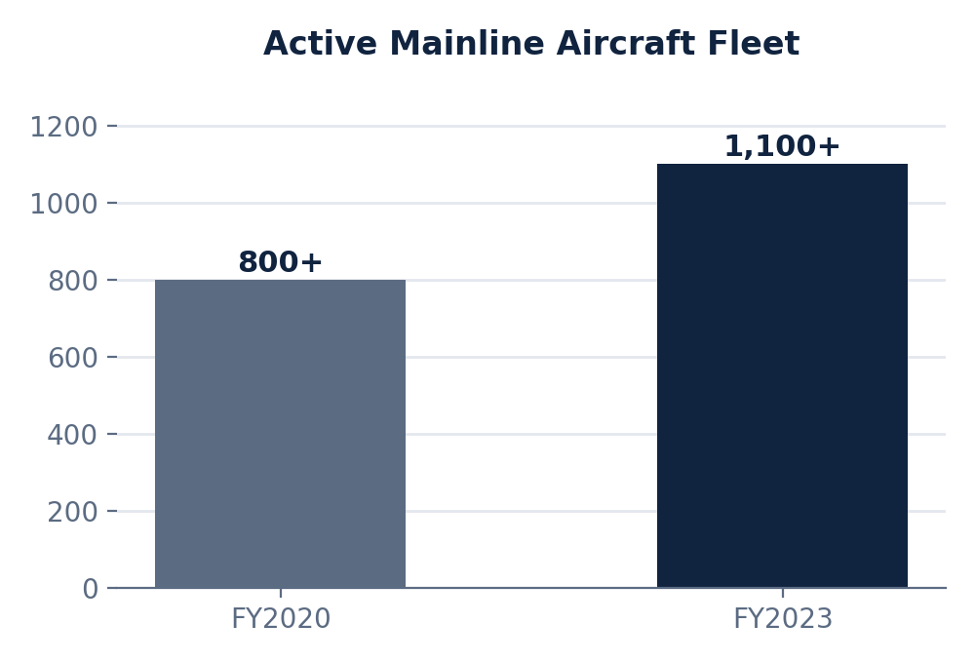 | Private capital raised: $26B+  Active transatlantic routes: 36

Metric | FY2020 | FY2023
Average Seats / Departure | Low baseline (regional-heavy) | +40% (mainline up-gauged)
Transatlantic Footprint | Retrenched / suspended | 36 destinations (industry leader)
Financing Position | Severe insolvency risk | $26B+ raised, order book intact

Competitor Strategic Response
While United hoarded capacity, rivals cut it
- Fleet Liquidation: Major domestic rivals permanently retired entire long-haul widebody fleets to cut overhead immediately.
- International Retrenchment: Prominent international carriers early-retired legacy fleets to protect short-term liquidity.
- Capacity Reduction: Crisis playbooks centered on shrinking footprint, leaving carriers resource-constrained when demand exploded.

UNITED'S DIFFERENTIATED PATH
Instead of retiring aircraft, United kept its widebody fleet in high-readiness storage — absorbing holding costs so it could redeploy instantly the moment international travel demand returned, capturing market share resource-constrained rivals could not contest.

The Strategic Lesson
Resilience wasn't built on cost-cutting — it was built on bold asset protection and operational pivots.
1. While the textbook response was to shrink and survive, United protected operating capacity through the downturn.
2. Underbelly cargo space, un-retired widebody aircraft, and segregated loyalty data became critical safety nets.
3. For heavy-asset industries, turnaround value peaks when capacity is preserved at market lows — ready to capture demand the instant it returns.
Sources: SEC disclosures · Asset-strategy mapping · Corporate finance records · Macroeconomic projections. Figures are illustrative case-study estimates and should be independently verified before external use.

