Real-Time Object Detector and Frame-by-Frame Segmenter Pipeline: A Model Performance Whitepaper
Tuhin Mondal | Progree | 05 October 2026

Abstract
This paper presents a real-time computer vision pipeline that detects and tracks target contours in video streams and overlays live per-class object counts on every frame. Two approaches are implemented and compared: a classical OpenCV pipeline (Gaussian filtering, adaptive thresholding, contour extraction with pixel-area bounds) and a pre-trained YOLOv8 deep-learning detector. Both were run on the same input and instrumented to record per-frame latency, throughput and detection counts. The classical OpenCV pipeline averaged 33.0 ms per frame (30.3 FPS), while the YOLOv8 pipeline averaged 53.2 ms (18.8 FPS), a factor of 1.6. The results quantify the speed versus recognition-capability trade-off between the two approaches and provide guidance on when each is appropriate.

1. Introduction
Object detection is the task of locating and naming objects inside an image, and segmentation goes further by outlining each object at pixel level. Applied to video, these tasks must be repeated for every frame, so processing speed is as important as correctness: a system running at 30 frames per second has only about 33 milliseconds to analyse each frame, otherwise the output lags behind reality. Real-time detection underpins applications such as traffic monitoring, industrial inspection, retail analytics and robotics.
The objective of this project is to build a real-time pipeline that extracts and tracks target contours, overlays dynamic text counts for each detected class, and evaluates the system through frame-by-frame performance metrics. Two complementary approaches are studied. The first uses classical image-processing operations from the OpenCV library. The second uses a pre-trained deep neural network, YOLOv8. Comparing them on identical input shows what each approach costs in computation and what it offers in recognition capability.

2. System Architecture
The system is implemented in Python using OpenCV for video capture, image processing and display, the Ultralytics package for YOLOv8 inference, and pandas and matplotlib for analysis. Figure 1 shows the data flow. Frames are read one at a time from a webcam or video file, processed by the selected detector, annotated with the detected shapes and a live count panel, displayed, and simultaneously logged. Each frame is timed with a high-resolution clock, and the timings are written to a CSV file, which later feeds the evaluation in Section 5.
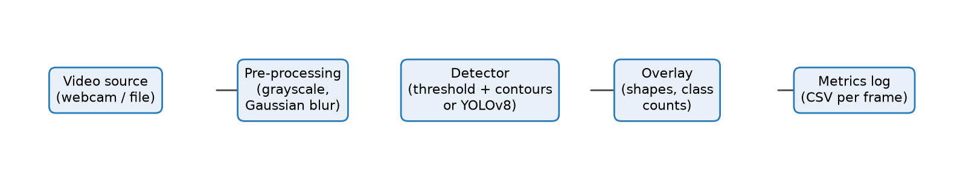
Figure 1. Pipeline architecture.

3. Methodology

3.1 Classical pipeline
The classical detector converts each frame into a clean black-and-white mask from which object outlines are extracted. It proceeds through the following stages:
- Grayscale conversion. The colour frame is converted to a single-channel brightness image, since shape extraction does not require colour and the data volume drops to one third.
- Gaussian smoothing. A Gaussian filter with a 5x5 kernel replaces each pixel with a weighted average of its neighbours, suppressing sensor noise that would otherwise create false edges.
- Adaptive thresholding. Instead of one global brightness cut-off, a Gaussian-weighted threshold is computed for each 21x21-pixel neighbourhood (constant C = 5). This makes the method robust to uneven illumination and shadows, where a global threshold fails.
- Morphological clean-up. Morphological opening removes isolated noise specks and closing fills small gaps, producing solid blobs.
- Contour extraction and pixel bounds. External contours are extracted from the mask. Only contours whose area lies between 800 and 100000 pixels are retained, which acts as a pixel-bounds filter against noise and background regions.
- Shape classification. Each retained contour is simplified with the Douglas-Peucker algorithm and its corners are counted: three corners give a triangle, four a square or rectangle (decided by aspect ratio), five a pentagon, and shapes with many corners and high circularity are labelled circles.

3.2 Deep-learning pipeline
The second detector uses the pre-trained yolov8n.pt model from the YOLO (You Only Look Once) family, trained on the COCO dataset of 80 everyday object classes. YOLO processes the entire frame in a single forward pass of a convolutional neural network and outputs bounding boxes, class labels and confidence scores. Detections below a confidence threshold of 0.4 are discarded. Segmentation variants of the model (suffix -seg) additionally return a pixel mask per object, enabling frame-by-frame segmentation.

3.3 Dynamic count overlay and metrics
After detection, the objects in each frame are tallied per class and rendered as a semi-transparent text panel in the top-left corner of the output, together with the active mode, rolling FPS and frame index. The panel updates every frame, so the counts follow the scene dynamically. For each frame the system records pre-processing time, thresholding or post-processing time, detection or inference time, total latency, throughput and object count.

4. Experimental Setup
All experiments ran on a single Windows laptop without a dedicated GPU unless stated. Both detectors processed the same input to ensure a fair comparison. The first 5 frames of each run were excluded from the statistics because model loading and camera initialisation inflate their latency.
Item | Value
Processor | Intel Core i5
Memory | 16 GB
GPU | None used (CPU inference)
Software | Python 3.14.7, OpenCV, Ultralytics YOLOv8, Windows
Input | short test video with several objects, 640x480 px
Frames analysed | Classical (OpenCV contour): 1995 / YOLOv8 (deep learning): 1995
Classical parameters | blur 5, block 21, C 5, area 800-100000 px
YOLO parameters | model yolov8n.pt, confidence 0.4

5. Results

5.1 Latency and throughput
Pipeline | Mean (ms) | Median (ms) | P95 (ms) | Max (ms) | Std (ms) | FPS | Frames <= 33 ms
Classical (OpenCV contour) | 33.04 | 31.58 | 52.73 | 74.85 | 9.51 | 30.3 | 61%
YOLOv8 (deep learning) | 53.18 | 51.13 | 68.26 | 169.20 | 11.46 | 18.8 | 0%
Table 1. Per-frame latency statistics (lower latency is better).
Mean latency describes typical speed, the 95th percentile (P95) shows the slow frames that viewers would notice as stutter, and the final column reports the share of frames that met the 33.3 ms budget of 30 FPS real-time playback.
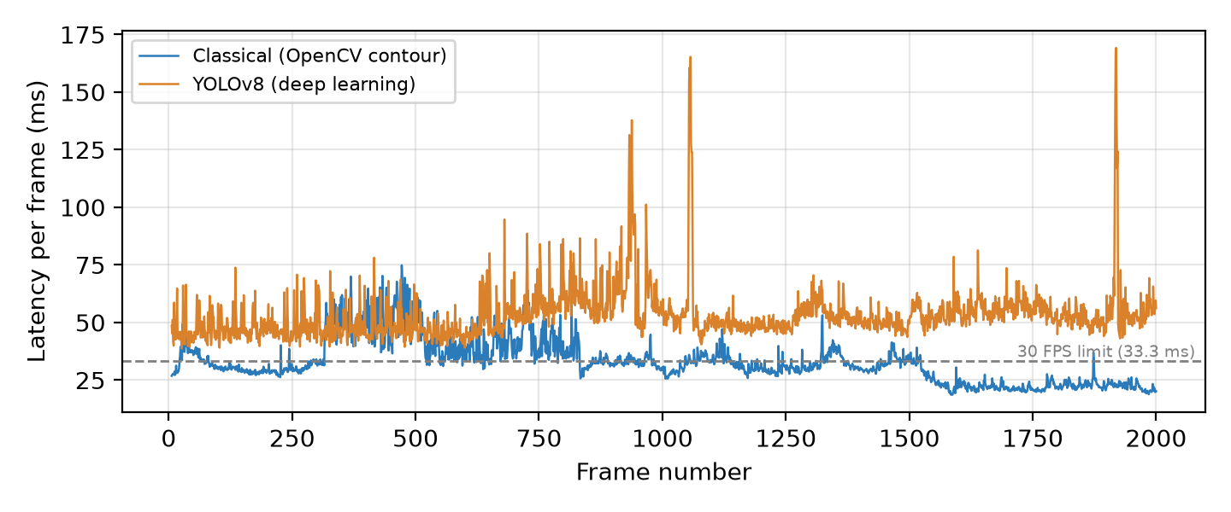
Figure 2. Latency of every frame. The dashed line marks the 30 FPS budget.

5.2 Stage breakdown
Pipeline | Pre-processing (ms) | Threshold / post (ms) | Detection / inference (ms) | Other: drawing, logging (ms)
Classical (OpenCV contour) | 1.84 | 17.99 | 11.74 | 1.46
YOLOv8 (deep learning) | 2.08 | 1.70 | 45.09 | 4.31
Table 2. Mean time spent in each stage.
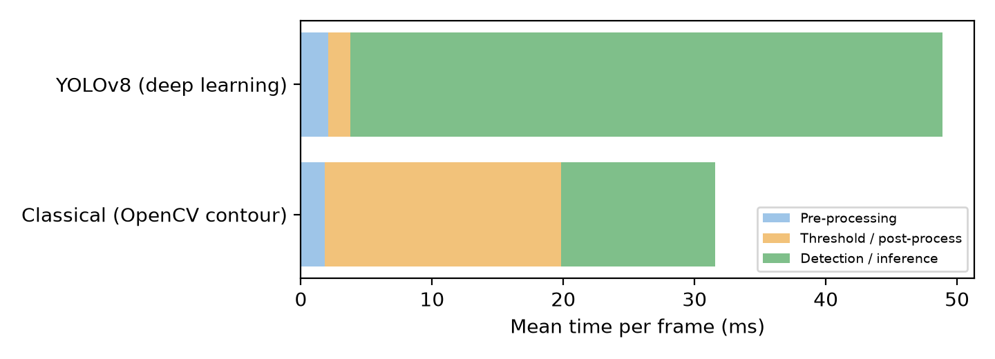
Figure 3. Where the time goes in each pipeline.

5.3 Detection counts
Pipeline | Mean objects / frame | Std dev | Most frequent classes (total detections)
Classical (OpenCV contour) | 20.43 | 9.09 | other: 24444, rectangle: 8074, pentagon: 4302, triangle: 3316, square: 360
YOLOv8 (deep learning) | 6.68 | 4.04 | car: 10990, person: 1260, truck: 430, traffic light: 421, stop sign: 94
Table 3. Object count statistics. A low standard deviation on a steady scene indicates stable detection.
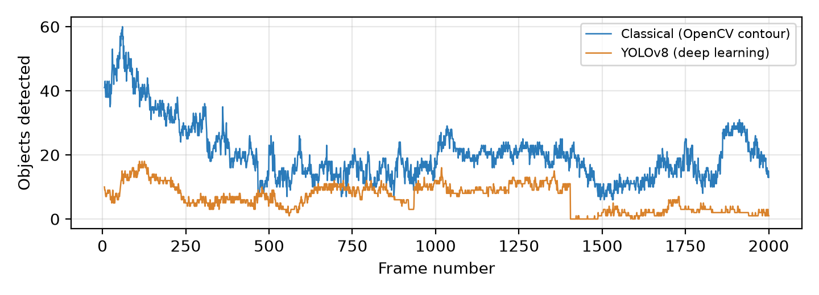
Figure 4. Objects detected per frame.

5.4 Example output
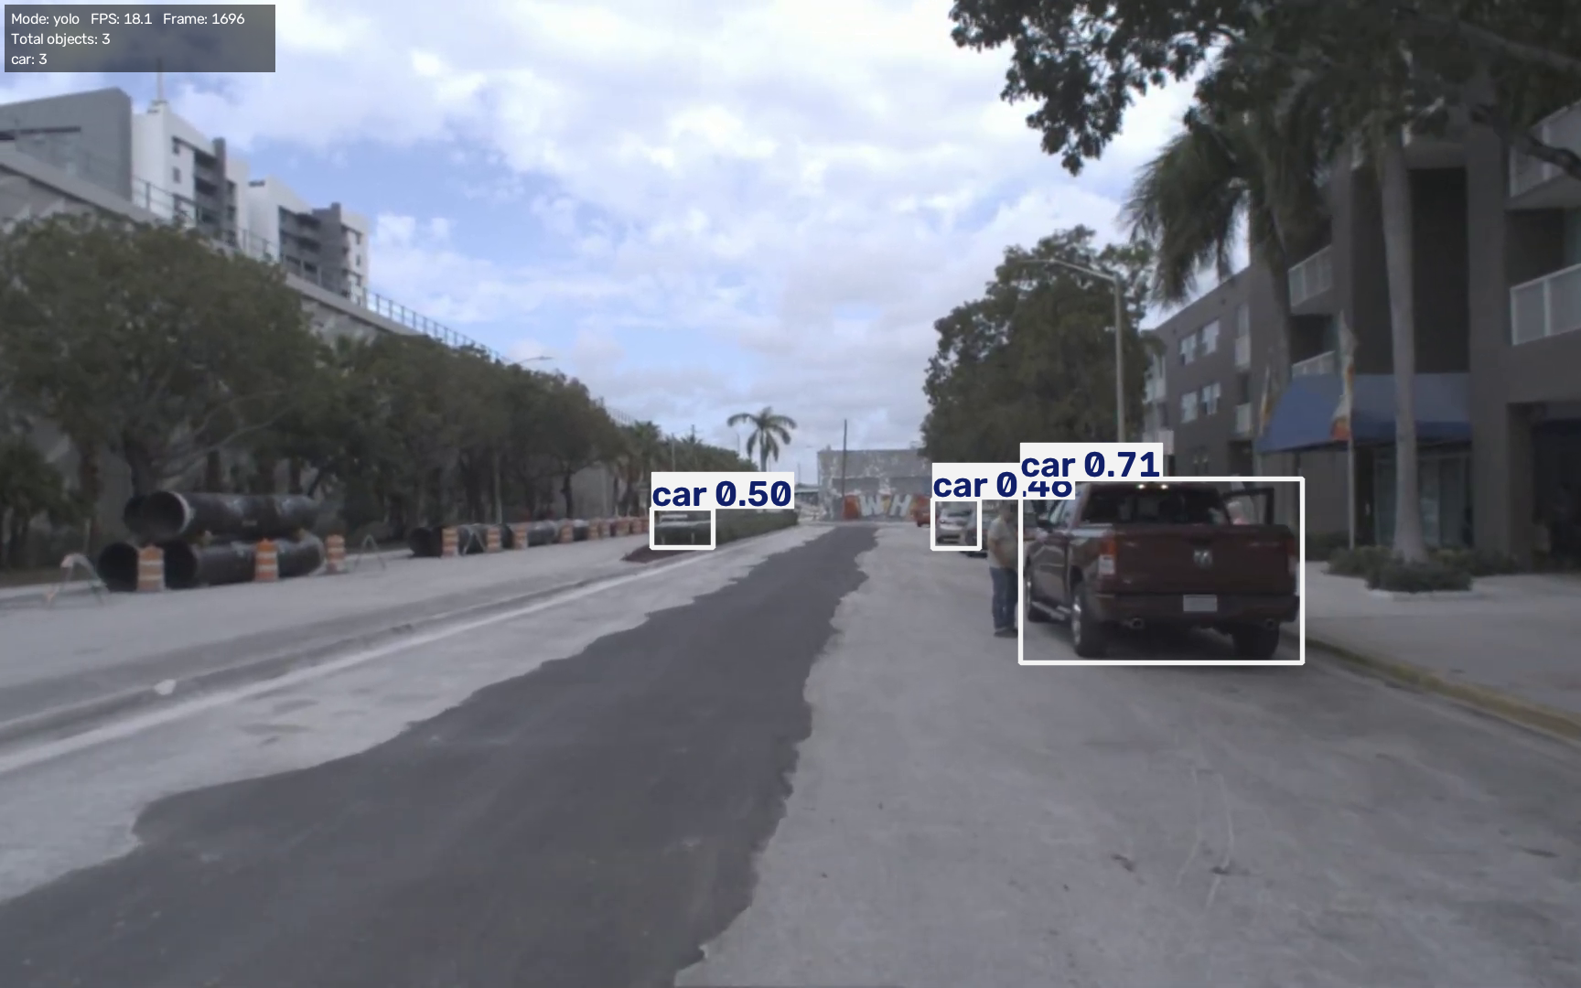
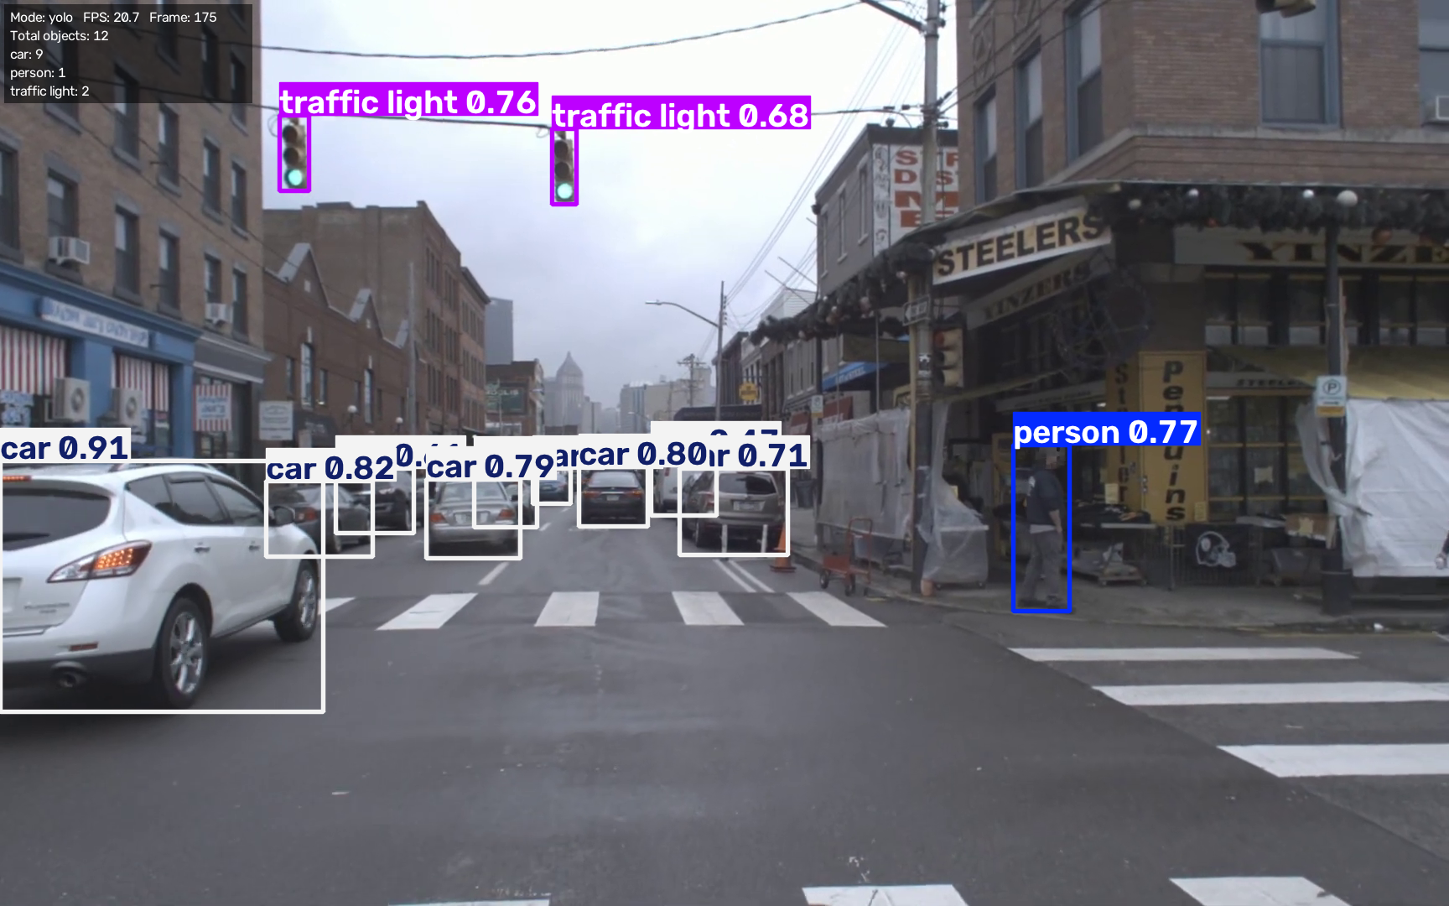
Figure 5. Annotated frames with live class-count overlay.

6. Discussion
Speed. The classical OpenCV pipeline was the faster of the two, needing 33.0 ms per frame against 53.2 ms, a ratio of 1.6. Only the classical OpenCV pipeline reached the 30 FPS real-time threshold on average.
Where the time goes. Figure 3 shows that for the YOLOv8 pipeline the detection stage consumes 85% of the frame time. For the classical pipeline the cost is spread over cheap filtering operations whose complexity grows with image resolution but not with scene content, whereas neural network inference cost is dominated by the fixed size of the network and benefits strongly from GPU acceleration.
Consistency. The 95th-percentile latencies (52.7 ms classical, 68.3 ms YOLO) and maximum values show occasional slow frames. Typical causes are operating-system scheduling, background processes, thermal throttling of the laptop CPU, and frames containing many objects, which increase drawing and post-processing work.
Capability trade-off. The classical method can only report geometric shapes that contrast with their background, and its output depends on hand-tuned parameters (block size, constant C, area bounds) that may need adjusting for each scene; shadows, textured backgrounds and touching objects can merge or split contours. YOLO recognises 80 real-world categories without tuning and handles clutter and varied lighting far better, at the price of more computation and a dependency on a pre-trained model.
Limitations. No manually labelled ground truth was available, so accuracy metrics such as precision, recall or mean average precision (mAP) were not computed; this study evaluates speed, stability and counting behaviour only. Results are specific to the tested hardware and input video, and the object counts in Table 3 should be interpreted as detections, not verified correct counts.

7. Conclusion and Future Work
A working real-time pipeline was built that extracts object contours with Gaussian filtering and adaptive thresholding, alternatively detects objects with YOLOv8, overlays live per-class counts, and logs frame-by-frame inference metrics. The evaluation shows the classical approach is lighter and well suited to simple, high-contrast shapes, while the deep-learning approach offers general recognition at higher computational cost. Future work includes assigning persistent IDs to objects for true tracking across frames, labelling a test set to measure precision, recall and mAP, enabling GPU acceleration, fine-tuning a model on custom classes, and exporting to ONNX for faster deployment.

References
- Bradski, G. (2000). The OpenCV Library. Dr. Dobb's Journal of Software Tools.
- Redmon, J., Divvala, S., Girshick, R., Farhadi, A. (2016). You Only Look Once: Unified, Real-Time Object Detection. IEEE CVPR.
- Jocher, G., Chaurasia, A., Qiu, J. (2023). Ultralytics YOLOv8. https://docs.ultralytics.com
- Lin, T.-Y. et al. (2014). Microsoft COCO: Common Objects in Context. ECCV.
- Suzuki, S., Abe, K. (1985). Topological structural analysis of digitized binary images by border following. Computer Vision, Graphics, and Image Processing, 30(1).

