Watson Cookbooks

Watson Cookbooks is a recipe storage software built using java. The goal of this questionnaire is to gather feedback to improve the software.

Figure 1: Cookbooks Screen

Figure 2: New Recipe Screen

Figure 3: Recipe Screen

Figure 4: Search Screen

**Using the above images as reference, how confident do you feel that you would be able to add a new recipe? Scale from 1, least confident to 10, most confident.**

1 2 3 4 5 6 7 8 9 10

**If you answered less than 10 on the previous question, please explain what I could do to make the experience better.**

It looks easy, but I put 9 because I haven’t tried to do it yet.

**Using the above images as reference, how confident do you feel that you would be able to open up an existing recipe? Scale from 1, least confident to 10, most confident.**

1 2 3 4 5 6 7 8 9 10

**If you answered less than 10 on the previous question, please explain what I could do to improve the experience.**

Same as above.

**Other than the existing features, are there any features that you would like to see in the finished product?**

No.

**Are there any features that you think shouldn't be in the finished product?**

No.

**In general, how would you rate the appearance of the application? Scale from 1, ugly to 10, beautiful.**

1 2 3 4 5 6 7 8 9 10

**If you answered less than 10 on the previous question, what could I do to improve the appearance?**

It looks pretty good.

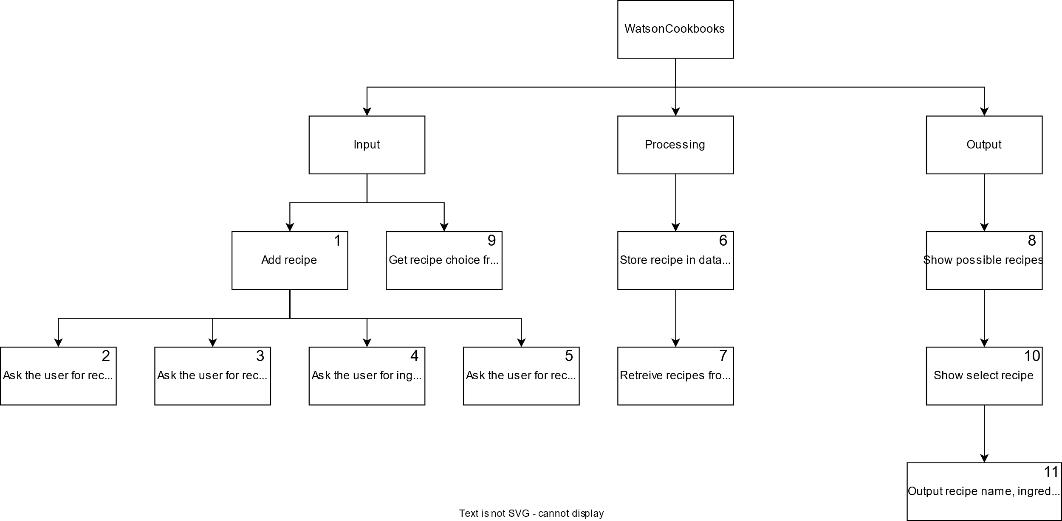

Figure 5: Structure Chart

**Given the following structure chart, is there anything that you would like to add or remove from the program?**

No, it looks good.