**Roles :**

the people creates database and change types of data

**The results we have and how we manage it:**

Research:

we choose to analyze the data with the bank evaluation criteria:

The changes of data:

Photo1:

From the codes below, we change excel data into database:

The selection of data:

Photo 2:

Then we consider divide the data types into 6 parts:

Problem statement:

Technologies: Python, MySQL, financial knowlodege.

**The results we will have and how we will manage it in the future:**

A database with clear division:

By the knowledge of database and MYSQL, we will achieve a relational database.

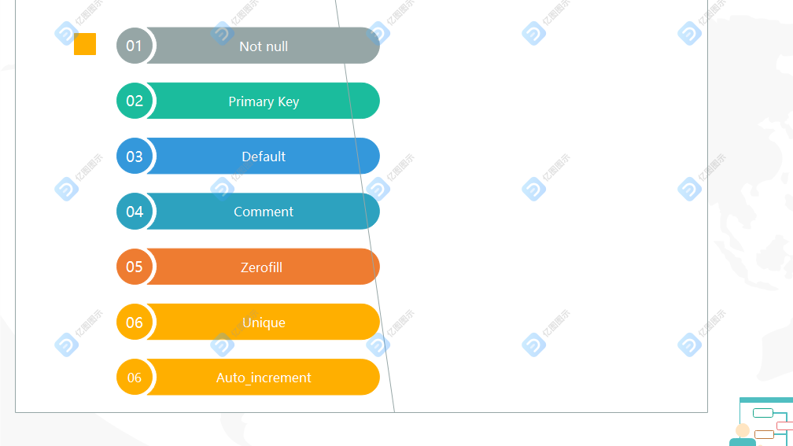

The changes of datatype:

Iwrite is an example.

Problems until now:

Considering 7 rules of database, the formats of data is still a question.

The division of database still needs to improve.

The safety of database may cause loss of companies.

