Анализ памяти Java-приложения сортировок:

1) С использованием сборщика Parallel GC:

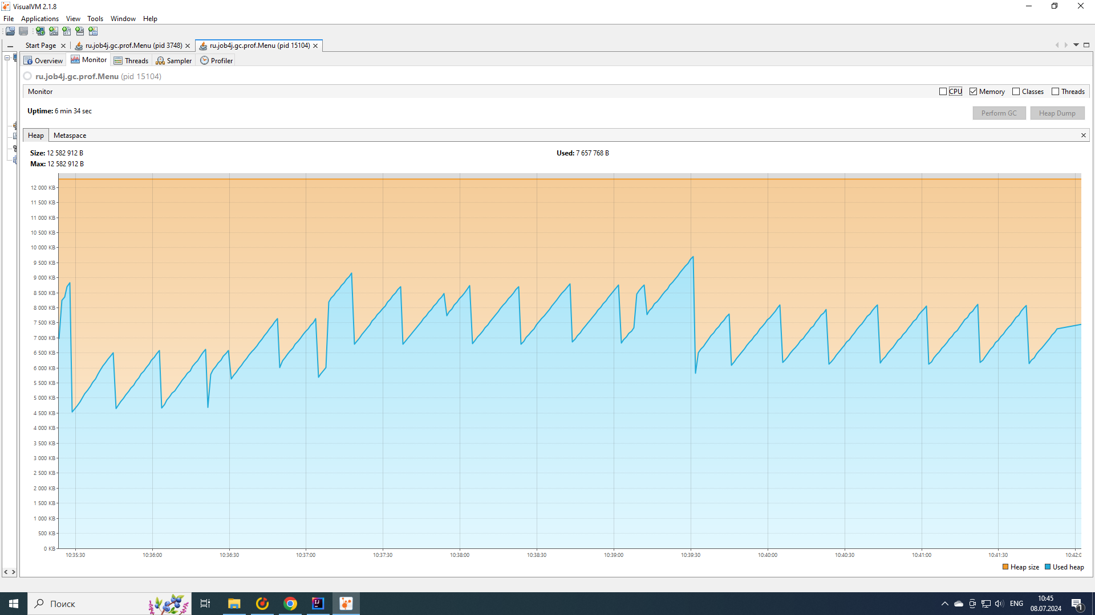

Время сборок мусора:

[1.065s][info][gc] GC(0) Pause Young (Allocation Failure) 3M->1M(11M) 3.778ms  
[3.734s][info][gc] GC(1) Pause Young (Allocation Failure) 4M->2M(11M) 2.930ms  
[3.825s][info][gc] GC(2) Pause Young (Allocation Failure) 5M->3M(11M) 1.966ms  
[3.897s][info][gc] GC(3) Pause Young (Allocation Failure) 6M->3M(11M) 3.000ms  
[3.933s][info][gc] GC(4) Pause Young (Allocation Failure) 6M->5M(11M) 3.735ms  
[4.238s][info][gc] GC(5) Pause Young (Allocation Failure) 8M->6M(10M) 4.230ms  
[4.427s][info][gc] GC(6) Pause Young (Allocation Failure) 8M->6M(11M) 3.464ms  
[9.478s][info][gc] GC(7) Pause Young (Allocation Failure) 8M->7M(11M) 3.593ms  
[9.517s][info][gc] GC(8) Pause Full (Ergonomics) 7M->4M(11M) 38.960ms  
[25.504s][info][gc] GC(9) Pause Young (Allocation Failure) 6M->4M(11M) 1.314ms  
[43.516s][info][gc] GC(10) Pause Young (Allocation Failure) 6M->4M(11M) 0.972ms  
[61.522s][info][gc] GC(11) Pause Young (Allocation Failure) 6M->4M(11M) 0.543ms  
[71.495s][info][gc] GC(12) Pause Young (Allocation Failure) 6M->5M(11M) 0.847ms  
[89.537s][info][gc] GC(13) Pause Young (Allocation Failure) 7M->5M(11M) 0.360ms  
[104.557s][info][gc] GC(14) Pause Young (Allocation Failure) 7M->5M(11M) 0.800ms  
[109.294s][info][gc] GC(15) Pause Young (Allocation Failure) 7M->6M(11M) 0.547ms  
[109.299s][info][gc] GC(16) Pause Young (Allocation Failure) 8M->6M(11M) 0.455ms  
[109.325s][info][gc] GC(17) Pause Full (Ergonomics) 6M->5M(11M) 25.664ms  
[109.346s][info][gc] GC(18) Pause Young (Allocation Failure) 7M->6M(11M) 0.453ms  
[109.364s][info][gc] GC(19) Pause Young (Allocation Failure) 8M->6M(11M) 0.264ms  
[109.367s][info][gc] GC(20) Pause Young (Allocation Failure) 8M->6M(11M) 0.239ms  
[109.371s][info][gc] GC(21) Pause Young (Allocation Failure) 8M->6M(11M) 0.240ms  
[109.374s][info][gc] GC(22) Pause Young (Allocation Failure) 8M->6M(11M) 0.234ms  
[109.379s][info][gc] GC(23) Pause Young (Allocation Failure) 8M->6M(11M) 0.531ms  
[109.383s][info][gc] GC(24) Pause Young (Allocation Failure) 8M->6M(11M) 0.830ms  
[109.408s][info][gc] GC(25) Pause Full (Ergonomics) 6M->6M(11M) 24.690ms  
[109.412s][info][gc] GC(26) Pause Young (Allocation Failure) 8M->6M(11M) 0.328ms  
[109.416s][info][gc] GC(27) Pause Young (Allocation Failure) 8M->6M(11M) 0.482ms  
[109.420s][info][gc] GC(28) Pause Young (Allocation Failure) 8M->6M(11M) 0.318ms  
[109.423s][info][gc] GC(29) Pause Young (Allocation Failure) 8M->6M(11M) 0.237ms  
[109.427s][info][gc] GC(30) Pause Young (Allocation Failure) 8M->7M(11M) 0.254ms  
[118.571s][info][gc] GC(31) Pause Young (Allocation Failure) 9M->6M(11M) 0.745ms  
[137.582s][info][gc] GC(32) Pause Young (Allocation Failure) 8M->6M(11M) 0.748ms  
[155.451s][info][gc] GC(33) Pause Young (Allocation Failure) 8M->6M(11M) 0.301ms  
[164.602s][info][gc] GC(34) Pause Young (Allocation Failure) 8M->6M(11M) 0.706ms  
[184.537s][info][gc] GC(35) Pause Young (Allocation Failure) 8M->6M(11M) 0.717ms  
[203.629s][info][gc] GC(36) Pause Young (Allocation Failure) 8M->6M(11M) 0.780ms  
[222.642s][info][gc] GC(37) Pause Young (Allocation Failure) 8M->6M(11M) 0.521ms  
[232.650s][info][gc] GC(38) Pause Young (Allocation Failure) 8M->7M(11M) 0.401ms  
[252.560s][info][gc] GC(39) Pause Young (Allocation Failure) 9M->7M(11M) 0.792ms  
[252.583s][info][gc] GC(40) Pause Full (Ergonomics) 7M->5M(11M) 22.121ms  
[265.685s][info][gc] GC(41) Pause Young (Allocation Failure) 7M->5M(11M) 1.105ms  
[285.708s][info][gc] GC(42) Pause Young (Allocation Failure) 7M->5M(11M) 0.565ms  
[304.429s][info][gc] GC(43) Pause Young (Allocation Failure) 7M->5M(11M) 0.469ms  
[323.744s][info][gc] GC(44) Pause Young (Allocation Failure) 7M->5M(11M) 0.802ms  
[342.766s][info][gc] GC(45) Pause Young (Allocation Failure) 7M->5M(11M) 0.738ms  
[362.775s][info][gc] GC(46) Pause Young (Allocation Failure) 7M->5M(11M) 0.700ms  
[381.791s][info][gc] GC(47) Pause Young (Allocation Failure) 7M->5M(11M) 0.861ms

Время работы методов сортировки:

1. Сортировка слиянием – 14 мс;
2. Сортировка вставками – 8 сек;
3. Сортировка пузырьком – 2 мин 20 сек;

График загрузки процессора:

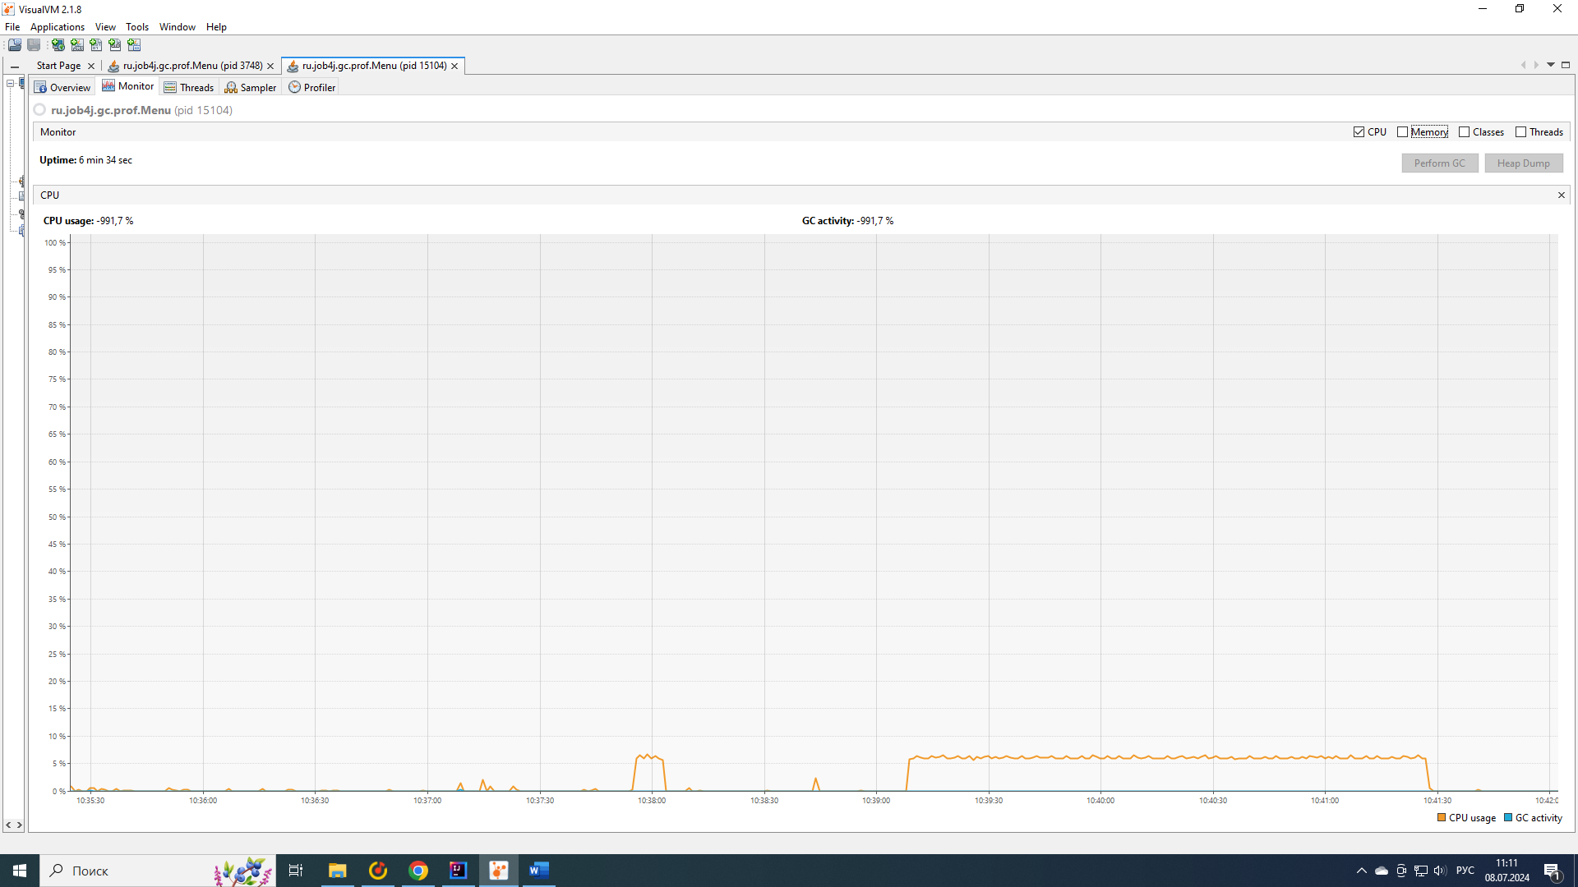

2) С использованием сборщика G1 GC:

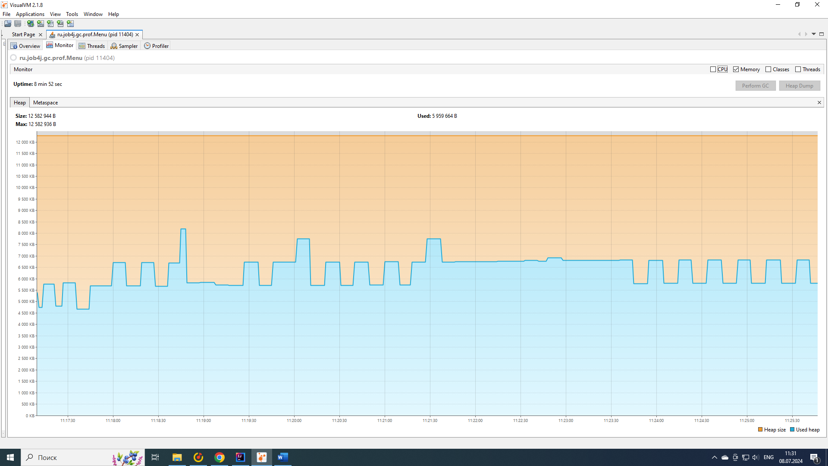

Время сборок мусора:

[14.556s][info][gc] GC(0) Pause Young (Normal) (G1 Evacuation Pause) 4M->2M(12M) 7.582ms  
[14.604s][info][gc] GC(1) Pause Young (Normal) (G1 Evacuation Pause) 3M->2M(12M) 2.783ms  
[14.632s][info][gc] GC(2) Pause Young (Normal) (G1 Evacuation Pause) 3M->2M(12M) 1.283ms  
[14.689s][info][gc] GC(3) Pause Young (Normal) (G1 Evacuation Pause) 4M->2M(12M) 1.797ms  
[14.767s][info][gc] GC(4) Pause Young (Normal) (G1 Evacuation Pause) 4M->3M(12M) 2.601ms  
[14.805s][info][gc] GC(5) Pause Young (Normal) (G1 Evacuation Pause) 5M->3M(12M) 2.615ms  
[14.840s][info][gc] GC(6) Pause Young (Normal) (G1 Evacuation Pause) 6M->4M(12M) 2.010ms  
[15.071s][info][gc] GC(7) Pause Young (Normal) (G1 Evacuation Pause) 6M->3M(12M) 1.821ms  
[15.273s][info][gc] GC(8) Pause Young (Normal) (G1 Evacuation Pause) 5M->4M(12M) 2.367ms  
[15.412s][info][gc] GC(9) Pause Young (Normal) (G1 Evacuation Pause) 6M->4M(12M) 3.196ms  
[27.426s][info][gc] GC(10) Pause Young (Normal) (G1 Evacuation Pause) 6M->4M(12M) 3.720ms  
[40.463s][info][gc] GC(11) Pause Young (Normal) (G1 Evacuation Pause) 6M->4M(12M) 1.538ms  
[55.811s][info][gc] GC(12) Pause Young (Concurrent Start) (G1 Humongous Allocation) 6M->4M(12M) 1.832ms  
[55.811s][info][gc] GC(13) Concurrent Undo Cycle  
[55.811s][info][gc] GC(13) Concurrent Undo Cycle 0.201ms  
[74.442s][info][gc] GC(14) Pause Young (Normal) (G1 Evacuation Pause) 7M->5M(12M) 3.616ms  
[92.490s][info][gc] GC(15) Pause Young (Concurrent Start) (G1 Evacuation Pause) 7M->5M(12M) 3.360ms  
[92.490s][info][gc] GC(16) Concurrent Mark Cycle  
[92.506s][info][gc] GC(16) Pause Remark 5M->5M(12M) 7.052ms  
[92.509s][info][gc] GC(16) Pause Cleanup 5M->5M(12M) 0.070ms  
[92.509s][info][gc] GC(16) Concurrent Mark Cycle 18.777ms  
[110.222s][info][gc] GC(17) Pause Young (Prepare Mixed) (G1 Evacuation Pause) 8M->6M(12M) 2.007ms  
[110.227s][info][gc] GC(18) Pause Young (Mixed) (G1 Evacuation Pause) 7M->6M(12M) 2.866ms  
[110.240s][info][gc] GC(19) Pause Young (Concurrent Start) (G1 Evacuation Pause) 8M->6M(12M) 1.690ms  
[110.240s][info][gc] GC(20) Concurrent Mark Cycle  
[110.247s][info][gc] GC(20) Pause Remark 6M->6M(12M) 2.846ms  
[110.249s][info][gc] GC(20) Pause Cleanup 6M->6M(12M) 0.036ms  
[110.249s][info][gc] GC(20) Concurrent Mark Cycle 8.982ms  
[110.264s][info][gc] GC(21) Pause Young (Prepare Mixed) (G1 Evacuation Pause) 8M->6M(12M) 2.084ms  
[110.274s][info][gc] GC(22) Pause Young (Mixed) (G1 Evacuation Pause) 7M->6M(12M) 6.651ms  
[110.283s][info][gc] GC(23) Pause Young (Concurrent Start) (G1 Evacuation Pause) 8M->6M(12M) 1.526ms  
[110.283s][info][gc] GC(24) Concurrent Mark Cycle  
[110.288s][info][gc] GC(25) Pause Young (Normal) (G1 Evacuation Pause) 8M->6M(12M) 2.084ms  
[110.293s][info][gc] GC(24) Pause Remark 6M->6M(12M) 4.241ms  
[110.293s][info][gc] GC(24) Pause Cleanup 6M->6M(12M) 0.004ms  
[110.294s][info][gc] GC(24) Concurrent Mark Cycle 10.860ms  
[110.298s][info][gc] GC(26) Pause Young (Normal) (G1 Evacuation Pause) 8M->6M(12M) 1.419ms  
[110.303s][info][gc] GC(27) Pause Young (Concurrent Start) (G1 Evacuation Pause) 8M->6M(12M) 1.722ms  
[110.303s][info][gc] GC(28) Concurrent Mark Cycle  
[110.306s][info][gc] GC(29) Pause Young (Normal) (G1 Evacuation Pause) 7M->6M(12M) 0.705ms  
[110.323s][info][gc] GC(30) Pause Young (Normal) (G1 Evacuation Pause) 7M->6M(12M) 0.363ms  
[110.331s][info][gc] GC(28) Pause Remark 6M->6M(12M) 7.573ms  
[110.333s][info][gc] GC(31) Pause Young (Normal) (G1 Evacuation Pause) 7M->6M(12M) 0.465ms  
[110.334s][info][gc] GC(28) Pause Cleanup 7M->7M(12M) 0.052ms  
[110.334s][info][gc] GC(28) Concurrent Mark Cycle 30.646ms  
[110.336s][info][gc] GC(32) Pause Young (Normal) (G1 Evacuation Pause) 7M->6M(12M) 0.506ms  
[110.338s][info][gc] GC(33) Pause Young (Concurrent Start) (G1 Evacuation Pause) 7M->6M(12M) 0.648ms  
[110.338s][info][gc] GC(34) Concurrent Mark Cycle  
[110.341s][info][gc] GC(35) Pause Young (Normal) (G1 Evacuation Pause) 7M->6M(12M) 0.522ms  
[110.347s][info][gc] GC(34) Pause Remark 7M->7M(12M) 4.340ms  
[110.348s][info][gc] GC(36) Pause Young (Normal) (G1 Evacuation Pause) 7M->6M(12M) 0.442ms  
[110.349s][info][gc] GC(34) Pause Cleanup 7M->7M(12M) 0.030ms  
[110.350s][info][gc] GC(34) Concurrent Mark Cycle 11.810ms  
[110.350s][info][gc] GC(37) Pause Young (Normal) (G1 Evacuation Pause) 7M->6M(12M) 0.385ms  
[110.353s][info][gc] GC(38) Pause Young (Concurrent Start) (G1 Evacuation Pause) 7M->6M(12M) 0.556ms  
[110.353s][info][gc] GC(39) Concurrent Mark Cycle  
[110.355s][info][gc] GC(40) Pause Young (Normal) (G1 Evacuation Pause) 7M->6M(12M) 0.392ms  
[110.357s][info][gc] GC(41) Pause Young (Normal) (G1 Evacuation Pause) 7M->6M(12M) 0.384ms  
[110.361s][info][gc] GC(39) Pause Remark 7M->7M(12M) 3.283ms  
[110.363s][info][gc] GC(42) Pause Young (Normal) (G1 Evacuation Pause) 7M->7M(12M) 0.410ms  
[110.363s][info][gc] GC(39) Pause Cleanup 7M->7M(12M) 0.029ms  
[110.364s][info][gc] GC(39) Concurrent Mark Cycle 10.739ms  
[110.365s][info][gc] GC(43) Pause Young (Concurrent Start) (G1 Humongous Allocation) 7M->7M(12M) 0.778ms  
[110.366s][info][gc] GC(44) Concurrent Mark Cycle  
[110.372s][info][gc] GC(44) Pause Remark 8M->8M(12M) 2.577ms  
[110.374s][info][gc] GC(44) Pause Cleanup 8M->8M(12M) 0.030ms  
[110.374s][info][gc] GC(44) Concurrent Mark Cycle 8.647ms  
[114.452s][info][gc] GC(45) Pause Young (Normal) (G1 Evacuation Pause) 9M->5M(12M) 1.665ms  
[123.458s][info][gc] GC(46) Pause Young (Concurrent Start) (G1 Evacuation Pause) 6M->5M(12M) 2.056ms  
[123.458s][info][gc] GC(47) Concurrent Mark Cycle  
[123.472s][info][gc] GC(47) Pause Remark 5M->5M(12M) 5.179ms  
[123.476s][info][gc] GC(47) Pause Cleanup 5M->5M(12M) 0.070ms  
[123.476s][info][gc] GC(47) Concurrent Mark Cycle 18.437ms  
[132.515s][info][gc] GC(48) Pause Young (Normal) (G1 Evacuation Pause) 6M->5M(12M) 1.133ms  
[142.460s][info][gc] GC(49) Pause Young (Concurrent Start) (G1 Evacuation Pause) 6M->5M(12M) 1.637ms  
[142.460s][info][gc] GC(50) Concurrent Mark Cycle  
[142.474s][info][gc] GC(50) Pause Remark 5M->5M(12M) 5.191ms  
[142.478s][info][gc] GC(50) Pause Cleanup 5M->5M(12M) 0.098ms  
[142.479s][info][gc] GC(50) Concurrent Mark Cycle 18.061ms  
[161.540s][info][gc] GC(51) Pause Young (Normal) (G1 Evacuation Pause) 7M->5M(12M) 0.919ms  
[176.970s][info][gc] GC(52) Pause Young (Concurrent Start) (G1 Humongous Allocation) 7M->5M(12M) 0.834ms  
[176.970s][info][gc] GC(53) Concurrent Mark Cycle  
[176.977s][info][gc] GC(53) Pause Remark 6M->6M(12M) 2.776ms  
[176.979s][info][gc] GC(53) Pause Cleanup 6M->6M(12M) 0.053ms  
[176.980s][info][gc] GC(53) Concurrent Mark Cycle 9.238ms  
[196.476s][info][gc] GC(54) Pause Young (Normal) (G1 Evacuation Pause) 8M->5M(12M) 1.613ms  
[215.578s][info][gc] GC(55) Pause Young (Concurrent Start) (G1 Evacuation Pause) 7M->5M(12M) 1.315ms  
[215.578s][info][gc] GC(56) Concurrent Mark Cycle  
[215.587s][info][gc] GC(56) Pause Remark 5M->5M(12M) 3.965ms  
[215.590s][info][gc] GC(56) Pause Cleanup 5M->5M(12M) 0.098ms  
[215.590s][info][gc] GC(56) Concurrent Mark Cycle 12.340ms  
[234.592s][info][gc] GC(57) Pause Young (Normal) (G1 Evacuation Pause) 7M->5M(12M) 1.547ms  
[254.604s][info][gc] GC(58) Pause Young (Concurrent Start) (G1 Evacuation Pause) 7M->5M(12M) 0.888ms  
[254.604s][info][gc] GC(59) Concurrent Mark Cycle  
[254.613s][info][gc] GC(59) Pause Remark 5M->5M(12M) 4.724ms  
[254.617s][info][gc] GC(59) Pause Cleanup 5M->5M(12M) 0.058ms  
[254.617s][info][gc] GC(59) Concurrent Mark Cycle 13.052ms  
[263.427s][info][gc] GC(60) Pause Young (Concurrent Start) (G1 Humongous Allocation) 6M->5M(12M) 0.890ms  
[263.427s][info][gc] GC(61) Concurrent Mark Cycle  
[263.434s][info][gc] GC(61) Pause Remark 6M->6M(12M) 2.970ms  
[263.436s][info][gc] GC(61) Pause Cleanup 6M->6M(12M) 0.034ms  
[263.436s][info][gc] GC(61) Concurrent Mark Cycle 9.136ms  
[282.627s][info][gc] GC(62) Pause Young (Normal) (G1 Evacuation Pause) 8M->6M(12M) 1.612ms  
[292.511s][info][gc] GC(63) Pause Young (Concurrent Start) (G1 Evacuation Pause) 7M->6M(12M) 1.570ms  
[292.511s][info][gc] GC(64) Concurrent Mark Cycle  
[292.519s][info][gc] GC(64) Pause Remark 6M->6M(12M) 3.363ms  
[292.521s][info][gc] GC(64) Pause Cleanup 6M->6M(12M) 0.092ms  
[292.521s][info][gc] GC(64) Concurrent Mark Cycle 9.937ms  
[301.644s][info][gc] GC(65) Pause Young (Normal) (G1 Evacuation Pause) 7M->6M(12M) 1.480ms  
[311.653s][info][gc] GC(66) Pause Young (Concurrent Start) (G1 Evacuation Pause) 7M->6M(12M) 1.588ms  
[311.653s][info][gc] GC(67) Concurrent Mark Cycle  
[311.660s][info][gc] GC(67) Pause Remark 6M->6M(12M) 2.704ms  
[311.662s][info][gc] GC(67) Pause Cleanup 6M->6M(12M) 0.058ms  
[311.662s][info][gc] GC(67) Concurrent Mark Cycle 9.035ms  
[320.526s][info][gc] GC(68) Pause Young (Normal) (G1 Evacuation Pause) 7M->6M(12M) 1.593ms  
[329.664s][info][gc] GC(69) Pause Young (Concurrent Start) (G1 Evacuation Pause) 7M->6M(12M) 1.570ms  
[329.664s][info][gc] GC(70) Concurrent Mark Cycle  
[329.673s][info][gc] GC(70) Pause Remark 6M->6M(12M) 5.263ms  
[329.675s][info][gc] GC(70) Pause Cleanup 6M->6M(12M) 0.106ms  
[329.676s][info][gc] GC(70) Concurrent Mark Cycle 11.885ms  
[337.668s][info][gc] GC(71) Pause Young (Normal) (G1 Evacuation Pause) 7M->6M(12M) 1.572ms  
[346.678s][info][gc] GC(72) Pause Young (Concurrent Start) (G1 Evacuation Pause) 7M->6M(12M) 1.698ms  
[346.678s][info][gc] GC(73) Concurrent Mark Cycle  
[346.691s][info][gc] GC(73) Pause Remark 6M->6M(12M) 8.229ms  
[346.693s][info][gc] GC(73) Pause Cleanup 6M->6M(12M) 0.088ms  
[346.693s][info][gc] GC(73) Concurrent Mark Cycle 14.899ms  
[352.683s][info][gc] GC(74) Pause Young (Normal) (G1 Evacuation Pause) 7M->6M(12M) 1.328ms  
[362.689s][info][gc] GC(75) Pause Young (Concurrent Start) (G1 Evacuation Pause) 7M->6M(12M) 1.800ms  
[362.689s][info][gc] GC(76) Concurrent Mark Cycle  
[362.697s][info][gc] GC(76) Pause Remark 6M->6M(12M) 3.367ms  
[362.699s][info][gc] GC(76) Pause Cleanup 6M->6M(12M) 0.068ms  
[362.699s][info][gc] GC(76) Concurrent Mark Cycle 10.084ms  
[372.558s][info][gc] GC(77) Pause Young (Normal) (G1 Evacuation Pause) 7M->6M(12M) 1.304ms  
[381.704s][info][gc] GC(78) Pause Young (Concurrent Start) (G1 Evacuation Pause) 7M->6M(12M) 1.682ms  
[381.705s][info][gc] GC(79) Concurrent Mark Cycle  
[381.715s][info][gc] GC(79) Pause Remark 6M->6M(12M) 5.381ms  
[381.718s][info][gc] GC(79) Pause Cleanup 6M->6M(12M) 0.098ms  
[381.719s][info][gc] GC(79) Concurrent Mark Cycle 13.918ms  
[391.571s][info][gc] GC(80) Pause Young (Normal) (G1 Evacuation Pause) 7M->6M(12M) 1.491ms  
[400.717s][info][gc] GC(81) Pause Young (Concurrent Start) (G1 Evacuation Pause) 7M->6M(12M) 1.389ms  
[400.717s][info][gc] GC(82) Concurrent Mark Cycle  
[400.726s][info][gc] GC(82) Pause Remark 6M->6M(12M) 5.403ms  
[400.729s][info][gc] GC(82) Pause Cleanup 6M->6M(12M) 0.097ms  
[400.729s][info][gc] GC(82) Concurrent Mark Cycle 12.039ms  
[410.586s][info][gc] GC(83) Pause Young (Normal) (G1 Evacuation Pause) 7M->5M(12M) 1.457ms  
[429.733s][info][gc] GC(84) Pause Young (Concurrent Start) (G1 Evacuation Pause) 7M->5M(12M) 1.798ms  
[429.733s][info][gc] GC(85) Concurrent Mark Cycle  
[429.747s][info][gc] GC(85) Pause Remark 5M->5M(12M) 5.527ms  
[429.751s][info][gc] GC(85) Pause Cleanup 5M->5M(12M) 0.095ms  
[429.751s][info][gc] GC(85) Concurrent Mark Cycle 18.429ms  
[449.589s][info][gc] GC(86) Pause Young (Normal) (G1 Evacuation Pause) 7M->5M(12M) 1.105ms  
[468.759s][info][gc] GC(87) Pause Young (Concurrent Start) (G1 Evacuation Pause) 7M->5M(12M) 1.443ms  
[468.759s][info][gc] GC(88) Concurrent Mark Cycle  
[468.768s][info][gc] GC(88) Pause Remark 5M->5M(12M) 2.978ms  
[468.772s][info][gc] GC(88) Pause Cleanup 5M->5M(12M) 0.067ms  
[468.772s][info][gc] GC(88) Concurrent Mark Cycle 13.516ms  
[488.605s][info][gc] GC(89) Pause Young (Normal) (G1 Evacuation Pause) 7M->5M(12M) 1.437ms  
[507.783s][info][gc] GC(90) Pause Young (Concurrent Start) (G1 Evacuation Pause) 7M->5M(12M) 1.741ms  
[507.783s][info][gc] GC(91) Concurrent Mark Cycle  
[507.797s][info][gc] GC(91) Pause Remark 5M->5M(12M) 5.487ms  
[507.801s][info][gc] GC(91) Pause Cleanup 5M->5M(12M) 0.093ms  
[507.802s][info][gc] GC(91) Concurrent Mark Cycle 18.436ms  
[527.616s][info][gc] GC(92) Pause Young (Normal) (G1 Evacuation Pause) 7M->5M(12M) 0.927ms

Время работы методов сортировки:

1. Сортировка слиянием – 15 мс;
2. Сортировка вставками – 5 сек;
3. Сортировка пузырьком – 2 мин 19 сек;

График загрузки процессора:

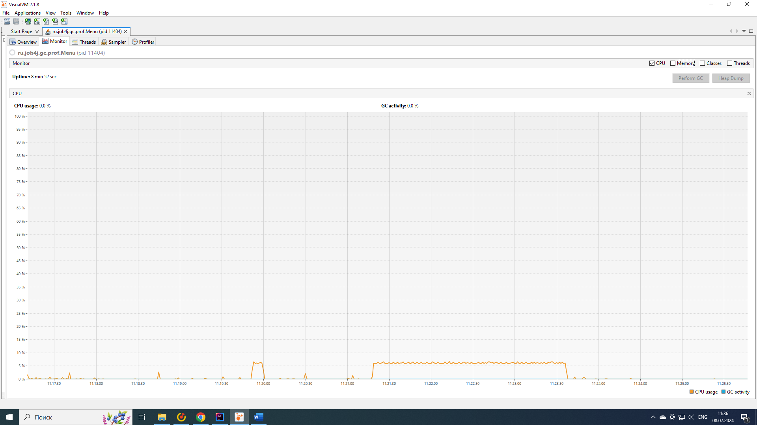

3) С использованием сборщика ZGC:

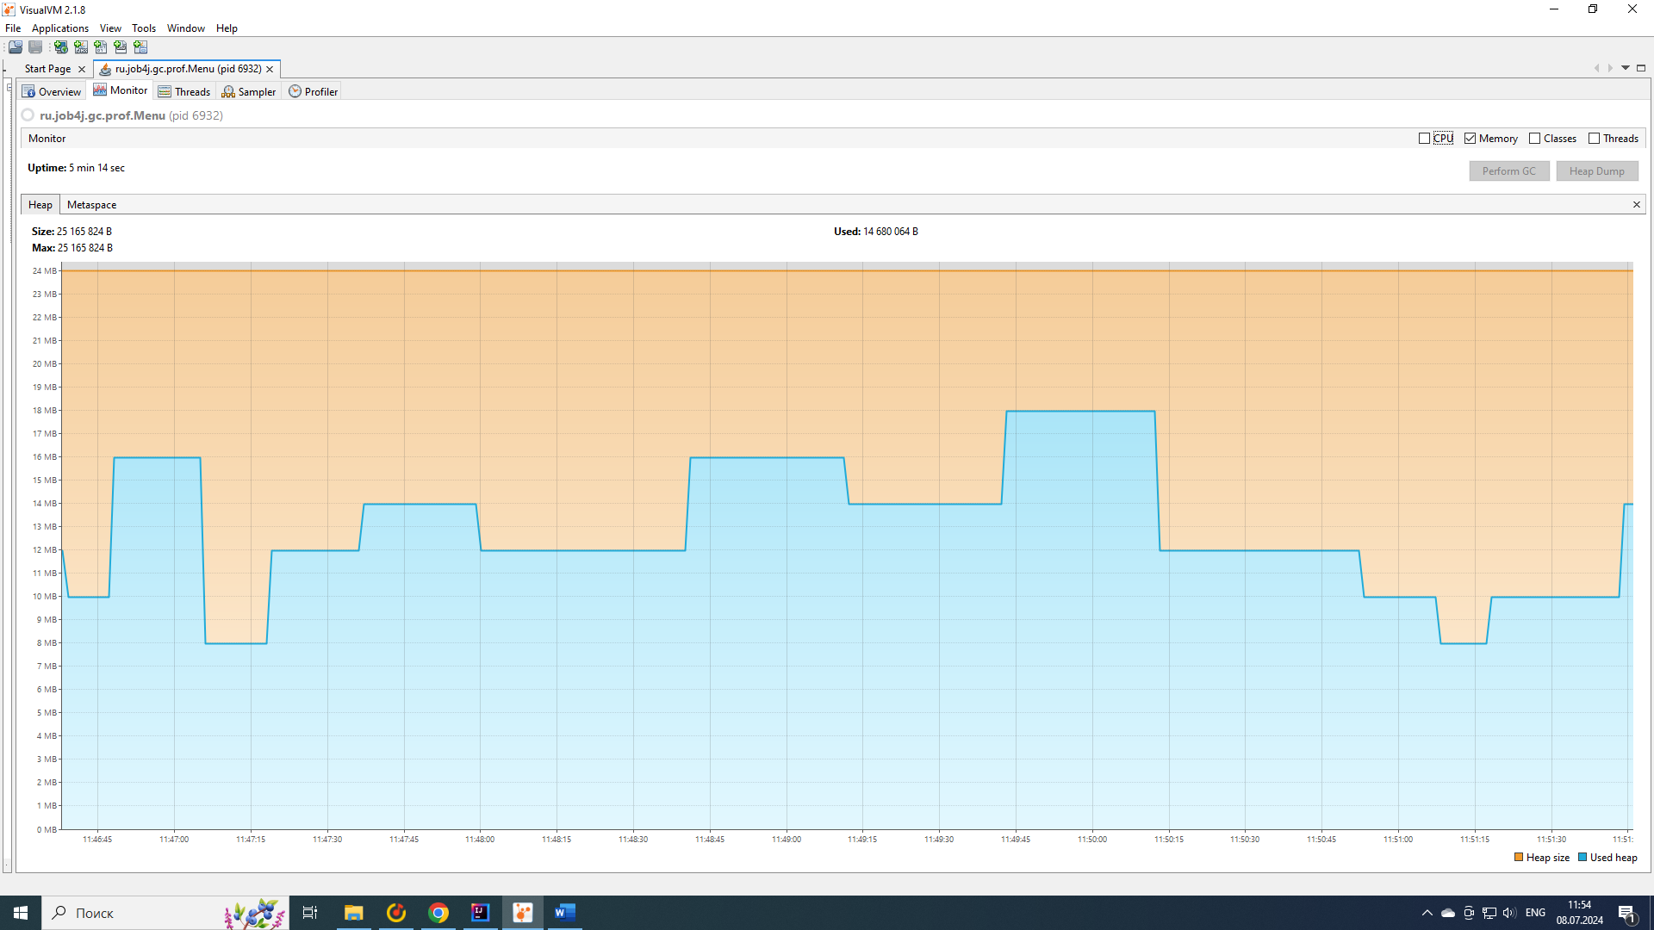

Время сборок мусора:

[0.176s][info][gc] GC(0) Garbage Collection (Warmup) 4M(17%)->4M(17%)  
[1.075s][info][gc] GC(1) Garbage Collection (Warmup) 6M(25%)->4M(17%)  
[5.777s][info][gc] GC(2) Garbage Collection (Warmup) 8M(33%)->6M(25%)  
[6.010s][info][gc] GC(3) Garbage Collection (Allocation Rate) 16M(67%)->10M(42%)  
[6.080s][info][gc] GC(4) Garbage Collection (Allocation Rate) 10M(42%)->8M(33%)  
[6.177s][info][gc] GC(5) Garbage Collection (Allocation Rate) 8M(33%)->8M(33%)  
[6.286s][info][gc] GC(6) Garbage Collection (Allocation Rate) 10M(42%)->8M(33%)  
[6.381s][info][gc] GC(7) Garbage Collection (Allocation Rate) 8M(33%)->8M(33%)  
[6.480s][info][gc] GC(8) Garbage Collection (Allocation Rate) 10M(42%)->8M(33%)  
[6.588s][info][gc] GC(9) Garbage Collection (Allocation Rate) 10M(42%)->10M(42%)  
[6.686s][info][gc] GC(10) Garbage Collection (Allocation Rate) 10M(42%)->10M(42%)  
[6.804s][info][gc] GC(11) Garbage Collection (Allocation Rate) 10M(42%)->10M(42%)  
[6.896s][info][gc] GC(12) Garbage Collection (Allocation Rate) 10M(42%)->10M(42%)  
[7.477s][info][gc] GC(13) Garbage Collection (Allocation Rate) 10M(42%)->10M(42%)  
[7.596s][info][gc] GC(14) Garbage Collection (Allocation Rate) 10M(42%)->10M(42%)  
[7.685s][info][gc] GC(15) Garbage Collection (Allocation Rate) 10M(42%)->10M(42%)  
[15.591s][info][gc] GC(16) Garbage Collection (Proactive) 14M(58%)->12M(50%)  
[33.833s][info][gc] Allocation Stall (main) 21.037ms  
[33.837s][info][gc] GC(17) Garbage Collection (Allocation Stall) 24M(100%)->14M(58%)  
[33.877s][info][gc] Allocation Stall (main) 23.508ms  
[33.879s][info][gc] GC(18) Garbage Collection (Allocation Rate) 24M(100%)->14M(58%)  
[33.984s][info][gc] GC(19) Garbage Collection (Allocation Stall) 22M(92%)->8M(33%)  
[34.084s][info][gc] GC(20) Garbage Collection (Allocation Rate) 8M(33%)->8M(33%)  
[34.177s][info][gc] GC(21) Garbage Collection (Allocation Rate) 8M(33%)->8M(33%)  
[34.283s][info][gc] GC(22) Garbage Collection (Allocation Rate) 8M(33%)->8M(33%)  
[34.386s][info][gc] GC(23) Garbage Collection (Allocation Rate) 8M(33%)->8M(33%)  
[34.489s][info][gc] GC(24) Garbage Collection (Allocation Rate) 8M(33%)->8M(33%)  
[34.583s][info][gc] GC(25) Garbage Collection (Allocation Rate) 10M(42%)->10M(42%)  
[34.704s][info][gc] GC(26) Garbage Collection (Allocation Rate) 10M(42%)->8M(33%)  
[35.104s][info][gc] GC(27) Garbage Collection (Allocation Rate) 8M(33%)->8M(33%)  
[35.183s][info][gc] GC(28) Garbage Collection (Allocation Rate) 8M(33%)->8M(33%)  
[35.286s][info][gc] GC(29) Garbage Collection (Allocation Rate) 8M(33%)->8M(33%)  
[35.394s][info][gc] GC(30) Garbage Collection (Allocation Rate) 8M(33%)->8M(33%)  
[35.491s][info][gc] GC(31) Garbage Collection (Allocation Rate) 8M(33%)->8M(33%)  
[35.589s][info][gc] GC(32) Garbage Collection (Allocation Rate) 10M(42%)->8M(33%)  
[46.590s][info][gc] GC(33) Garbage Collection (Proactive) 12M(50%)->10M(42%)  
[64.690s][info][gc] GC(34) Garbage Collection (Proactive) 14M(58%)->12M(50%)  
[87.699s][info][gc] GC(35) Garbage Collection (Proactive) 16M(67%)->8M(33%)  
[98.179s][info][gc] GC(36) Garbage Collection (Proactive) 12M(50%)->12M(50%)  
[128.683s][info][gc] GC(37) Garbage Collection (Proactive) 16M(67%)->12M(50%)  
[159.685s][info][gc] GC(38) Garbage Collection (Proactive) 16M(67%)->12M(50%)  
[190.692s][info][gc] GC(39) Garbage Collection (Proactive) 16M(67%)->12M(50%)  
[220.789s][info][gc] GC(40) Garbage Collection (Proactive) 16M(67%)->12M(50%)  
[247.801s][info][gc] GC(41) Garbage Collection (Proactive) 16M(67%)->8M(33%)  
[260.796s][info][gc] GC(42) Garbage Collection (Proactive) 12M(50%)->8M(33%)  
[275.794s][info][gc] GC(43) Garbage Collection (Proactive) 12M(50%)->8M(33%)  
[285.695s][info][gc] GC(44) Garbage Collection (Proactive) 12M(50%)->8M(33%)  
[299.801s][info][gc] GC(45) Garbage Collection (Proactive) 12M(50%)->8M(33%)  
[311.794s][info][gc] GC(46) Garbage Collection (Proactive) 12M(50%)->10M(42%)

Время работы методов сортировки:

1. Сортировка слиянием – 13 мс;
2. Сортировка вставками – 8 сек;
3. Сортировка пузырьком – 2 мин 21 сек;

График загрузки процессора:

