Locked me project Assessment: -

Main Menu;

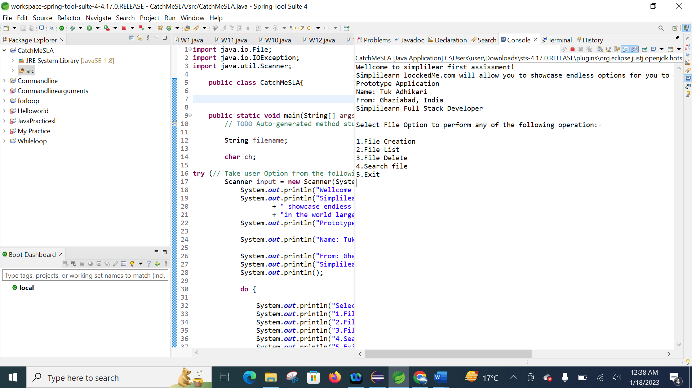

Select File Option to perform any of the following operation: -

1.File Creation

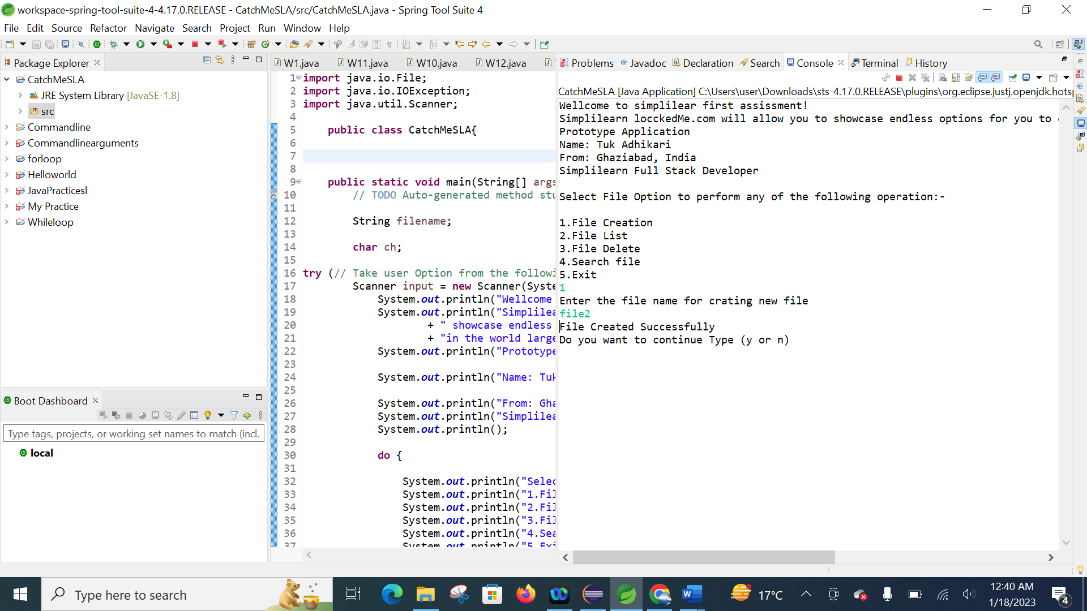

Select File Option to perform any of the following operation: -

2.File List

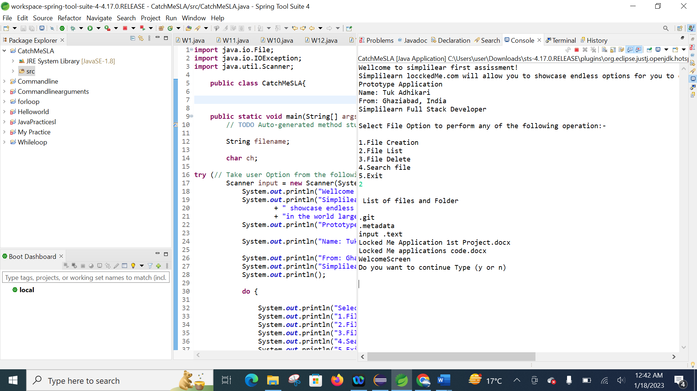

Select File Option to perform any of the following operation: -

3.File Delete

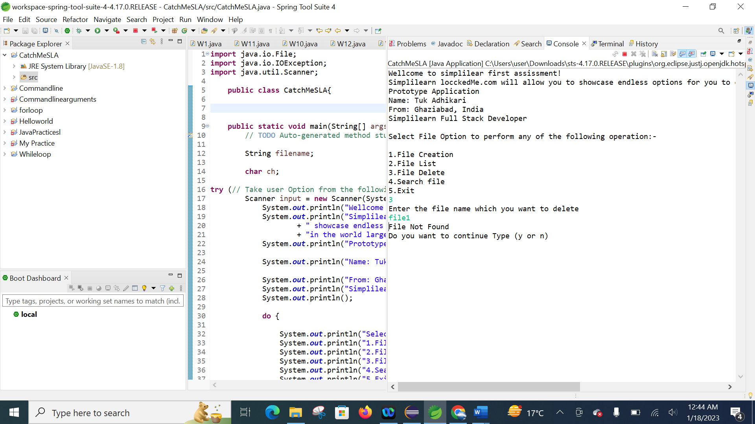

Select File Option to perform any of the following operation:-

3.File Delete

4.Search file

5.Exit

