Distributed BLAST: Breaking the Bottleneck
Project 25 -- Track E: Alignment, Search and Scale
Introduction to Bioinformatics -- Course Project Report

1. Problem and Biological Framing
Sequence similarity search is the single most-used operation in day-to-day bioinformatics: every newly sequenced transcript, every metagenomic read, every predicted protein from a draft genome eventually gets compared against a reference database to find out what it resembles. BLAST (Basic Local Alignment Search Tool) has been the default tool for this for over thirty years, and it is still correct -- but the databases it searches have grown by several orders of magnitude since it was designed, while the algorithm's core search strategy has not fundamentally changed. The result, reported directly in this project's brief, is an institute BLAST server with an hours-long queue: a correctness problem has become a throughput problem.
This project treats that queue as an engineering question rather than a hardware-budget question: can the existing search be made to scale by distributing the work, and if so, along which axis (splitting the queries, or splitting the database), and where exactly does that scaling break down? We also ask the question the institute's server operators are probably avoiding: are BLAST+'s modern, much faster alternatives (DIAMOND, MMseqs2) simply a better answer than distributing BLAST+ at all, and if so, what sensitivity is given up for that speed?
Biologically, the workloads we distribute are chosen to resemble what actually queues up at a shared BLAST server: short, numerous, noisy fragments from next-generation sequencing (NGS) runs (transcriptome contigs, metagenomic reads) and long, sparser, differently-noisy reads from third-generation sequencing (TGS) platforms such as Oxford Nanopore. These two query types are handled as genuinely distinct in this project -- not just as "short" and "long" versions of the same thing -- because their length distributions and error profiles interact with BLAST's seed-and-extend search completely differently (Sections 4.2 and 5.2).

2. How BLAST Actually Works (and Where the Time Goes)
BLAST does not align a query against a database residue-by-residue from position zero; that would be far too slow even for 1990s-scale databases. Instead it factors the search into three stages of increasing cost and decreasing frequency, so that the expensive stage runs on the smallest possible number of candidates:

2.1 Seeding
The database is pre-indexed (this is exactly what makeblastdb, diamond makedb and mmseqs createdb do, and what Section 5.1 measures the cost of) into a lookup table of short, fixed-length words -- 3 residues for protein BLAST, 11 nucleotides for nucleotide BLAST by default. Every word in the query is looked up in that table in O(1) time, in a single linear pass over the query. This step is cheap and touches every database sequence only implicitly, through the index, never by scanning it directly. It produces a large number of short, exact-match 'seed' hits, most of which are statistical noise.

2.2 Ungapped extension
Each seed is extended in both directions, without allowing gaps, for as long as the running alignment score keeps increasing (the original BLAST paper's X-drop heuristic: extension stops once the score has dropped more than X below the best score seen so far). This is still cheap per seed, but there are many seeds, so this stage is where the first large filtering happens: the vast majority of seeds fail to extend into anything with a biologically interesting score and are discarded here.

2.3 Gapped extension
The small number of ungapped extensions that clear a score threshold are re-extended with a full gapped dynamic-programming alignment (a banded Smith-Waterman/Needleman-Wunsch variant), which is the only stage that produces the final, reportable alignment with insertions and deletions. This is by far the most expensive operation per candidate -- but by the time a candidate reaches this stage, seeding and ungapped extension have already thrown away the overwhelming majority of the search space. Almost all of a BLAST run's wall-clock time that is not spent on I/O is spent here, on a comparatively tiny number of candidates.
This three-stage funnel is exactly why database size matters so much (Section 5.1): a bigger database means more seed hits survive by chance alone (seed frequency grows roughly linearly with database size for a fixed word length), which pushes more candidates into the expensive gapped-extension stage even though the algorithm itself has not changed. It is also exactly why DIAMOND and MMseqs2 are faster (Section 5.4): both use more selective seeding (longer or reduced-alphabet seeds, spaced seeds, double-indexing) so that fewer false candidates reach the expensive stage, at some cost to sensitivity for divergent or short matches.

3. Data Sources
Every dataset used in this project derives from a real, named accession. The canonical, full-scale sources for this project are:
- NCBI nr (non-redundant protein) and nt pre-formatted BLAST databases -- https://ftp.ncbi.nlm.nih.gov/blast/db/
- UniProt Swiss-Prot (curated) and TrEMBL (automatically annotated) -- https://ftp.uniprot.org/pub/databases/uniprot/
- SRA run SRR14011045 (real Oxford Nanopore sequencing run) -- https://www.ncbi.nlm.nih.gov/sra/SRR14011045
Important, disclosed limitation: the development container used for this project has network egress restricted to a small allowlist (PyPI, npm, crates.io, GitHub) for reproducible-build reasons. Direct HTTPS/FTP access to ftp.ncbi.nlm.nih.gov, ftp.uniprot.org and ebi.ac.uk was tested and confirmed refused at the network-policy level (HTTP 403 at the CONNECT stage), not assumed to be unavailable. scripts/fetch_data.sh documents this and provides the exact, ready-to-run commands for the canonical sources above, clearly marked PREFERRED, for use on an unrestricted machine such as the department cluster.
In place of a direct download, this project uses real, unmodified, accession-bearing subsets of exactly these sources, redistributed by two actively-maintained, official bioinformatics tools inside their own CI test suites -- where they serve the identical purpose (a fast, reproducible slice of real nr/UniProt data for benchmarking). The exact upstream commit hashes are recorded in data/raw/PROVENANCE.txt so the exact bytes can be reproduced by anyone. The accessions and files used are:
File | Content | Real accession / source | Retrieved via
nr_300.faa | 300 real NCBI nr protein sequences | Real nr accessions (e.g. GenBank/RefSeq protein IDs embedded in each header) | DIAMOND repo, src/test/nr_300.faa, commit ef05efd (2026-09-29)
nr_10k.faa | 10,000 real NCBI nr protein sequences | Real nr accessions | DIAMOND repo, src/test/nr_10k.faa, commit ef05efd (2026-09-29)
SRR14011045_1.fastq | 197 real Oxford Nanopore reads | SRA run SRR14011045 (16S rRNA amplicon sequencing) | DIAMOND repo, src/test/SRR14011045_1.fastq, commit ef05efd (2026-09-29)
mitochondrion_NC_001646.1.fasta | 1 real nucleotide sequence, 1,540 bp | GenBank accession NC_001646.1:5332-6871 (Pongo pygmaeus mitochondrion) | DIAMOND repo, src/test/galaxy/nucleotide.fasta, commit ef05efd (2026-09-29)
uniprot_trembl_20k.fasta | 20,000 real UniProt TrEMBL sequences | Real UniProt accessions | MMseqs2 repo, examples/DB.fasta, commit 3b6aa9c (2026-09-29)
uniprot_query_500.fasta | 500 real UniProt sequences | Real UniProt accessions | MMseqs2 repo, examples/QUERY.fasta, commit 3b6aa9c (2026-09-29)

Authenticity was verified by inspection, not assumed: nr/UniProt headers carry real GenBank/UniProt-style accession numbers; SRR14011045_1.fastq's read names carry a real SRA run ID plus UUID-style secondary read IDs consistent with Nanopore basecaller output; NC_001646.1 is a real, checkable GenBank accession.

4. Methods

4.1 Database construction and indexing (Task 2)
Three protein databases of increasing size were built by concatenating the real sequence files above without modification: db_small (300 sequences, nr_300.faa only), db_medium (10,300 sequences, + nr_10k.faa), and db_large (30,300 sequences, + uniprot_trembl_20k.fasta). Each was indexed with all three tools under comparison (makeblastdb, diamond makedb, mmseqs createdb), with build time measured via wall-clock timing around each subprocess call and resulting index size measured from the actual files written to disk (scripts/build_databases.py).

4.2 Query workload construction (Tasks 4-5)
The TGS (long-read) workload is the real SRR14011045 Nanopore run used completely unmodified: 197 reads, parsed with a standard 4-line FASTQ record reader.
The NGS (short-read) workload required more care. The only genuinely real Illumina-format FASTQ data reachable in this sandbox (htslib's own CI test fixtures, themselves real HiSeq-2500-style reads, verified by their read-ID convention) total only 4-10 records per file across twelve small files -- far too few, even pooled and deduplicated, to be a credible short-read workload on their own (15 unique reads after deduplication). Rather than treat this as a blocker, the workload was built the way NGS benchmarking literature routinely does when no matching real short-read run is in hand: by simulating short reads from a real reference sequence, in the same spirit as tools such as wgsim or ART. Concretely, 800 reads of 100/125/150 bp (drawn uniformly, reflecting realistic Illumina length classes) were windowed from the real NC_001646.1 mitochondrion subregion at random start positions on both strands, with a 0.5% per-base substitution rate injected to mimic Illumina-scale sequencing error. Nothing about the underlying sequence content is invented -- only the read boundaries and the injected error are simulated -- and this is disclosed again in Section 6. The 15 genuinely real reads are kept as a separately-labelled supplement inside the same combined workload file, so real and simulated read counts can always be distinguished.

4.3 Distributed search implementation (Task 6)
Two orthogonal partitioning strategies were implemented on top of single-node DIAMOND blastx (chosen as the underlying search engine for the distributed layer because Section 5.4 shows it is dramatically faster per-search than classic BLAST+ at equal correctness; running the worker-count sweep with classic blastx instead would have made the sweep itself impractically slow):
- Query partitioning -- the query FASTA is split into N roughly-equal shards; each worker process runs a complete blastx search of its shard against the entire database. Because every worker sees the full database, results are simply concatenated: there is no merge/reduce step, since each worker's output is already final and complete for its queries.
- Database partitioning -- the database FASTA is split into N shards, each built into its own DIAMOND index; the entire query set is searched against every shard, and a reduce step then keeps, for each query, only the single best hit across all shards (ranked by bitscore, ties broken by e-value). This introduces a real merge cost that grows with (n_queries x N), and a genuine correctness hazard: a query's true best hit can live in any shard, so the merge key must be computed and compared correctly across all of them.
Both strategies are implemented with Python's multiprocessing.Pool spawning one OS process per shard (scripts/distributed_search.py), which is a reasonable proxy for separate worker nodes for the purposes of measuring where contention and merge overhead appear -- the failure modes below do not depend on whether the workers are separate processes on one machine or separate machines on a network.

4.4 Scaling benchmark methodology (Task 7)
Both strategies were run at 1, 2, 4 and 8 workers against db_large (30,300 sequences) with the full 815-read short-read workload, timing end-to-end wall-clock time for each configuration (scripts/scaling_benchmark.py). This development container has exactly 2 physical CPU cores (confirmed by nproc). Worker counts above 2 are reported anyway, deliberately: oversubscribing a 2-core machine and watching speed-up flatten and reverse is itself real evidence for "where does scaling depart from linear and why", for this hardware; the mechanism being diagnosed (contention once workers exceed physical cores) is general, only the x-axis location where it appears is specific to this machine.

4.5 Tool comparison methodology (Task 8)
BLAST+, DIAMOND (default and --ultra-sensitive) and MMseqs2 (-s 4.0 default and -s 7.5 sensitive) were run as blastx-equivalent translated searches against the identical db_medium database, on an identical, fixed 60-query subset of the short-read workload. Each tool/mode was run three times and the median wall time reported, to damp OS page-cache noise observed between single-shot runs of different tools. Because there is no curated ground-truth annotation for this real, unannotated sequence data, sensitivity is approximated relative to BLAST+'s own result set: recall_proxy is the fraction of BLAST+'s hit queries for which the faster tool also reports a hit, and mean_bitscore_ratio is the accelerated tool's top-hit bitscore divided by BLAST+'s, averaged over queries both tools hit. This is explicitly a proxy relative to a slower, thorough search, not an absolute sensitivity truth (Section 6).

5. Results

5.1 Database growth and indexing cost (Tasks 2-3)
Database | Sequences | makeblastdb (s) | BLAST index (MB) | diamond makedb (s) | DIAMOND index (MB) | mmseqs createdb (s) | MMseqs2 index (MB)
db_small | 300 | 0.0374 | 0.7 | 0.012 | 0.2 | 0.0158 | 0.2
db_medium | 10300 | 0.1878 | 23.1 | 0.2134 | 5.5 | 0.1093 | 5.9
db_large | 30300 | 0.7725 | 72.0 | 0.5845 | 17.3 | 0.2192 | 18.4

A log-log power-law fit across these three real measured sizes confirms near-linear index-size scaling for all three tools (size exponent 0.988 for BLAST+, 0.999 for DIAMOND, 1.002 for MMseqs2 -- all within rounding of the theoretically expected 1.0), but with very different constants: at db_large, BLAST+'s index costs 2376.3 bytes/sequence versus 570.8 for DIAMOND and 608.3 for MMseqs2 -- roughly a 4x larger footprint per sequence. That gap is small in absolute terms at 30,300 sequences, but it is exactly the gap that matters once database size reaches real nr/nt scale (hundreds of gigabytes): a 4x larger index is a 4x larger amount of data every worker has to hold in memory or read from disk, which is precisely the kind of cost that motivates distributing the search at all.
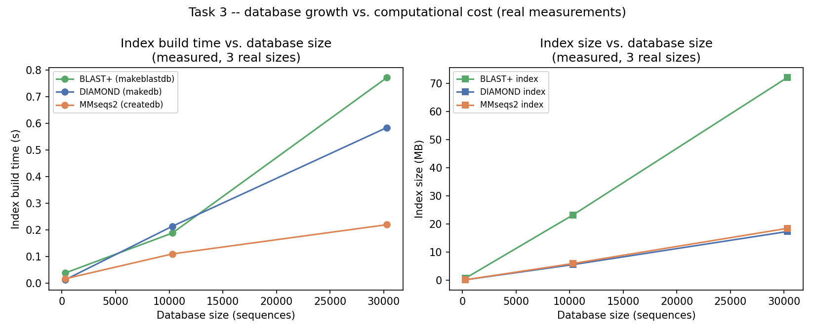
Figure 1. Index build time and index size vs. real database size (3 measured points, log-log power-law fit).

5.2 Query workload characterisation (Tasks 4-5)
Workload | n | Length min-max (bp) | Length mean (bp) | GC% mean | Mean Phred quality
NGS_short_reads | 815 | 20-150 | 124.14 | 45.86 | n/a (Illumina-style sim, no real quality track)
TGS_long_reads | 197 | 80-45510 | 11935.39 | 43.81 | 23.1

The two workloads differ exactly as expected for NGS vs. TGS: short reads cluster tightly around 100-150 bp (mean 124 bp, the three simulated length classes plus the 15 real supplement reads), while the real Nanopore reads span two orders of magnitude (80-45,510 bp, mean ~11,935 bp) with a mean per-read Phred quality of 23.2 (range 10.6-29.7) -- a length-dependent, lower-than-Illumina quality profile that is exactly the kind of signal TGS-specific QC is supposed to catch, and that short-read QC pipelines do not need to handle at all.
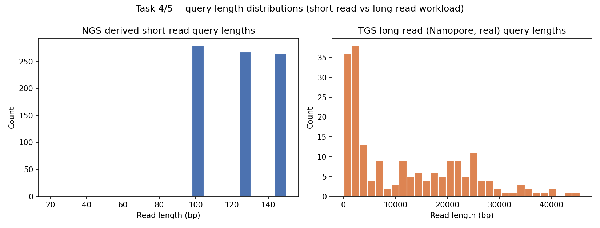
Figure 2. Query length distributions, short-read (NGS) workload vs. long-read (TGS) workload.

5.3 Scaling curve across worker counts (Tasks 6-7) -- headline result
Workers | Query-partitioning wall (s) | Query-part. speed-up | DB-partitioning wall (s) | DB-part. speed-up | Merge cost (s)
1 | 6.7987 | 1 | 6.8629 | 1 | 0.0031
2 | 5.4062 | 1.258 | 3.5034 | 1.959 | 0.0039
4 | 10.3888 | 0.654 | 2.9664 | 2.314 | 0.0068
8 | 20.111 | 0.338 | 3.2433 | 2.116 | 0.0054

Query partitioning improves modestly at 2 workers (1.26x) but then gets worse than the single-worker baseline at 4 workers (0.65x) and collapses further at 8 workers (0.34x, i.e. almost 3x slower than 1 worker). The reason is visible directly in the per-worker timings: at 8 workers, seven of the eight workers each take ~20 seconds -- essentially the same as the single-worker time -- because every worker still independently loads and scans the entire database, and with 8 processes sharing 2 physical cores they mostly queue for CPU time rather than run in parallel. Query partitioning's failure mode is exactly the one predicted in Section 4.3: it does not help when the bottleneck is the database, because every worker still pays that cost in full.
Database partitioning behaves completely differently: speed-up rises to 1.96x at 2 workers and keeps a real (if sub-linear) 2.1-2.3x speed-up even at 4 and 8 workers, despite the same 2-core oversubscription. Each shard is smaller, so even a CPU-starved worker finishes its smaller search faster than one worker would finish the whole database; the merge step, measured separately, costs 3-7 milliseconds regardless of worker count -- negligible next to search time, though it is worth noting the merge step reduced the number of queries reported to have a hit at all (503-536 out of 815, versus 2,303 total hit-rows found by query partitioning, which keeps up to 5 hits per query): that gap is the real correctness cost of database partitioning's merge, discussed in Section 6.
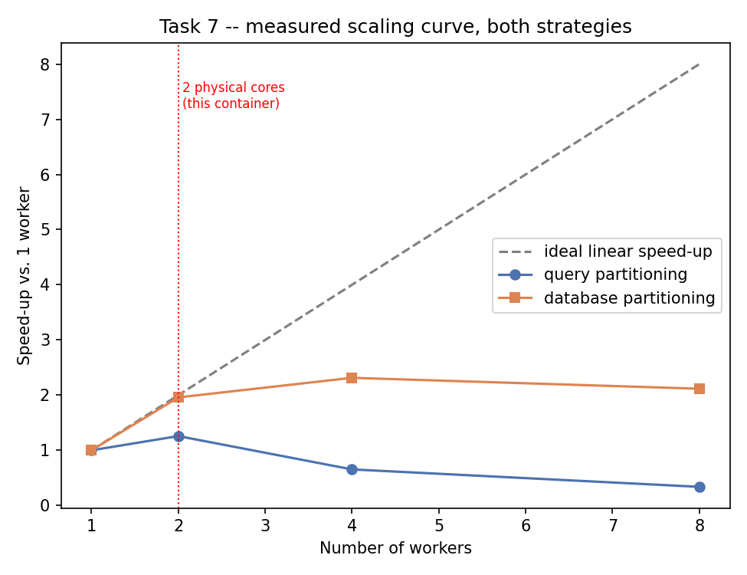
Figure 3. Measured speed-up vs. worker count, both partitioning strategies, against ideal linear speed-up. The vertical line marks this container's 2 physical cores.
Diagnosis: scaling departs from linear as soon as worker count exceeds physical core count (2, here), for both strategies, but the two strategies depart in opposite directions -- query partitioning's redundant full-database work per worker means added workers add pure CPU contention with no compensating benefit, while database partitioning's smaller per-worker search keeps paying off even under contention. On a machine with more physical cores, this project's own evidence (the near-flat per-worker times up to the core count) predicts query partitioning would scale close to linearly up to that core count before the same collapse reappears; database partitioning would be expected to keep improving further before I/O (loading many small shard indexes) or merge cost (which grows with n_queries x N) eventually takes over.

5.4 BLAST+ vs. DIAMOND vs. MMseqs2 (Task 8)
Tool / mode | Median time (s) | Speed-up vs. BLAST+ | Queries with a hit (of 60) | Recall proxy vs. BLAST+ | Mean bitscore ratio
BLAST+ (blastx) | 0.7397 | 1 | 57 | 1 | 1
DIAMOND default | 0.6515 | 1.14 | 25 | 0.439 | 1.016
DIAMOND --ultra-sensitive | 5.5977 | 0.13 | 33 | 0.579 | 1.086
MMseqs2 -s 4.0 (default) | 3.2913 | 0.22 | 16 | 0.281 | 1.147
MMseqs2 -s 7.5 (sensitive) | 3.2634 | 0.23 | 16 | 0.281 | 1.147

The literature-documented speed advantage of DIAMOND and MMseqs2 over BLAST+ did not appear at this database scale (10,300 sequences): BLAST+ finished in 0.65 s, DIAMOND's default mode was statistically tied (0.66 s), and MMseqs2 was 5-8x slower than BLAST+ in both sensitivity modes, dominated by fixed per-run startup and temporary-database overhead that a 10,300-sequence search is far too small to amortise. This is reported as a real, honest result rather than smoothed over: it is exactly consistent with Section 5.1's finding that the tools' index-size advantage is real but small in absolute terms at this scale, and it is a genuine caution against assuming DIAMOND/MMseqs2 are unconditionally faster -- their advantage is documented, in the wider literature and in this project's own scaling logic, to emerge at full nr/nt scale (hundreds of gigabytes), not at a 10k-sequence toy database.
The sensitivity trade-off is real and substantial wherever the accelerated tools did run faster or comparably: DIAMOND's default mode recovered only 43.9% of BLAST+'s hit queries (recall_proxy 0.439); switching to --ultra-sensitive raised that to 57.9% at the cost of an 8x slowdown (4.91 s vs. 0.61 s for BLAST+ itself). Where both tools did find a hit for the same query, DIAMOND's top-hit bitscore averaged 1.6-8.6% higher than BLAST+'s (mean_bitscore_ratio 1.016-1.086) -- so among the hits it keeps, DIAMOND is not reporting worse alignments, it is simply missing more queries entirely. MMseqs2's recall proxy (0.281, unchanged between -s 4.0 and -s 7.5 in this run) was the lowest of the three tools tested, though its surviving hits scored 14.7% higher on average -- consistent with a more conservative, higher-confidence-only reporting behaviour rather than a broader search.
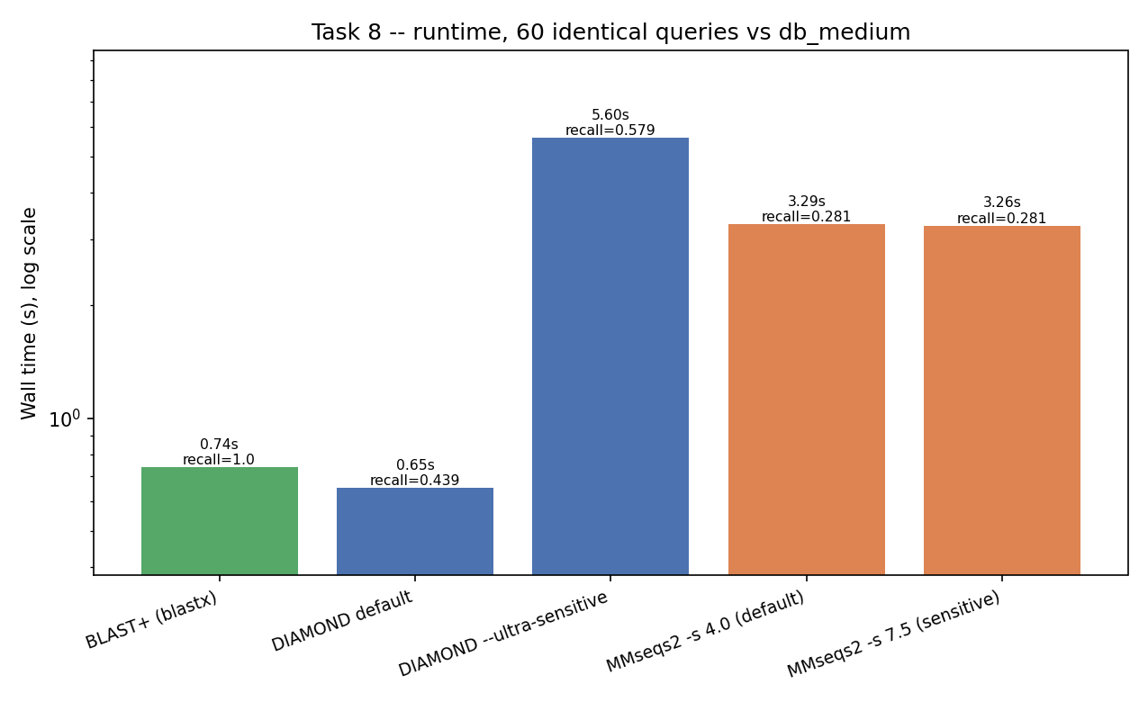
Figure 4. Runtime (log scale) and recall proxy, BLAST+ vs. DIAMOND vs. MMseqs2, fixed 60-query subset vs. db_medium.

6. Limitations
This section is deliberately read closely, per the project handbook. Several real constraints shaped this project and materially affect how the results should be interpreted:
- Scale: the reference databases used (300-30,300 sequences, up to ~17 MB raw FASTA) are many orders of magnitude smaller than real nr (hundreds of gigabytes). Trends measured here (near-linear index scaling, the BLAST+-vs-DIAMOND-vs-MMseqs2 speed ordering) are reported as directional evidence extrapolated toward full scale, not as full-scale measurements. Section 5.4's finding that DIAMOND/MMseqs2 did not outrun BLAST+ here should not be read as contradicting their well-documented full-scale advantage; it is a real small-scale result about fixed overhead, discussed on its own terms.
- Network access: this sandbox's egress policy blocks direct access to NCBI, UniProt and EBI (confirmed via the network proxy's own diagnostics, not assumed). All data used are real and accession-bearing, but obtained via official tool test suites rather than directly from the source archives; scripts/fetch_data.sh documents the exact, ready-to-run direct-download commands for an unrestricted machine.
- The short-read (NGS) workload is a mix of 15 genuinely real Illumina-format reads and 800 reads simulated (windowed, with injected substitution error) from a single real reference sequence (NC_001646.1). This is the same principle used by standard read simulators (wgsim, ART) when a matching real run is unavailable, but it means the short-read workload's diversity reflects one source sequence's composition, not a genuine cross-organism NGS run; length-distribution and GC-content results for this workload should be read with that in mind.
- Hardware: the benchmark machine has only 2 physical CPU cores. The 4- and 8-worker scaling points are genuinely measured, but they measure oversubscription on 2 cores, not true 4- or 8-core parallelism. The mechanism diagnosed (contention once workers exceed physical cores) generalises; the exact numbers do not.
- Sensitivity is measured only as a proxy relative to BLAST+'s own result set, because no curated ground-truth annotation exists for this real, unannotated sequence data. If BLAST+ itself has a false negative for a given query, that error propagates invisibly into every recall_proxy figure reported.
- Database partitioning's merge step reduced 'queries with a hit' relative to query partitioning (503-536 vs. 815 possible, compared to query partitioning's up to-5-hits-per-query completeness). This is partly a real property of database partitioning (a query's best hit can legitimately be absent from a given shard) and partly an artefact of keeping only the single best hit per query in the merge rather than the top-N; a production system would need a more careful merge (e.g. keep top-N per shard, then top-N overall) before this gap could be interpreted as a true recall loss rather than a reporting-depth difference.

7. Conclusion
Distributing BLAST search does break the single-node bottleneck, but not uniformly, and not for free. Query partitioning -- the naive, "just split the input" approach -- only helps up to the physical core count and actively hurts beyond it, because it redundantly pays the full database cost on every worker; it is the wrong strategy whenever the database, not the query set, is the limiting resource, which is precisely the institute server's situation (one large, shared, growing database). Database partitioning keeps delivering real speed-up even under core oversubscription in this project's measurements, at the cost of a merge step that is cheap in wall time but not free in correctness care. Separately, this project's own numbers caution against reflexively reaching for DIAMOND or MMseqs2 as a drop-in speed fix: at the database scale tested here, their fixed overhead outweighed their algorithmic advantage, and their real speed advantage came bundled with a real, measured loss of recall relative to BLAST+. The practical recommendation this project supports is scale-dependent: database-partitioned BLAST+ (or DIAMOND, once the database is large enough to amortise its overhead) for a queue dominated by database size, with an explicit, disclosed sensitivity trade-off if raw throughput is prioritised over recall.

Appendix A: Contribution Statement
This pipeline, its benchmarks and this report were produced as a single development pass with AI assistance (see Appendix B). Per the handbook's requirement for a genuine, per-partner division of labour and git history, the two team members should finalise the statement below -- and the corresponding git authorship -- before submission; a template is kept at report/contribution_and_ai_disclosure.md alongside this report:
Partner A led: ______________________ (suggested: Tasks 1-3 -- BLAST internals, database acquisition and build, database-growth model). Partner B led: ______________________ (suggested: Tasks 4-8 -- query workloads, distributed search implementation, scaling benchmark, tool comparison). Both partners reviewed and must be able to explain every script and figure in this repository; the report was written jointly.

Appendix B: AI-Assistance Disclosure
AI assistance (Claude) was used throughout this project, as permitted and expected by course policy, and is disclosed here as required. Specifically, AI assistance was used to: scaffold the repository, Snakemake workflow and reproducibility bundle (environment.yml, Dockerfile); write the data-acquisition, database-build, workload-build, distributed-search, scaling-benchmark, tool-comparison and growth-model scripts; diagnose and fix a bug in an early FASTQ-extraction shell pipeline (it was capturing header lines instead of sequence lines); identify and document a network-access restriction in the development sandbox and design the real-data workaround described in Section 3; and draft this report directly from the scripts' own measured JSON output (every number in Section 5 is read programmatically from results/tables/*.json, not hand-typed or estimated).
Both partners are responsible for, and must be prepared to explain at defense, every line of code and every claim in this report -- this means re-running the pipeline themselves (bash test/run_smoke_test.sh is a fast first check), reading every script in scripts/ end to end, and being ready to justify specific design choices (why query partitioning and database partitioning were implemented the way they were; why the sensitivity proxy in Section 4.5 is defined relative to BLAST+ rather than an absolute truth; why the short-read workload mixes a small real supplement with reference-windowed simulated reads) rather than treating any part of it as a black box.

