Employee Management System

Project Title: Build a Employee Management system with Spring Boot, HTML, CSS and JS or Thymeleaf Framework.

How to create spring boot project-

1. To create the project application, follow the path follow given below:

File > New > Project> Spring Boot>Spring Starter Project

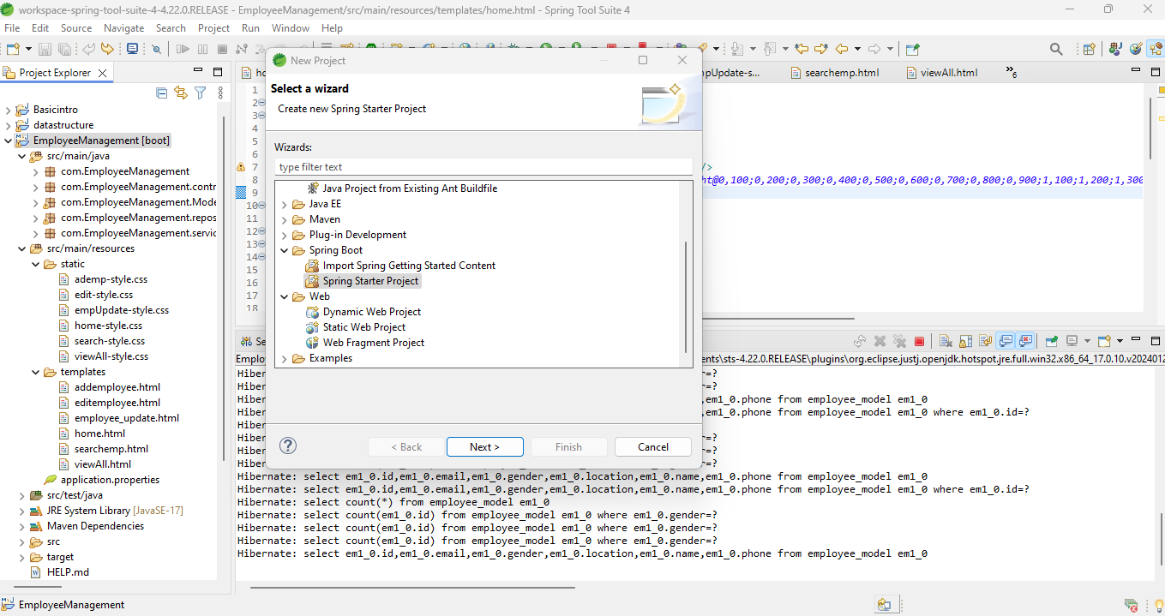

1. Adding required dependencies for the project:

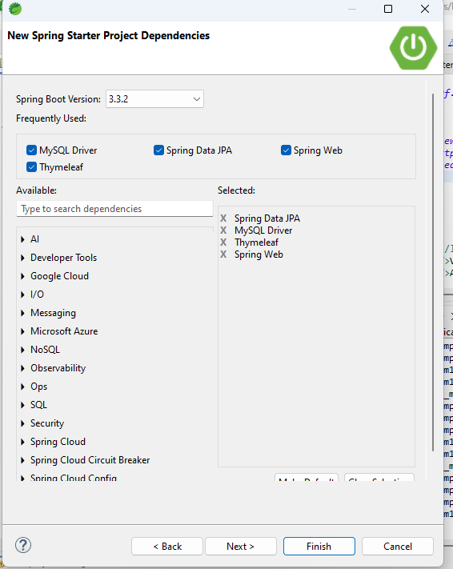

1. “EmployeeManagement” Spring boot project is created.

src/main/java – In this path all Back-End related files are there like:

* Controller
* Model
* Repository
* Service files

src/main/resources/static – In this path all CSS related files are there.

src/main/resources/templates – In this path all Front-End related files are there

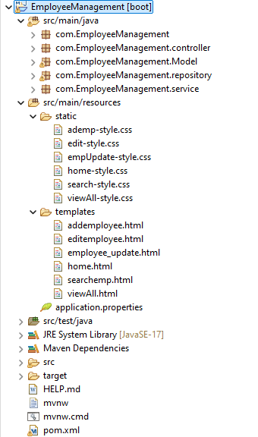

1. Database connection and server port related data will be there in src/main/resources/application.properties file

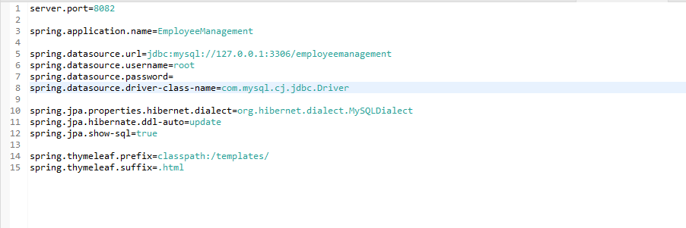

1. This is Xml file has the All Dependency of the project.

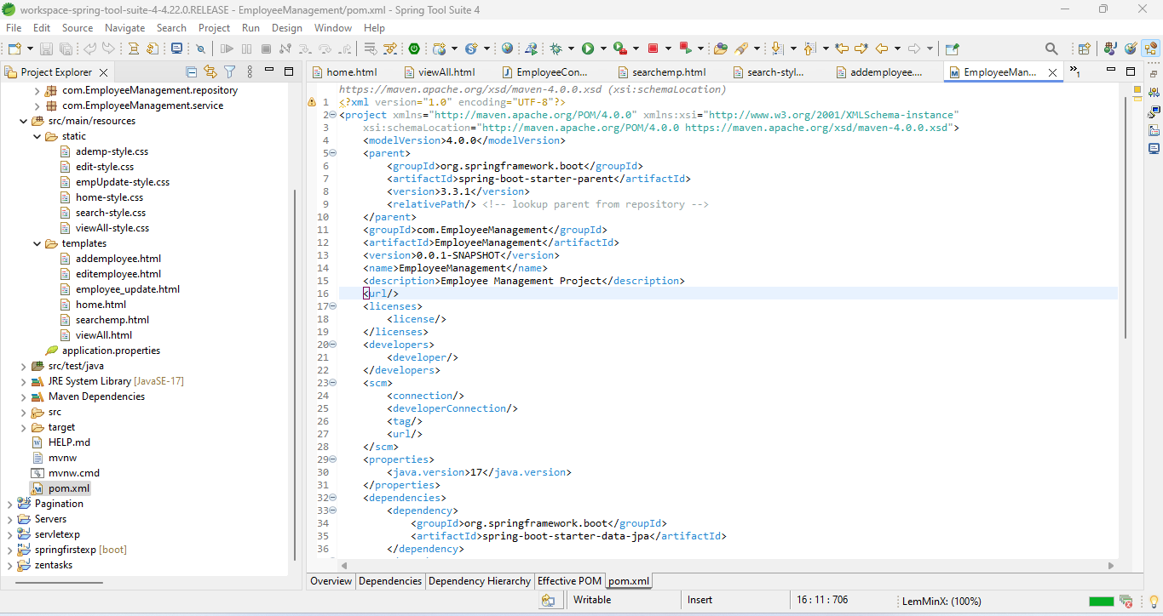

How to Run-

Follow the below path:

EmployeeManagement >Right click>Run As >Spring boot app

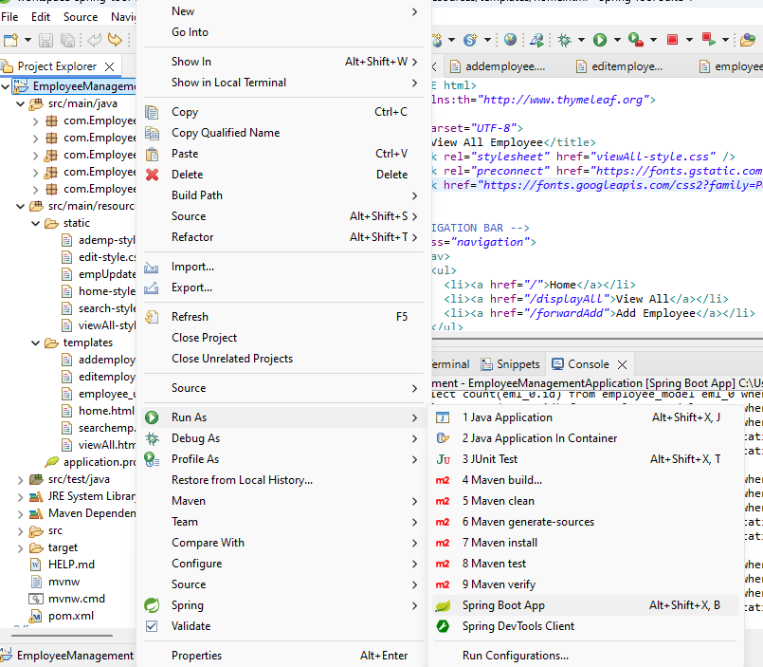

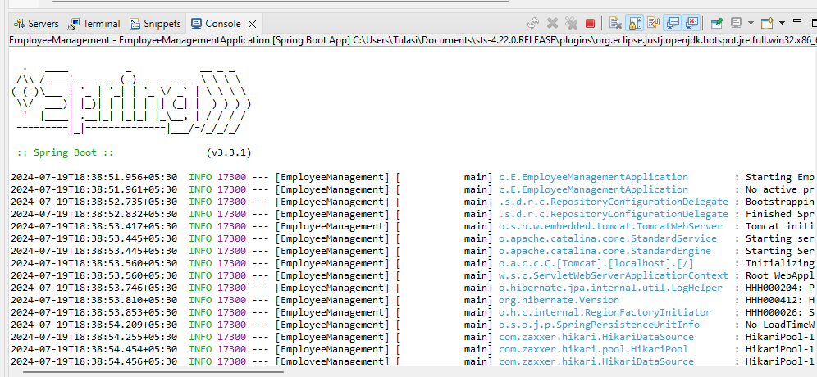

Enter the localhost:8082 in the brower.

1. Home Page

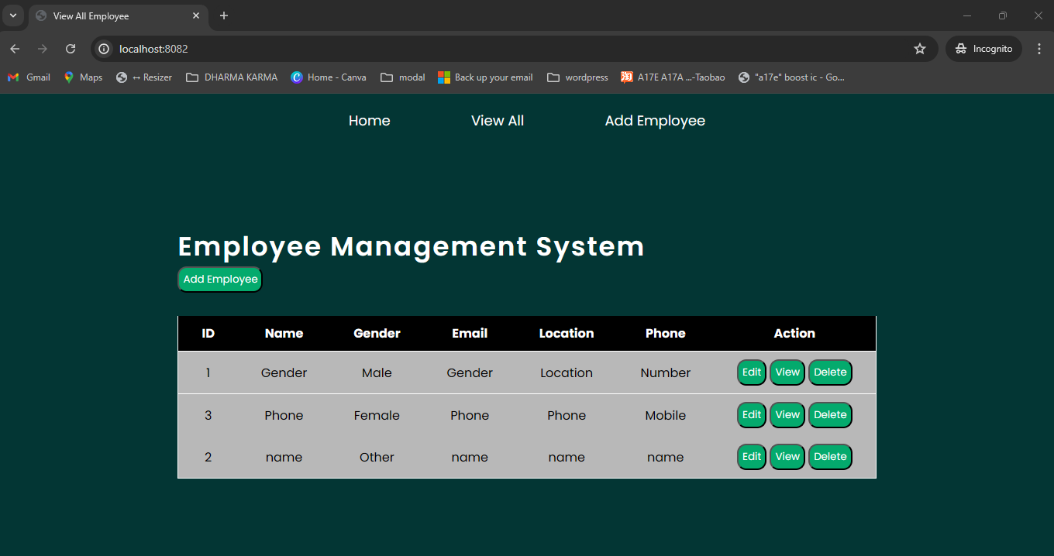

1. Add Employee Page

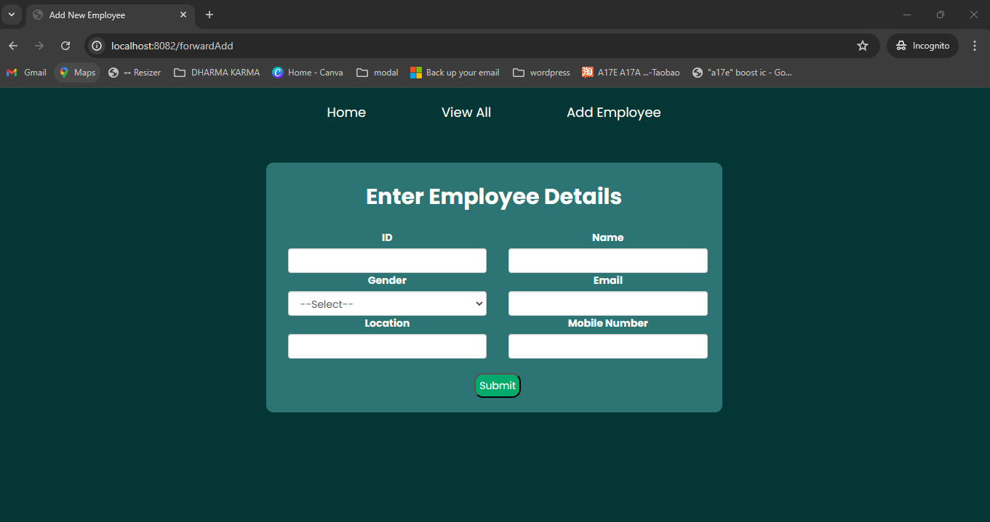

1. Edit Employee Page

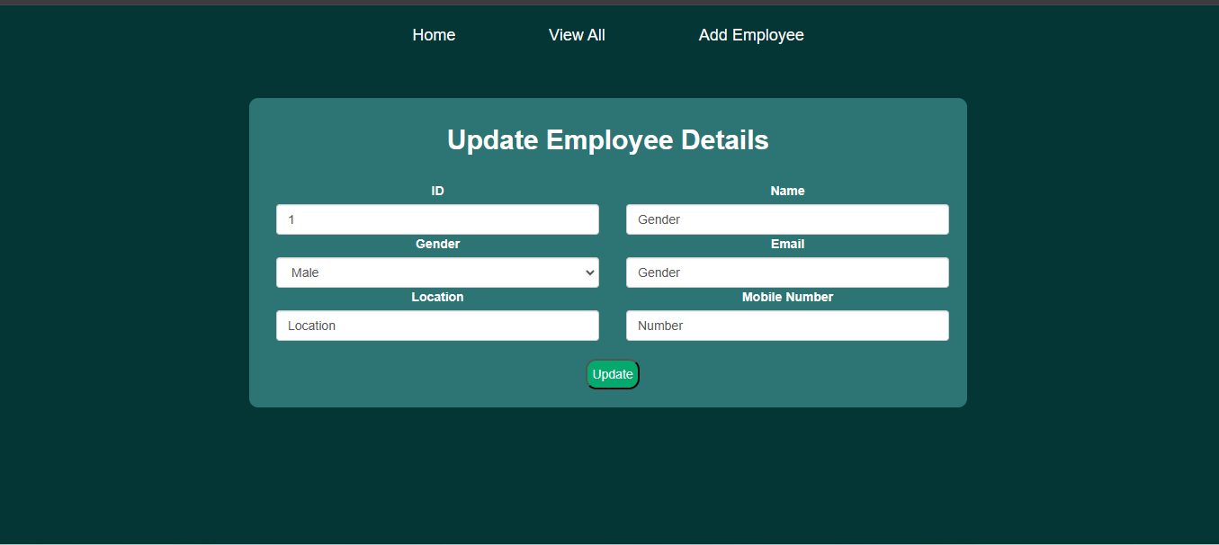

1. View Employee page

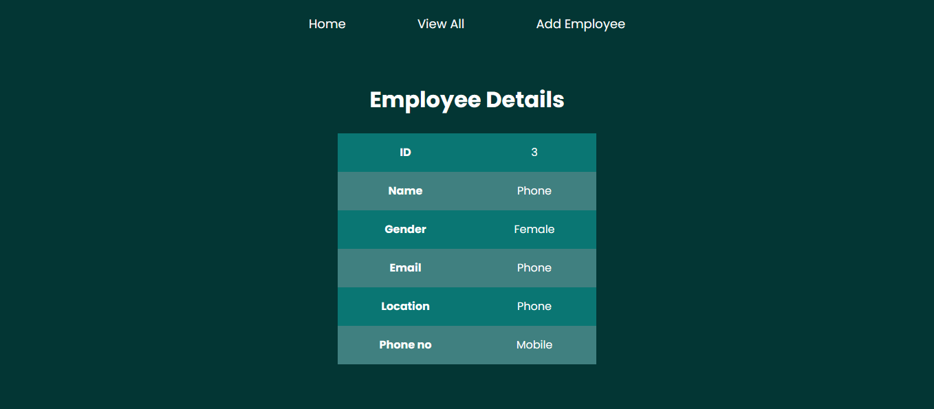

1. All Employees List Page

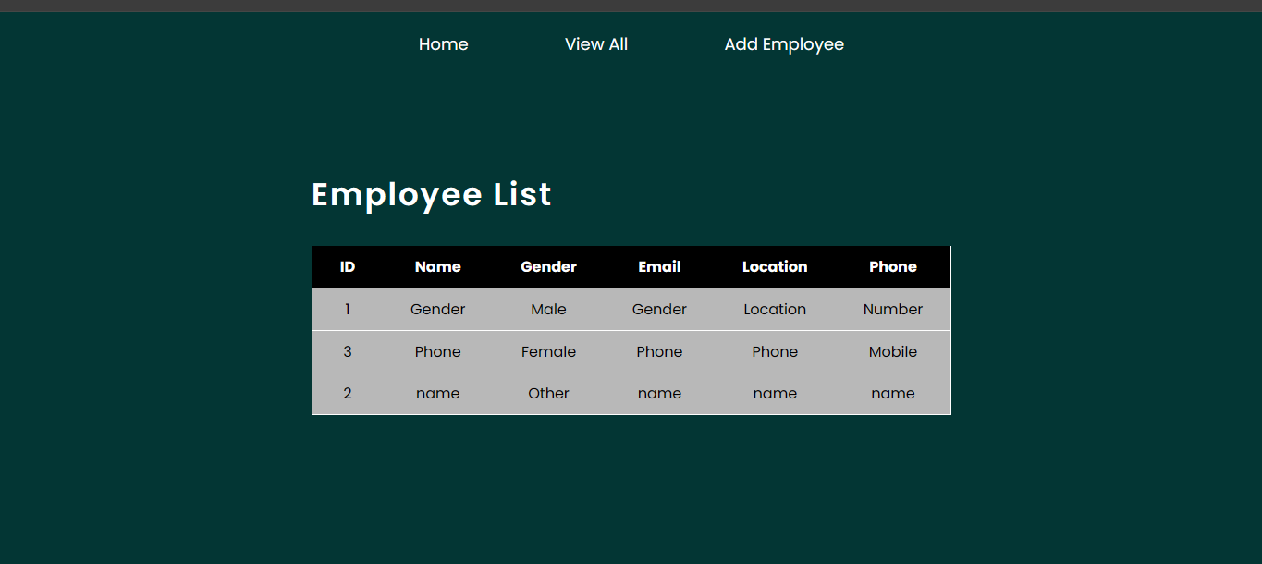

Employeemanagement table in MYSQL:

