Patient Medicine & Appointment System

Project Title: Build a Patient medicine and Appointment system App with Spring Boot, HTML, CSS and JS or Thymeleaf Framework.

How to create spring boot project-

1. To create the project application, follow the path follow given below:

File > New > Project> Spring Boot>Spring Starter Project

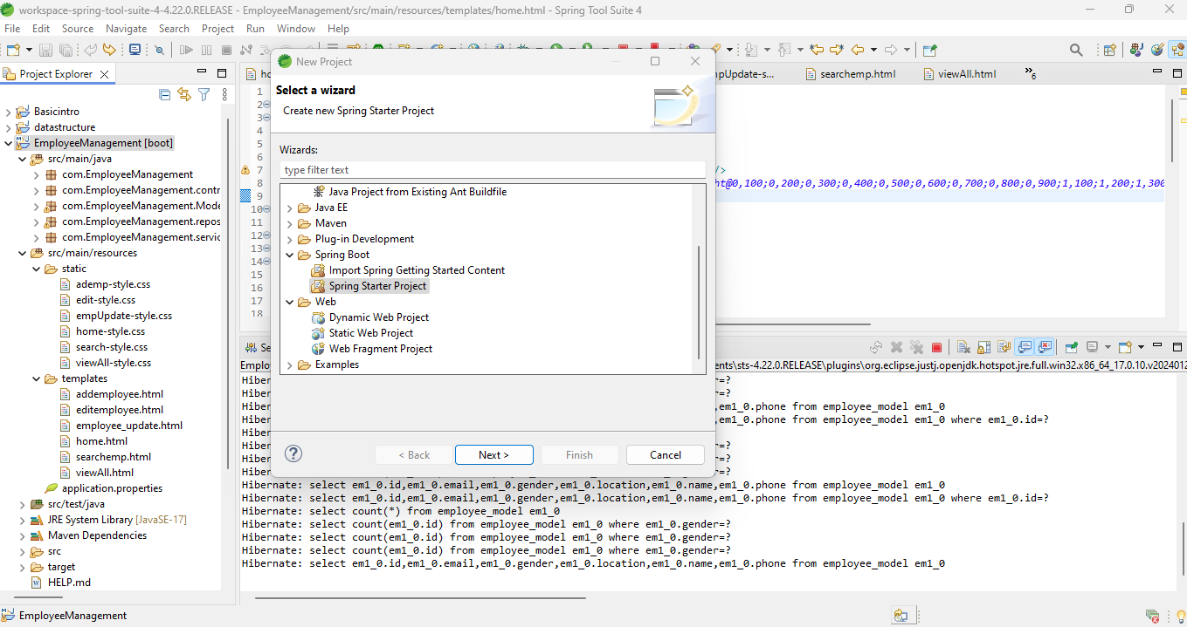

1. Adding required dependencies for the project:

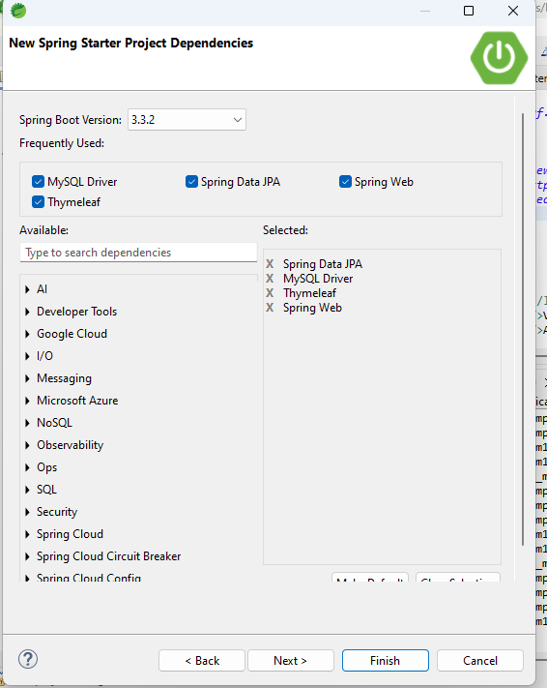

1. “MedicalSystem” Spring boot project is created.

src/main/java – In this path all Back-End related files are there like:

* Controller
* Model
* Repository
* Service files

src/main/resources/static – In this path all CSS related files are there.

src/main/resources/templates – In this path all Front-End related files are there

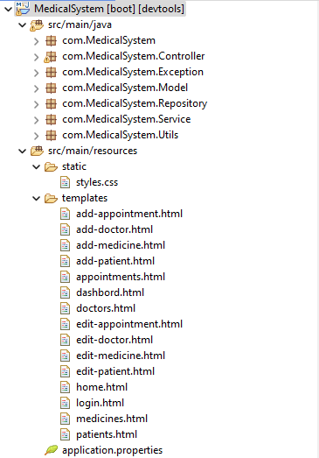

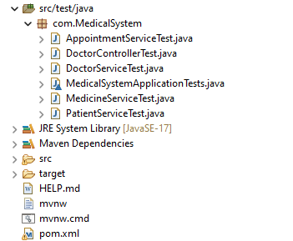

1. Database connection and server port related data will be there in src/main/resources/application.properties file

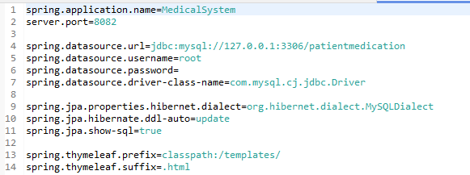

1. This is Xml file has the All Dependency of the project.

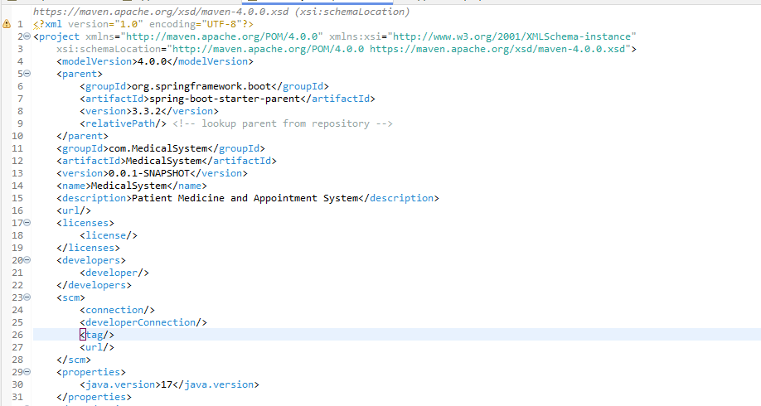

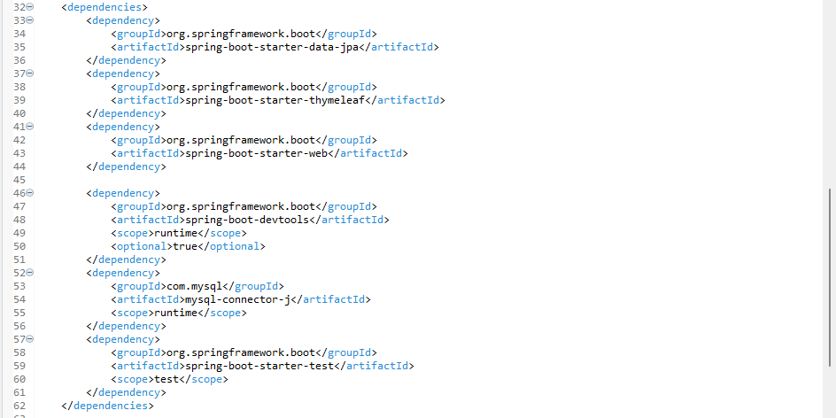

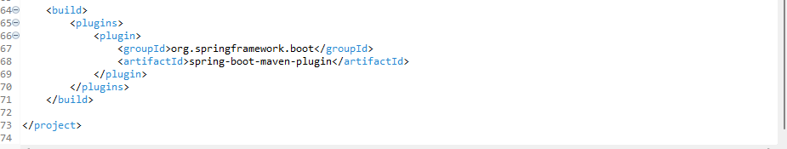

1. Test cases data will be there in src/test/java file:

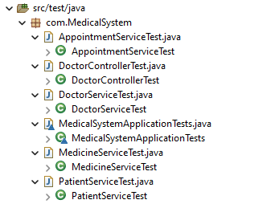

1. Javascript Validation for Register form:

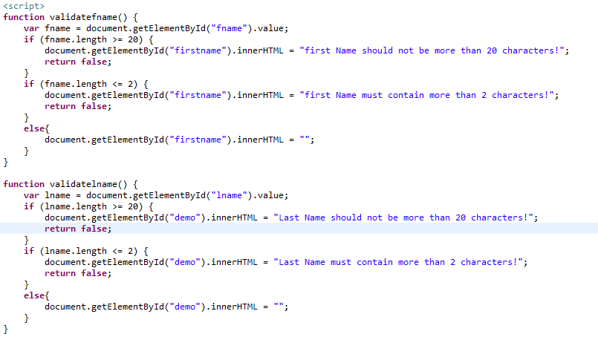

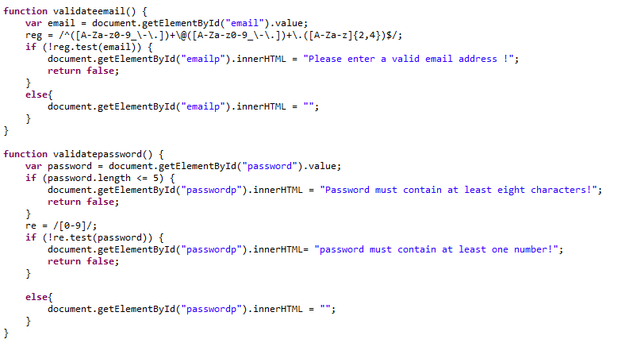

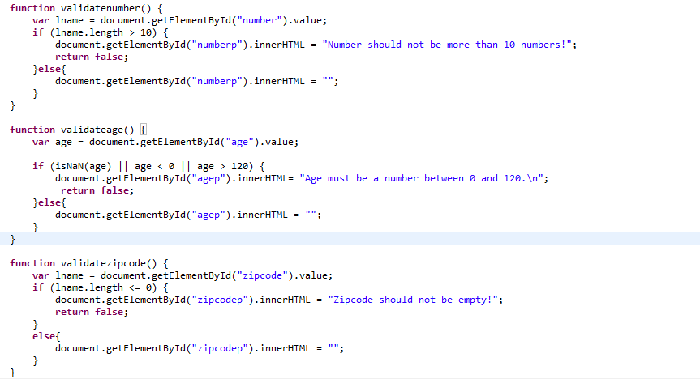

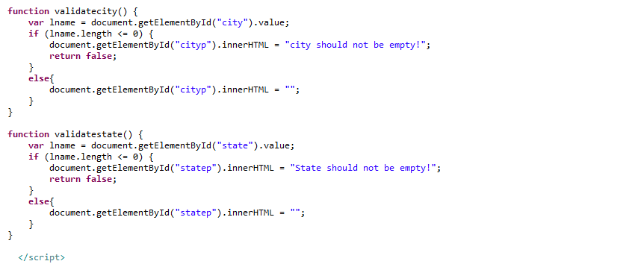

How to Run- Follow the below path:

MedicalSystem >Right click>Run As >Spring boot app

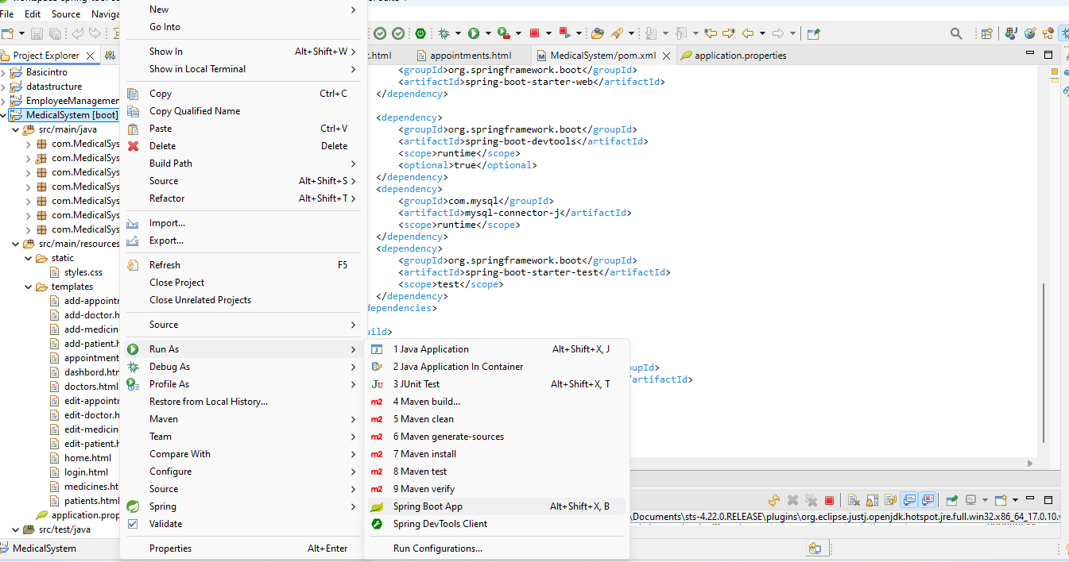

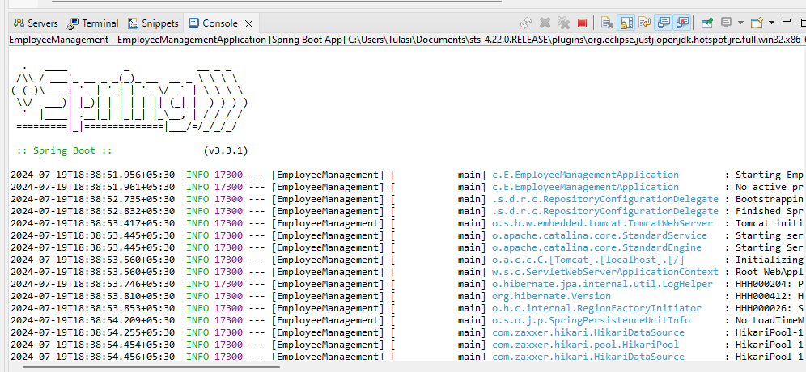

Enter the localhost:8082 in the brower.

1. Home Page

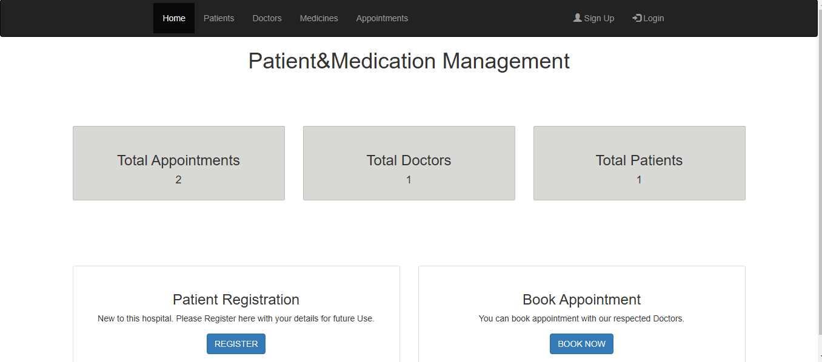

1. Register Page

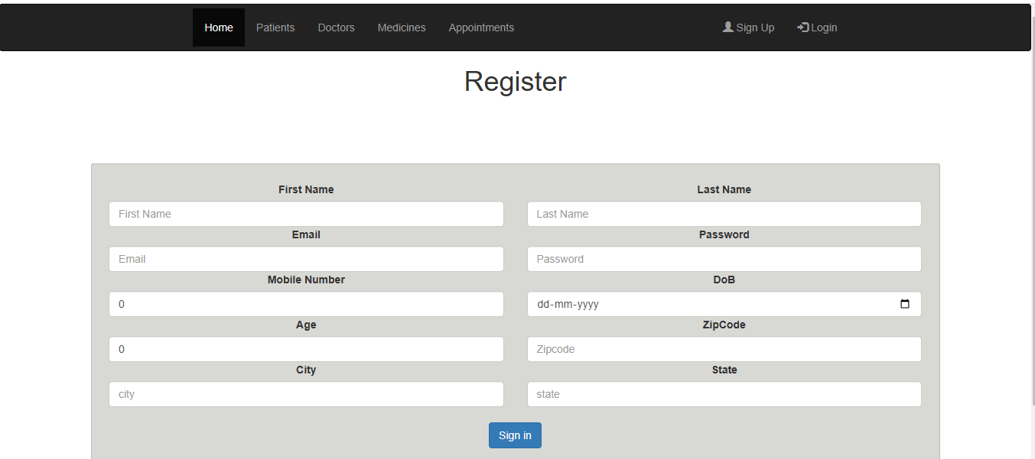

1. Login Page

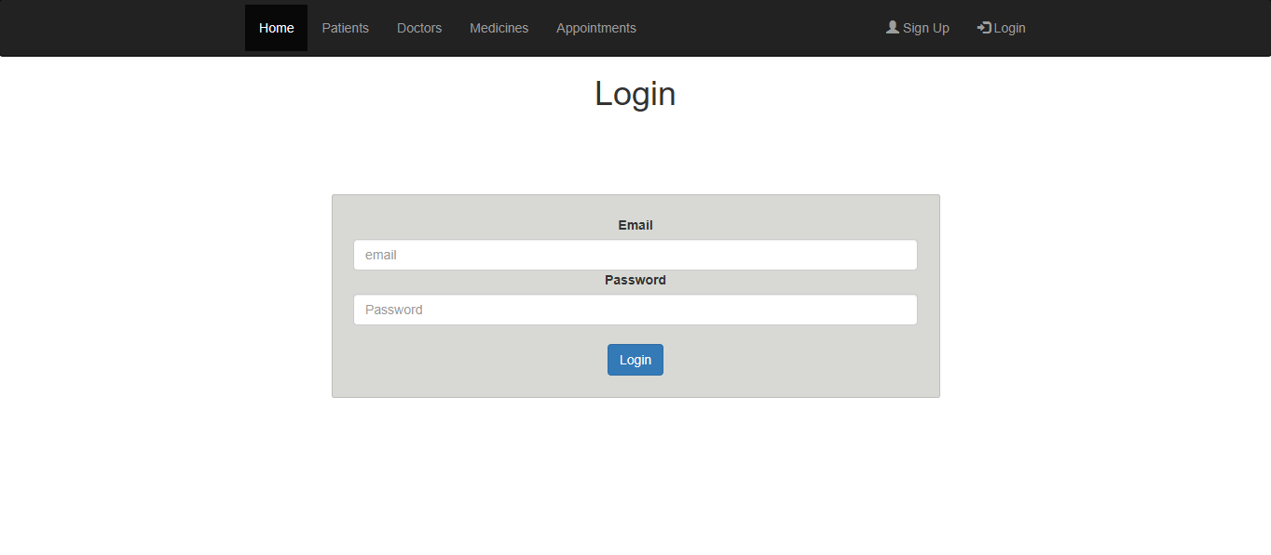

1. After Login

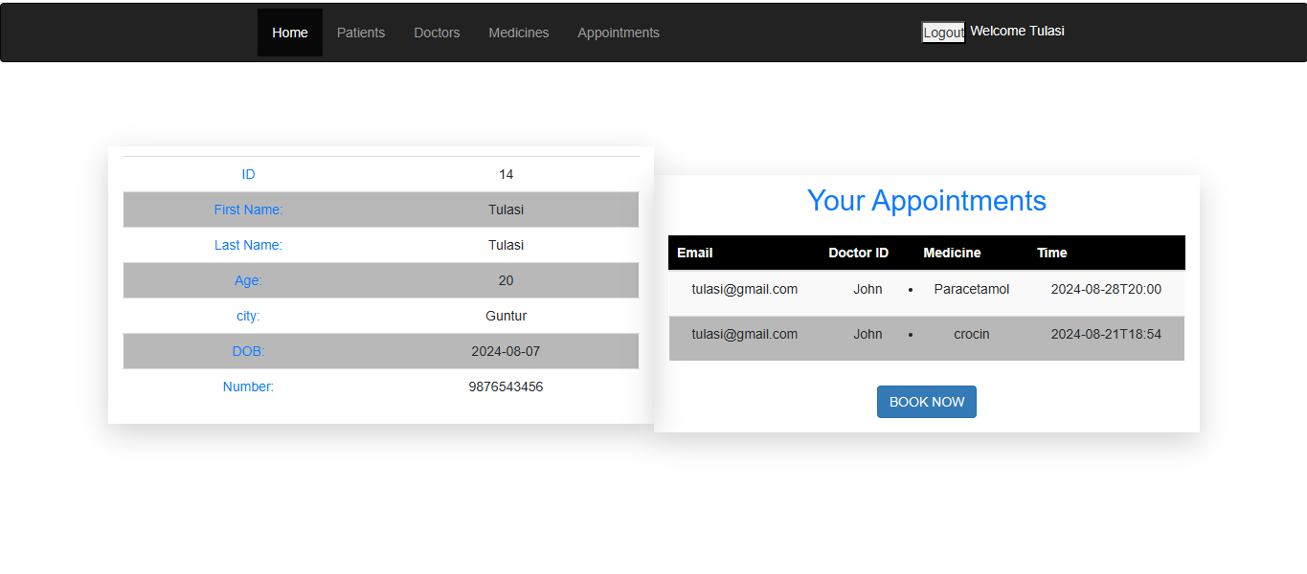

1. Add Appointment Page

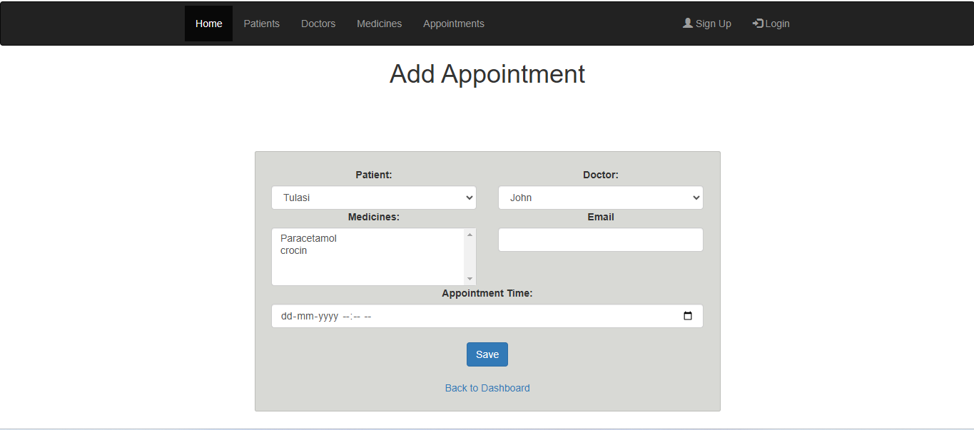

1. Add Doctor Page

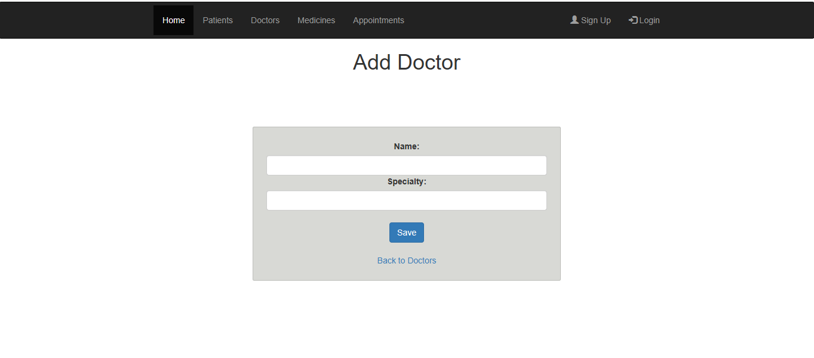

1. Edit Doctor Page

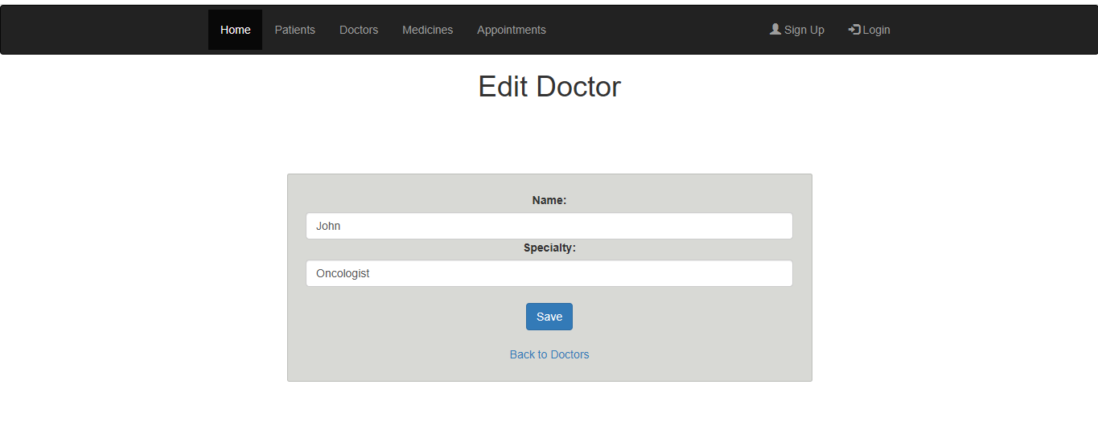

1. All Doctors list page

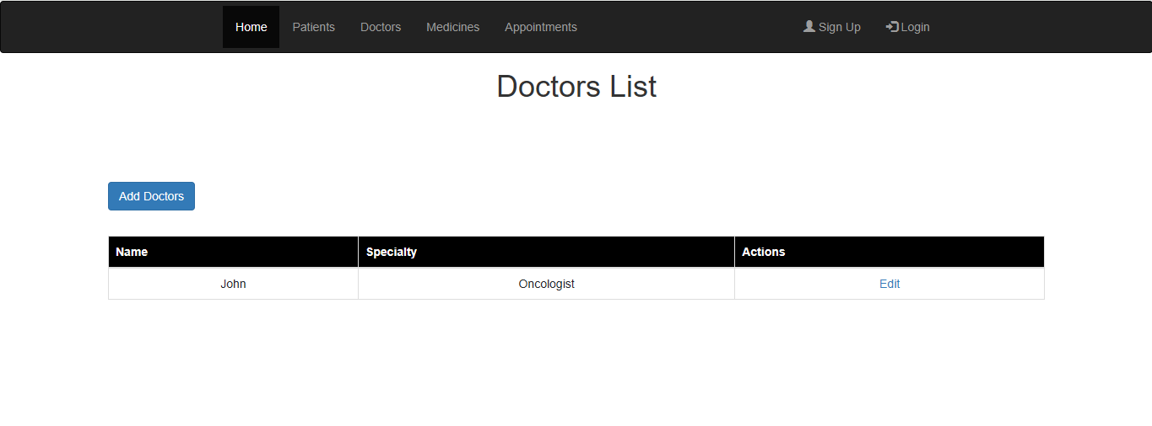

1. Add Medicine Page

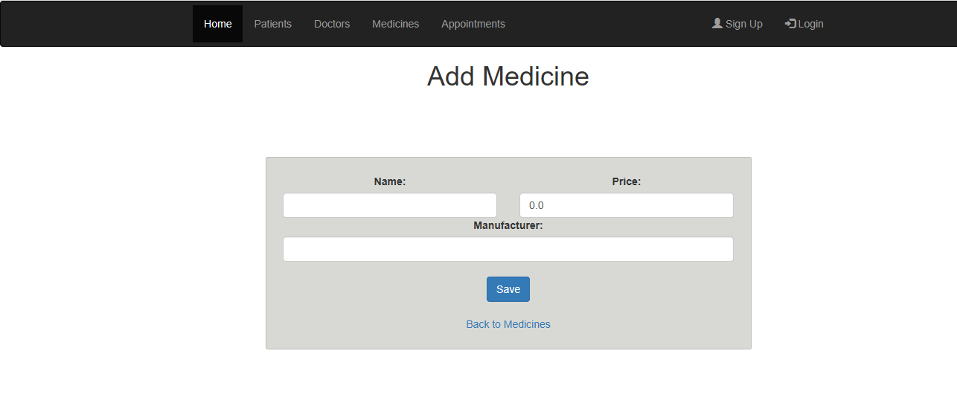

1. Edit Medicine Page

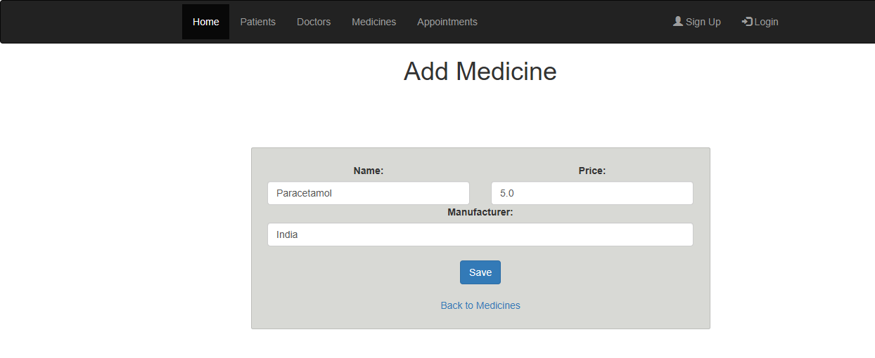

1. All Medicine List page

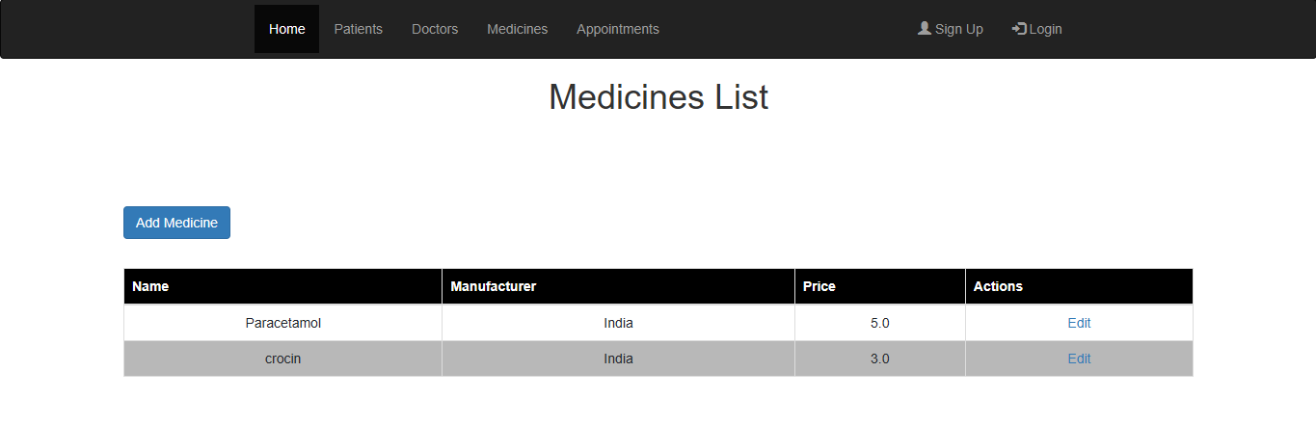

1. All Patients List Page

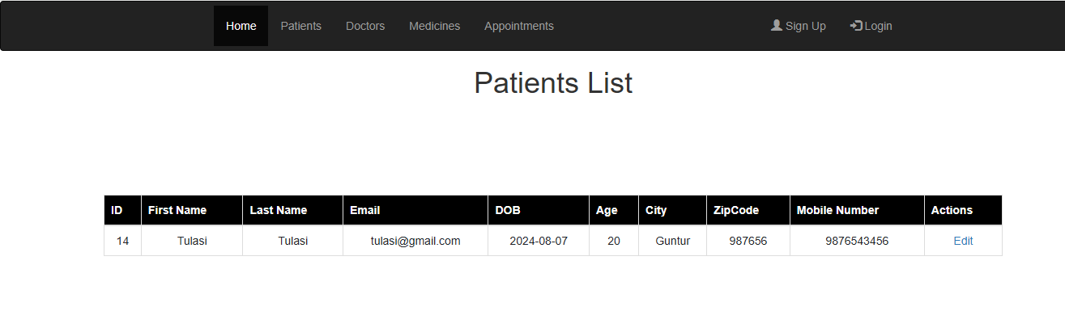

1. All Appointments List Page

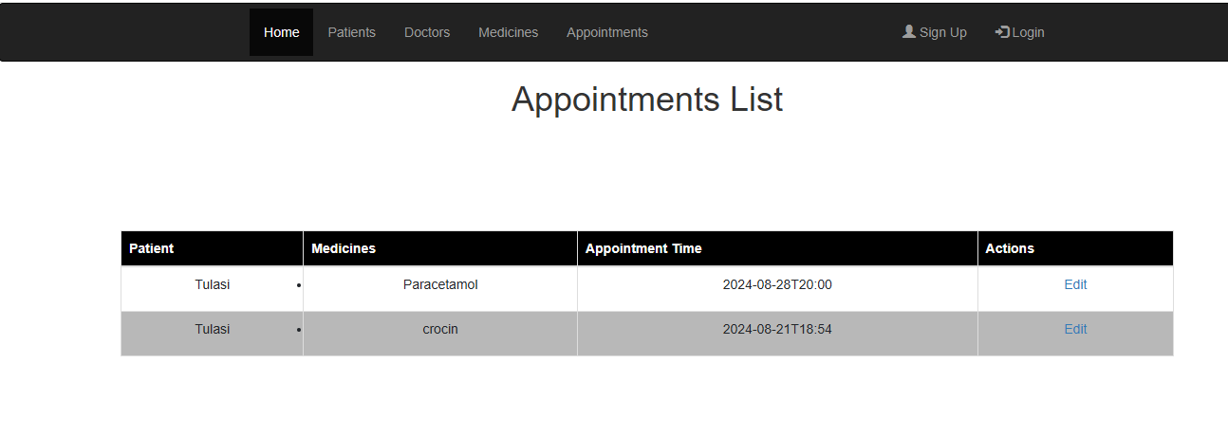

Patientmedication table in MYSQL:

Patient Table:

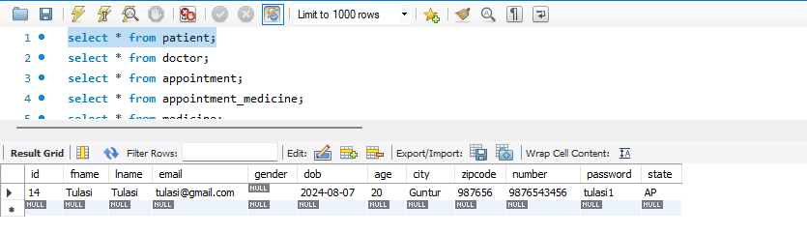

Doctor Table:

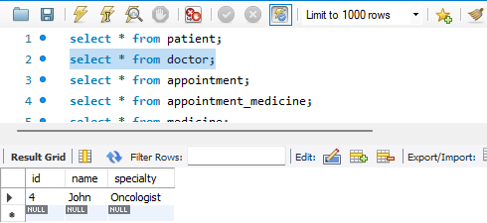

Appointments Table:

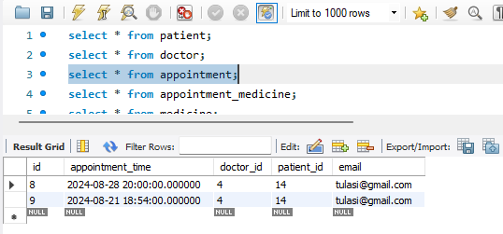

Appointment Medicine Table:

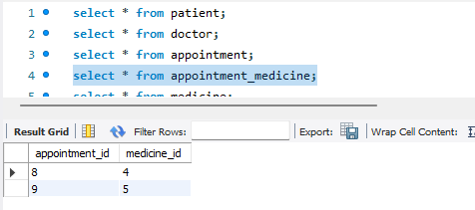

Medicine Table:

