Task-9

1. Find all the information about each products.

Ans. db.product.find();

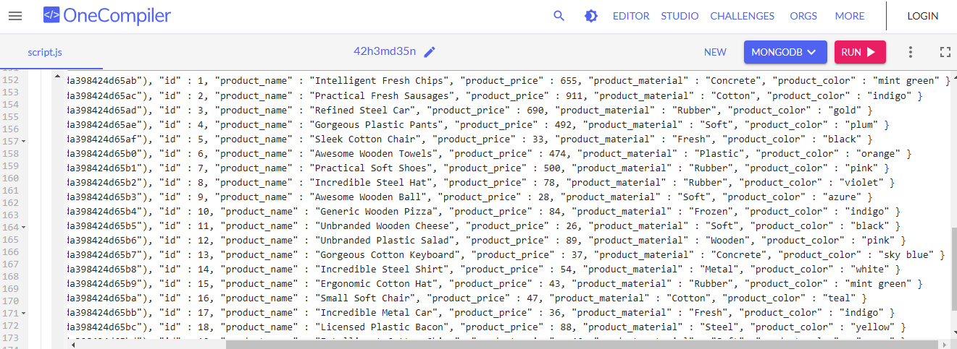

1. Find the product price which are between 400 to 800.

Ans. db.product.find({ product_price : { $gt : 400, $lt : 800}});

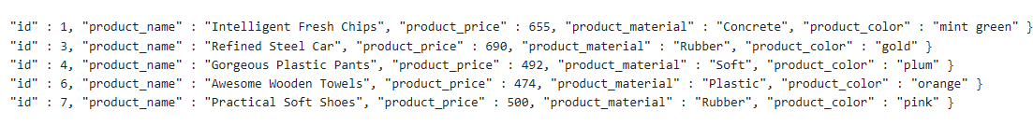

1. Find the product price which are not between 400 to 600.

Ans: db.product.find({$or:[{product_price:{$lt:400}},{product_price:{$gt:600}}]});

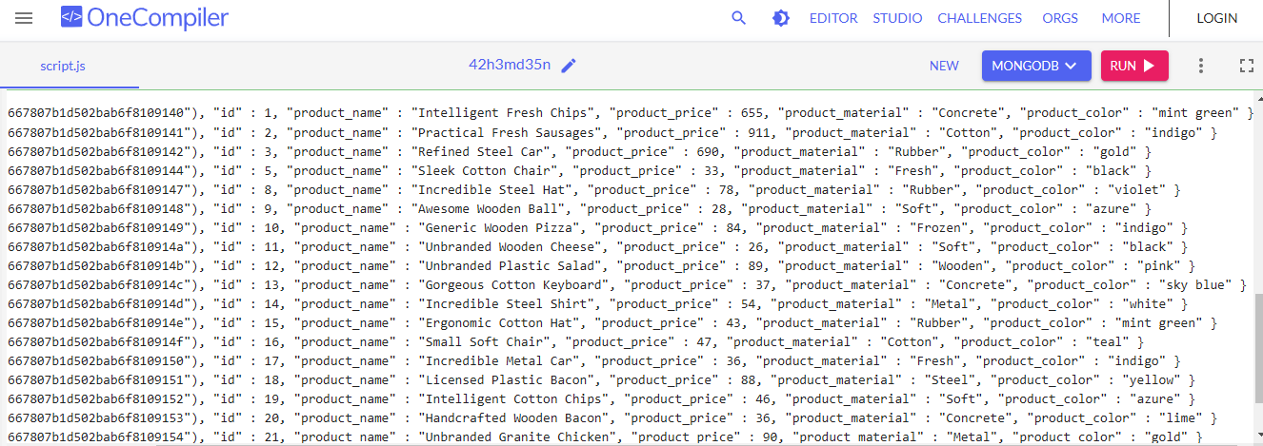

1. List the four product which are greater than 500 in price.

Ans: db.product.find({ product_price : { $gt : 500}});



1. Find the product name and product material of each products.

Ans: db.product.find({},{product_name:1,product_material:1});

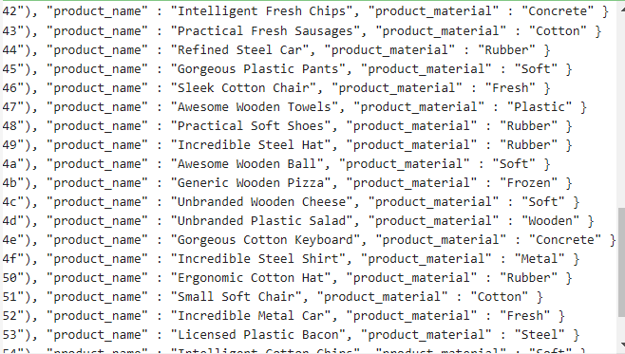

1. Find the product with a row id of 10.

Ans: db.product.find({id:10});



1. Find only the product name and product material.

Ans: db.product.find({},{product_name:1,product_material:1});



1. Find all products which contain the value of soft in product material.

Ans: db.product.find({product_material:"Soft"});



1. Find products which contain product colour indigo and product price 492.00.

Ans: db.product.find({product_color:"indigo",product_price:492.00});

1. Delete the products which product price value are 28.

Ans: db.products.deleteMany({ product_price: 28 });