SWARNANDHRA COLLEGE OF ENGINEERING AND TECHNOLOGY

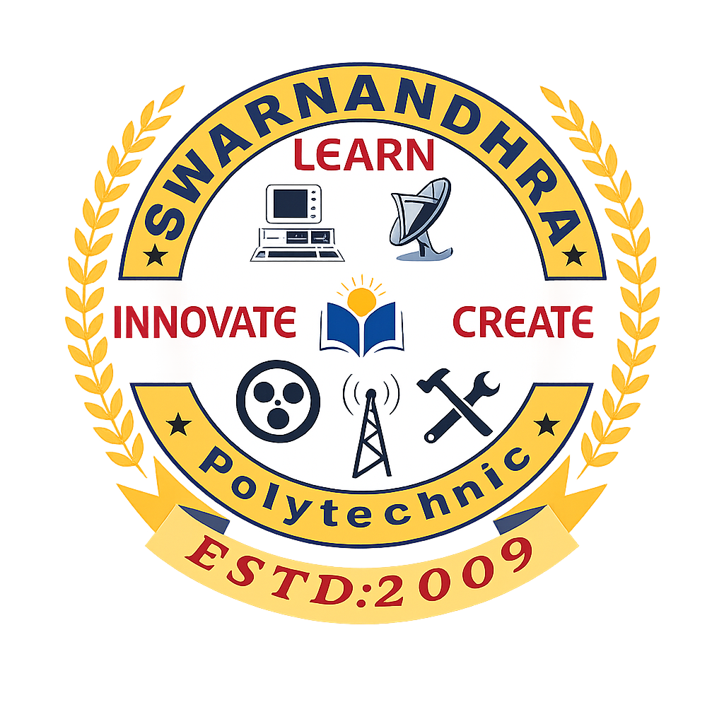
SWARNANDHRA POLYTECHNIC COLLEGE
SEETHARAMAPURAM, NARSAPUR-534280, W.G.Dist.,
DEPARTMENT OF COMPUTER SCIENCE AND ENGINEERING
State Board of Technical Education & Training, Andhra Pradesh

TEACHING PLAN

Name of the Faculty Member | : | Ms. T. Tulasi Aparna
Subject Name | : | Computer & Digital Skills Lab
Class &Branch | : | I Year CSE
Department | : | Computer Science and Engineering
With effect from | : | 8-06-2026
Last Working Day | : | --
Allocated Periods | : | 3 periods per week (30 weeks)
Total no. of Periods planned | : | 90

I. Computer Hardware and Software Basics
1 | - To get familiarized with Computer system and hardware connections.  - To start and Shut down Computer correctly.  - To explore Windows Desktop. | 3
2 | To check the software details of the computer. | 3
3 | To check the hardware present in your computer.
II. Windows’s operating system
4 | To work with Files and Folders. | 3
5 | To use Windows Accessories: Calculator – Notepad – WordPad – MS Paint.
III. MS-WORD
6 | To get familiarized with Ribbon layout of MS Word. | 3
7 | To perform basic word processing.
8 | To use basic formatting techniques. | 3
9 | To insert a table of required number of rows and columns. | 3
10 | To insert Objects, Clipart and Hyperlinks.
11 | To use Mail Merge feature of MS Word. | 3
12 | To use Equations and symbols features.
IV. MS-EXCEL
13 | To get familiarized with MS-EXCEL ribbon layout. | 6
14 | To access and enter data in the cells.
15 | To edit a spread sheet- Copy, Cut, Paste, and selecting Cells. | 3
16 | To use built in functions and Data Formatting.
17 | To create Excel Functions, use autofill feature. | 3
18 | To enter a Formula for automatic calculations. | 3
19 | To sort and filter data in sheet. | 3
20 | To present data using Excel Graphs and Charts.
21 | To format a Worksheet in Excel for printing using Page layout. | 3
22 | To develop lab report formats of respective discipline.
V. Practice with MS-POWERPOINT
23 | To get familiarized with Ribbon layout features of PowerPoint. | 3
24 | To create a simple PowerPoint Presentation.
25 | To set up a Master Slide in PowerPoint. | 6
26 | To insert Text and Objects.
27 | To insert Flow Charts. | 3
28 | To insert Tables.
29 | To insert Charts/Graphs. | 3
30 | To insert video, audio & hyperlinks.
31 | To animate text, objects and slides. | 3
32 | To Review Presentations.
VI. AI, ML & Quantum Computing Tools
33 | To get familiarized with AI Tools. | 3
34 | To get familiarized with working of ChatGPT.
35 | Identify Objects using AI Tools based on CNN, YOLO, SSD, R-CNN. | 6
36 | To paraphrase text using AI Tools (PEGASUS, GPT, T5).
37 | To use text-to-Image Generation AI Tools (DALL-E, MIDJOURNEY). | 6
38 | To use voice command simulation AI Tools (SPEECH-TO-TEXT).
39 | To get familiarized with ML Tools. | 6
40 | To get familiarized with Quantum Computing Tools.
41 | To familiarize with quantum bits (qubits) using Dirac notation. | 6
42 | To familiarize the behavior of single and multiple qubit gates.
43 | To familiarize with Qubit as a Coin / Spin Analogy. | 3
 | TOTAL | 90

Prepared By Verified By Approved By

