STRATEGIC AI PLANNING
AND ROADMAP DEVELOPMENT
AI-Powered Logistics Intelligence & Delivery Prediction System
Week 1 Internship Assignment

Executive Summary
This report proposes a practical AI strategy for a logistics intelligence solution that predicts whether shipments are likely to arrive late and helps operations teams prioritize intervention. The first version uses structured shipment data, a supervised machine-learning model and an interactive dashboard. A Random Forest classifier is proposed as a candidate model, not assumed to be the best model before testing. The system is intended as human-in-the-loop decision support: staff remain responsible for operational actions.
The 2026 Stanford AI Index reports that 88% of surveyed organizations used AI in at least one business function in 2025, and 70% used generative AI in at least one business function [1]. Logistics research also emphasizes that useful delay prediction requires practical data combinations, suitable prediction timing and decision-support workflows—not simply a high model score [2]. The recommended roadmap is staged: foundation, prototype, validation, pilot and scale.
If the internship prototype uses synthetic or public sample data, all results must be labelled as demonstration results. They must not be represented as evidence of real carrier performance or production readiness.

1. Introduction

1.1 Background and business context
Logistics operations coordinate orders, warehouses, carriers, vehicles, routes and customer delivery expectations. Delays can increase handling costs, reduce customer satisfaction and cause service-level failures. Conventional tracking systems report current shipment status; predictive analytics adds an estimate of future delay risk so that teams can prioritize exceptions earlier.

1.2 Project purpose and scope
The proposed application will analyze shipment attributes, estimate the likelihood of delay, identify high-risk shipments and summarize patterns in an interactive Streamlit dashboard. Its initial scope includes data ingestion from CSV, data validation, exploratory data analysis, feature engineering, model training, evaluation and visual reporting. Autonomous dispatch, live carrier integrations and automated customer notifications are outside the first prototype.

1.3 Proposed technology
- Python for application logic; Pandas and NumPy for data processing.
- Scikit-learn for preprocessing, baseline models and Random Forest.
- Streamlit and Plotly for interactive analytics.
- GitHub for version control, documentation and reproducibility.
Potential data fields include shipment origin and destination, dispatch timestamp, promised delivery window, distance, carrier, service level, package characteristics, previous transit duration and available weather or route indicators. These are candidate fields; actual availability and permissions must be confirmed.

2. Current AI Market and Technology Analysis

2.1 Enterprise adoption
AI is increasingly being embedded in business workflows. Stanford HAI's 2026 AI Index reports 88% organizational AI adoption in 2025 and generative AI use in at least one business function at 70% of surveyed organizations [1]. These are broad cross-industry indicators. They do not mean that 88% of logistics firms use delivery prediction, nor do they prove that all deployments create positive returns.
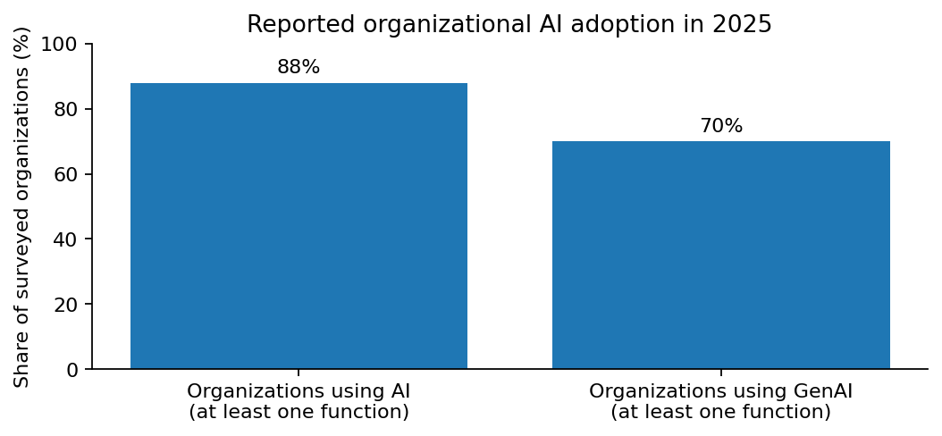
Figure 1. Stanford HAI-reported organizational AI adoption measures for 2025; not logistics-specific adoption rates.

2.2 Relevant logistics applications
Application | AI capability | Potential value
Delivery-delay prediction | Classification or regression | Flag shipments likely to miss delivery windows
Demand forecasting | Time-series forecasting and ML | Improve capacity and staffing plans
Inventory planning | Forecasting and optimization | Reduce stockouts and excess inventory
Route and fleet planning | Optimization and predictive models | Support route and vehicle utilization decisions
Exception monitoring | Anomaly detection and risk scoring | Prioritize unusual shipments and disruptions
Operations knowledge support | Generative AI over approved documents | Summarize exceptions and retrieve procedures

2.3 Research findings
A 2025 review of delivery-delay prediction finds that machine learning offers potential, but much research focuses on on-time/late classification rather than predicting delay magnitude. It also identifies the value of combining enterprise resource planning information with logistics data and notes that environmental and location features are often underused [2]. This supports starting with a classifier while planning a later delay-duration model and carefully governed contextual data.
A 2024 systematic review of empirical AI research in supply chain management warns against assuming that AI is automatically transformative and emphasizes connecting AI methods with established supply-chain processes [3]. A 2025 systematic review of machine learning in supply chains maps applications across supply-chain activities and supports examining forecasting, planning and distribution use cases [4]. The strategic implication is to define the business decision and data conditions before choosing a complex model.

2.4 Data landscape
Potential sources include transportation management systems, warehouse systems, order management systems, carrier tracking feeds, GPS/telematics, weather services and holiday calendars. Each source has different ownership, refresh frequency, quality and privacy requirements. A public Kaggle distribution-time dataset describes delivery records with timestamps, vehicle type, package count, geography and weather fields [5]. Dataset access terms must be checked, and a public dataset must not be assumed to represent the target company's operations or geography.

3. Strategic Project Formulation

3.1 Vision and mission
Vision: enable logistics teams to anticipate delivery exceptions and make earlier, better-informed decisions. Mission: build a transparent, reliable and maintainable predictive decision-support system that turns shipment data into actionable risk signals.

3.2 Strategic objectives
Objective | Proposed measure | Reason
Data readiness | Data dictionary, missingness, duplicates and label-quality review | Trustworthy inputs are essential
Predictive usefulness | Compare baseline and Random Forest with suitable validation | Avoid unsupported performance claims
Risk detection | Recall, precision, F1 and PR-AUC for delayed class | False negatives and false alarms have different costs
Decision support | Dashboard displays risk, shipment details and limitations | Predictions must be actionable
Responsible use | Human review, access control, monitoring and documentation | Reduce unsafe automation and unmanaged data use

3.3 Proposed architecture
The system will ingest shipment records from CSV initially, validate schemas and data quality, preprocess fields, engineer time/distance/carrier indicators, and train a supervised model. The model produces a delay probability or risk category. Streamlit and Plotly present shipment-level results and aggregate analytics. Model versions, assumptions and evaluation results are recorded to support reproducibility.
Layer | Components | Control
Input | CSV initially; approved TMS/WMS/carrier feeds later | Source, timestamp, permissions and schema checks
Preparation | Pandas, NumPy, Scikit-learn | Missing values, duplicates, leakage prevention
Model | Baseline classifier and Random Forest candidate | Train/test separation and versioned settings
Evaluation | Confusion matrix, precision, recall, F1, ROC-AUC/PR-AUC | Threshold based on operational costs
Interface | Streamlit and Plotly | Clear risk interpretation and human review
Operations | GitHub, tests, logs and model documentation | Reproducibility and monitoring

3.4 Model selection
Random Forest is a reasonable first candidate for structured data because it can model nonlinear relationships and interactions, generally needs limited feature scaling and offers feature-importance methods for initial interpretation. It must be compared with a meaningful baseline such as a majority-class predictor, simple business rules, Logistic Regression or a shallow decision tree. If the business question becomes 'how many hours late?', a regression model should be evaluated separately.

3.5 SWOT analysis
Strengths | Weaknesses
Clear, measurable business problem; structured shipment data may support supervised learning; dashboard makes outputs accessible; baseline models can be prototyped quickly. | Prediction quality depends on timely, complete records and consistent labels; initial public or synthetic data may not reflect real operations; risk scores cannot explain every disruption.

Opportunities | Threats
Earlier exception handling; improved customer communication; addition of weather, route and carrier data; future delay-duration prediction and capacity planning. | Privacy or cyber incidents; model drift; uneven performance across regions or carriers; noisy alerts; integration costs; low user adoption.

3.6 Strategic priorities
- Start with one narrow decision: identify shipments likely to miss their promised window.
- Define data sources and the delay label before model tuning.
- Evaluate a transparent baseline and operationally meaningful error types.
- Design the dashboard around exception workflows, not just model scores.
- Pilot with human oversight and scale only when evidence supports it.

4. Strategic Roadmap and Milestones
The following is a proposed planning sequence, not a guaranteed delivery schedule. Actual duration depends on dataset access, integration complexity and stakeholder availability.
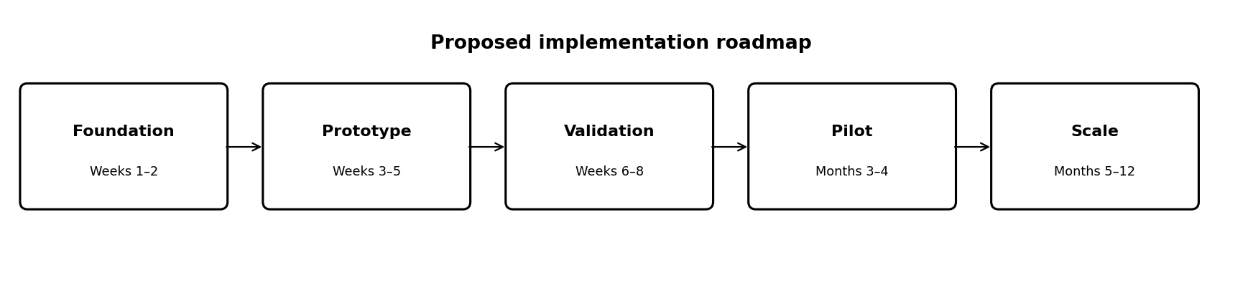
Figure 2. Proposed implementation roadmap and indicative timing.
Phase | Timing | Activities | Exit criteria
Foundation | Weeks 1–2 | Define users and decision; identify dataset; data dictionary; define label and baseline | Approved scope, data inventory and evaluation plan
Prototype | Weeks 3–5 | Clean data; EDA; feature engineering; baseline and Random Forest; dashboard | Reproducible prototype and initial results
Validation | Weeks 6–8 | Validation, threshold analysis, error review, usability and subgroup checks | Model card, test results and limitations
Pilot | Months 3–4 | Shadow-mode trial with approved data; compare predictions with outcomes; gather feedback | Evidence of alert usefulness and manageable workload
Scale | Months 5–12 | Integrate feeds; monitor drift; governed retraining; extend use cases | Operational ownership and documented business case

4.1 Short-term goals
- Document the dataset and target-variable definition.
- Complete EDA for class balance, missing values, duplicates and leakage.
- Build a reproducible preprocessing and training pipeline.
- Compare a baseline with Random Forest using suitable metrics.
- Deliver a dashboard with shipment-level risk and summary analytics.

4.2 Long-term goals
- Integrate approved carrier, route, weather and operational data.
- Estimate delay duration in addition to binary delay risk.
- Calibrate probabilities and set thresholds based on review capacity.
- Monitor data drift and performance by region, carrier and service level.
- Measure business outcomes such as intervention lead time and avoidable late deliveries.

4.3 Accountability
A future organizational deployment should assign a business owner to define the decision and alert workload, a data owner to approve access and definitions, a technical owner to maintain pipelines and models, and operations users to review high-risk shipments. A designated reviewer should approve model changes. These are recommended roles, not claims that such a team currently exists.

5. Evaluation Metrics and Success Framework
Accuracy alone can mislead when most shipments arrive on time. The evaluation should report class balance and confusion-matrix counts, then precision, recall, F1 and precision-recall AUC for the delayed class. ROC-AUC can be a secondary ranking metric. If predicting delay duration, use MAE and RMSE in clear units such as hours. Check probability calibration before presenting scores as reliable probabilities.
Metric | Meaning | Decision relevance
Recall (delayed class) | Share of actual delayed shipments detected | Higher recall can reduce missed risky shipments but may increase alerts
Precision (delayed class) | Share of flagged shipments that are truly delayed | Higher precision reduces unnecessary intervention
F1-score | Harmonic mean of precision and recall | Balances both error types
PR-AUC | Precision-recall trade-off across thresholds | Useful when delayed cases are a minority
MAE (regression extension) | Average absolute delay estimate error | Typical error expressed in hours/minutes
Alert rate | Share of shipments flagged for review | Tests operational workload
Business outcome | Change in avoidable delays or intervention lead time | Tests whether the tool creates value

Acceptance thresholds should be set after measuring the baseline. A candidate model might be required to outperform the baseline on PR-AUC, achieve an agreed recall and keep alert volume within review capacity. No target should be described as achieved until measured on held-out data. A pilot should compare outcomes with the existing process and account for seasonality and operational changes.

6. Risk Assessment and Mitigation
Risk | Potential impact | Mitigation
Poor or incomplete data | Unreliable predictions | Profiling, validation rules, missingness reports and label audits
Data leakage | Artificially high test results | Time-aware splits where appropriate; remove post-delivery fields
Class imbalance | Model misses delayed shipments | Per-class metrics; class weights or resampling only within training folds
Model drift | Performance declines as routes and conditions change | Monitor distributions and outcomes; define retraining triggers
Privacy and security | Exposure of customer or shipment data | Minimize personal data, mask identifiers, restrict access and encrypt data
Uneven performance | Some regions or carriers receive worse predictions | Evaluate subgroup errors and investigate data coverage
Overreliance | Staff treat predictions as certainty | Show limitations, require human review and allow overrides
Integration/adoption | Tool disrupts workflow or is ignored | Co-design, shadow-mode pilot and usability testing
Cybersecurity/dependencies | Unauthorized access or vulnerable packages | Least privilege, dependency updates, secrets management and code review
Missing context | Model overlooks weather, traffic or disruptions | Add approved contextual feeds incrementally and document gaps

6.1 Responsible AI principles
- Transparency: document data sources, target, model version, metrics and limitations.
- Accountability: assign human ownership for decisions and model changes.
- Privacy: collect only the information required for the defined use case.
- Fairness: check for uneven error rates across meaningful operational groups.
- Reliability: test the full data-to-dashboard pipeline and monitor after deployment.
- Safety: use predictions to support rather than replace operational judgment.

7. Future Outlook and Innovation Opportunities
A future version could progress from shipment-level classification to a broader logistics decision-support platform. Delay-duration prediction is a logical next step because estimated magnitude can help prioritize interventions. Approved weather, traffic, holiday, route and carrier-event data may add context, but their value must be demonstrated through controlled evaluation.
Generative AI could later summarize shipment exceptions, search approved operating procedures or draft customer-service explanations. It should not invent delivery commitments or send communications without verification. Optimization methods may eventually compare routes or resource allocations, but require operational constraints and reliable current data.
A 2026 review of generative AI in logistics and supply-chain management identifies applications in forecasting, inventory control, warehouse management and risk assessment. It also notes that much of the literature relies on simulations and synthetic datasets, while empirical field studies remain limited [6]. This is a reason to validate innovations in real operations before claiming measurable impact.

8. Conclusion
The recommended strategy is focused: predict delivery-delay risk, make the result understandable and help people prioritize exceptions. Broad AI adoption is increasing, while logistics research highlights the importance of practical data integration, prediction timing and decision support. The best first step is not a complex autonomous system; it is a reliable baseline, honest evaluation, user testing and gradual expansion based on operational evidence.
The internship application should be presented as a proof of concept. If synthetic data is used, the report, dashboard and GitHub README must state this clearly. Model metrics should only be reported after execution, alongside dataset provenance and validation method. This creates a credible foundation for responsible future development.

References
[1] Stanford Institute for Human-Centered Artificial Intelligence (HAI). (2026). The 2026 AI Index Report – Economy. https://hai.stanford.edu/ai-index/2026-ai-index-report/economy
[2] Müller, N., Burggräf, P., Steinberg, F., Sauer, C. R., & Schütz, M. (2025). An analytical review of predictive methods for delivery delays in supply chains. Supply Chain Analytics, 11, 100130. https://doi.org/10.1016/j.sca.2025.100130
[3] Artificial intelligence in supply chain management: A systematic literature review of empirical studies and research directions. (2024). Computers in Industry, 162, 104132. https://doi.org/10.1016/j.compind.2024.104132
[4] Vlachos, I., & Reddy, P. G. (2025). Machine learning in supply chain management: systematic literature review and future research agenda. International Journal of Production Research, 63(16), 5987–6016. https://doi.org/10.1080/00207543.2025.2466062
[5] Tejedor Aguilera, J. Distribution time prediction dataset. Kaggle. https://www.kaggle.com/c/distribution-time-prediction/data (Check access and competition terms before reuse.)
[6] Potentials of generative AI in logistics and supply chain management: A guiding review on applications and future research directions. (2026). https://doi.org/10.1080/00207543.2026.2680586

Appendix A. Submission and implementation checklist
- Confirm dataset source, license and whether records are synthetic, public or operational.
- Define the target label and prediction point in time.
- Remove identifiers and features only known after delivery.
- Record split method, random seed and model settings.
- Report confusion matrix and class-specific metrics; do not report unrun results.
- Add screenshots only after executing the application.
- Include setup instructions, dependencies and limitations in GitHub README.
- State clearly that prototype results are not production guarantees.

