PROJECT-10:

Performing operations on S3 buckets within an EC2 instance by means of an IAM Role:

STEPS:

1.create an EC2 instance using amazon linux.

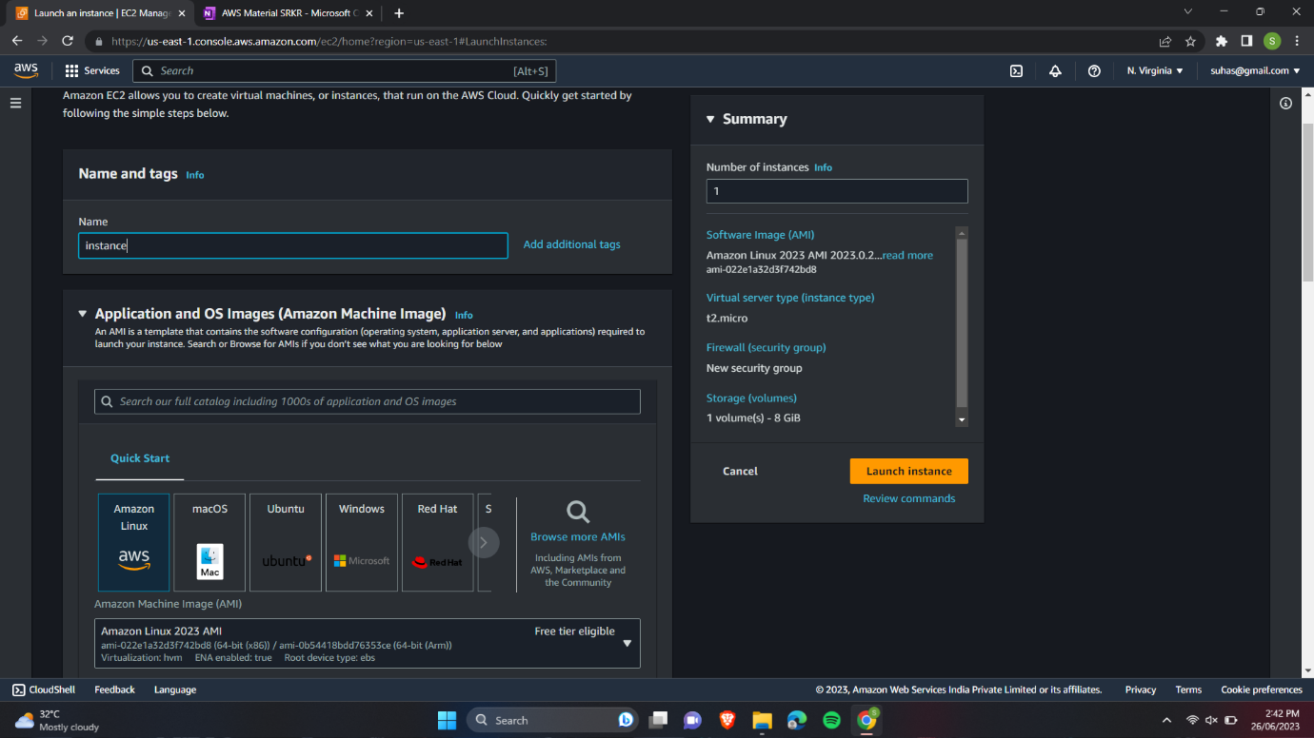

2.Create a role in IAM .

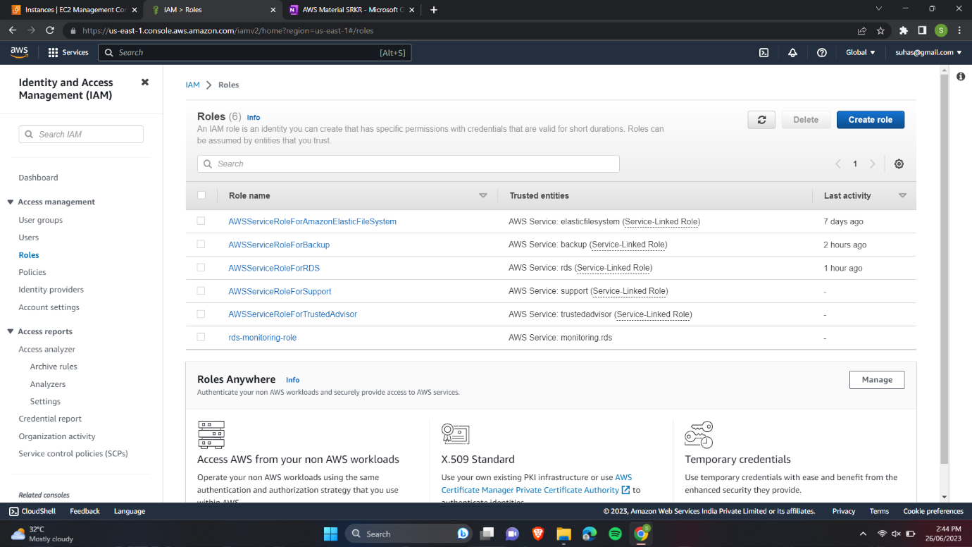

3.Select EC2 an common use case.

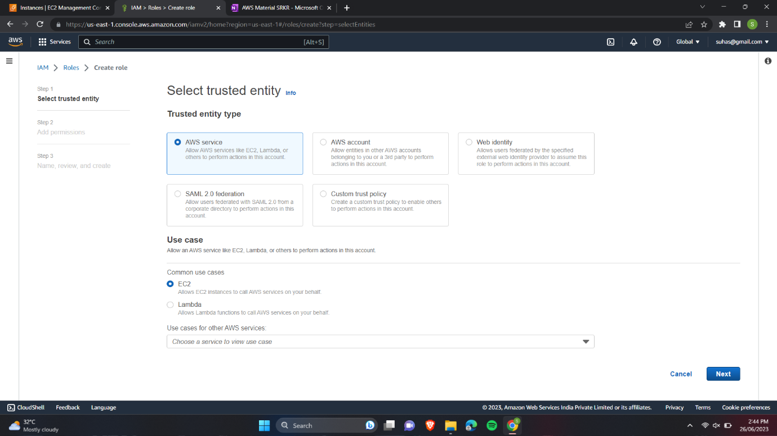

4.Give S3 permissions for the role.

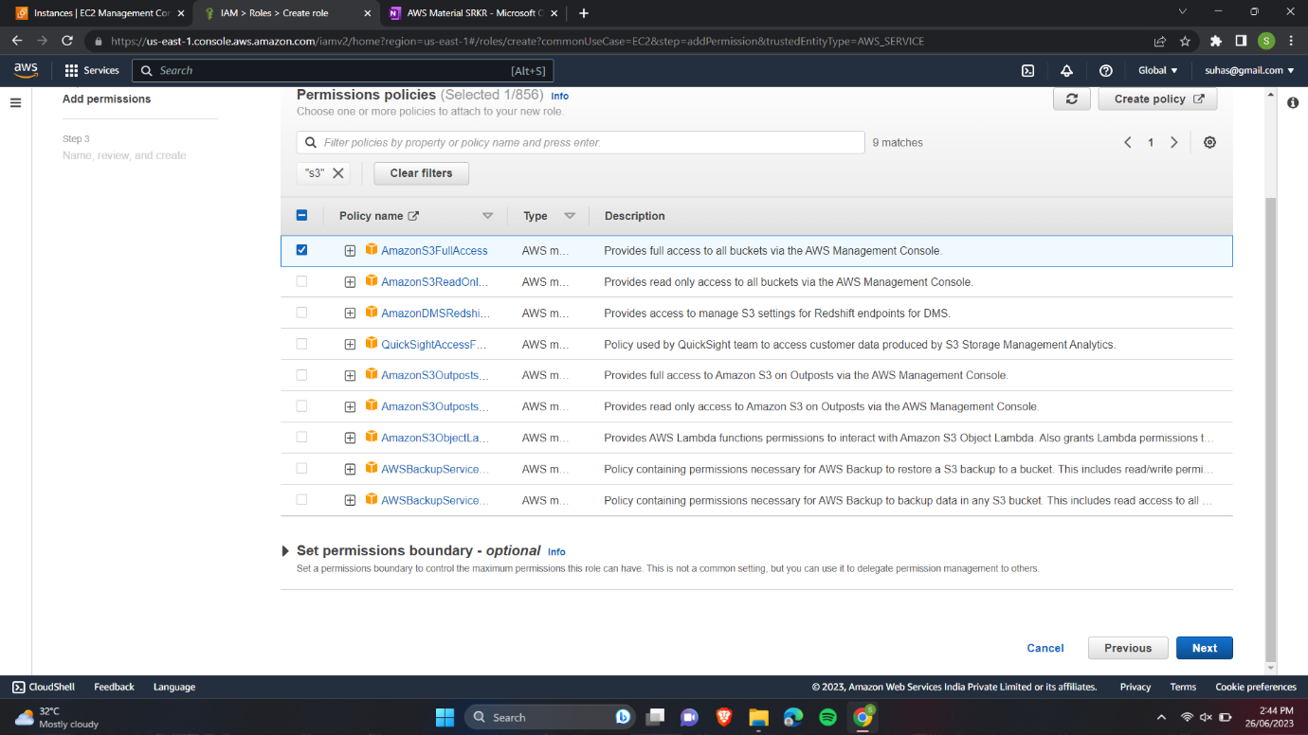

5.Give a name for the role.

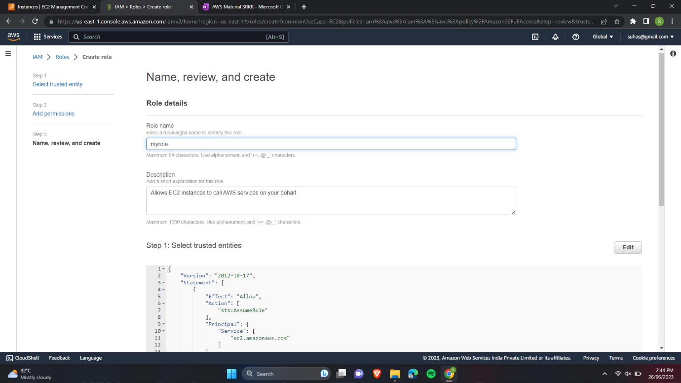

6.Now select the instance and modify IAM role.

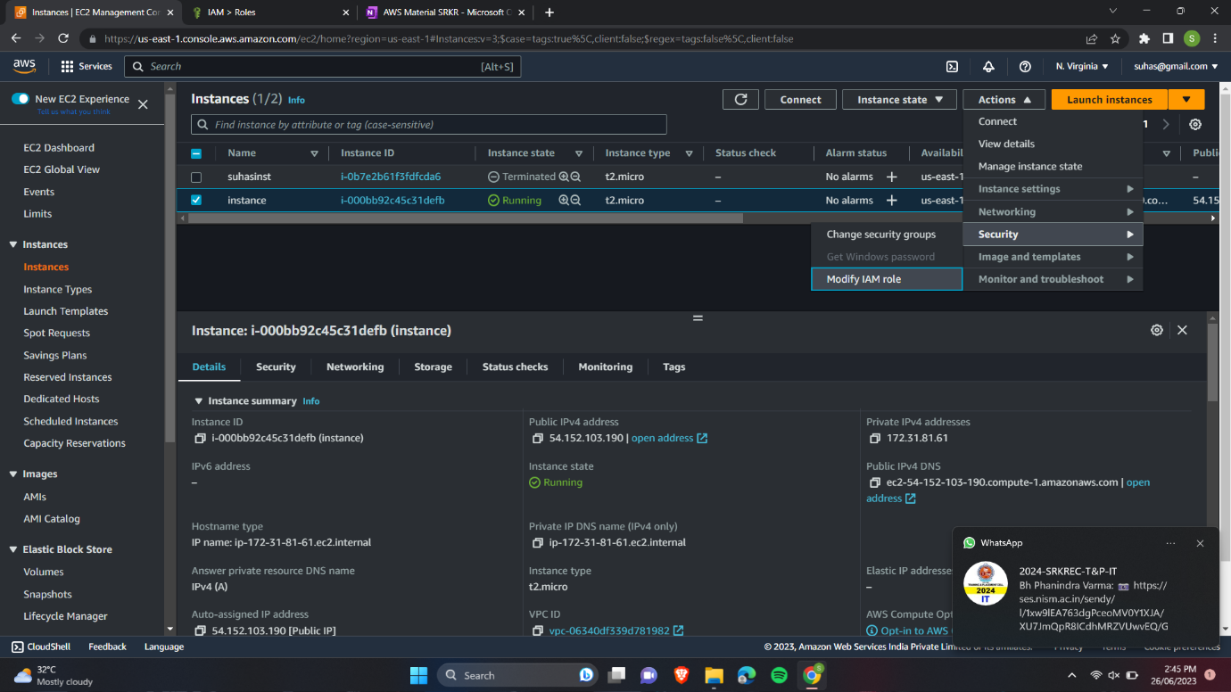

7.Select the role we have created.

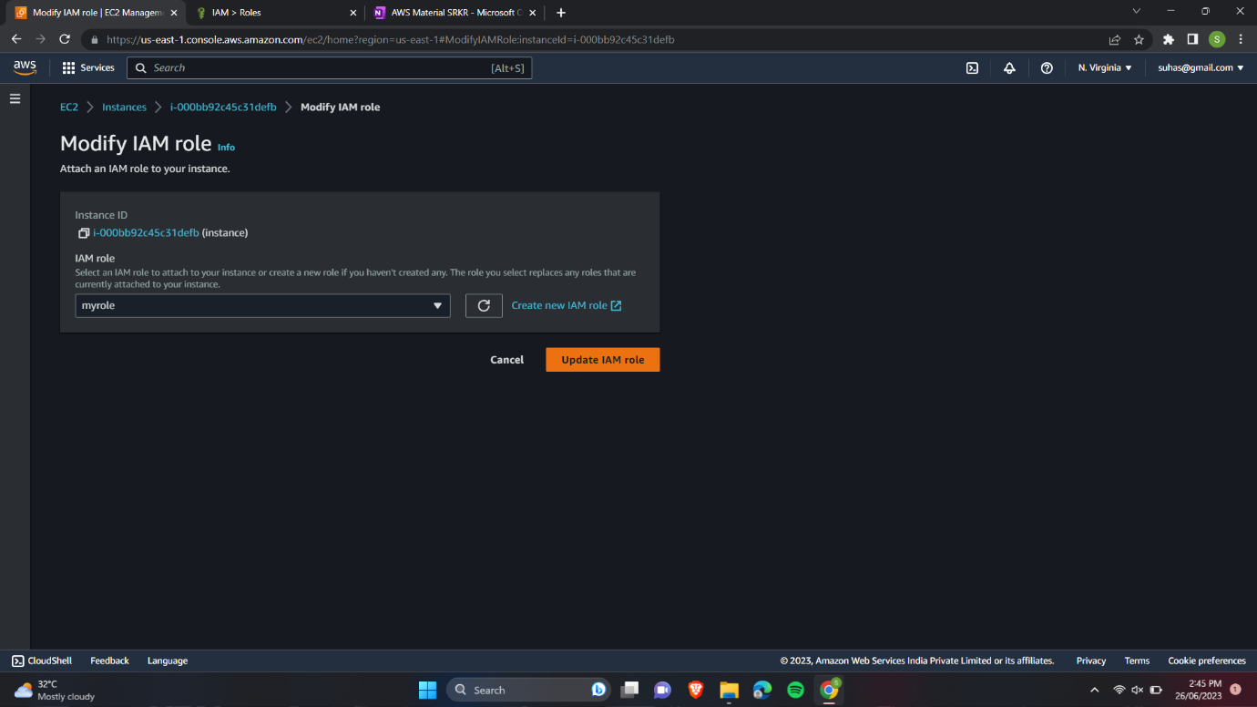

8.Create a bucket with default configurations.

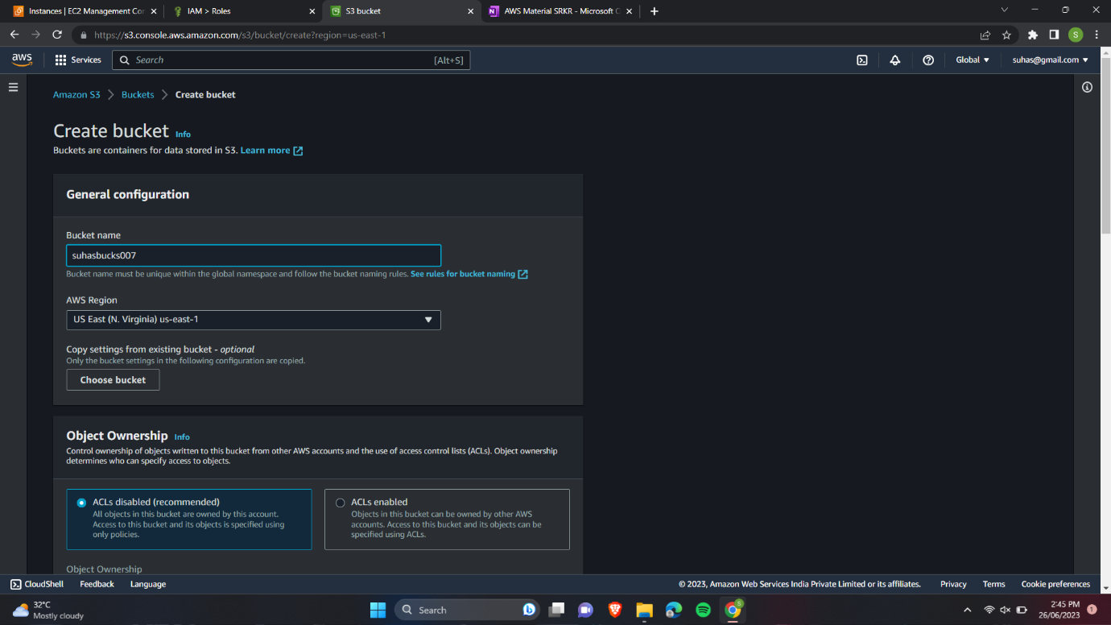

9.Add a file into the bucket.

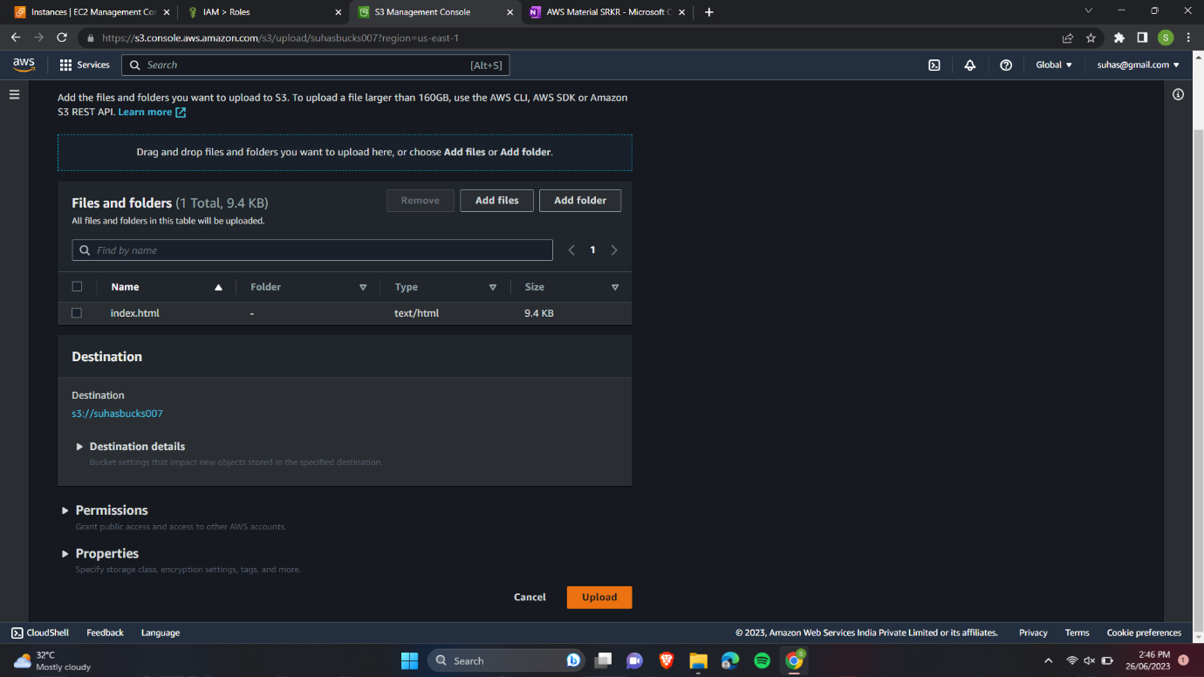

10.Connect to our instance.

11.List the files present in our S3 bucket.

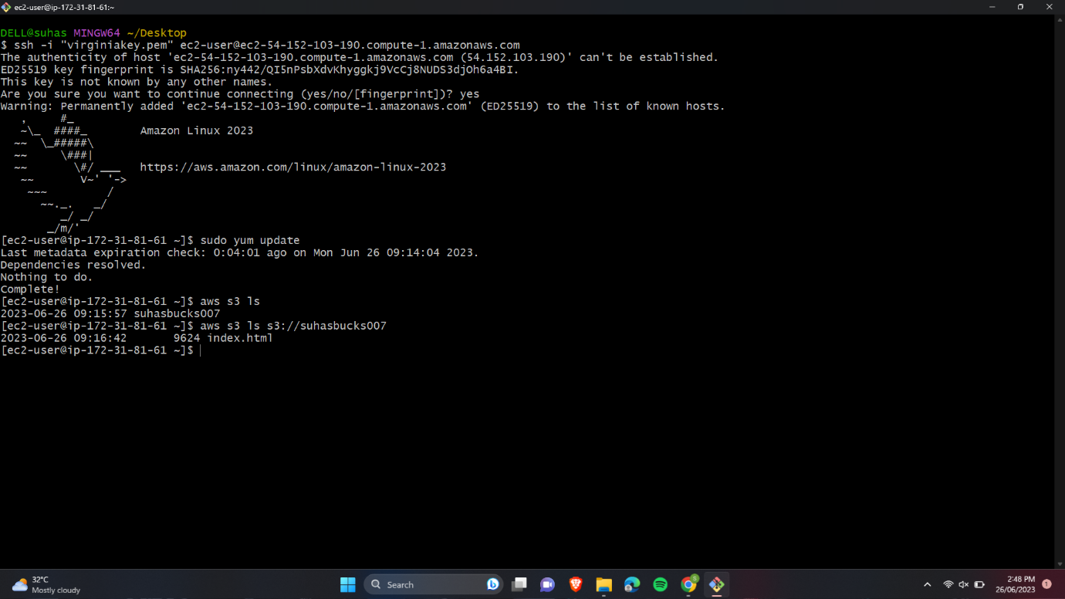

12.Create a file and copy to our S3 bucket.

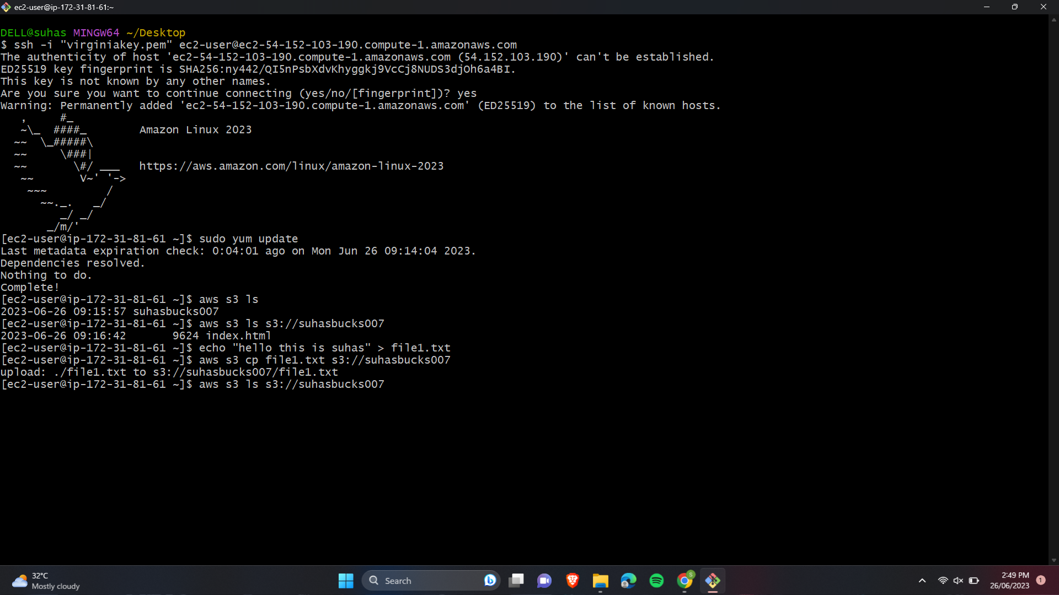

13.Create a new bucket.

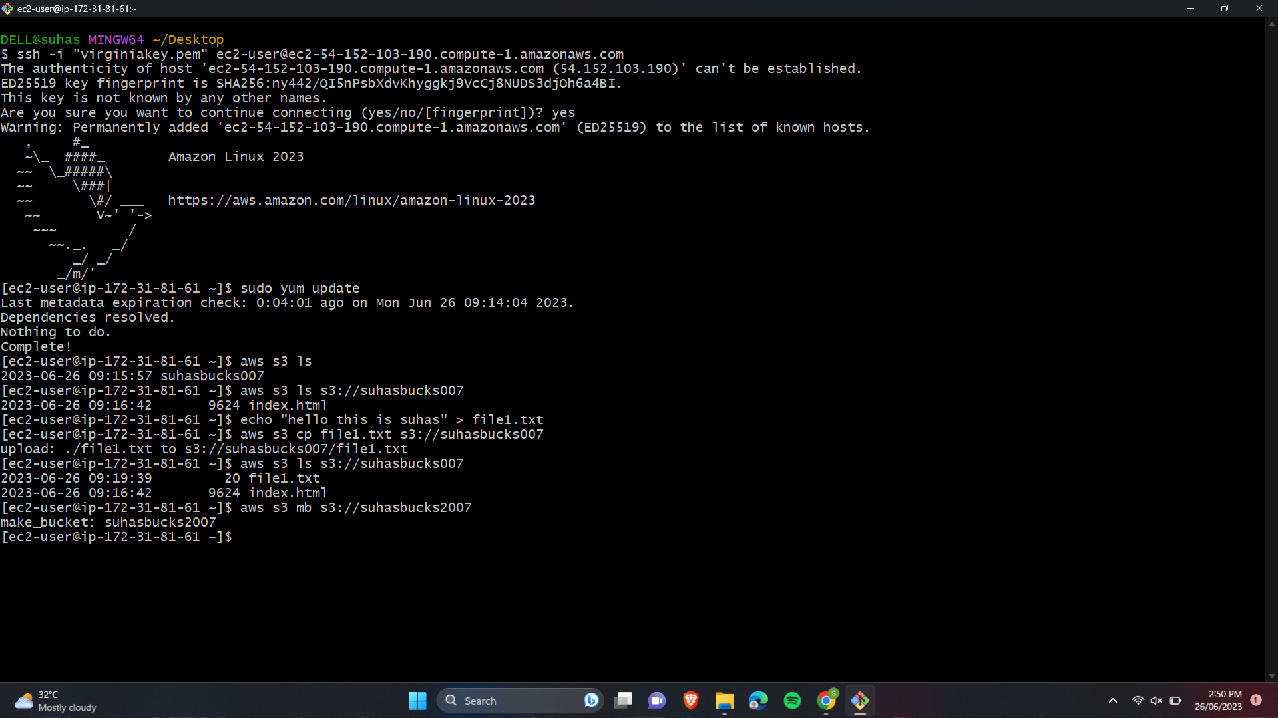

14.Copy contents from one bucket to another bucket.

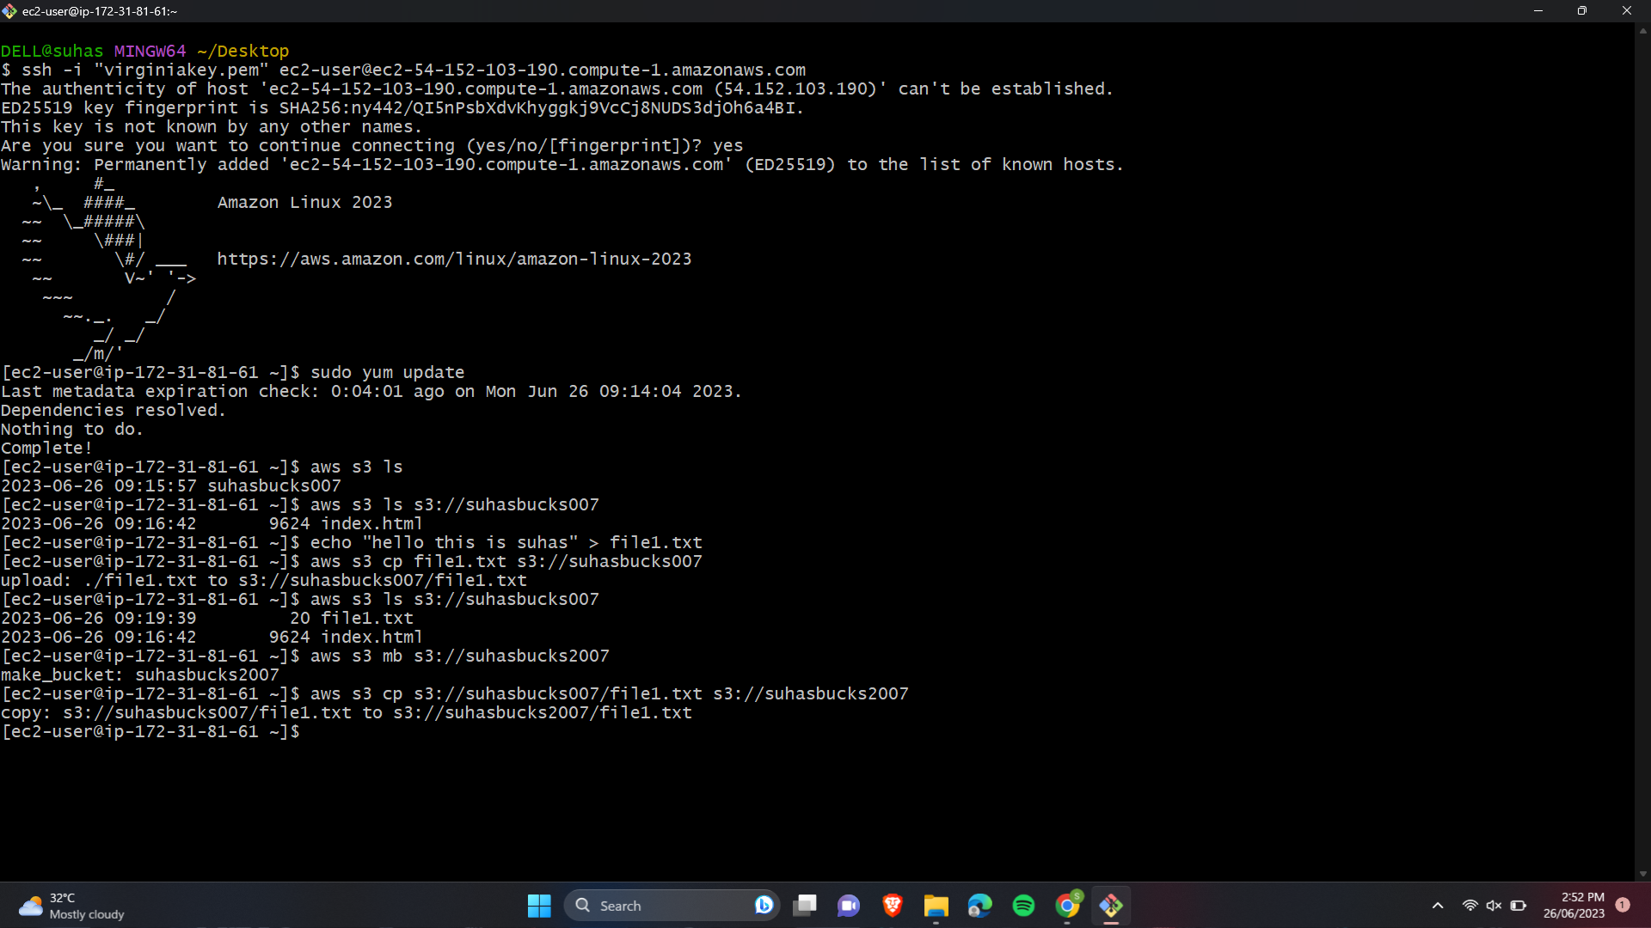

15.Remove contents from a bucket.

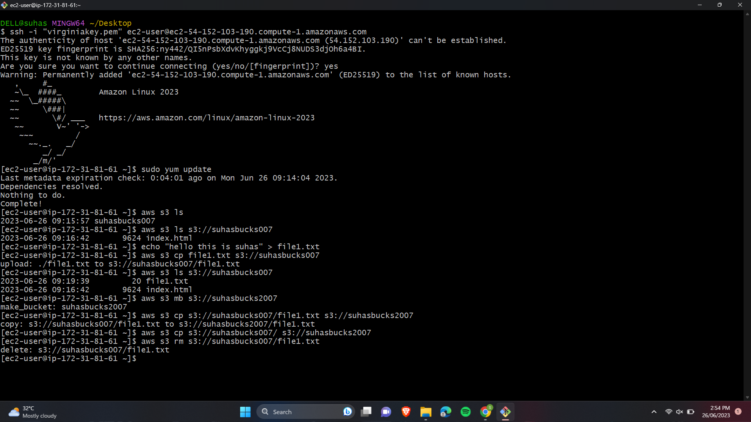

16.Remove total bucket.

