**PROJECT- 3:**

**AIM: Managing EFS and establishing connectivity between EC2 instances and EFS.**

EFS VOLUME (elastic file system):

* Elastic File System (EFS) is a scalable and fully managed file storage service provided by Amazon Web Services (AWS).
* It is designed to provide shared file storage for use with Amazon EC2 instances.
* EFS offers a simple and scalable way to share files across multiple instances, making it suitable for a wide range of applications and workloads.
* EFS automatically scales storage capacity as you add more files, without requiring any upfront provisioning.
* EFS provides high availability by storing data redundantly across multiple Availability Zones within a region. This ensures that your file system remains accessible even in the event of AZ failures.
* EFS supports the Network File System version 4 (NFSv4) protocol.
* This allows you to mount EFS file systems on your EC2 instances and access them using standard file system operations.
* EFS can be used in conjunction with other AWS services, such as AWS Lambda, Amazon ECS, and Amazon EKS, to provide shared storage for containerized applications and serverless functions.

Working with EC2 AND EFS:

Steps:

1.Initially we need to create a security group with NFS protocol open.

* The Network File System (NFS) is a distributed file system protocol that allows clients to access files and directories on remote servers over a network.
* NFS is widely used in Unix and Linux environments for sharing files and resources between systems.

2.Creating a EFS volume with the above created security group and making sure we do not enable encryption, life cycle management and auto back-ups to avoid charges.

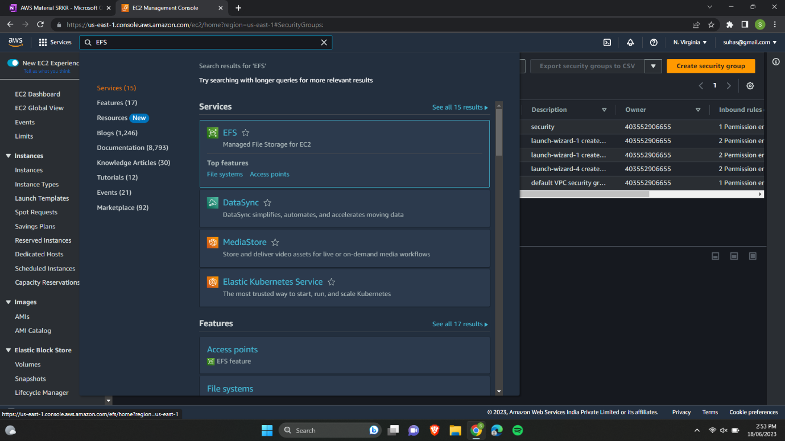

3. Creating an EC2 instance in us-east-1a region.

4. Creating another EC2 instance in us-east-1b region.

5.Connecting both EC2 instances using gitbash.

6.Updating both VM’s using the command sudo apt-get update.

7.Installing NFS in both VM’s using sudo apt-get install nfs-common.

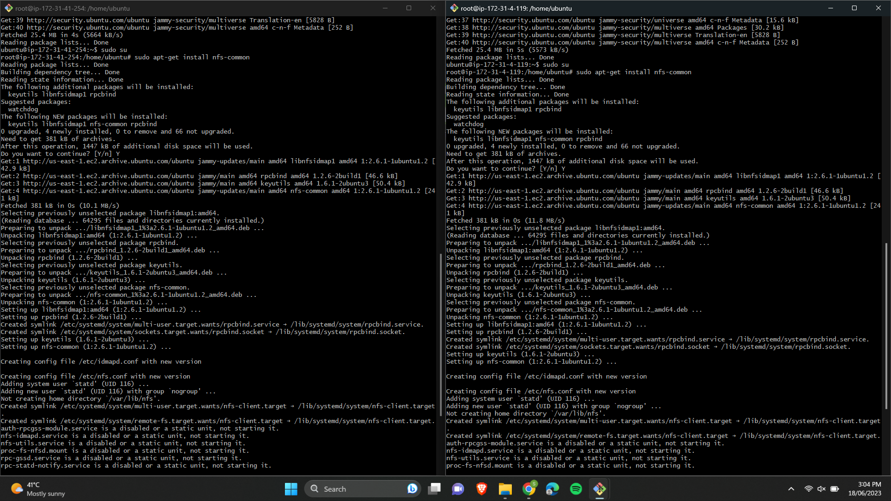

8.Creating a directory called EFS in both VM’s which we will use as a shared resource.

9.Selecting the EFS volume which is in AWS and selecting the option view details.

10.Selecting attach option in order to attach our EFS volume.

11.We can view the link to mount our EFS volume to the directory EFS which we have created.

12.Pasting the link in both VM’s.

13.Now creating a file in the first virtual machine.

14.Accesing the file in the second virtual machine.

