PROJECT-8:

Establishing a connection to RDS using the local machine:

* RDS (Relational Database Service) is a managed database service provided by Amazon Web Services (AWS). It simplifies the process of setting up, operating, and scaling a relational database in the cloud.
* Easy deployment: RDS makes it simple to launch a fully functional relational database instance with just a few clicks or API calls.
* Scalability: RDS allows you to scale your database instance up or down based on your application's needs. You can vertically scale by increasing or decreasing the instance size or horizontally scale by adding read replicas to offload read traffic.
* High availability: RDS provides built-in features for high availability, such as automated backups, database snapshots, and automated Multi-AZ (Availability Zone) deployments.
* Multi-AZ deployments replicate your database synchronously to a standby instance in a different Availability Zone to provide automatic failover in the event of a hardware or Availability Zone failure.
* RDS provides several security features, including network isolation, encryption at rest using AWS Key Management Service.
* RDS integrates seamlessly with other AWS services, such as AWS CloudFormation, AWS Identity and Access Management (IAM), AWS CloudWatch for monitoring, AWS VPC (Virtual Private Cloud) for network isolation, and AWS Elastic Beanstalk for application deployment.

STEPS:

1.Create a database using MySQL engine.

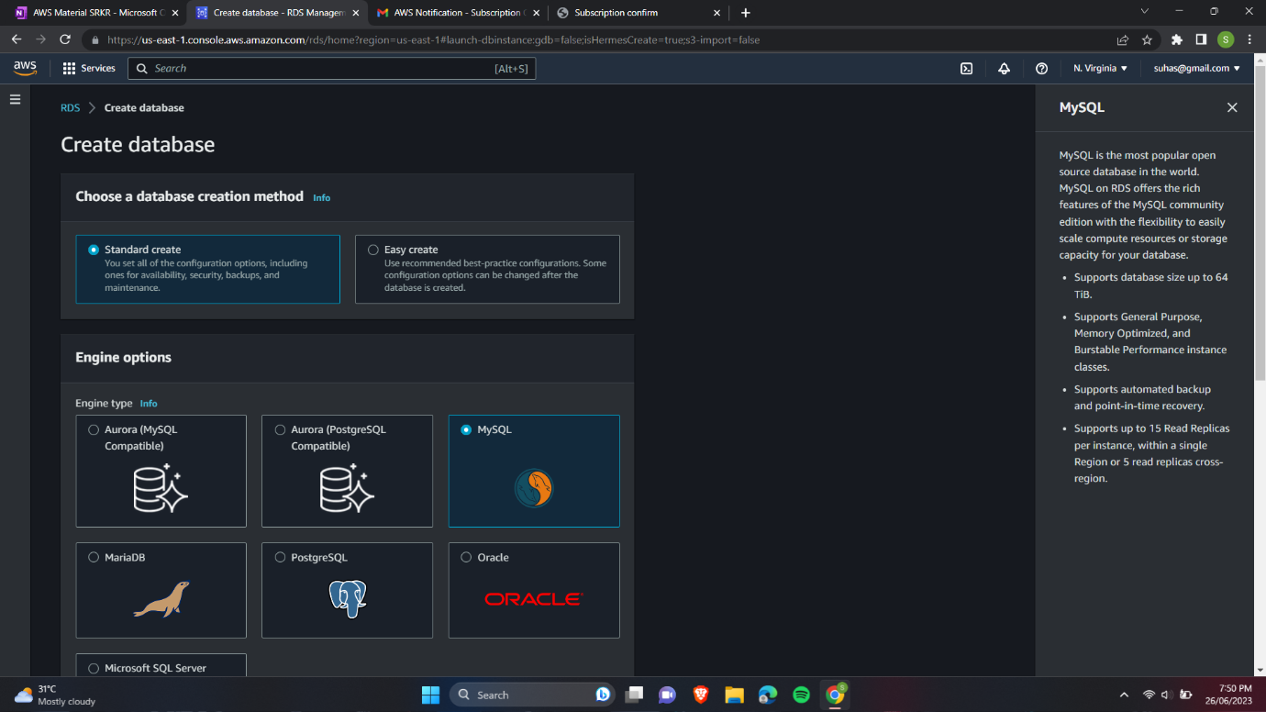

2.Select free tier to avoid costs.

3.Provide the database with master username and password.

4.Disable the auto-scaling option as we don’t use it now.

5.Allow public access and keep the vpc settings to default.

6.Install MySQL server and workbench.

7.Click on new connection and provide the endpoint of our database as host.

8.Click on check connection and enter password.

9.You can see the connection is established.

Establishing a connection to RDS using EC2 instance:

STEPS:

1.Create an instance using amazon linux AMI.

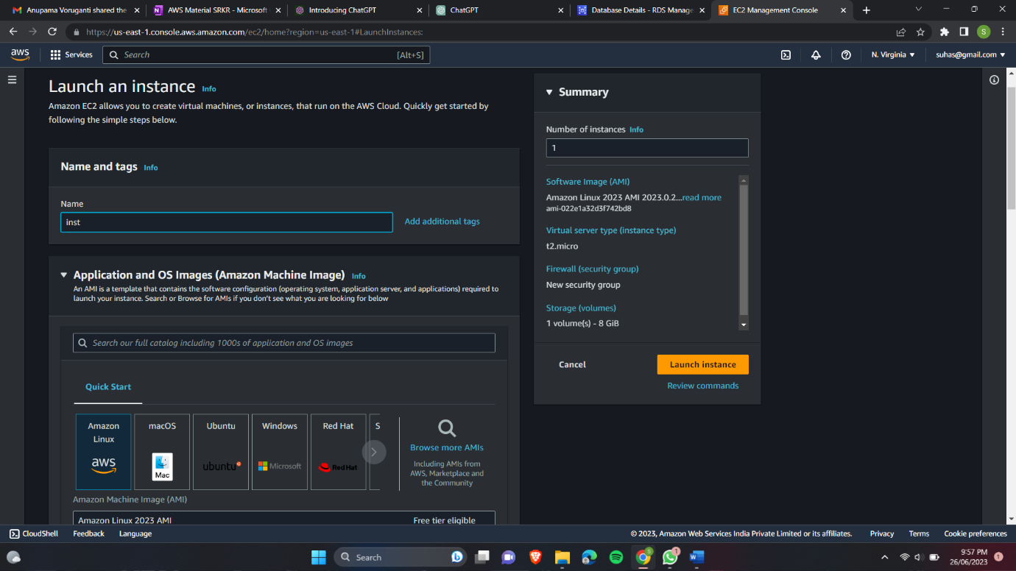

2.create this instance in same vpc and availability x=zone of our RDS-database.

3.After creating select the database and in action click on set up an EC2 connection.

4.Select the instance that we have created.

5.You will see review and confirm then confirm the EC2-connection.

6.If we browse to connectivity and security of our database there at last, we can see the connected resources.

