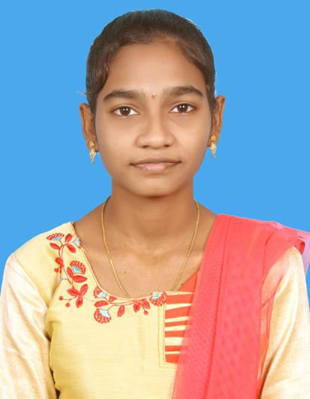

**AKKIREDDY TULASI MANI**

**Contact No:** +91 9398995157

**Email Id:** [tulasimani2003@gmail.com](mailto:tulasimani2003@gmail.com)

**LinkedIn:** linkedin.com/in/tulasi-mani-1a7b81277

**CAREER OBJECTIVE:**

An Enthusiastic and a hardworking fresher, wants to learn and work in the challenging environment where I can showcase skills and get adapted to new challenges.

**EDUCATION QUALIFICATIONS:**

|  |  |  |  |  |
| --- | --- | --- | --- | --- |
| **Course** | **Board/University** | **School/College** | **Year of passing** | **Percentage** |
| B.Tech(CSE) | Jawaharlal Nehru Technological University, Vizianagaram | Raghu Engineering College, Vizianagaram | 2025 | 8.53 (CGPA) |
| Intermediate | State Board of Intermediate, Vizakhapatnam | Sri Chaitanya Junior College, NAD, Vizag | 2021 | 87% |
| School | Board of Secondary Education , Visakhapatnam | Dr. K.K.R’s Gowtham School, Vizag | 2019 | 9.3 (CGPA) |

**EXPERIENCE:**

* Worked as an Online Intern in IStudio
* Workes as an Offline Intern in Symbiosis, Madhurwada, Vizag.

**TECHNICAL SKILLS:**

* Scripting Languages: HTML,CSS , JS and GoDot Script
* Frame works: ReactJs
* Programming languages: Python, Java, C
* DBMS

**PROJECTS:**

**Major Projects:**

* **Detecting and Mitigating Botnet attacks in Software-Defined Networks using Deep Learning (ON GOING)**

Botnet is one of the type of Malware attack that will perfom an attack on the victims system and get an unauthorized access to all the data in the system. The main goal of our project is to detect whether there is any botnet attacks are taking place in victim system and mitigate them using different algorithms and approaches.

**Minor Projects:**

* **Generating a 2D Game using GoDot programming script**
* **Creating a NetFlix Clone using Web Technology**
* **Developing an E Commerce Website using HTML, CSS and JS**
* **A Messaging Application using HTML, CSS and JS**

**WORKSHOPS:**

* Participated in workshop related to Web Designing in JNTU - GV
* Participated in workshop related to Front-end in ANITS – Thagarapuvalasa

**STRENGTHS:**

* Hardworking person
* Good at Communication
* Adaptive to the work place
* Hopeful minded

**CERTIFIED COURSES:**

* NPTEL certification in DBMS
* Edx certification in HTML, CSS and JS
* Edx certification in Basics of SQL

**DECLARATION:**

I hereby declare that the details provided in the above are true to the best of my knowledge.

**Date: (AKKIREDDY TULASI MANI )**