**SKYLINE**

**EER DIAGRAM:-**

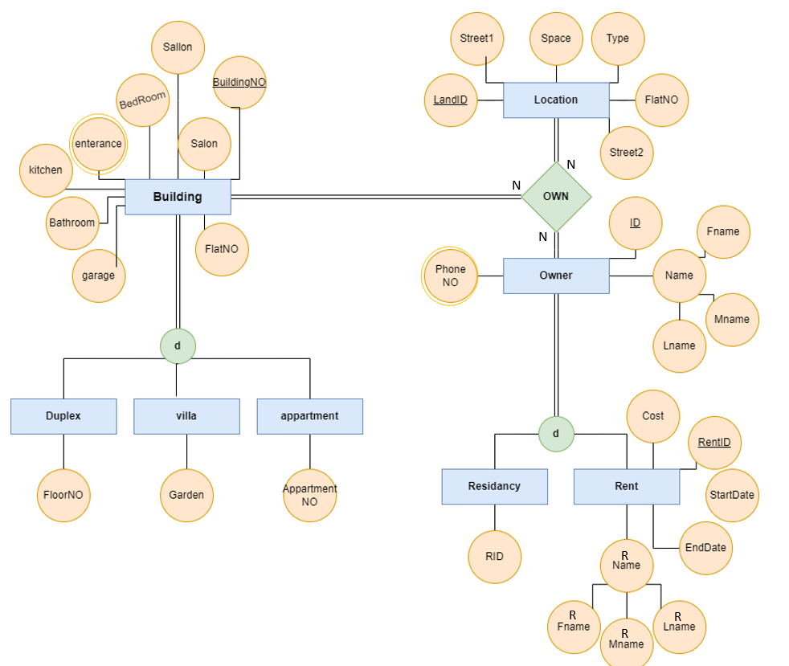

**NORMALIZATION:-**

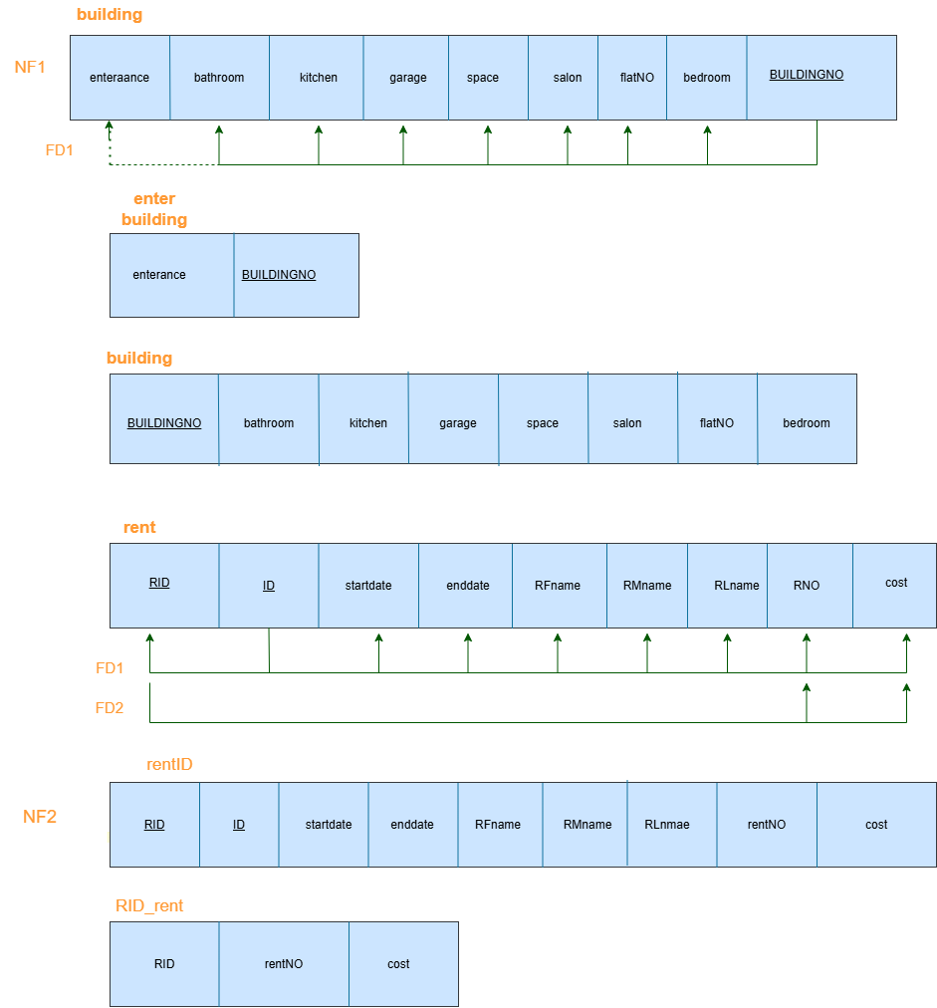

**SQL:-**

**CREATE TABLE Building** (

building_no INT PRIMARY KEY,

bathroom INT,

kitchen INT,

garage INT,

space FLOAT,

salon INT,

entrance INT,

flat_num INT,

bedroom INT

);

**CREATE TABLE Duplex** (

building_no INT PRIMARY KEY,

floor_no INT,

FOREIGN KEY (building_no) REFERENCES Building(building_no)

);

**CREATE TABLE Villa** (

building_no INT PRIMARY KEY,

garden int,

FOREIGN KEY (building_no) REFERENCES Building(building_no)

);

**CREATE TABLE Apartment** (

building_no INT,

apartment_no INT,

PRIMARY KEY (building_no),

FOREIGN KEY (building_no) REFERENCES Building(building_no)

);

**CREATE TABLE Location** (

land_id INT PRIMARY KEY,

space FLOAT,

type VARCHAR(50),

street1 VARCHAR(100),

street2 VARCHAR(100)

);

**CREATE TABLE Owner** (

id INT PRIMARY KEY,

fname VARCHAR(50),

mname VARCHAR(50),

lname VARCHAR(50)

);

**CREATE TABLE PhoneNum** (

id INT,

phone_no VARCHAR(15),

PRIMARY KEY (id),

FOREIGN KEY (id) REFERENCES Owner(id)

);

**CREATE TABLE Residency** (

resident_id INT PRIMARY KEY,

owner_id INT,

FOREIGN KEY (owner_id) REFERENCES Owner(id)

);

**CREATE TABLE Rent** (

residence_id INT,

owner_id INT,

fname VARCHAR(50),

mname VARCHAR(50),

lname VARCHAR(50),

term_of_rent VARCHAR(50),

cost FLOAT,

start_date DATE,

end_date DATE,

rent_no INT PRIMARY KEY,

rent_phone_no VARCHAR(15),

renter_id INT,

FOREIGN KEY (residence_id) REFERENCES Residency(resident_id),

FOREIGN KEY (owner_id) REFERENCES Owner(id)

);

**CREATE TABLE Own** (

building_no INT,

land_id INT,

id INT,

PRIMARY KEY (building_no, land_id, id),

FOREIGN KEY (building_no) REFERENCES Building(building_no),

FOREIGN KEY (land_id) REFERENCES Location(land_id),

FOREIGN KEY (id) REFERENCES Owner(id)

);

**INSERT:-**

**INSERT INTO Building**

**VALUES**

(1, 2, 1, 1, 120.5, 1, 1, 4, 3);

**INSERT INTO Building**

**VALUES**

(2, 3, 1, 2, 250.0, 2, 1, 6, 5);

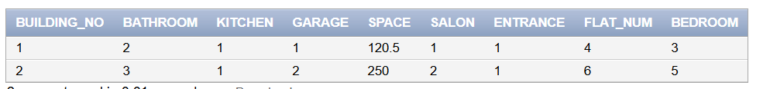

**INSERT INTO Duplex** (building_no, floor_no)

VALUES

(1, 2);

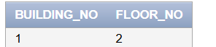

**INSERT INTO Villa** (building_no, garden)

VALUES

(2, 1);

**INSERT INTO Apartment** (building_no, apartment_no)

VALUES

(1, 1);

**INSERT INTO Apartment** (building_no, apartment_no)

VALUES

(2, 3);

**INSERT INTO Location** (land_id, space, type, street1, street2)

VALUES

(1, 500.0, 'Residential', 'khalil hamad St', 'qasim aladli st');

**INSERT INTO Location** (land_id, space, type, street1, street2)

VALUES

(2, 750.0, 'Commercial', ' haro alrasheed St', 'raibow st');

**INSERT INTO Owner** (id, fname, mname, lname)

VALUES

(202210366, 'dalaa', 'yaser', 'saqer');

**INSERT INTO Owner** (id, fname, mname, lname)

VALUES

(202210418, 'sara', 'nabil', 'abu odeh');

**INSERT INTO Owner** (id, fname, mname, lname)

VALUES

(202210551, 'toleen', 'malik', 'al shattel');

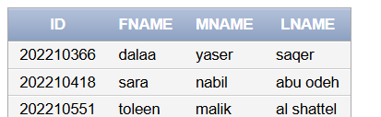

**INSERT INTO PhoneNum** (id, phone_no)

VALUES

(202210366, '079-789');

(202210418, '079-456');

(202210551, '079-123');

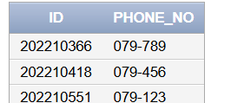

**INSERT INTO Residency** (resident_id, owner_id, number_of_owners)

VALUES

(56349, 202210366, 1);

**INSERT INTO Residency** (resident_id, owner_id, number_of_owners)

VALUES

(23456, 202210551, 1);

**INSERT INTO Residency** (resident_id, owner_id, number_of_owners)

VALUES

(87656, 202210418, 2);

**INSERT INTO Rent** (residence_id, owner_id, fname, mname, lname, term_of_rent, cost, start_date, end_date, rent_no, rent_phone_no, renter_id)

VALUES

(56349,202210366, 'ali', 'hamzeh', 'alakhras', 'yearly', 12000.0, '01-01-2023', '01-01-2024', 1, '555-1234', 5671);

**INSERT INTO Rent** (residence_id, owner_id, fname, mname, lname, term_of_rent, cost, start_date, end_date, rent_no, rent_phone_no, renter_id)

VALUES

(23456, 202210551, 'ahmed', 'anas', 'awameh', 'yearly', 12000.0, '07-05-2023', '07-05-2024', 7, '555-1234', 1764);

**INSERT INTO Rent** (residence_id, owner_id, fname, mname, lname, term_of_rent, cost, start_date, end_date, rent_no, rent_phone_no, renter_id)

VALUES

(87656, 202210418, 'mohammed', 'omar', 'masri', 'Monthly', 500.0, '01-01-2023', '01-01-2024', 2, '555-5678', 2742);



**INSERT INTO Own** (building_no, land_id, id)

VALUES

(1, 1, 202210366);

**INSERT INTO Own** (building_no, land_id, id)

VALUES

(2, 2, 202210551);

**SELECTED:-**

SELECT COUNT(*) AS building_count

FROM Building B

JOIN

Own O ON B.building_no = O.building_no

JOIN

Location L ON O.land_id = L.land_id

WHERE L.space > 600;

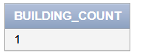

SELECT *

FROM Rent

WHERE end_date > CURRENT_DATE;



SELECT AVG(cost) AS average_rent_cost

FROM Rent;

that retrieves the rent details along with the corresponding owner's information

SELECT RT.rent_no,

RT.cost,

RT.start_date,

RT.end_date,

R.fname AS owner_fname,

R.mname AS owner_mname,

R.lname AS owner_lname

FROM

Rent RT

JOIN

(SELECT id, fname, mname, lname FROM Owner) R ON RT.owner_id = R.id;

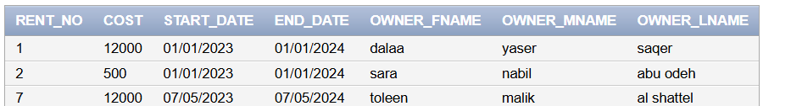

--List all buildings along with their corresponding location details

SELECT b.building_no, b.bathroom, b.kitchen, b.garage, b.space, b.salon, b.entrance, b.flat_num, b.bedroom, l.space AS location_space, l.type, l.street1, l.street2

FROM Building b

JOIN Own o ON b.building_no = o.building_no

JOIN Location l ON o.land_id = l.land_id;



--Find all rents that have expired

SELECT * FROM Rent

WHERE end_date < CURRENT_DATE;



-- List all duplexes with floor number greater than 1

SELECT * FROM Duplex

WHERE floor_no > 1;

--List all rents with their terms and costs

SELECT r.residence_id, r.owner_id, r.fname, r.mname, r.lname, r.term_of_rent, r.cost, r.start_date, r.end_date

FROM Rent r;

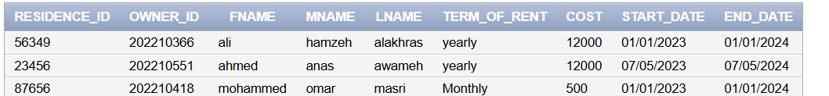

--List all rents along with the owner details and residence details

SELECT r.residence_id, r.owner_id, o.fname, o.mname, o.lname, r.term_of_rent, r.cost, r.start_date, r.end_date, r.rent_no, r.rent_phone_no, r.renter_id

FROM Rent r

JOIN Residency res ON r.residence_id = res.resident_id

JOIN Owner o ON r.owner_id = o.id;



CREATE TRIGGER Update_Rent_Cost

AFTER INSERT ON Residency

FOR EACH ROW

BEGIN

UPDATE Rent

SET cost = NEW.number_of_owners * 1000

WHERE residence_id = NEW.resident_id;

END;

**INDEXING:-**

CREATE INDEX idx_building_no ON Building(building_no);

CREATE INDEX idx_floor_no ON Duplex(floor_no);

CREATE INDEX idx_space ON Location(space);

CREATE INDEX idx_owner_id ON Owner(id);

CREATE INDEX idx_residency_owner_id ON Residency(owner_id);

CREATE INDEX idx_rent_residence_id ON Rent(residence_id);

**تولين الشطل**

**دلع صقر**

**سارة ابو عودة**