pXRF analysis

Uine Kailamäki

11/27/2020

## Title

set.seed(3)

A random seed is set for reprodicibility

## Rows: 54  
## Columns: 12  
## $ Al2O3 <dbl> -0.268931371, 0.624322360, -0.337896566, -0.342088692, 1.0988...  
## $ SiO2 <dbl> -0.32960233, 0.40267185, -0.51842829, -0.31911798, 1.16574201...  
## $ P2O5 <dbl> 0.235437493, 0.170363763, 0.579837138, -0.308480664, 0.372337...  
## $ CaO <dbl> -0.18682238, 0.17697590, -0.52003831, -0.01712480, 0.69040890...  
## $ Ti <dbl> 0.06048082, 0.24912385, 0.12480888, -0.46914039, 0.87306658, ...  
## $ Mn <dbl> 0.35014917, 0.40167424, 0.88343360, -0.58760702, 0.45062305, ...  
## $ Fe <dbl> 0.16177825, 0.11814247, 0.34377004, -0.49264733, 0.71737017, ...  
## $ Cu <dbl> 0.47734056, 0.47734056, 0.35481062, 0.04848577, 0.72240044, -...  
## $ Zn <dbl> 1.4150105, -0.2416698, 2.3967469, -0.4871039, 0.1264814, -0.8...  
## $ Sr <dbl> -0.163489387, 0.023169208, -0.107057719, 0.053555491, 0.21416...  
## $ Zr <dbl> -0.46189040, 0.07601448, -0.07237307, 0.24295048, 0.52117715,...  
## $ Area <fct> Area D Acropolis, Area D Acropolis, Area D Acropolis, Area D ...

## [1] "1" "2" "3" "4" "5" "6" "7" "8" "9" "10" "11" "12" "13" "14" "15"  
## [16] "16" "17" "18" "19" "20" "21" "22" "23" "24" "25" "26" "27" "28" "29" "30"  
## [31] "31" "32" "33" "34" "35" "36" "37" "38" "39" "40" "41" "42" "43" "44" "45"  
## [46] "46" "47" "48" "49" "50" "51" "52" "53" "54"

## [1] "Al2O3" "SiO2" "P2O5" "CaO" "Ti" "Mn" "Fe" "Cu" "Zn"   
## [10] "Sr" "Zr" "Area"

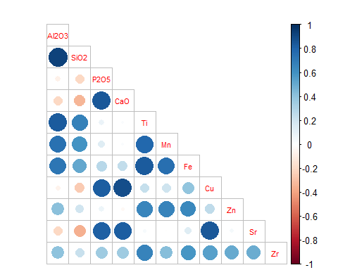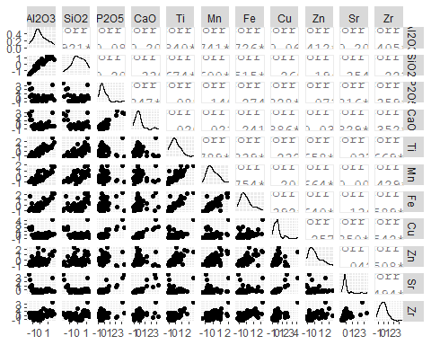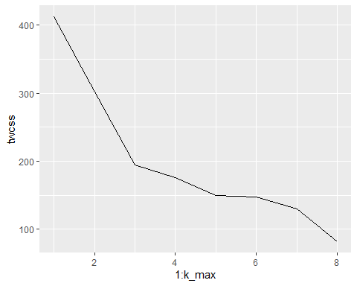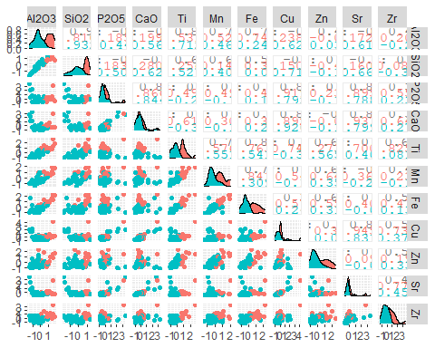

## Importance of components:  
## PC1 PC2 PC3 PC4 PC5 PC6 PC7  
## Standard deviation 1.8535 1.6722 0.76719 0.61863 0.43204 0.34429 0.2886  
## Proportion of Variance 0.4414 0.3593 0.07563 0.04918 0.02398 0.01523 0.0107  
## Cumulative Proportion 0.4414 0.8007 0.87636 0.92553 0.94952 0.96475 0.9755  
## PC8 PC9 PC10 PC11  
## Standard deviation 0.26351 0.22965 0.22167 0.14054  
## Proportion of Variance 0.00892 0.00678 0.00631 0.00254  
## Cumulative Proportion 0.98437 0.99115 0.99746 1.00000

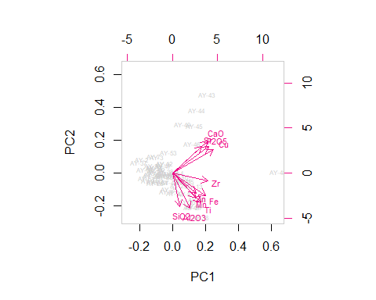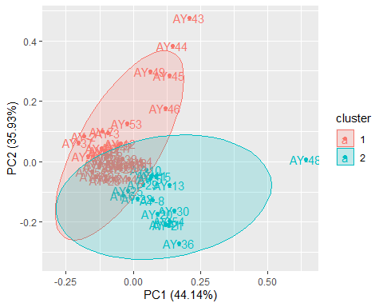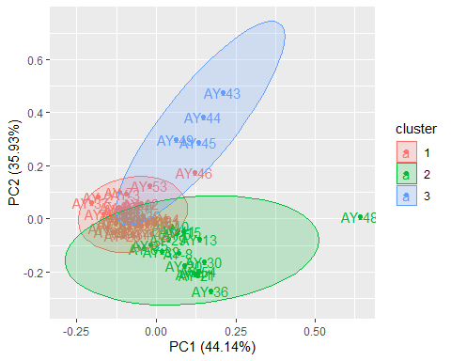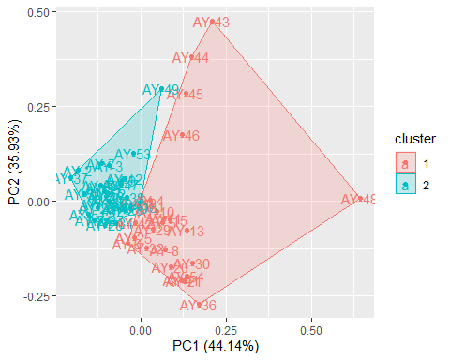

## [1] 0.8539664

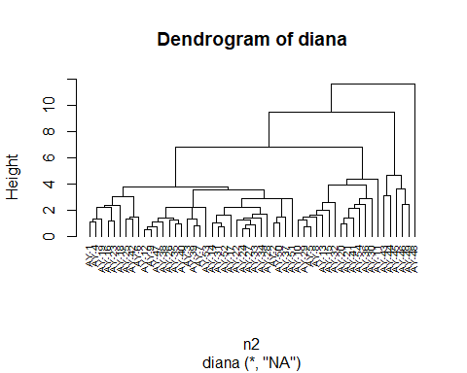

## Importance of components:  
## PC1 PC2 PC3 PC4 PC5 PC6 PC7  
## Standard deviation 1.8535 1.6722 0.76719 0.61863 0.43204 0.34429 0.2886  
## Proportion of Variance 0.4414 0.3593 0.07563 0.04918 0.02398 0.01523 0.0107  
## Cumulative Proportion 0.4414 0.8007 0.87636 0.92553 0.94952 0.96475 0.9755  
## PC8 PC9 PC10 PC11  
## Standard deviation 0.26351 0.22965 0.22167 0.14054  
## Proportion of Variance 0.00892 0.00678 0.00631 0.00254  
## Cumulative Proportion 0.98437 0.99115 0.99746 1.00000

