pXRF analysis

Uine Kailamäki

11/27/2020

## Title

set.seed(3)

A random seed is set for reprodicibility

## Rows: 54  
## Columns: 8  
## $ Area <fct> Area D Acropolis, Area D Acropolis, Area D Acropolis, Area D A...  
## $ Ti <dbl> 0.06048082, 0.24912385, 0.12480888, -0.46914039, 0.87306658, -...  
## $ Mn <dbl> 0.35014917, 0.40167424, 0.88343360, -0.58760702, 0.45062305, -...  
## $ Fe <dbl> 0.16177825, 0.11814247, 0.34377004, -0.49264733, 0.71737017, -...  
## $ Cu <dbl> 0.47734056, 0.47734056, 0.35481062, 0.04848577, 0.72240044, -0...  
## $ Zn <dbl> 1.4150105, -0.2416698, 2.3967469, -0.4871039, 0.1264814, -0.85...  
## $ Sr <dbl> -0.163489387, 0.023169208, -0.107057719, 0.053555491, 0.214168...  
## $ Zr <dbl> -0.46189040, 0.07601448, -0.07237307, 0.24295048, 0.52117715, ...

## [1] "AY-1" "AY-10" "AY-11" "AY-12" "AY-13" "AY-14" "AY-15" "AY-16" "AY-17"  
## [10] "AY-18" "AY-19" "AY-2" "AY-20" "AY-21" "AY-22" "AY-23" "AY-24" "AY-25"  
## [19] "AY-26" "AY-27" "AY-28" "AY-29" "AY-3" "AY-30" "AY-31" "AY-32" "AY-33"  
## [28] "AY-34" "AY-35" "AY-36" "AY-37" "AY-38" "AY-39" "AY-4" "AY-40" "AY-41"  
## [37] "AY-42" "AY-43" "AY-44" "AY-45" "AY-46" "AY-47" "AY-48" "AY-49" "AY-5"   
## [46] "AY-50" "AY-51" "AY-52" "AY-53" "AY-54" "AY-6" "AY-7" "AY-8" "AY-9"

## [1] "Area" "Ti" "Mn" "Fe" "Cu" "Zn" "Sr" "Zr"

## Rows: 54  
## Columns: 7  
## $ Ti <dbl> 0.06048082, 0.24912385, 0.12480888, -0.46914039, 0.87306658, -0....  
## $ Mn <dbl> 0.35014917, 0.40167424, 0.88343360, -0.58760702, 0.45062305, -0....  
## $ Fe <dbl> 0.16177825, 0.11814247, 0.34377004, -0.49264733, 0.71737017, -0....  
## $ Cu <dbl> 0.47734056, 0.47734056, 0.35481062, 0.04848577, 0.72240044, -0.0...  
## $ Zn <dbl> 1.4150105, -0.2416698, 2.3967469, -0.4871039, 0.1264814, -0.8552...  
## $ Sr <dbl> -0.163489387, 0.023169208, -0.107057719, 0.053555491, 0.21416870...  
## $ Zr <dbl> -0.46189040, 0.07601448, -0.07237307, 0.24295048, 0.52117715, -1...

## [1] "AY-1" "AY-10" "AY-11" "AY-12" "AY-13" "AY-14" "AY-15" "AY-16" "AY-17"  
## [10] "AY-18" "AY-19" "AY-2" "AY-20" "AY-21" "AY-22" "AY-23" "AY-24" "AY-25"  
## [19] "AY-26" "AY-27" "AY-28" "AY-29" "AY-3" "AY-30" "AY-31" "AY-32" "AY-33"  
## [28] "AY-34" "AY-35" "AY-36" "AY-37" "AY-38" "AY-39" "AY-4" "AY-40" "AY-41"  
## [37] "AY-42" "AY-43" "AY-44" "AY-45" "AY-46" "AY-47" "AY-48" "AY-49" "AY-5"   
## [46] "AY-50" "AY-51" "AY-52" "AY-53" "AY-54" "AY-6" "AY-7" "AY-8" "AY-9"

## [1] "Ti" "Mn" "Fe" "Cu" "Zn" "Sr" "Zr"

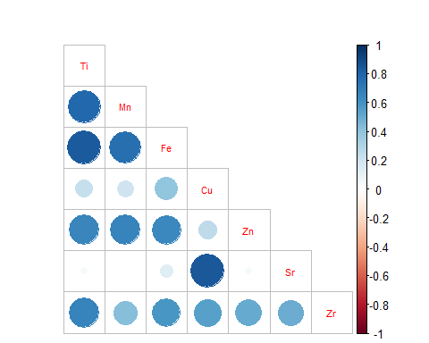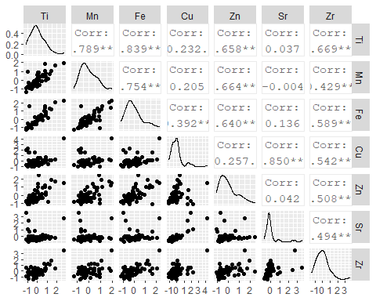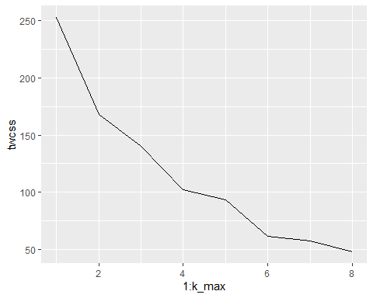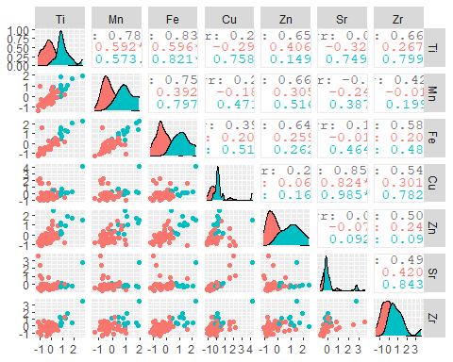

## Importance of components:  
## PC1 PC2 PC3 PC4 PC5 PC6 PC7  
## Standard deviation 1.6261 1.1229 0.56279 0.52610 0.37407 0.26036 0.25355  
## Proportion of Variance 0.5543 0.2643 0.06639 0.05802 0.02933 0.01421 0.01348  
## Cumulative Proportion 0.5543 0.8186 0.88496 0.94298 0.97231 0.98652 1.00000

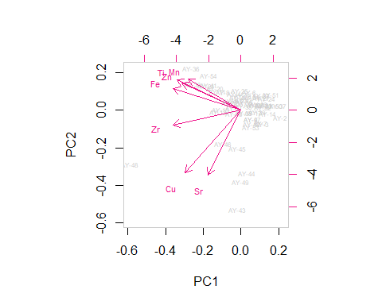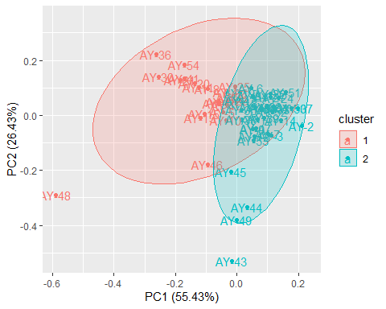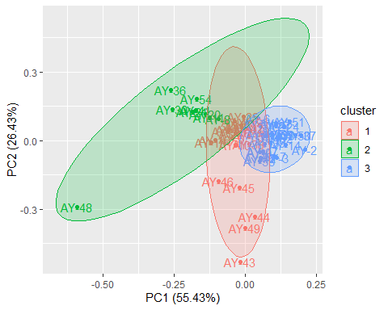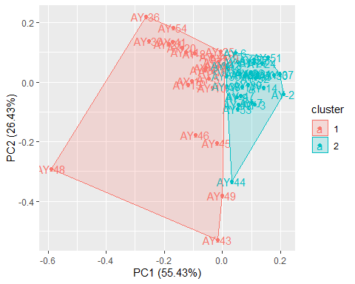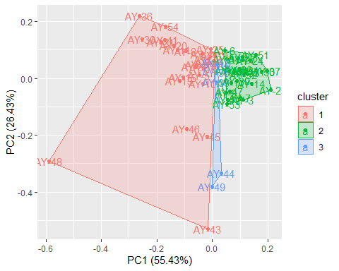

## [1] 0.8766969

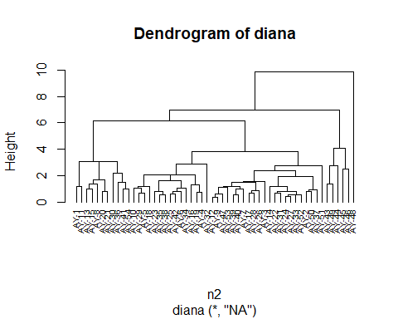

## Importance of components:  
## PC1 PC2 PC3 PC4 PC5 PC6 PC7  
## Standard deviation 1.6261 1.1229 0.56279 0.52610 0.37407 0.26036 0.25355  
## Proportion of Variance 0.5543 0.2643 0.06639 0.05802 0.02933 0.01421 0.01348  
## Cumulative Proportion 0.5543 0.8186 0.88496 0.94298 0.97231 0.98652 1.00000

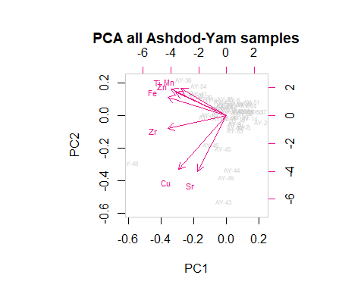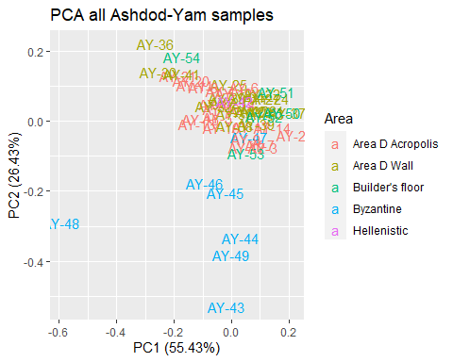

## [1] "AY-1" "AY-10" "AY-11" "AY-12" "AY-13" "AY-14" "AY-15" "AY-16" "AY-17"  
## [10] "AY-18" "AY-19" "AY-2" "AY-20" "AY-21" "AY-22" "AY-23" "AY-24" "AY-25"  
## [19] "AY-26" "AY-27" "AY-28" "AY-29" "AY-3" "AY-30" "AY-31" "AY-32" "AY-33"  
## [28] "AY-34" "AY-35" "AY-36" "AY-37" "AY-38" "AY-39" "AY-4" "AY-40" "AY-41"  
## [37] "AY-42" "AY-43" "AY-44" "AY-45" "AY-46" "AY-47" "AY-48" "AY-49" "AY-5"   
## [46] "AY-50" "AY-51" "AY-52" "AY-53" "AY-54" "AY-6" "AY-7" "AY-8" "AY-9"

## [1] "AY-1" "AY-10" "AY-11" "AY-12" "AY-13" "AY-14" "AY-15" "AY-16" "AY-17"  
## [10] "AY-18" "AY-19" "AY-2" "AY-20" "AY-21" "AY-22" "AY-23" "AY-24" "AY-25"  
## [19] "AY-26" "AY-27" "AY-28" "AY-29" "AY-3" "AY-30" "AY-31" "AY-32" "AY-33"  
## [28] "AY-34" "AY-35" "AY-36" "AY-37" "AY-38" "AY-39" "AY-4" "AY-40" "AY-41"  
## [37] "AY-42" "AY-5" "AY-50" "AY-51" "AY-52" "AY-53" "AY-54" "AY-6" "AY-7"   
## [46] "AY-8" "AY-9"

## Importance of components:  
## PC1 PC2 PC3 PC4 PC5 PC6 PC7  
## Standard deviation 1.4238 0.6107 0.53717 0.35983 0.31484 0.17781 0.11267  
## Proportion of Variance 0.6845 0.1259 0.09743 0.04372 0.03347 0.01068 0.00429  
## Cumulative Proportion 0.6845 0.8104 0.90785 0.95157 0.98504 0.99571 1.00000

