pXRF analysis

Uine Kailamäki

11/27/2020

## Title

Text

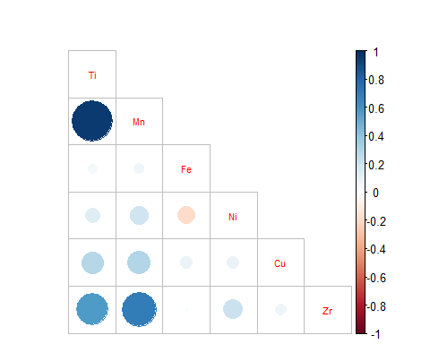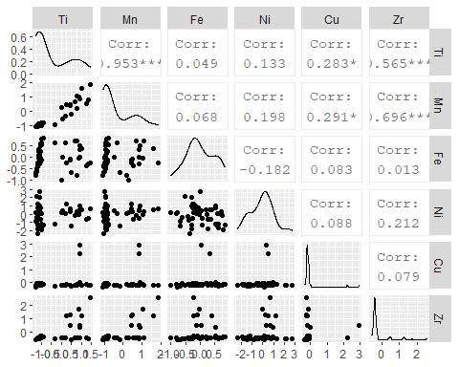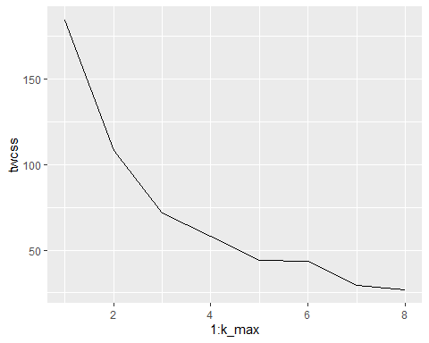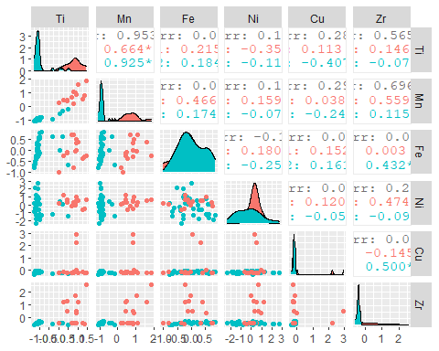

## Importance of components:  
## PC1 PC2 PC3 PC4 PC5 PC6  
## Standard deviation 1.3282 1.0351 0.54269 0.45510 0.43314 0.14521  
## Proportion of Variance 0.4975 0.3022 0.08306 0.05841 0.05291 0.00595  
## Cumulative Proportion 0.4975 0.7997 0.88273 0.94114 0.99405 1.00000

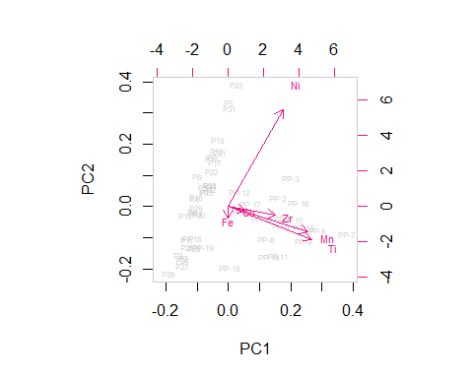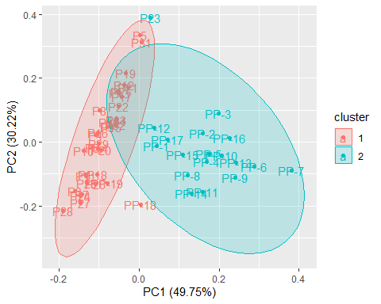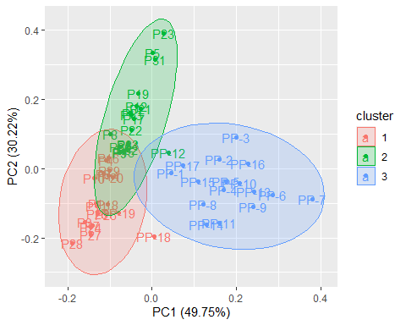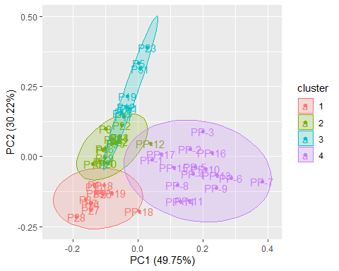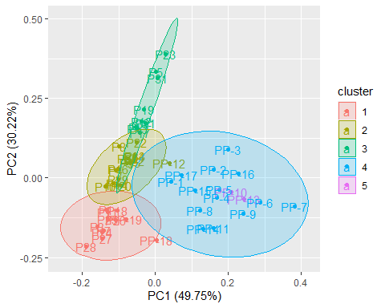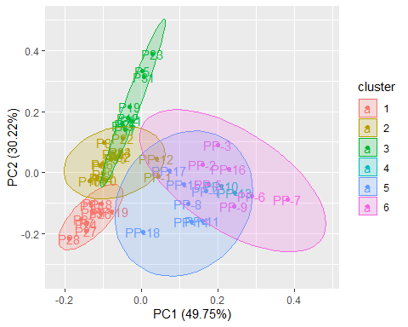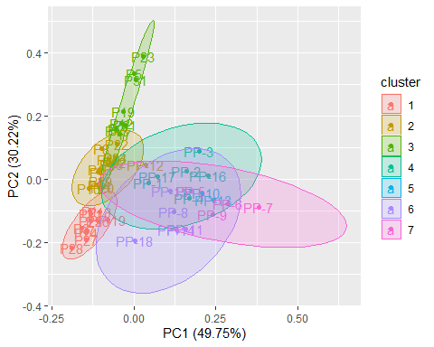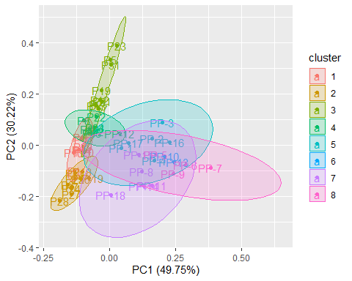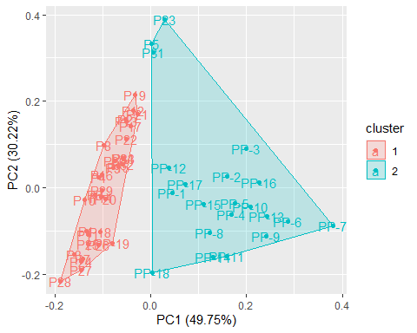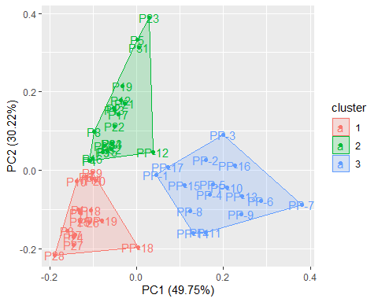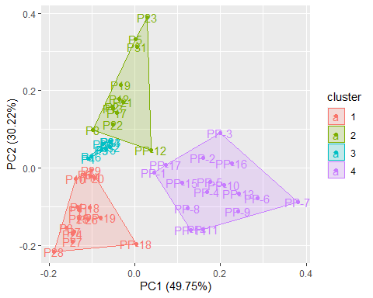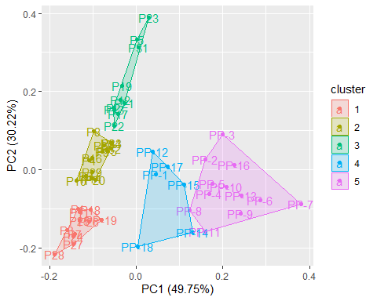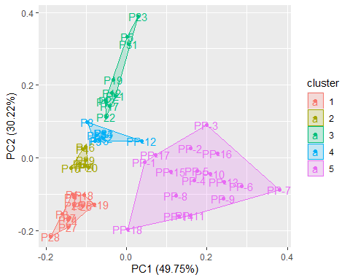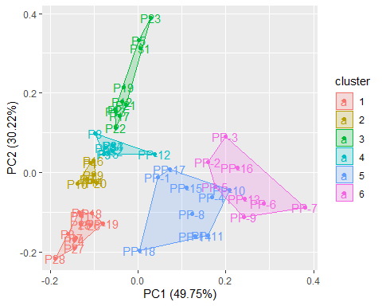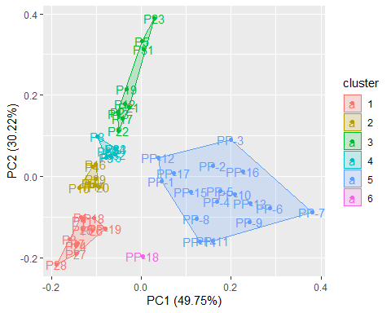

## [1] "P1" "P10" "P11" "P12" "P13" "P14" "P15" "P16" "P17"   
## [10] "P18" "P19" "P2" "P20" "P21" "P22" "P23" "P24" "P25"   
## [19] "P26" "P27" "P28" "P29" "P3" "P30" "P31" "P32" "P33"   
## [28] "P34" "P4" "P5" "P6" "P7" "P8" "P9" "PP-1" "PP-10"  
## [37] "PP-11" "PP-12" "PP-13" "PP-14" "PP-15" "PP-16" "PP-17" "PP-18" "PP-19"  
## [46] "PP-2" "PP-3" "PP-4" "PP-5" "PP-6" "PP-7" "PP-8" "PP-9"

## [1] "P1" "P10" "P11" "P12" "P13" "P14" "P15" "P16" "P17"   
## [10] "P18" "P19" "P2" "P20" "P21" "P22" "P23" "P24" "P25"   
## [19] "P26" "P27" "P28" "P29" "P3" "P30" "P31" "P32" "P33"   
## [28] "P34" "P4" "P5" "P6" "P7" "P8" "P9" "PP-10" "PP-11"  
## [37] "PP-12" "PP-13" "PP-14" "PP-15" "PP-16" "PP-17" "PP-18" "PP-19" "PP-9"

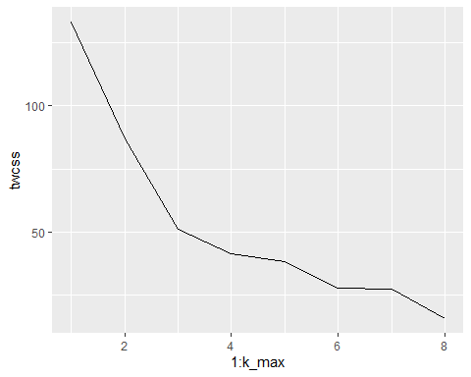

## Importance of components:  
## PC1 PC2 PC3 PC4 PC5 PC6  
## Standard deviation 1.1617 1.0603 0.52348 0.42158 0.30688 0.1031  
## Proportion of Variance 0.4454 0.3710 0.09043 0.05865 0.03108 0.0035  
## Cumulative Proportion 0.4454 0.8163 0.90676 0.96542 0.99650 1.0000

