pXRF analysis

Uine Kailamäki

11/27/2020

## Title

set.seed(3)

A random seed is set for reprodicibility

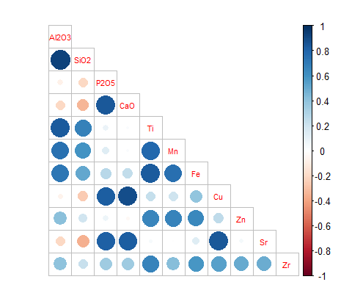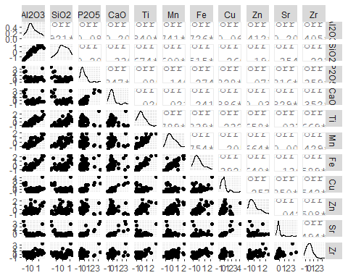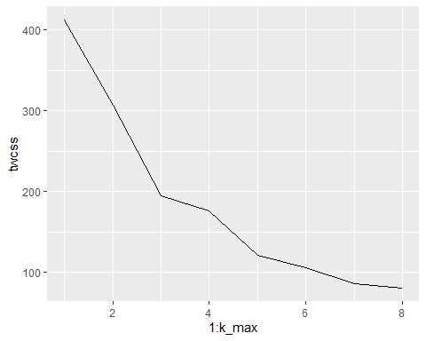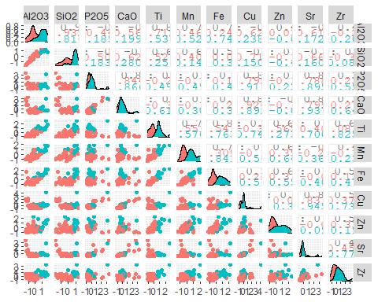

## Importance of components:  
## PC1 PC2 PC3 PC4 PC5 PC6 PC7  
## Standard deviation 1.8535 1.6722 0.76719 0.61863 0.43204 0.34429 0.2886  
## Proportion of Variance 0.4414 0.3593 0.07563 0.04918 0.02398 0.01523 0.0107  
## Cumulative Proportion 0.4414 0.8007 0.87636 0.92553 0.94952 0.96475 0.9755  
## PC8 PC9 PC10 PC11  
## Standard deviation 0.26351 0.22965 0.22167 0.14054  
## Proportion of Variance 0.00892 0.00678 0.00631 0.00254  
## Cumulative Proportion 0.98437 0.99115 0.99746 1.00000

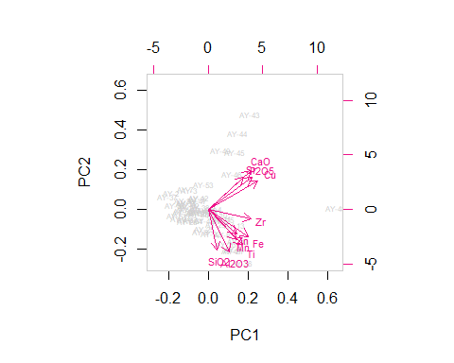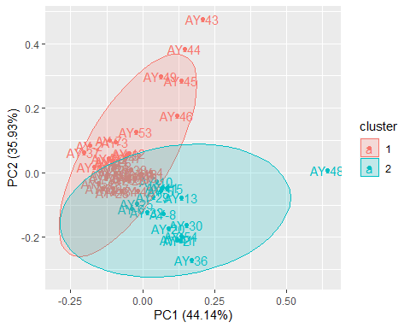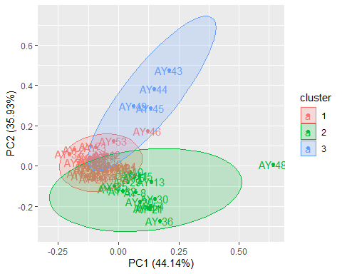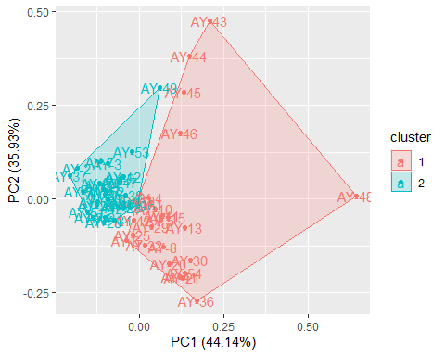

## [1] "AY-1" "AY-10" "AY-11" "AY-12" "AY-13" "AY-14" "AY-15" "AY-16" "AY-17"  
## [10] "AY-18" "AY-19" "AY-2" "AY-20" "AY-21" "AY-22" "AY-23" "AY-24" "AY-25"  
## [19] "AY-26" "AY-27" "AY-28" "AY-29" "AY-3" "AY-30" "AY-31" "AY-32" "AY-33"  
## [28] "AY-34" "AY-35" "AY-36" "AY-37" "AY-38" "AY-39" "AY-4" "AY-40" "AY-41"  
## [37] "AY-42" "AY-43" "AY-44" "AY-45" "AY-46" "AY-47" "AY-48" "AY-49" "AY-5"   
## [46] "AY-50" "AY-51" "AY-52" "AY-53" "AY-54" "AY-6" "AY-7" "AY-8" "AY-9"

## [1] "AY-1" "AY-10" "AY-11" "AY-12" "AY-13" "AY-14" "AY-15" "AY-16" "AY-17"  
## [10] "AY-18" "AY-19" "AY-2" "AY-20" "AY-21" "AY-22" "AY-23" "AY-24" "AY-25"  
## [19] "AY-26" "AY-27" "AY-28" "AY-29" "AY-3" "AY-30" "AY-31" "AY-32" "AY-33"  
## [28] "AY-34" "AY-35" "AY-36" "AY-37" "AY-38" "AY-39" "AY-4" "AY-41" "AY-42"  
## [37] "AY-43" "AY-44" "AY-45" "AY-46" "AY-47" "AY-48" "AY-49" "AY-5" "AY-8"   
## [46] "AY-9"

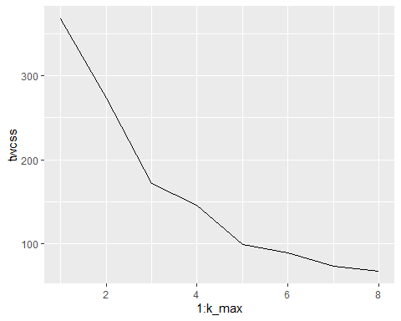

## Importance of components:  
## PC1 PC2 PC3 PC4 PC5 PC6 PC7  
## Standard deviation 1.9047 1.7348 0.77157 0.61544 0.42608 0.34584 0.27846  
## Proportion of Variance 0.4438 0.3682 0.07283 0.04634 0.02221 0.01463 0.00949  
## Cumulative Proportion 0.4438 0.8120 0.88483 0.93116 0.95337 0.96801 0.97749  
## PC8 PC9 PC10 PC11  
## Standard deviation 0.26595 0.23012 0.20723 0.13179  
## Proportion of Variance 0.00865 0.00648 0.00525 0.00212  
## Cumulative Proportion 0.98614 0.99262 0.99788 1.00000

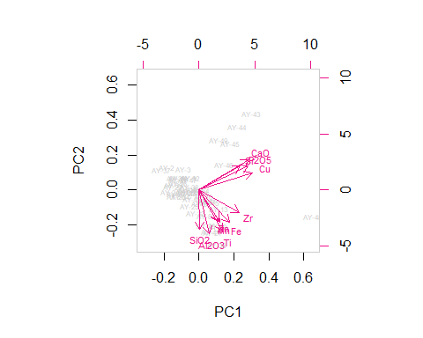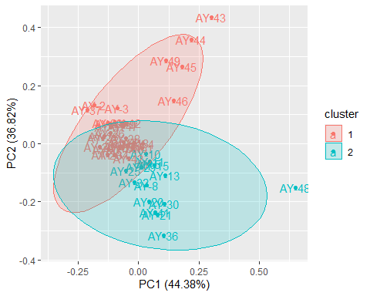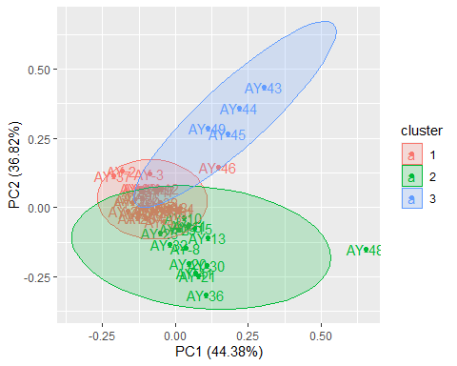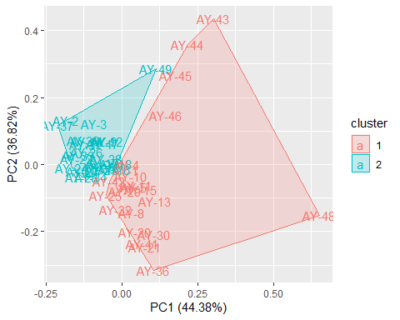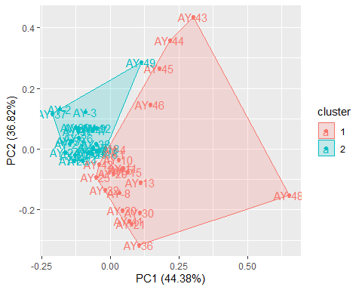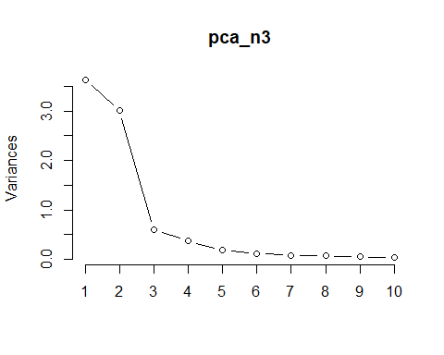

## [1] 0.8589872

