pXRF analysis

Uine Kailamäki

11/27/2020

## Title

set.seed(3)

A random seed is set for reprodicibility

## Rows: 54  
## Columns: 9  
## $ Type <fct> mudbrick, mudbrick, mudbrick, mudbrick, mudbrick, mudbrick, mu...  
## $ Area <fct> Area D Acropolis, Area D Acropolis, Area D Acropolis, Area D A...  
## $ Ti <dbl> 0.075580150, 0.267036203, 0.140867465, 0.900283105, -0.4166781...  
## $ Mn <dbl> 0.37436618, 0.42662947, 0.91529121, 0.47627959, -0.73361551, -...  
## $ Fe <dbl> 0.18786829, 0.14368601, 0.37213936, 0.75041850, -0.44920083, 0...  
## $ Cu <dbl> 0.52006470, 0.52006470, 0.39591324, 0.76836763, -0.03861688, 0...  
## $ Zn <dbl> 1.42776399, -0.23652717, 2.41401059, 0.13331531, -0.85293130, ...  
## $ Sr <dbl> -0.13799936, 0.05213538, -0.08051676, 0.24669185, -0.40330364,...  
## $ Zr <dbl> -0.42016363, 0.11088317, -0.03561250, 0.55037018, -1.36322951,...

## [1] "AY-1" "AY-10" "AY-11" "AY-13" "AY-14" "AY-15" "AY-16" "AY-17" "AY-18"  
## [10] "AY-19" "AY-2" "AY-20" "AY-21" "AY-3" "AY-4" "AY-5" "AY-7" "AY-9"   
## [19] "AY-12" "AY-39" "AY-27" "AY-29" "AY-40" "AY-6" "AY-8" "AY-22" "AY-23"  
## [28] "AY-24" "AY-25" "AY-26" "AY-28" "AY-30" "AY-31" "AY-32" "AY-33" "AY-34"  
## [37] "AY-35" "AY-36" "AY-37" "AY-38" "AY-41" "AY-50" "AY-51" "AY-52" "AY-53"  
## [46] "AY-54" "AY-43" "AY-47" "AY-48" "AY-44" "AY-45" "AY-46" "AY-49" "AY-42"

## [1] "Type" "Area" "Ti" "Mn" "Fe" "Cu" "Zn" "Sr" "Zr"

## Rows: 54  
## Columns: 7  
## $ Ti <dbl> 0.075580150, 0.267036203, 0.140867465, 0.900283105, -0.416678194...  
## $ Mn <dbl> 0.37436618, 0.42662947, 0.91529121, 0.47627959, -0.73361551, -0....  
## $ Fe <dbl> 0.18786829, 0.14368601, 0.37213936, 0.75041850, -0.44920083, 0.5...  
## $ Cu <dbl> 0.52006470, 0.52006470, 0.39591324, 0.76836763, -0.03861688, 0.2...  
## $ Zn <dbl> 1.42776399, -0.23652717, 2.41401059, 0.13331531, -0.85293130, 0....  
## $ Sr <dbl> -0.13799936, 0.05213538, -0.08051676, 0.24669185, -0.40330364, 0...  
## $ Zr <dbl> -0.42016363, 0.11088317, -0.03561250, 0.55037018, -1.36322951, 1...

## [1] "AY-1" "AY-10" "AY-11" "AY-13" "AY-14" "AY-15" "AY-16" "AY-17" "AY-18"  
## [10] "AY-19" "AY-2" "AY-20" "AY-21" "AY-3" "AY-4" "AY-5" "AY-7" "AY-9"   
## [19] "AY-12" "AY-39" "AY-27" "AY-29" "AY-40" "AY-6" "AY-8" "AY-22" "AY-23"  
## [28] "AY-24" "AY-25" "AY-26" "AY-28" "AY-30" "AY-31" "AY-32" "AY-33" "AY-34"  
## [37] "AY-35" "AY-36" "AY-37" "AY-38" "AY-41" "AY-50" "AY-51" "AY-52" "AY-53"  
## [46] "AY-54" "AY-43" "AY-47" "AY-48" "AY-44" "AY-45" "AY-46" "AY-49" "AY-42"

## [1] "Ti" "Mn" "Fe" "Cu" "Zn" "Sr" "Zr"

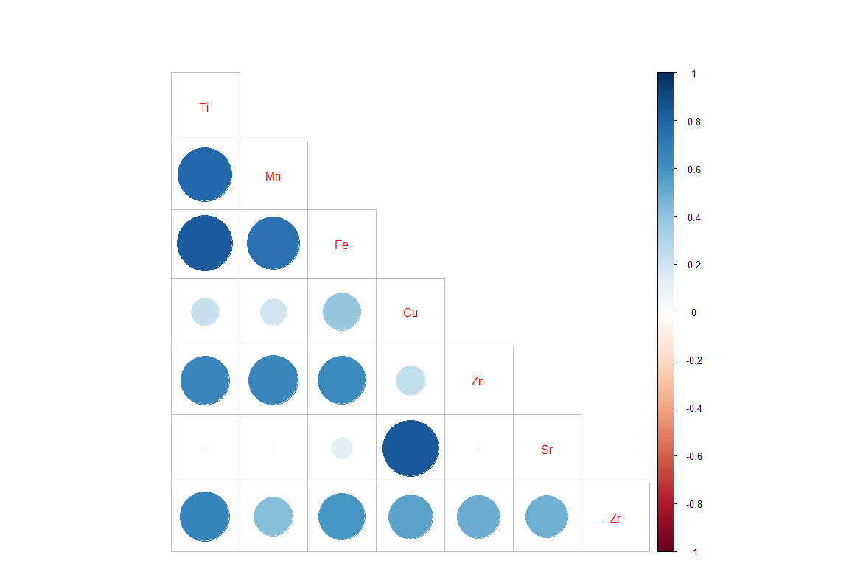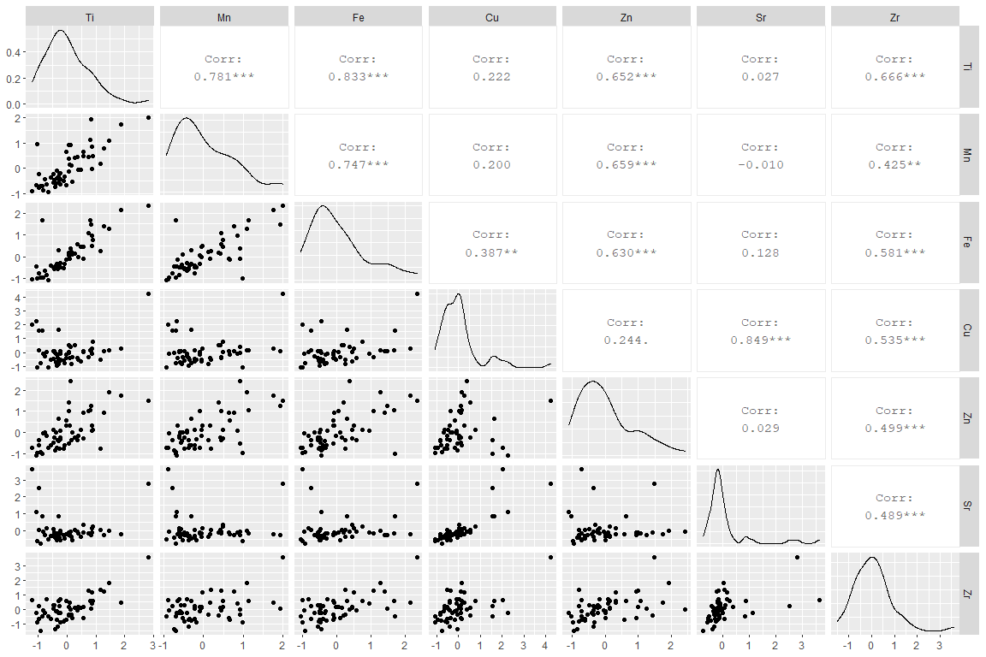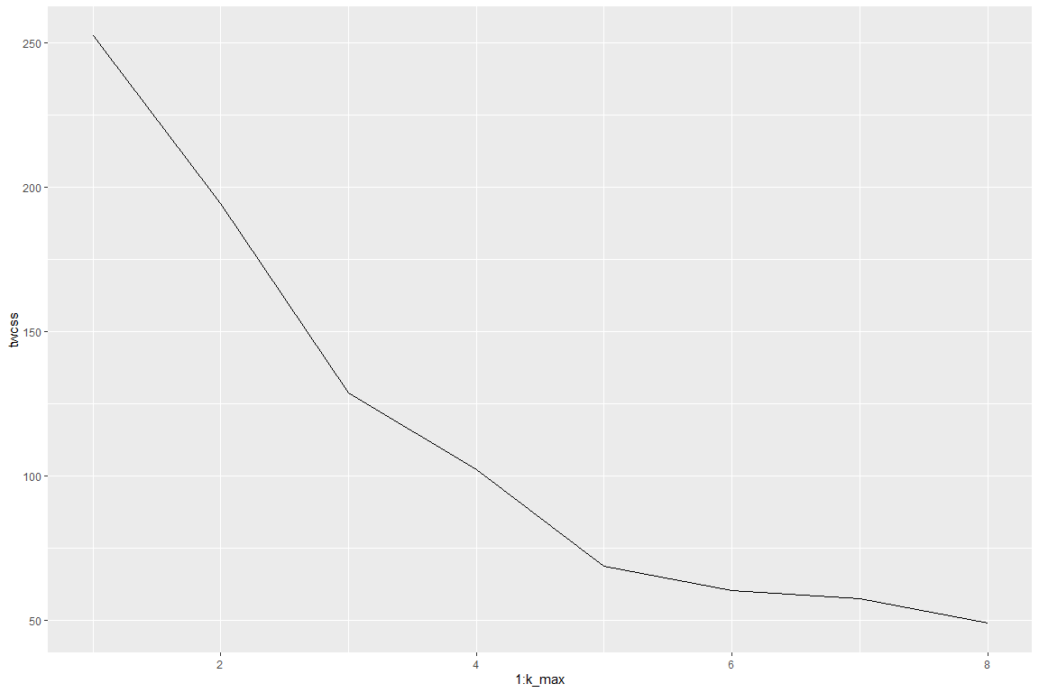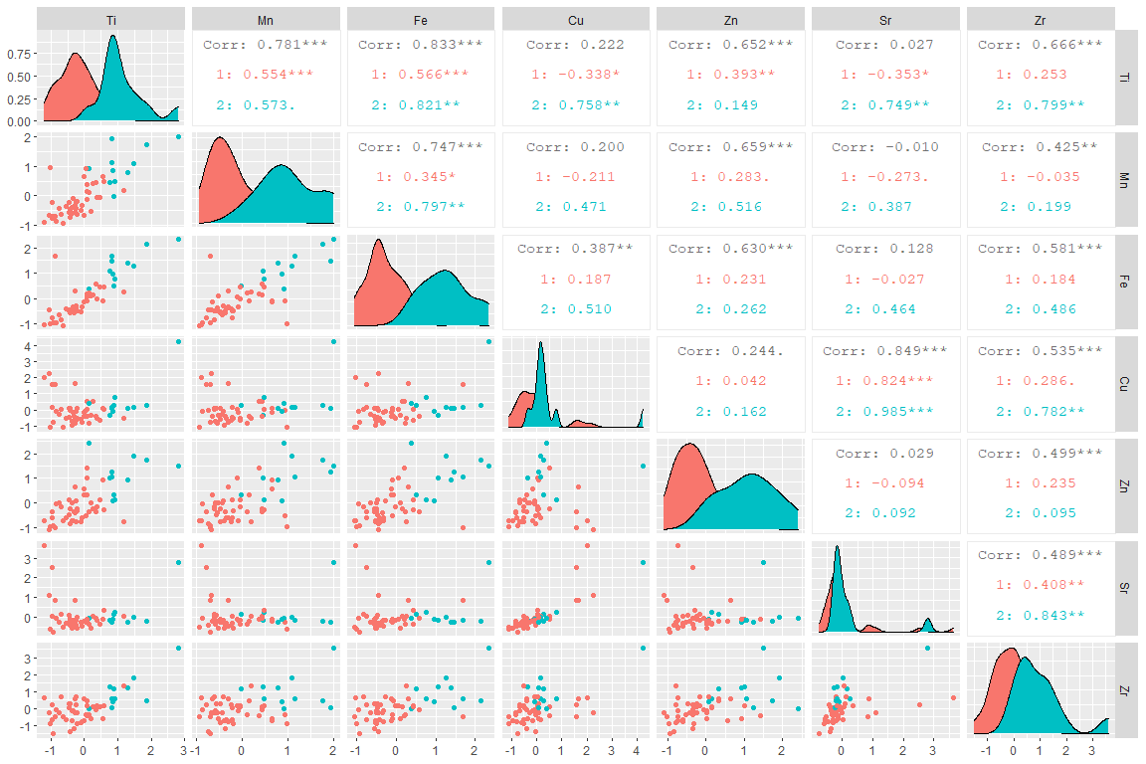

## Importance of components:  
## PC1 PC2 PC3 PC4 PC5 PC6 PC7  
## Standard deviation 1.6114 1.1376 0.56274 0.52823 0.37649 0.26319 0.25717  
## Proportion of Variance 0.5451 0.2717 0.06648 0.05858 0.02976 0.01454 0.01388  
## Cumulative Proportion 0.5451 0.8168 0.88324 0.94182 0.97158 0.98612 1.00000

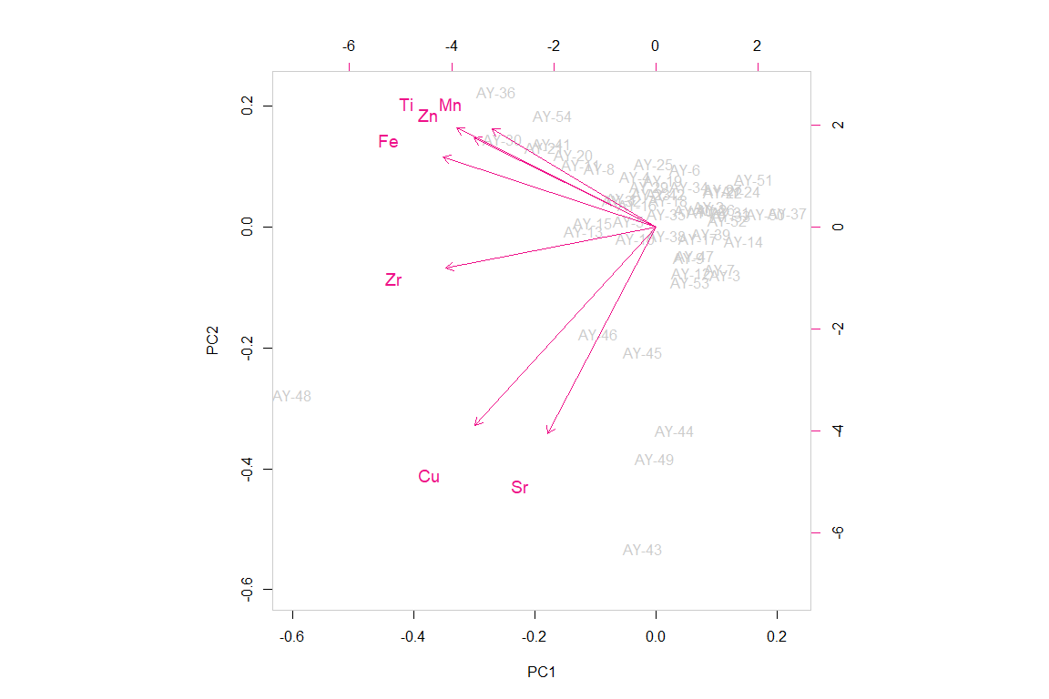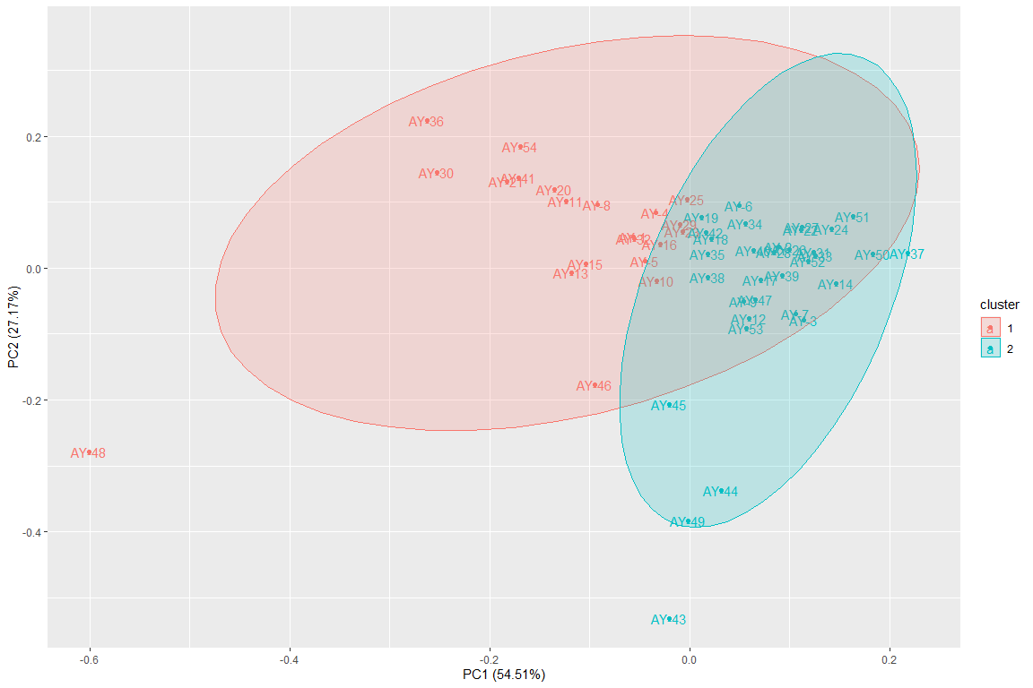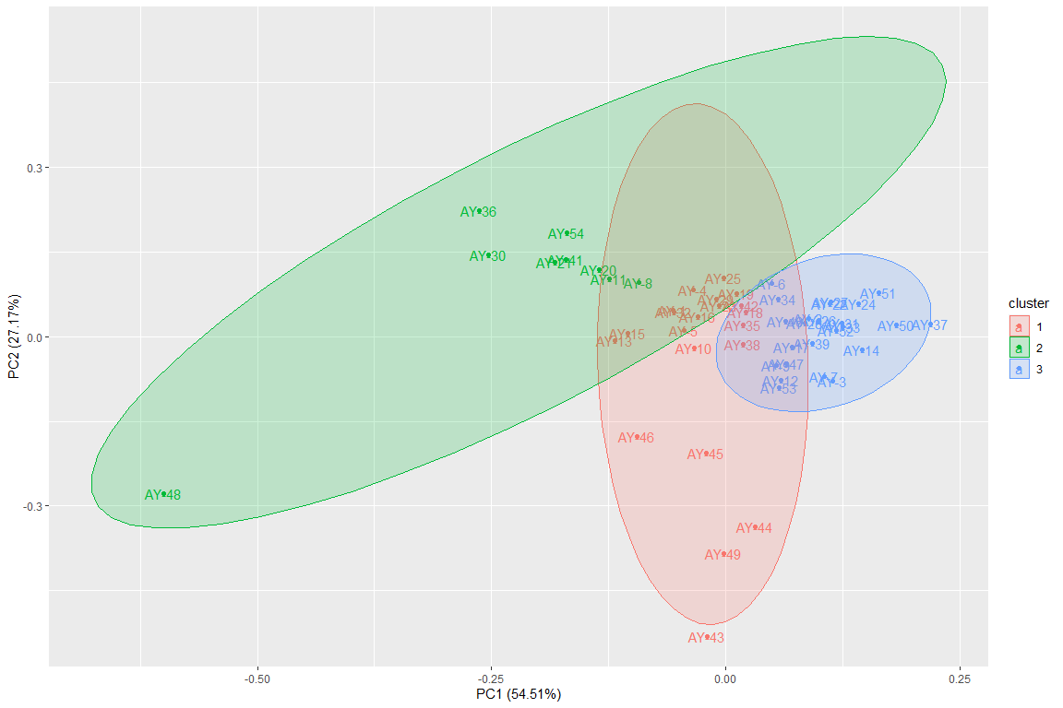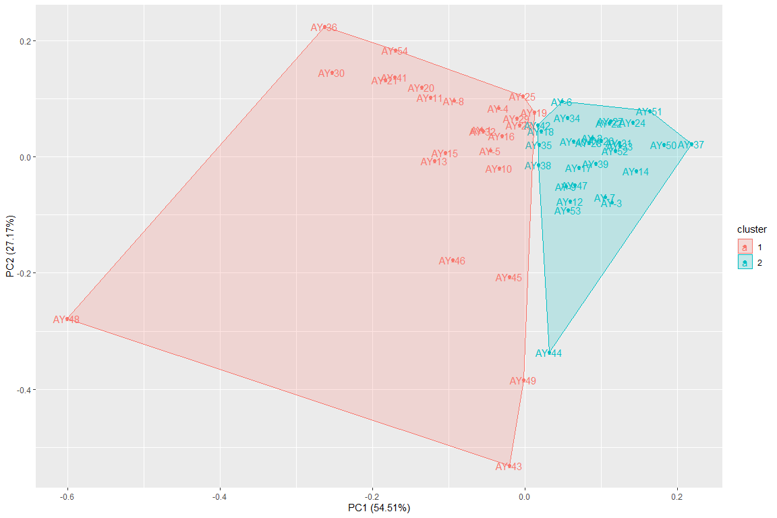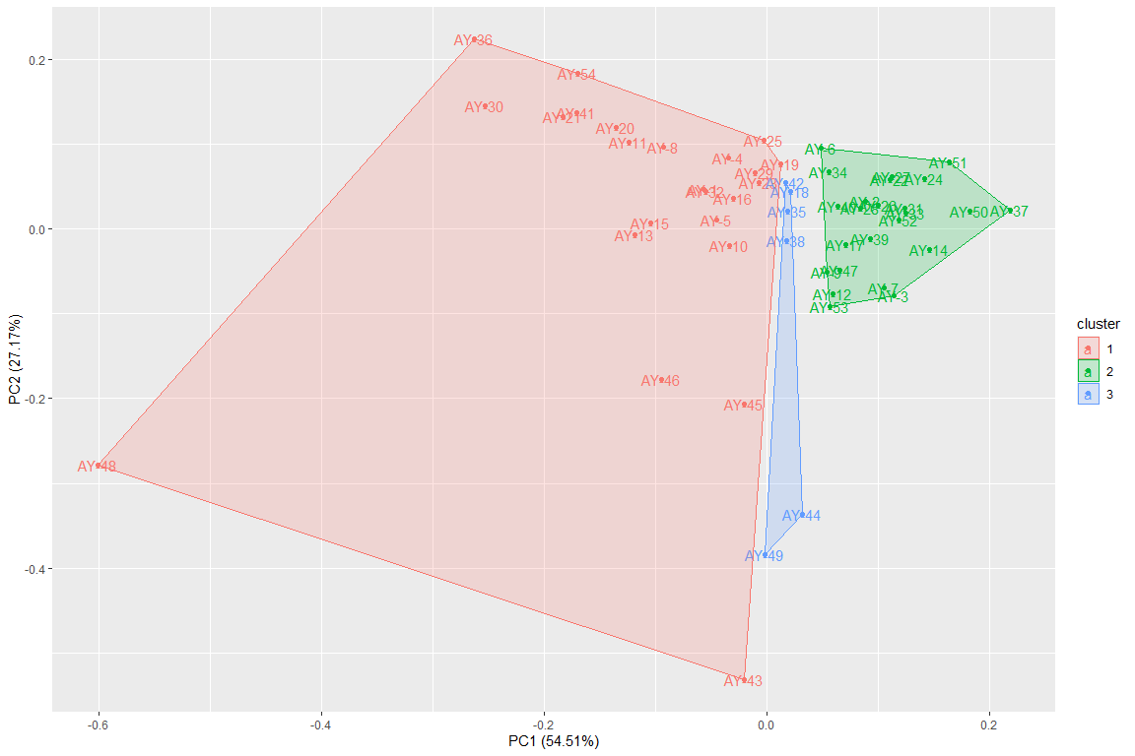

## [1] 0.8785454

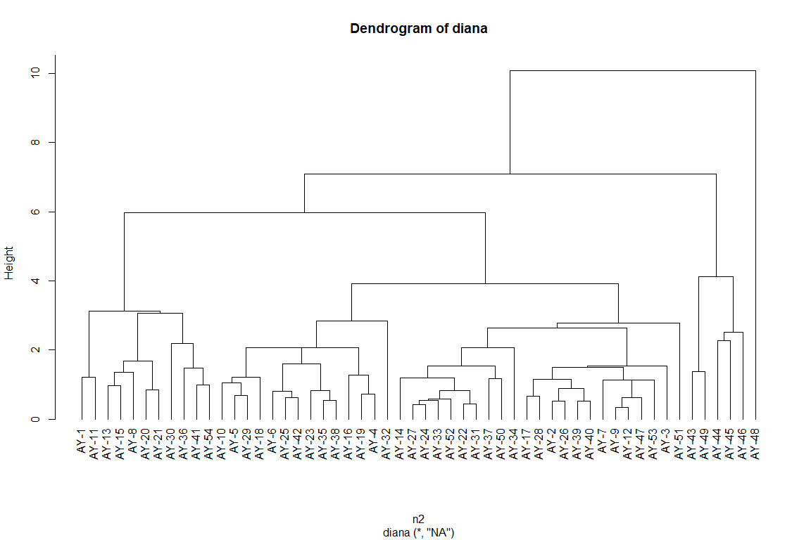

## Importance of components:  
## PC1 PC2 PC3 PC4 PC5 PC6 PC7  
## Standard deviation 1.6114 1.1376 0.56274 0.52823 0.37649 0.26319 0.25717  
## Proportion of Variance 0.5451 0.2717 0.06648 0.05858 0.02976 0.01454 0.01388  
## Cumulative Proportion 0.5451 0.8168 0.88324 0.94182 0.97158 0.98612 1.00000

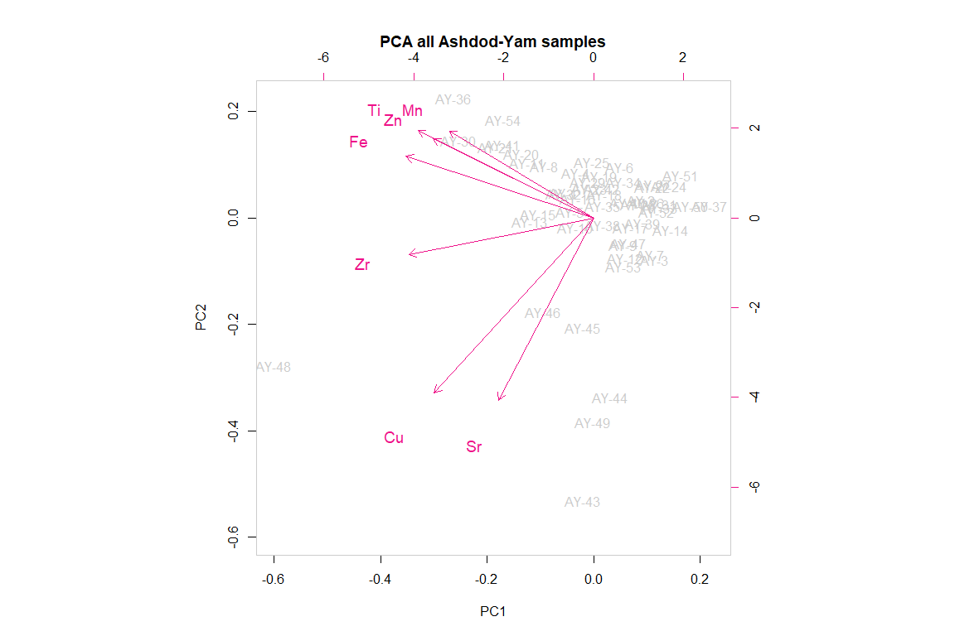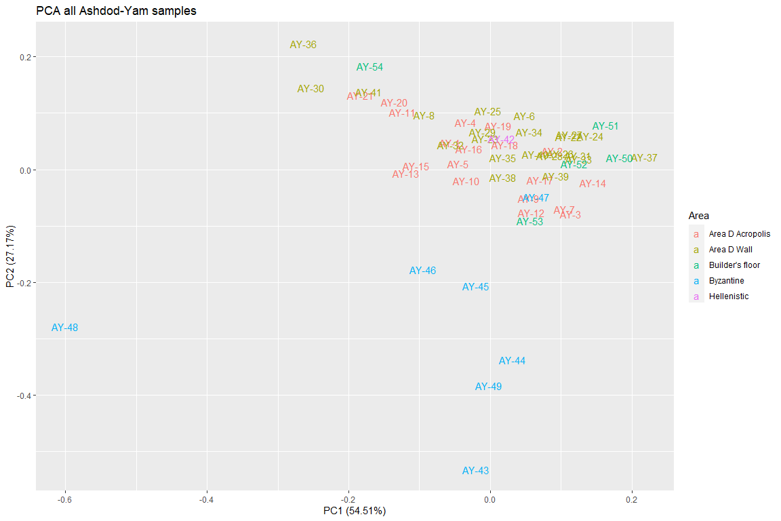

## [1] "AY-1" "AY-10" "AY-11" "AY-13" "AY-14" "AY-15" "AY-16" "AY-17" "AY-18"  
## [10] "AY-19" "AY-2" "AY-20" "AY-21" "AY-3" "AY-4" "AY-5" "AY-7" "AY-9"   
## [19] "AY-12" "AY-39" "AY-27" "AY-29" "AY-40" "AY-6" "AY-8" "AY-22" "AY-23"  
## [28] "AY-24" "AY-25" "AY-26" "AY-28" "AY-30" "AY-31" "AY-32" "AY-33" "AY-34"  
## [37] "AY-35" "AY-36" "AY-37" "AY-38" "AY-41" "AY-50" "AY-51" "AY-52" "AY-53"  
## [46] "AY-54" "AY-43" "AY-47" "AY-48" "AY-44" "AY-45" "AY-46" "AY-49" "AY-42"

## [1] "AY-1" "AY-10" "AY-11" "AY-13" "AY-14" "AY-15" "AY-16" "AY-17" "AY-18"  
## [10] "AY-19" "AY-2" "AY-20" "AY-21" "AY-3" "AY-4" "AY-5" "AY-7" "AY-9"   
## [19] "AY-12" "AY-39" "AY-27" "AY-29" "AY-40" "AY-6" "AY-8" "AY-22" "AY-23"  
## [28] "AY-24" "AY-25" "AY-26" "AY-28" "AY-30" "AY-31" "AY-32" "AY-33" "AY-34"  
## [37] "AY-35" "AY-36" "AY-37" "AY-38" "AY-41" "AY-50" "AY-51" "AY-52" "AY-53"  
## [46] "AY-54" "AY-42"

## Importance of components:  
## PC1 PC2 PC3 PC4 PC5 PC6 PC7  
## Standard deviation 1.399 0.6073 0.53631 0.36984 0.31870 0.1785 0.11061  
## Proportion of Variance 0.676 0.1273 0.09928 0.04721 0.03506 0.0110 0.00422  
## Cumulative Proportion 0.676 0.8032 0.90251 0.94972 0.98478 0.9958 1.00000

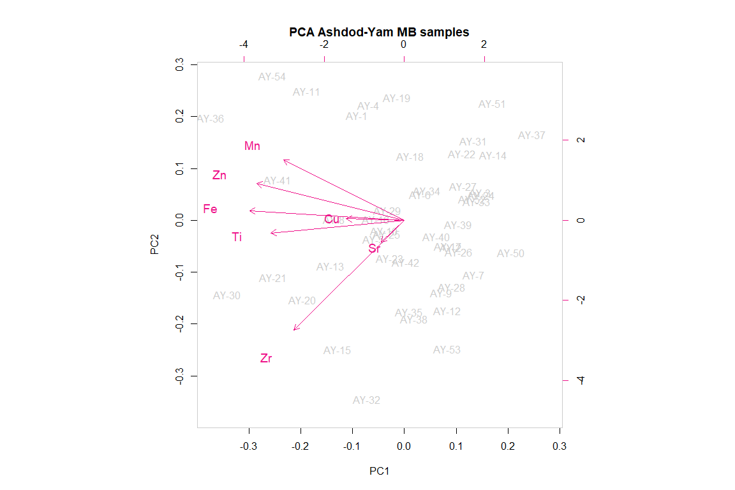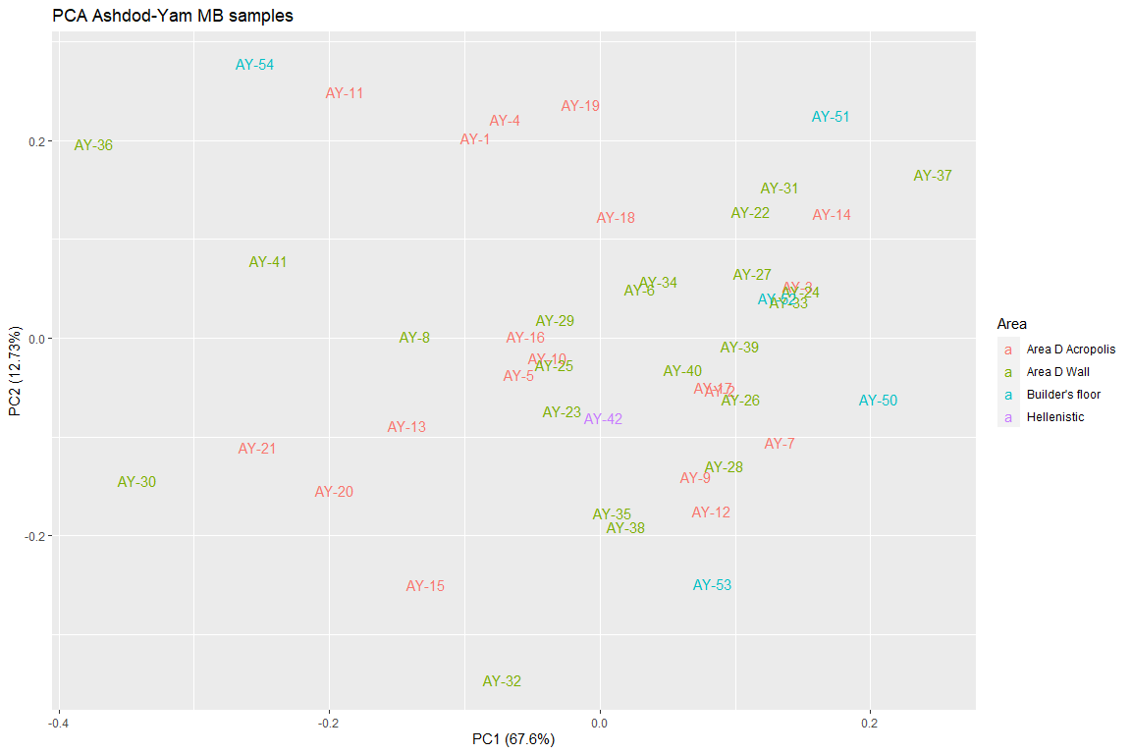

## Rows: 54  
## Columns: 9  
## $ Type <fct> mudbrick, mudbrick, mudbrick, mudbrick, mudbrick, mudbrick, mu...  
## $ Area <fct> Area D Acropolis, Area D Acropolis, Area D Acropolis, Area D A...  
## $ Ti <dbl> 0.075580150, 0.267036203, 0.140867465, 0.900283105, -0.4166781...  
## $ Mn <dbl> 0.37436618, 0.42662947, 0.91529121, 0.47627959, -0.73361551, -...  
## $ Fe <dbl> 0.18786829, 0.14368601, 0.37213936, 0.75041850, -0.44920083, 0...  
## $ Cu <dbl> 0.52006470, 0.52006470, 0.39591324, 0.76836763, -0.03861688, 0...  
## $ Zn <dbl> 1.42776399, -0.23652717, 2.41401059, 0.13331531, -0.85293130, ...  
## $ Sr <dbl> -0.13799936, 0.05213538, -0.08051676, 0.24669185, -0.40330364,...  
## $ Zr <dbl> -0.42016363, 0.11088317, -0.03561250, 0.55037018, -1.36322951,...

