pXRF analysis

Uine Kailamäki

11/27/2020

## Title

set.seed(3)

A random seed is set for reprodicibility

## Rows: 53  
## Columns: 8  
## $ Type <fct> mudbrick, mudbrick, mudbrick, mudbrick, mudbrick, mudbrick, mu...  
## $ Area <fct> new, new, new, new, new, new, new, new, new, new, new, old, ol...  
## $ Ti <dbl> -0.08864489, 0.50860567, -1.30244990, -0.13427226, 0.32083150,...  
## $ Mn <dbl> -0.16094790, -0.19109377, -1.63345806, -0.16326681, -0.5435686...  
## $ Fe <dbl> -0.28329566, -0.09906124, -1.56867933, -0.37096045, -0.2720847...  
## $ Ni <dbl> 0.485920350, -0.505670441, 0.423945925, 0.361971501, -0.660606...  
## $ Cu <dbl> 2.25063918, -0.62019844, -0.55495213, 2.23432760, -0.01667007,...  
## $ Zr <dbl> -0.429976074, -0.747514761, -0.006591157, 0.681409332, -0.0418...

## [1] "PP-10" "PP-11" "PP-12" "PP-13" "PP-14" "PP-15" "PP-16" "PP-17" "PP-18"  
## [10] "PP-19" "PP-9" "P1" "P10" "P11" "P12" "P13" "P14" "P15"   
## [19] "P16" "P17" "P18" "P19" "P2" "P20" "P21" "P22" "P23"   
## [28] "P24" "P25" "P26" "P27" "P28" "P29" "P3" "P30" "P31"   
## [37] "P32" "P33" "P34" "P4" "P5" "P6" "P7" "P8" "P9"   
## [46] "PP-1" "PP-2" "PP-3" "PP-4" "PP-5" "PP-6" "PP-7" "PP-8"

## [1] "Type" "Area" "Ti" "Mn" "Fe" "Ni" "Cu" "Zr"

## Rows: 53  
## Columns: 6  
## $ Ti <dbl> -0.08864489, 0.50860567, -1.30244990, -0.13427226, 0.32083150, -...  
## $ Mn <dbl> -0.16094790, -0.19109377, -1.63345806, -0.16326681, -0.54356865,...  
## $ Fe <dbl> -0.28329566, -0.09906124, -1.56867933, -0.37096045, -0.27208479,...  
## $ Ni <dbl> 0.485920350, -0.505670441, 0.423945925, 0.361971501, -0.66060650...  
## $ Cu <dbl> 2.25063918, -0.62019844, -0.55495213, 2.23432760, -0.01667007, 0...  
## $ Zr <dbl> -0.429976074, -0.747514761, -0.006591157, 0.681409332, -0.041873...

## [1] "PP-10" "PP-11" "PP-12" "PP-13" "PP-14" "PP-15" "PP-16" "PP-17" "PP-18"  
## [10] "PP-19" "PP-9" "P1" "P10" "P11" "P12" "P13" "P14" "P15"   
## [19] "P16" "P17" "P18" "P19" "P2" "P20" "P21" "P22" "P23"   
## [28] "P24" "P25" "P26" "P27" "P28" "P29" "P3" "P30" "P31"   
## [37] "P32" "P33" "P34" "P4" "P5" "P6" "P7" "P8" "P9"   
## [46] "PP-1" "PP-2" "PP-3" "PP-4" "PP-5" "PP-6" "PP-7" "PP-8"

## [1] "Ti" "Mn" "Fe" "Ni" "Cu" "Zr"

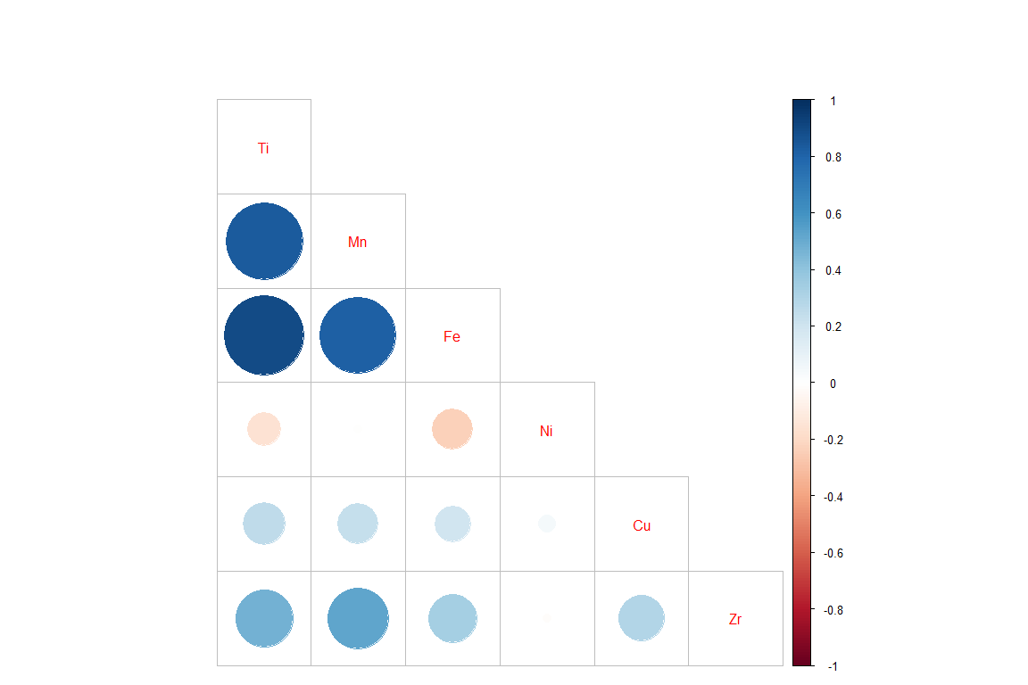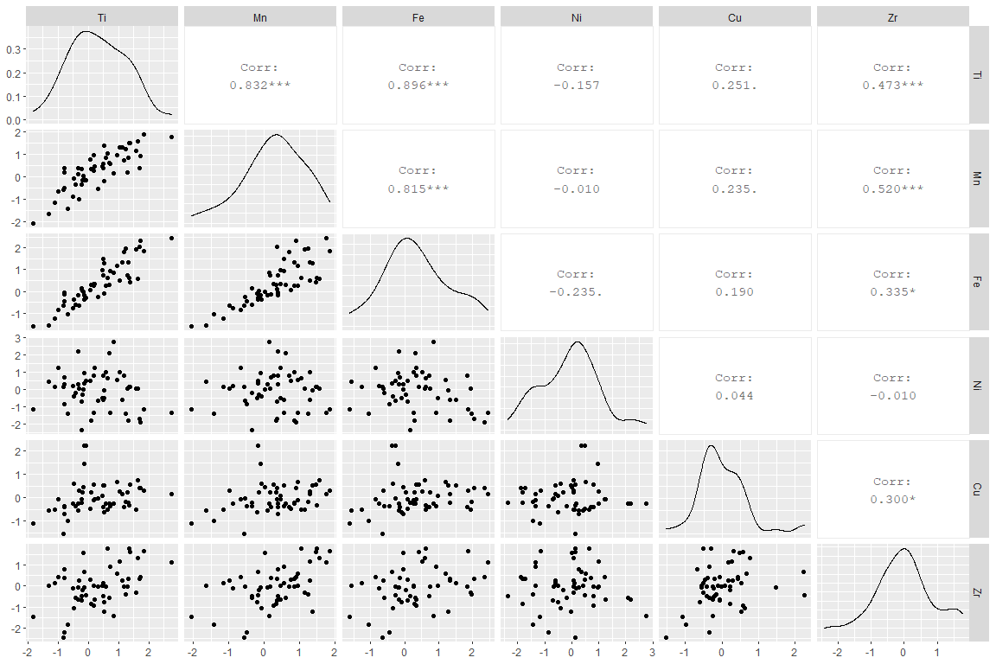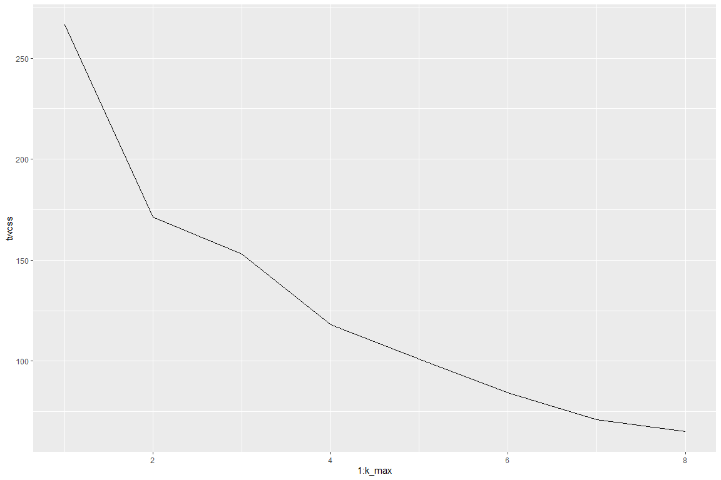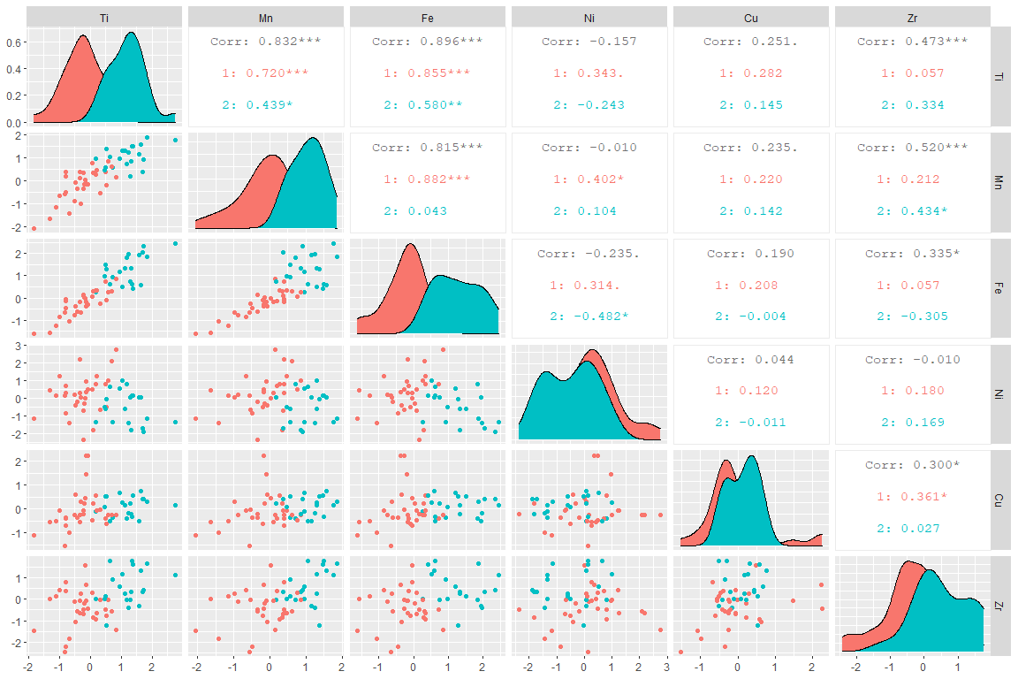

## Importance of components:  
## PC1 PC2 PC3 PC4 PC5 PC6  
## Standard deviation 1.6328 1.0883 0.8191 0.62862 0.35886 0.28046  
## Proportion of Variance 0.5203 0.2312 0.1309 0.07712 0.02513 0.01535  
## Cumulative Proportion 0.5203 0.7514 0.8824 0.95952 0.98465 1.00000

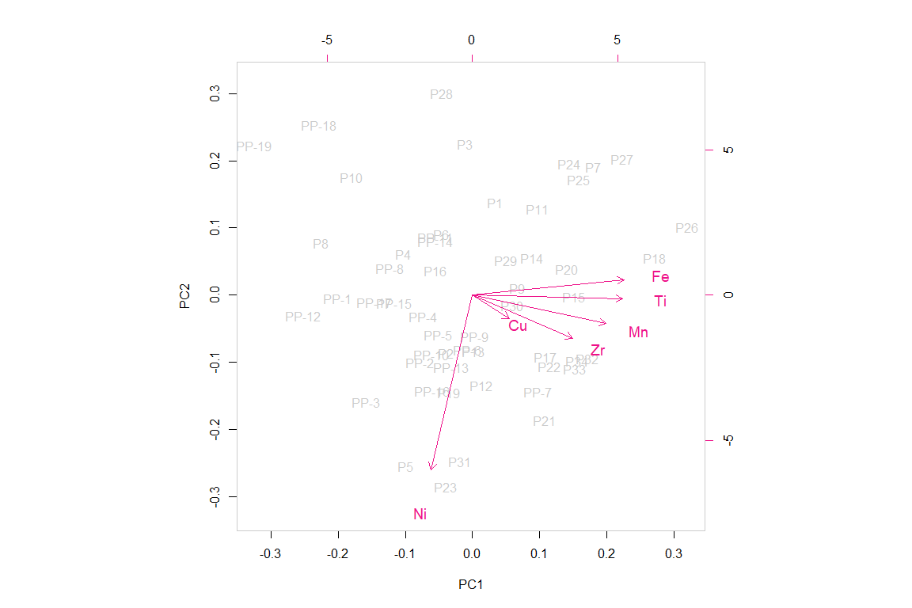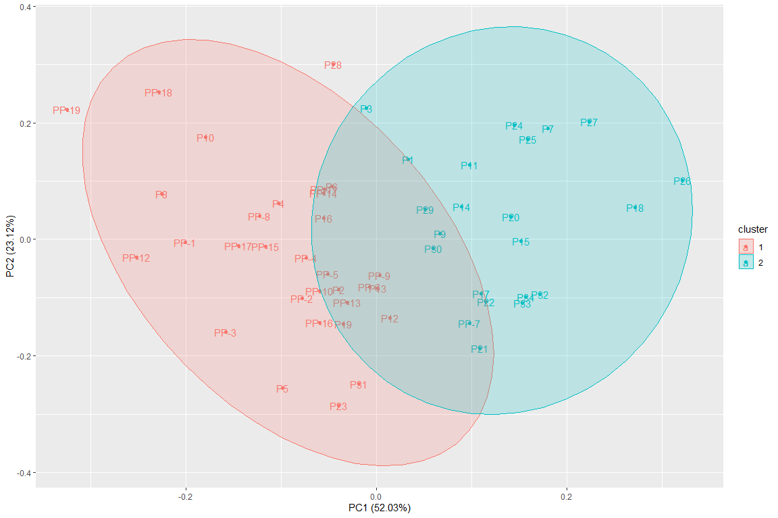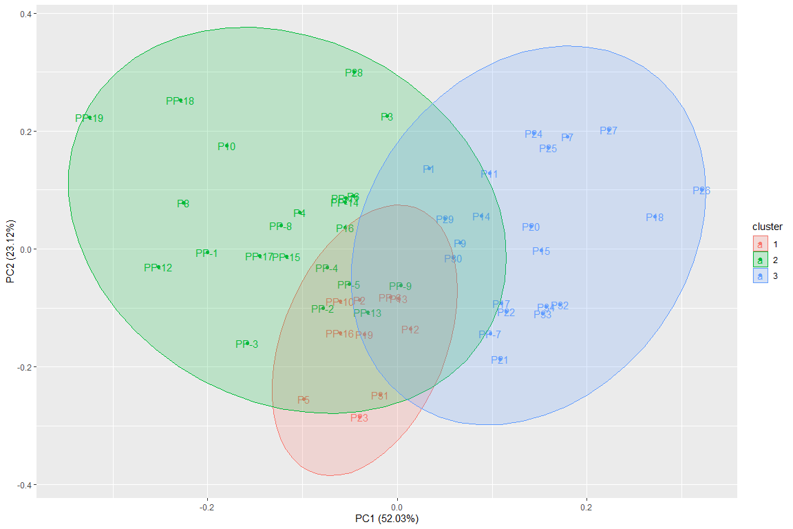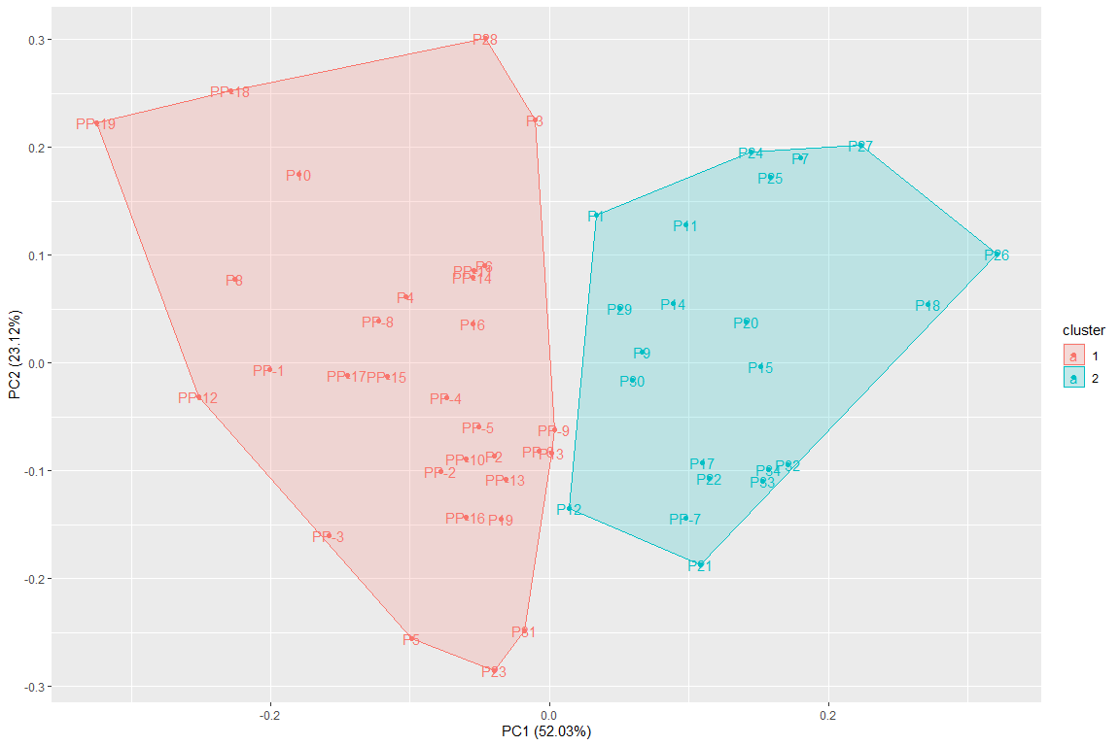

## [1] "PP-10" "PP-11" "PP-12" "PP-13" "PP-14" "PP-15" "PP-16" "PP-17" "PP-18"  
## [10] "PP-19" "PP-9" "P1" "P10" "P11" "P12" "P13" "P14" "P15"   
## [19] "P16" "P17" "P18" "P19" "P2" "P20" "P21" "P22" "P23"   
## [28] "P24" "P25" "P26" "P27" "P28" "P29" "P3" "P30" "P31"   
## [37] "P32" "P33" "P34" "P4" "P5" "P6" "P7" "P8" "P9"   
## [46] "PP-1" "PP-2" "PP-3" "PP-4" "PP-5" "PP-6" "PP-7" "PP-8"

## [1] "PP-10" "PP-11" "PP-12" "PP-13" "PP-14" "PP-15" "PP-16" "PP-17" "PP-18"  
## [10] "PP-19" "PP-9" "P1" "P10" "P11" "P12" "P13" "P14" "P15"   
## [19] "P16" "P17" "P18" "P19" "P2" "P20" "P21" "P22" "P23"   
## [28] "P24" "P25" "P26" "P27" "P28" "P29" "P3" "P30" "P31"   
## [37] "P32" "P33" "P34" "P4" "P5" "P6" "P7" "P8" "P9"

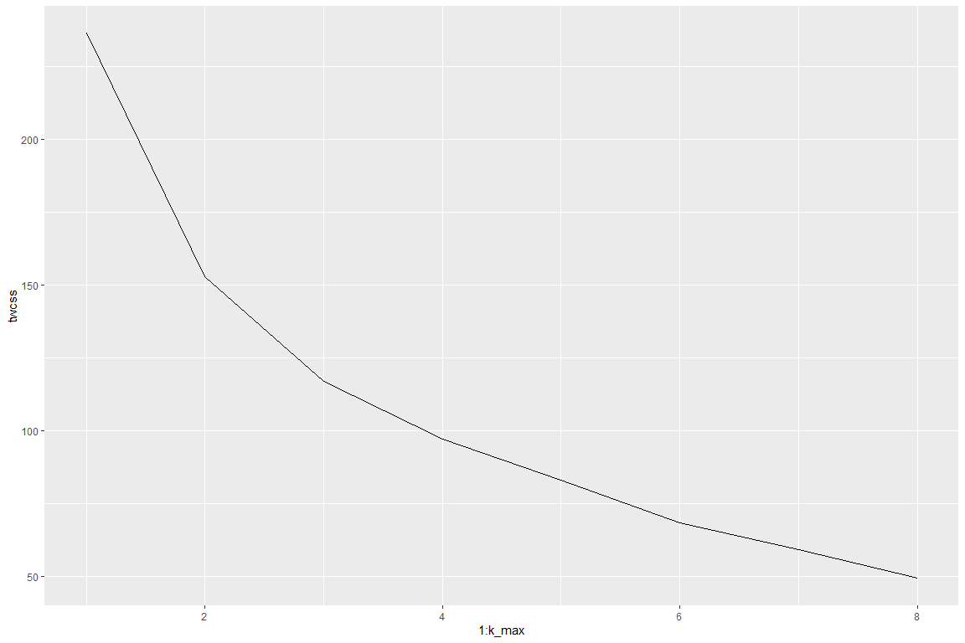

## Importance of components:  
## PC1 PC2 PC3 PC4 PC5 PC6  
## Standard deviation 1.6735 1.1429 0.8461 0.59258 0.36664 0.25433  
## Proportion of Variance 0.5212 0.2431 0.1332 0.06535 0.02502 0.01204  
## Cumulative Proportion 0.5212 0.7644 0.8976 0.96294 0.98796 1.00000

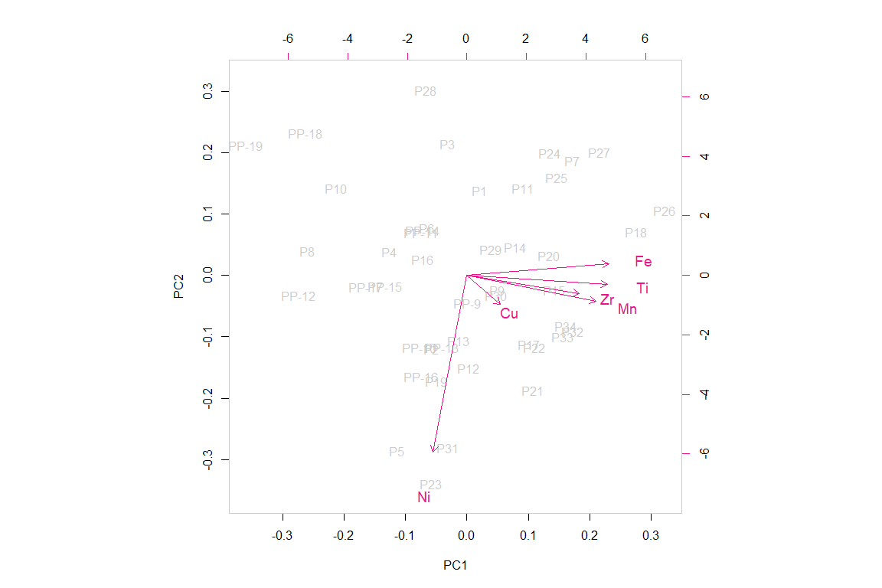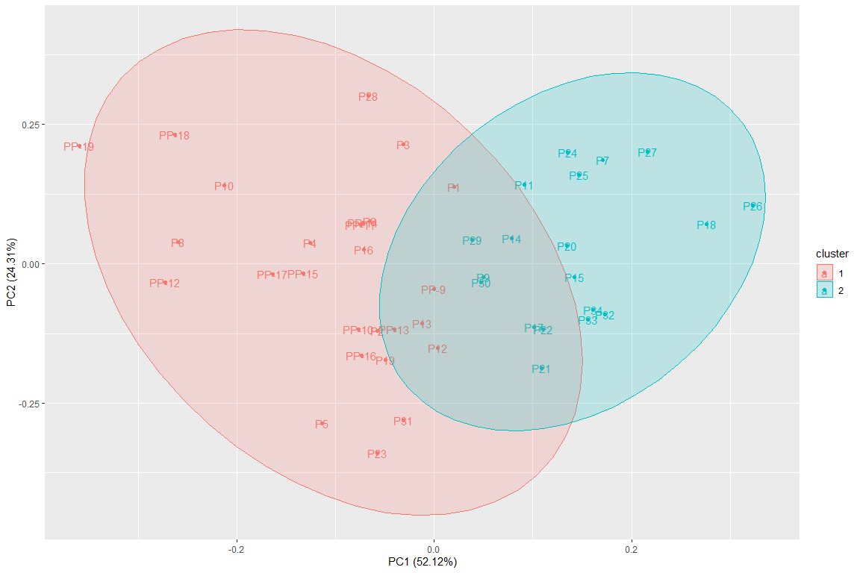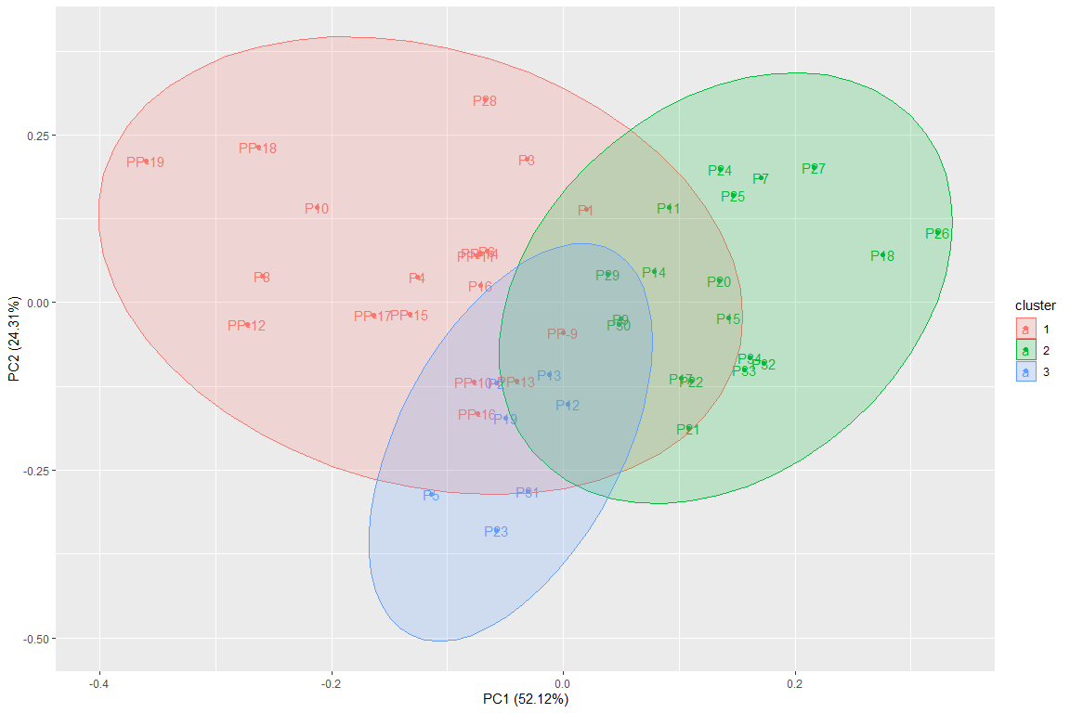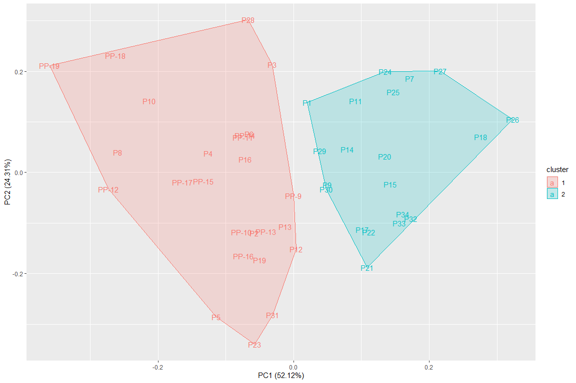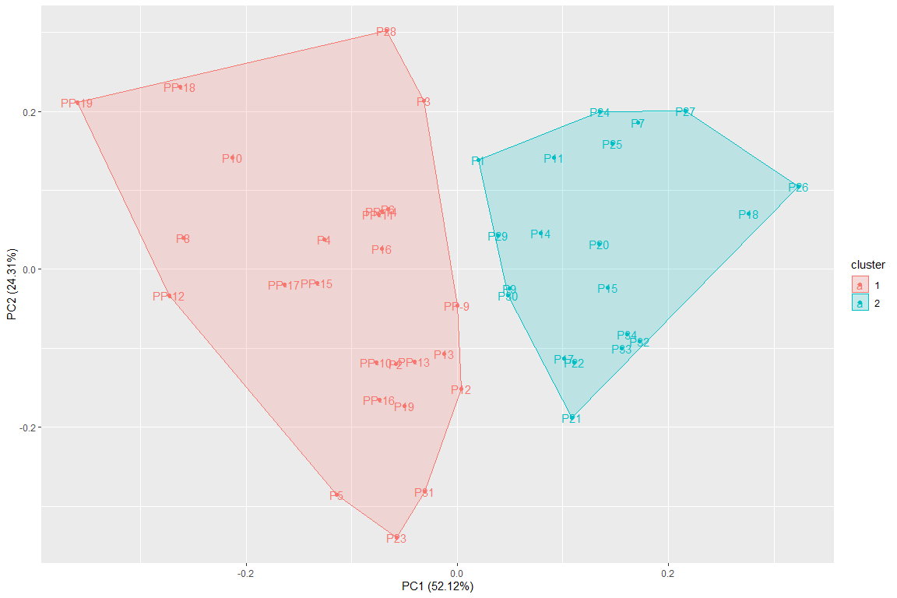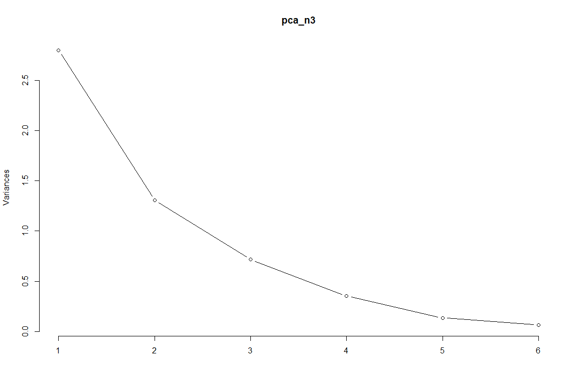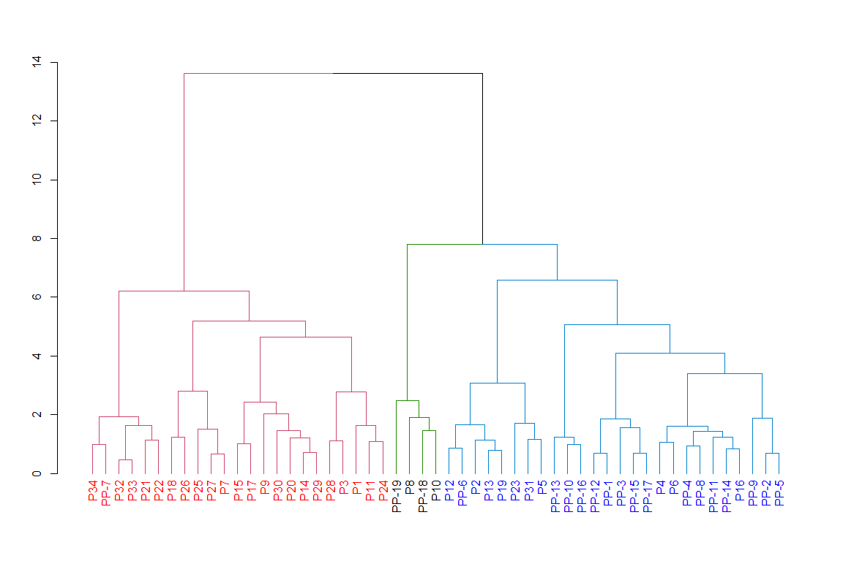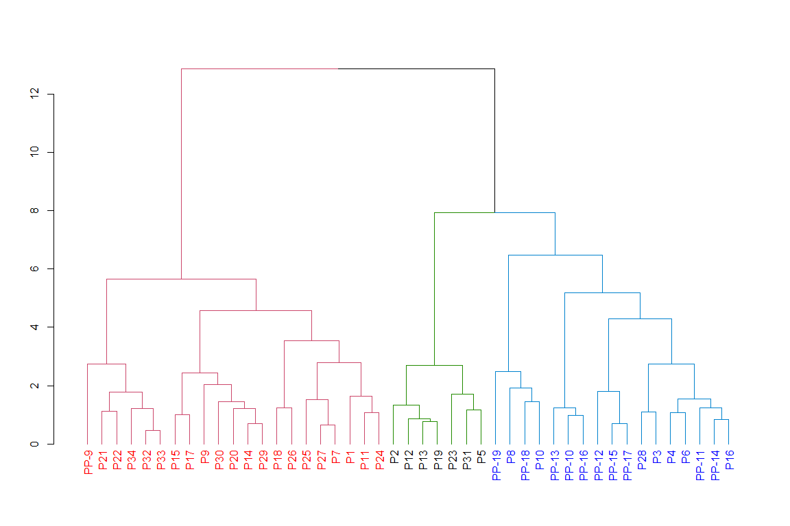

## Importance of components:  
## PC1 PC2 PC3 PC4 PC5 PC6  
## Standard deviation 1.6328 1.0883 0.8191 0.62862 0.35886 0.28046  
## Proportion of Variance 0.5203 0.2312 0.1309 0.07712 0.02513 0.01535  
## Cumulative Proportion 0.5203 0.7514 0.8824 0.95952 0.98465 1.00000

## Importance of components:  
## PC1 PC2 PC3 PC4 PC5  
## Standard deviation 1.6222 0.8392 0.6292 0.38007 0.28635  
## Proportion of Variance 0.6649 0.1779 0.1000 0.03649 0.02072  
## Cumulative Proportion 0.6649 0.8428 0.9428 0.97928 1.00000

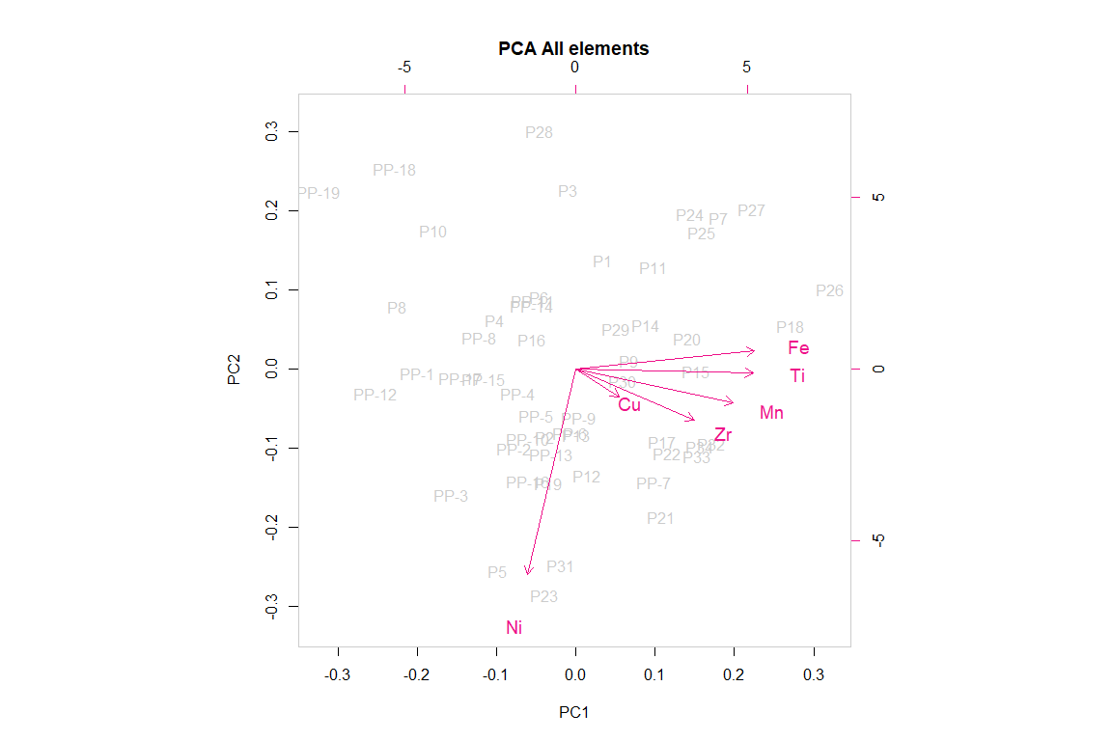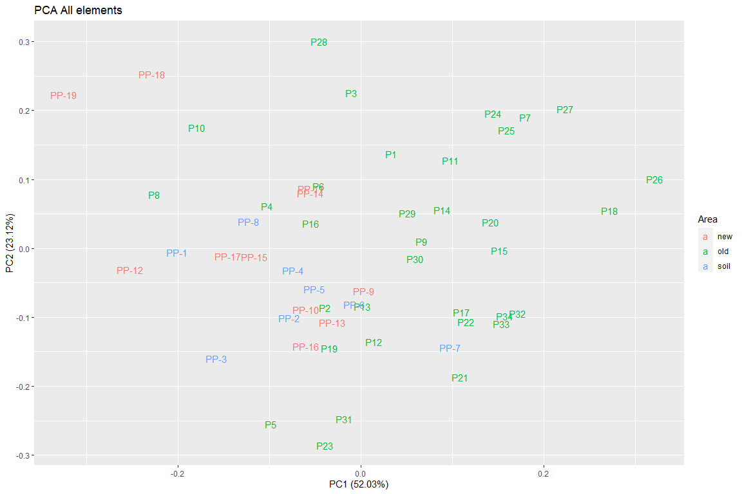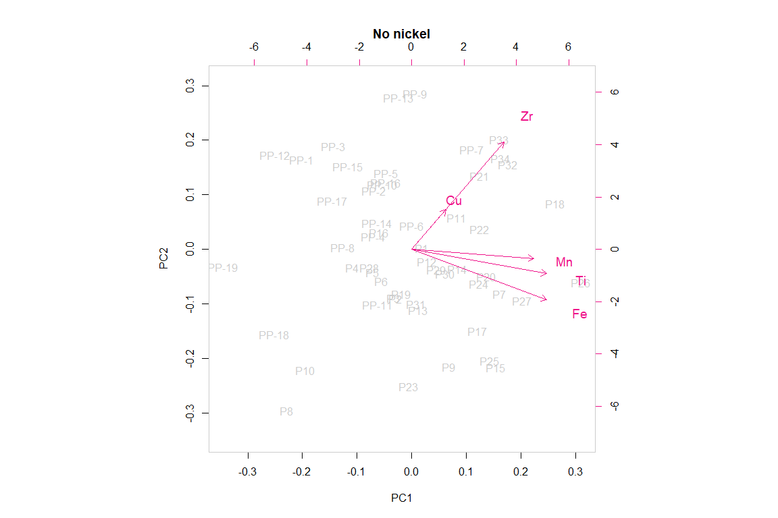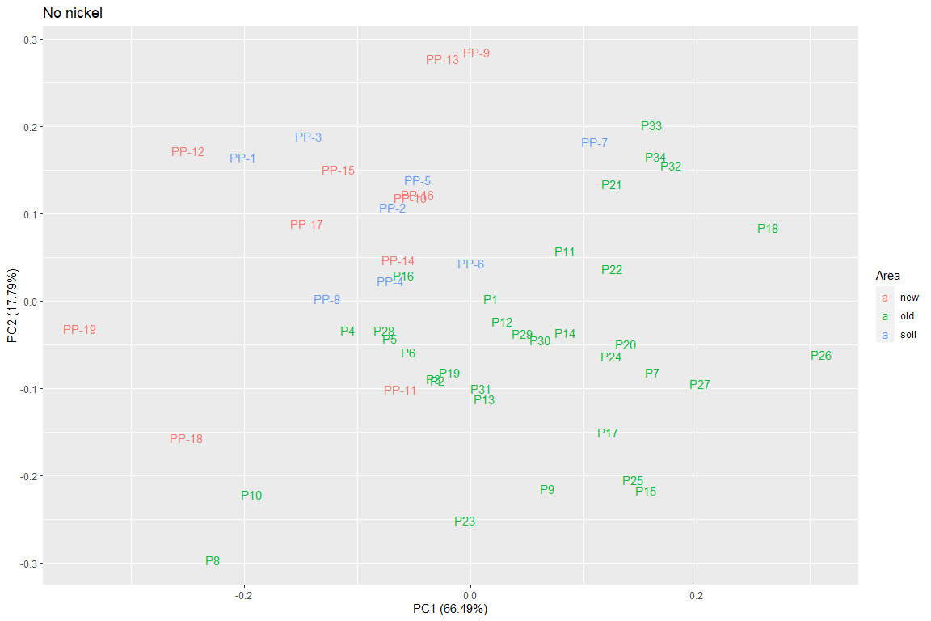

## Importance of components:  
## PC1 PC2 PC3 PC4 PC5  
## Standard deviation 1.3284 0.9043 0.6313 0.32331 0.09594  
## Proportion of Variance 0.5702 0.2642 0.1288 0.03378 0.00297  
## Cumulative Proportion 0.5702 0.8345 0.9633 0.99703 1.00000

