Week 1

Uine Kailamäki

2021

## IMPORTING DATA IN R

In importing the .csv data to R there was a problem with importing European style .csv in which data is separated with ; instead of comma, and decimals are displayed with commas instead of dots. This was resolved by adding [sep=“;”, dec=“,”] when importing the data. I did also need to define the margin size for plots in order to display the results, but otherwise the exercise didn’t pose much difficulty.

## [1] TRUE

## [1] "data.frame"

## km_number find_type length width thickness weight x y  
## 1 32039 kirveet 120.0 40.0 40 420.0 6987601 559225  
## 2 33070 kirveet 91.0 50.0 25 331.0 7204072 587496  
## 3 35902 kirveet 197.0 75.0 37 620.0 7638696 492759  
## 4 39149 kirveet 193.0 82.0 45 1016.0 6941672 467565  
## 5 39178 kirveet 174.0 41.0 84 759.8 6802153 328646  
## 6 39452 kirveet 99.5 53.5 30 248.1 6748437 371160

## km_number find_type length width   
## Min. :32039 Length:16 Min. : 55.0 Min. : 40.00   
## 1st Qu.:39171 Class :character 1st Qu.:110.4 1st Qu.: 54.62   
## Median :39599 Mode :character Median :143.0 Median : 70.50   
## Mean :38635 Mean :136.8 Mean : 75.97   
## 3rd Qu.:40106 3rd Qu.:163.5 3rd Qu.: 92.25   
## Max. :40334 Max. :197.0 Max. :151.00   
##   
## thickness weight x y   
## Min. : 9 Min. : 88.1 Min. :6705920 Min. :328646   
## 1st Qu.:29 1st Qu.: 317.5 1st Qu.:6746623 1st Qu.:364874   
## Median :37 Median : 466.9 Median :6872906 Median :469289   
## Mean :36 Mean : 501.4 Mean :6969577 Mean :468313   
## 3rd Qu.:40 3rd Qu.: 652.5 3rd Qu.:7201614 3rd Qu.:577979   
## Max. :84 Max. :1016.0 Max. :7638696 Max. :587496   
## NA's :3

## Min. 1st Qu. Median Mean 3rd Qu. Max.   
## 88.1 317.5 466.9 501.4 652.5 1016.0

## Min. 1st Qu. Median Mean 3rd Qu. Max.   
## 55.0 110.4 143.0 136.8 163.5 197.0

## [1] 277.1391

## [1] 17.46425

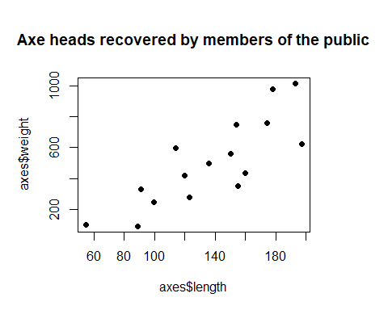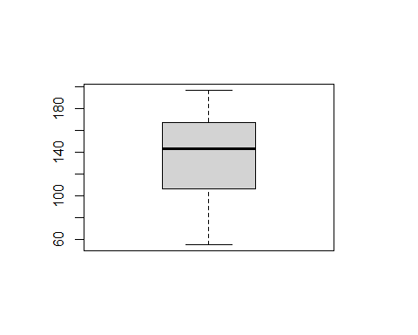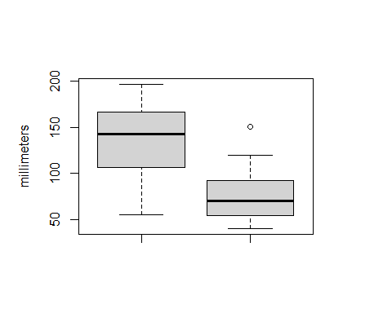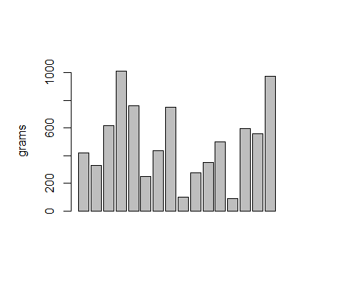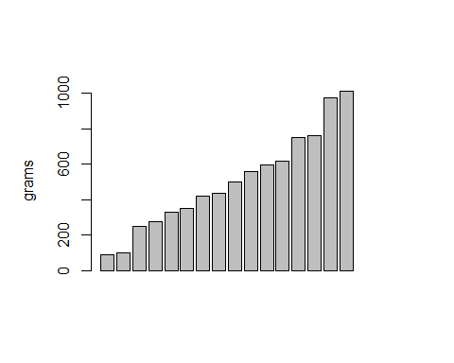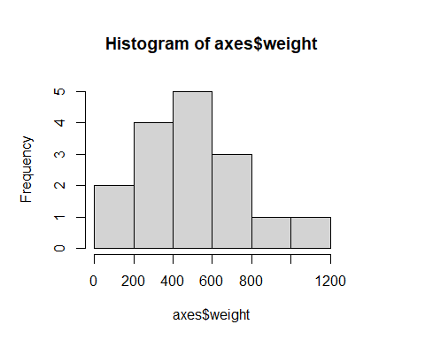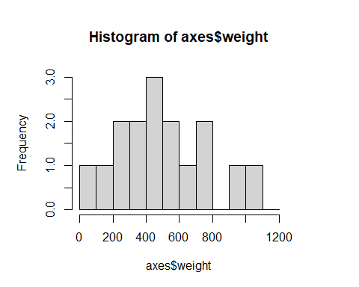

## PLOTTING MAPS AND SPATIAL DATA

You can also embed plots, for example:

## Warning: package 'rgdal' was built under R version 4.0.4

## Loading required package: sp

## rgdal: version: 1.5-23, (SVN revision 1121)  
## Geospatial Data Abstraction Library extensions to R successfully loaded  
## Loaded GDAL runtime: GDAL 3.2.1, released 2020/12/29  
## Path to GDAL shared files: C:/Users/Uine/Documents/R/win-library/4.0/rgdal/gdal  
## GDAL binary built with GEOS: TRUE   
## Loaded PROJ runtime: Rel. 7.2.1, January 1st, 2021, [PJ_VERSION: 721]  
## Path to PROJ shared files: C:/Users/Uine/Documents/R/win-library/4.0/rgdal/proj  
## PROJ CDN enabled: FALSE  
## Linking to sp version:1.4-5  
## To mute warnings of possible GDAL/OSR exportToProj4() degradation,  
## use options("rgdal_show_exportToProj4_warnings"="none") before loading rgdal.  
## Overwritten PROJ_LIB was C:/Users/Uine/Documents/R/win-library/4.0/rgdal/proj

## Warning: package 'raster' was built under R version 4.0.4

## Warning in OGRSpatialRef(dsn, layer, morphFromESRI = morphFromESRI, dumpSRS =  
## dumpSRS, : Discarded datum European_Terrestrial_Reference_System_1989 in Proj4  
## definition: +proj=utm +zone=35 +ellps=GRS80 +towgs84=0,0,0,0,0,0,0 +units=m  
## +no_defs

## OGR data source with driver: ESRI Shapefile   
## Source: "C:\Users\Uine\Documents\R\SADE\week1\finland", layer: "finland_valtakunta_simpler"  
## with 1 features  
## It has 4 fields  
## Integer64 fields read as strings: GML_ID

## Object of class SpatialPolygonsDataFrame  
## Coordinates:  
## min max  
## x 83725.35 732881.9  
## y 6637635.87 7776440.6  
## Is projected: TRUE   
## proj4string :  
## [+proj=utm +zone=35 +ellps=GRS80 +towgs84=0,0,0,0,0,0,0 +units=m  
## +no_defs]  
## Data attributes:  
## GML_ID NATCODE NAMEFIN NAMESWE   
## Length:1 Length:1 Length:1 Length:1   
## Class :character Class :character Class :character Class :character   
## Mode :character Mode :character Mode :character Mode :character

## Warning in proj4string(fin): CRS object has comment, which is lost in output

## Warning in showSRID(uprojargs, format = "PROJ", multiline = "NO", prefer_proj  
## = prefer_proj): Discarded datum Unknown based on GRS80 ellipsoid in Proj4  
## definition

