**PIZZA SALES REPORT**

**PROBLEM STATEMENT**

To boost pizza store sales, we're diving into a detailed analysis of our dataset. We're looking at customer preferences, popular pizzas, and key ordering times. By checking pizza sizes, categories, and ingredients, we aim to customize our menu to what customers love.

We're also analyzing prices to find the sweet spot for customers and profits. Understanding when people order most helps us manage inventory better. The goal is to use these insights for smarter marketing, better menus, and overall, make our pizza store a hit with customers, old and new.

**Average KPI**

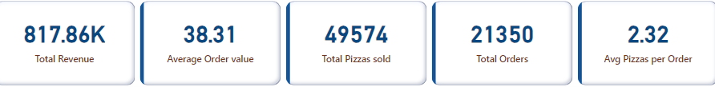

The store acknowledged total revenue of 817.86K by recording sales of 21,350 total orders. The store sold 49,574 total pizzas. Meanwhile the average pizzas per order were 2.32 and average order value was $38.31.

**Monthly sales analysis**

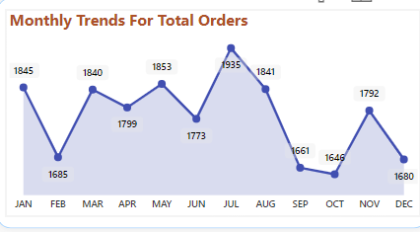

The sale remained consistent around the year except a significant decline seen in September/October as September being the onset of School season due to which families and kids become busy in focussing on school schedules and heavy expenses made for school admissions, books, other stuffs which leaves fewer opportunities for dining out.

Another dip could be seen in February which might be due to factors such as end of holiday season spending, customers recovering from holiday expenses or change in weather affecting consumer’s behavior.

The sales peaked in July which can be accounted to pleasant summers and people engaging more in outdoor events, vacations making pizza their go-to-choice as it is convenient.

**Daily Trend Analysis**

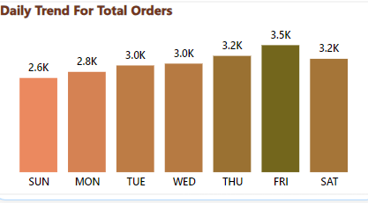

The store’s pizza sale peaked on Thursday/Friday/Saturday which can be due to weekend social activities.

Least sales were observed on Sunday so the store should focus on daily trends in orders and manage workforce accordingly to optimize expenses.

**Analysis by Pizza Category and Size**

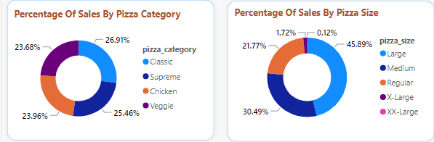

CATEGORY

Classic Category Pizza contributes to maximum sales and total orders followed by Supreme Category Pizza , whereas Veggie category contributes to least sales.

SIZE

Large Size Pizza contributes to maximum sales and orders followed by Medium Size Pizza whereas XX Large and X Large contributes to least sales and orders.

**Top 5 pizzas in all categories**

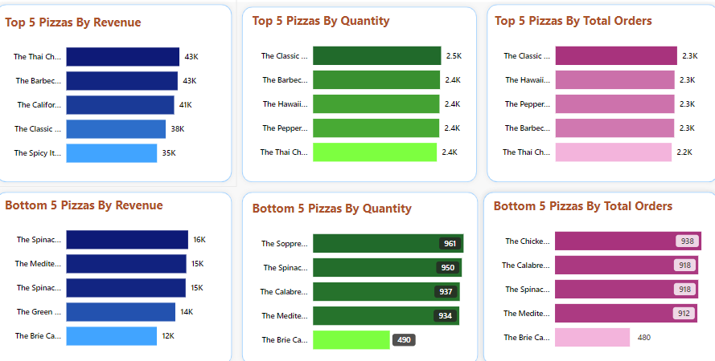

BY REVENUE

Thai Chicken Pizza contributes to maximum revenue whereas The Brie Carre Pizza contributes to least revenue.

BY QUANTITY

The Classic Deluxe Pizza contributes to maximum quantity whereas The Brie Carre Pizza contributes to least quantity.

BY TOTAL ORDERS

The Classic Deluxe Pizza contributes to maximum orders whereas The Brie Carre Pizza contributes to least orders.

**CONCLUSION:**

* The company can offer promotional discounts on regular, xl, xxl size pizzas on Sunday and Monday to boost their sales.
* Keep The Classic Deluxe Pizza’s inventory well stocked to keep up with the demand.
* Company can keep less inventory of The Carie Barre pizza or discontinue it.
* The company should manage workforce according to number of orders placed ie., More workforce is required on Thursday, Friday, Saturday to keep up with the higher number of orders placed and demand.
* Meanwhile to optimize operational costs, reduction in the workforce can be scheduled for Sunday shifts.
* The company can offer promotional discounts during September/ October to boost their sales.