# LAB 8 - Post Exploitation/Cracking Hashes

1. On your Kali machine, open a terminal window and browse to the location of the user_logins.txt file.
2. John the Ripper has a bunch of rules for common password permutations based on usernames that could potentially crack some of the passwords. To list the available rule list type the following command:

* john --list=rules

all  
korelogic  
replaceletters  
replacespecial2special  
l33t  
appendyears_addspecialeverywhere  
appendnumnumnum_addspecialeverywhere  
appendnumnum_addspecialeverywhere  
appendnum_addspecialeverywhere  
prependnumnum_appendnumspecial  
append1_addspecialeverywhere  
prependjustspecials  
appendjustspecials3times  
appendspeciallowerlower  
appendcap-num_or_special-twice  
adddotcom  
replaceletterscaps  
replacenumbers  
replacenumbers2special  
appendmonthcurrentyear  
appendmonthday  
add1234_everywhere  
prependdaysweek  
add2010everywhere  
prepend4lettermonths  
addshortmonthseverywhere  
monthsfullpreface  
appendjustspecials  
appendnumbers_and_specials_simple  
appendjustnumbers  
prependandappendspecial  
devprodtestuat  
addjustnumbers  
append2numspecial  
append3numspecial  
append4numspecial  
prepend4numappendspecial  
append2letters  
prependspecialspecialappendnumbersnumbernumber  
prependspecialspecialappendnumbersnumber  
prependspecialspecialappendnumber  
appendspecialnumbernumbernumber  
appendspecialnumbernumber  
prependspecialspecial  
prepend2numbersappend2numbers  
prependnumnumspecial  
prependnumnumnumnum  
prependnumnumnum  
prependnumnum  
prependnumnumappendspecial  
prependcapcapappendspecial  
appendspecial4num  
appendspecial3num  
append6num  
append5num  
append4num  
appendcurrentyearspecial  
appendyears  
prependyears  
prependhello  
appendseason  
prependseason  
jumbo  
unicodesubstitution  
upperunicodesubstitution  
lowerunicodesubstitution  
single-extra  
loopback  
passphrase-rule2  
passphrase-rule1  
hashcat  
specific  
rockyou-30000  
t0xlc  
insidepro  
dive  
d3ad0ne  
best64  
t9  
oi  
i  
i3  
i2  
i1  
o  
o3  
o2  
o1  
oldoffice  
split  
phrasewrap  
phrasecaseone  
phrase  
phrasepreprocess  
multiword  
shifttoggle  
nt  
wordlist  
extra  
single  
jumbosingle  
drop  
none

1. What is the output of the command? (include screenshot).

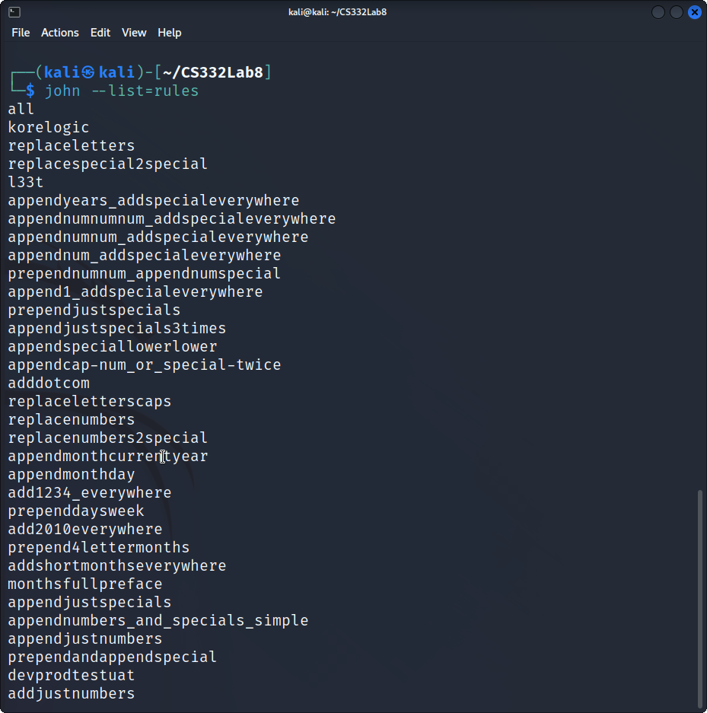

stdout

1. Use the the “–single” rule to crack the hashes by using the following command:

* john --single user_logins.txt

Warning: detected hash type "md5crypt", but the string is also recognized as "md5crypt-long"  
Use the "--format=md5crypt-long" option to force loading these as that type instead  
Using default input encoding: UTF-8  
Loaded 7 password hashes with 7 different salts (md5crypt, crypt(3) $1$ (and variants) [MD5 256/256 AVX2 8x3])  
Will run 2 OpenMP threads  
Press 'q' or Ctrl-C to abort, almost any other key for status  
user (user)   
postgres (postgres)   
msfadmin (msfadmin)   
service (service)   
Almost done: Processing the remaining buffered candidate passwords, if any.  
4g 0:00:00:01 DONE (2022-11-05 23:11) 2.061g/s 3587p/s 3619c/s 3619C/s sdev1903..dsys1900  
Use the "--show" option to display all of the cracked passwords reliably  
Session completed.

john --show user_logins.txt

msfadmin:msfadmin:1000:1000:msfadmin,,,:/home/msfadmin:/bin/bash  
postgres:postgres:108:117:PostgreSQL administrator,,,:/var/lib/postgresql:/bin/bash  
user:user:1001:1001:just a user,111,,:/home/user:/bin/bash  
service:service:1002:1002:,,,:/home/service:/bin/bash  
  
4 password hashes cracked, 3 left

1. What is the password for the following users:

|  |  |
| --- | --- |
| * Username | * Password |
| * user | * user |
| * msfadmin | * msfadmin |
| * service | * service |
| * postgres | * postgres |

1. While john the ripper did reveal the password for some of the users using the “single” rule, it did not crack the password for all the users. We will now use a dictionary list to crack even more passwords.
2. Type the following command:

* john --wordlist=/usr/share/john/password.lst --rules user_logins.txt

1. What does the --wordlist=/usr/share/john/password.lst do?

* Uses password.lst as the word list of passwords that we will use when running the crack from john. john provides this file and the option --wordlist reads words from FILE or using --stdin.

1. What does the --rules option do?

* Specifies the rules used for word mangling, or if no option specified then the default rules are ran from /etc/john/john.conf. You may have to specify the rules on the command line and rules requires the option --wordlist.

1. What is the password for ‘sys’ user?

* batman

1. What is the password for ‘klog’ user?

* 123456789

1. What command would you use to have john display all the passwords you have cracked for user_logins.txt?

* john --show user_logins.txt

sys:batman:3:3:sys:/dev:/bin/sh  
klog:123456789:103:104::/home/klog:/bin/false  
msfadmin:msfadmin:1000:1000:msfadmin,,,:/home/msfadmin:/bin/bash  
postgres:postgres:108:117:PostgreSQL administrator,,,:/var/lib/postgresql:/bin/bash  
user:user:1001:1001:just a user,111,,:/home/user:/bin/bash  
service:service:1002:1002:,,,:/home/service:/bin/bash  
  
6 password hashes cracked, 1 left