Institute of Information Technology

University of Dhaka

Assignment on Optical Fiber Cable

Submitted to:

Dr. Md. Shariful Islam

Professor, IIT DU

Submitted by:

Tulshi Chandra Das-BSSE 0811

Maloy kanti sarker - BSSE 0834

Optical Fiber:

An optical fiber or optical fibre is a flexible, transparent fiber made by drawing glass (silica) or plastic to a diameter slightly thicker than that of a human hair.[1] Optical fibers are used most often as a means to transmit light between the two ends of the fiber and find wide usage in fiber-optic communications, where they permit transmission over longer distances and at higher bandwidths (data rates) than wire cables.

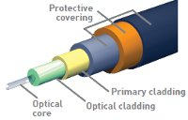

Fibers are used instead of metal wires because signals travel along them with lesser amounts of loss; in addition, fibers are also immune to electromagnetic interference, a problem from which metal wires suffer excessively.Fibers are also used for illumination, and are wrapped in bundles so that they may be used to carry images, thus allowing viewing in confined spaces, as in the case of a fiberscope.Specially designed fibers are also used for a variety of other applications, some of them being fiber optic sensors and fiber lasers.

Principle of operation of optical fiber:

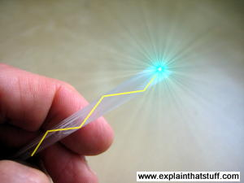

Fiber optical cables are highly transparent, cylindrical conduits for light. These cables are formed of two materials with different refractive indices. This creates a optimal waveguide for transmitting light. When light enters the fiber made of material with higher refractive index than the cladding surrounding it, it stays inside the material due to total internal reflection and is thus transmitted forward.

Index of refraction:

Index of refraction is a measurement of speed of light in material. By definition, vacuum has refractive index of 1(c in vacuum = 1) . The higher the index, the slower the light will travel in the material. Typical value for fiber core is 1,62 and for the cladding 1,52.

Total internal refraction:

When light traveling inside material hits a boundary, it is partially refracted and partially reflected. However if the angle is greater than the critical angle of the materials them it is reflected back in its entirety. For this to occur the material in which the light is traveling in must have higher refractive index than the material outside.

Optical fibers are 2 type:

1. single mode fiber
2. Multi-mode fiber

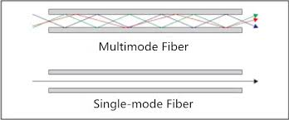

Single mode fiber:

Single Mode cable is a single stand (most applications use 2 fibers) of glass fiber with a diameter of 8.3 to 10 microns that has one mode of transmission. Single Mode Fiber with a relatively narrow diameter, through which only one mode will propagate typically 1310 or 1550nm. Carries higher bandwidth than multimode fiber, but requires a light source with a narrow spectral width. Synonyms mono-mode optical fiber, single-mode fiber, single-mode optical waveguide, uni-mode fiber.Single

Modem fiber is used in many applications where data is sent at multi-frequency (WDM Wave-Division-Multiplexing) so only one cable is needed - (single- mode on one single fiber).Single-mode fiber gives you a higher transmission rate and up to 50 times more distance than multimode, but it also costs more. Single-mode fiber has a much smaller core than multimode. The small core and single light-wave virtually eliminate any distortion that could result from overlapping light pulses, providing the least signal attenuation and the highest transmission speeds of any fiber cable type. Single-mode optical fiber is an optical fiber in which only the lowest order bound mode can propagate at the wavelength of interest typically 1300 to 1320nm[1].

Data transmission rate of single mode:

Single mode fiber is used for both interbuilding and intrabuilding backbone cable. At distances up to 3 km, single mode fiber will deliver data rates up to 10 Gbps with a bandwidth of 20Ghz. Its operating wavelengths are 1310 nm and 1550 nm. Single mode fiber's primary uses are full motion video and any applications requiring extremely high bandwidth.[3]

Application of single-mode fiber:

Single Mode fiber optic cable has a small diametral core that allows only one mode of light to propagate. Because of this, the number of light reflections created as the light passes through the core decreases, lowering attenuation and creating the ability for the signal to travel further. This application is typically used in long distance, higher bandwidth runs by Telcos, CATV companies, and Colleges and Universities.

Data transmission rate of multi-mode cable:

As an intra building backbone cable at distances of under 2 km, multi-mode fiber optic cable will deliver data rates up to 1 Gbps. Its operating wavelengths are 850 nm

and 1300 nm. For distances of 100 m or less, the bandwidth is virtually unlimited. Multi mode fiber is used for voice, data, security, and video systems.[3]

Application of multi-mode cable:

Multi mode fiber optic cable has a large diametrical core that allows multiple modes of light to propagate. Because of this, the number of light reflections created as the light passes through the core increases, creating the ability for more data to pass through at a given time. Because of the high dispersion and attenuation rate with this type of fiber, the quality of the signal is reduced over long distances. This application is typically used for short distance, data and audio/video applications in LANs. RF broadband signals, such as what cable companies commonly use, cannot be transmitted over multi mode fiber. Multi mode fiber is usually 50/125 and 62.5/125 in construction. This means that the core to cladding diameter ratio is 50 microns to 125 microns and 62.5 microns to 125 microns.

Graded index fiber:

In [fiber optics](https://en.wikipedia.org/wiki/Fiber_optics), a graded index is an [optical fiber](https://en.wikipedia.org/wiki/Optical_fiber) whose [core](https://en.wikipedia.org/wiki/Fiber_optics#Principle_of_operation) has a [refractive index](https://en.wikipedia.org/wiki/Refractive_index) that decreases with increasing radial distance from the [optical axis](https://en.wikipedia.org/wiki/Optical_axis) of the fiber.

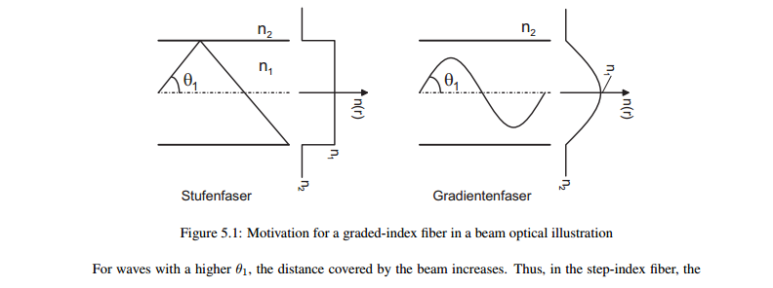

Because parts of the core closer to the fiber axis have a higher refractive index than the parts near the cladding, light rays follow [sinusoidal](https://en.wikipedia.org/wiki/Sinusoidal) paths down the fiber. The most common refractive index profile for a graded-index fiber is very nearly parabolic. The [parabolic profile](https://en.wikipedia.org/wiki/Parabola) results in continual refocusing of the rays in the core, and minimizes modal dispersion.

[Multi-mode optical fiber](https://en.wikipedia.org/wiki/Multi-mode_optical_fiber) can be built with either graded index or [step index](https://en.wikipedia.org/wiki/Step-index_profile). The advantage of the multi-mode graded index compared to the multi-mode step index is the considerable decrease in [modal dispersion](https://en.wikipedia.org/wiki/Modal_dispersion). Modal dispersion can be further decreased by selecting a smaller core size (less than 5-10μm) and forming a single mode step index fiber.[[6]](https://en.wikipedia.org/wiki/Graded-index_fiber#cite_note-1)

The Step-Index Fiber

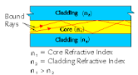

Step Index Fiber Optics consists of a simple optical cable that is surrounded by a homogeneous core. Throughout the entire cross section of the core and cladding the refractive index remains constant while light rays that travel along straight lines in the care are completely reflected at the core and cladding interface. This results in the individual light rays traveling different distances and consequently different travel times[7].

References:

1. http://services.eng.uts.edu.au/~akadi/ite/m[h](http://services.eng.uts.edu.au/~akadi/ite/major_assignments/barber/fibtypes.htm)ajor_assignments/barber/fibtypes.ht m
2. http://www.arcelect.com/fibercable.htm
3. http://www.itcom.itd.umich.edu/cabling/fibopt.html
4. http://www.arcelect.com/fibercable.htm
5. <http://www.multicominc.com/training/technical-resources/single-mode-vs-multi-mode-fiber-optic-cable/>
6. [A Reference Guide to Optical Fibers and Light Guides](http://www.pti-nj.com/OldWeb/obb_fiber2.html)

7. http://www.fiberfin.com/index.php/pof-specifications/step- index-fiber/