**Project Report**

**TITLE**

**Course: SE305 Software Project Lab - I**

Submitted by

|  |  |  |
| --- | --- | --- |
| *Tulshi Chandra Das* | *ROLL :0811* | *2015-16* |

Document Version: 1.0

Submitted to

**SPL I Coordinators**

**Rezvi Shahariar, Assistant Professor, IITDU**

**Amit Seal Ami, Lecturer, IITDU**



**Institute of Information Technology**

**University of Dhaka**

[23-04-2017]

**To Whom It May Concern**

This is to certify that Tulshi Chandra Das, BSSE0811 has successfully completed the project titled “A Digital Watch” at Institute of Information Technology, University of Dhaka under my supervision and guidance in the fulfillment of requirements of Software Project Lab – I.



Amit Seal Ami

Lecture

Institute of Information Technology

University of Dhaka

**Acknowledgement**

At first, I thank almighty creator Sree Krishna because all credits goes to him.

I express my gratitude to my respectful supervisor Amit Seal Ami, without whose help I could not complete my project. I also thank my brother Uddip Acharjee and my senior sister of IIT Prianka Priya who helped me to complete my project.



Tulshi Chandra Das

Roll: BSSE0811

Institute of Information Technology

University of Dhaka

**Executive Summary**

**Table of Content**

1. Introduction 1

2. Background Study 1

3. Broad Domain 1

4. Challenges 1

5. Dependencies 2

5.1. Software 2

5.2. Hardware 2

6. Methodology 2

7. Achievements 2

8. Analysis and Design 2

9. Implementation and Testing 2

10. Program Output 2

11. User Manual 2

12. Conclusion 2

**List of Tables**

Table 1: A Sample Table. Caption is centered above 1

**List of Figures**

Figure 1: A Sample of methodology……………………………………………………………………. 1

Figure 2: FileManager Class……………………………………………………………….......2

Figure3: Class Watch…………………………………………………………………………………..3

Figure4: Class StopWatch………………………………………………………………………………..4

Figure5: Class MyTimer…………………………………………………………………………………...5

Figure6: Class MyTimer…………………………………………………………………………………..6

Figure7: Class diagram………………………………………………………………………………………..7

Software Project Lab-I report : A Digital Watch

**1. Introduction**

Time is very important in one’s life. Everyone has to maintain and observe the time in all of his moments of daily activities. So a well-organized dates and time representation is very helpful to anybody. This software has been developed from this aspect.

**2. Background Study**

In past there were different systems for determining time like position of sun, shadow of sun position of moon to define times and dates. For example ”water clock[1]”, ”candle clock[2]”, ”pendulum clock[3]”, ”sundial[4]”, ”hourglass[5]” were the ancient systems of time determination. With the progress of technology the modern watch is invented like led display watch, digital watch etc. The project have been implemented the several time related interfaces such as watch, stopwatch, calendar, timer.

**3. Broad Domain**

I have started the project to provide a good organized of timing facilities in Bengali language. For many lower class people in our country Bengali is preferable than English to understand. Besides, it is very rare to find a combined application of digital watch, stopwatch, timer and calendar. So my project will be helpful for these purpose.

Software Project Lab-I report : A Digital Watch

It is an application that show the current local time of Bangladesh, edit time, stopwatch, timer and calendar through:

1. Reading text file
2. Taking time and date from System
3. Providing a good graphical user interfaces

This application can provide:

1. Digital Watch
2. Stopwatch
3. Timer
4. Calendar

All of these are in Bengali language with user interfaces.

Software Project Lab-I report : A Digital Watch

**4. Challenges**

To implement the whole project I have solved some challenges. To make the

Digital watch I have used 2d graphics and using it I have drawn the Bengali numerical digits. My project is mostly depend on GUI. I have analyzed the usage of the GUI.

There are main challenges to implement the project:

1. Drawing the Bengali Digits with dots
2. Usage of System time or time as input from user
3. Handling locality of time as time zone.
4. Implementation of Graphical User Interface of java
5. Completing the software within 4 months

Software Project Lab-I report : A Digital Watch

**5. Dependencies**

1. **1. Software**

To run the software Java Runtime Environment-8 have to be installed. System like windows XP, 7,8,10, Linux based system or MAC that have JRE-8 can run my software.

* 1. **Hardware**

My software is desktop based. All hardware are not supported for this software.

**6. Methodology**

To complete my project I have used the waterfall approach. It is a sequential process of software development that goes to upward to downward. At first I have analyzed requirements of the project. Then design the software. After software design I start coding. Then after coding I have test the software to check is it give correct output. Then accept it.

Software Project Lab-I report : A Digital Watch

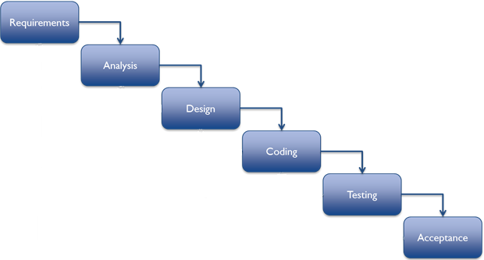

Figure 1: An Image of methodology.

Software Project Lab-I report : A Digital Watch

1. **Achievements**

By implementing the project I got several success. The software is able to keep accordance with the time handling efficiently. It is very user friendly from the aspect of our country as it is in Bengali user interface. The success results from the implementation of GUI of java, correct use of system time with java Timer Class, taking time and date from ZonedDateAndTime class, leap year calculation. The success are given below:

1. Bengali digital watch
2. Bengali stopwatch
3. Bengali timer
4. Bengali calendar

After all I have gathered experience with making a desktop app.

1. **Analysis and Design**

I have divided my whole process into two module.

1. Making each component separately
2. Set them to a single frame

There are four components. I have implemented them in separated class for each component. For watch I have created a text file to keep the coordinates of the dots that make a digit. To make ten digit 0-9 I have created ten txt file.

Software Project Lab-I report : A Digital Watch

Total seven class has been made for the implementation of the project.

The description of all classes are as follows:

Class “FileManager”: This class implement a method that returns the list of x, y coordinates of specific digit written in file specified in index.

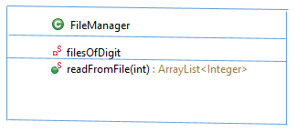

Figure 2: FileManager Class

Class “Watch”: This class implements the digital watch and its interfaces.

This is an extended JPanel.

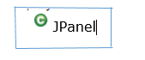

Software Project Lab-I report : A Digital Watch

  
 ­­­­ 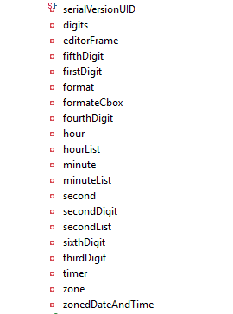

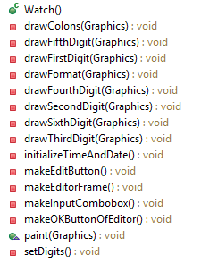

Software Project Lab-I report : A Digital Watch

Figure3: Class Watch

Class “StopWatch”: This an extended JPanel class that draws the Stopwatch GUI.



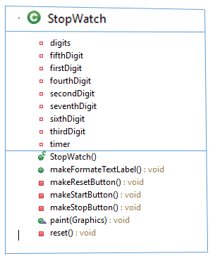

Figure4: Class StopWatch

Software Project Lab-I report : A Digital Watch

Class “MyTimer”: This class implements the timer and its GUI.



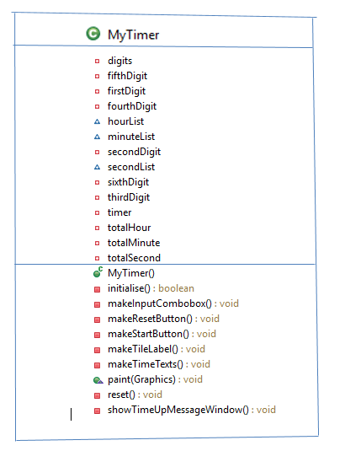

Figure5: Class MyTimer

Software Project Lab-I report : A Digital Watch

Class “MyCalendar”: This Class implements the Calendar and its GUI. It is also extended JPanel class.



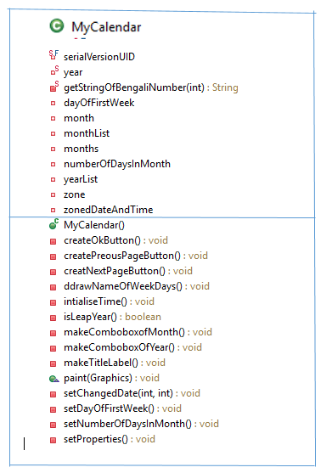

 Figure6: Class MyCalendar

Software Project Lab-I report : A Digital Watch

Class “MainFrame” and “Main” class: This class creates the main frame in which all other components contain. The other components entered in a tabbedPane and this tabbedPane is entered in the contentPane of the mainFrame. Then mainFrame pack them. After all mainframe is called from Main class.

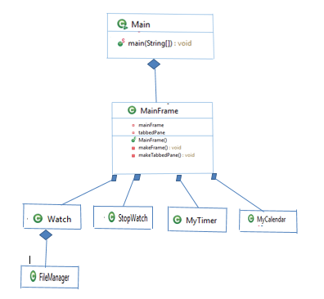

Figure7: Class diagram

**References**

1. [Conference of Qanat in Iran - water clock in Persia 1383,](http://www.aftabir.com/articles/view/science_education/technical/c3c1183387267p1.php/%D9%82%D9%86%D8%A7%D8%AA-%D9%85%DB%8C%D8%B1%D8%A7%D8%AB-%D9%81%D8%B1%D9%87%D9%86%DA%AF%DB%8C-%D9%88-%D8%B9%D9%84%D9%85%DB%8C-%D8%A7%DB%8C%D8%B1%D8%A7%D9%86%DB%8C%D8%A7%D9%86) in Persian.
2. [Donald Routledge Hill,](https://en.wikipedia.org/wiki/Donald_Routledge_Hill) "Mechanical Engineering in the Medieval Near

East".

3. Milham, Willis I. (1945). Time and Timekeepers*.*

1. Sabanski, Carl. ["The Sundial Primer".](http://www.mysundial.ca/tsp/north_vs_south.html)
2. American Institute of the City of New York (1870).