**Project Report**

**TITLE**

**Course: SE305 Software Project Lab - I**

Submitted by

|  |  |  |
| --- | --- | --- |
| *Tulshi Chandra Das* | *ROLL :0811* | *2015-16* |

Document Version: 1.0

Submitted to

**SPL I Coordinators**

**Rezvi Shahariar, Assistant Professor, IITDU**

**Amit Seal Ami, Lecturer, IITDU**



**Institute of Information Technology**

**University of Dhaka**

[23-04-2017]

**To Whom It May Concern**

This is to certify that Tulshi Chandra Das, BSSE0811 has successfully completed the project titled “A Digital Watch” at Institute of Information Technology, University of Dhaka under my supervision and guidance in the fulfillment of requirements of Software Project Lab – I.



Amit Seal Ami

Lecture

Institute of Information Technology

University of Dhaka

**Acknowledgement**

At first, I thank almighty creator Sree Krishna because all credits goes to him.

I express my gratitude to my respectful supervisor Amit Seal Ami, without whose help I could not complete my project. I also thank my brother Uddip Acharjee and my senior sister of IIT Prianka Priya who helped me to complete my project.



Tulshi Chandra Das

Roll: BSSE0811

Institute of Information Technology

University of Dhaka

**Executive Summary**

My project title is a “Digital Watch”. In this project without watch there are stopwatch, timer and calendar. My project has user interface with our mother tongue Bengali.

I have started this project actually to make a software that will give good facilities to a person to manage the time and date.

To develop this project I have used eclipse and jdk-8. As I have used Bengali in this project I have installed “Vrinda” font. To run the project user must install Java Runtime Environment-8.

As the project is in Bengali, the project is friendly only with the people who know Bengali. This project show calendar and can be shown the date of any year from 1 -6000. This is desktop based project not mobile or android.

To implement the project I have divided the whole project into two module. One is developing the components and keep them in single frame. Then run the mainframe from main class.

At the run time of project user can first see the watch a tab. Then he will open the other tab as he wish.

Working with this project I have experienced with java library object oriented concepts.

**Table of Content**

1. Introduction 1

2. Background Study 1

3. Broad Domain 1

4. Challenges 1

5. Dependencies 2

5.1. Software 2

5.2. Hardware 2

6. Methodology 2

7. Achievements 2

8. Analysis and Design 2

9. Implementation and Testing 2

10. Program Output 2

11. User Manual 2

12. Conclusion 2

**List of Tables**

Table 1: Table 1:one.txat file 1

Table 2: Painting process………………………………………………………………………………………2

**List of Figures**

Figure 1: A Sample of methodology……………………………………………………………………. 1

Figure 2: FileManager Class……………………………………………………………….......2

Figure3: Class Watch…………………………………………………………………………………..3

Figure4: Class StopWatch………………………………………………………………………………..4

Figure5: Class MyTimer…………………………………………………………………………………...5

Figure6: Class MyTimer…………………………………………………………………………………..6

Figure7: Class diagram………………………………………………………………………………………..7

Software Project Lab-I report : A Digital Watch

**1. Introduction**

Time is very important in one’s life. Everyone has to maintain and observe the time in all of his moments of daily activities. So a well-organized dates and time representation is very helpful to anybody. This software has been developed from this aspect.

**2. Background Study**

In past there were different systems for determining time like position of sun, shadow of sun position of moon to define times and dates. For example ”water clock[1]”, ”candle clock[2]”, ”pendulum clock[3]”, ”sundial[4]”, ”hourglass[5]” were the ancient systems of time determination. With the progress of technology the modern watch is invented like led display watch, digital watch etc. The project have been implemented the several time related interfaces such as watch, stopwatch, calendar, timer.

**3. Broad Domain**

I have started the project to provide a good organized of timing facilities in Bengali language. For many lower class people in our country Bengali is preferable than English to understand. Besides, it is very rare to find a combined application of digital watch, stopwatch, timer and calendar. So my project will be helpful for these purpose.

Software Project Lab-I report : A Digital Watch

It is an application that show the current local time of Bangladesh, edit time, stopwatch, timer and calendar through:

1. Reading text file
2. Taking time and date from System
3. Providing a good graphical user interfaces

This application can provide:

1. Digital Watch
2. Stopwatch
3. Timer
4. Calendar

All of these are in Bengali language with user interfaces.

Software Project Lab-I report : A Digital Watch

**4. Challenges**

To implement the whole project I have solved some challenges. To make the

Digital watch I have used 2d graphics and using it I have drawn the Bengali numerical digits. My project is mostly depend on GUI. I have analyzed the usage of the GUI.

There are main challenges to implement the project:

1. Drawing the Bengali Digits with dots
2. Usage of System time or time as input from user
3. Handling locality of time as time zone.
4. Implementation of Graphical User Interface of java
5. Completing the software within 4 months

Software Project Lab-I report : A Digital Watch

**5. Dependencies**

1. **1. Software**

To run the software Java Runtime Environment-8 have to be installed. System like windows XP, 7,8,10, Linux based system or MAC that have JRE-8 can run my software.

* 1. **Hardware**

My software is desktop based. All hardware are not supported for this software.

**6. Methodology**

To complete my project I have used the waterfall approach. It is a sequential process of software development that goes to upward to downward. At first I have analyzed requirements of the project. Then design the software. After software design I start coding. Then after coding I have test the software to check is it give correct output. Then accept it.

Software Project Lab-I report : A Digital Watch

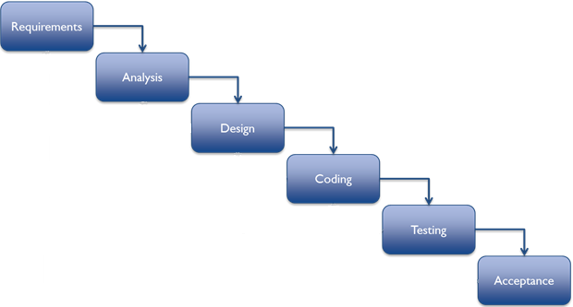

Figure 1: An Image of methodology.

Software Project Lab-I report : A Digital Watch

1. **Achievements**

By implementing the project I got several success. The software is able to keep accordance with the time handling efficiently. It is very user friendly from the aspect of our country as it is in Bengali user interface. The success results from the implementation of GUI of java, correct use of system time with java Timer Class, taking time and date from ZonedDateAndTime class, leap year calculation. The success are given below:

1. Bengali digital watch
2. Bengali stopwatch
3. Bengali timer
4. Bengali calendar

After all I have gathered experience with making a desktop app.

**8.Analysis and Design**

I have divided my whole process into two module.

1. Making each component separately
2. Set them to a single frame

There are four components. I have implemented them in separated class for each component. For watch I have created a text file to keep the coordinates of the dots that make a digit. To make ten digit 0-9 I have created ten txt file.

Software Project Lab-I report : A Digital Watch

Total seven class has been made for the implementation of the project.

The description of all classes are as follows:

Class “FileManager”: This class implement a method that returns the list of x, y coordinates of specific digit written in file specified in index.

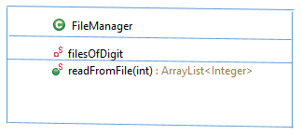

Figure 2: FileManager Class

Class “Watch”: This class implements the digital watch and its interfaces.

This is an extended JPanel.

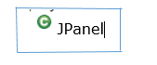

Figure 3- 2/1: Class Watch

Software Project Lab-I report : A Digital Watch

  
 ­­­­ 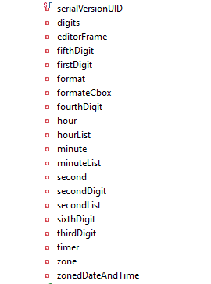

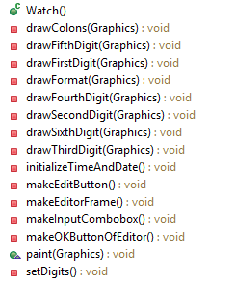

Figure 3- 2/2: Class Watch

Software Project Lab-I report : A Digital Watch

Class “StopWatch”: This an extended JPanel class that draws the Stopwatch GUI.



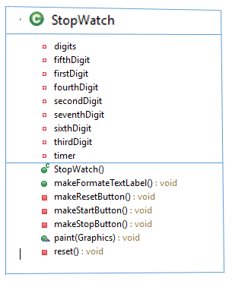

Figure4: Class StopWatch

Software Project Lab-I report : A Digital Watch

Class “MyTimer”: This class implements the timer and its GUI.



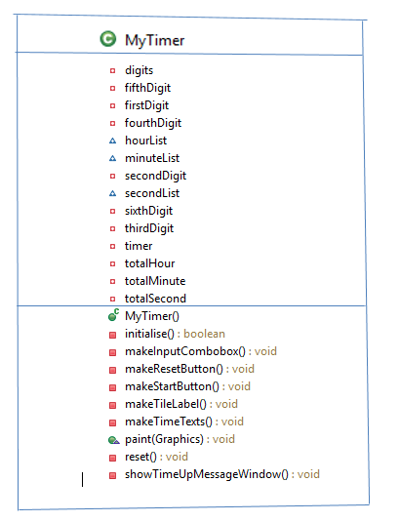

Figure5: Class MyTimer

Software Project Lab-I report : A Digital Watch

Class “MyCalendar”: This Class implements the Calendar and its GUI. It is also extended JPanel class.



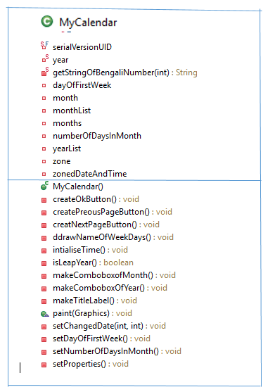

 Figure6: Class MyCalendar

Software Project Lab-I report : A Digital Watch

Class “MainFrame” and “Main” class: This class creates the main frame in which all other components contain. The other components entered in a tabbedPane and this tabbedPane is entered in the contentPane of the mainFrame. Then mainFrame pack them. After all mainframe is called from Main class.

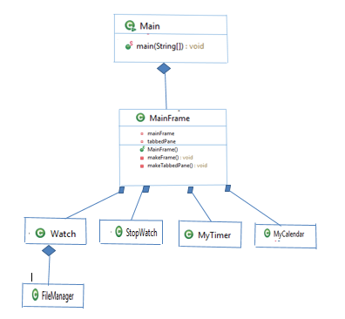

Figure7: Class diagram

Software Project Lab-I report : A Digital Watch

**9. Implementation and Testing**

I have divided my project in two main module: implementing the components and join them in a single frame.

Components are watch, stopwatch, timer and calendar.

The implementation process are as follows:

Watch: I have drawn the Bengali digits with filled ovals. The coordinates to draw these has been saved in ten text files.

Table 1: “one.txt” file

161 212

169 226

179 237

189 244

189 244

196 251

205 259

.

.

.

To read from file I have made “FileManager.java” class. The method “readFromFile()” method read coordinates and returns a Arraylist of the coordinates. This method takes an integer to identify the one of ten text file.

In the watch total 6 digits have been drawn that changes according to time.

Using the coordinates I painted the dots and with these a full digit. I have used “Timer” class of java to take the changing time every second I have drawn the updated digits. To show the current time I have used “ZonedDateAndTime” class of java.

Software Project Lab-I report : A Digital Watch

Table 2: Painting process

**public** **void** paint(Graphics g){

**super**.paint(g);

g.setColor(Color.***BLUE***);

drawFormat(g);

drawColons(g);

drawSixthDigit(g);

**if**(firstDigit!=0) drawFirstDigit(g);

drawSecondDigit(g);

drawThirdDigit(g);

drawFourthDigit(g);

drawFifthDigit(g);

}

**private** **void** drawFormat(Graphics g) {

g.setFont(**new** Font("Vrinda", Font.***BOLD***, 70));

g.drawString(format, 1200, 600);

}

Software Project Lab-I report : A Digital Watch

* StopWatch: I have used Vrinda font to draw digits in the stopwatch. With the “Timer” class I have taken the change of time and drawn the updated digits. In this I have drawn total 7 digits. The process is same as the Watch class just I have used Vrinda font to draw the digits here. I have given options to pause, cancel and start the stopwatch with button.
* MyTimer: In this class I have made a combobox to take the total time to run the timer and then I decrease down the time with one second up to zero. When time becomes zero I give the user a time up message with a frame. I have given the option to cancel the process.
* MyCalendar: In this class I have taken the current date and time from “ZonedDateAndTime”. Then I take the current month and year. At a time I have shown the calendar of single month. To do this I have determined the first weekday of first week. From the first weekday I have drawn the digits up to last day of month with loop. I have made user interface to go next and previous page too.
* MainFrame and Main: In the MainFrame class I have concatenated the components. For this I have used tabbedPane and add the components to this.Then I have added the tabbedPane to the contentPane of the mainframe. After all I have created an object of MainFrame and called it to run.

Testing: Deferent methods of testing can be applied to test the project. I have used user manual testing process to test my process.

User manual Testing: With all requirements to be fulfilled I have made an input output experiences with the project and checked the out of the input are correct or not. With this process I encountered several errors. I have investigated the line of code in which error exists and then I have corrected it.

Software Project Lab-I report : A Digital Watch

**10. Program Output**

The project has four component. Therefor four parts exist as output. At time of running the software first show the watch.

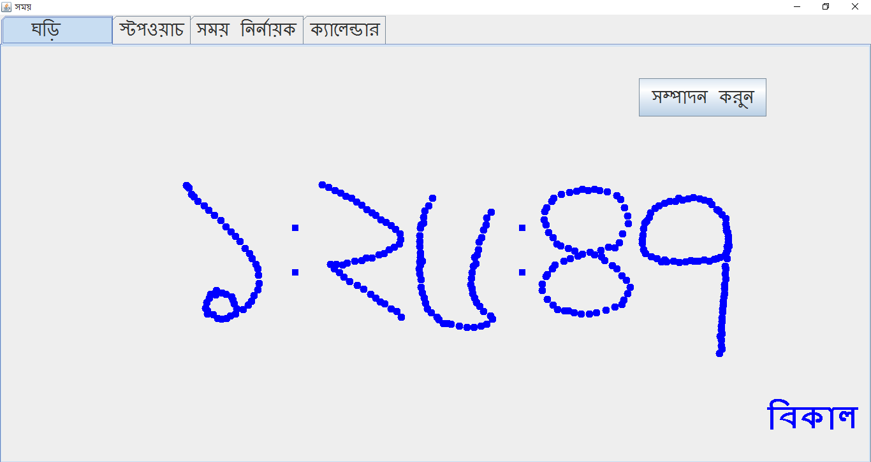

Figure 8: output of the project at watch tab

User can edit the time as he wish.

Software Project Lab-I report : A Digital Watch

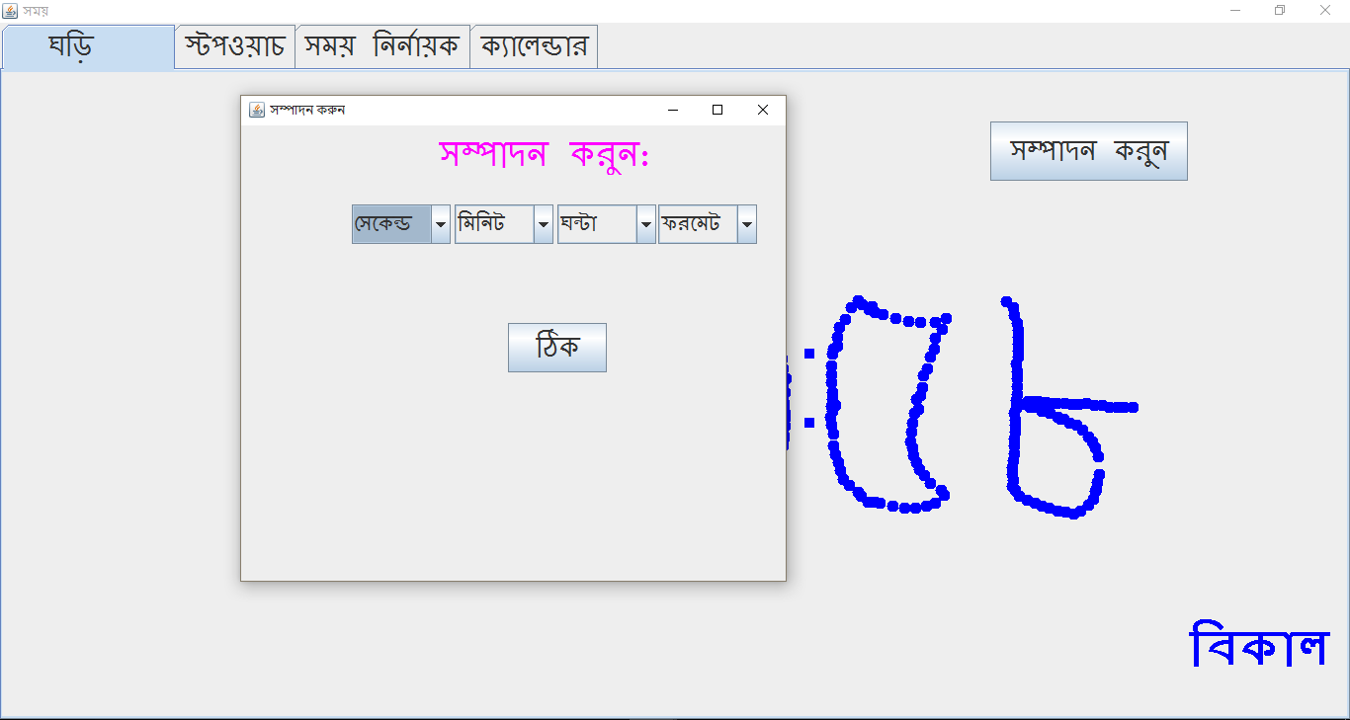

Figure 9: output of the project when clicked edit tab

Software Project Lab-I report : A Digital Watch

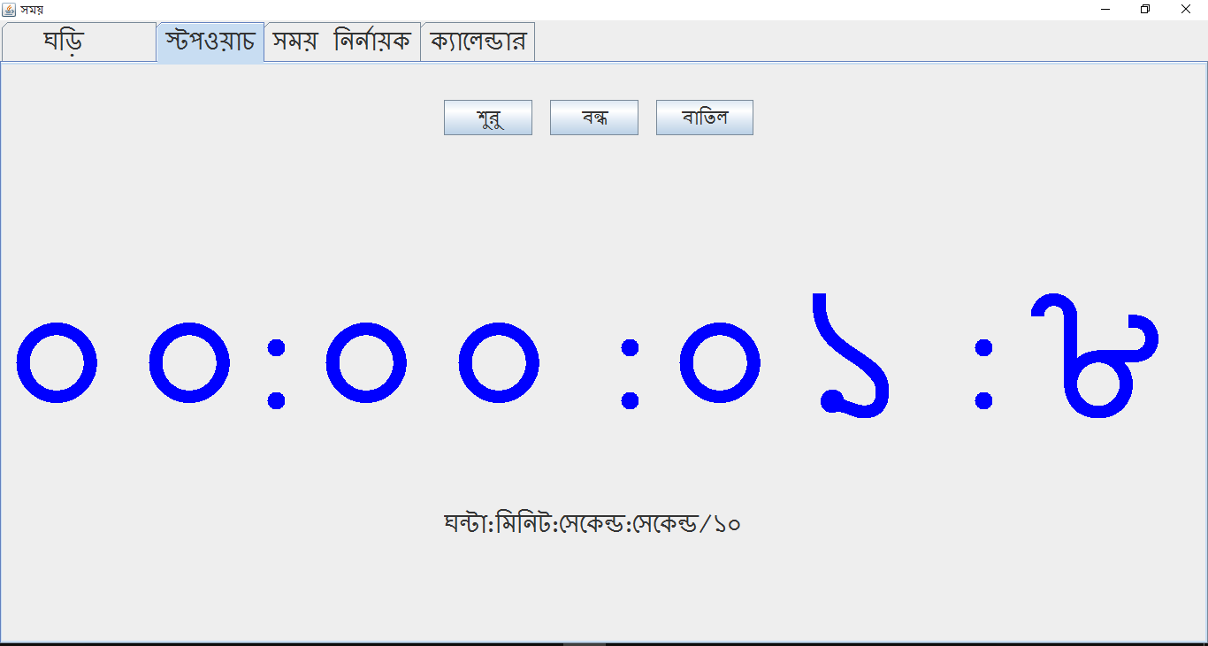

Figure 10: output of the project at stopwatch tab

Software Project Lab-I report : A Digital Watch

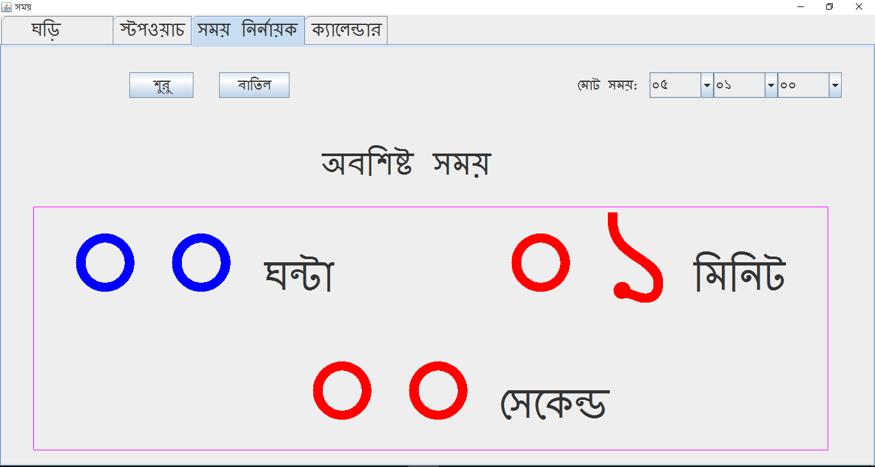

Figure 11: output of the project at timer tab

Software Project Lab-I report : A Digital Watch

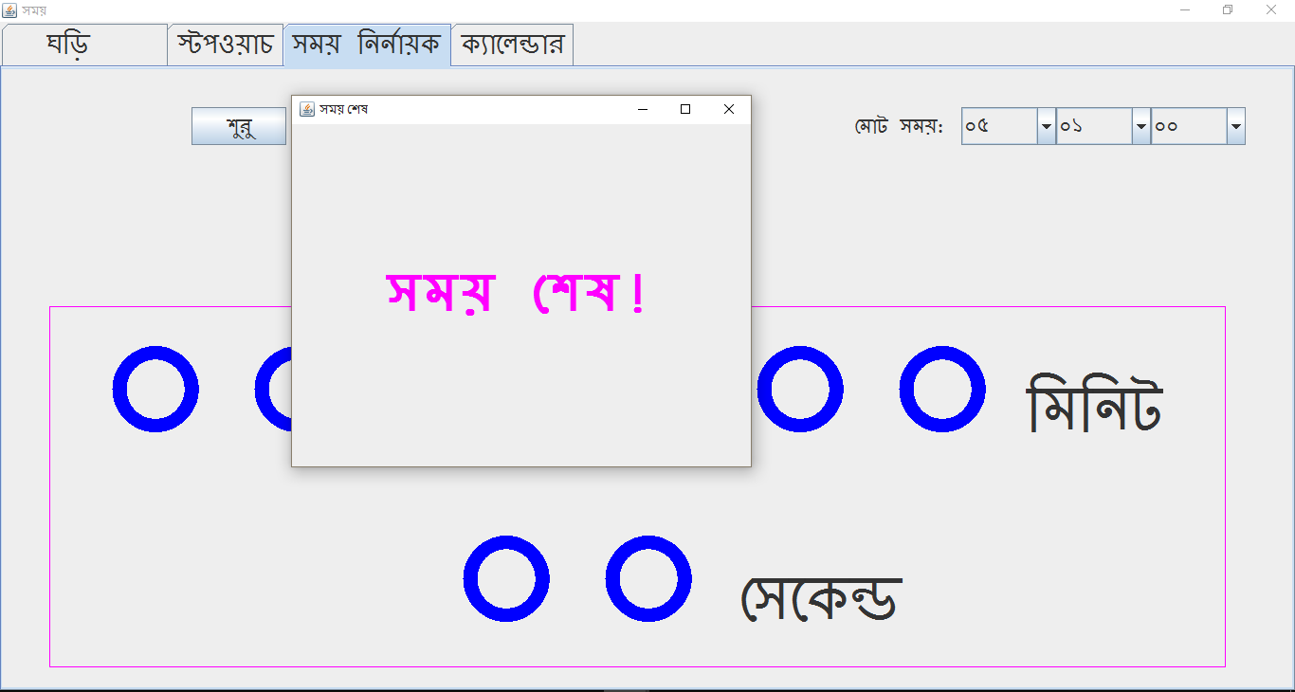

Figure 12: output of the project at timer tab when time up

Software Project Lab-I report : A Digital Watch

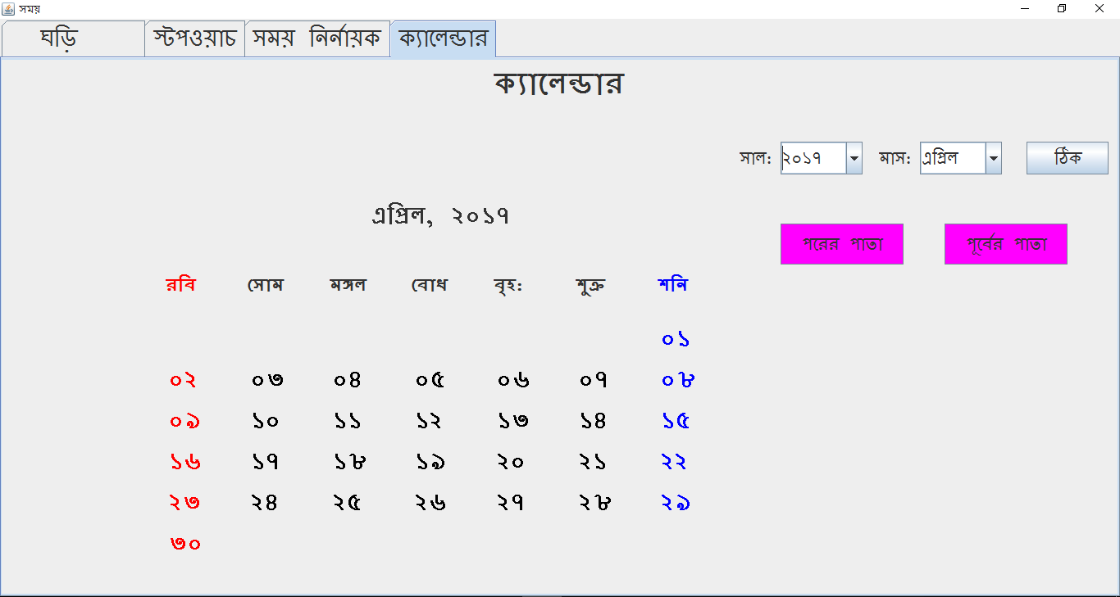

Figure 13: output of the project at stopwatch tab

**References**

1. [Conference of Qanat in Iran - water clock in Persia 1383,](http://www.aftabir.com/articles/view/science_education/technical/c3c1183387267p1.php/%D9%82%D9%86%D8%A7%D8%AA-%D9%85%DB%8C%D8%B1%D8%A7%D8%AB-%D9%81%D8%B1%D9%87%D9%86%DA%AF%DB%8C-%D9%88-%D8%B9%D9%84%D9%85%DB%8C-%D8%A7%DB%8C%D8%B1%D8%A7%D9%86%DB%8C%D8%A7%D9%86) in Persian.
2. [Donald Routledge Hill,](https://en.wikipedia.org/wiki/Donald_Routledge_Hill) "Mechanical Engineering in the Medieval Near

East".

3. Milham, Willis I. (1945). Time and Timekeepers*.*

1. Sabanski, Carl. ["The Sundial Primer".](http://www.mysundial.ca/tsp/north_vs_south.html)
2. American Institute of the City of New York (1870)