**Project Report**

**A Digital Watch**

**Course: SE305 Software Project Lab - I**

Submitted by

|  |  |  |
| --- | --- | --- |
| *Tulshi Chandra Das* | *ROLL :0811* | *2015-16* |

Document Version: 1.0

Submitted to

**SPL I Coordinators**

**Rezvi Shahariar, Assistant Professor, IITDU**

**Amit Seal Ami, Lecturer, IITDU**



**Institute of Information Technology**

**University of Dhaka**

[30-04-2017]

**To Whom It May Concern**

This is to certify that Tulshi Chandra Das, BSSE0811 has successfully completed the project titled “A Digital Watch” at Institute of Information Technology, University of Dhaka under my supervision and guidance in the fulfillment of requirements of Software Project Lab – I.



Amit Seal Ami

Lecture

Institute of Information Technology

University of Dhaka

**Acknowledgement**

At first, I thank almighty creator Sree Krishna because all credits go to him.

I express my gratitude to my respectful supervisor Amit Seal Ami sir, without whose help I could not complete my project. I also thank my brother Uddip Acharjee and my senior sister Prianka Priya of IIT DU who helped me to complete my project.



Tulshi Chandra Das

Roll: BSSE0811

Institute of Information Technology

University of Dhaka

**Executive Summary**

My project title is a “Digital Watch”. In this project without watch there are stopwatch, timer and calendar. My project is with user interface in our mother tongue Bengali.

I have started this project to make a software that will give good facilities to a person to manage the time and date.

To develop this project I have used eclipse and JDK-8. As I have used Bengali in this project I have installed “Vrinda” font. To run the project user must install Java Runtime Environment-8 and “Vrinda” font.

As the project is in Bengali, the project is friendly only with the people who know Bengali. This project show calendar and can be shown the date of any year from 0001 -6000. This is desktop based project.

To implement the project I have divided the whole project into two modules. One is developing the components and the other one is to keep them in single frame. Then call the mainframe from main class.

At the run time user can first see the watch in a tab. Then he will open the other tab as he wishes.

Working with this project, I have experienced with java library object oriented concepts.

**Table of Content**

1. Introduction 8

2. Background Study 8

3. Broad Domain 8

4. Challenges 9

5. Dependencies 10

6. Methodology 10

Achievements 11

Analysis and Design 12

9. Implementation and Testing 18

10. Program Output 20

11. User Manual 24

12. Conclusion 25

**List of Tables**

Table 1: one.txt file……………..………………………………………………………….…18

Table 2: Painting process…………………………………………………………………………………..19

**List of Figures**

Figure 1: A Sample of methodology……………………………………………………………………. ……......11

Figure 2: Class “FileManager” ……………………………………………………………….............12

Figure3: Class “Watch”…………………………………………………………………………………….…13

Figure4: Class “StopWatch”………………………………………………………………………………….14

Figure5: Class “MyTimer”…………………………………………………………………………………....15

Figure6: Class “MyCalendar”…………………………………………………………………………………16

Figure7: Class diagram….…….………………………………………………………………………………17

Figure 8: output of the project at watch tab…………………………………………….….……..21

Figure 9: output of the project when clicked edit tab…………………………………..…….21

Figure 10: output of the project at stopwatch tab…………………………………………….22

Figure 11: output of the project at timer tab…………………………………………………….22

Figure 12: output of the project at timer tab when time up……………………………..23

Figure 13: output of the project at stopwatch tab…………………………………………….23

Figure 14: output of the project at stopwatch tab………………………………………………24

Software Project Lab-I report : A Digital Watch

# 1. Introduction

Time is very important in one’s life. Everyone has to maintain and observe the time in all of his moments of daily activities. Therefore a well-organized date and time representation is very helpful to anybody. This software has been developed from this aspect.

# 2. Background Study

In past, there were different systems for determining time like the position of the sun, the shadow of sun position of the moon to define times and dates. For example ”water clock[1]”, ”candle clock[2]”, ”pendulum clock[3]”, ”sundial[4]”, ”hourglass[5]” were the ancient systems of time determination. With the progress of technology, the modern watch is invented like led display watch, digital watch etc. The project has been implemented the several time-related interfaces such as a watch, stopwatch, calendar, timer.

# 3. Broad Domain

I have started the project to provide a good organized of timing facilities in the Bengali language. For many lower class people in our country, Bengali is preferable than English to understand. Besides, it is very rare to find a combined application of

Software Project Lab-I report: A Digital Watch

digital watch, stopwatch, timer, and calendar. So my project will be helpful for this purpose.

It is an application that shows the current local time of Bangladesh, edit time, stopwatch, timer and calendar through:

1. Reading text file
2. Taking time and date from System
3. Providing a good graphical user interfaces

This application can provide:

1. Digital Watch
2. Stopwatch
3. Timer
4. Calendar

All of these are in the Bengali language with user interfaces.

# 4. Challenges

To implement the whole project I have solved some challenges. To make the

Digital watch I have used 2d graphics and using it I have drawn the Bengali numerical digits. My project mostly depends on GUI. I have analyzed the usage of the GUI.

There are main challenges to implementing the project:

1. Drawing the Bengali Digits with dots
2. Usage of System time or time as input from user
3. Handling locality of time as time zone.

Software Project Lab-I report: A Digital Watch

1. Implementation of Graphical User Interface of java
2. Completing the software within 4 months

# 5. Dependencies

1. **1. Software**

To run the software Java Runtime Environment-8 have to be installed. A system that has Java Runtime Environment-8 can run my software.

* 1. **Hardware**

My software is desktop based. All hardware are not supported for this software.

# 6. Methodology

To complete my project I have used the waterfall approach. It is a sequential process of software development that goes to upward to downward. At first, I have analyzed requirements of the project. After that, I have made a design of software. After software design, I start coding. After coding, I have tested the software to check is it give correct output. Then accept it.

Software Project Lab-I report : A Digital Watch

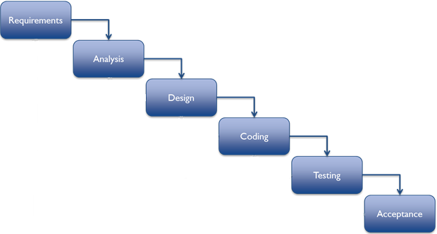

Figure 1: An Image of methodology.

# Achievements

By implementing the project I got several success. The software is able to keep accordance with the time handling efficiently. It is very user-friendly from the aspect of our country as it is in Bengali user interface. The success results from the implementation of GUI of java, correct use of system time with java Timer

Class, taking time and date from ZonedDateAndTime class, leap year calculation. The successes are given below:

Software Project Lab-I report: A Digital Watch

1. Bengali digital watch
2. Bengali stopwatch
3. Bengali timer
4. Bengali calendar

After all, I have gathered experience with making a desktop app.

# Analysis and Design

I have divided my whole process into two module.

1. Making each component separately
2. Set them to a single frame

There are four components. I have implemented them in separated class for each component. For watch I have created a text file to keep the coordinates of the dots that make a digit. To make ten digit 0-9 I have created ten txt file. Total seven class has been made for the implementation of the project.

The description of all classes are as follows:

Class “FileManager”: This class implements a method that returns the list of x, y coordinates of specific digit written in the file specified in the index.

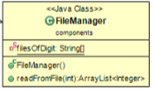

Figure 2: “FileManager” Class

Software Project Lab-I report: A Digital Watch

Class “Watch”: This class implements the digital watch and its interfaces.

This is an extended JPanel.

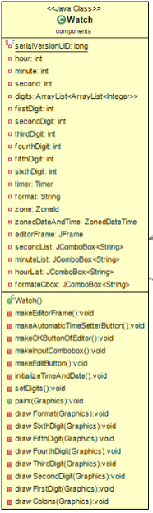

Figure 3- 2/1: Class “Watch”

Software Project Lab-I report: A Digital Watch

Class “StopWatch”: This an extended JPanel class that draws the Stopwatch GUI.

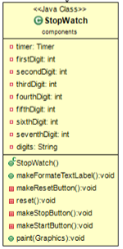

Figure 4: Class “StopWatch”

Software Project Lab-I report: A Digital Watch

Class “MyTimer”: This class implements the timer and its GUI.

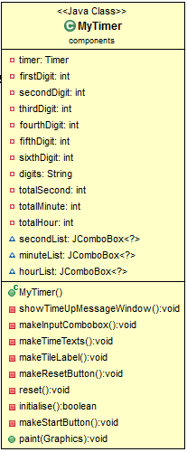

Figure 5: Class “MyTimer”

Software Project Lab-I report: A Digital Watch

Class “MyCalendar”: This Class implements the Calendar and its GUI. It is also extended JPanel class.

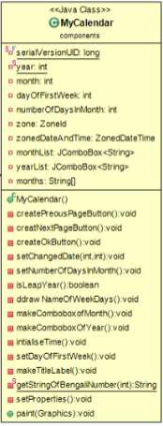

 Figure6: Class “MyCalendar”

Software Project Lab-I report: A Digital Watch

Class “MainFrame” and “Main” class with the class diagram: This class creates the main frame in which all other components contain. The other components entered in a tabbedPane and this tabbedPane is entered in the contentPane of the mainFrame. After that mainFrame packs them. After all, mainframe is called from Main class.

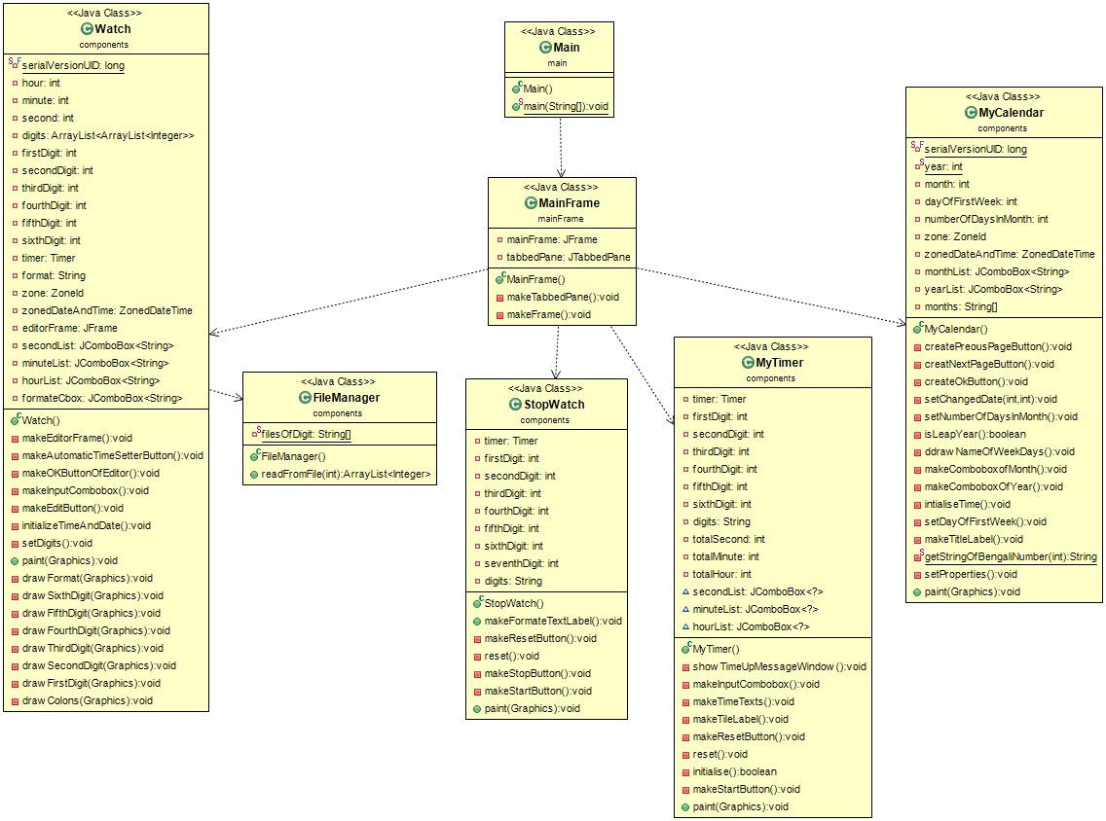

Figure7: Class diagram

Software Project Lab-I report: A Digital Watch

# 9. Implementation and Testing

I have divided my project into two main module: implementing the components and join them in a single frame. Components are a watch, stopwatch, timer, and calendar.

The implementation process is as follows:

Watch: I have drawn the Bengali digits with filled ovals. The coordinates to draw these has been saved in ten text files.

Table 1: “one.txt” file

161 212

169 226

179 237

189 244

189 244

196 251

205 259

.

.

.

To read from the file I have made “FileManager.java” class. The method “readFromFile()” method read coordinates and returns an ArrayList of the coordinates. This method takes an integer to identify the one of ten text file.

In the watch total 6 digits have been drawn that changes according to time.

Using the coordinates I painted the dots and with these a full digit. I have used “Timer” class of java to take the changing time every second I have drawn the

Software Project Lab-I report: A Digital Watch

updated digits. To show the current time I have used “ZonedDateAndTime” class of java.

Table 2: Painting process

**public** **void** paint(Graphics g){

**super**.paint(g);

g.setColor(Color.***BLUE***);

drawFormat(g);

drawColons(g);

drawSixthDigit(g);

**if**(firstDigit!=0) drawFirstDigit(g);

drawSecondDigit(g);

drawThirdDigit(g);

drawFourthDigit(g);

drawFifthDigit(g);

}

**private** **void** drawFormat(Graphics g) {

g.setFont(**new** Font("Vrinda", Font.***BOLD***, 70));

g.drawString(format, 1200, 600);

}

* StopWatch: I have used Vrinda font to draw digits in the stopwatch. With the “Timer” class I have taken the change of time and drawn the updated digits. In this, I have drawn total 7 digits. The process is same as the Watch class just I have used “Vrinda” font to draw the digits here. I have given options to pause, cancel and start the stopwatch with a button.

Software Project Lab-I report: A Digital Watch

* MyTimer: In this class, I have made a combobox to take the total time to run the timer and then I decrease down the time with one second up to zero. When time becomes zero I give the user a time up message with a frame. I have given the option to cancel the process.
* MyCalendar: In this class, I have taken the current date and time from “ZonedDateAndTime”. Then I take the current month and year. At a time I have shown the calendar of a single month. To do this I have determined the first weekday of the first week. From the first weekday, I have drawn the digits up to last day of the month with loop. I have made a user interface to go next and previous page too.
* MainFrame and Main: In the MainFrame class I have concatenated the components. For this, I have used tabbedPane and add the components to this.Then I have added the tabbedPane to the contentPane of the mainframe. After all, I have created an object of MainFrame and called it to run.

Testing: Deferent methods of testing can be applied to test the project. I have used the user manual testing process to test my process.

User manual Testing: With all requirements to be fulfilled I have made an input-output experiences with the project and checked the out of the input are correct or not. With this process, I encountered several errors. I have investigated the line of code in which error exists and then I have corrected it.

# 10. Program Output

The project has four component. Therefor four parts exist as output. At time of running the software first show the watch.

Software Project Lab-I report: A Digital Watch

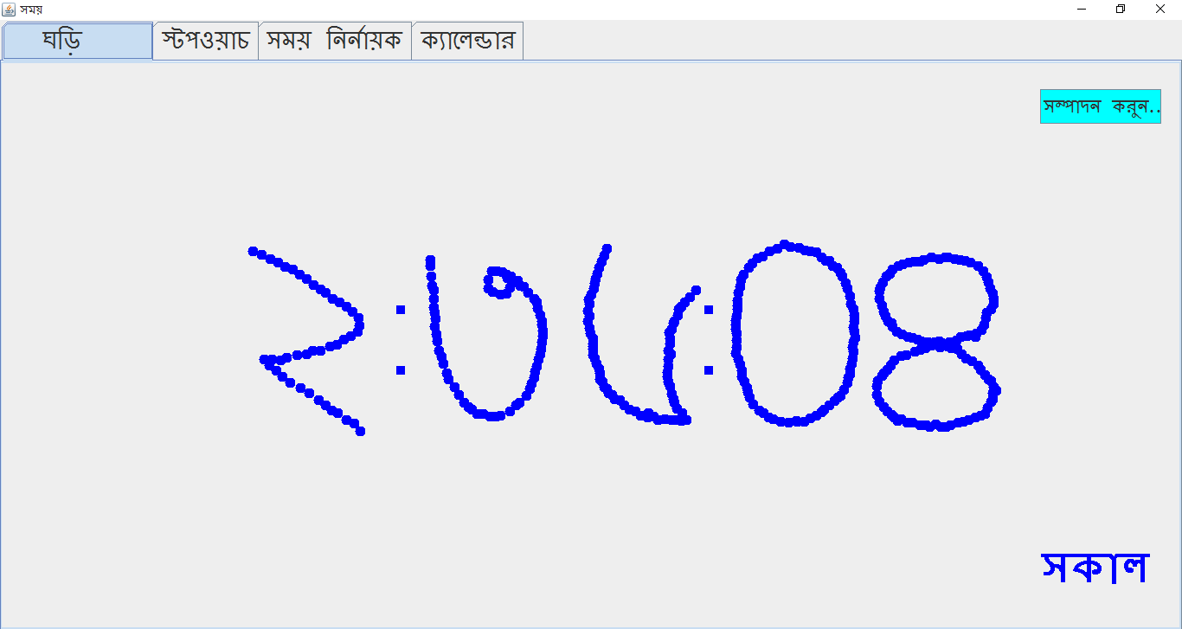

Figure 8: output of the project at watch tab

User can edit the time as he wishes.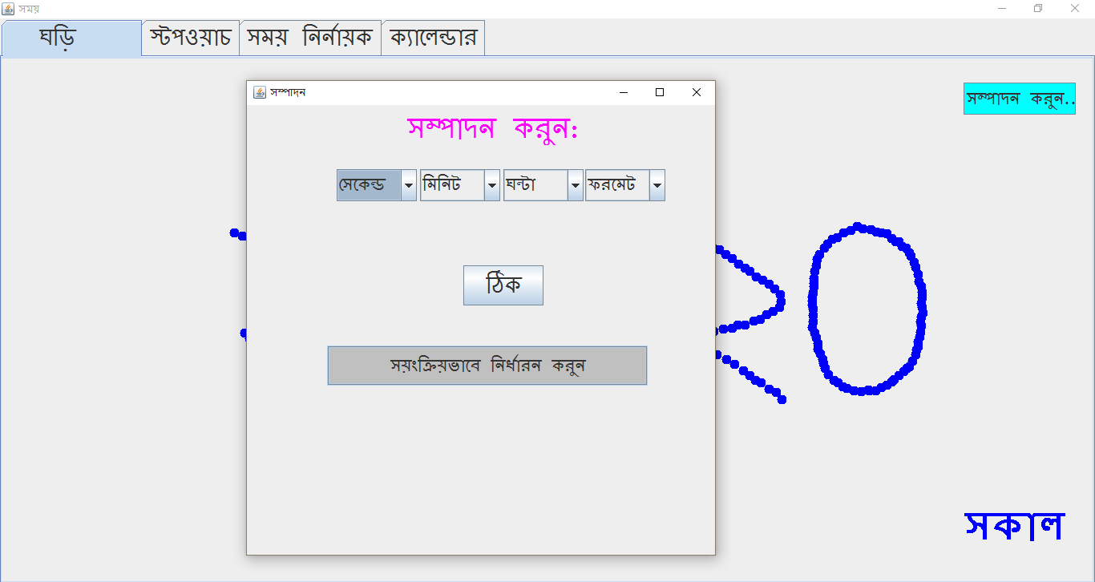

Figure 9: output of the project when clicked edit tab

Software Project Lab-I report: A Digital Watch

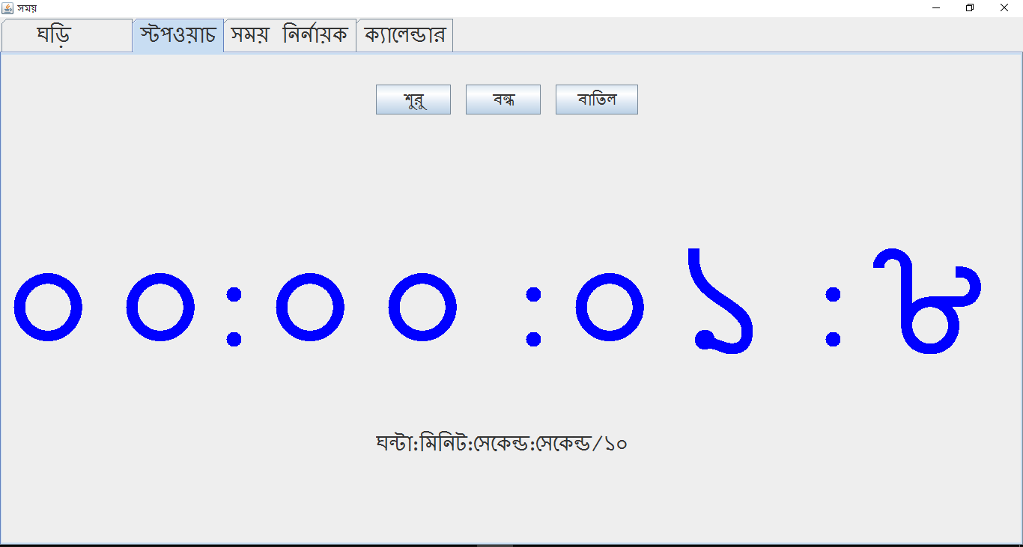

Figure 10: output of the project at stopwatch tab

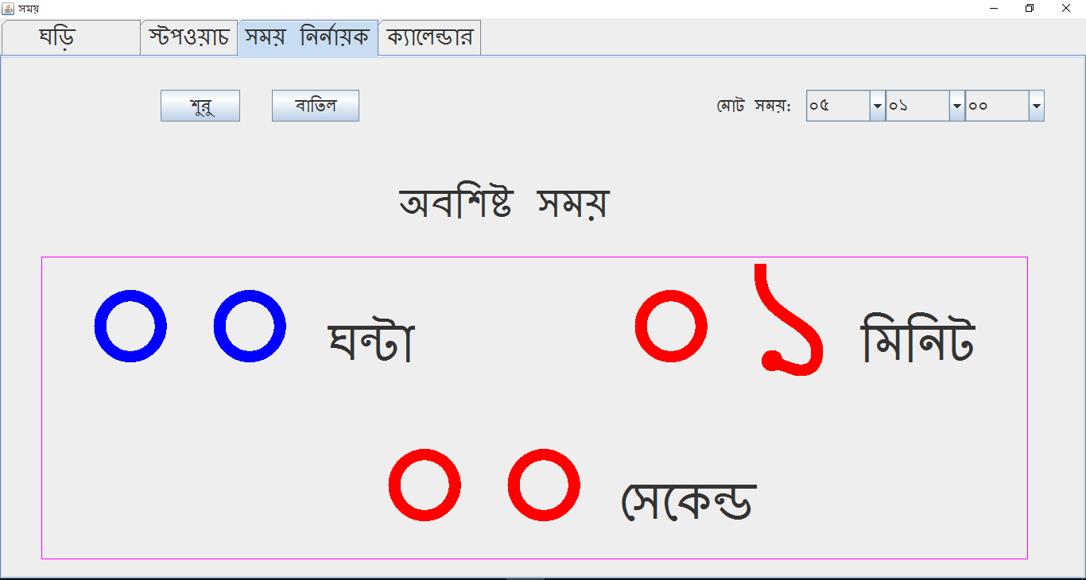

Figure 11: output of the project at timer tab

Software Project Lab-I report: A Digital Watch

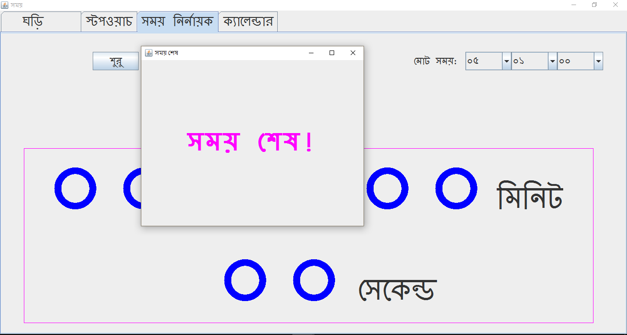

Figure 12: output of the project at timer tab when time up

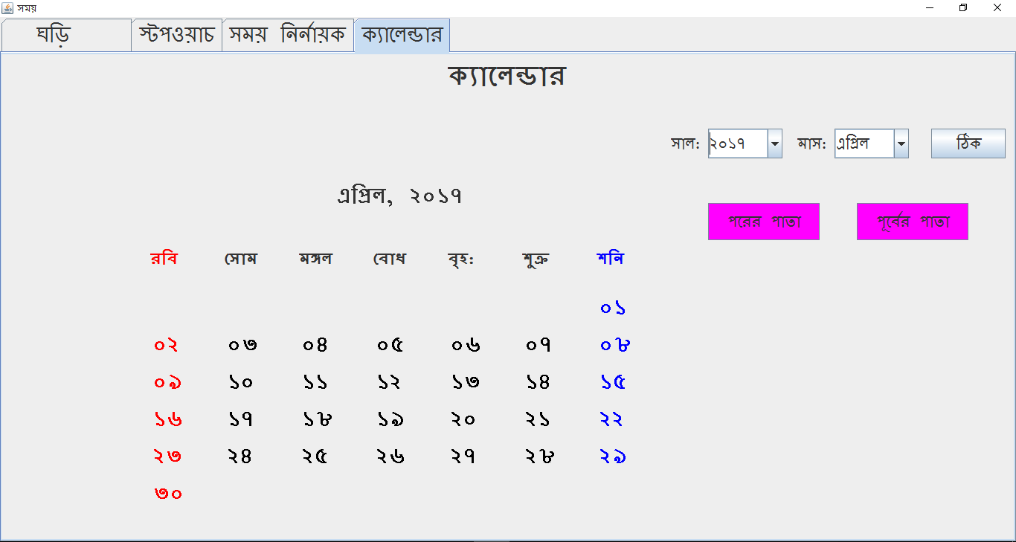

Figure 13: output of the project at calendar tab

Software Project Lab-I report: A Digital Watch

# 11. User Manual

* Visit this link: <http://www.oracle.com/technetwork/java/javase/downloads/jre8-downloads-2133155.html>
* According to your operating system download and install Java Runtime Environment
* Take the jar file and the “digits” folder in another folder.
* Right click on the jar file and click properties
* In open with option, set Java(TM) Platform SE binary
* Create a shortcut of the jar file in the desktop.
* To run double click on the shortcut.

When you run it you will see the frame:

Figure 14: output of the project at stopwatch tab

* Now it is very simple to go other components with clicking tabs.

Software Project Lab-I report: A Digital Watch

# 12. Conclusion

To develop every step of the project my concept of object oriented programming has been enriched. Though the working with this project was a little bit hard the impact of this is very important.

**References**

1. [Conference of Qanat in Iran - water clock in Persia 1383,](http://www.aftabir.com/articles/view/science_education/technical/c3c1183387267p1.php/%D9%82%D9%86%D8%A7%D8%AA-%D9%85%DB%8C%D8%B1%D8%A7%D8%AB-%D9%81%D8%B1%D9%87%D9%86%DA%AF%DB%8C-%D9%88-%D8%B9%D9%84%D9%85%DB%8C-%D8%A7%DB%8C%D8%B1%D8%A7%D9%86%DB%8C%D8%A7%D9%86) in Persian.
2. [Donald Routledge Hill,](https://en.wikipedia.org/wiki/Donald_Routledge_Hill) "Mechanical Engineering in the Medieval Near

East", May 1991, pp. 64-9.

3. Milham, Willis I. (1945). Time and Timekeepers (1942)*.*

4. Sabanski, Carl. ["The Sundial Primer".](http://www.mysundial.ca/tsp/north_vs_south.html) Retrieved 2008-07-11

5. American Institute of the City of New York (1870)