Institute of Information Technology

University of Dhaka

Assignment on TCP protocol observation

Submitted to:

Professor Md. Shariful Islam

IIT,DU

Submitted by:

Tulshi Chandra Das

Roll:811

1. 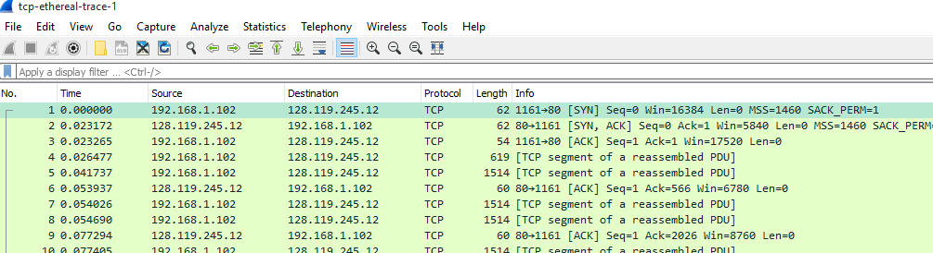

IP address and TCP port number used by the client computer:

192.168.1.102 and 1161

2.

gaia.cs.umass.edu’s IP address is *128.119.245.12*, port number is *80*

3. 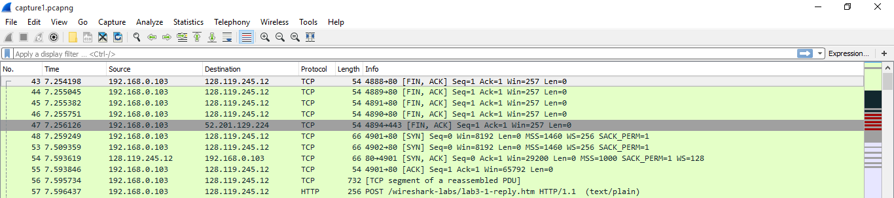

Sorce ip: 192.168.0.103; source port: 4894

4.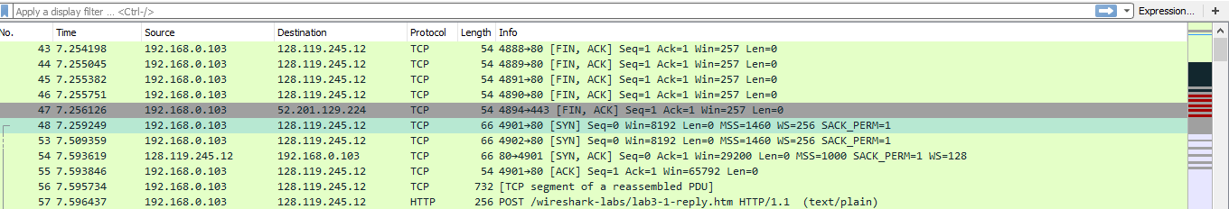

Seq number: 0. At flag part SYN in set to 1, so it is SYN segment.

5.

According to the screenshot below, the sequence number of the SYN_ACK segment sent by gaia.cs.umass.edu to the client computer in reply to the SYN is 0. The value of the acknowledgement field in the SYN_ACK segment is determined by the server gaia.cs.umass.edu. The server adds 1 to the initial sequence number of the SYN segment from the client computer. For this case, the initial sequence number of the SYN segment from the client computer is 0, thus the value of the acknowledgement field in the SYN_ACK segment is 1. A segment will be identified as a SYN_ACK segment if both SYN flag and ACKnowledgement flag in the segment are set to 1.

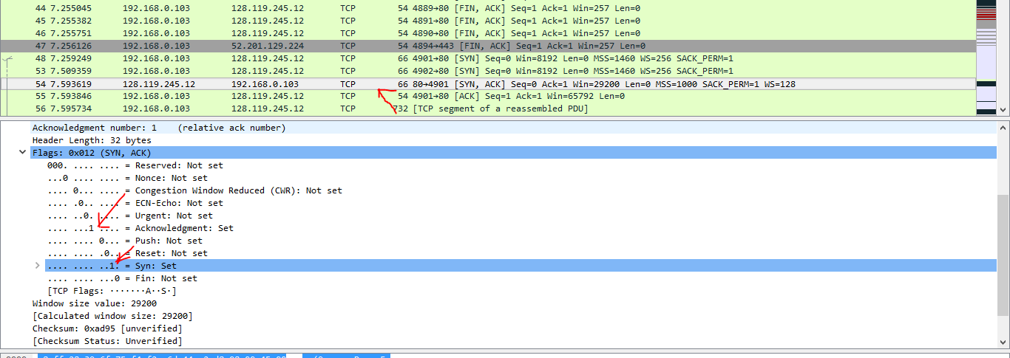

6.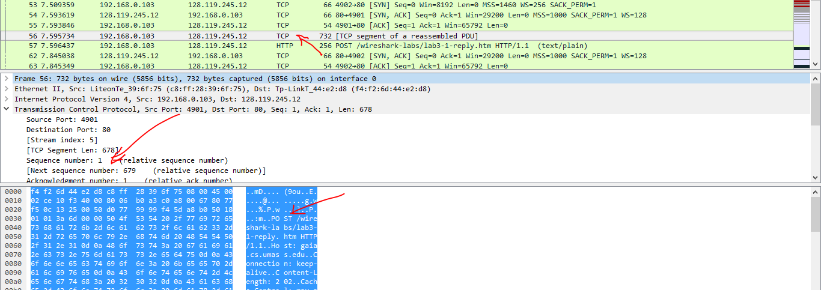

Seq number: 1

7.

Sequence number for segment 1 is 1,

Sequence number for segment 2 is 881.

Sequence number of segment 3 is 0.

Sequence number of segment 4 is 1.

Sequence number of segment 5 is 1.

Sequence number of segment 6 is 1.

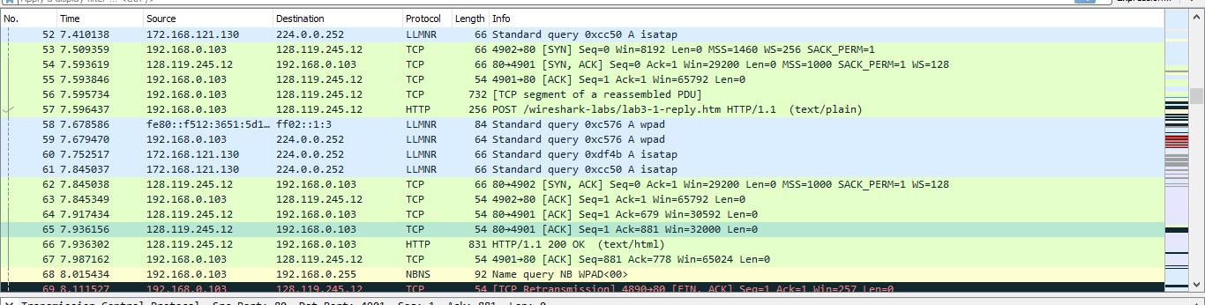

b.

Time for segment 1: 7.595734

Time for segment 2: 7.5964377

Time for segment 3: 7.845038

Time for segment 4: 7.845349

Time for segment 5: 7.917434

Time for segment 6: 7.936156

8.

Length for segment 1: 732

Length for segment 1: 256

Length for segment 1: 66

Length for segment 1: 54

Length for segment 1: 54

Length for segment 1: 54

9.

Available Buffer Space for segment 1:65792

Available Buffer Space for segment 2:65792

Available Buffer Space for segment 3:29200

Available Buffer Space for segment 4:65792

Available Buffer Space for segment 5:30592

Available Buffer Space for segment 6:32000

10.

Yes, there are some retransmitted segments in the trace file. This can be explained by packets with same sequence number at different time is not found.

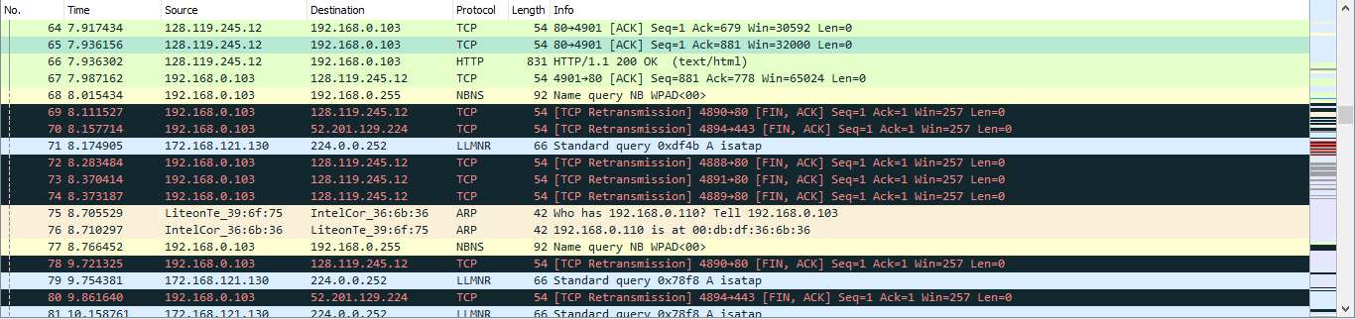

11.

According to the screenshot below, we can see that the ACK numbers increase in the sequence of 679, 881 and so on.