The HTTP CONDITIONAL GET/response interaction

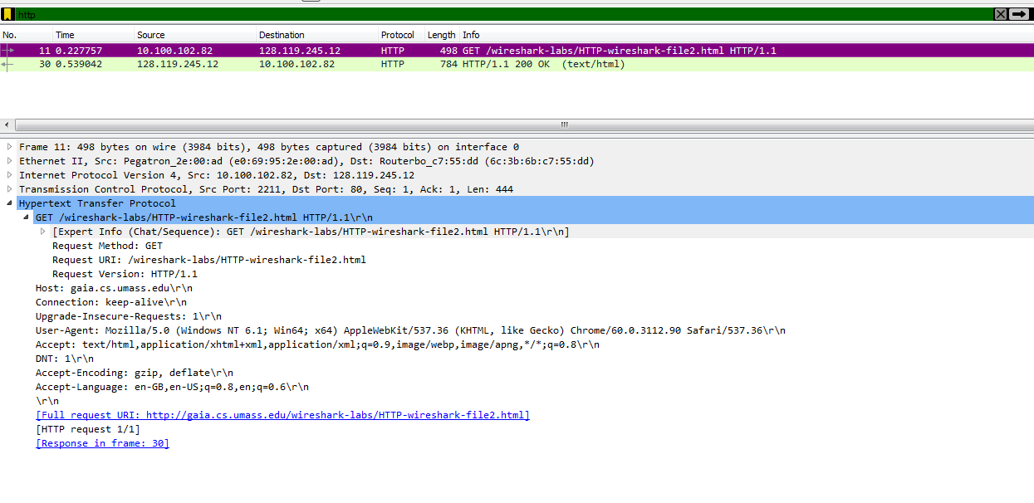

Fig: application layer information of the http request

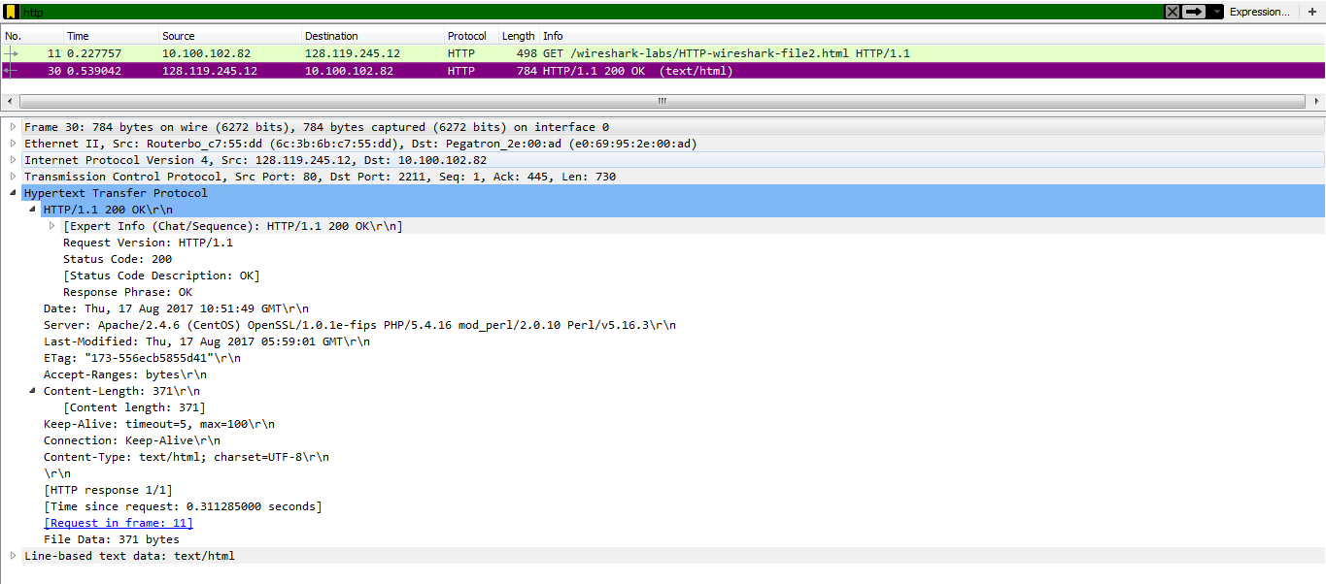

Fig: application layer information of the http response

8. No, I have not seen.

9.

. The content of http get message: GET /wireshark-labs/HTTP-wireshark-file2.html HTTP/1.1\r\n