Institute of Information Technology

University of Dhaka

Assignment on TCP protocol observation

Submitted to:

Professor Md. Shariful Islam

Director, IIT,DU

Submitted by:

Tulshi Chandra Das

Roll: 811

1.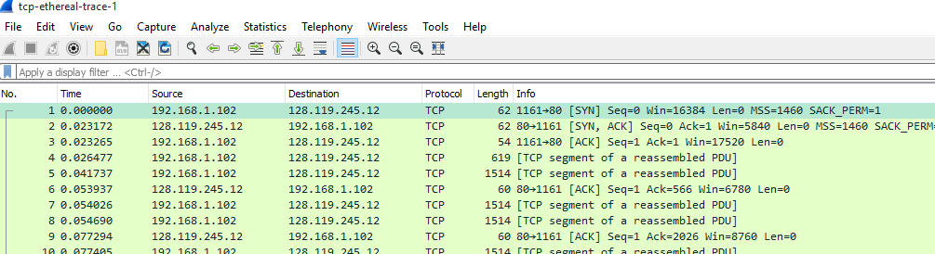

IP address and TCP port number used by the client computer:

192.168.1.102 and 1161

2.

gaia.cs.umass.edu’s IP address is *128.119.245.12*, port number is *80*

3.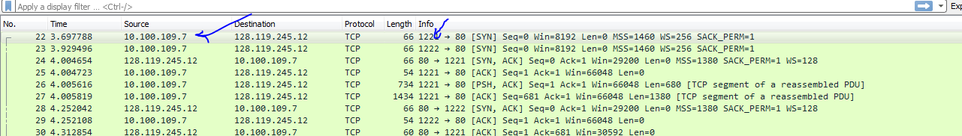

Sorce ip: 10.100.109.7; source port: 1221

4.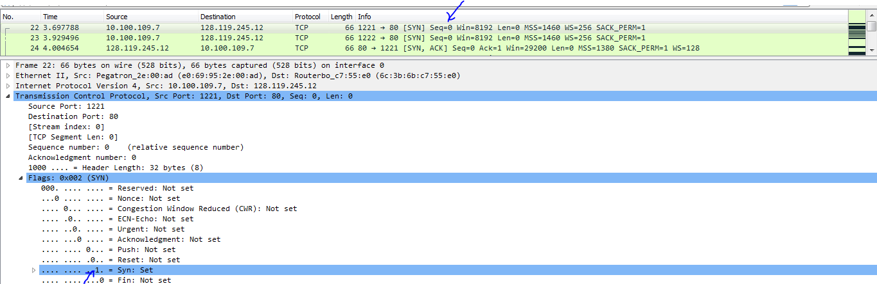

Seq number: 0. At flag part SYN in set to 1, so it is SYN segment.

5.

According to the screenshot below, the sequence number of the SYN_ACK segment sent by gaia.cs.umass.edu to the client computer in reply to the SYN is 0. The value of the acknowledgement field in the SYN_ACK segment is determined by the server gaia.cs.umass.edu. The server adds 1 to the initial sequence number of the SYN segment from the client computer. For this case, the initial sequence number of the SYN segment from the client computer is 0, thus the value of the acknowledgement field in the SYN_ACK segment is 1. A segment will be identified as a SYN_ACK segment if both SYN flag and ACKnowledgement flag in the segment are set to 1.

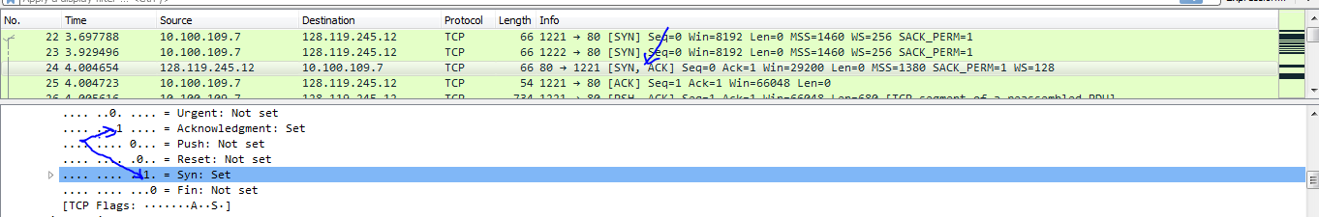

6.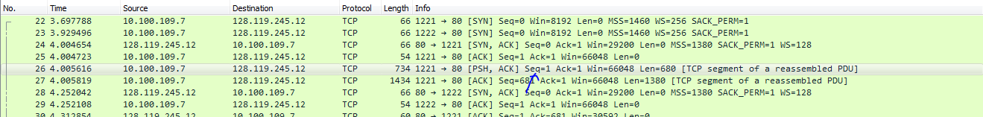

Seq number: 1

7. a.

Sequence number for segment 1 is 1,

Sequence number for segment 2 is 681.

Sequence number of segment 3 is 2061.

Sequence number of segment 4 is 6201.

Sequence number of segment 5 is 14481.

Sequence number of segment 6 is 25521.

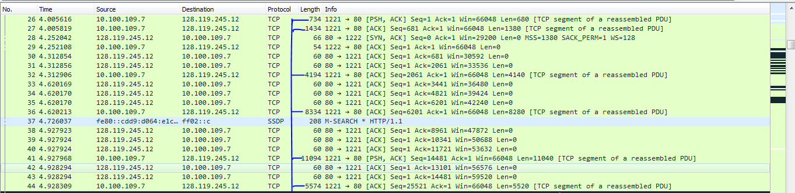

b. From the picture of par ‘a’ we can find:

Time for segment 1: 4.005616

Time for segment 2: 4.005819

Time for segment 3: 4.312906

Time for segment 4: 4.620213

Time for segment 5: 4.928294

Time for segment 6: 4.928309

c. Receive time are given below:

Time for segment 1: 4.312854

Time for segment 2: 4.312856

Time for segment 3: 4.620170

Time for segment 4: 4.928294

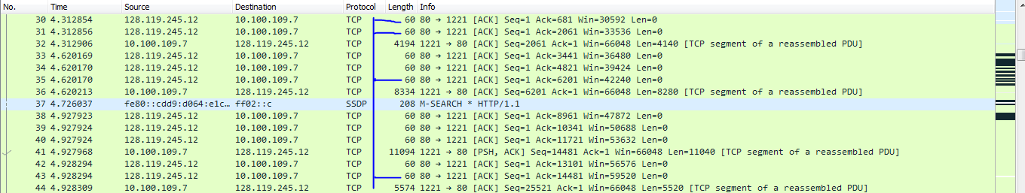

Time for segment 5: 5.237489

Time for segment 6: 4.237898

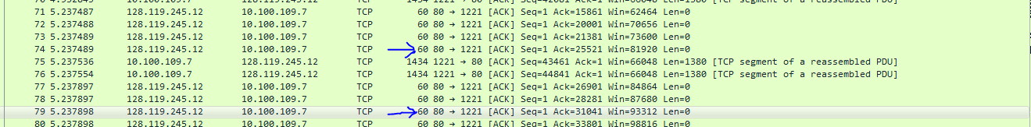

d. From ‘b’ and ‘c’ we can find RTT:

RTT for segment 1 is 0.307238 seconds,

RTT for segment 2 is 0.307037 seconds,

RTT for segment 3 is 0.307264 seconds,

RTT for segment 4 is 0.308081 seconds,

RTT for segment 5 is 0.30918 seconds,

RTT for segment 6 is 0.309589 seconds.

8.

Length for segment 1: 734

Length for segment 2: 1434

Length for segment 3: 4194

Length for segment 4: 8334

Length for segment 5: 11094

Length for segment 6: 5574



9.

Available Buffer Space for segment 1:30592

Available Buffer Space for segment 2:33536

Available Buffer Space for segment 3:42240

Available Buffer Space for segment 4:59520

Available Buffer Space for segment 5:81920

Available Buffer Space for segment 6:93312

10.

Yes, there are some retransmitted segments in the trace file. This can be explained by packets with same sequence number at different time is not found.

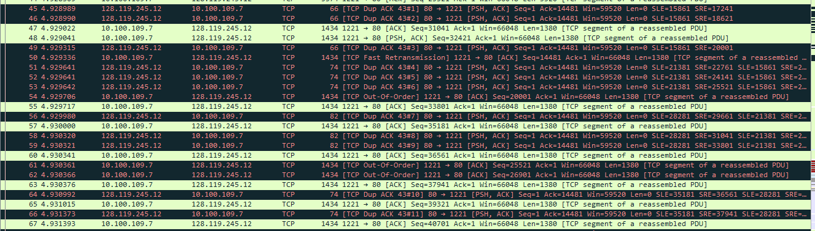

11.

According to the screenshot below, we can see that the ACK numbers increase in the sequence of 681, 2061, 3441 and so on. The difference between the acks are always 1380. 1380 data acknowledge the receiver typically.

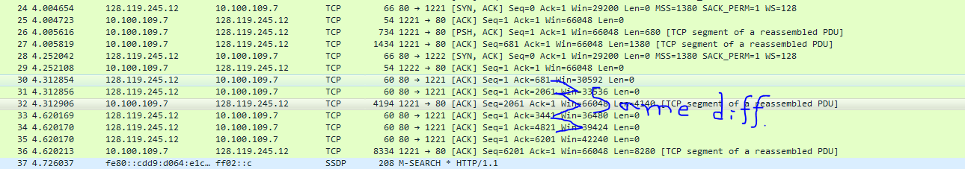

12.

Throughput = Amount of data transmitted / time incurred

Amount of data transmitted = 1175688

Time incurred = 8.588083 – 4.004723= 4.58336

Throughput = 1175688/4.58336 = 256512.253



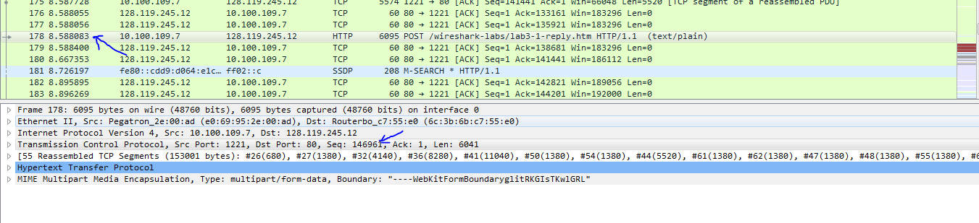

13. *Time-Sequence-Graph(Stevens*) is given below:

