**List of subsystems:**

1. Authentication

2. Stock Management

3. Financial Management

4. Information System

5. Human Resource Management

**1. Authentication**

*Primary Actor: Everyone*

*Secondary Actor: None*

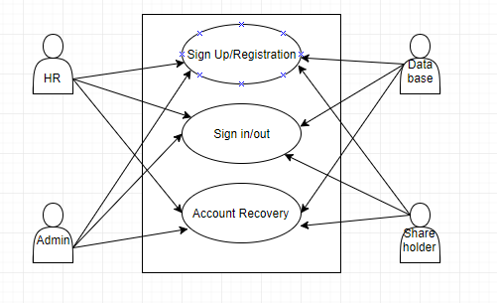

Figure 1: Authentication: use case diagram

**1.1 Sign up/ Registration**

*Primary Actor: Database, Administrator.*

*Secondary Actor: Salesperson, Shareholder.*

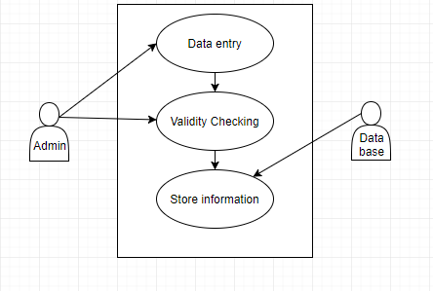

Figure 2: Sign up: use case diagram

**1.1.1 Data Entry**

*Primary Actor: Administrator.*

*Secondary Actor: None.*

**Administrator's Action/reply:**

Action: Administrator enters data during sign up.

Reply: Data entry successful or unsuccessful.

**1.1.2 Validity Checking**

*Primary Actor: Administrator.*

*Secondary Actor: None.*

**Administrator's Action/reply:**

Action: System will receive data from UI.

Reply: Show if the data is valid or not.

**1.1.3 Store Information**

Primary Actor: Database.

Secondary Actor: None.

**Database's Action/reply:**

Action: Store valid data.

Reply: Data entry successful or unsuccessful.

**Sign up: Description**

The system will hold 3 kinds of accounts. These are:

-Administrator (Owner)

-Salesperson (HR)

-Shareholder

**Data entry:**

The owner will register himself/herself as the administrator of the system.The registration involves the entering of the following data:

* Full name
* User name
* Phone no
* Email
* Address
* password
* Backup questions and answer

**Validity Check:**

The password must contain minimum 8 characters including at least a number. Confirmation codes will be sent to the valid phone numbers and email addresses. The owner will create account for the each of the salesperson. The following information of the salesperson will be stored:

* Full name
* User name
* Phone no
* Email
* Address
* password
* Joining date
* salary
* NID NO
* Date of Birth
* Present and permanent address.

The owner will also include shareholders in the system. The registration of the shareholder will include the following attributes:

* Full name
* User name
* Phone no
* Email
* Address
* password
* NID NO

**Store Information:**

After validity check all the data will be stored in the database and every registered individual will be able to log in to the system.

**1.2 Sign in/out:**

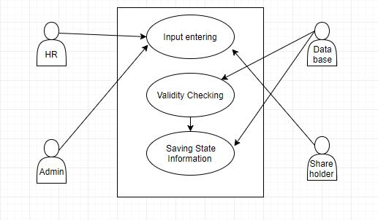

Figure 3: Sign in/out: use case diagram

**1.2.1 Input entering:**

*Primary actors: owner, salesperson*

*Secondary actors: shareholder.*

**Action/reply:**

Action: Take user name and password from the user.

Reply: Login successful or not.

**1.2.2 Validity Checking:**

*Primary Actor: Database.*

*Secondary Actor: none.*

**Action/Reply:**

Action: System will receive data from the UI(entered by user).

Reply: Check if the entered data is matched or not.

**1.2.3 Saving information:**

Primary actor: Database.

Secondary Actor: none.

**Action/Reply:**

Action: In case of logout shows prompt to user for unsaved data.

Reply: Data will be saved if the user enters otherwise not.

**Sign in/out: Description:**

The system will be displayed differently to the different type of the user upon signing in.

**Input entering:**

The user will enter his or her username and password. Correct input results in successful log in to the system.

**Validity Checking:**

Entered data will be checked with the store data in the database.

**Saving information:**

In case of a salesperson the first log in time of a particular day will be saved in the database. During logout, logout time, active transaction/process will be displayed. The running processes are either terminated or saved in Database based on the user's choice.

**1.3 Account recovery:**

*Primary Actor: Everyone.*

*Secondary Actor: Database.*

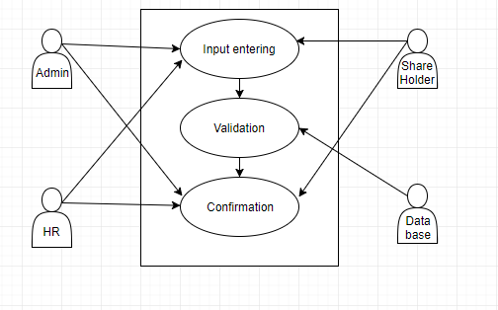

Figure 4: Account Recovery: use case diagram

**Action/Reply:**

Action: In case of logout shows prompt to user for unsaved data.

Reply: Data will be saved if the user enters otherwise not.

**1.3.1 Input entering:**

Primary Actor: Everyone.

Secondary Actor: none.

**Action/Reply:**

Action: User presses forget password option.

Reply: In case of owner backup questions will be displayed and other types of user will enter their mobile no/email where the confirmation code will be sent.

**1.3.2 Validation:**

*Primary Actor: Database.*

*Secondary Actor: none.*

**Action/Reply:**

Action: Match the entered data with the database.

Reply: Send confirmation code (to shareholder/salesperson) or authentication information (to administrator).

**Confirmation:**

*Primary Actor: HR, Shareholder.*

*Secondary Actor: none.*

**Action/Reply:**

Action: User enters the confirmation code.

Reply: Users will be allowed to reset their username and password.

**Stock Management:**

*Primary Actor: HR, Database.*

*Secondary Actor: none.*

**Stock Management: Description:**

Stock management is one of the core functions of the pharmacy management system. Automating this will greatly help all the individuals of the pharmacy management system.

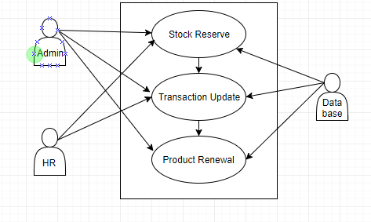

*Figure 5:* Stock Management: Use case diagram

**Stock Reserve:**

At the beginning of the business the owner will perform the initial stock update. Afterwards, the HR will update upon receiving the products delivered by the suppliers.

**Action/Reply:**

1. Action: Admin performs the initial update.

Reply: Update successful or not.

2. Action: HR updates the stock upon supplier’s delivery and regular transaction.

Reply: System shows the quantity of products received/sold with a pop-up.

**Transaction Update:**

When a customer buys product the stock decreases. This decrease will be tracked via update performed by salesman after each sale.

**Action/Reply:**

Action: After every transaction HR will update the cash.

Reply: System shows the quantity of products sold and there corresponding cost with a pop-up.

**Product Renewal:**

The database will keep record of expiry date of products. If the expiry date of unsold products passes then the no of products in the stock will be decremented. If a supplier exchanges fresh products for the expired ones, HR will perform the update.

**Action/Reply:**

Action: Database shows pop-up if the expiry date of any products has passed.

Reply: The stock will be decremented.

Action: If supplier allows the return of the expired products and provides new products in return, HR performs the update.

Reply: System shows if the update is successful or not.

**Stock Management: Description**

The stock of pharmacy includes drugs, first aid products, minimal medical tools etc. The following attributes of the products will be stored in the database:

* product name
* product type
* component
* component’s company name
* manufacturing date
* expiry date
* discount
* cost price
* sale frequency

**1.3 Financial Management:**

*Primary actors: HR, Database, Owner.*

*Secondary actors: Shareholder.*

*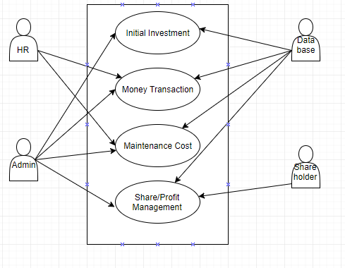 Figure 6:* Financial Management: Use case diagram

**1.3.1 Initial Investment:**

**Action/Reply:**

Action: Admin enters his principal amount in the system in the start of the business.

Reply: Database stores information and system shows if update is successful or not with a pop-up.