Computer Networking: A Top-Down Approach,
6th Edition

Solutions to Review Questions and Problems

Version Date: May 2012

This document contains the solutions to review questions and problems for the 5th edition of Computer Networking: A Top-Down Approach by Jim Kurose and Keith Ross. These solutions are being made available to instructors ONLY. Please do NOT copy or distribute this document to others (even other instructors). Please do not post any solutions on a publicly-available Web site. We’ll be happy to provide a copy (up-to-date) of this solution manual ourselves to anyone who asks.

Acknowledgments: Over the years, several students and colleagues have helped us prepare this solutions manual. Special thanks goes to HongGang Zhang, Rakesh Kumar, Prithula Dhungel, and Vijay Annapureddy. Also thanks to all the readers who have made suggestions and corrected errors.

All material © copyright 1996-2012 by J.F. Kurose and K.W. Ross. All rights reserved

Chapter 1 Review Questions

- There is no difference. Throughout this text, the words “host” and “end system” are used interchangeably. End systems include PCs, workstations, Web servers, mail servers, PDAs, Internet-connected game consoles, etc.

- From Wikipedia: Diplomatic protocol is commonly described as a set of international courtesy rules. These well-established and time-honored rules have made it easier for nations and people to live and work together. Part of protocol has always been the acknowledgment of the hierarchical standing of all present. Protocol rules are based on the principles of civility.
- Standards are important for protocols so that people can create networking systems and products that interoperate.

- 1. Dial-up modem over telephone line: home; 2. DSL over telephone line: home or small office; 3. Cable to HFC: home; 4. 100 Mbps switched Ethernet: enterprise; 5. Wifi (802.11): home and enterprise: 6. 3G and 4G: wide-area wireless.

- HFC bandwidth is shared among the users. On the downstream channel, all packets emanate from a single source, namely, the head end. Thus, there are no collisions in the downstream channel.

- In most American cities, the current possibilities include: dial-up; DSL; cable modem; fiber-to-the-home.

7. Ethernet LANs have transmission rates of 10 Mbps, 100 Mbps, 1 Gbps and 10 Gbps.

8. Today, Ethernet most commonly runs over twisted-pair copper wire. It also can run over fibers optic links.

9. Dial up modems: up to 56 Kbps, bandwidth is dedicated; ADSL: up to 24 Mbps downstream and 2.5 Mbps upstream, bandwidth is dedicated; HFC, rates up to 42.8 Mbps and upstream rates of up to 30.7 Mbps, bandwidth is shared. FTTH: 2-10Mbps upload; 10-20 Mbps download; bandwidth is not shared.

10. There are two popular wireless Internet access technologies today:

- Wifi (802.11) In a wireless LAN, wireless users transmit/receive packets to/from an base station (i.e., wireless access point) within a radius of few tens of meters. The base station is typically connected to the wired Internet and thus serves to connect wireless users to the wired network.
- 3G and 4G wide-area wireless access networks. In these systems, packets are transmitted over the same wireless infrastructure used for cellular telephony, with the base station thus being managed by a telecommunications provider. This provides wireless access to users within a radius of tens of kilometers of the base station.

11. At time t₀ the sending host begins to transmit. At time t₁ = L/R₁, the sending host completes transmission and the entire packet is received at the router (no propagation delay). Because the router has the entire packet at time t₁, it can begin to transmit the packet to the receiving host at time t₁. At time t₂ = t₁ + L/R₂, the router completes transmission and the entire packet is received at the receiving host (again, no propagation delay). Thus, the end-to-end delay is L/R₁ + L/R₂.

12. A circuit-switched network can guarantee a certain amount of end-to-end bandwidth for the duration of a call. Most packet-switched networks today (including the Internet) cannot make any end-to-end guarantees for bandwidth. FDM requires sophisticated analog hardware to shift signal into appropriate frequency bands.

13. a) 2 users can be supported because each user requires half of the link bandwidth.

b) Since each user requires 1Mbps when transmitting, if two or fewer users transmit simultaneously, a maximum of 2Mbps will be required. Since the available bandwidth of the shared link is 2Mbps, there will be no queuing delay before the link. Whereas, if three users transmit simultaneously, the bandwidth required will be 3Mbps which is more than the available bandwidth of the shared link. In this case, there will be queuing delay before the link.

c) Probability that a given user is transmitting = 0.2

d) Probability that all three users are transmitting simultaneously = 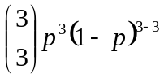
= (0.2)³ = 0.008. Since the queue grows when all the users are transmitting, the fraction of time during which the queue grows (which is equal to the probability that all three users are transmitting simultaneously) is 0.008.

14. If the two ISPs do not peer with each other, then when they send traffic to each other they have to send the traffic through a provider ISP (intermediary), to which they have to pay for carrying the traffic. By peering with each other directly, the two ISPs can reduce their payments to their provider ISPs. An Internet Exchange Points (IXP) (typically in a standalone building with its own switches) is a meeting point where multiple ISPs can connect and/or peer together. An ISP earns its money by charging each of the the ISPs that connect to the IXP a relatively small fee, which may depend on the amount of traffic sent to or received from the IXP.
15. Google's private network connects together all its data centers, big and small. Traffic between the Google data centers passes over its private network rather than over the public Internet. Many of these data centers are located in, or close to, lower tier ISPs. Therefore, when Google delivers content to a user, it often can bypass higher tier ISPs. What motivates content providers to create these networks? First, the content provider has more control over the user experience, since it has to use few intermediary ISPs. Second, it can save money by sending less traffic into provider networks. Third, if ISPs decide to charge more money to highly profitable content providers (in countries where net neutrality doesn't apply), the content providers can avoid these extra payments.

16. The delay components are processing delays, transmission delays, propagation delays, and queuing delays. All of these delays are fixed, except for the queuing delays, which are variable.

17. a) 1000 km, 1 Mbps, 100 bytes
b) 100 km, 1 Mbps, 100 bytes

18. 10msec; d/s; no; no

19. a) 500 kbps
b) 64 seconds
c) 100kbps; 320 seconds

20. End system A breaks the large file into chunks. It adds header to each chunk, thereby generating multiple packets from the file. The header in each packet includes the IP address of the destination (end system B). The packet switch uses the destination IP address in the packet to determine the outgoing link. Asking which road to take is analogous to a packet asking which outgoing link it should be forwarded on, given the packet’s destination address.

21. The maximum emission rate is 500 packets/sec and the maximum transmission rate is
350 packets/sec. The corresponding traffic intensity is 500/350 =1.43 > 1. Loss will eventually occur for each experiment; but the time when loss first occurs will be different from one experiment to the next due to the randomness in the emission process.

22. Five generic tasks are error control, flow control, segmentation and reassembly, multiplexing, and connection setup. Yes, these tasks can be duplicated at different layers. For example, error control is often provided at more than one layer.

23. The five layers in the Internet protocol stack are – from top to bottom – the application layer, the transport layer, the network layer, the link layer, and the physical layer. The principal responsibilities are outlined in Section 1.5.1.

24. Application-layer message: data which an application wants to send and passed onto the transport layer; transport-layer segment: generated by the transport layer and encapsulates application-layer message with transport layer header; network-layer datagram: encapsulates transport-layer segment with a network-layer header; link-layer frame: encapsulates network-layer datagram with a link-layer header.

25. Routers process network, link and physical layers (layers 1 through 3). (This is a little bit of a white lie, as modern routers sometimes act as firewalls or caching components, and process Transport layer as well.) Link layer switches process link and physical layers (layers 1 through2). Hosts process all five layers.

26. a) Virus
Requires some form of human interaction to spread. Classic example: E-mail viruses.
b) Worms
No user replication needed. Worm in infected host scans IP addresses and port numbers, looking for vulnerable processes to infect.

27. Creation of a botnet requires an attacker to find vulnerability in some application or system (e.g. exploiting the buffer overflow vulnerability that might exist in an application). After finding the vulnerability, the attacker needs to scan for hosts that are vulnerable. The target is basically to compromise a series of systems by exploiting that particular vulnerability. Any system that is part of the botnet can automatically scan its environment and propagate by exploiting the vulnerability. An important property of such botnets is that the originator of the botnet can remotely control and issue commands to all the nodes in the botnet. Hence, it becomes possible for the attacker to issue a command to all the nodes, that target a single node (for example, all nodes in the botnet might be commanded by the attacker to send a TCP SYN message to the target, which might result in a TCP SYN flood attack at the target).

28. Trudy can pretend to be Bob to Alice (and vice-versa) and partially or completely modify the message(s) being sent from Bob to Alice. For example, she can easily change the phrase “Alice, I owe you $1000” to “Alice, I owe you $10,000”. Furthermore, Trudy can even drop the packets that are being sent by Bob to Alice (and vise-versa), even if the packets from Bob to Alice are encrypted.

Chapter 1 Problems

Problem 1

There is no single right answer to this question. Many protocols would do the trick. Here's a simple answer below:

Messages from ATM machine to Server
Msg name purpose
-------- -------
HELO <userid> Let server know that there is a card in the ATM machine
ATM card transmits user ID to Server
PASSWD <passwd> User enters PIN, which is sent to server
BALANCE User requests balance
WITHDRAWL <amount> User asks to withdraw money
BYE user all done

Messages from Server to ATM machine (display)
Msg name purpose
-------- -------
PASSWD Ask user for PIN (password)
OK last requested operation (PASSWD, WITHDRAWL) OK
ERR last requested operation (PASSWD, WITHDRAWL) in ERROR
AMOUNT <amt> sent in response to BALANCE request
BYE user done, display welcome screen at ATM

Correct operation:

client server

HELO (userid) --------------> (check if valid userid)
<------------- PASSWD
PASSWD <passwd> --------------> (check password)
<------------- OK (password is OK)
BALANCE -------------->
<------------- AMOUNT <amt>
WITHDRAWL <amt> --------------> check if enough $ to cover withdrawl
<------------- OK
ATM dispenses $
BYE -------------->
<------------- BYE

In situation when there's not enough money:

HELO (userid) --------------> (check if valid userid)
<------------- PASSWD
PASSWD <passwd> --------------> (check password)
<------------- OK (password is OK)
BALANCE -------------->
<------------- AMOUNT <amt>
WITHDRAWL <amt> --------------> check if enough $ to cover withdrawl
<------------- ERR (not enough funds)
error msg displayed
no $ given out
BYE -------------->
<------------- BYE

Problem 2

At time N*(L/R) the first packet has reached the destination, the second packet is stored in the last router, the third packet is stored in the next-to-last router, etc. At time N*(L/R) + L/R, the second packet has reached the destination, the third packet is stored in the last router, etc. Continuing with this logic, we see that at time N*(L/R) + (P-1)*(L/R) = (N+P-1)*(L/R) all packets have reached the destination.

Problem 3

a) A circuit-switched network would be well suited to the application, because the application involves long sessions with predictable smooth bandwidth requirements. Since the transmission rate is known and not bursty, bandwidth can be reserved for each application session without significant waste. In addition, the overhead costs of setting up and tearing down connections are amortized over the lengthy duration of a typical application session.

b) In the worst case, all the applications simultaneously transmit over one or more network links. However, since each link has sufficient bandwidth to handle the sum of all of the applications' data rates, no congestion (very little queuing) will occur. Given such generous link capacities, the network does not need congestion control mechanisms.

Problem 4

- Between the switch in the upper left and the switch in the upper right we can have 4 connections. Similarly we can have four connections between each of the 3 other pairs of adjacent switches. Thus, this network can support up to 16 connections.

- We can 4 connections passing through the switch in the upper-right-hand corner and another 4 connections passing through the switch in the lower-left-hand corner, giving a total of 8 connections.
- Yes. For the connections between A and C, we route two connections through B and two connections through D. For the connections between B and D, we route two connections through A and two connections through C. In this manner, there are at most 4 connections passing through any link.

Problem 5

Tollbooths are 75 km apart, and the cars propagate at 100km/hr. A tollbooth services a car at a rate of one car every 12 seconds.

a) There are ten cars. It takes 120 seconds, or 2 minutes, for the first tollbooth to service the 10 cars. Each of these cars has a propagation delay of 45 minutes (travel 75 km) before arriving at the second tollbooth. Thus, all the cars are lined up before the second tollbooth after 47 minutes. The whole process repeats itself for traveling between the second and third tollbooths. It also takes 2 minutes for the third tollbooth to service the 10 cars. Thus the total delay is 96 minutes.

b) Delay between tollbooths is 8*12 seconds plus 45 minutes, i.e., 46 minutes and 36 seconds. The total delay is twice this amount plus 8*12 seconds, i.e., 94 minutes and 48 seconds.

Problem 6

a) 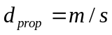 seconds.
b) 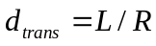 seconds.
c) 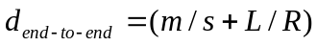 seconds.
d) The bit is just leaving Host A.
e) The first bit is in the link and has not reached Host B.
f) The first bit has reached Host B.
g) Want
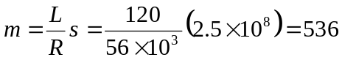km.

Problem 7

Consider the first bit in a packet. Before this bit can be transmitted, all of the bits in the packet must be generated. This requires

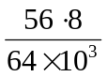sec=7msec.

The time required to transmit the packet is

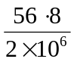sec=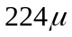sec.

Propagation delay = 10 msec.
The delay until decoding is

7msec +sec + 10msec = 17.224msec

A similar analysis shows that all bits experience a delay of 17.224 msec.

Problem 8

a) 20 users can be supported.
b) 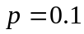.
c) 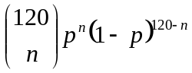.
d) 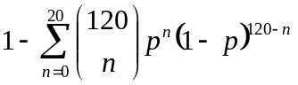.
We use the central limit theorem to approximate this probability. Let 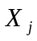 be independent random variables such that 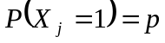.
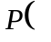“21 or more users”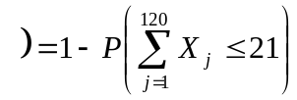

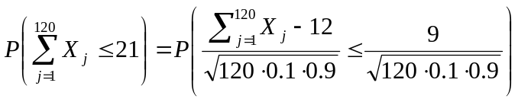
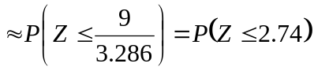
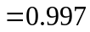
when 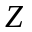 is a standard normal r.v. Thus “21 or more users”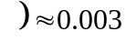.

Problem 9

- 10,000
- 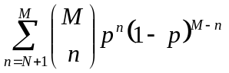

Problem 10

The first end system requires L/R₁ to transmit the packet onto the first link; the packet propagates over the first link in d₁/s₁; the packet switch adds a processing delay of d_{proc}; after receiving the entire packet, the packet switch connecting the first and the second link requires L/R₂ to transmit the packet onto the second link; the packet propagates over the second link in d₂/s₂. Similarly, we can find the delay caused by the second switch and the third link: L/R₃, d_{proc}, and d₃/s₃.
Adding these five delays gives
d_{end-end} = L/R₁ + L/R₂ + L/R₃ + d₁/s₁ + d₂/s₂ + d₃/s₃+ d_{proc}+ d_{proc}

To answer the second question, we simply plug the values into the equation to get 6 + 6 + 6 + 20+16 + 4 + 3 + 3 = 64 msec.

Problem 11

Because bits are immediately transmitted, the packet switch does not introduce any delay; in particular, it does not introduce a transmission delay. Thus,
d_{end-end} = L/R + d₁/s₁ + d₂/s₂+ d₃/s₃

For the values in Problem 10, we get 6 + 20 + 16 + 4 = 46 msec.

Problem 12

The arriving packet must first wait for the link to transmit 4.5 *1,500 bytes = 6,750 bytes or 54,000 bits. Since these bits are transmitted at 2 Mbps, the queuing delay is 27 msec. Generally, the queuing delay is (nL + (L - x))/R.

Problem 13

- The queuing delay is 0 for the first transmitted packet, L/R for the second transmitted packet, and generally, (n-1)L/R for the n^{th} transmitted packet. Thus, the average delay for the N packets is:

(L/R + 2L/R + ....... + (N-1)L/R)/N
= L/(RN) * (1 + 2 + ..... + (N-1))
= L/(RN) * N(N-1)/2
= LN(N-1)/(2RN)
= (N-1)L/(2R)

Note that here we used the well-known fact:

1 + 2 + ....... + N = N(N+1)/2

- It takes 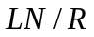 seconds to transmit the 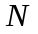 packets. Thus, the buffer is empty when a each batch of packets arrive. Thus, the average delay of a packet across all batches is the average delay within one batch, i.e., (N-1)L/2R.

Problem 14

- The transmission delay is 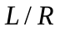. The total delay is
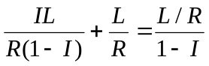
- Let 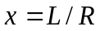.
Total delay = 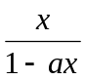
For x=0, the total delay =0; as we increase x, total delay increases, approaching infinity as x approaches 1/a.

Problem 15

Total delay 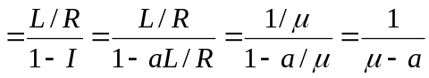.

Problem 16

The total number of packets in the system includes those in the buffer and the packet that is being transmitted. So, N=10+1.

Because 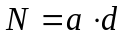, so (10+1)=a*(queuing delay + transmission delay). That is,
11=a*(0.01+1/100)=a*(0.01+0.01). Thus, a=550 packets/sec.

Problem 17

- There are  nodes (the source host and the 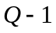 routers). Let 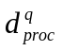denote the processing delay at the th node. Let 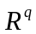 be the transmission rate of the th link and let
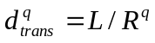. Let 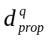 be the propagation delay across the th link. Then

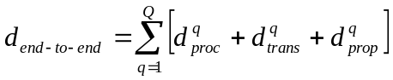.

- Let 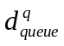 denote the average queuing delay at node . Then
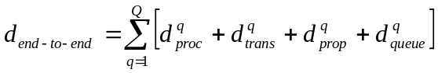.

Problem 18

On linux you can use the command

traceroute www.targethost.com

and in the Windows command prompt you can use

tracert www.targethost.com

In either case, you will get three delay measurements. For those three measurements you can calculate the mean and standard deviation. Repeat the experiment at different times of the day and comment on any changes.

Here is an example solution:

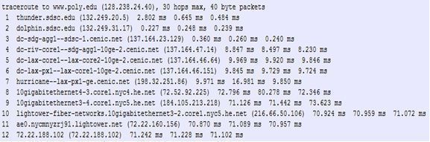

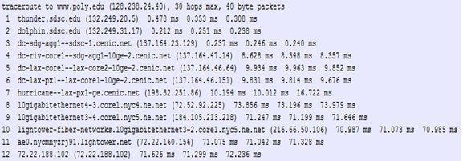

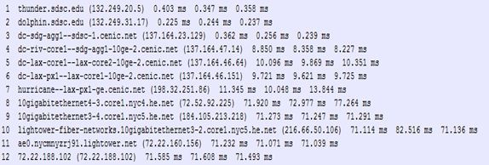

Traceroutes between San Diego Super Computer Center and www.poly.edu

- The average (mean) of the round-trip delays at each of the three hours is 71.18 ms, 71.38 ms and 71.55 ms, respectively. The standard deviations are 0.075 ms, 0.21 ms, 0.05 ms, respectively.

- In this example, the traceroutes have 12 routers in the path at each of the three hours. No, the paths didn’t change during any of the hours.

- Traceroute packets passed through four ISP networks from source to destination. Yes, in this experiment the largest delays occurred at peering interfaces between adjacent ISPs.

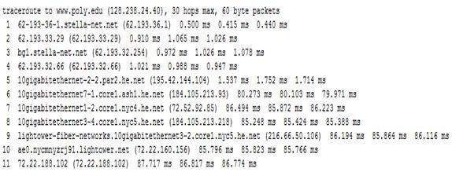

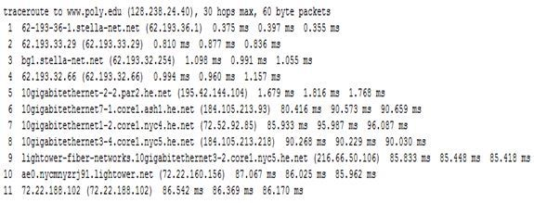

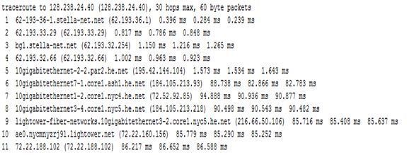

Traceroutes from www.stella-net.net (France) to www.poly.edu (USA).

- The average round-trip delays at each of the three hours are 87.09 ms, 86.35 ms and 86.48 ms, respectively. The standard deviations are 0.53 ms, 0.18 ms, 0.23 ms, respectively. In this example, there are 11 routers in the path at each of the three hours. No, the paths didn’t change during any of the hours. Traceroute packets passed three ISP networks from source to destination. Yes, in this experiment the largest delays occurred at peering interfaces between adjacent ISPs.

Problem 19
An example solution:
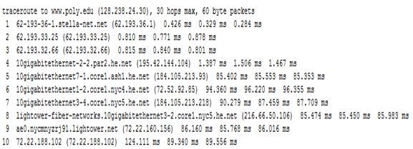

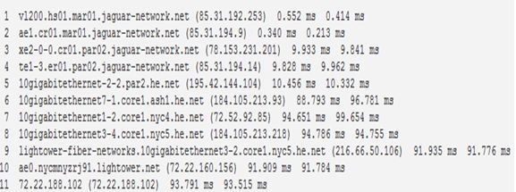

Traceroutes from two different cities in France to New York City in United States

- In these traceroutes from two different cities in France to the same destination host in United States, seven links are in common including the transatlantic link.

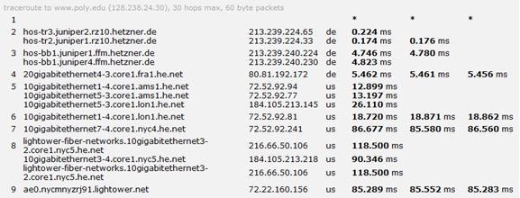

- In this example of traceroutes from one city in France and from another city in Germany to the same host in United States, three links are in common including the transatlantic link.

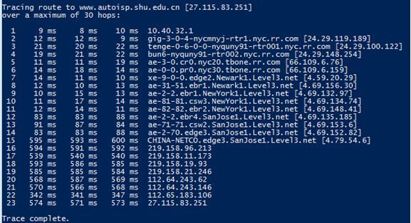

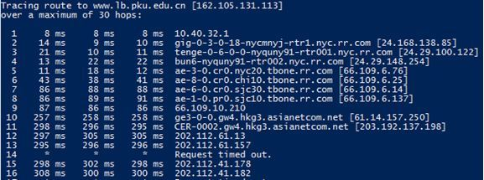

Traceroutes to two different cities in China from same host in United States

- Five links are common in the two traceroutes. The two traceroutes diverge before reaching China

Problem 20

Throughput = min{R_{s}, R_{c}, R/M}

Problem 21

If only use one path, the max throughput is given by:
.

If use all paths, the max throughput is given by 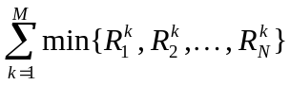.

Problem 22

Probability of successfully receiving a packet is: p_{s}= (1-p)^{N}.

The number of transmissions needed to be performed until the packet is successfully received by the client is a geometric random variable with success probability p_{s}. Thus, the average number of transmissions needed is given by: 1/p_{s} . Then, the average number of re-transmissions needed is given by: 1/p_{s} -1.

Problem 23

Let’s call the first packet A and call the second packet B.

- If the bottleneck link is the first link, then packet B is queued at the first link waiting for the transmission of packet A. So the packet inter-arrival time at the destination is simply L/R_{s}.

- If the second link is the bottleneck link and both packets are sent back to back, it must be true that the second packet arrives at the input queue of the second link before the second link finishes the transmission of the first packet. That is,

L/R_{s} + L/R_{s} + d_{prop} < L/R_{s} + d_{prop} + L/R_{c}

The left hand side of the above inequality represents the time needed by the second packet to arrive at the input queue of the second link (the second link has not started transmitting the second packet yet). The right hand side represents the time needed by the first packet to finish its transmission onto the second link.

If we send the second packet T seconds later, we will ensure that there is no queuing delay for the second packet at the second link if we have:

L/R_{s} + L/R_{s} + d_{prop} + T >= L/R_{s} + d_{prop} + L/R_{c}

Thus, the minimum value of T is L/R_{c} − L/R_{s} .

Problem 24

40 terabytes = 40 * 10¹² * 8 bits. So, if using the dedicated link, it will take 40 * 10¹² * 8 / (100 *10⁶ ) =3200000 seconds = 37 days. But with FedEx overnight delivery, you can guarantee the data arrives in one day, and it should cost less than $100.

Problem 25

- 160,000 bits
- 160,000 bits
- The bandwidth-delay product of a link is the maximum number of bits that can be in the link.
- the width of a bit = length of link / bandwidth-delay product, so 1 bit is 125 meters long, which is longer than a football field
- s/R

Problem 26

s/R=20000km, then R=s/20000km= 2.5*10⁸/(2*10⁷)= 12.5 bps

Problem 27

- 80,000,000 bits
- 800,000 bits, this is because that the maximum number of bits that will be in the link at any given time = min(bandwidth delay product, packet size) = 800,000 bits.
- .25 meters

Problem 28

- t_{trans} + t_{prop} = 400 msec + 80 msec = 480 msec.
- 20 * (t_{trans} + 2 t_{prop}) = 20*(20 msec + 80 msec) = 2 sec.
- Breaking up a file takes longer to transmit because each data packet and its corresponding acknowledgement packet add their own propagation delays.

Problem 29

Recall geostationary satellite is 36,000 kilometers away from earth surface.
- 150 msec
- 1,500,000 bits
- 600,000,000 bits

Problem 30

Let’s suppose the passenger and his/her bags correspond to the data unit arriving to the top of the protocol stack. When the passenger checks in, his/her bags are checked, and a tag is attached to the bags and ticket. This is additional information added in the Baggage layer if Figure 1.20 that allows the Baggage layer to implement the service or separating the passengers and baggage on the sending side, and then reuniting them (hopefully!) on the destination side. When a passenger then passes through security and additional stamp is often added to his/her ticket, indicating that the passenger has passed through a security check. This information is used to ensure (e.g., by later checks for the security information) secure transfer of people.

Problem 31
- Time to send message from source host to first packet switch = 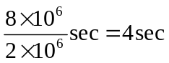With store-and-forward switching, the total time to move message from source host to destination host = 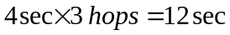
- Time to send 1st packet from source host to first packet switch = . 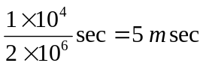. Time at which 2nd packet is received at the first switch = time at which 1st packet is received at the second switch = 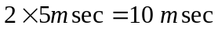
- Time at which 1st packet is received at the destination host = 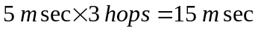. After this, every 5msec one packet will be received; thus time at which last (800th) packet is received = . It can be seen that delay in using message segmentation is significantly less (almost 1/3rd).

- Without message segmentation, if bit errors are not tolerated, if there is a single bit error, the whole message has to be retransmitted (rather than a single packet).
- Without message segmentation, huge packets (containing HD videos, for example) are sent into the network. Routers have to accommodate these huge packets. Smaller packets have to queue behind enormous packets and suffer unfair delays.

- Packets have to be put in sequence at the destination.
- Message segmentation results in many smaller packets. Since header size is usually the same for all packets regardless of their size, with message segmentation the total amount of header bytes is more.

Problem 32

Yes, the delays in the applet correspond to the delays in the Problem 31.The propagation delays affect the overall end-to-end delays both for packet switching and message switching equally.

Problem 33

There are F/S packets. Each packet is S=80 bits. Time at which the last packet is received at the first router is 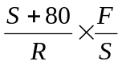sec. At this time, the first F/S-2 packets are at the destination, and the F/S-1 packet is at the second router. The last packet must then be transmitted by the first router and the second router, with each transmission taking 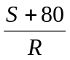sec. Thus delay in sending the whole file is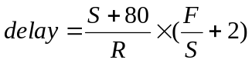
To calculate the value of S which leads to the minimum delay,
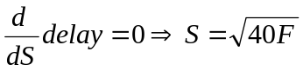

Problem 34

The circuit-switched telephone networks and the Internet are connected together at "gateways". When a Skype user (connected to the Internet) calls an ordinary telephone, a circuit is established between a gateway and the telephone user over the circuit switched network. The skype user's voice is sent in packets over the Internet to the gateway. At the gateway, the voice signal is reconstructed and then sent over the circuit. In the other direction, the voice signal is sent over the circuit switched network to the gateway. The gateway packetizes the voice signal and sends the voice packets to the Skype user.

