CS4750 – The Bank Database – from Database System Concepts

branch(branch-name, branch-city, assets)

customer(customer-name, customer-street, customer-city)
account(account-number, branch-name, balance)
loan(loan-number, branch-name, amount)
depositor(customer-name, account-number)
borrower(customer-name, loan-number)

Branch Table Customer Table
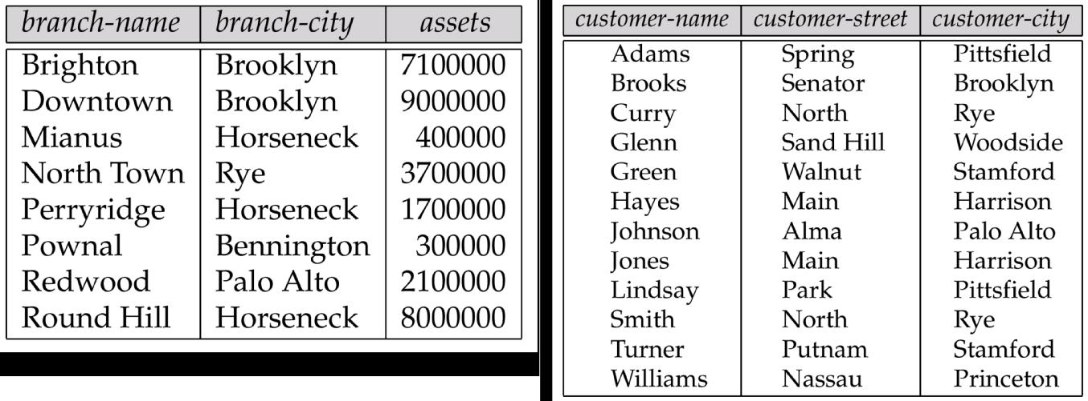

Account Table Loan Table
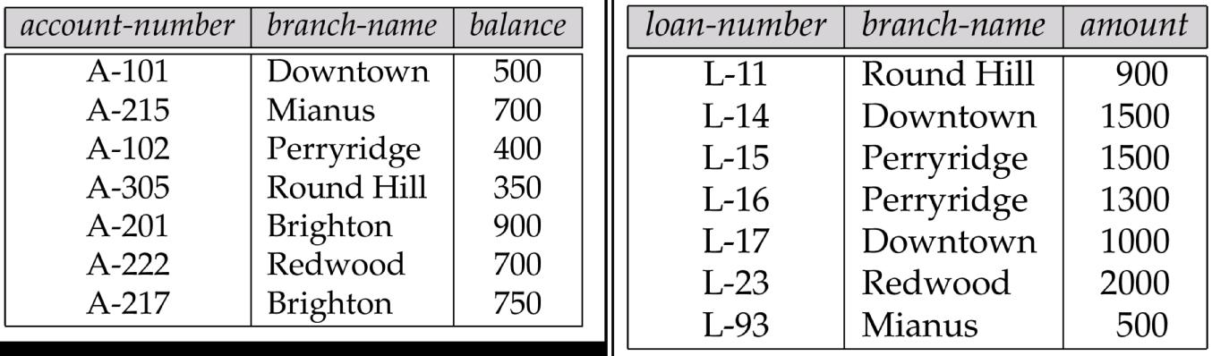

Depositor Table Borrower Table
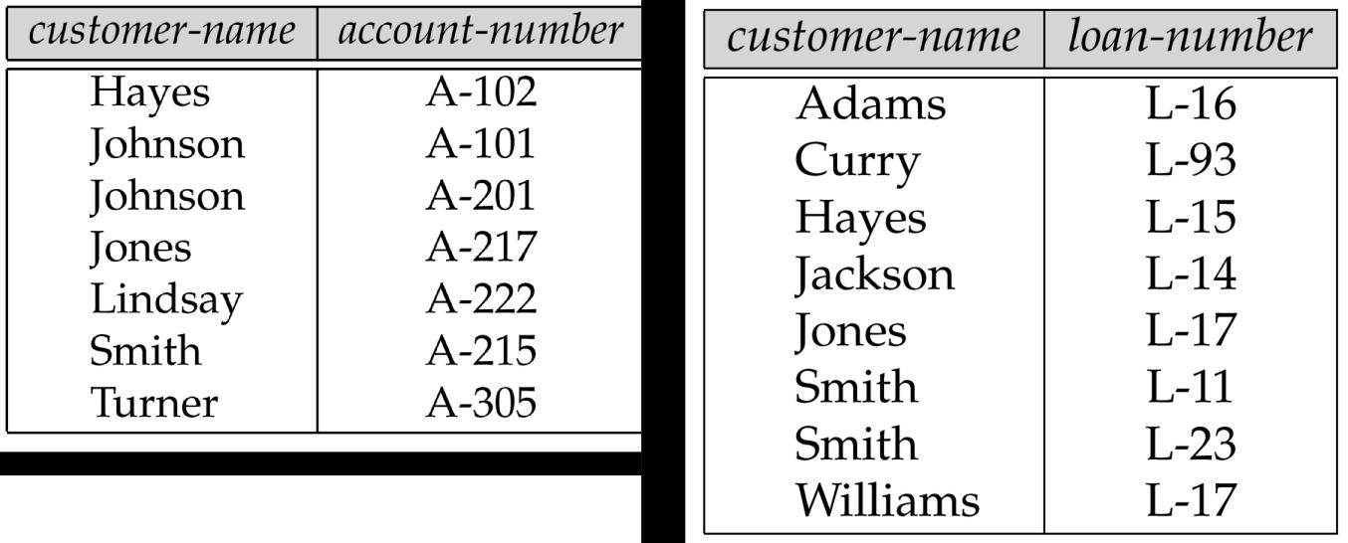
Example Questions for the Bank Database

- Find all loans over $1200.

- Find the loan number for each loan of an amount greater than $1200.

- Find the names of all customers who have a loan, an account, or both from the bank.

- Find the names of all customers who have a loan and an account at the bank.

- Find the names of all customers who have a loan at the Perryridge branch.

- Find the names of all customers who have a loan at the Perryridge branch, but no account at any branch of the bank.

- Find the names of all customers who have an account at the Downtown and Mianus branches.

- Find the total amount each branch has in accounts.

- Find the average loan amount of each customer

- Find the names of all customers who have an account at every branch located in Brooklyn.

