**Activity diagram of a library management system**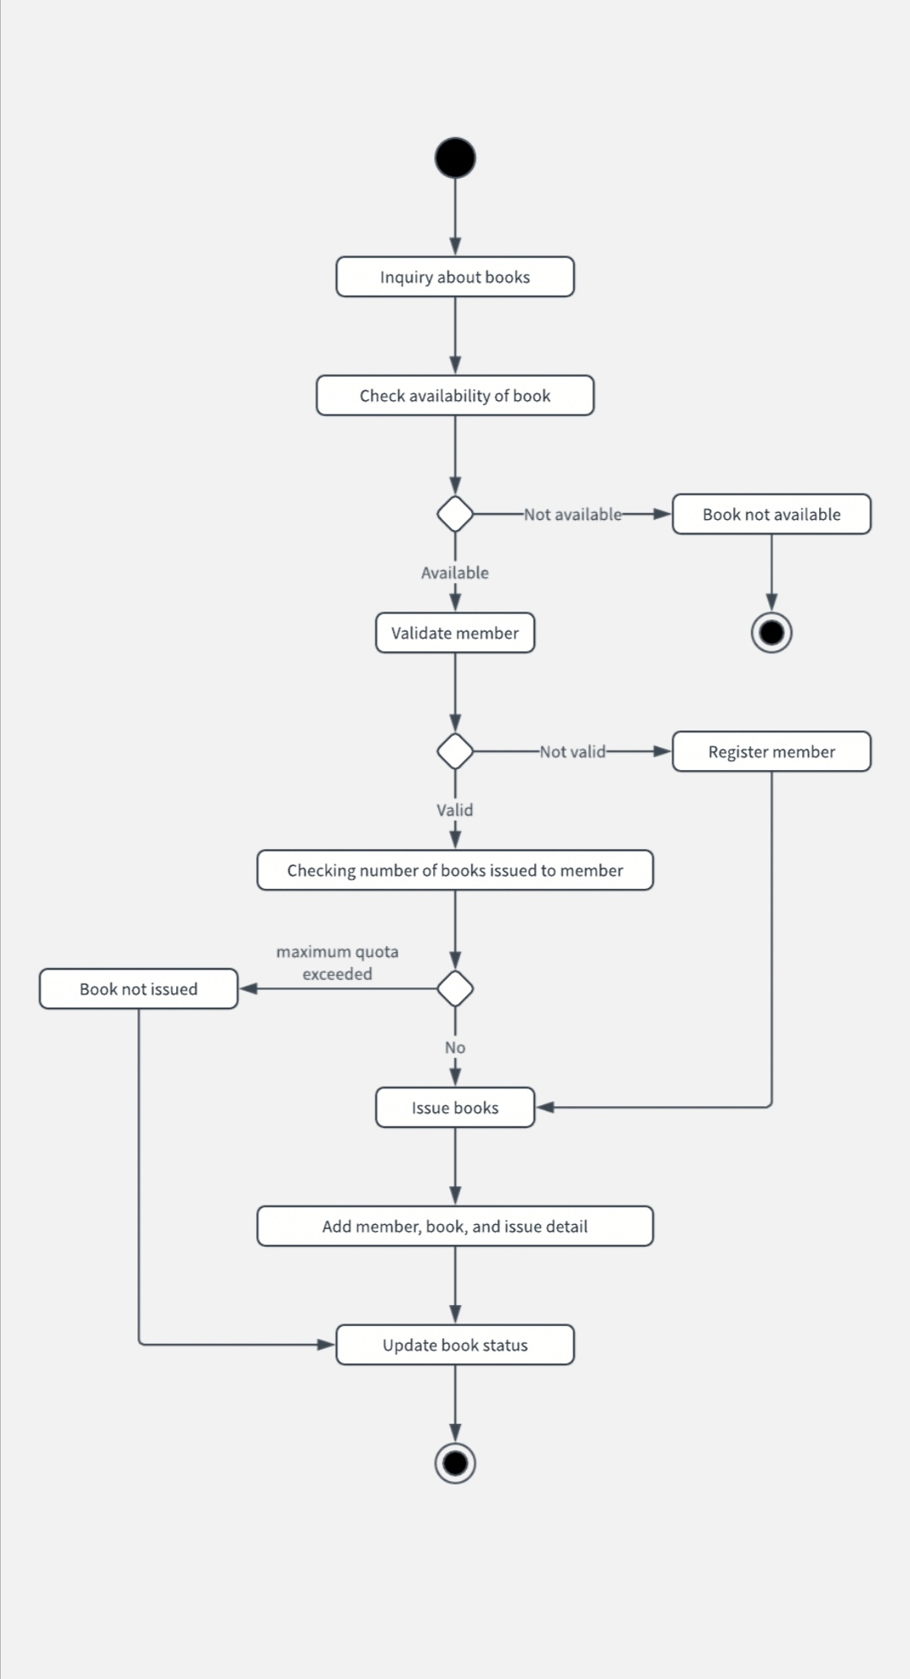

The figure here shows the activity diagram of a library management system from student(member) perspective. A student can ask for books, check availability of books, validate their ID and can issue books if their maximum quota is not exceeded. The students who aren’t the members of the library can register to be a member and issue books.