## An example of a use-case diagram

Following use case diagram represents the working of the student management system:

[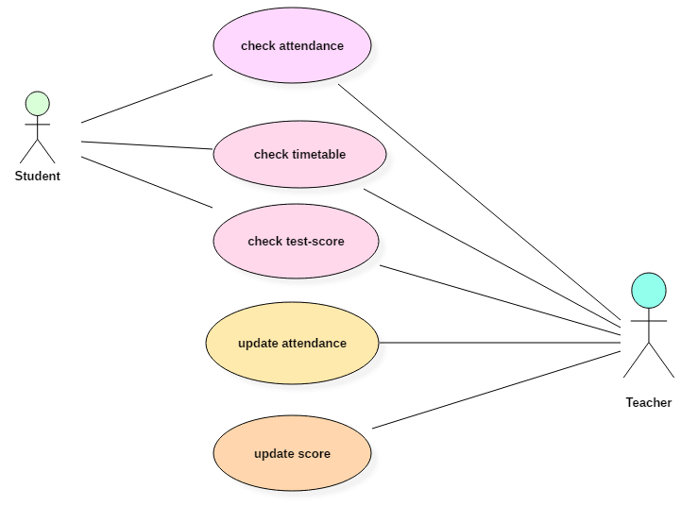](https://www.guru99.com/images/1/052919_0831_UMLUseCaseD3.png)

In the above use case diagram, there are two actors named student and a teacher. There are a total of five use cases that represent the specific functionality of a student management system. Each actor interacts with a particular use case. A student actor can check attendance, timetable as well as test marks on the application or a system. This actor can perform only these interactions with the system even though other use cases are remaining in the system.

The second actor named teacher can interact with all the functionalities or use cases of the system. This actor can also update the attendance of a student and marks of the student. These interactions of both student and a teacher actor together sums up the entire student management application.