SQL Assignment 3

Creating the database named EmployeeDB
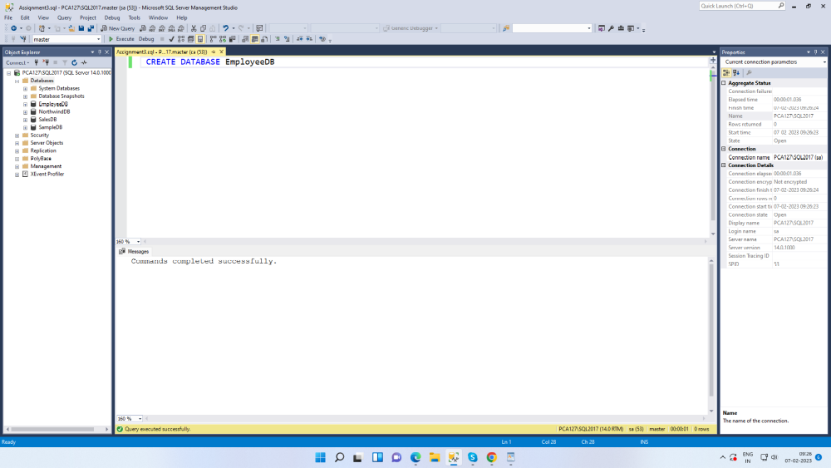

Creating the table named Department
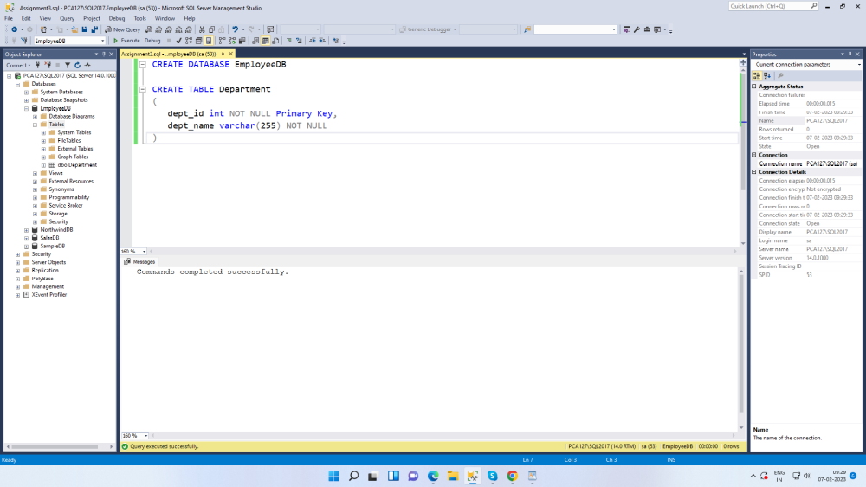

Creating the table named Employee
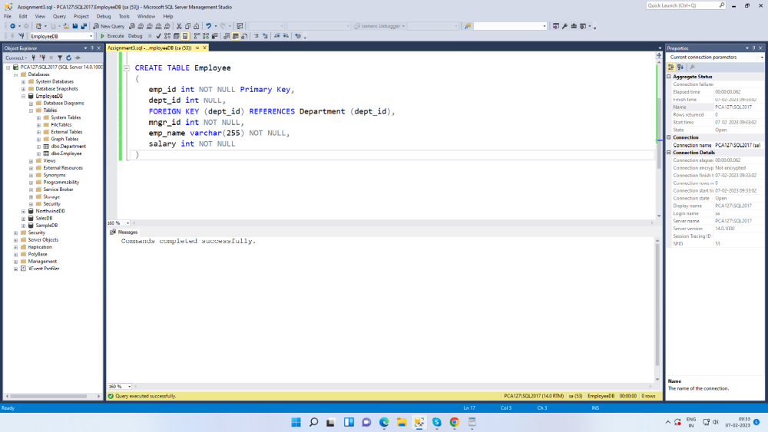

Inserting the data into Department table
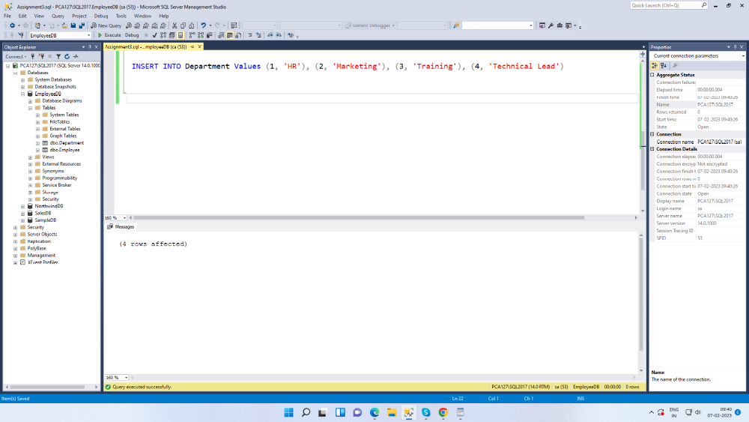

Inserting the data into Employee table
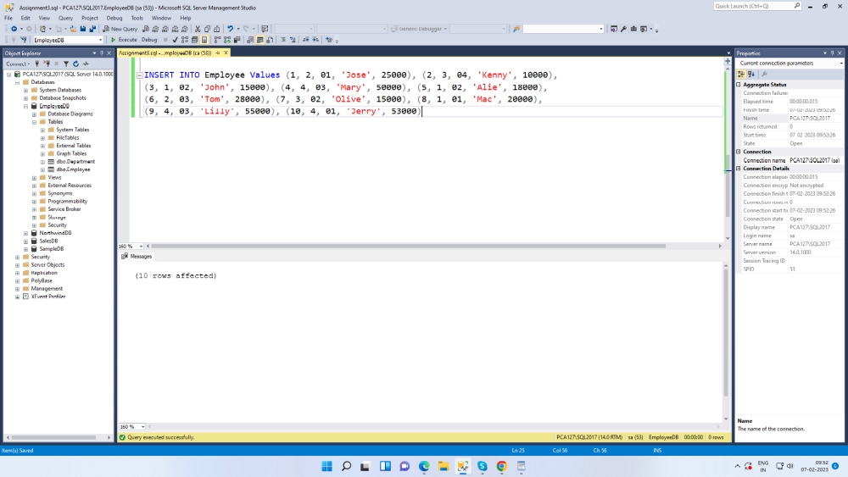

1. write a SQL query to find Employees who have the biggest salary in their Department
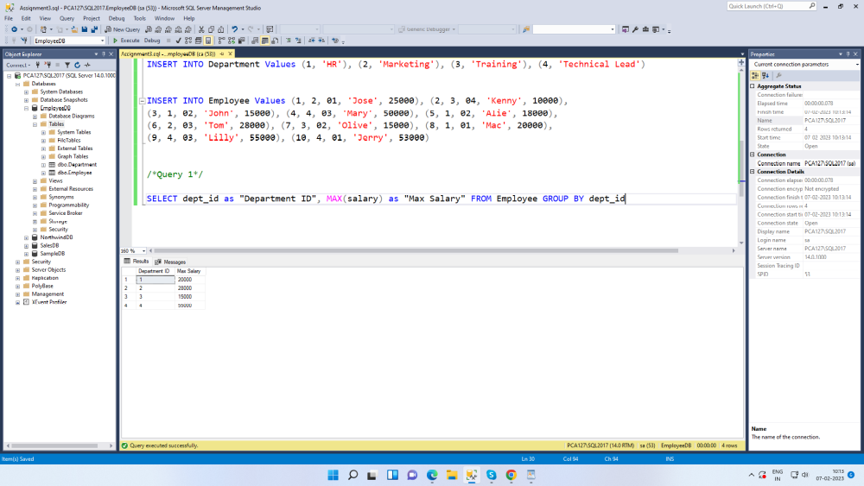

2. write a SQL query to find Departments that have less than 3 people in it
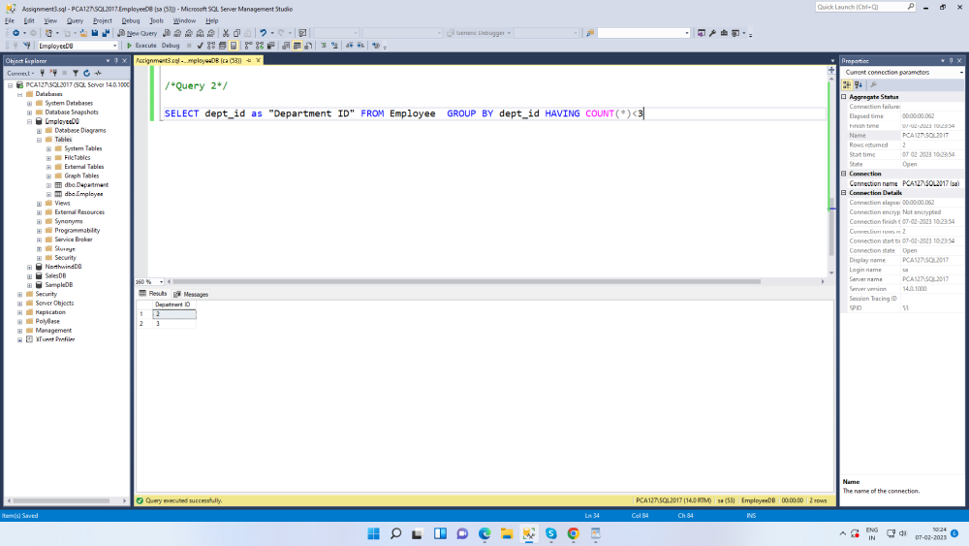

3. write a SQL query to find All Department along with the number of people there
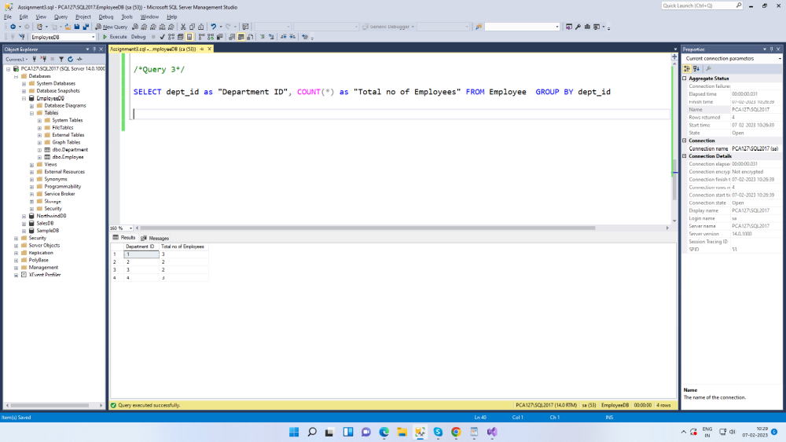

4. write a SQL query to find All Department along with the total salary there
