SQL ASSIGNMENT - 1

Creating the Database
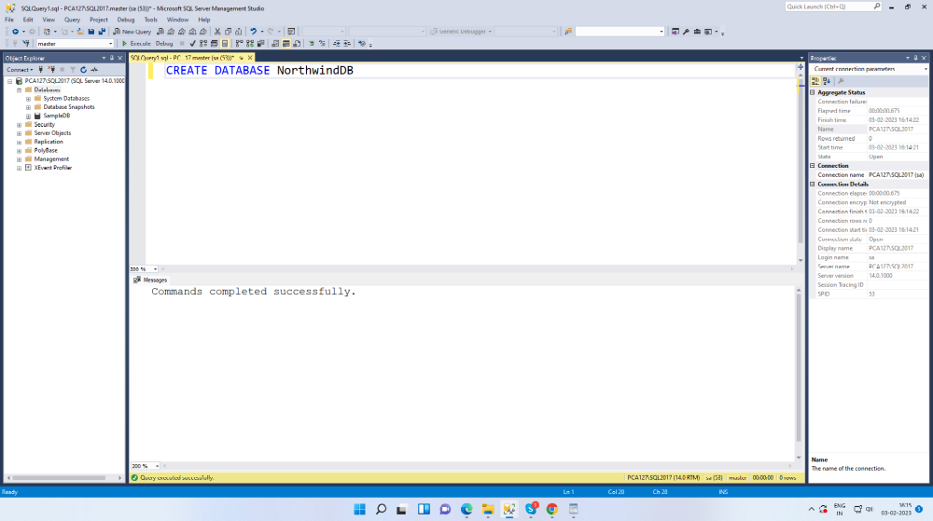

Creating the table named Products
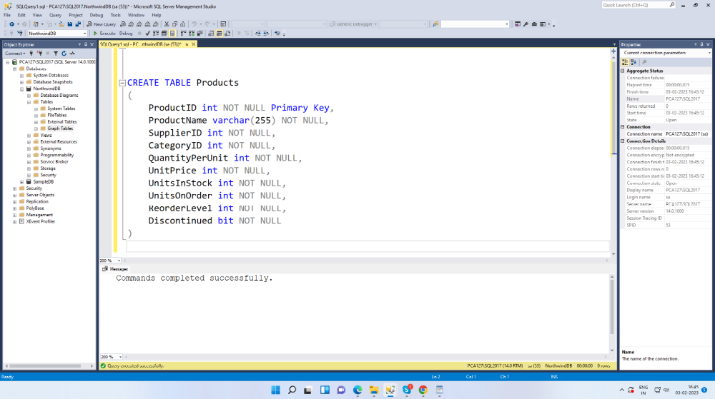

Inserting records to the table Products
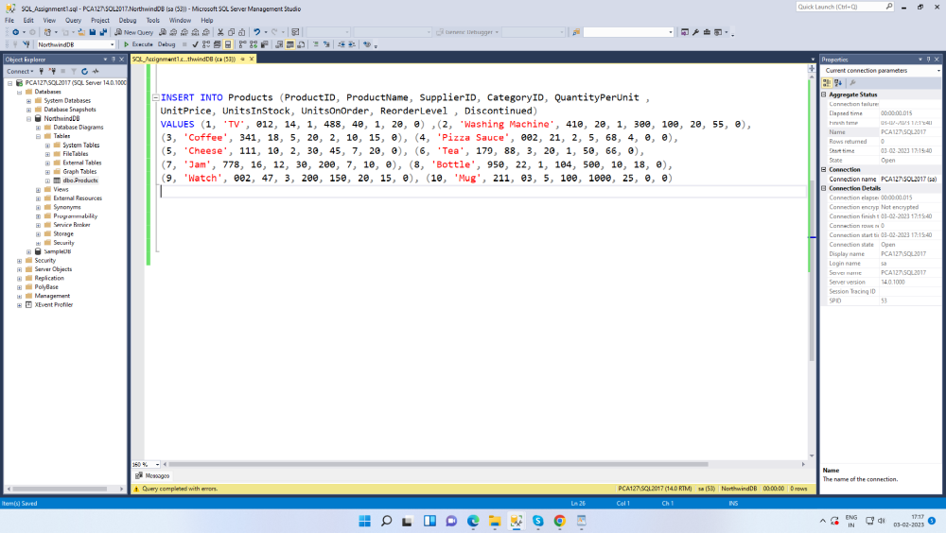

Fetching the details
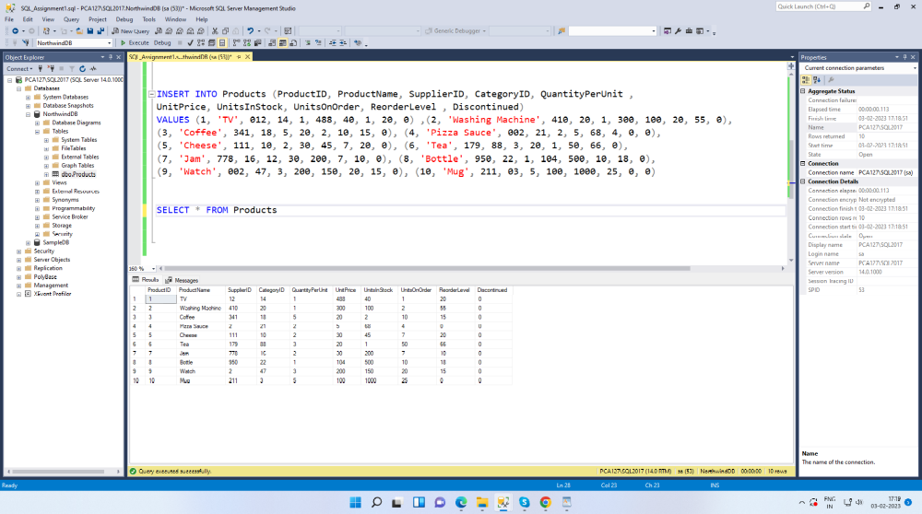

1. Write a query to get a Product list (id, name, unit price) where current products cost less than $20.
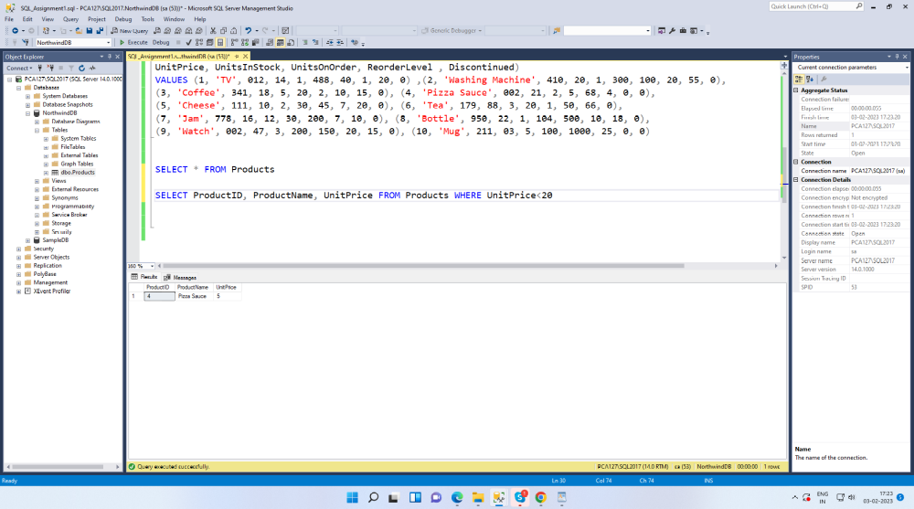

2. Write a query to get Product list (id, name, unit price) where products cost between $15 and $25.
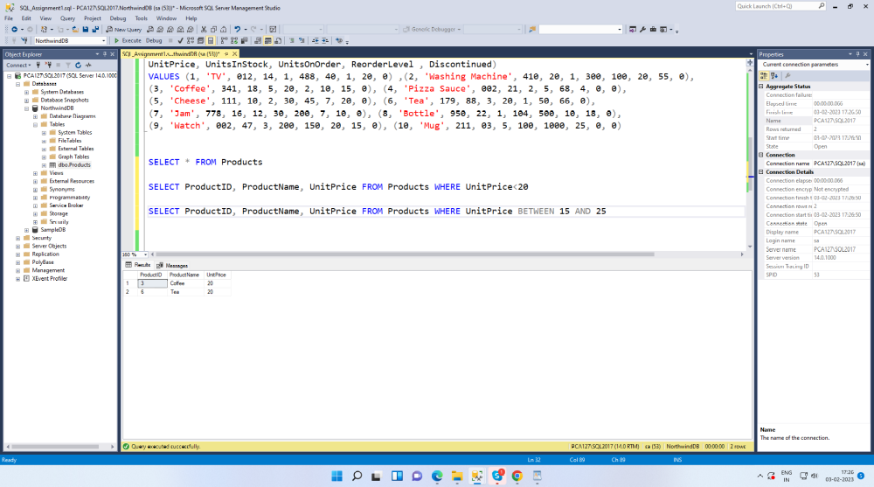

3. Write a query to get Product list (name, unit price) of above average price.
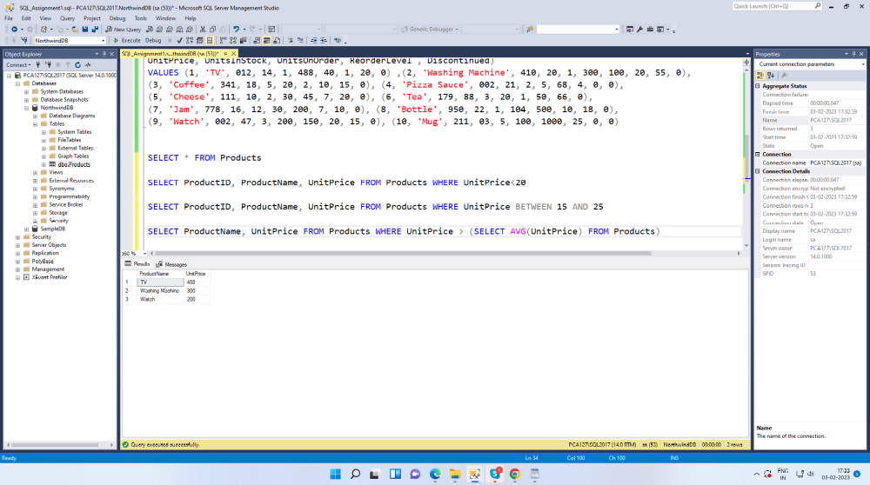

4. Write a query to get Product list (name, unit price) of ten most expensive products.
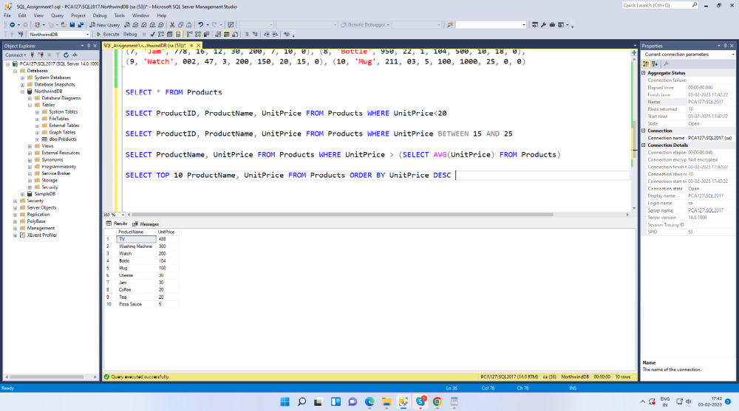

5. Write a query to count current and discontinued products.
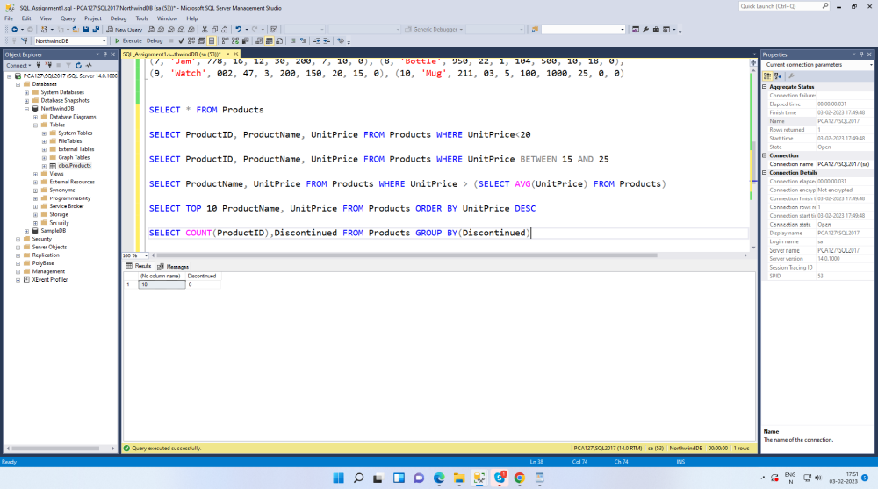

6. Write a query to get Product list (name, units on order , units in stock) of stock is less than the quantity on order.
