PROBLEM INVENTORY
AUDIBLE DATASET
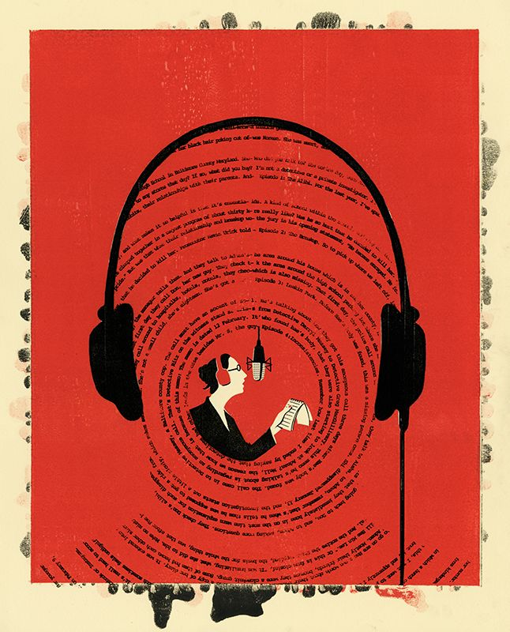
Tulsidai Singh
April 22, 2026

Summary
The Audible dataset contains 87,489 records with 8 variables. No Nas or empty strings were found in the raw data. All data quality issues were limited to structure. There were values stored in incorrect types concatenated fields, inconsistent formatting and placeholder strings for missing values.

Issues by Variable
# | Variable | Issue | Count
1 | author | “Writtenby:” prefix with no space  Words concatenated (e.g GeronimoStilton) | 87,489
2 | narrator | “Narratedby:” prefix with no space  Words concatenated | 87,489
3 | time | Duration is unstandardized in multiple formats  “2 hrs and 20 mins”  “1 hr”  “1 min”  “Less than 1 minute” | 87,489
4 | releasedate | Date stored as string in DD-MM-YY format  Needed to guess the century due to 2 digit year | 87,489
5 | stars | Rating and count concatenated in one string (e.g “4.5 out of 5 stars41 ratings.”  72,417 records have “Not rated yet” | 72,417
6 | price | Stored as a string  Commas in values (e.g “1,002.00”)  338 records have “Free” instead of a numeric value | 87,489
7 | language | Inconsistent casing with title case, lowercase and underscore formats | 87,489
8 | name | 50 entries with fewer than 3 characters, flagged for review | 87,489

Conclusion
No issues found for true Nas, empty strings, row duplicates
1,523 records share the same name and author but differ by narrator, language, release date or price. They are distinct editions not duplicates.

