Audible Dataset Data Cleaning Report
  - BOS Analytical Unit | Technical Assessment
Tulsidai Singh
2026-04-30
Table of contents

1. Dataset Overview
The dataset used in this pipeline is the Audible audiobook dataset sourced from Kaggle (CC0 Public Domain, collected by Snehangsude via web scraping from Audible.in). It contains 87,489 records across 8 variables covering audiobook titles, authors, narrators, duration, release dates, languages, star ratings, and prices in INR. The data spans releases from December 1998 through November 2025.
Variable | Description
name | Audiobook title
author | Author(s)
narrator | Narrator(s)
time | Duration as text string
releasedate | Release date (DD-MM-YY)
language | Language of the audiobook
stars | Rating string
price | Price in INR

2. Data Quality Diagnostics

2.1 Missingness
No true NA values were present in the raw dataset. However, two variables contained placeholder strings used in place of missing values: stars had 72,417 entries (82.8%) recorded as "Not rated yet", and price had 338 entries (0.4%) recorded as "Free". These were treated as structural missing and encoding issues respectively, not as data errors.
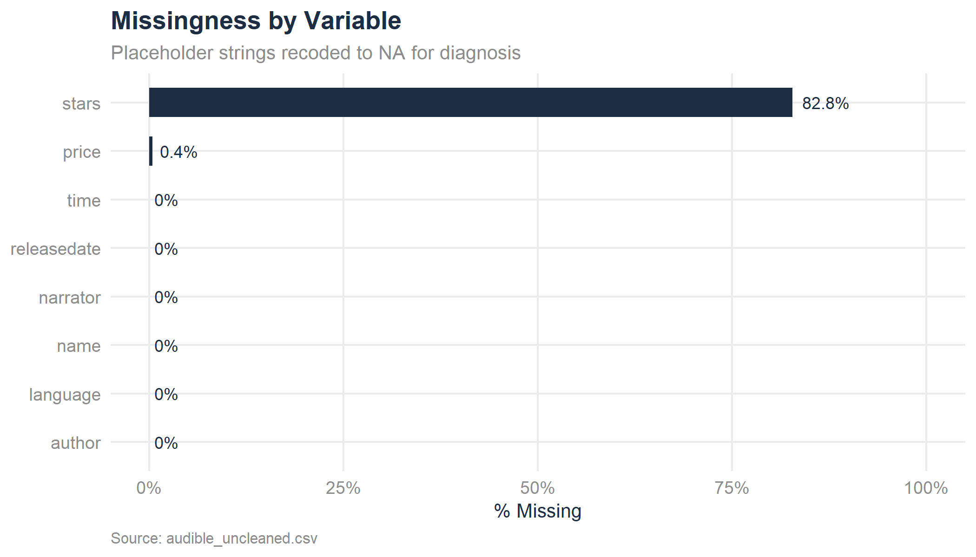
Figure 1: Missingness by variable, placeholders recoded to NA for visualisation

2.2 Column Types
All eight raw variables were ingested as character strings. Type coercion was required for price (numeric), releasedate (date), time (numeric minutes), and stars (split into numeric rating and integer count).

2.3 Duplicates
No full-row duplicates were found. 1,523 records share the same name and author but differ by narrator, language, release date, or price and confirmed as distinct editions. No deduplication was applied.

3. Cleaning Decisions

3.1 Author and Narrator
Both fields contained a concatenated prefix (Writtenby:, Narratedby:) with no spaces between words (e.g. GeronimoStilton). The prefix was stripped using regex and word boundaries were inserted between camelCase joins. This was verified to work correctly on Latin, accented, and Asian-script names. A known edge case exists where compound lowercase particles (e.g. de, van) following an initial may not be separated but it was documented as a limitation.

3.2 Language
All language values were normalised to title case and underscores replaced with spaces (mandarin_chinese → Mandarin Chinese). Only English and Hindi were already title case; all other 34 languages were lowercase.

3.3 Price
Comma separators were stripped from values like "1,002.00". The 338 "Free" entries were converted to 0 rather than NA, free audiobooks are a legitimate price point, not missing data. Converted to numeric.

3.4 Stars
The concatenated string "4.5 out of 5 stars41 ratings" was split into two columns: rating (numeric, 0–5) and rating_count (integer). The 72,417 "Not rated yet" entries were converted to NA for both columns. This is a structural missing error, 83% of the dataset is unrated, reflecting genuine absence of ratings rather than a data collection failure.

3.5 Time
Duration strings were parsed into duration_mins (total minutes, numeric). All format variants were handled: "2 hrs and 20 mins", "10 hrs", "1 hr and 1 min", "1 min", and "Less than 1 minute" (converted to 0).

3.6 Release Date
Dates stored as DD-MM-YY were parsed to proper R date objects. A century cutoff rule was applied: 2-digit years 95–99 map to 1995–1999; 00–94 map to 2000–2094. This is justified by the dataset’s documented range of 1998–2025. No NAs were produced by the parse.

3.7 Short Name Flagging
50 records with titles shorter than 3 characters were flagged via short_name_flag. These are likely legitimate titles (single characters, numbers, Japanese kanji) and were not removed.

3.8 Outlier Flagging
IQR-based outlier detection (k = 1.5) was applied to price and duration_mins. 704 price outliers and 2,098 duration outliers were flagged. No records were dropped, but flags are available for downstream analysis.

4. Imputation
Only rating and rating_count contained missing values after cleaning (72,417 NAs, 82.8%). Imputation was not applied. With 83% of the column missing, any imputed value would reflect the distribution of the rated minority, not the true population. The missingness is structural, books without ratings on Audible simply have no rating. Leaving these as NA is the honest and defensible choice.
All other variables had zero missing values after cleaning.

5. Post-Cleaning Summary
Table 1: Post-cleaning dataset summary
Metric | Value
Total records | 87,489
Total variables (after cleaning) | 14
Records with price = 0 (Free) | 338 (0.4%)
Records flagged: short name | 50 (0.1%)
Records flagged: price outlier | 704 (0.8%)
Records flagged: duration outlier | 2,098 (2.4%)
Missing: rating / rating_count | 72,417 (82.8%)
Missing: all other variables | 0

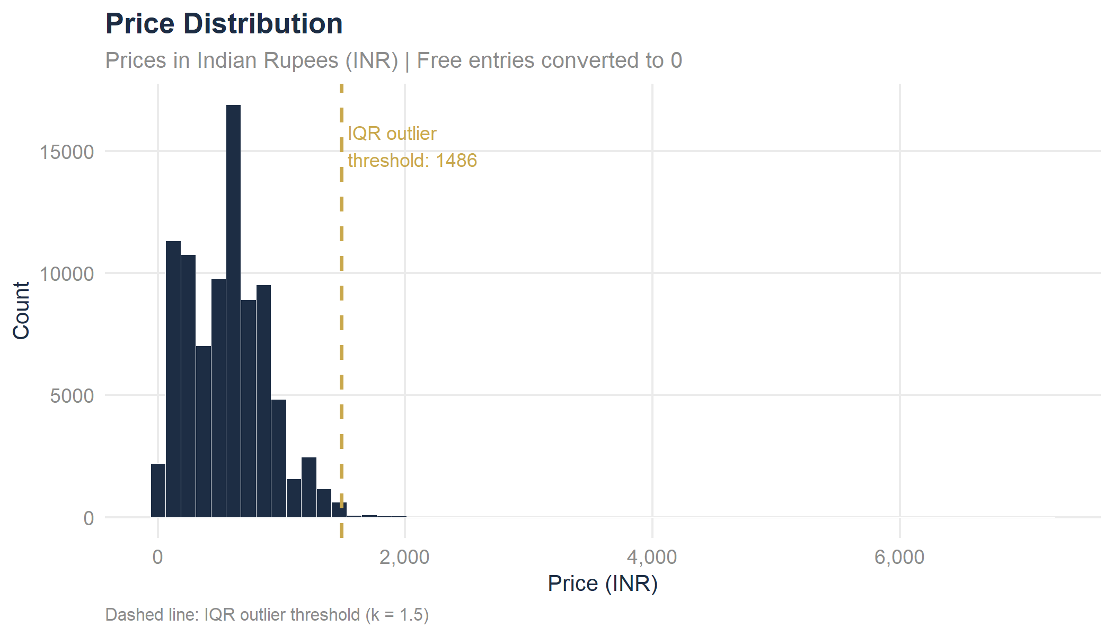
Figure 2: Distribution of audiobook price (INR) after cleaning
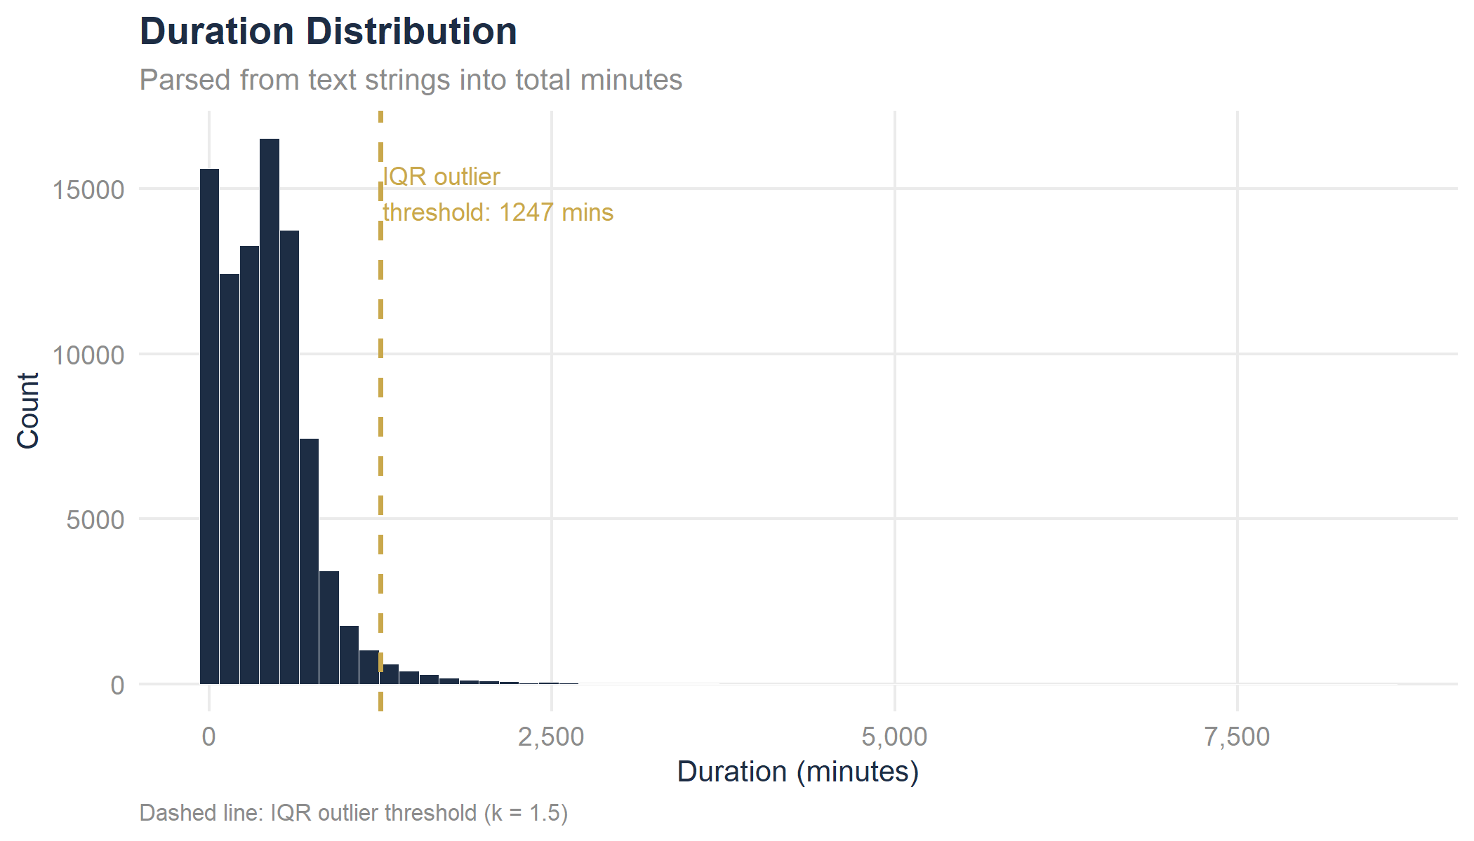
Figure 3: Distribution of audiobook duration (minutes) after cleaning
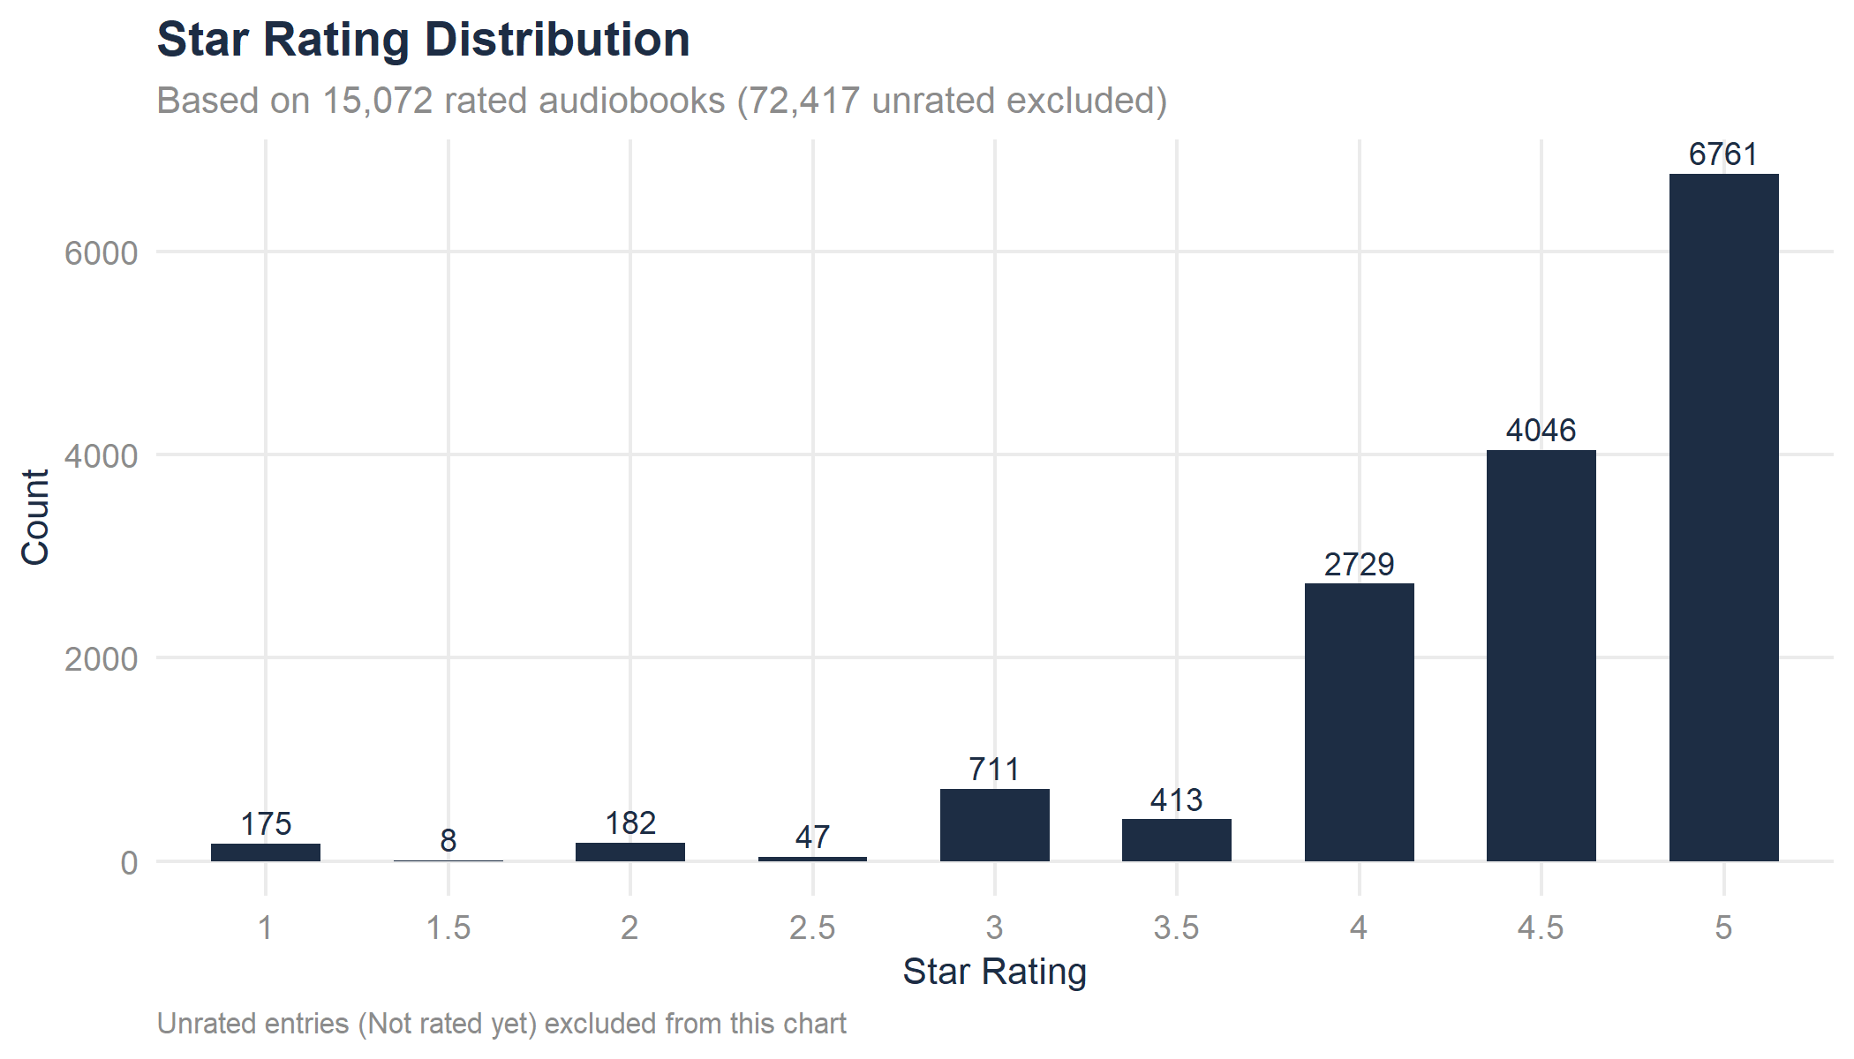
Figure 4: Distribution of star ratings among rated audiobooks
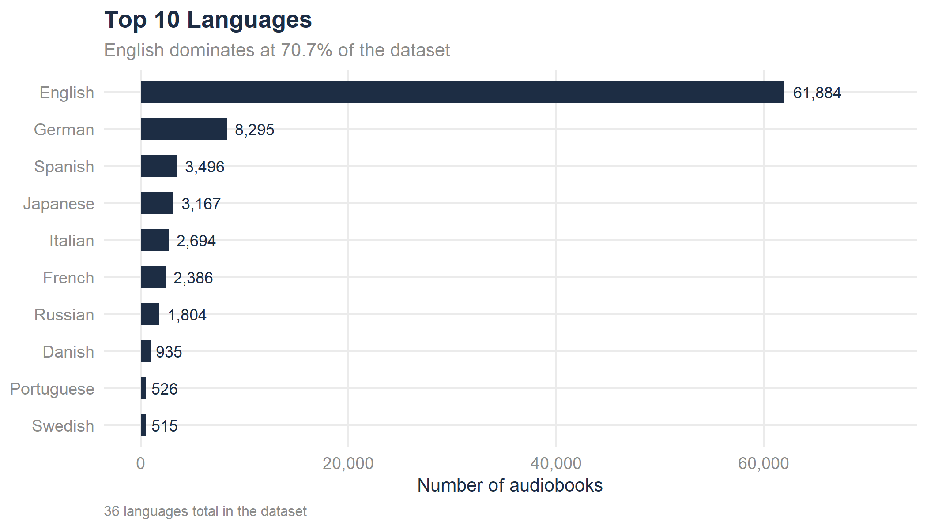
Figure 5: Top 10 languages by number of audiobooks

6. Limitations and Known Risks
- Author/narrator word spacing - the regex correctly handles standard camelCase but may miss spaces before lowercase particles (e.g. de, van, al) in non-English names. Affected records are a small minority and have been noted.
- 2-digit year inference - the century cutoff rule is a judgment call. Any record with a release year of 95–99 has been mapped to the 1990s. If future data contains genuine 2095–2099 releases, this rule would need revisiting.
- Price currency - all prices are in Indian Rupees (INR), as this data was scraped from Audible.in. No currency conversion has been applied.
- Structural missing in ratings - 82.8% of rating values are NA. Any analysis using rating or rating_count applies only to the 17.2% of audiobooks that have been rated, and may not be representative of the full catalogue.
- Web-scraped data - the dataset was collected via scraping and may contain transcription errors, encoding artefacts, or records that were incomplete at the time of collection.

