Appendix 1: Assignment submission cover sheet ASSIGNMENT SUBMISSION COVER SHEET
Student Id:
CSE25-326
Student names:
Tumisang Luciano Sebego
Student email:
cse25-326@thuto.bac.ac.bw
Cohort:
2026
Assignment title:
SCIS WMD_2026 A01
Date of submission:
19/05/2026
.
Programme of Study:
Year 1
Bsc Computer Systems Engineering
Year of Study:

Intellectual property statement
By checking the box below, I certify that this assignment is my own work and is free from plagiarism. I understand that the assignment may be checked for plagiarism by electronic or other means and may be transferred and stored in a database for the purposes of data-matching to help detect plagiarism. The assignment has not previously been submitted for assessment in any other unit or to any other institution. I
have read and understood the Botswana Accountancy College plagiarism guidelines policy.
- Agree Signature……………………………………. Date………………………………………….
1 9 May 2026

BAC.ACAD.PM.03. F02.V3.0
Page 9 of 9



PART A – WEBSITE SPECIFICATION DOCUMENT

Website Objective and Business Goals
The primary goal of Sanele Timepieces is to design a sophisticated digital platform that presents luxury watches in a manner that reflects their quality and precision. From a business perspective, the website seeks to bridge the gap
between traditional watchmaking and modern online availability for its
customers. In line with industry standards for high-end retail, a strong digital presence is essential for building the brand equity and effective storytelling. The platform aims to establish strong customer relationships through immersive brand experiences while enhancing lead generation by enabling clients to reserve personal viewings through an online system/platform.

i. Project Goals
  - Attract High Value Customers: Enable high-intent clients to reserve personal viewings via an online system.
  - Immersive Experience: Creating a digital boutique environment that mirrors (direct reflection) the exclusive feeling of being in a physical luxury
showroom.
  - Ensure 100% responsiveness across mobile, tablet, and desktop viewing.
  - Achieve a “3-click” navigation standard to enhance user experience.
  - Achieve a High Brand Value: Establishing a digital presence essential for brand storytelling and high-end retail positioning in the market.
  - Deliver a visually immersive user experience using HTML5 and CSS3.

Target Audience
Demographics:
The target audience includes affluent individuals such as professionals and watch

collectors between the ages of 25 and 60. These users appreciate and value exclusivity, detailed engineering, and refined modern and traditional design.
Technical Aptitude:
Users are comfortable and very much understand technology and extensively use high-end smartphones and laptops. They expect fast-loading pages, smooth navigation, and modern user interface designs, and are unlikely to tolerate slow or poorly functioning websites. To meet these expectations, the site follows the "3-Click Rule" a web design standard ensuring that any piece of information or product detail is accessible or found within three mouse clicks from the homepage, minimizing user frustration and mirroring the efficient, high-end service found in a physical luxury boutique.

Phase | Tools | Outcome
Strategy | Market Research | Defined Target Audience (Affluent, 25-60 yrs).
Visual Design | Figma | An interactive prototype that bridges the gap between early ideas and final development.
Deployment (Publishing) | Git / GitHub Pages | Live production environment at tumi065.github

Website Type and Content
Sanele Timepieces offers modern electronic catalogue combined with a brand storytelling platform. Its content includes:
  - Visual Content: High-quality images optimized for performance and including W3C standard alt text for accessibility.
  - Technical Information: Detailed specifications of each watch, such as materials for the dials, similar design references, and materials used in constructing the cases .
  - Interactive Features: An HTML5 based contact form that allows users to submit inquiries and feedback (which can be done in the contact page).

Information Design & Taxonomy

The website follows a hierarchical and progressively structured approach to present information in a logical and understandable manner. Content is sectioned into major categories such as Collections, Brand History, and Customer Care Services, allowing users to locate information easily without having to navigate through extensive amount of information. The navigation is designed around the 3-click rule, ensuring a clear
structure of pages with easy access to content
  - Navigation Flow: Home, About, Collection, Service, Contact/Feedback
- Global Navigation: A consistent menu navigation bar that appears on every page, enabling a persistent navigation path (which mimics the web structure type of layout), high usability, and allowing users to move easily throughout the site at any time at any page they are at.
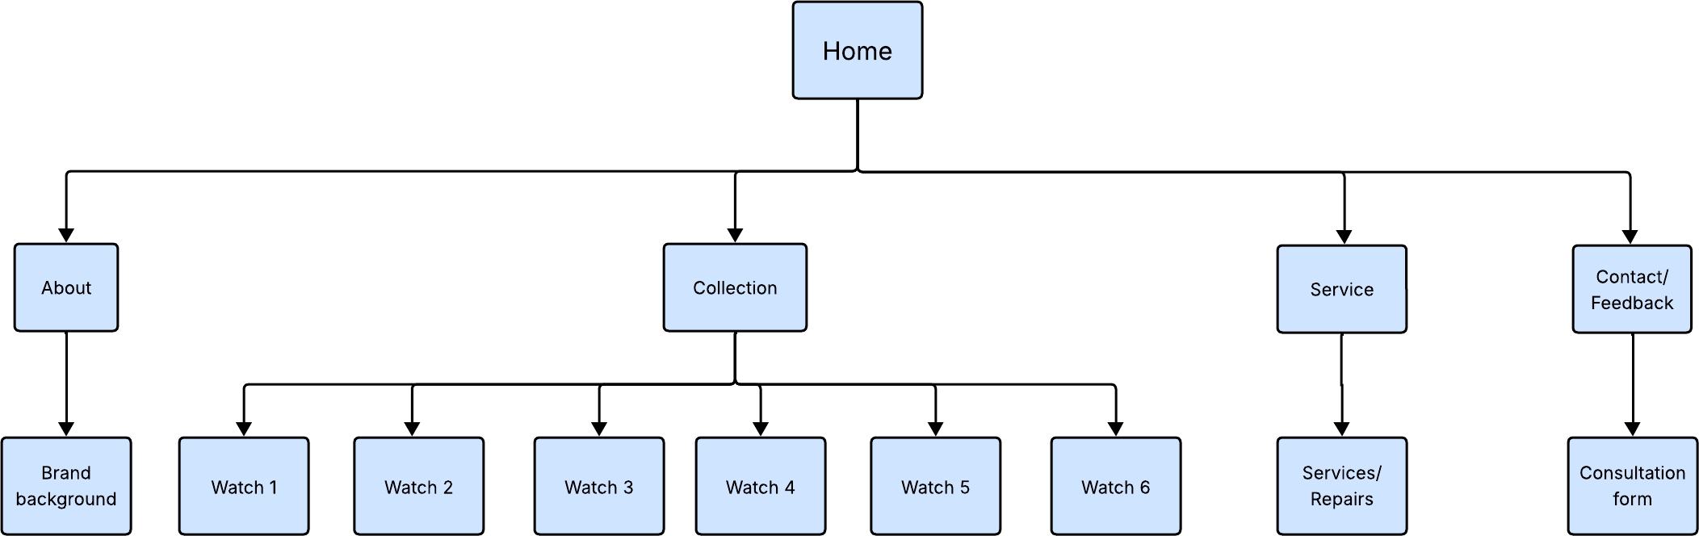

Page Template Design
The website uses a unified template (a single blueprint defining the common layout) to maintain consistency across all pages, which helps build user trust through visual familiarity.
- Layout Structure: The design is consistent throughout all the pages of website.
- Mock-up design: it shows a rough presentation of how the website will be structured and some of the details that will be added.

Wireframe Design:

  - Home Page: Uses a hero section to capture user attention immediately.
  - Contact Page: Features a simple, centred form layout to encourage user interaction.
- Visual Design: The use of active white space is intentional and strictly
maintained between elements. This is a core principle of luxury design, ensuring that the visual focus remains entirely on the high-end products without visual clutter.

Mock-up Designs

Opening page

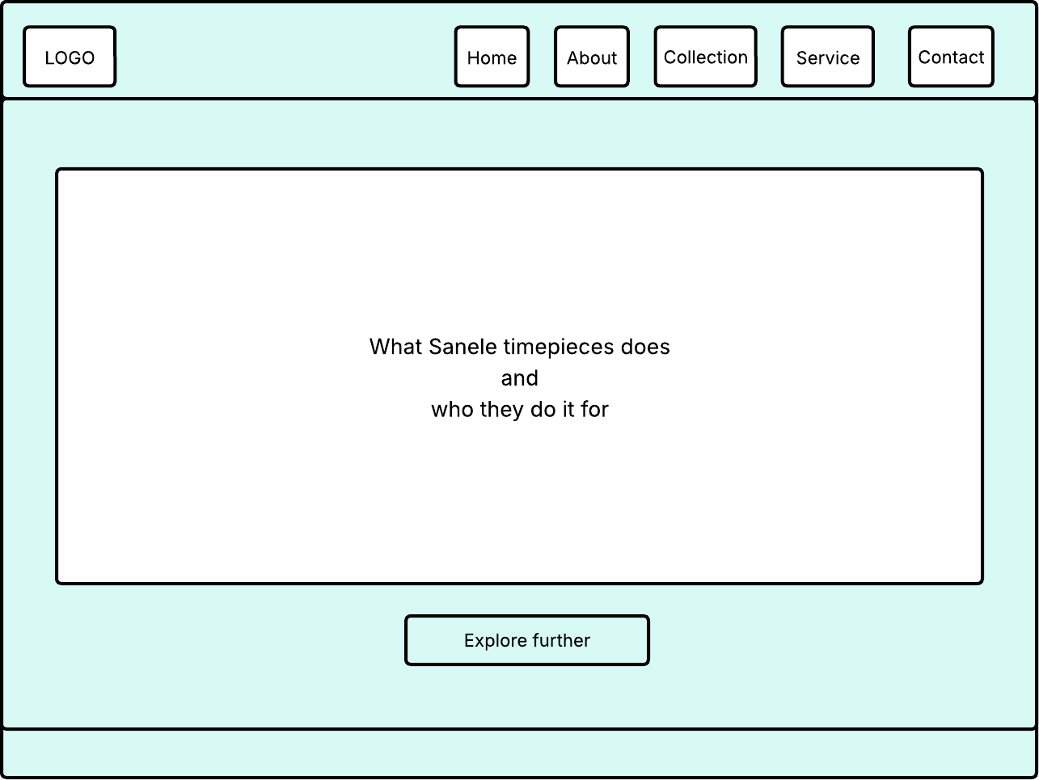

Home page

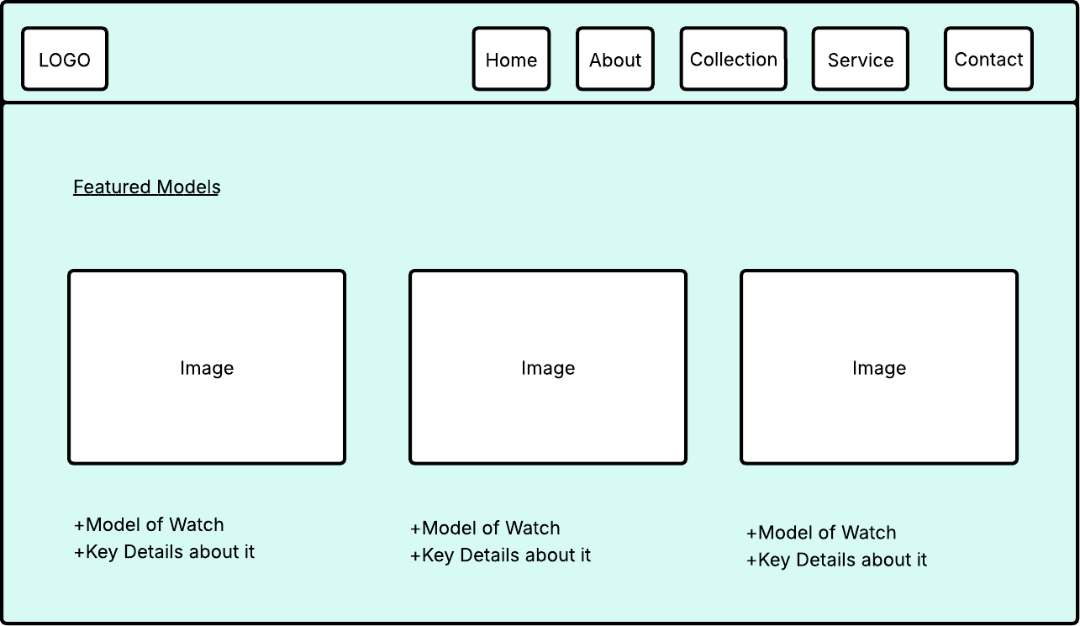

About page
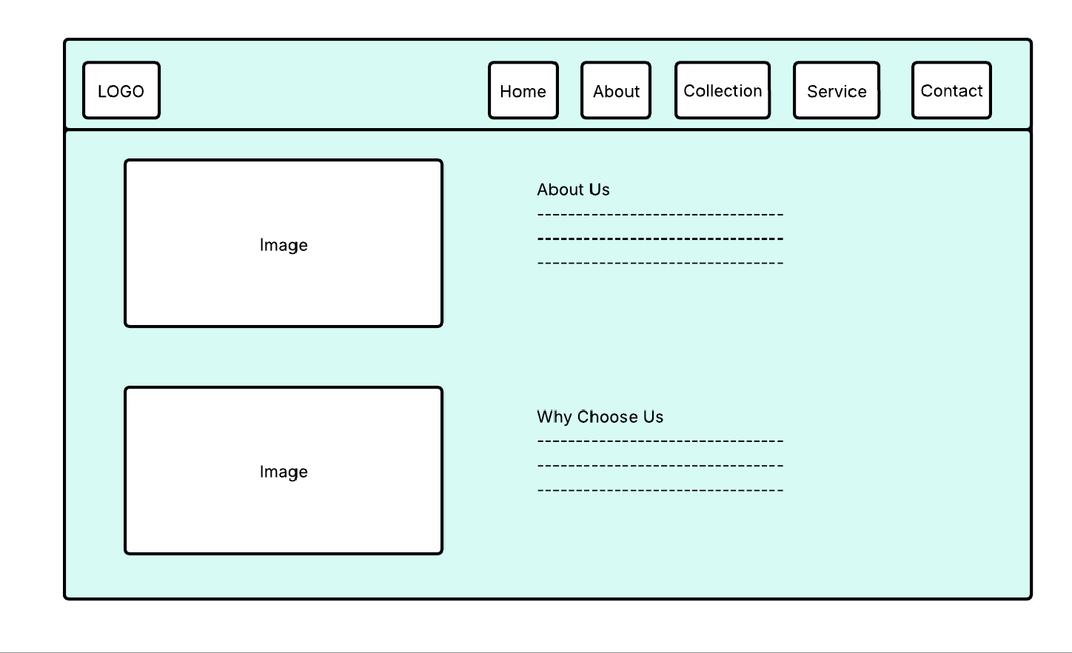

Collection
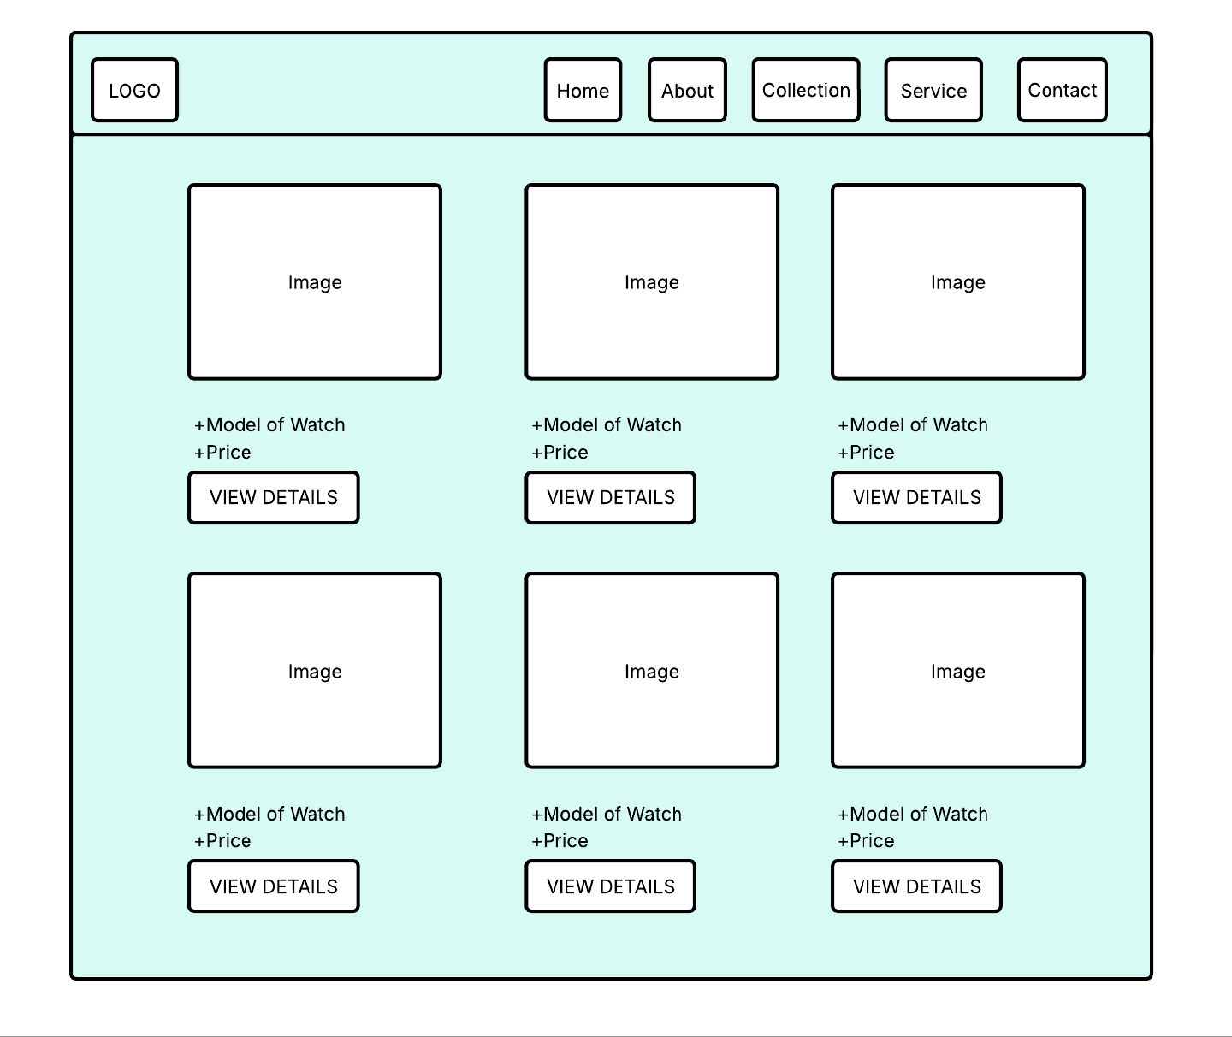

Service page

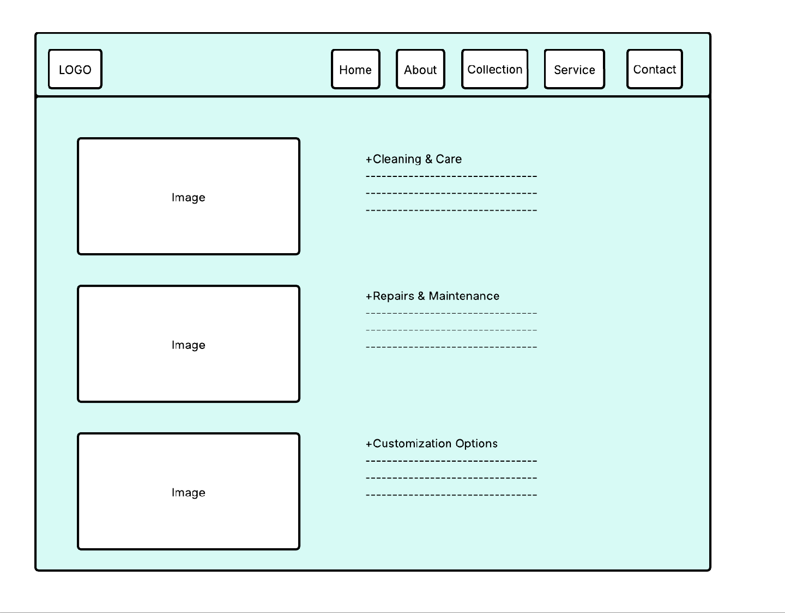

Contact page.

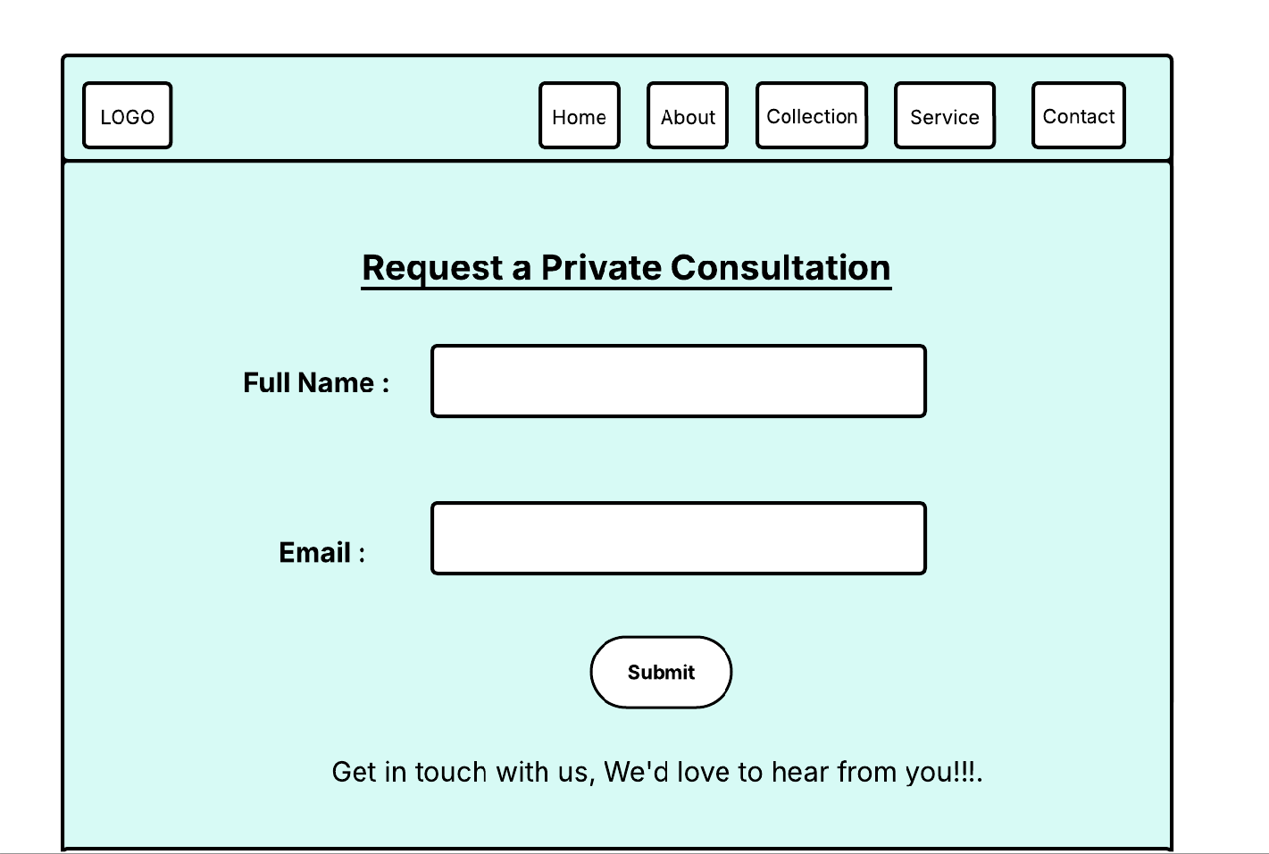

Wireframe Designs

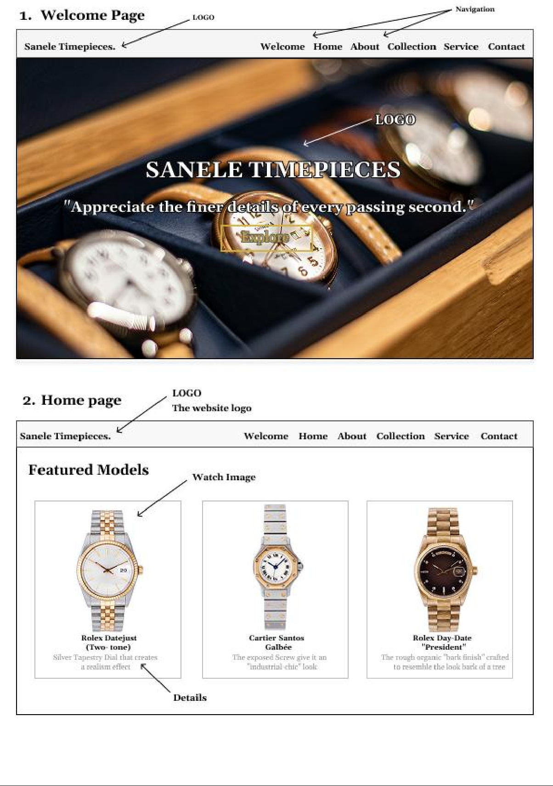

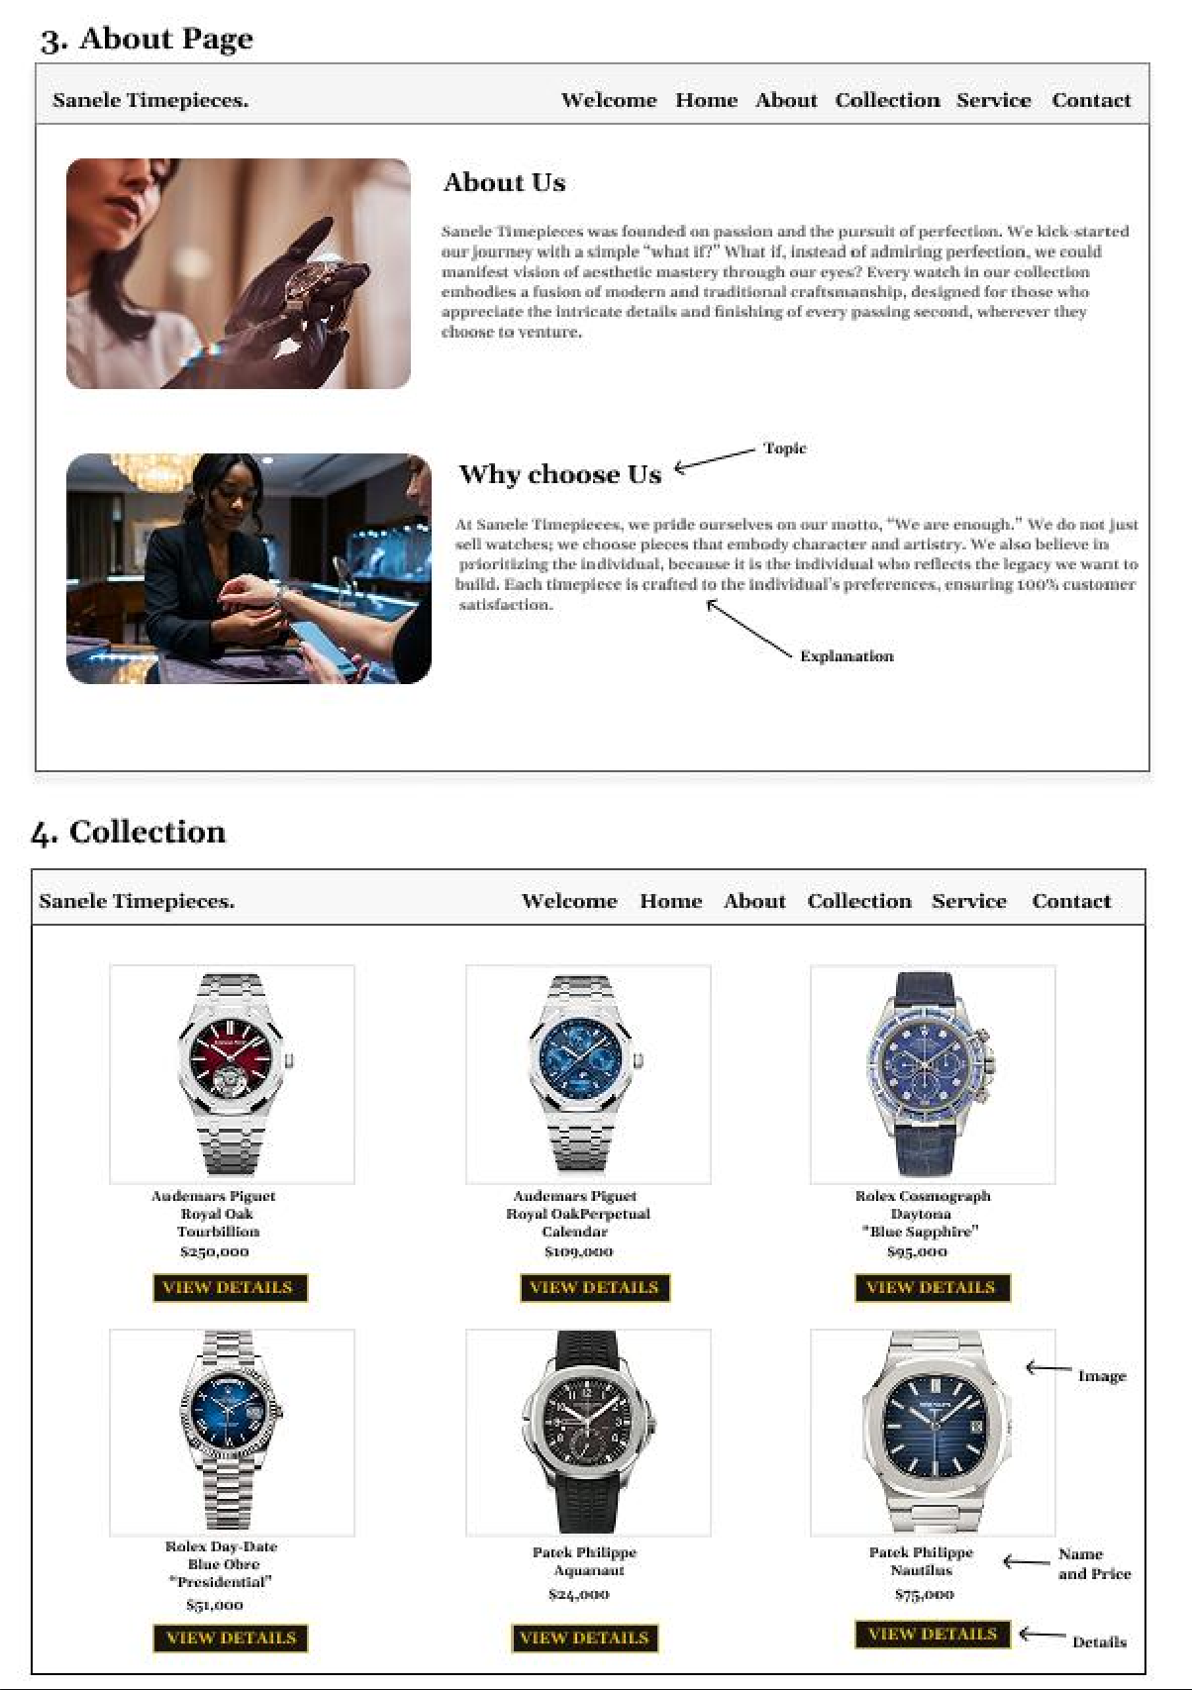

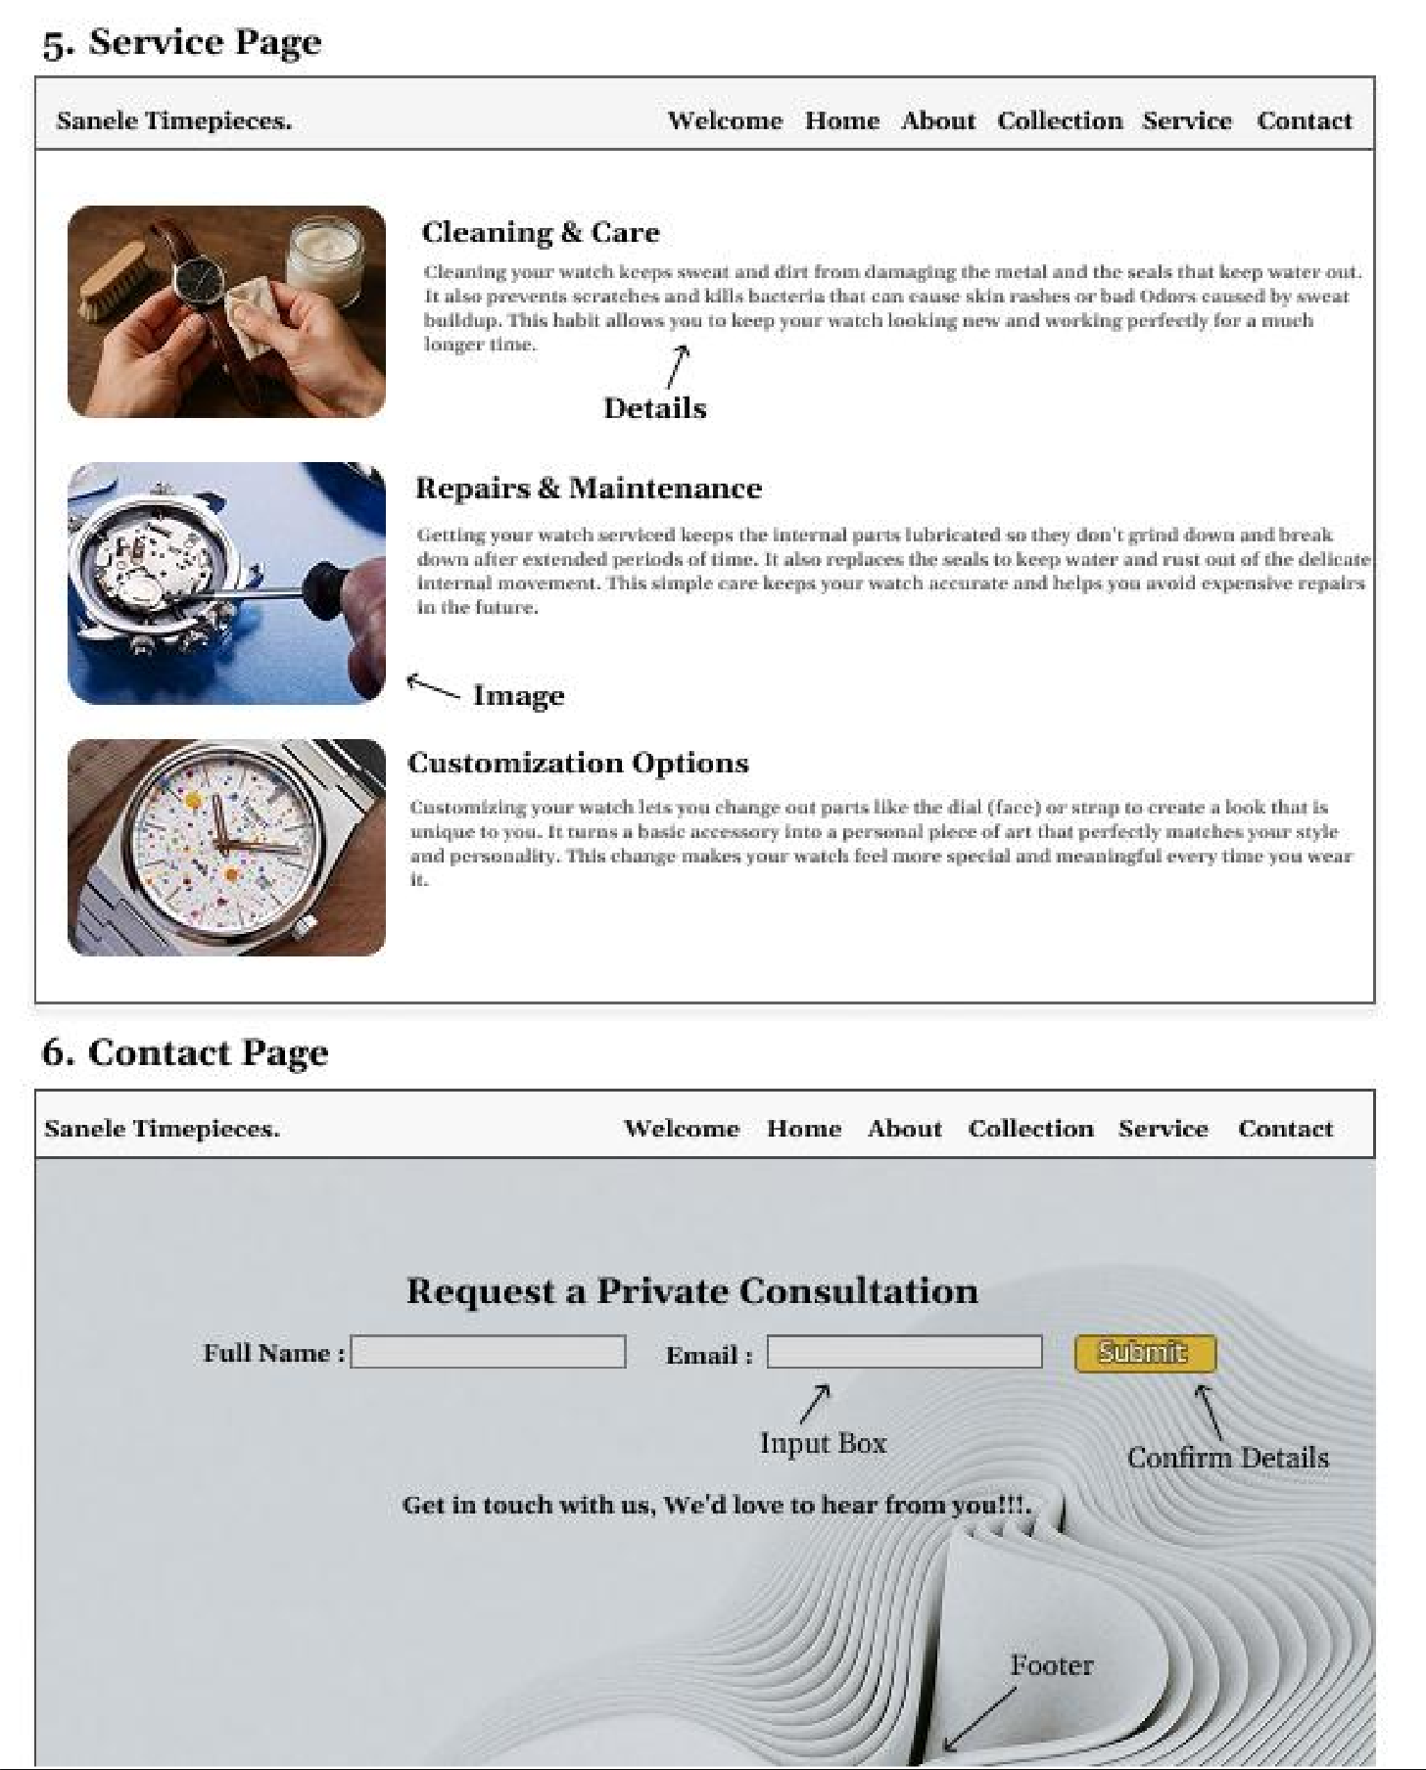

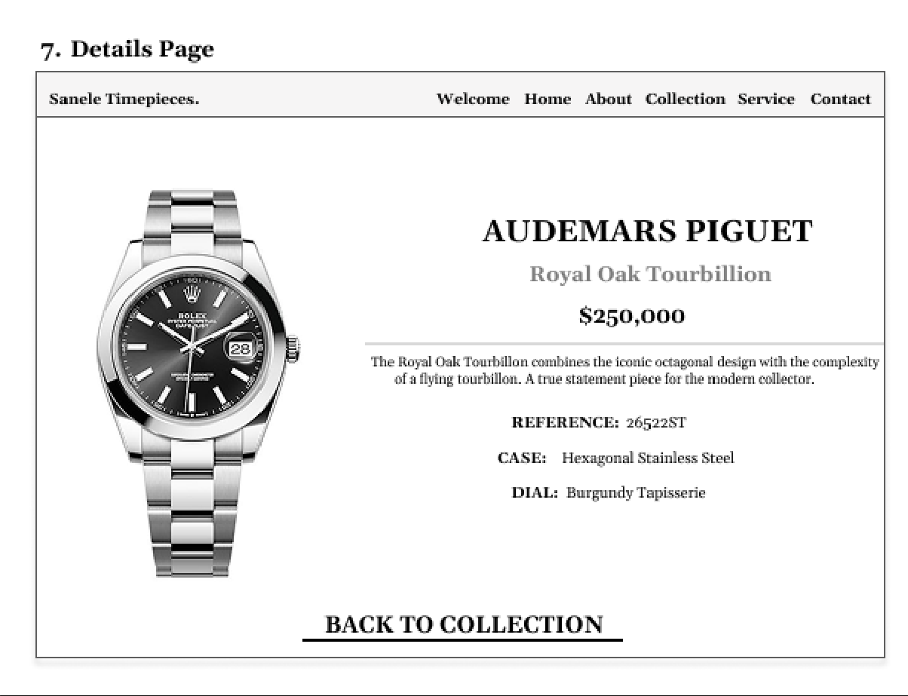

Typography selection
- Georgia (Serif)
The font is generally used by a lot of established institutions as well as history. The font choice for a brand such as Sanele Timepieces suggests that there is a long legacy behind it that is accompanied by skilled craftsmanship. The font also gives of refined look while also being readable.

Theme Choice
The layout of the website focuses more on the colour combination (It uses white, Gold and black) being used for the look of the website. The white background and watch images allow for each individual watch to standout on each page without competing.

The hover effect of the navigation turns Gold when the cursor is above it. The colour gives off the feeling of wealth and high-quality materials.

Hero Image Choice
The background image on the landing page gives off the feeling that the atmosphere you have walked into is like that of which you are walking into a high-end shop.

The Choice of Images
The images chosen are of high quality to suit what the users needs. They get enough time to look at each image and how it stands out boldly on each of the pages immersing them into wanting to continue to absorb the website deliverables.

Website Layout
The website is designed based off the web structure format/plan (the layout allows the user to return to the index (landing page) from anywhere on the website making it easier to navigate. By pressing the logo, users expect it to act as a reset point as it is common in majority of websites and without it the website can feel broken to its users.

The site adheres to the “3-Click Rule” which ensures that technical specifications or products are found within a maximum of three interactions from the landing page. The site also utilizes a minimalist colour palette and the choice of typography for a luxurious aesthetic.

Design  Element | Implementation  Detail | Strategic  Justification
Typography | Georgia (Serif) | Conveys institutional trust, authority, and high readability.
Colour Palette | White, Gold (#D4AF37), Black | Symbols of purity, wealth, and premium market positioning.
Visual Layout | Active White Spaces | Prevents visual clutter, ensuring focus remains on the product detailing

Technical Brief
The website is developed using modern technologies to ensure performance and responsiveness:
- Languages: HTML5 is used for semantic structure, while CSS3 is applied for styling elements such as typography, fonts, colours, and custom animations.
- Framework: Bootstraps is used for its form system, simplifying layout design and ensuring the site functions perfectly.
- Graphics Tools: Figma is used to edit images maintaining high visual quality as well as making the wireframe.

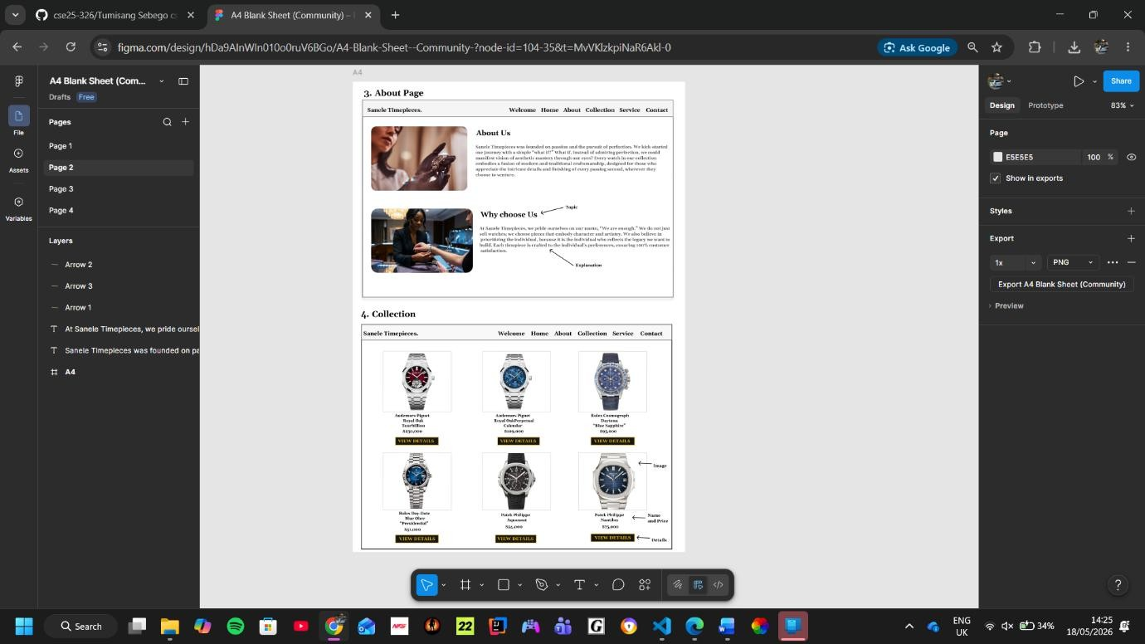
- Development Tools: Visual Studio Code is used for coding, and GitHub is used for robust version control and project management as well as deploying the
website.
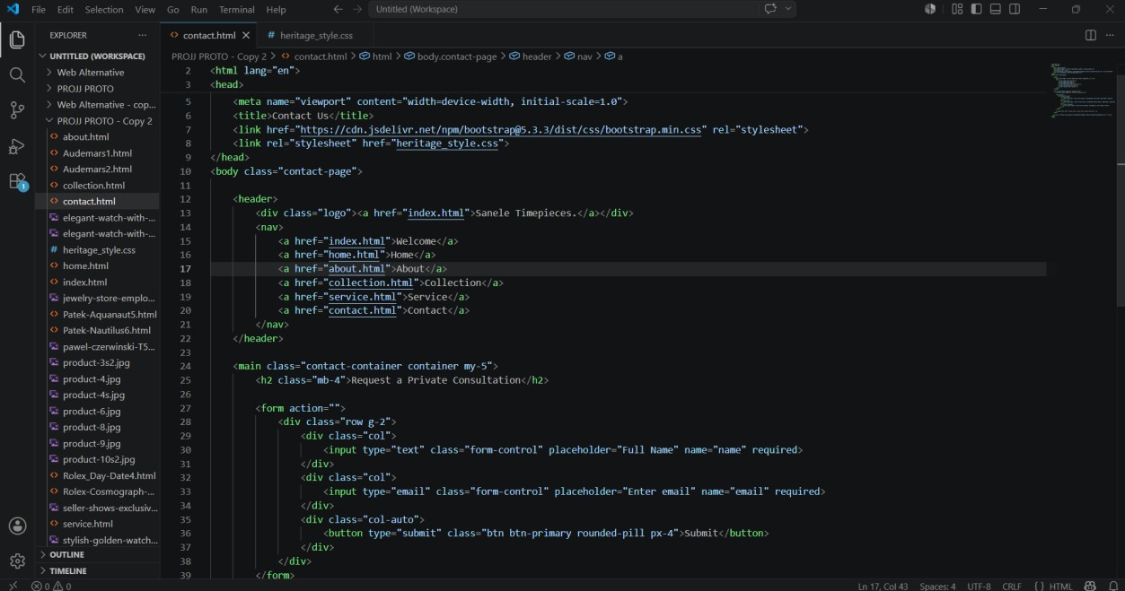

Quality Assurance
To ensure the site provides a high-quality user experience and functions properly, the following testing techniques are implemented:

- Cross-Browser Testing: The site is validated across Google Chrome, Opera GX, Avast Secure Browser, and Microsoft Edge to ensure consistent appearance, styling, and functionality.

Opera GX
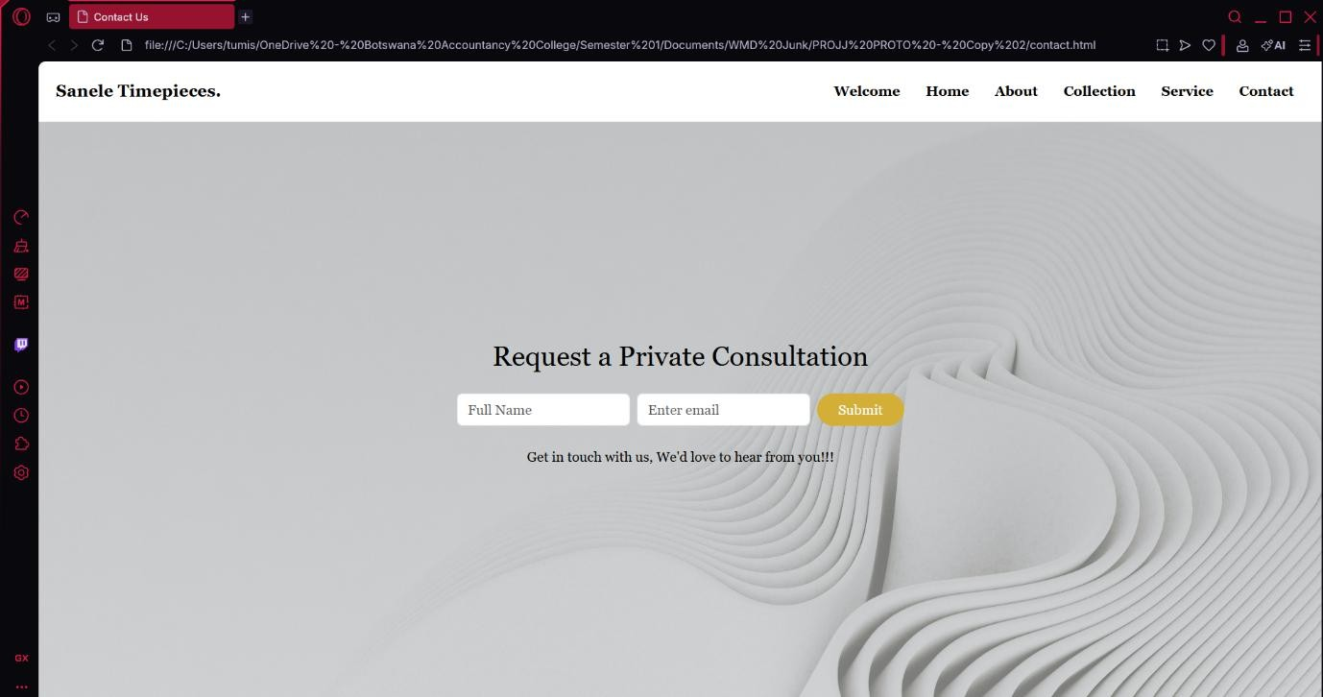

Google Chrome
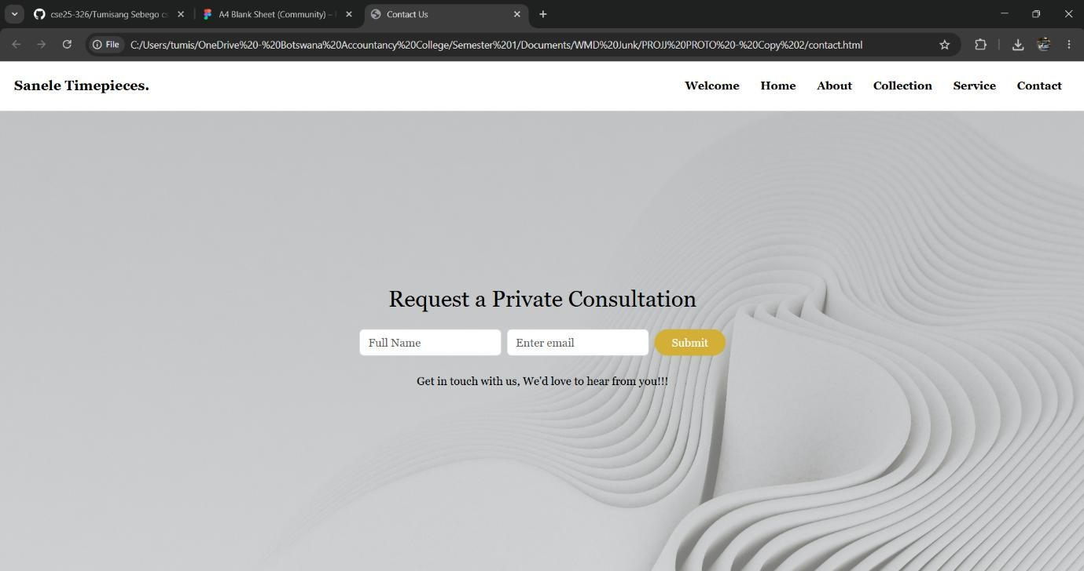

Microsoft Edge

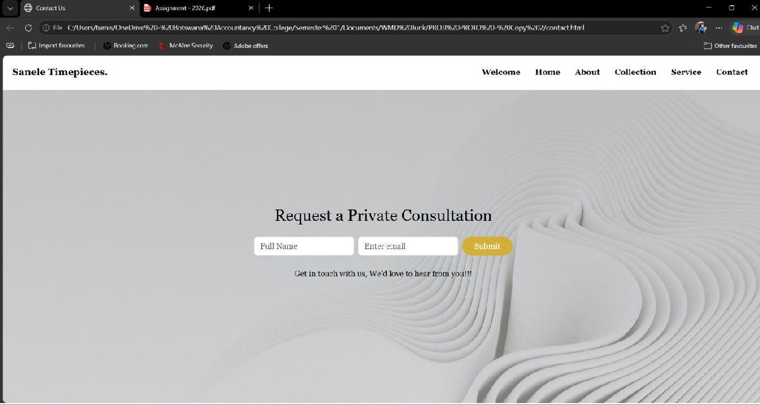
- Responsive Testing: Chrome DevTools are utilized to simplify the process of designing the contact page using Bootstrap for it. Also ensuring the page is reacts when a user enters their details on it.
- Functionality Testing: The contact form is assessed to ensure all HTML5 "Required" attributes are functioning correctly and that submissions are processed without errors.

Publishing and Promotion
The website is hosted on GitHub Pages, providing reliable and fast hosting.

Issue-Out Process:
- Initialize the local repository using git init.
- Stage and add all project files on the GitHub repository.
- Save changes with GitHub commit changes - "final submission ".
- Publish to the live server using GitHub.

Live Website Link:
https://tumi065.github.io/cse25-326/

Future Developments/Recommendations
To enhance the website further, the following improvements are suggested:

- Search Engine: A JavaScript search tool for model identification from the collection page without users having to search manually.
- Comparison Tool: A feature allowing collectors to compare mechanical movements (Watches) side-by-side.
- Bootstrap for Mobile: This would allow the website to align the right way when being viewed on devices with small screens.
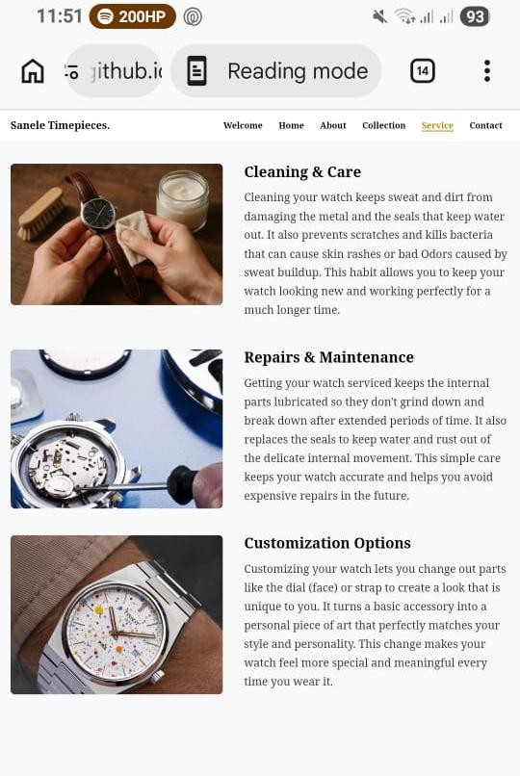
- Image Slideshow: This would add a sophisticated look to the website as well as showcasing the many models that are available at Sanele Timepieces.
- Adding quick processing feature: Add a enquire now button on each page for the watch a user might want to purchase which will take the to the contact page for them to check if it is available for purchase.

SANELE TIMEPIECES REPORT
This report outlines the design and building of Sanele Timepieces, an online platform for the viewing and buying of luxury watches. The goal was to create a beautifully designed, user-friendly website that visually
pleasing. By combining a high-end visual style with a simple layout, the site delivers an immersive brand experience that does more than just showcase luxury watches it smoothly guides visitors toward booking private
consultations.
- Project Goals
- Attract High Value Customers: Enable high-intent clients to reserve personal viewings via an online system.
- Immersive Experience: Creating a digital boutique environment that mirrors (direct reflection) the exclusive feeling of being in a physical luxury showroom.
- Ensure 100% responsiveness across mobile, tablet, and desktop viewing.
- Achieve a “3-click” navigation standard to enhance user experience.
- Achieve a High Brand Value: Establishing a digital presence essential for brand storytelling and high-end retail positioning in the market.
- Deliver a visually immersive user experience using HTML5 and CSS3.

PROJECT MANAGEMENT
The website uses the "3-Click Rule." This means a customer can
find any product or info in three clicks or less from the homepage. It keeps things fast and frustration-free, giving users the same high-end, effortless service they’d get in a luxury store.

Phase | Tools | Outcome
Strategy | Market Research | Defined Target Audience (Affluent, 25-60  yrs).
Visual Design | Figma | An interactive prototype that bridges the gap between early ideas and final development.
Deployment (Publishing) | Git / GitHub Pages | Live production environment at tumi065.github

- DESIGN s NAVIGATION
The site adheres to the “3-Click Rule” which ensures that technical specifications or products are found within a maximum of three interactions from the landing page. The site also utilizes a minimalist colour palette and the choice of typography for a luxurious aesthetic.

Design  Element | Implementation  Detail | Strategic  Justification
Typography | Georgia (Serif) | Conveys institutional trust, authority, and high readability.
Colour Palette | White, Gold  (#D4AF37),  Black | Symbols of purity, wealth, and premium market positioning.
Visual Layout | Active White Spaces | Prevents visual clutter, ensuring focus remains on the product detailing

TECHNICAL IMPLEMENTATION
The site architecture is built on a foundation of Semantic HTML5 and CSS3. To ensure modern responsive standards, the Bootstrap 5 Form System was implemented for fluid contact page layout.

TESTING AND QUALITY ASSURANCE

  - Works on all browsers: I tested the site on Chrome, Opera GX, Avast Secure Browser, Safari, and Edge. I adjusted the code where needed so the design looks consistent and polished on all of them.
  - Looks great on all screens: Using Chrome DevTools, I checked the layout on everything from a tiny phone screen screens to a massive desktop monitor.

  - Everything works perfectly: I manually clicked through the entire site to make sure all links, navigation menus, hover effects, and contact forms worked flawlessly without any errors.
  - Live testing: I kept testing the site continuously once it was live on GitHub Pages to ensure nothing broke after deployment.

- CONCLUSION s RECOMMENDATIONS
The website is up and running everything works the way it is supposed to (the are no broken links in it and the navigation stays consistent throughout all the pages), however the following improvements are suggested so that the
website can be improved in the future:
- Search Engine: A JavaScript search tool for model identification from the collection page without users having to search manually.
- Comparison Tool: A feature allowing collectors to compare mechanical movements (Watches) side-by-side.
- Bootstrap for Mobile: This would allow the website to align the right way when being viewed on devices with small screens.

- Image Slideshow: This would add a sophisticated look to the website as well as showcasing the many models that are available at Sanele Timepieces.
- Adding quick processing feature: Add a enquire now button on each page for the watch a user might want to purchase which will take the to the contact page for them to check if it is available for purchase.

