
VIETNAM NATIONAL UNIVERSITY, HANOI
INTERNATIONAL SCHOOL



PROJECT IN FINTECH
DEVELOPING A BLOCKCHAIN-BASED PAYMENT PROTECTION SOLUTION AND SMART CONTRACT PLATFORM SUPPORTING ESCROW PAYMENTS FOR PEER-TO-PEER (P2P) TRANSACTIONS IN VIETNAM

Full name: Nguyen A
ID: 12345678
Class: FDB2023B
Project Supervisor: Dr. Tran Vu Anh

Hanoi, May 15th, 2026
PERFACE
Throughout the course of study and the execution of Project In Fintech, under the dedicated supervision of Dr. Tran Vu anh, our group has had the opportunity to acquire and apply fundamental knowledge while honing essential research and practical skills within our field of expertise. Dr. Anh’s passionate lectures, meticulous guidance, and scholarly feedback have provided us with a clear direction during the implementation phase. Specifically, these insights have enabled us to effectively collect and process data, select appropriate methodologies, and evaluate the efficacy of each component within the project.
Undertaking this project has not only allowed us to consolidate theoretical frameworks but has also expanded our practical understanding, enhanced our analytical thinking, and improved our ability to apply knowledge to solve specific problems. Throughout the process, we consistently received dedicated support from our supervisor, ranging from the orientation of research content to the refinement of each section to ensure the report is both scientific and rigorous.
The duration of this project has fostered a systematic working mindset and developed our skills in presenting, evaluating, and synthesizing information. This is not merely a major assignment; it serves as a vital foundation that strengthens our confidence in future coursework and research endeavors.
Despite our best efforts to achieve the highest possible quality, certain shortcomings are inevitable. We sincerely look forward to receiving valuable comments and constructive feedback from our supervisor to further improve our future research and academic performance.
Finally, we would like to express our deepest gratitude to Dr. Tran Vu anh for his dedicated teaching and the profound knowledge he has imparted, which has supported us throughout our studies and the completion.

TABLE OF CONTENT
CHAPTER 1: THEORETICAL FOUNDATION 1
1.1. Blockchain Technology 1
1.1.1. Definition and Fundamental Characteristics 1
1.1.2. Classification and Rationale for Choosing the Execution Environment 2
1.1.3. Ethereum and the Account Model 2
1.2. Smart Contracts 3
1.2.1. Concept and the "Code is Law" Principle 3
1.2.2. Solidity Programming Language 4
1.2.3. Security Patterns in Solidity 4
1.2.4. ERC-20 Standard 5
1.3. Escrow Protocols 6
1.3.1. Traditional Escrow 6
1.3.2. Trustless Escrow on Blockchain 6
1.3.3. Dispute Resolution Mechanism 7
1.4. Supporting Technologies 7
CHAPTER 2: SYSTEM ANALYSIS AND DESIGN 8
2.1. Requirement Analysis 8
2.1.1. Functional Requirements 8
2.1.2. Non-Functional Requirements 9
2.1.3. Demo Constraints 10
2.2. Architectural Design 10
2.2.1. Four Layer Architecture 10
2.2.2. Rationale for the Technology Stack 11
2.3. Smart Contract Design 12
2.3.1. VNDToken.sol 12
2.3.2. EscrowManager.sol: State Machine 13
2.3.3. Core business functions 14
2.3.4. Events and audit trail 15
2.4. Database design 16
2.4.1. The users table 16
2.4.2. The deals table 16
2.4.3. The disputes table 16
2.4.4. The blockchain_events table 17
2.4.5. The dispute_messages table and ERD relationships 17
2.5. Backend API design 18
2.5.1. REST architecture and authentication 18
2.5.2. Processing flow of the deals API group 19
2.5.3. Dispute processing flow and three-way chat 19
2.5.4. TimerService cron job auto-release 20
2.6. User interface design 21
2.6.1. Navigation flow 21
2.6.2. DealDetailPage 21
2.6.3. DisputePage: Three-way chat 22
2.6.4. WalletPage 22
CHAPTER 3: SYSTEM DEPLOYMENT 22
3.1. Smart Contract Deployment 22
3.2. Backend Deployment 23
3.3. Frontend Deployment 24
CHAPTER 4: TESTING AND EVALUATION 25
4.1. Smart Contract Testing 25
4.2. Testing three main demo scenarios 30
4.2.1. The Happy Path scenario 30
4.2.2. The Auto-release scenario 31
4.3.3. The Dispute scenario 31
4.3. Comparative assessment 33
4.4. Evaluating the four blockchain characteristics within the system 34
CHAPTER 5: LIMITATIONS AND FUTURE DEVELOPMENT 35
5.1. Limitations 35
5.2. Future roadmap 37
CHAPTER 6: CONCLUSION 37
REFERENCES 39

TABLE OF FIGURE:

Figure 1: The ERD relationships between the tables 18
Figure 2: The Sequence Diagram of Happy Path 27
Figure 2: The Sequence Diagram of Auto-release 28
Figure 3: The Sequence Diagram of Dispute 29
Figure 4: The dashboard of new trancsaction 30
Figure 5: The dasboard of completed transaction 31
Figure 6: Admin interface for completed dispute resolution 32

INTRODUCTION:
The P2P second-hand market in Vietnam has grown rapidly on unstructured channels like Facebook Marketplace, Zalo groups, and Cho Tot. According to the Vietnam E-commerce Association (VECOM) 2023 report, the national e-commerce market reached approximately $20.5 billion, with C2C transactions constituting an expanding share [1]. Transactions in this segment are highly fragmented, relying on social media discovery, private message negotiations, and direct bank transfers or cash, completely bypassing structured transaction management systems.
The core issue in off-platform P2P trades is the absence of post-obligation binding mechanisms, creating persistent fraud risks where buyers fail to receive goods after paying or sellers deliver without receiving payment. Existing payment methods like bank transfers, MoMo, or ZaloPay only execute point-to-point transfers. They lack conditional asset custody, cannot bind disbursement to successful delivery, and offer no arbitration mechanisms, thereby solving the payment problem while completely ignoring transaction trust.
While traditional escrow models mitigate this by introducing a third-party intermediary, they establish a centralized single point of failure. Blockchain-based smart contracts eliminate this by introducing a "trustless escrow" protocol, where funds are secured and automatically disbursed by public, immutable code rather than a centralized entity.
To address this, this study develops "TrustDeal," a demo P2P escrow payment platform based on Ethereum smart contracts. It enables buyers to lock funds into a contract, allows sellers to receive disbursement upon delivery, and integrates a three-way chat for instant, on-chain dispute resolution executed by an admin. Theoretically, this research analyzes and proves the technical feasibility of trustless escrow protocols for P2P second-hand markets in Vietnam. Practically, it constructs a fully operational system encompassing smart contracts, backend, and user interface to validate the entire escrow lifecycle. The scope is confined to a Hardhat local network utilizing mock tokens and backend-side transaction signing for simplified academic evaluation, with an architecture ready for testnet or mainnet scaling. The methodology integrates literature reviews on blockchain architecture with a layered software development approach, verified through smart contract unit tests and three representative integration demo scenarios.

CHAPTER 1: THEORETICAL FOUNDATION

1.1. Blockchain Technology

1.1.1. Definition and Fundamental Characteristics
Blockchain is a distributed data structure in which records are grouped into blocks linked together in chronological order via the cryptographic hash of the preceding block. This concept was first introduced by Satoshi Nakamoto in 2008 in the whitepaper describing the Bitcoin peer to peer electronic cash system, with the objective of eliminating the need for a trusted third party in online financial transactions [2]. The core idea is to replace trust in an intermediary institution with trust in algorithms and network consensus a paradigm shift that subsequently became the foundation for the entire decentralized finance ecosystem.
Four fundamental characteristics of blockchain constitute its application value in financial problems. Firstly, decentralization ensures that no single entity controls the entire system data is replicated across multiple network nodes, and decisions are reached through consensus mechanisms rather than being delegated to a central server. In the context of P2P transactions, this has practical significance: no one can unilaterally modify transaction history or misappropriate funds without the protocol's consent. Secondly, immutability is a direct consequence of the hash-chain structure once a block has been added to the chain and confirmed by a majority of nodes, altering its content requires recalculating all subsequent blocks, a task that is computationally impossible for a sufficiently large network. This characteristic directly serves the need for an undeniable audit trail in financial transactions every action of locking funds, delivering goods, and disbursement is permanently recorded.
Thirdly, transparency allows anyone with network access to verify the status and history of every transaction. In TrustDeal, this is demonstrated through the Blockchain Info Card on the interface users can view the transaction hash, contract address, and the on-chain status of the deal without having to rely on the assertions of any party. Fourthly, cryptographic security involves the use of the SHA-256 hash function and ECDSA digital signatures to ensure data integrity and identity authentication. The Merkle Tree mechanism a binary hash tree where each leaf node is a hash of a transaction and each parent node is a hash of two child nodes enables rapid verification of the existence of a specific transaction within a block without downloading the entire data, representing the most formal method to ensure the integrity of each individual block within the chain [3].

1.1.2. Classification and Rationale for Choosing the Execution Environment
Blockchain is classified into three main types based on access permissions. Public blockchains, such as Ethereum, allow anyone to join the network, read data, and send transactions suitable for applications requiring maximum transparency but requiring the acceptance of gas fees and processing speeds limited by consensus mechanisms. Private blockchains, like Hyperledger Fabric, limit participation to authorized entities, prioritizing speed and control. Consortium blockchains serve as an intermediary between the two, suitable for corporate alliances sharing data.
TrustDeal utilizes the Hardhat local network as its execution environment an intentional decision for an academic demo. Hardhat fully simulates the EVM with chainId 31337, an auto mining interval of 0 (where each transaction is mined immediately instead of waiting 12 seconds as on the mainnet), and each account is allocated 10,000 ETH for gas fees. Architecturally, it is crucial that all TrustDeal smart contracts comply with the Solidity ^0.8.20 standard and utilize OpenZeppelin libraries meaning they are fully compatible for deployment to the Sepolia testnet or Ethereum mainnet without altering any logic within the contracts, requiring only a network reconfiguration in hardhat.config.js.

1.1.3. Ethereum and the Account Model
Ethereum, proposed by Vitalik Buterin in 2014, expanded the blockchain concept from a pure transaction ledger into an arbitrary code execution platform [4]. Unlike Bitcoin, which only supports simple transaction scripts, Ethereum integrates the EVM a Turing-complete virtual machine capable of executing any computational logic, provided the caller provides sufficient gas. This makes Ethereum an ideal platform for complex decentralized applications such as escrow systems, where disbursement condition logic requires multiple states and transition rules.
Ethereum utilizes an account model consisting of two types. Externally Owned Account (EOA) is controlled by a public-private key pair the owner of the private key is the only one authorized to sign transactions from that account. Contract Account is an account controlled by deployed program code it has no private key, no one directly "owns" the funds within it, and funds can only be moved when the contract logic permits. In TrustDeal, the three demo accounts (Admin, Demo Buyer, Demo Seller) are each mapped to an EOA from Hardhat's set of 20 accounts generated from a fixed mnemonic. The backend stores the private keys of each account and signs transactions in the background on behalf of the user via the getSigner(privateKey) function this is a design for demonstration purposes, allowing users to interact with the blockchain without knowledge of the MetaMask wallet or ETH gas fees. The EscrowManager contract is a Contract Account when a buyer locks funds, VNDToken is transferred to the address(this) of the EscrowManager and can only exit when the contract logic allows.

1.2. Smart Contracts

1.2.1. Concept and the "Code is Law" Principle
The concept of smart contracts was first proposed by Nick Szabo in 1994, described as a digitized transaction protocol that executes contract terms automatically [5]. It was not until the emergence of Ethereum two decades later that this idea gained the technical foundation for realization, as the EVM provides a decentralized execution environment where program code is stored on the blockchain and executed by the entire network.
The "code is law" principle is the core operational philosophy of smart contracts: once a contract is deployed on the blockchain, no entity, including its creator, can alter the written logic, and the contract will execute exactly as defined by its source code. In TrustDeal, this principle is directly manifested: when a buyer calls lockFunds() to lock funds into the EscrowManager, VNDToken is transferred into the contract address, and from that point onward, no one can withdraw the funds except through the three pathways permitted by the code: buyer confirmation of receipt (confirmReceived), automatic disbursement after 48 hours (autoRelease), or admin dispute resolution (resolveDispute). Even the deployer lacks a function to withdraw funds to a personal wallet. This serves as a technical guarantee that replaces trust in individuals.
However, "code is law" also implies risks: if the contract logic contains an error, that error is also executed "as law" and cannot be corrected after deployment. This is why security patterns and rigorous testing are mandatory requirements in smart contract development.

1.2.2. Solidity Programming Language
Solidity is a high-level, statically typed programming language specifically designed for the EVM. TrustDeal utilizes version ^0.8.20 this version integrates built-in overflow checking without the need for the SafeMath library. Solidity's language constructs are designed to directly model multi-state financial protocols with complex conditions.
Enum types allow for the definition of a finite set of states transforming the contract into a formal state machine. Struct types group related data fields of a deal into a single logical unit. The modifier keyword creates reusable protection layers.
This modifier functions as a "control gate": if the deal is not in the required state, the transaction is immediately reverted, ensuring that no functions can be called outside of the prescribed order. The event keyword records significant events into the transaction receipt this data does not consume storage memory but is permanently saved on the blockchain, creating an indisputable audit trail.

1.2.3. Security Patterns in Solidity
Smart contract security requires a distinct mindset compared to traditional software development, as a logic error on a deployed contract can result in the permanent loss of funds with no possibility of recovery. TrustDeal’s EscrowManager applies three core security patterns recognized by the Ethereum community.
The first pattern is OpenZeppelin's ReentrancyGuard, which protects against reentrancy attacks a vulnerability where an external contract can call back into an executing function before the state is updated, thereby withdrawing funds multiple times. This is the specific vulnerability that led to The DAO hack in 2016, causing a $60 million loss and forcing Ethereum to perform a hard fork [6]. In TrustDeal, the nonReentrant modifier is applied to all functions involving token transfers: lockFunds(), confirmReceived(), autoRelease(), openDispute(), and resolveDispute().
The second pattern is SafeERC20, an OpenZeppelin wrapper that handles inconsistencies in how various ERC-20 tokens implement the standard interface. EscrowManager declares using SafeERC20 for IERC20 and utilizes safeTransfer and safeTransferFrom instead of direct transfer and transferFrom calls. This ensures the contract operates safely with any ERC-20 token, including those that do not fully comply with the standard.
The third pattern is Checks-Effects-Interactions a function design principle where input conditions are checked first, the internal state is updated next, and finally, interactions with external contracts are performed. In the _releaseToSeller() function, TrustDeal updates deal.state = State.COMPLETED before calling vndToken.safeTransfer(). If the token transfer fails, the state has already been updated, preventing the function from being successfully called again.
In addition to these three patterns, EscrowManager utilizes access control modifiers: onlyBuyer and onlySeller verify that msg.sender matches the address recorded in the Deal struct, and onlyOwner restricts the authority to call resolveDispute() solely to the address that deployed the contract the Admin account.

1.2.4. ERC-20 Standard
ERC-20 is the interface standard for fungible tokens on Ethereum, formalized through EIP-20 [7]. This standard specifies six mandatory functions (totalSupply, balanceOf, transfer, transferFrom, approve, allowance) and two events (Transfer, Approval), ensuring that all ERC-20 compliant tokens are compatible with each other and with the entire DeFi ecosystem.
Particularly important in the context of TrustDeal is the approve then transferFrom mechanism. When a buyer intends to lock funds into the EscrowManager, the process occurs through two separate on-chain transactions: first, the buyer calls vndToken.approve(escrowManagerAddress, amount) to authorize the EscrowManager to withdraw a maximum of the specified amount of tokens from the buyer's wallet; subsequently, the buyer calls escrowManager.lockFunds(dealId), within which the EscrowManager invokes vndToken.safeTransferFrom(buyer, address(this), amount) to execute the actual token transfer. If the approval step is bypassed, the transferFrom command will revert with an "insufficient allowance" error, causing the entire transaction to fail.

1.3. Escrow Protocols

1.3.1. Traditional Escrow
Escrow is a financial mechanism in which a trusted third party holds funds or assets on behalf of two transacting parties, disbursing them only when pre-agreed conditions are met [8]. This model has existed for centuries in real estate, international trade, and more recently, e-commerce PayPal Buyer Protection and Shopee Guarantee are modern examples of the escrow principle.
The clear advantage of traditional escrow is the establishment of trust between two unacquainted parties. However, this model possesses two structural disadvantages: reliance on the reputation and integrity of the fund holder (the escrow agent could commit misappropriation, face bankruptcy, or exhibit bias), and high operational costs due to the necessity of maintaining an intermediary organization. Particularly for small-scale P2P transactions where the value of each deal may range only from a few hundred thousand to a few million VND the cost of traditional escrow renders the model economically unviable.

1.3.2. Trustless Escrow on Blockchain
Trustless escrow on blockchain addresses both aforementioned disadvantages by replacing the escrow agent with a smart contract. The term "trustless" here does not imply a lack of control, but rather that control is executed by public and verified source code instead of an individual who might act arbitrarily.
When a buyer locks funds into TrustDeal's EscrowManager, VNDTokens are transferred to address(this) the contract's own address. The pivotal point is that no one possesses a private key for the contract address. This is a fundamental difference from traditional escrow, where the escrow agent holds funds in a bank account to which they have full access. Funds within the EscrowManager can only exit through hard-coded functions: _releaseToSeller() upon transaction completion, or resolveDispute() in the event of a dispute ruling. The Admin (the contract deployer) does not have any withdraw() function to pull funds into a private wallet the admin's authority is strictly limited to adjudicating disputes, and even then, the fund distribution logic is rigidly defined within the code [9].
The operational cost of trustless escrow is nearly zero beyond gas fees requiring no management personnel, no escrow agent licensing, and the system operates 24/7 without supervision. For small scale P2P transactions, this represents a decisive economic advantage.

1.3.3. Dispute Resolution Mechanism
Dispute is an unavoidable scenario in any transactional system. Three common dispute resolution models in DeFi escrow include: centralized arbitration (a single administrator or organization renders a verdict), decentralized jury (a decentralized jury panel Kleros Protocol [10] is a typical example, utilizing the Schelling Point mechanism to incentivize honest adjudication), and DAO voting (token holders collectively vote).
TrustDeal utilizes the centralized arbitration model for the demo stage: when a buyer opens a dispute, the system creates a three-party chat session (buyer, seller, admin) allowing all parties to exchange messages and upload evidence images; the administrator reviews the entire conversation and evidence, then renders a verdict with only two possible outcomes: Seller Wins (the seller receives the principal plus 5% of the buyer's deposit) or Buyer Wins (the buyer receives the full principal plus 5% deposit). The verdict is executed immediately on-chain by resolveDispute(). This model is suitable for the demo due to its simplicity and efficiency, but it represents a structural weakness requiring improvement: a centralized admin creates a single point of failure and a risk of bias. The long-term developmental direction is to integrate a decentralized jury mechanism similar to Kleros.

1.4. Supporting Technologies
The architecture of TrustDeal utilizes a purposefully selected technological ecosystem, where each component assumes a specific role and coordinates closely with others. The ethers.js library (version 6) serves as the bridge between the Node.js backend and the Ethereum blockchain it provides the JsonRpcProvider to connect to the Hardhat node, Wallet to create signers for signing transactions with private keys, and Contract abstraction to invoke smart contract functions in a type-safe manner [11]. The choice of ethers.js over web3.js is based on three reasons: a more modern API with native BigInt support (crucial when handling ${10}^{8}$wei units), a smaller bundle size, and clearer documentation for version 6.
Hardhat functions as the integrated development and testing environment [12]. Beyond providing a local Ethereum network, Hardhat also supports the helpers.time.increase() function, allowing for the acceleration of block time an essential feature for testing the 48-hour auto-release mechanism without waiting in real-time. SQLite was selected as the off-chain database due to its lightweight nature and lack of requirement for a separate server installation making it ideal for an academic demo, while production environments would transition to PostgreSQL or MySQL. Off-chain data includes titles, descriptions, product images, waybill numbers, chat messages, and evidence images information that does not require on-chain immutability but is necessary for the user experience. Finally, node-cron provides the scheduling mechanism for the timer service every 5 minutes, the system scans the database for deals that have passed the auto-release deadline and invokes the autoRelease() function on-chain, resolving a fundamental limitation of the EVM: smart contracts lack endogenous timers and cannot self-activate.

CHAPTER 2: SYSTEM ANALYSIS AND DESIGN

2.1. Requirement Analysis

2.1.1. Functional Requirements
The TrustDeal system serves three user roles with distinct usage journeys, each understood as a continuous sequence of actions within the escrow transaction lifecycle.
The Buyer begins the journey by logging into the system with a pre-allocated demo account. From the Dashboard, the buyer creates a new deal by providing product information (product name, detailed description, price in VND, and illustrative images), selecting the delivery method (in-person or shipping), return policy, and entering the seller's blockchain wallet address. Once the seller accepts the deal, the buyer performs the most critical step: locking funds into the smart contract an action that sends VNDTokens from the buyer's wallet to the EscrowManager contract address via two on-chain transactions (approve followed by lockFunds). From this point, the funds are outside the control of both the buyer and the seller. After the seller confirms delivery, the buyer has 48 hours to inspect and decide: either confirm receipt (disbursing funds to the seller) or open a dispute (locking an additional 5% deposit and participating in a three-party chat session with the seller and admin to present the issue and upload photographic evidence).
The Seller receives a notification when a new deal is created involving their wallet address. The seller reviews the deal information and decides to either accept or reject a decision recorded on-chain via the acceptDeal() function. After the buyer locks the funds, the seller proceeds with delivery and confirms this on the system, accompanied by a waybill number (if shipped) or proof-of-delivery photos (if in-person). The moment delivery is confirmed triggers a 48-hour countdown if the buyer fails to take action within this window, the funds are automatically disbursed to the seller via the auto-release mechanism, protecting the seller against cases where the buyer remains intentionally silent. In the event of a dispute, the seller joins the three-party chat session to respond to complaints and upload rebutting evidence.
The Administrator (Admin) has an overview of the entire system through an Admin Panel featuring a statistical dashboard (total deals, completed deals, active deals, pending disputes, and total users). The admin's primary responsibility is dispute resolution: entering the three-party chat session to review the entire conversation between the buyer and seller, examining photographic evidence from both sides, and rendering a final verdict limited to two options: Seller Wins or Buyer Wins. The verdict is submitted on-chain via resolveDispute(), and the contract executes the fund distribution immediately. The admin also possesses account management privileges: viewing the user list and banning violating accounts.

2.1.2. Non-Functional Requirements
Historical immutability is the most critical non-functional requirement: every state transition within the deal lifecycle (creation, acceptance, fund locking, delivery, completion, dispute, and resolution) generates a blockchain transaction with a unique transaction hash, which is recorded in the blockchain_events table. There are no functions within the EscrowManager that allow for a state rollback once a deal is marked as COMPLETED or RESOLVED, it remains in that final state permanently.
Verifiable transparency is demonstrated through the Blockchain Info Card in the DealDetailPage interface, displaying the contract deal ID, lock transaction hash, and completion transaction hash allowing anyone to verify the transaction history directly on the blockchain without relying on the database. Asset security is guaranteed at the contract level: funds only exit the EscrowManager when the pre-defined logic is met, supported by multiple protection layers (ReentrancyGuard, SafeERC20, and modifiers for role and state validation). The system operates without the need for continuous supervision thanks to the auto-release cron job every 5 minutes, the timer service automatically scans and disburses funds for deals that have exceeded the 48-hour deadline.

2.1.3. Demo Constraints
TrustDeal is an academic demo system with several intentional assumptions and limitations. The system operates with three fixed demo accounts pre-created upon deployment (Admin, DemoBuyer, DemoSeller), although the code supports the registration of new accounts (up to 20, limited by the number of Hardhat accounts). The VNDToken is a mock ERC-20 token with no real-world value each account is granted 10 million VND upon creation and can claim an additional 1 million VND every 24 hours via a faucet. The backend signs blockchain transactions on behalf of users using private keys stored in SQLite this design eliminates the requirement for MetaMask and knowledge of cryptocurrency wallets, but represents a severe security vulnerability in a production environment. The Hardhat local network does not reflect real network conditions (gas fees, 12-second block times, mempool congestion). There is no actual payment gateway hence, no flow for depositing real VND into the system. Each of these constraints exists for the purpose of serving a demo environment, and Chapter 5 will provide a detailed analysis of the solutions for production implementation.

2.2. Architectural Design

2.2.1. Four Layer Architecture
TrustDeal is designed according to a four-layer architecture: the Blockchain layer (smart contracts on Hardhat EVM), the Backend layer (Node.js/Express orchestration), the Database layer (SQLite off-chain storage), and the Frontend layer (React SPA). Each layer maintains distinct responsibilities and communicates through clearly defined interfaces.
The Blockchain Layer contains two smart contracts, VNDToken and EscrowManager, which are solely responsible for financial logic: holding funds, transferring funds, and enforcing transfer conditions. All on-chain data is immutable including state, amounts, buyer/seller addresses, financial timestamps, and events. The Backend Layer acts as the orchestration layer it does not contain financial logic but coordinates the data flow between the frontend, database, and blockchain. When the frontend sends a "lock funds" request, the backend validates the JWT, retrieves the buyer's private key from SQLite, creates an ethers.Wallet signer, invokes approve() on-chain, waits for confirmation, invokes lockFunds() on-chain, waits for confirmation, updates SQLite, and finally returns a response to the frontend. The backend functions as an orchestration layer rather than the client calling the blockchain directly in this demo, this is because the backend signs transactions on behalf of the user; in production, when users sign via MetaMask, the frontend would call the blockchain directly, and the backend would only manage metadata.
The SQLite Database Layer stores off-chain metadata: titles, descriptions, product images, waybill numbers, chat messages, evidence photos, and admin notes data essential for UX but not requiring on-chain immutability. The React Frontend Layer provides the user interface; it does not interact directly with the blockchain but calls backend APIs the backend merges metadata from SQLite and state from on-chain before returning a single response object, thereby simplifying the frontend logic.

2.2.2. Rationale for the Technology Stack
The selection of Hardhat over Ganache is based on three primary advantages: Hardhat provides detailed error messages when a transaction reverts (displaying the specific require message instead of a generic "transaction failed"), supports console.log within Solidity for debugging, and possesses a richer plugin ecosystem, including the hardhat-toolbox which integrates the Mocha/Chai testing framework. Ethers.js v6 was chosen over web3.js due to its more modern API with native BigInt support which is critical when handling currency amounts in wei units (${10}^{8}$), where integer overflow in standard JavaScript is a practical risk; simultaneously, ethers.js has a significantly smaller bundle size and maintains a clear separation between the Provider (reading the blockchain) and the Signer (signing transactions).
SQLite is suitable for the demo version as it does not require the installation of a separate database server all data resides within a single file (trustdeal.db), allowing for easy resets by simply deleting the file. The better-sqlite3 library provides a synchronous API appropriate for the Express middleware chain, avoiding the complexity of nested callbacks or promises when interleaving database queries and blockchain calls. The frontend utilizes React with Tailwind CSS React enables the construction of a component-based interface suitable for the complex nature of the DealDetailPage (which requires extensive conditional rendering based on a matrix of role × state), while Tailwind CSS accelerates UI development through its utility-first approach.

2.3. Smart Contract Design

2.3.1. VNDToken.sol
VNDToken is an ERC-20 contract simulating the Vietnamese Dong, serving as the sole currency unit within the escrow system. The rationale for utilizing a dedicated ERC-20 token instead of using ETH directly lies in the purpose of the demo: ETH possesses real-world value on the mainnet, and the wei unit is too abstract for Vietnamese users, whereas VNDToken allows for the display of familiar VND amounts (e.g., 8,000,000 VND for a phone) and avoids confusion regarding actual value.
VNDToken inherits from OpenZeppelin’s ERC20 and Ownable contracts, providing two token allocation mechanisms. The mintInitial(address to) function can only be invoked by the owner (admin), minting 10 million VND (INITIAL_SUPPLY = 10,000,000 * ${10}^{8}$ wei) for each demo account during system initialization. The faucet() function allows anyone to self-claim an additional 1 million VND with a 24-hour cooldown enforced on-chain
The cooldown utilizes block.timestamp instead of a backend variable meaning that even if the backend is bypassed, the contract will still refuse to mint tokens before the 24-hour period has elapsed. This is a typical example of the principle of "enforcing at the lowest layer possible."

2.3.2. EscrowManager.sol: State Machine
Designing EscrowManager based on the state machine pattern is the correct choice for a smart contract managing the transaction lifecycle, due to three reasons. First, consistency: at any given moment, a deal can only be in exactly one state, and only a valid subset of actions is permitted from that state. Second, prevention of invalid actions: the inState modifier checks the state before each function, therefore it is impossible to lock funds when the deal has not been accepted, confirm delivery when funds have not been locked, or open a dispute when the deal is already completed. Third, ease of auditing: any auditor can reconstruct the state machine diagram from the code and verify that there are no unintended state transitions.
The state transition diagram of EscrowManager:
CREATED → ACCEPTED → FUNDED → DELIVERED → COMPLETED
↓
DISPUTED → RESOLVED
CREATED or ACCEPTED→ CANCELLED
Each state carries a specific business implication. CREATED is the moment the buyer proposes a deal and awaits the seller's response there is no financial commitment yet. ACCEPTED indicates the seller's agreement to participate, signaling that the buyer can lock the funds. FUNDED is the pivotal state: the funds are secured within the contract, and both parties have "skin in the game". DELIVERED marks that the seller has delivered the goods and initiates the 48-hour clock this is the state with the most branching paths: it can transition to COMPLETED (buyer confirms), COMPLETED (auto-release), or DISPUTED (buyer files a complaint). DISPUTED is the state awaiting the administrator's verdict, and RESOLVED is the final state post-dispute.
The Deal struct stores all on-chain data of a transaction. The autoReleaseTime field is calculated separately (deliveredAt + 48 hours) rather than relying solely on deliveredAt for two reasons: the autoRelease() function only needs to evaluate block.timestamp >= autoReleaseTime (a single comparison operation) instead of computing block.timestamp >= deliveredAt + AUTO_RELEASE_DELAY (two operations), thereby saving gas; and the autoReleaseTime value is emitted in the DeliveryConfirmed event, allowing the frontend to display the exact deadline. The disputeDeposit field separately stores the 5% deposit amount when the buyer opens a dispute, as these funds are distributed differently depending on the verdict if the seller wins, the seller receives the amount + disputeDeposit; if the buyer wins, the buyer receives the amount + disputeDeposit.

2.3.3. Core business functions
The initialization group consists of createDeal() and acceptDeal(). The createDeal() function accepts the seller's address, the amount, and the return policy the requirements seller != address(0) and seller != msg.sender prevent creating a deal with oneself or a null address. The deal counter increases monotonically, ensuring each deal has a unique ID on the contract. acceptDeal() requires onlySeller and inState(CREATED), transitioning the state to ACCEPTED. These two functions are not related to funds they merely establish the agreement between the two parties.
The financial group includes lockFunds() the most critical function regarding security. It requires onlyBuyer, inState(ACCEPTED), and nonReentrant. The core logic is a single line: vndToken.safeTransferFrom(msg.sender, address(this), deal.amount). This line executes the token transfer from the buyer to the contract but it only succeeds if the buyer has previously approved sufficient funds. The backend processes these two steps sequentially with explicit nonces to prevent race conditions:
The delivery group features confirmDelivery() callable only by the seller when the deal is in the FUNDED state. This function records deliveredAt = block.timestamp and calculates autoReleaseTime = block.timestamp + 48 hours, marking the beginning of the 48-hour window for the buyer to take action.
The valid termination group has two paths: confirmReceived() (active confirmation by the buyer) and autoRelease() (expiration of the 48-hour period). Both invoke the internal function _releaseToSeller() to transfer the funds to the seller and set the state to COMPLETED. A crucial distinction: autoRelease() does not possess the onlyOwner modifier anyone (buyer, seller, admin, or a cron job) can call it when block.timestamp >= autoReleaseTime. This design is intentional: if autoRelease required onlyOwner, the system would rely on the admin to trigger it creating a single point of failure. With the current design, even if the backend ceases to operate, the seller can still manually invoke autoRelease from any client.
The dispute group comprises openDispute() and resolveDispute(). openDispute() requires the buyer to be within the 48-hour window (block.timestamp < autoReleaseTime) and lock an additional 5% of the deal's value as a deposit this economic mechanism prevents the buyer from opening unfounded disputes, as they risk losing the 5% if defeated. resolveDispute() is callable only by the admin (onlyOwner), accepts a verdict (0 = seller wins, 1 = buyer wins), and executes the fund distribution immediately: if the seller wins, the seller receives the amount + disputeDeposit; if the buyer wins, the buyer receives the amount + disputeDeposit.

2.3.4. Events and audit trail
EscrowManager emits eight events: DealCreated, DealAccepted, FundsLocked, DeliveryConfirmed, FundsReleased, DisputeOpened, DisputeResolved, DealCancelled. In Ethereum, events are stored in transaction receipt logs they do not consume contract storage (significantly saving gas) but are permanently recorded on the blockchain and can be queried via filters.
The backend listens to these events and persists them into the blockchain_events table in SQLite, creating an "easily queryable replica" of the on-chain audit trail. This table only allows INSERT operations, with no UPDATE or DELETE reflecting the immutability of the source data. The on-chain timeline in the DealDetailPage interface displays all events in chronological order, accompanied by the tx_hash for each event users can verify any event directly on the blockchain.

2.4. Database design

2.4.1. The users table
The users table stores account information with two functional column groups. The identity group consists of username, email, and password (bcrypt hash) to serve JWT authentication. The blockchain group consists of wallet_address, wallet_private_key, and wallet_index mapping each user to a Hardhat EOA. The reputation group consists of reputation_score (starting at 100, decreasing by 5 upon losing a dispute), total_deals, success_deals, and disputes_lost serving the reputation assessment system. The is_admin flag distinguishes administrators from regular users, and the is_banned flag allows for the locking of violating accounts.

2.4.2. The deals table
The deals table is the central table, featuring an on-chain/off-chain bridge design. The contract_deal_id column (UNIQUE) is the deal ID on EscrowManager this is the sole bridge between SQLite and the blockchain, allowing the backend to query the on-chain state of any deal. The three tx_hash columns (lock_tx_hash, delivery_tx_hash, complete_tx_hash) store the on-chain evidence of three critical moments: locking funds, confirming delivery, and completing the transaction. The auto_release_at column is the off-chain replica of the on-chain autoReleaseTime it exists so that the cron job can query SQL efficiently (WHERE auto_release_at <= datetime('now')) instead of having to call the contract for each deal to check the deadline.

2.4.3. The disputes table
The disputes table stores dispute metadata: reason (NOT_RECEIVED, ITEM_DAMAGED, WRONG_ITEM, CHANGED_MIND), reason_description, buyer_evidence and seller_evidence (a JSON array containing file paths to the evidence images), system_suggestion (automated suggestions based on the reason and return_policy), admin_verdict, admin_note, and resolve_tx_hash. Each deal can have at most one dispute (a UNIQUE constraint on the deal_id).

2.4.4. The blockchain_events table
The blockchain_events table functions as an off-chain audit log, recording each on-chain event with deal_id, event_name, tx_hash, block_number, and data (supplementary JSON). The table is INSERT only there is no API or logic that performs UPDATE or DELETE.

2.4.5. The dispute_messages table and ERD relationships
The dispute_messages table stores three-way chat messages with the following columns: dispute_id (foreign key), user_id (sender), message (text content), and image_url (attached image). Messages are queried in chronological order (ORDER BY created_at ASC), and the backend appends a role field (buyer/seller/admin) based on comparing the user_id against the buyer_id and seller_id of the deal.
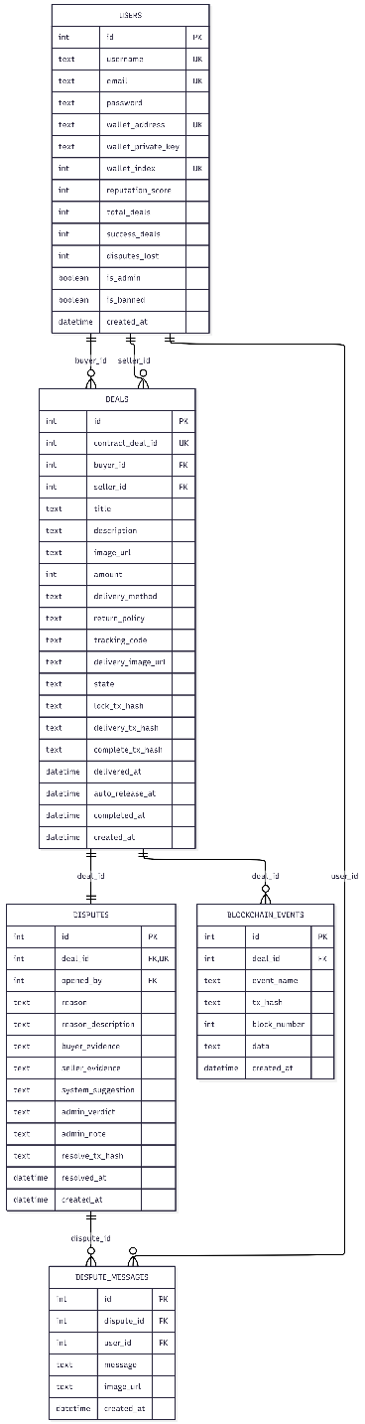
The relationships between the tables are as follows:
Figure 1: The ERD relationships between the tables

2.5. Backend API design

2.5.1. REST architecture and authentication
The backend utilizes a RESTful architecture with the base URL /api, divided into five route groups: auth (registration, login, profile), wallet (balance, faucet, history), deals (CRUD and lifecycle actions), disputes (open, resolve, chat), admin (statistics, user management). All routes except /auth/login and /auth/register require a JWT token in the Authorization: Bearer header. Middleware chain: authMiddleware verifies the JWT → loads the user from SQLite → checks is_banned → attaches req.user. Admin routes add an adminMiddleware to check req.user.is_admin.

2.5.2. Processing flow of the deals API group
POST /api/deals creates a new deal: the backend receives form data (including product images via Multer), searches for the seller in SQLite by wallet_address, calls createDeal() on-chain with the buyer's signer, parses the DealCreated event from the receipt to retrieve the contractDealId, saves the deal into SQLite along with the contract_deal_id, records the blockchain_event, and updates total_deals for both the buyer and the seller.
POST /api/deals/:id/lock is the most complex endpoint because it must execute two sequential blockchain transactions. First, the backend calls vndToken.approve(escrowAddress, amount) for the buyer to authorize EscrowManager to withdraw tokens. Subsequently, it calls escrow.lockFunds(dealId) for EscrowManager to actually withdraw the tokens from the buyer's wallet to address(this). The two transactions cannot be merged into one because approve and transferFrom are two functions on two different contracts (VNDToken and EscrowManager) the ERC-20 standard mandates the approve step beforehand. The backend utilizes explicit nonce management (currentNonce and currentNonce + 1) to ensure the precise execution order and prevent race conditions.
GET /api/deals/:id returns a merged response: the backend queries SQLite to retrieve metadata, calls escrow.getDeal(contractDealId) on-chain to fetch the real-time state, queries blockchain_events and disputes, and then returns a unified object {deal, onChainDeal, events, dispute} the frontend only needs to process a single response.

2.5.3. Dispute processing flow and three-way chat
When the buyer calls POST /api/disputes with dealId, reason, description, and optional evidence images, the backend executes a sequence of actions: verifies that the deal is in the DELIVERED state and within the 48-hour window, calculates the 5% deposit amount (deal.amount × 0.05), calls approve + openDispute on-chain (similar to the approve-then-action flow of lockFunds), creates a dispute record in SQLite with the system_suggestion automatically calculated based on the reason and return_policy, updates the deal state to DISPUTED, and records the blockchain_event.
The three-way chat system operates via two APIs: GET /api/disputes/:id/messages returns all messages in chronological order, with each message accompanied by a role identifier (buyer/seller/admin) determined by comparing the user_id with the buyer_id and seller_id of the deal; POST /api/disputes/:id/messages receives the message text and/or image file, saving it into dispute_messages. Messages are stored in SQLite not on-chain because chat content does not require blockchain immutability and gas costs would be excessively high. The DisputePage renders the entire conversation with color and position differentiation based on role.
The admin delivers a verdict via POST /api/disputes/:id/resolve with the verdict (seller or buyer) and adminNote. The backend maps the verdict string to an enum (seller→0, buyer→1), calls resolveDispute(dealId, verdictEnum) on-chain using the admin signer, and updates the dispute and deal st

2.5.4. TimerService cron job auto-release
Smart contracts lack an endogenous timer the EVM only executes code when a transaction is submitted, and cannot self-activate based on time. This is a fundamental architectural limitation of all blockchains. TrustDeal resolves this via an external trigger: a node-cron job runs every 5 minutes, queries SQLite to find deals with state = 'DELIVERED' and auto_release_at <= datetime('now'), and then calls autoRelease(contractDealId) on-chain for each deal.
The autoRelease() function in the contract does not have the onlyOwner modifier this is an intentional design. Anyone calling this function is accepted, as long as block.timestamp >= autoReleaseTime. The time condition is the only necessary protection layer: if 48 hours have not elapsed, the require statement will revert; if they have, anyone can call it because the outcome is the same the funds go to the seller. The timer service features error handling for each individual deal (a try-catch block inside the loop) if the auto-release of one deal fails, the service continues processing the other deals instead of crashing entirely.

2.6. User interface design

2.6.1. Navigation flow
The frontend utilizes React Router v6 with a ProtectedRoute component that checks for a token in localStorage. Unauthenticated users are redirected to /login. The Navbar displays the main navigation (Dashboard, Wallet, Create Deal), and the Admin link is only visible when user.is_admin = true. Routing: / → DashboardPage, /wallet → WalletPage, /deals/new → NewDealPage, /deals/:id → DealDetailPage, /disputes/:id → DisputePage, /admin → AdminPage.

2.6.2. DealDetailPage
DealDetailPage is the most complex and critical page, integrating five main components. The DealStatusBar visualizes the current position in the deal lifecycle through five steps (Created → Accepted → Funded → Delivered → Completed), with the current step highlighted using color and a glow animation; when the deal is in the DISPUTED state, the "Delivered" step turns red, accompanied by a warning icon and a pulse animation.
The Blockchain Info Card demonstrates on-chain transparency displaying the Contract Deal ID, Lock TX hash (primary blue), Complete TX hash (emerald green), and a "Protected by Blockchain" badge. This is the most crucial component in terms of transparency: it proves that every financial action possesses on-chain evidence that can be independently verified.
The CountdownTimer counts down the 48 hours using setInterval every second, changing color from amber to red when less than 1 hour remains (isUrgent = remaining < 3600), and displaying the message "Time's up Auto-release" when the countdown reaches 0. The Action Panel utilizes conditional rendering according to a role × state matrix: the buyer sees the "Lock funds" button when the deal is ACCEPTED, and the "Received" and "Open dispute" buttons when DELIVERED; the seller sees the "Accept/Reject" buttons when CREATED, and the form to enter the tracking code when FUNDED.
The on-chain Timeline displays all blockchain events in chronological order with visual connections (vertical lines connecting the nodes), with each event accompanied by its name, timestamp, and abbreviated tx_hash.

2.6.3. DisputePage: Three-way chat
The DisputePage consists of three main sections: the deal summary (value, dispute reason, system suggestion), two evidence columns (buyer evidence and seller evidence with an image grid), and the chat frame. The chat interface is similar to familiar messaging applications: one's own messages appear on the right with a primary color background, while the other party's messages appear on the left with a dark background. The three types of messages are distinguished by label colors: buyer (emerald), seller (blue), admin (amber). Each message can include an attached image via the button. The admin's verdict section (two buttons: Buyer wins / Seller wins, a reason textarea, a confirmation button) is only displayed when user.is_admin = true and the dispute does not yet have a verdict.

2.6.4. WalletPage
The WalletPage displays the VNDToken balance read directly from the on-chain balanceOf() function, the wallet address with a copy button, network information (Hardhat Local, Chain ID 31337), a Faucet button to receive 1 million VND (limited to once per day), and the escrow transaction history from blockchain_events. A prominent warning banner reminds users that this is a simulated token with no real-world value there is no deposit/withdrawal form as it is a demo token.

CHAPTER 3: SYSTEM DEPLOYMENT

3.1. Smart Contract Deployment
The Hardhat configuration is established in hardhat.config.js with parameters serving the demo environment. ChainId 31337 is the default value of the Hardhat network, distinct from the mainnet (1) or Sepolia testnet (11155111) the frontend and backend applications utilize this chainId to confirm they are connecting to the correct network. The auto-mining interval is set to 0, meaning each transaction is mined instantaneously instead of waiting for the 12-second block cycle like the mainnet suitable for a demo as users do not have to wait, but significantly different from real network conditions where transactions can take from a few seconds to several minutes. Each of the 20 Hardhat accounts is allocated 10,000 ETH (initialBalance: "10000000000000000000000") as gas fees a large figure ensuring gas is never depleted during the demo process.
The deployment process in deploy.js adheres to a mandatory, irreversible order. The first step deploys VNDToken this contract is independent and does not rely on any other contract. The second step deploys EscrowManager with the constructor parameter being the address of the recently deployed VNDToken this is on-chain dependency injection, as EscrowManager needs to know the token address to call safeTransferFrom. If the order were reversed, EscrowManager would lack the VNDToken address to pass into the constructor. The third step saves the ABI and addresses of both contracts into JSON files (blockchain/deployments/localhost.json and backend/src/config/contracts.json) the backend loads this file upon startup to create Contract instances.
The script displays three demo accounts (Account 0 = Admin, Account 1 = Buyer, Account 2 = Seller) but does not mint tokens the minting is executed by the backend upon startup, checking the balance beforehand to avoid duplicate minting.

3.2. Backend Deployment
When server.js launches, the system executes five sequential steps:
- Step 1: getHardhatAccounts() generates 20 accounts from a static mnemonic ("test test test...junk") via ethers.HDNodeWallet.fromMnemonic, then initDB(accounts) runs schema.sql to create 5 tables and seed 3 demo accounts with bcrypt hashed passwords.
- Step 2: initBlockchain() creates a JsonRpcProvider connecting to (http://127.0.0.1:8545), loads contracts.json, and creates Contract instances for VNDToken and EscrowManager.
- Step 3: mintForDemoUsers() checks the on-chain balance of each user if it equals 0, it calls mintInitial() via the admin signer.
- Step 4: startTimerService() registers the cron job.
- Step 5: app.listen(5000). This sequence is critical if routes are registered before the database is ready, the first request to the endpoint will crash due to missing tables.
The timer service is the most crucial background service. Every 5 minutes, it executes an SQL query: `SELECT deals WHERE state = 'DELIVERED' AND auto_release_at <= datetime('now')` combined with a JOIN on users to retrieve the admin's private key. For each overdue deal, the service calls escrow.connect(adminSigner).autoRelease(contractDealId), awaits the receipt, and then updates SQLite (state → COMPLETED, complete_tx_hash, completed_at, and success_deals for both buyer and seller). Error handling is designed following the isolation principle: a try-catch block inside the for loop ensures that if the auto-release of one deal fails (for instance, the contract reverts because the state has changed), the service continues processing the other deals and logs the error instead of crashing the entire process.
The dispute route processing flow comprises two parts: dispute management and the chat system. When POST /disputes is called, the backend saves the evidence images via Multer (maximum 5 files, 10MB limit per file, accepting only jpeg/jpg/png/webp/mp4), and calculates the system_suggestion based on the following rules: if reason = NOT_RECEIVED and a tracking code exists, it suggests seller wins (the seller has provided the tracking code); if reason = CHANGED_MIND and policy = no_return, it suggests seller wins (the buyer changed their mind, but the deal does not support returns). The chat API GET /disputes/:id/messages returns the entire conversation in chronological order, with each message accompanied by a role identifier the frontend renders the buyer's messages on the left (emerald), the seller's on the right (blue), and the admin's in the center (amber).

3.3. Frontend Deployment
The React frontend utilizes Vite as the build tool with a proxy configuration to forward /api requests to backend port 5000. The authentication mechanism utilizes localStorage to store the JWT token and user object an axios interceptor automatically attaches the token to every request, and redirects to /login upon receiving a 401 response.
DealDetailPage does not utilize periodic polling instead, it fetches data once upon mounting (useEffect with dependency [id]) and re-fetches after each successful action via the fetchDeal() callback. When the seller accepts a deal in another tab, the buyer needs to refresh the page to see the "Lock funds" button appear this is a trade-off between simplicity (suitable for a demo) and real-time capability (requiring WebSockets, which is more complex). The backend has pre-merged the metadata from SQLite and the on-chain state before returning it (in GET /deals/:id, the backend calls escrow.getDeal() on-chain and then combines it with data from SQLite), so the frontend only needs to process a single response object this design is superior to the frontend directly calling both the API and the blockchain, as it reduces the number of requests and avoids requiring the user to have a provider/signer on the client side.
The DisputePage implements the chat by fetching messages upon mounting, and calls fetchMessages() to update the list after each successful message transmission. New messages are appended by re-fetching the entire conversation rather than appending to the local state ensuring the precise chronological order from the server. The three types of messages are distinguished in the UI: one's own messages (isMe = userId === user.id) appear on the right with a primary 600 background and rounded corners except for the bottom right, the other party's messages appear on the left with a dark background and border, and the role label above each message uses different colors depending on the role.

CHAPTER 4: TESTING AND EVALUATION

4.1. Smart Contract Testing
Unit testing for smart contracts is of particular importance compared to traditional software: a deployed contract cannot be patched, and a bug in the financial logic can lead to permanent loss of funds without a rollback mechanism. TrustDeal utilizes the Hardhat test framework integrated with Mocha/Chai, alongside the time.increase() helper function of the Hardhat Network which allows accelerating block time an essential feature when testing the 48-hour auto-release mechanism without waiting for real time.
The Happy Path test suite verifies the complete transaction flow: createDeal → acceptDeal → approve + lockFunds → confirmDelivery → confirmReceived. The verification results: state transitions occur in the correct order (CREATED → ACCEPTED → FUNDED → DELIVERED → COMPLETED), the buyer's balance decreases by the exact amount after lockFunds, the seller's balance increases by the exact amount after confirmReceived, and each step emits the correct event with the correct arguments (dealId, addresses, amounts). Specifically, the test confirms that the balance of the EscrowManager contract increases by the exact amount after lockFunds and returns to 0 after confirmReceived proving that the funds actually pass through the contract rather than being transferred directly.
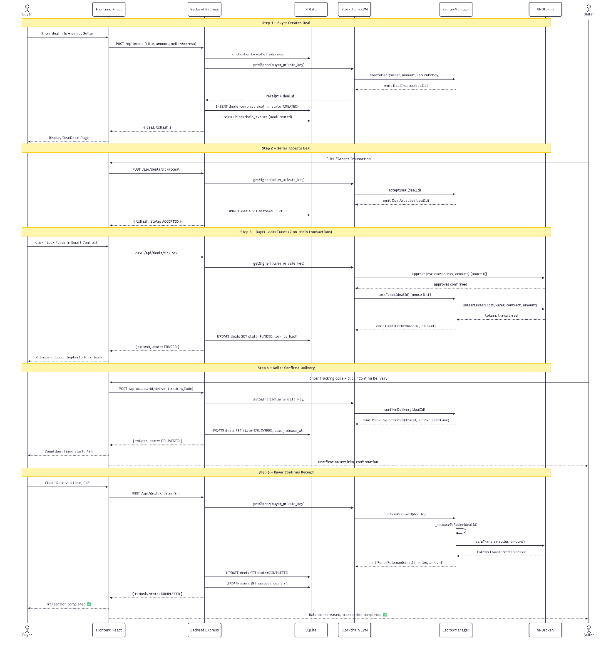
Figure 2: The Sequence Diagram of Happy Path
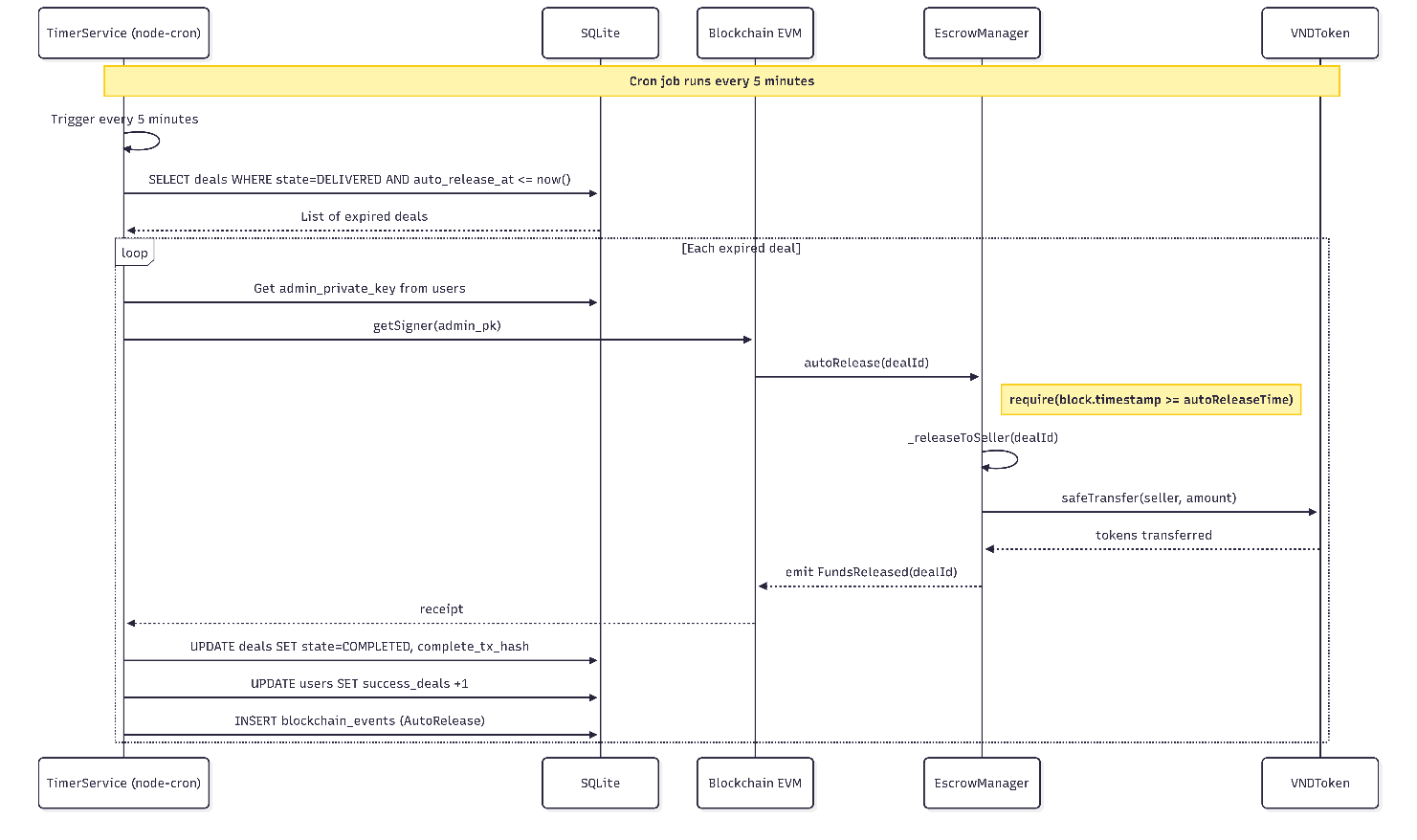
The Auto-release test suite examines the automated disbursement mechanism. After the seller executes confirmDelivery, the test calls time.increase(48 * 3600) to advance the block time by 48 hours, and then calls autoRelease() the result: the state transitions to COMPLETED, and the seller receives the exact amount. The test also verifies the counter-case: if autoRelease() is called before 48 hours (time.increase(47 * 3600)), the contract reverts with the message "48h not elapsed" this is a critical protective behavior preventing premature disbursement. Hardhat's time.increase() mechanism allows testing the entire time logic without waiting for a real 48 hours, illustrating the value of a local development network.
Figure 2: The Sequence Diagram of Auto-release
The Dispute test suite evaluates two verdicts. With Seller Wins (verdict = 0): after the buyer executes openDispute (locking an additional 5% deposit), the admin calls resolveDispute(dealId, 0) the seller receives the amount + disputeDeposit, and the buyer receives nothing. With Buyer Wins (verdict = 1): the admin calls resolveDispute(dealId, 1) the buyer receives the amount + disputeDeposit (refunding both the principal and the deposit). The test confirms that the final balances of both parties are accurate down to the wei, and the DisputeResolved event emits the correct verdict string ("seller_wins" or "buyer_wins").

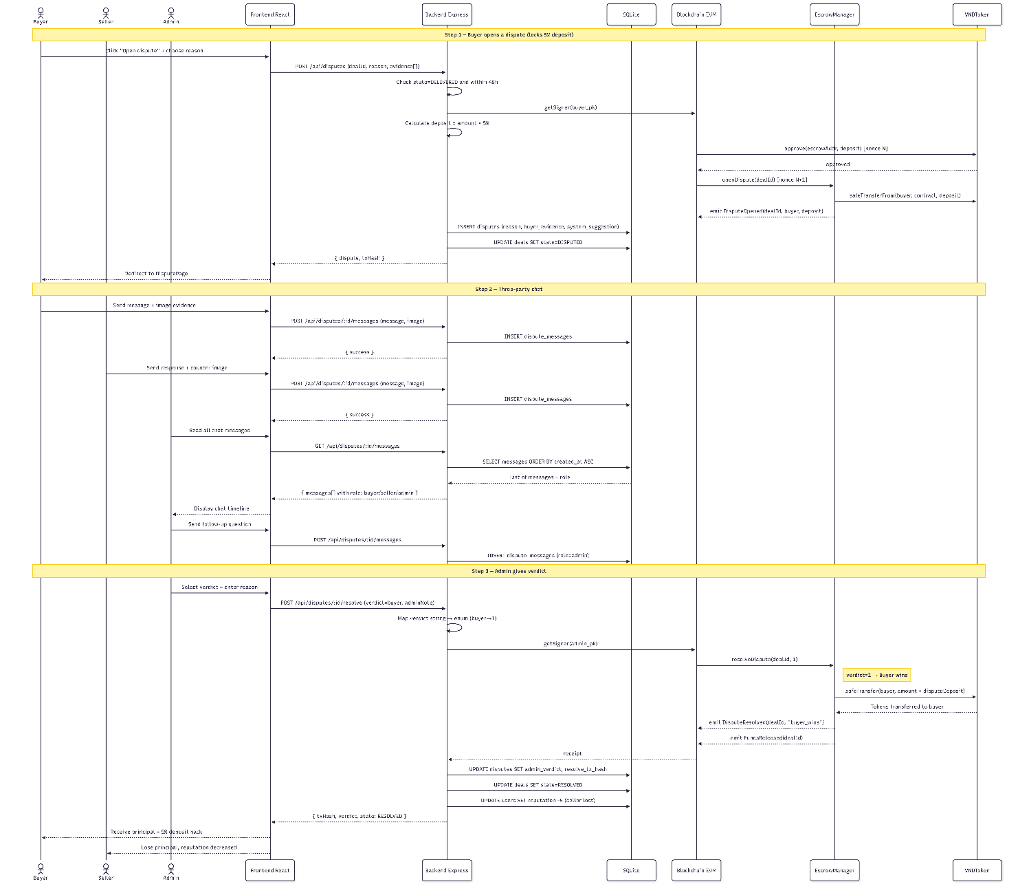
Figure 3: The Sequence Diagram of Dispute
The Security test suite verifies critical revert cases: the buyer cannot call acceptDeal (only the seller), the seller cannot call lockFunds (only the buyer), no one can call lockFunds when the deal is in CREATED (it must be ACCEPTED first), the buyer cannot execute openDispute outside the 48-hour window, non-owners cannot call resolveDispute, and lockFunds reverts if sufficient allowance has not been approved. Each test case also confirms the specific error message for example, "Only buyer", "Invalid state", "48h window expired" ensuring that it not only reverts, but reverts for the correct reason.

4.2. Testing three main demo scenarios

4.2.1. The Happy Path scenario
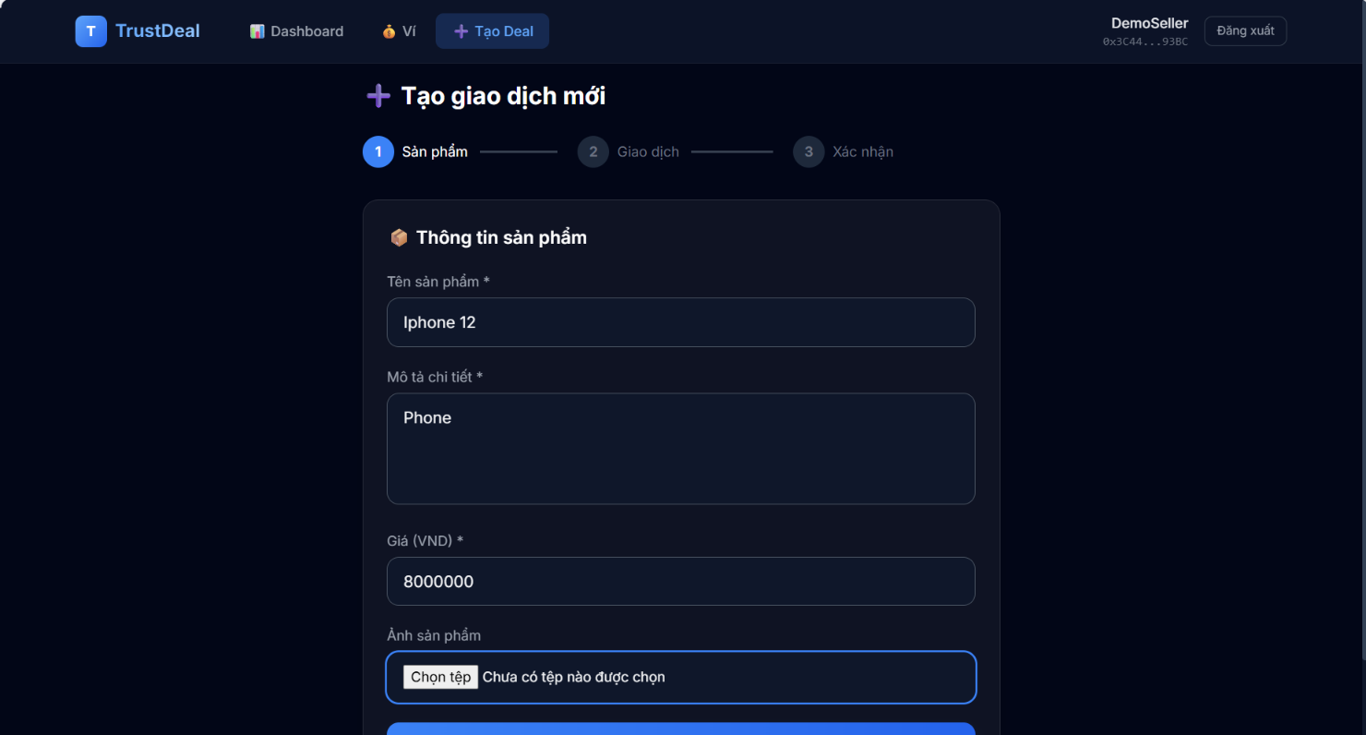
Testing is conducted using two browser tabs: one logged in as buyer@demo.vn, and the other as seller@demo.vn. The buyer creates a deal titled "iPhone 12 Pro Max" with a price of 8,000,000 VND, selecting the seller via their wallet address. Upon submission, the DealDetailPage displays the DealStatusBar at step 1 (Created), the Blockchain Info Card displays the contract_deal_id, and the Timeline records the DealCreated event along with its tx_hash.
Figure 4: The dashboard of new trancsaction
The seller refreshes their tab, sees the new deal on the Dashboard, navigates to the details, and clicks "Accept". The buyer refreshes their tab, sees the "Lock 8,000,000 VND into Smart Contract" button appear, and clicks lock the wallet balance decreases by exactly 8 million, the Blockchain Info Card displays the lock_tx_hash, and the Timeline appends the FundsLocked event. The seller clicks "Confirm delivery" with the tracking code GHN123456789 the CountdownTimer begins counting down from 48:00:00, and the Timeline appends the DeliveryConfirmed event. The buyer clicks "Received, OK" the state transitions to COMPLETED, the seller's balance increases by 8 million, and the Timeline displays all 5 events (DealCreated → DealAccepted → FundsLocked → DeliveryConfirmed → FundsReleased), with each event accompanied by a verifiable tx_hash.

4.2.2. The Auto-release scenario
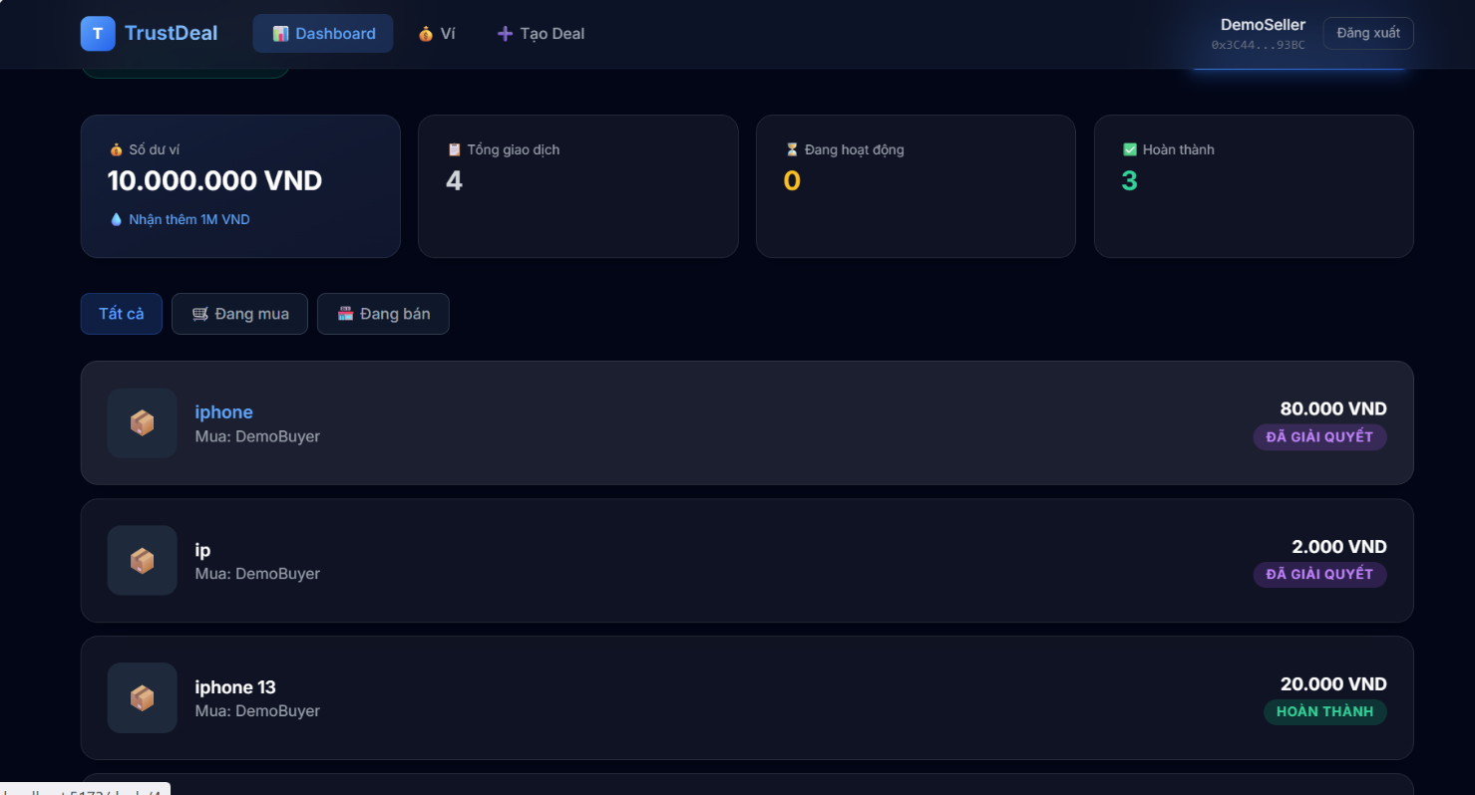
For rapid testing, the AUTO_RELEASE_DELAY in the contract can be reduced to 2 minutes prior to the demo deployment. The buyer locks the funds, the seller confirms delivery, and the countdown begins. The buyer takes no action. After 2 minutes, the cron job triggers the seller refreshes to see the state transition to COMPLETED and their balance increase. The on-chain Timeline records the AutoRelease event with a different tx_hash compared to the Happy Path scenario (since the transaction is submitted by the admin signer instead of the buyer signer). Verification result: the auto-release mechanism protects the seller from scenarios where the buyer intentionally remains silent.
Figure 5: The dasboard of completed transaction

4.3.3. The Dispute scenario
This is the most distinctive scenario of the system. The buyer opens a dispute with the reason "Item not as described" the buyer's balance decreases by an additional 5% (a 400,000 VND deposit), the state transitions to DISPUTED, and the "Delivery" step on the DealStatusBar turns red, accompanied by a ⚠ icon and a pulse animation. The system automatically navigates to the DisputePage featuring the three-way chat session.
The buyer sends the message "The item is heavily scratched, not matching the '99% like new' description" along with a photo of the damaged product. The seller responds "The item was delivered in the correct condition, here is the photo taken before shipping" along with a photo of the product prior to packaging. The admin logs into a third tab, accesses the Admin Panel, sees a red "1" badge on the Disputes tab, clicks on the dispute, reads the entire conversation, and reviews the evidence from both sides.
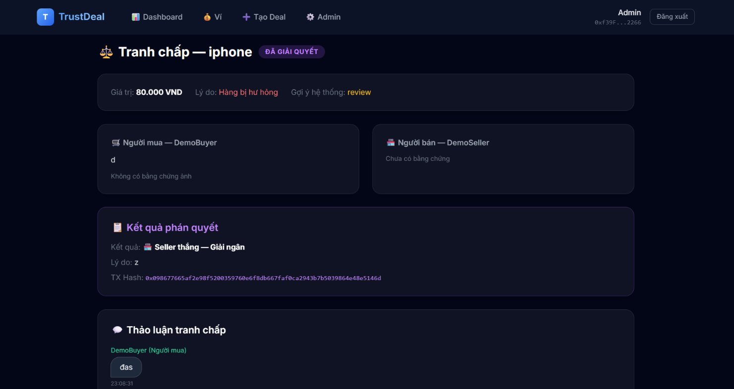
The admin selects the "Buyer wins" verdict with the reason "The photo proves the product has scratches not mentioned in the description", and clicks "Confirm verdict" the contract executes resolveDispute() immediately: the buyer receives back the 8,000,000 VND principal + the 400,000 VND deposit = 8,400,000 VND. The on-chain Timeline records DisputeResolved along with its tx_hash. The distinction compared to traditional escrow platforms: the verdict is executed by the contract code instantaneously, requiring no administrative processing or waiting for the losing party to transfer the funds.
Figure 6: Admin interface for completed dispute resolution

4.3. Comparative assessment
Criteria | Bank Transfer | E-wallet | E-commerce Platform | TrustDeal
Third-party trust requirement | No protection | No protection | Trust the platform | Trust the code (trustless)
Buyer protection | No | No | Yes (return/refund) | Yes (escrow + dispute)
Seller protection | No | No | Limited | Yes (48h auto-release)
Dispute mechanism | No | No | Internal to platform | 3-way chat + on-chain
Transparency | Bank statement | Wallet history | Internal to platform | On-chain audit trail
Off-platform P2P application | Yes | Yes | No | Yes
TrustDeal fills exactly the gap left open by current solutions: off-platform P2P transactions require protection for both parties without relying on an intermediary organization. Bank transfers and e-wallets merely transfer funds without holding them conditionally; e-commerce platforms feature internal escrow but only apply it to on-platform transactions, failing to serve P2P transactions outside their ecosystem.
However, TrustDeal still falls behind traditional solutions in certain aspects. The user experience is more complex compared to a simple transfer the buyer must understand the concepts of "locking funds into the contract" and the "48-hour window". The dispute mechanism still relies on a centralized admin, not yet achieving complete trustlessness. Furthermore, the mock VND token is disconnected from the real financial system, restricting its practical applicability in the current phase.

4.4. Evaluating the four blockchain characteristics within the system
Immutability manifests at multiple levels within TrustDeal. At the smart contract level, not a single function in EscrowManager permits state rollback once a deal transitions to COMPLETED or RESOLVED, it is the permanent final state; there is no setState() or updateDeal() function to revert it. At the database level, the blockchain_events table is strictly INSERT, with no UPDATE or DELETE operations every on-chain event is recorded and preserved. At the transaction level, each state transition generates a unique transaction hash permanently stored on the blockchain even if the SQLite database is deleted, the on-chain history persists and can be restored.
Transparency is demonstrated through the Blockchain Info Card in the DealDetailPage users can view the contract_deal_id, lock_tx_hash, delivery_tx_hash, and complete_tx_hash without requiring admin privileges or special permissions. The on-chain Timeline displays all events accompanied by the tx_hash for each occurrence. Anyone possessing the tx_hash can verify the transaction on a blockchain explorer this is unfeasible in centralized systems where the transaction history is controlled by administrators.
Decentralization is partially exhibited in TrustDeal. The financial logic (holding funds, transferring funds, enforcing conditions) runs on the EVM no one can modify it post-deployment. The funds are locked within the contract's address(this) no one holds the private key for this address. However, the system is not entirely decentralized: the admin remains a centralized point in dispute resolution, the backend is a single point of failure for off-chain metadata, and the Hardhat local network possesses only a single node.
Security is ensured across multiple layers. The modifiers onlyBuyer, onlySeller, and onlyOwner control access privileges to each function. ReentrancyGuard prevents reentrancy attacks on all token transfer functions. SafeERC20 handles non-standard token behavior. The Checks-Effects-Interactions pattern in _releaseToSeller() prevents exploits. The 24-hour cooldown for the faucet is enforced on-chain utilizing block.timestamp, independent of the backend.

CHAPTER 5: LIMITATIONS AND FUTURE DEVELOPMENT

5.1. Limitations
Private keys stored in the database. This is the most critical issue of the current demo version. The backend stores the wallet_private_key of each user in the users table of SQLite an unencrypted database file located on the filesystem. This design exists for demonstration purposes: it allows the backend to sign transactions on behalf of the user without requiring them to know about MetaMask or manage a wallet. However, in production, this is an unacceptable security vulnerability a database breach (via SQL injection, server compromise, or insecure backups) would lead to the exposure of all users' private keys, allowing an attacker to drain all tokens from every wallet. The solution is to transition to a client-side signing model: users connect a MetaMask or WalletConnect wallet, sign transactions directly on their devices, and the private key never leaves the browser. Additionally, Account Abstraction according to EIP-4337 [13] enables the abstraction of user wallets, supporting social login and recovery without sacrificing security.
Mock token and lack of a real deposit/withdrawal flow. VNDToken is an ERC-20 token with no real-world value anyone can claim it for free via the faucet. In production, the system requires a complete flow: users deposit real VND through a payment gateway (VNPay, MoMo) → the system mints an equivalent amount of VNDToken → the escrow operates normally → upon withdrawal, the system burns the tokens and transfers the real VND back to the bank account. This flow demands an intermediary payment service provider license from the State Bank of Vietnam according to Decree 52/2024/ND-CP [14], and requires the integration of a Chainlink Price Oracle [15] if a stablecoin is used instead of a mock token both of which are significant legal and technical barriers.
Centralized admin in dispute resolution. The system claims to aim for a trustless escrow, but the dispute resolution mechanism still completely relies on a single admin. The admin possesses the authority to issue the final verdict, and the contract executes it immediately there is no appeal or cross-checking mechanism. The admin could adjudicate with bias (moral hazard), or the admin account could be compromised, leading to an attacker deciding all disputes. The Kleros Protocol [10] proposes an alternative model: a jury panel randomly selected from a pool of token holders, where each juror stakes tokens to participate, and the verdict is based on the Schelling Point mechanism (minority votes lose their stake, majority votes receive rewards) this model minimizes moral hazard and the single point of failure.
Lack of KYC/identity verification. The current system does not verify user identities. A banned account can register a new account with a different email and continue operating. Especially in a P2P context where disputes may involve legal matters, the absence of KYC renders the system unable to provide information to authorities when necessary. The solution is to integrate authentication via VNeID (the national digital identity application), or to implement Decentralized Identity (DID) according to the W3C standard [16], allowing users to manage their digital identities themselves while remaining verifiable when required.
Smart contract is unaudited. Although EscrowManager implements sound security patterns (ReentrancyGuard, SafeERC20, Checks-Effects-Interactions) and passes all unit tests, logical vulnerabilities undetected by unit tests may still exist for instance, edge cases in calculating the disputeDeposit with very small amounts (rounding errors), or interaction effects between multiple simultaneous deals. Prior to production deployment, the contract must undergo an audit by a professional organization such as CertiK, Hacken, or Trail of Bits [17] audit costs typically range from 10,000 to 50,000 USD, but it is an unavoidable requirement for a financial management system.
The Hardhat local network differs from real network conditions. An auto-mining interval = 0 means transactions are confirmed instantaneously, whereas the Ethereum mainnet requires 12 seconds per block, and transactions can be pending due to low gas prices. Gas fees on the local network equal 0 real ETH, but on the mainnet, they can cost 5-50 USD per transaction (depending on network congestion). Mempool congestion, MEV (Miner Extractable Value), and reorg risk all of these do not exist on Hardhat local but significantly impact the UX on the real network.

5.2. Future roadmap
Short-term (3-6 months): Priority is given to the two most urgent issues. First, transition to client-side signing via MetaMask integration entirely eliminating the storage of private keys in the database, allowing users to sign transactions directly on their devices. Second, deploy to the Sepolia testnet to test under near-realistic conditions (12s block time, gas fees, multiple nodes) the contract logic does not require modifications, only the network configuration in Hardhat config and the RPC URL in the backend need updating. Simultaneously, implement WebSockets instead of polling to improve real-time UX when multiple users interact concurrently.
Medium-term (6-12 months): Integrate VNPay/MoMo payment gateways for a real VND deposit/withdrawal flow, which requires an intermediary payment service provider license. Implement basic KYC through VNeID or an eKYC provider. Transition from a centralized admin to a multi-sig wallet (2-of-3) for dispute resolution requiring consensus from at least two out of three admins, thereby reducing the single point of failure risk. Upgrade the database from SQLite to PostgreSQL for production workloads.
Long-term (12-24 months): Research and integrate a decentralized dispute resolution mechanism based on the Kleros model a decentralized jury system replacing the administrator. Implement Account Abstraction (EIP-4337) to enable users to log in via email/social accounts while maintaining an on-chain wallet. Deploy to Layer 2 networks (Arbitrum, Optimism, or zkSync) to reduce gas fees to below 0.01 USD per transaction a prerequisite for low-value P2P transactions. Establish an on-chain reputation system utilizing non-transferable Soulbound Tokens (SBT).

CHAPTER 6: CONCLUSION
The thesis originates from a real-world issue within the P2P second-hand transaction market in Vietnam: in off-platform transactions, no mechanism exists to protect both parties after one side has fulfilled their obligation. Current payment tools bank transfers and e-wallets merely transfer funds without holding them conditionally. TrustDeal proposes an alternative approach: utilizing Ethereum smart contracts as automated escrow agents, where funds are held by public code rather than by an individual, and the disbursement logic is executed without possibility of interference.
The system has demonstrated the technical feasibility of the trustless escrow model across three aspects. First, the EscrowManager smart contract operates as a deterministic state machine funds locked within address(this) can only leave through three hardcoded paths (buyer confirmation, 48h auto-release, admin resolution); even the deployer cannot withdraw the funds, proving that on-chain escrow eliminates the risk of misappropriation by a third party. Second, the 5% dispute deposit economic mechanism creates an effective deterrent the buyer must "deposit" funds when opening a dispute and loses the deposit if defeated, preventing unfounded complaints. Third, the on-chain audit trail where each state transition generates an immutable and independently verifiable transaction hash provides a level of transparency that no centralized system can achieve.
However, the gap between the demo version and a production product remains substantial. Private keys stored in the database represent an unacceptable security vulnerability. The mock token is disconnected from the real financial system. The centralized admin in dispute resolution creates a paradox: the system claims to be trustless, yet disputes still rely on humans. Furthermore, the smart contract has not undergone a professional audit a mandatory requirement prior to any deployment involving real money.
The outlook of this research direction is closely linked to two ongoing trends. The P2P second-hand transaction market in Vietnam continues to grow alongside the popularity of social networks and online trading groups, generating an increasing demand for transaction protection solutions. Concurrently, the regulatory framework regarding digital assets and electronic payments is gradually maturing once a clear legal corridor is established, the on-chain escrow model can transition from an academic demo into a practical product serving millions of P2P transactions daily.

REFERENCES
[1] Vietnam E-commerce Association (VECOM), "Vietnam E-commerce Index Report 2023," Hanoi, 2023. [Online]. Available: https://vecom.vn
[2] S. Nakamoto, "Bitcoin: A Peer-to-Peer Electronic Cash System," 2008. [Online]. Available: https://bitcoin.org/bitcoin.pdf
[3] A. Narayanan, J. Bonneau, E. Felten, A. Miller, and S. Goldfeder, *Bitcoin and Cryptocurrency Technologies: A Comprehensive Introduction*. Princeton University Press, 2016.
[4] V. Buterin, "Ethereum: A Next-Generation Smart Contract and Decentralized Application Platform," 2014. [Online]. Available: https://ethereum.org/en/whitepaper/
[5] N. Szabo, "Smart Contracts," 1994. [Online]. Available: https://www.fon.hum.uva.nl/rob/Courses/InformationInSpeech/CDROM/Literature/LOTwinterschool2006/szabo.best.vwh.net/smart.contracts.html
[6] G. Wood, "Ethereum: A Secure Decentralised Generalised Transaction Ledger," Ethereum Yellow Paper, 2014. [Online]. Available: https://ethereum.github.io/yellowpaper/paper.pdf
[7] F. Vogelsteller and V. Buterin, "EIP-20: Token Standard," Ethereum Improvement Proposals, 2015. [Online]. Available: https://eips.ethereum.org/EIPS/eip-20
[8] Investopedia, "Escrow: Definition, How It Works, Types, and Uses." [Online]. Available: https://www.investopedia.com/terms/e/escrow.asp
[9] M. Bartoletti and L. Pompianu, "An empirical analysis of smart contracts: platforms, applications, and design patterns," in *Financial Cryptography and Data Security*, Springer, 2017, pp. 494–509.
[10] F. Ast and C. Lesaege, "Kleros: A Decentralized Justice Protocol," Kleros Whitepaper, 2019. [Online]. Available: https://kleros.io/whitepaper.pdf
[11] R. Moore, "ethers.js Documentation v6," 2023. [Online]. Available: https://docs.ethers.org/v6/
[12] Nomic Foundation, "Hardhat Documentation," 2023. [Online]. Available: https://hardhat.org/docs
[13] V. Buterin, Y. Resnick, et al., "EIP-4337: Account Abstraction Using Alt Mempool," Ethereum Improvement Proposals, 2021. [Online]. Available: https://eips.ethereum.org/EIPS/eip-4337
[14] Chính phủ Việt Nam, "Nghị định 52/2024/NĐ-CP quy định về thanh toán không dùng tiền mặt," 2024.
[15] Chainlink Labs, "Chainlink Data Feeds Documentation." [Online]. Available: https://docs.chain.link/data-feeds
[16] W3C, "Decentralized Identifiers (DIDs) v1.0," W3C Recommendation, 2022. [Online]. Available: https://www.w3.org/TR/did-core/
[17] CertiK, "Smart Contract Auditing." [Online]. Available: https://www.certik.com/products/security-audit

