* | - ติดอะไรก็ Raise
 | [User HyDE Pipeline] Unit Test and testing the user HyDe pipeline | - ???
 | [User HyDE Pipeline] Deploying the user HyDE pipeline endpoints | - Is it done?
 | [OnlineServingPipeline] Develop Engine for retrieving user HyDE vectors, based on user_id
 | [OnlineServingPipeline] Develop Engine for getting and ranking candidate items from vector DB (Consine + BM25)
 | [OnlineServingPipeline] Develop Engine for removing list of items from the lists (i.e. Seen, Completed, etc)
 | [OnlineServingPipeline] Unit Test and testing the online serving pipeline
 | [OnlineServingPipeline] Documents the HyDE pipeline endpoints and refactoring
 | [OnlineServingPipeline] Documents the HyDE pipeline endpoints and refactoring
 | [HyDE Orchestration Pipeline] Documents the HyDE Orchestration Pipeline + API spec + refactoring
New | 1.1 [Online Serving] User state loader (JSON from lake + optional Redis Cache if needed to be faster)  - Owner: Tun  - MD: 2.0  Output: UserState object including user HyDe Vectors, and JSON with the user's state and info (i.e., skills list, user onboarding type, user personality, seen items list, etc.). This is an expansion of the user pipeline; instead of just returning user HyDe Vectors, the API should return the state JSON file too. This development includes the storage of the new user state JSON file when creating user HyDe vectors. | - ดึง สิ่งที่เก็บอยู่ใน Cloud Storage ออกมา  - สร้าง Function ที่ใช้ในการดึงที่มันมีความ Flexible สามารถดึงได้ทั้งแบบ Feeds และ Course
New | 1.2 [Online Serving] HyDE vector loader + cache policy  - Owner: Tun  - MD: 1.0  Must include: “cache miss → soft fail + trigger refresh event (async)” | - ทำ cacha กล้องส้ม  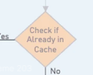
New | 1.3 [Online Serving] Deterministic filters module (seen/completed/expired/company blacklist)  - Owner: Shin (shared module), Tun consult for the JSON file containing user-state shape  - MD: 1.0  Output: The output vectors should come with their metadata too, to later be used in sub-score calculation and reranking | shin
New | 1.4 [Online Serving] Pluggable scoring interface (no scoring yet, just interface)  - Owner: Tun  - MD: 0.5  Deliverable: Scorer protocol like score(user_state, candidates) -> scored_candidates. This is a template scorer that defines how later score input and output will be. | Subscore
New | 1.5 [Online Serving] Develop simple sub-score with the coring interface  - Owner: Tun  - MD: 0.5  Deliverable: Popularity & Recency sub-score calculation engine. | Develop simple subsore for prove score + weight system
New | 1.6 [Online Serving] Rank + post-processing (tie-breakers, diversity not included yet)  - Owner: Tun  MD: 0.5 | Rank เอา score เยอะสุดขึ้นก่อน  Post processing เอาสิ่งที่ user เคยเห็นแล้วออกไป  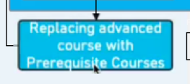  โดยดึงเอาข้อมูลจากกล่องส้ม
New | 1.7 [Online Serving] Develop a module to store a user’s recommendation list in Redis with a timestamp.  - Owner: Shin  - MD: 0.5  Deliverable: Cache storage of user’s recommendation list
New | 1.8 [Online Serving] Develop a module to retire old an user’s recommendation list in user Redis  - Owner: Shin  MD: 0.5
New | 1.9 [Online Serving] Online serving orchestrator core feature  - Owner: Shin  - MD: 1.0  - Triggers: API request  - Runs: deterministic Check user Redis → retrieval → scoring → cache write  Emits: request logs, latency metrics, cache hit rate, soft-fail rate
New | 2.0 [Online Serving] Online serving orchestrator logging  - Owner: Shin  - MD: 1.0  Output: Log state and time of users API, items API, vector search API, and own functions.
New | 2.1 [Online Serving] Deploy endpoints  - Owner: Shin  MD: 0.5
New | 2.2 [Online Serving] Unit tests + API contract tests + Documentation  - Owner: Shin + Tun  - MD: 1.0 (two DSs combined)
 | 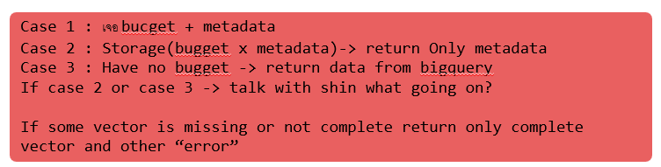
 | 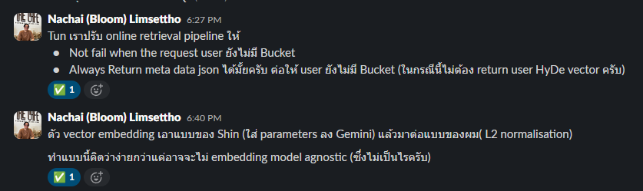
 | 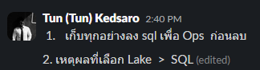
ทำ Unit test
- เตรียม JSON เอาไว้สำหรับการทำยิง Test เอาแบบ minimum ที่สุดคือยิงแล้วไม่พัง

