Freight Load Rate Prediction
Spotter - Machine Learning Engineer assessment. Code, metrics and figures are reproducible with `python -m src.pipeline` (see README).

Summary
- Task. Predict posted_rate for 12,000 loads in Nov-Dec 2025 from 48,000 labelled loads in Jan-Oct 2025, and a daily December curve for one fixed lane.
- Validation. Rolling-origin time folds with a 2-month horizon (the real setup), plus a city-holdout and a random split for comparison. Every learned statistic is refitted inside each fold.
- Model. Two stages on log rate-per-mile: a LightGBM tree for the load-level price (lane/city/region encodings, distance, equipment, weight, quote_signal and its daily regime) plus a small ridge model for day-level effects (weekday, quarter-end ramp).
- Result (final model A34). Time-fold MAE $40.4 (MAPE 1.85%), worst fold $64.1; city holdout $31.3, random split $28.6; vs $71.8 for ridge and $70.1 for a plain LightGBM on all features.
- Key finding. quote_signal looked useless (pooled correlation ~0) but its relation to price flips sign between regimes that the daily mean quote identifies; modelling the regime is the largest single accuracy gain.

1. Data and key findings
- Split in time. Training covers 2025-01-01..10-31, validation 11-01..12-31: the task is a 2-month-ahead forecast. 8 cities appear only in validation (1,447 loads, 12.1%); every other validation load is on a lane seen in training (4,014 lanes, median 10 loads each).
- Price structure. Rate per mile falls with distance (~$2.65 below 330 mi, ~$1.89 above 2,200 mi); Reefer > Flatbed > Dry Van; heavier loads pay up to ~6% more.
- market_index is one value per day plus small per-load noise (within-day sd 0.025 vs 0.168 overall), with a strong weekly cycle (Thu high, Sun low). Its slow level is confounded with time: low in Jan-Feb when prices were low, low again in Aug-Oct when they were not.
- Calendar. Prices rise over the last ~3 weeks of each quarter (Mar, Jun, Sep) and drop after; weekday effect about +/-0.8%; a ~5% upward drift Jan-Oct not explained by the index. No visible public-holiday effect.
- quote_signal regimes. Pooled correlation with price is -0.04, so it first looked like noise, not leakage. Per week, on long loads, the correlation ranges -0.32..+0.49 and tracks the weekly mean quote (r = 0.87): positive when the mean quote is high (> 2.1: late Feb, Mar, Jun, Sep), negative when low (< 2.0: Apr, May, Jul, Oct), ~0 in between (Aug). The regimes cancel out when pooled. Nov-Dec sit at ~2.05, the transition zone.
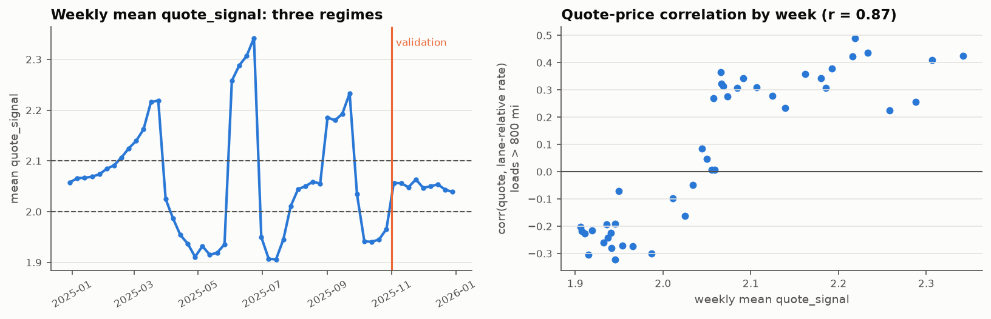
Figure 1. Left: weekly mean quote_signal forms three regimes. Right: the quote-price correlation per week follows the regime.

2. Data-quality issues and fixes
Validation rows are never dropped; feature problems are fixed or imputed and flagged. Only training rows with a corrupted target are removed. Fitted rules (weight medians, the corrupted-label filter) are refitted inside every CV fold.
Rule | Fix | Train rows | Valid rows
R1 city/equipment spelling | strip + title-case (defensive) | 0 | 0
R2 negative weight | absolute value (sign flip) | 292 | 145
R3 weight at cap/floor | keep value, add flag column | 1,236 | 308
R4 missing weight | impute lane x equipment median (>=5 loads) else equipment median, fitted on training rows; flag | 300 | 165
R5 missing market_index | same-date mean of the feature; flag | 374 | 249
R6 clipped coordinates (kept) | keep; distance is authoritative | 2,052 | 669
R7 corrupted posted_rate | drop from training (rate/expected outside 0.6-1.7) | 677 | 0

- Corrupted rates. 677 training rates (1.4%) are x2-x6 away from the expected price, spread evenly over equipment, month, weekday, distance and city: random multiplicative errors. They are flagged by an out-of-fold robust (L1) GBM that uses no lane identity; a lane-median rule agreed on 673 rows but mis-flagged thin lanes (1-2 loads) where the bad row itself moves the median. Sanity check: Huber loss on uncleaned labels matches L2 on cleaned labels, plain L2 on uncleaned labels is much worse.
- Coordinates are distorted and partly clipped (e.g. Boston/Providence lon = -69.5); distance is consistent (~1.18x great-circle, +/-5% within lane), so distance is authoritative.
- No duplicates, unparseable dates or spelling variants were found (checked defensively).

3. Validation approach
- Time folds (primary). T1 Jan-Apr > May-Jun, T2 Jan-Jun > Jul-Aug, T3 Jan-Aug > Sep-Oct: a 2-month horizon after the training cut-off, mirroring Jan-Oct > Nov-Dec. The model is chosen on the worst fold, not only the mean.
- City holdout. 64 cities in 8 random groups; each fold holds out every load touching a group city as pickup OR delivery. It measures the unseen-city risk (12% of validation).
- Random 5-fold only as a contrast: train and test share dates, so it rewards memorising day-level prices; its MAE is 2.9x lower than the time folds for the first LightGBM and 1.4x lower for the final model.
- Leakage guard. Weight medians, the corrupted-label filter, target encodings and their priors, the unseen-city blanking (training rows only), the stage-2 model and the tree are refitted in every fold on that fold's training rows. Test rows get encodings from the training period only.
- Labels. Metrics are reported on clean labels and on raw labels (corrupted rows kept), since the scored labels likely contain the same ~1.4% corruption.

4. Model
- Target: log(rate per mile); predictions are exp(.) x distance (log vs rpm vs $ targets were compared; smearing changed nothing measurable).
- Stage 1 - LightGBM: distance, great-circle distance, coordinates, equipment, weight (+ cap/floor/missing flags), per-load market-index deviation, quote_signal and the day's mean quote (regime), and out-of-fold smoothed target encodings of lane, pickup, delivery, 5-degree region and region pair. Unseen keys fall back to an equipment x distance-band prior; 12% of training rows get one city blanked so the model learns that case. Recency weights with a 60-day half-life.
- Stage 2 - day effects: ridge on the tree's date-grouped out-of-fold residuals: weekday dummies + a linear ramp over the last 21 days of a quarter. Keeping date features out of the tree stops it from memorising day-level prices that do not carry over to new dates.
- Tested and rejected: slow market-index level (-3..-5% bias two months out), holiday features (no gain; Thanksgiving/Christmas never seen), linear time trend (unstable: much worse on T2), level offsets from recent residuals (overshoot after the June peak), a ridge blend (weight tuned on T1-T2 = 0.60; failed on T3: $44.5 vs $26.8).

5. Results
Model | T1 | T2 | T3 | Mean | Worst | MAPE % | City | Random
Baseline: global median $/mile x distance | 189.8 | 199.2 | 203.7 | 197.6 | 203.7 | 9.37 | 213.0 | 213.5
Baseline: lane median $/mile | 148.8 | 83.8 | 76.2 | 102.9 | 148.8 | 4.25 | 94.8 | 90.9
Baseline: ridge on log $/mile | 52.5 | 52.3 | 110.7 | 71.8 | 110.7 | 3.01 | 59.6 | 54.8
LightGBM, all features (first model) | 59.2 | 70.0 | 81.2 | 70.1 | 81.2 | 3.11 | 26.6 | 23.8
Two-stage: tree + weekday/quarter-end model | 55.9 | 80.2 | 30.9 | 55.7 | 80.2 | 2.38 | 42.9 | 41.0
+ coarse quote regime + recency (smooth alt.) | 42.5 | 71.4 | 32.4 | 48.8 | 71.4 | 2.12 | 38.4 | 36.7
+ trailing quote x regime (smooth alt.) | 32.8 | 68.2 | 30.2 | 43.7 | 68.2 | 1.95 | 28.4 | 26.3
FINAL (A34): + daily quote regime + recency | 30.2 | 64.1 | 26.8 | 40.4 | 64.1 | 1.85 | 31.3 | 28.6

MAE in $ on clean labels. T1-T3 = time folds; City = city-holdout mean; Random = random 5-fold mean.
- Versus baselines: mean time-fold MAE is 44% below ridge and 61% below the lane median, and lower than the first LightGBM on every fold. Ridge remains better on T2 ($52.3 vs $64.1) but fails on T3 ($110.7, -5% bias when the market index is low).
- Raw labels: time-fold MAE $94.3 and RMSE $627 with corrupted rows kept (clean: $40.4 / $63). RMSE on raw labels is dominated by the ~1.4% corrupted rows for every model.
- Unseen cities: city-holdout MAE $31.3 vs $28.6 on the random split: the penalty for an unknown city is small (~$3).
- Where it errs: the weakest fold is T2 (Aug under-predicted ~3%: August's quote regime was neutral while January, the only similar training month, was positive). MAPE is highest on short loads.

6. December chart
The December file has no coordinates, market_index or quote_signal. Coordinates are looked up per city (identical for every load of a city); market_index and the daily quote regime use the real daily means of validation.csv (input features, not targets; a forecast from October missed the index by 0.02-0.07); quote_signal is the median of comparable training loads (Dry Van, 300-420 mi: 2.108). December 2025 lies outside the training range, so the model contains no absolute-time feature a tree would have to extrapolate.
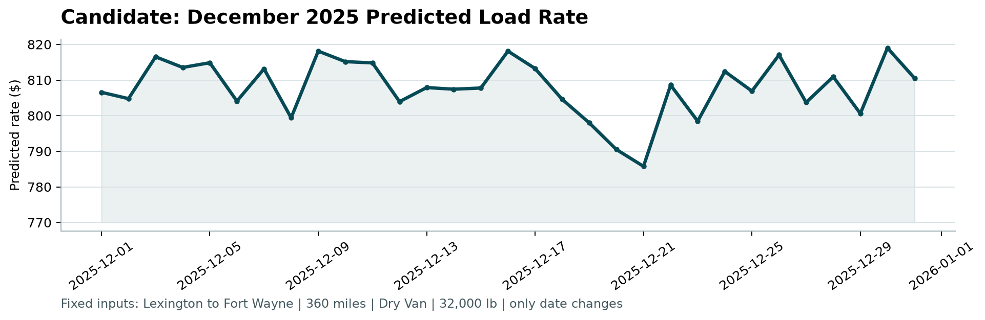
Figure 2. candidate_december.png produced by score.py.
- Range $786-$819 (mean $808; recent Aug-Oct Dry Van loads on this lane scaled to 360 mi average ~$808).
- Stage-2 day effects are small in the final model (Thursday +0.6% vs Monday, quarter-end ramp +0.2% by 31 Dec): the daily quote mean also carries day-level information, so the tree absorbs much of that movement.
- Day-to-day jitter: the load-level part moves between $788 and $816 because the daily mean quote (2.009-2.089) sits on the regime boundary, where the tree switches between the positive (Jan-like) and neutral (Aug-like) regime. Smoothed regime features (coarse bins, trailing 7/14-day means, quote x regime interaction) reduced or removed the jitter but cost 8-21% mean MAE on the time folds (a fully smooth weekday + quarter-end curve cost 21%); since validation accuracy is what is scored, the more accurate model was kept, and the same model produced both files.

7. Limitations and next steps
- No Christmas/year-end period in training: Thanksgiving and Christmas are predicted like ordinary days (e.g. 25 Dec as a Thursday).
- Quarter-end effect is learned from only three quarter-ends (Mar, Jun, Sep); the year-end may differ.
- Quote regime ambiguity: Nov-Dec sit at the regime boundary (~2.05), where training has only Jan (positive) and Aug (neutral) as examples; this is the largest source of risk and of the December jitter.
- Price-level drift is only partly predictable; level errors of 1-3% per month remain the main error source on the time folds.
- Next steps: a longer history (a previous December), an explicit regime model (e.g. hidden-Markov on the daily quote), quantile outputs for pricing ranges, and monitoring of the regime indicator.

