
ADVANCED EXCEL PROJECT REPORT
E-Commerce Order & Customer Analytics
Advanced Excel Dashboard & Analytics Project

Project Information | Details
Student Name | Tuna Santra
AF Code | AF05329974
Project Title | E-Commerce Order & Customer Analytics
Project Duration | 4 Days
Trainer Name | Sayan Sau
Submission Date | 02.09.2026
GitHub Username | TunaSantra63
GitHub Repository Link | https://github.com/TunaSantra63/Data-Analysis-Dashboard/upload/main

1. Project Objective
The main objective of this project is to transform an e-commerce order dataset into an interactive Excel-based analytics solution. The workbook summarizes revenue, orders, customer activity, product performance, regional performance, payment methods and customer segments. An interactive dashboard provides KPI cards, charts and slicers so that users can explore the data and identify important business trends.

2. Tools & Technologies Used
- Microsoft Excel workbook with structured Excel Table (SalesData).
- Structured references and Excel formulas for KPI calculations.
- SUM for total revenue and quantity calculations.
- COUNTA for order counts.
- SUMPRODUCT with COUNTIF for distinct customer counting.
- AVERAGE for average customer rating.
- Pivot-style backend summaries for category, month, region, product, payment method and customer segment analysis.
- Charts/PivotCharts: monthly revenue trend, revenue by category, top products by revenue, revenue by region, revenue by customer segment and payment method distribution.
- Interactive slicers for Category, City, Customer Segment, Order Status, Payment Method and Region.
- Data Dictionary sheet for documenting the meaning of dataset columns.

3. Dataset Description
The workbook uses an e-commerce order dataset containing 100 order records and 22 fields. The records cover orders dated from January to August 2026. The dataset combines order details, customer attributes, geography, product information, payment details, order status, ratings and calculated sales measures.
Attribute | Dataset Detail
Records | 100 orders
Fields | 22 columns
Customers | 20 unique customers
Products | 12 products
Categories | 6 categories
Regions | 4 regions
Cities | 10 cities
States | 8 states
Payment methods | 5 methods
Order statuses | Delivered, Pending, Returned, Cancelled
Customer segments | New Customer, Regular Customer, Loyal Customer
Date range | January–August 2026

4. Workbook Structure
Sheet | Purpose
Dashboard | Interactive management dashboard containing KPI cards, charts and slicers.
Raw_Data | Primary 100-row source dataset stored as the SalesData Excel Table.
Sheet3 | Supporting summary/pivot output used in the workbook.
Sheet5 | Supporting copy/analysis sheet containing the dataset.
Backend | Supporting aggregated analysis used for dashboard visualizations.
Data_Dictionary | Definitions and meanings of all 22 dataset columns.

5. Key Features
Feature | Implementation / Purpose
KPI Dashboard | Displays Total Revenue, Total Orders, Customers, Quantity Sold, Average Order Value and Average Rating.
Revenue Trend | Monthly revenue is visualized to show changes in performance across January–August 2026.
Category Analysis | Revenue is compared across six product categories.
Product Analysis | Top products are ranked by net revenue.
Regional Analysis | Revenue is compared across East, North, South and West regions.
Customer Segment Analysis | Revenue is analyzed for New, Regular and Loyal customers.
Payment Analysis | Payment method distribution is visualized across five payment methods.
Interactive Filtering | Slicers are available for Category, City, Customer Segment, Order Status, Payment Method and Region.
Data Documentation | The Data_Dictionary sheet explains every source and calculated field.

6. Formula & Calculation Logic
KPI / Measure | Formula Logic Used
Total Revenue | =SUM(SalesData[Net Revenue])
Total Orders | =COUNTA(SalesData[Order ID])
Unique Customers | =SUMPRODUCT((SalesData[Customer ID]<>"")/COUNTIF(SalesData[Customer ID],SalesData[Customer ID]&""))
Quantity Sold | =SUM(SalesData[Quantity])
Average Order Value | =SUM(SalesData[Net Revenue])/COUNTA(SalesData[Order ID])
Average Rating | =AVERAGE(SalesData[Rating])
The workbook also contains calculated source columns for Gross Sales, Discount Amount and Net Revenue. According to the Data Dictionary, Gross Sales is Quantity × Unit Price, Discount Amount is Gross Sales × Discount, and Net Revenue is Gross Sales − Discount Amount + Shipping Cost.

7. Key Analytical Results
Metric | Result
Total Net Revenue | ₹393,143.60
Total Orders | 100
Unique Customers | 20
Quantity Sold | 257
Average Order Value | ₹3,931.44
Average Rating | 3.98 / 5
Highest Revenue Category | Electronics — ₹140,692.10
Highest Revenue Region | West — ₹138,824.45
Highest Revenue Customer Segment | Loyal Customer — ₹141,179.75
Highest Revenue Product | Smart Watch — ₹72,413.25
Highest Revenue Month | July — ₹68,669.85
These results are calculated from the 100 records in Raw_Data and the supporting dashboard/backend summaries. They provide a concise view of the strongest categories, products, regions, customer segments and months in the dataset.

8. Dashboard Screenshot
The dashboard combines KPI cards, trend analysis and category/product/region/customer/payment visualizations. The workbook also contains Excel slicer objects for interactive filtering.
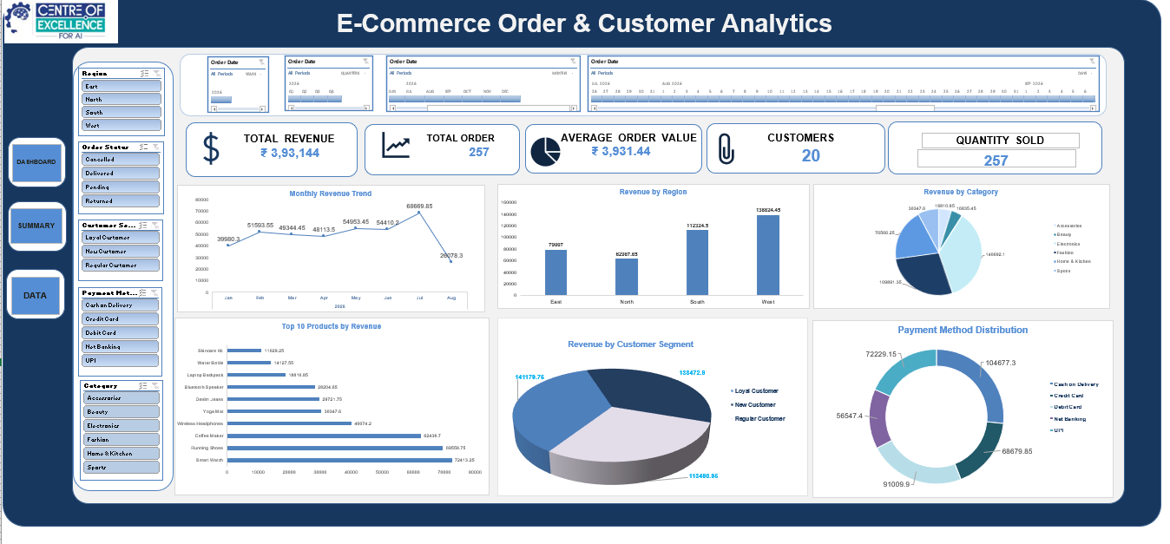
Figure 1. Dashboard overview.
Note: the screenshot is an exported preview. Some Excel slicer objects are not rendered by non-Excel spreadsheet exporters; the original workbook should be opened in Microsoft Excel to view and operate the slicers.

9. Learning Outcome
- Learned how to organize and document a structured e-commerce dataset in Excel.
- Practiced using structured references and formulas to create dynamic KPI calculations.
- Learned how to summarize large datasets using PivotTable-style analysis and supporting backend summaries.
- Developed skills in selecting appropriate charts for trend, comparison and distribution analysis.
- Learned how Excel slicers can make dashboards interactive and user-friendly.
- Improved dashboard layout, formatting, readability and business-oriented data presentation.
- Understood how a Data Dictionary improves clarity and maintainability of an analytical workbook.

10. Conclusion
The E-Commerce Order & Customer Analytics project converts raw order-level information into a structured and interactive Excel analytics solution. The final workbook provides clear KPIs and multiple visual analyses for revenue, products, categories, regions, customer segments and payment methods. With slicer-based filtering and documented calculations, the dashboard supports faster exploration of the dataset and demonstrates practical application of Advanced Excel skills.

11. GitHub Repository Submission

Item | Details
GitHub Repository Link | https://github.com/TunaSantra63/Data-Analysis-Dashboard/upload/main
GitHub Username | TunaSantra63
Repository Name | Data-Analysis-Dashboard

12. Trainer Verification
Trainer Remarks
Signature | ____________________________

